Georgina Henderson
[Email address]
Student Name: Georgina May Courtney Estelle Henderson-Ord
P Number: 2004490
Programme of study: Fine Art Studio Site and Context (BA
Module: Ways of Perceiving
Lecturers name: Ryan L. Moule
Words 1550

Love is Blind
My exhibition “Love is Blind” surrounds Domestic Violence and Sexual abuse towards women. I have chosen five artists and one philosopher, all women. All works capture what it is to be a woman and gives an insight to what it feels to be a survivor of abuse.
I have chosen this theme as being a survivor myself I feel it is important to raise awareness. I was also heavily influenced by the affects of the pandemic on the levels of Domestic Violence and Sexual Abuse. I carried out research which sadly uncovered what some have called a ‘hidden epidemic’.
As recorded by the National Statistics, police recorded 259,324 domestic abuse offences between March and June. This for context being 7% up on the same period in 2019. During the first lockdown of the pandemic one-fifth of the offenses were domestic abuse. Furthermore, there were 64domestic homicides in England and Wales between January and June 2020. 30 of them in the period between April and June. This is nearly 10 more than the same period in 2019.
Following these findings, I discovered the term Femicide, meaning any killing of women by men. The term was established by Diana Russell a feminist researcher in the 1970’s, with the intentions of governments taking a specific type of male violence towards women seriously. With this I discovered the UK Femicide Census. The census provides information on these femicides: the crimes, the victims, the perpetrators and the criminal justice outcomes. Carried out between 2009-2018 in which time 1,425 women were killed, or one woman every three days. Tragically the report findings show no evidence of the rate of femicide decreasing. With femicide also being identified as the leading cause of premature death in women globally.

Figure 1.

Figure 2.

Figure 3.

Feminist Philosopher Bell Hooks, book All About Love: New Visions (2000) speaks about the modern view of love and what prevents it. Bell discusses how men and women love differently. Bell references her past abuses by her family and previous partners and how it affected her own view of herself and what love is.
“Those of us who do not learn how to love among family are expected to experience love in romantic relationships. However, this love often eludes us”.
Due to the nature of abuse consisting of manipulation and coercion. Perpetrators warp the minds of their victims, prey on their vulnerabilities, test their belief systems self and external and often separating the victim from loved ones and society leaving them isolated.
However, what also cements the victim into staying with the perpetrator is love and the alternative side (fake side) acted out seamlessly by them. For example, we often hear of a man who beats his children and wife and then goes to the corner bar and passionately proclaims how much he loves them. If you talk to the wife on a good day, she may also insist he loves her, despite his violence. Otherwise, the so called “good times”. The victim remains trapped in this cycle or otherwise known as hope.
“We still hope that love will prevail. We still believe in love's promise.”
However, this is not love…..
“Abuse and neglect are, by definition, the opposites of nurturance and care.”
Nurturance and care which are key components of love and the actions of love, therefore the basic principle is that….
“Love and abuse cannot coexist.”
Leading on the artists works which I have included in ‘Love is Blind’ consist of Tracey Emin. Ana Mendieta, Jenny Holzer, Louise Bourgeois and Rineke Dijkstra. I have chosen all female artist to portray my theme as its surrounds Domestic Abuse against Women and therefore should be told only by the perspective of women.

My first piece in my exhibition is,
Tracey Emin – ‘They Held Me Down While He Fucked Me, 1976’
This piece made in direct response to Tracey’s own childhood trauma. At the age of 13, her 14-year-old female friend alongside her then 19-year-old boyfriend literally held her down whilst her then partners friend raped her. Their reasoning for this being they thought she needed to lose her virginity. Even more tragically unbeknown to them Tracey had been raped just four months before.
This piece had been originally shown as part of an exhibition entitled “A Fortnight of Tears” in which Tracey said,
“I’ve killed my shame; I’ve hung it on the walls.”
I found this statement incredibly moving in association with the theme of my exhibition ‘Love is Blind’. I intend to display this quote alongside the work.
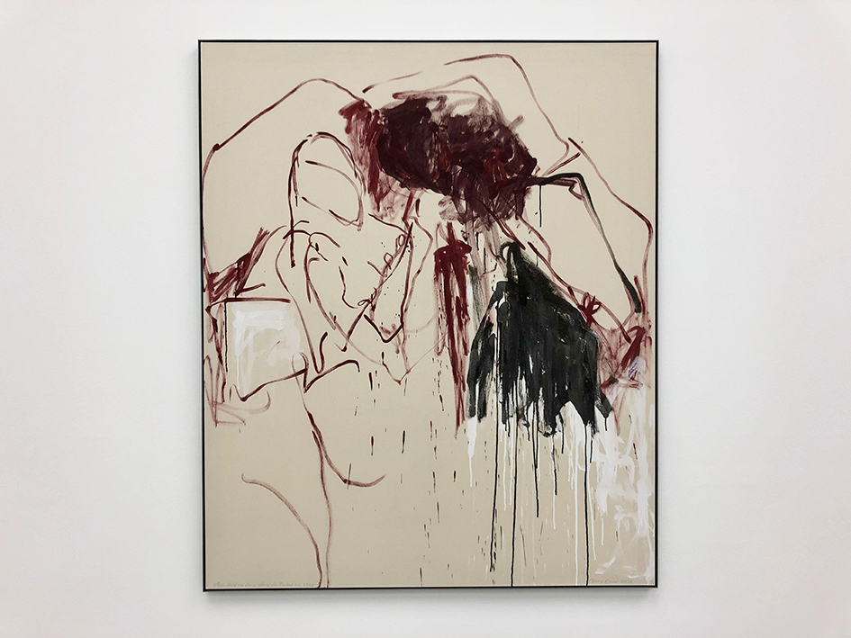
This piece shows the destructive nature of abuse through the gestural brushstrokes and the simple bold red, black and white colours used, whilst not going into too much detail of the events.

Emin,T.They held me down while he fucked me 1976’(Acrylic on canvas)
Alongside this the message behind piece displays the brutal events of abuse many women are subjected to.
I intend to place this piece on the left-hand side wall as you come into the gallery space.

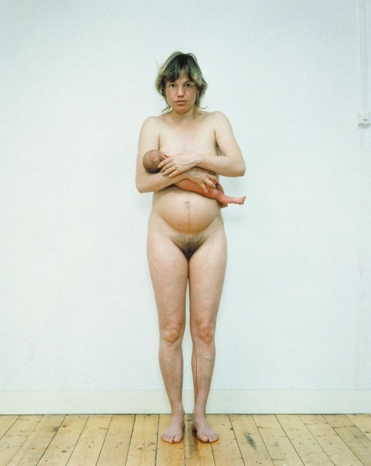
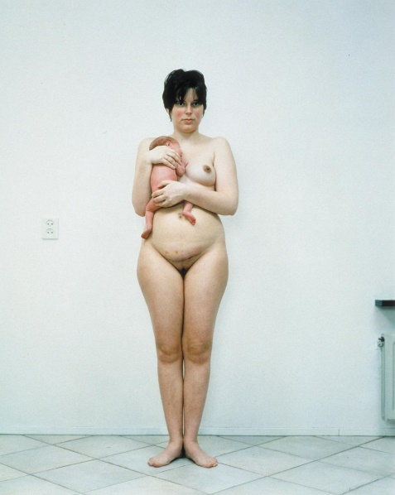
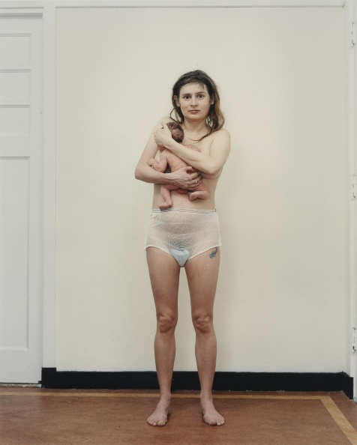
In contrast to Tracey’s piece, I intend to display Rineke Dijkstra’s three photographed portraits of three women after giving birth , next to Tracey’s work on the right-hand side of the left side wall. Each photo displayed in chronological order.
Dijkstra,R.(1994) Julie, Den Haag, Netherlands, February 29 1994, Tecla, Amsterdam, Netherlands, May 16 1994, Saskia, Harderwijk, Netherlands, March 16 1994, Tecla, Amsterdam, Netherlands, May 16 1994[Photograph, C-print on paper, mounted on aluminium] Tate, London.
Rineke was inspired to make this piece after witnessing her friend give birth. Shown in chronological order starting with Julie at one hour, Tecla at one day and Saskia at one week. Each woman displaying a range of emotions invincible, vulnerable, traumatised yet self-composed. All women are captured embracing and protecting their baby appearing metaphorically like Celtic warriors due to their nakedness and strength.
In relation to the context of my exhibition I decided on this piece to contrast a time at which women are most vulnerable with Tracey’s work next to the time at which women are at their strongest. It is when we are at our strongest is when we are most feared by men. It is the one thing men cannot do and cannot interfere with. It is the impenetrable bond between mother and child which threatens men. This same bond I have with my mother. The same bond which saved her life when in a domestically violent relationship with my father.
“lot of women came to me and said, you know it’s really great that you make these photographs because it’s really the way it is, but nobody ever shows it, and I can recognize myself in it. And the men were all like, you can’t show a woman like that.”
Rineke combines flash with natural giving a beautiful soft, clear and light effect. Each displaying small details of the mothers body with the birth leaving individual imprints.

The third piece I will be displaying is an installation piece by Ana Mendieta and preformed by. It will be situated in the half dome apart of the gallery. Installed into the gallery will be a wall with the door set a jar like that of the scene so as viewers walk by, they can see into the space.
Ana Mendieta ‘Untitled’(Rape Scene), 1973’

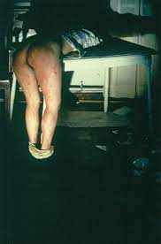

Mendieta,A. (1973) Untitled (Rape Scene)[ Photograph, colour on paper] Tate,London.
This piece is the most striking out of the works in the exhibition. Ana created this piece in response to rape and murder of nursing student, Sarah Ann Otten by another student in March 1973. This piece in conjunction with the context of femicide. The dramatic lighting casting strong shadows unveils a Woman stripped form waist down- bent over a table. With blood smeared covering her legs and pool of blood visible on dark floor besides her feet.
Mendieta recorded that her audience.
‘All sat down, and started talking about it. I did not move. I stayed in position about an hour. It really jolted them’.

Louise Bourgeois 1946-47 – Femme Maison
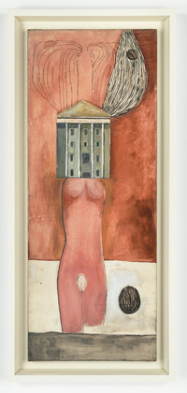
Bourgeois,L (1946-47) Femme Maison[Oil and ink on linen]
Femme Maison (Housewife) is a series of paintings exploring ‘traditional’ ideas of female identity. The piece takes a literal approach merging the female nude with the home. Louise was ahead of the times with this piece created before the second wave of feminism. She depicts the struggles women face balancing work and home life. She challenges the women’s role of Marriage and domesticity. Whilst being a mother. The piece was also created post war. Whereby women had taken over male roles only to be expected to return to life as it was before ‘severing their husband’. It is this friction which can be a cause of domestic violence.
Louise felt trapped by the domestic responsibilities that consumed her life.
She said the femme maison “Does not know that she is half naked, and she does not know that she is trying to hide”.
This piece is to be displayed on the right fair wall directly opposite Rineke Dijkstra’s work showing a parallel in life.

Jenny Holzer Lustmord 1993-6
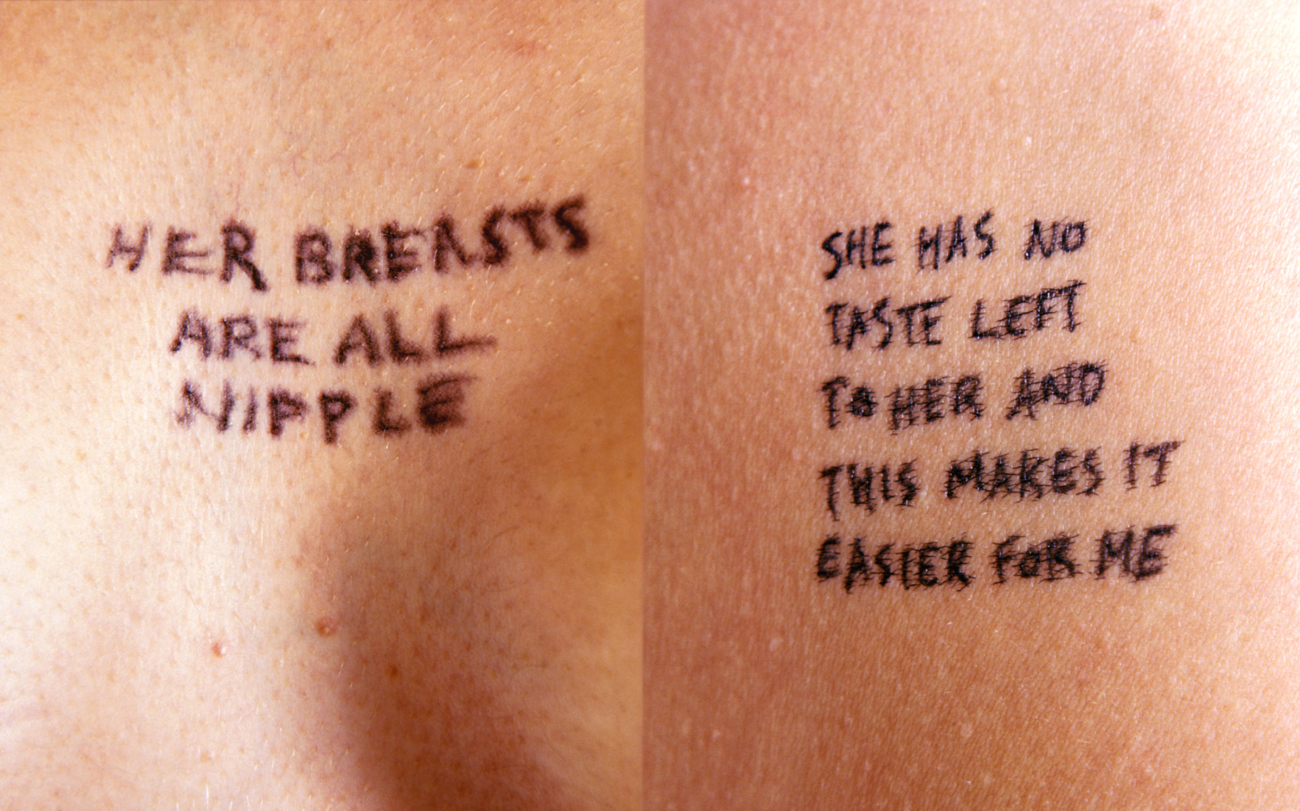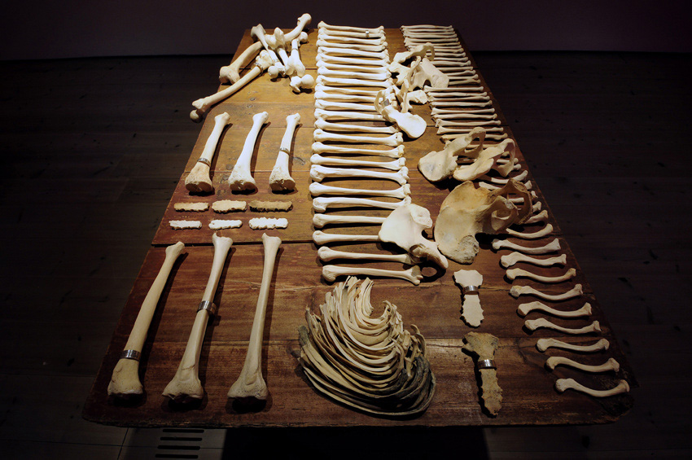
Holzer,J (1993-6) Lustmord[human bones, engraved silver, wood table,ink on skin, Photograph]
This is the last piece in my exhibition. The photography on the right-hand side wall at the end with the table in the middle of the room.
The context of this piece is directly in line with my exhibition.
The work approaches violence against women. In direct response (similar to Mendieta) the methodical rape and murder (femicide) of women as an act of ‘ethical cleansing’ during the Bosnian war. Hence the title being German for both murder and sexual pleasure.
There are two parts to Lustmord. Firstly the 3 poems inked on skin and photographed. Each from 3 perspectives- perpetrator, victim and observer. The poems are mixed to break the boundaries enabling the viewer to relate to all. Making the victim harder to identify. Making the viewer feel uncomfortable as society tends to turn a blind eye.
The second component is the table which displays human bones as a scientific examination. Each representing parts of feminine beauty and sensuality. With silver rings engraved with the poems.
The context in terms of the exhibition highlights viewpoints not only from the victim and perpetrator but the witness to. This witness so many of us have been. The witness who turned a blind eye.

.

Bibliography
- BBC.(2020) Coronavirus: Domestic abuse offenses increased during the pandemic. Available at: https://www.bbc.co.uk/news/uk-55073229. (Accessed at 26 April 2021)
- BBC.(2020) Coronavirus: Domestic abuse offenses increased during the pandemic. Available at: https://www.bbc.co.uk/news/uk-55073229. (Accessed at 26 April 2021)
- Long, J. Wertans, E. Harper,K. Brennan,D. Harvey,H. Allen,R. Elliott,K.(2019) Femicide Census. Available at : https://www.femicidecensus.org/wp-content/uploads/2020/11/Femicide-Census-10-year-report.pdf (Accessed at 12 March 2021)
- Hooks,B.(2000) All About Love: New Visions.United States, Haper Collins.
- Hooks,B.(2000) All About Love: New Visions.United States, Haper Collins.
- Hooks,B.(2000) All About Love: New Visions.United States, Haper Collins.
- Hooks,B.(2000) All About Love: New Visions.United States, Haper Collins.
- Lloyd-Smith,H.(2019) Tracey Emin lays bare her own traumas in piercing new show.Avaliable at: https://www.wallpaper.com/art/tracey-emin-a-fortnight-of-tears-white-cube-bermondsey (Accessed at 12 March 2021)
- Tate. Rineke Dijkstra. Available at: https://www.tate.org.uk/art/artworks/dijkstra-tecla-amsterdam-netherlands-may-16-1994-p78098 (Accessed at 12 March 2021)
- Tate. Ana Mendieta.Avaliable at https://www.tate.org.uk/art/artworks/mendieta-untitled-rape-scene-t13355 (Accessed at 12 March 2021)
- The Art Story. Louise Bourgeois. Available at https://www.theartstory.org/artist/bourgeois-louise/artworks/ (Accessed at 12 March 2021)
- Holzer,J (1993-6) Lustmord[human bones, engraved silver, wood table,ink on skin, Photograph]

Figure 1.Long, J. Wertans, E. Harper,K. Brennan,D. Harvey,H. Allen,R. Elliott,K.(2019) Femicide Census. Available at : https://www.femicidecensus.org/wp-content/uploads/2020/11/Femicide-Census-10-year-report.pdf (Accessed at 12 March 2021)
Figure 2. Long, J. Wertans, E. Harper,K. Brennan,D. Harvey,H. Allen,R. Elliott,K.(2019) Femicide Census. Available at : https://www.femicidecensus.org/wp-content/uploads/2020/11/Femicide-Census-10-year-report.pdf (Accessed at 12 March 2021)
Figure 3. Long, J. Wertans, E. Harper,K. Brennan,D. Harvey,H. Allen,R. Elliott,K.(2019) Femicide Census. Available at : https://www.femicidecensus.org/wp-content/uploads/2020/11/Femicide-Census-10-year-report.pdf (Accessed at 12 March 2021)
Figure 4. Emin,T.They held me down while he fucked me 1976’(Acrylic on canvas)
Figure 5. Dijkstra,R.(1994) Julie, Den Haag, Netherlands, February 29 1994, Tecla, Amsterdam, Netherlands, May 16 1994, Saskia, Harderwijk, Netherlands, March 16 1994, Tecla, Amsterdam, Netherlands, May 16 1994[Photograph, C-print on paper, mounted on aluminium] Tate, London.
Figure 6. Mendieta,A. (1973) Untitled (Rape Scene)[ Photograph, colour on paper] Tate,London.
Figure 7. Bourgeois,L (1946-47) Femme Maison[Oil and ink on linen]

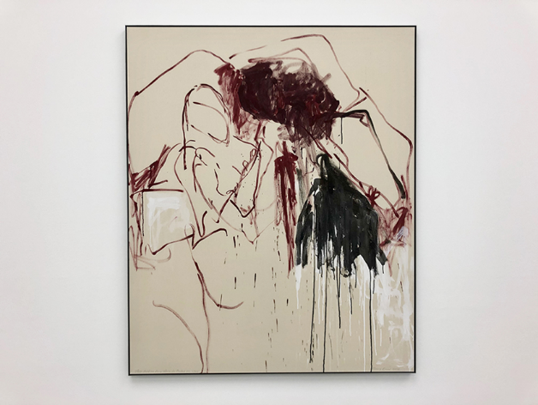
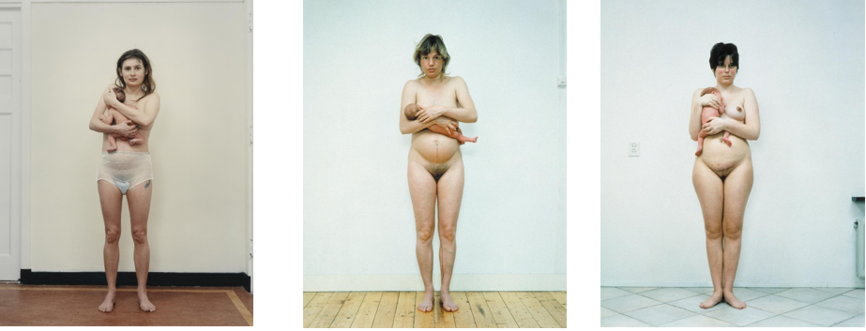

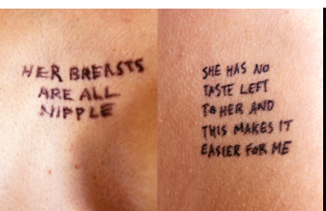
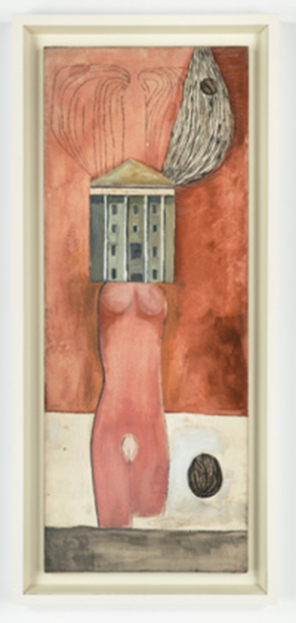
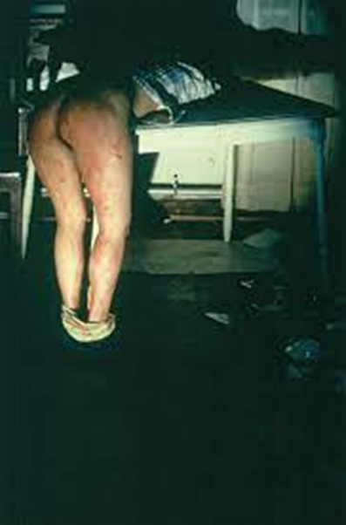
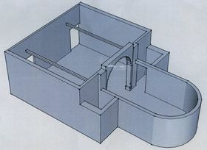
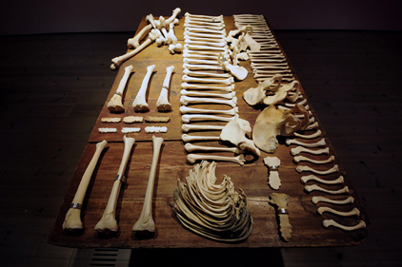

https://www.bbc.co.uk/news/uk-55073229
https://www.bbc.co.uk/news/uk-55073229
https://www.femicidecensus.org/wp-content/uploads/2020/11/Femicide-Census-10-year-report.pdf
https://wtf.tw/ref/hooks.pdf
https://wtf.tw/ref/hooks.pdf
https://wtf.tw/ref/hooks.pdf
https://wtf.tw/ref/hooks.pdf
https://www.wallpaper.com/art/jenny-holzer-like-beauty-in-flames-ar-guggenheim-bilbao
https://www.tate.org.uk/art/artists/rineke-dijkstra-2666
https://www.tate.org.uk/art/artworks/mendieta-untitled-rape-scene-t13355
https://www.theartstory.org/artist/bourgeois-louise/#nav

