Technical Report
Introduction:
This technical report is created in order to outline the rules and regulations of the soapbox event in which we wish to take part in as well as emphasising how these rules will affect the sourcing of materials and design of the soap box. With these rules in place it is vital to ensure passenger safety even if its at the expense of aerodynamics.
Rules and Regulations:
Drivetrain;
The rules and regulations state that our ‘soapbox’ rally car must be only be propelled by gravity. There can be no engine, motor, pedals or stored potential energy. This rule obviously means that there can be no alternative power source to drive the axel in order to turn the wheels of the vehicle. This, therefore, limits the maximum speed of the car that it could go. Without this in place we could buy an engine and place this in our design in order to make the vehicle go faster.

They also state that the car must be maximum length of 2500mm and have a maximum width of 1500mm. It must also have a ground clearance of at least 50mm. These regulations limit the size of the rally car that we could create. This, in turn, limits the performance of our car. For example, if there were no limitations, we could make the car as big as we want which would make the car heavier. And since this car is propelled by gravity alone, this would mean the car would travel the course in a quicker time. The rules also state that there can be no loose additional weights added to the car. This is because with extra weights added to the car freely with no purpose it would give us an unfair advantage due to extra mass would aid the gravitational pull.
Driver Safety;
The rules also mention that we must include two substantial roll bars. One above the driver’s head and the other above the steering wheel. Although these are a necessary safety precaution, without this regulation in place, we could use the money that would be needed for the materials and manufacture of these parts on other areas of the rally car that we enhance the performance of our vehicle. This would therefore mean we would do better in the competition. 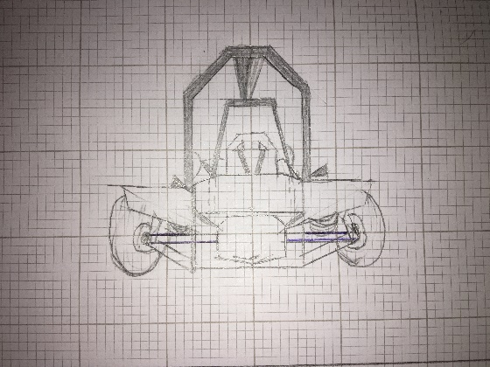 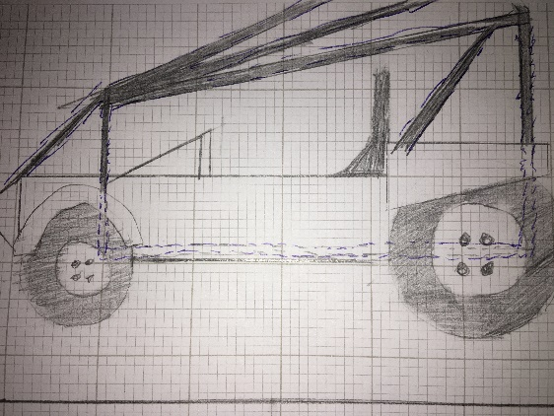
As Can be seen in the two images provided using a rectangular frame the shell loses aerodynamics.
However this frame is crucial in ensuring that the structure does not impede on the drivers head space allowing further protection of the neck and head in the worst case a roll, This works alongside a driver rule that a full helmet must be worn by anyone attempting to go down the track.

Budget limitations;
Our budget, along with the rules and regulations, also prohibits us on what we could create. For instance, if we had an unlimited budget, we could buy the best materials, such as carbon fibre, and the best parts we require, like very good brakes and tyres, in order to make the best vehicle it could be and therefore win the competition. However, having a limited budget means we can’t buy the best money can buy. We must be decisive on where to spend more money in some areas than others so that we get the best out of what we have or what we can get. Our budget limitations also link with the rules and regulations limits to what we could build. For instance, if we had unlimited money and no rules and regulations, you could theoretically build a ‘supercar’ and win the competition. Therefore, these rules make the competition a fair environment.
It leaves us open to alternative sourcing of material including recycling and sponsorship. First and for most we need to search for recycle materials for the soapbox car. Old pieces of wood, discarded strollers and cushions should be very helpful. When it comes to wheels, we can even use old wheels that we found or already had. The main metal structure of the soap box is a galvanised tubing covered in zinc to prevent rusting; with an internal diameter of 48.3mm. too obtain this material in pre-cut lengths and joints suitable to the length of the cart would engulf a larger percentage of our budget then needed so with the use of the local colleges welding students and facilities we are able to eliminate labour costs of getting a frame made, in order to get cost efficient resources we can use scaffolding poles and use cross cuts to create corners, this reduces the prices to £14.40 per 10ft of pole. As for the front centre of the frame where four frame poles connect, we can source an exhaust manifold from a local scrapyard that can be welded in order to space apart all components of the frame and connect them. This manifold also offers an aerodynamic advantage due to it being a smoothed edge that pushes air upwards reducing air pressure.
By using scaffold poles as well as the base boards to create a wooden shell we will be left with suitable surface area to display a sponsor; logo, name and number. If a suitable sponsor is found this will allow us to focus the budget on the Ackerman’s steering mechanism as well as sourcing an independent rear suspension (IRS) system that will be able to handle the ramps without a loss of momentum, this is crucial because of the gravity propulsion being the only acceptable drive force allowed.
IRS was a popular choice in most modern cars allowing a purchase of a rear axle from a car can be a complete transfer. If possible, we aim to source a real wheel drive axel and differential system due to being able to allow both wheels to move at different speeds through corners furthermore eliminating the loss of momentum through corners.

CAD Drawings:
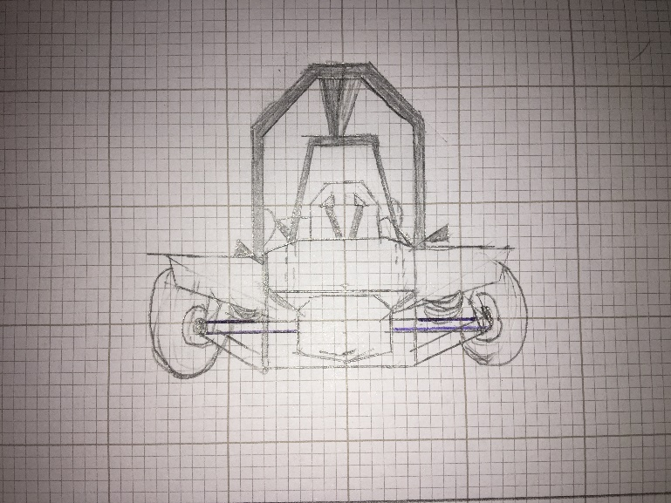
This drawing of the rear shows how the bucket seat is enclosed inside the soapbox’s frame in order to optimise security of the driver as well as balancing weight out throughout the cart in order to help the speed collected from gravity on the downhill descent. Highlighted in blue is the axels that go from the hubs of the wheels into the differential (circled in red)

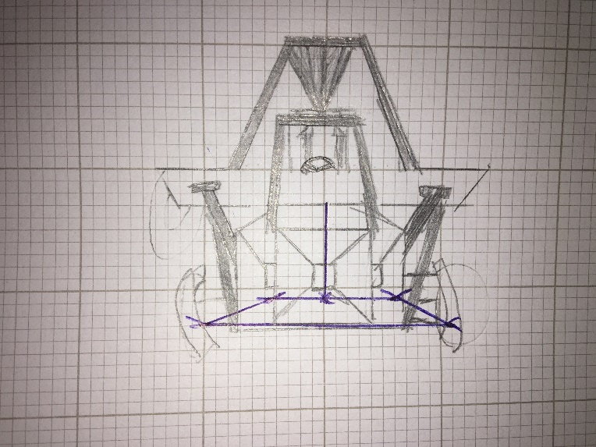
In this sketch of the front of the soapbox The Ackerman’s steering mechanism that consists of a rectangle and a pivot point that when shifted causes an offset in frame causing the wheels to shift and turn.

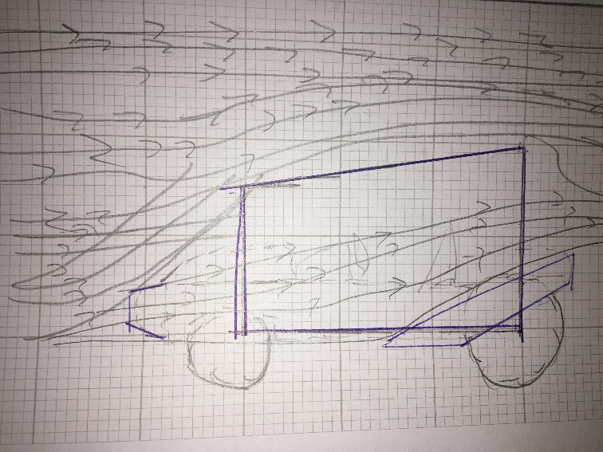
In this drawing I show the offset of air due to the shape of the cage as well as how the arches kick air away from the wheels. Highlighted in blue is the frame as well as the arches that cover the wheels.

