Macmillan Distribution Management Sustainability Report

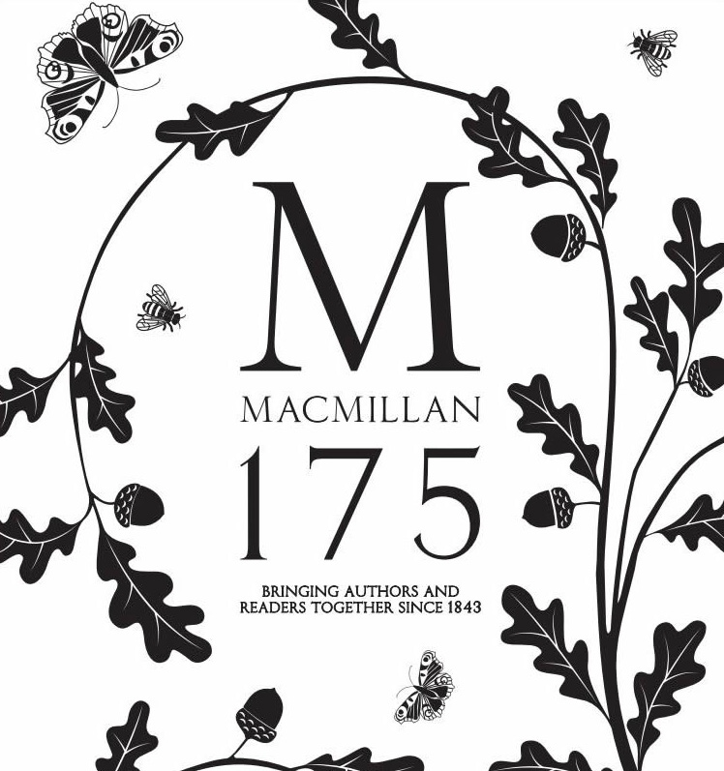

MBA Sustainability Leadership
BMSP7003D - Embedding Sustainability within Organisations

Antony Swistun - 1604713
Table of Contents
The aim of the report 1
Internal factors 2
External factors 1
MDL emissions report 2020 1
Conclusion. 1

“MDL provide a first-class distribution service with the ability to supply books seamlessly to customers all over the world.
Their customer service teams are dedicated, professional and a joy to work with and they have systems in place that give a publisher all the information they need to manage their business.
Being distributed by MDL has been a key factor in facilitating sales growth both in the UK and Export markets for many of the publishers I work with”. (MDL, 2021)

The aim of the report
This report aims to identify the current, and potential sustainability practices and processes carried out by the company, identify and address any interrelated issues, and / or conflicts of interests with stakeholders, and try provide a current sustainability level of the company.

It is clear that in this ever changing world that the need to be sustainable is as important as ever, the need to not only out perform our competitors, but to be seen as being greener than them is now an important factor as to how we are percieved by the customers, as without them, the company will not survive.

To address the issue of sustainability within a company, the company must look internally at its own culture, how it orders, uses, then disposes of its products. The company should set out a clear objective and communicate it to the workforce to ensure everyone knows what needs to be done, what affect their actions have on the company, the environemnt, so that the workforce will buy into the companys policies and procedures when being implemented.

Hofstede’s prolific writings constantly remind us that although ‘values’ are ingrained and reinforced from birth; ‘practices’ are learned, inured, and can be changed, such as in the business environment when one moves from one employment situation to another and openly adapts and accepts a new business culture. (Borkovich, 2011)

Internal factors
Since the creation of the sustainability team, what internal sustainability practices are currently in place, and what can be done to improve them.

- Implementation of a sustainability team
- A clear indication to become carbon neutral.
- 33% reduction in plastic usage.
- 27% reduction in paper usage.
- 100% renewable energy used at site.
- LED lighting installed to reduce energy consumption.
- Partnered with local recycling businesses to increase recycling.
- MDL diverted 97% of all waste away from landfill or incineration.
- Partnered with DPD so in the past 12 months over 6,000 MDL parcels have been delivered.
- An all-electric truck fleet.
- A diverse, and inclusive workplace, for all races, religions, sexual orientation, physical, or mental disability.
- Increased on site recycling team, waste sorted into separate bins for recycling efficiency.

The company has taken steps to make itself more sustainable, and it is becoming so, however there is still scope for improvement. Some of the issues that need addressing are:

- No communication between sustainability team and workforce.
- Poor departmental leadership, failing to follow through on communicating company objectives and goals.
- Departments unable to work together to address issues, (managerial).
- Still an over reliance on paper in all departments.
- Not all of the workforce is aware of the sustainability team.
- Not all of the workforce is actively engaged in sustainability measures.
- Current VNA (Very Narrow Aisle) truck batteries have a 3x8 hour cycle, 8 hours to charge, 8 hours to cool down, and 8 hours of usage, (When in optimum condition). This system takes too long as there is a day and night shift, and most batteries have suffered failures as a result.
- The company is bound to local pallet manufacturers due to the nature of the business, however, a recent shortage has meant a significant decline in good quality pallets, leading to poorer quality pallets being used, which has led to damaged stock from protruding nails and rougher surface areas.

Most managers look for short-term financial benefits to justify socially responsible or sustainable practices. Such practices also help firms become more resilient. (Natalia Ortiz-de-Mandojana, 2016)
While the company has identified and implemented cost saving and sustainability measures, some additional areas of opportunity are:

- Hold bi-monthly / quarterly meetings with the workforce to address any issues that have arisen, brainstorming sessions for new ideas, it is an opportunity to get all of the workforce behind the measures.
- Installation of solar panels on the vast warehouse roofing systems.
- Invest in Lithium-Ion batteries for the VNA’s, as used on the OPT’s (Order Pick Truck), they are fully charged in an hour, and thrive on opportunistic charging that currently damage the current VNA batteries.
- Training courses / toolbox sessions, so the workforce understand the impact of their actions, and those of the company on the environment.
- Strive to achieve the following ISO certifications, ISO 14001 Environment, ISO 50001 Energy, ISO 45001 Health and Safety, ISO 90001 Quality, ISO 20400 Sustainable Procurement.
- Renegotiate contracts with third-party suppliers, and operators, to ensure all aspects of the company’s inbound consumables, and transportation needs, are sustainably sourced, recyclable, and more environmentally friendly.
- Reduce unnecessary operations so that more time and effort can be spent on training, housekeeping, ensuring a cleaner, safer, more sustainable operation.
- Work towards achieving some of the 17 UN social development goals, SDG’s.

There are still internal threats that can prevent successful implementation of the above measures, either through:

- Ignorance.
- A lack of understanding / training.
- Poor communication.
- Inter departmental feuding.
- An unwillingness to change.
- The workforce not being motivated by sub-standard leadership.
- Department heads own agendas blocking the way of progression, workers ideas, and lowering morale, therefore affecting the culture of the company.

External factors
There are many external factors that can have an affect on the company, some with less of an impact than others, but all can cause significant issues. As we come to terms with the implications of Brexit, we can see how the UK is seen as a trading power, how the government deals with the political fallout, and how it can affect the company as an international organisation.
There are many political factors that cause issues for international trade, be it through distribution to customers, suppliers to the company, or a shortage of non-UK HGV drivers that are, or were, based in the UK, working for UK companies.

Some of the political factors include:

- Import, export duties, customs border checks.
- Business taxation.
- Value Added Tax (VAT).
- International trade policies and embargos.
- Domestic and international funding grants for investments.
- Infrastructure improvements.
- Environmental policies and regulations.
- Noise and vehicle pollution regulation. (Euro 5 ratings)
- Local and international policies for international operations
- Political issues in other countries (e.g. France)
- European union (EU), market rules, regulations, and policies.
- Other nations trade rules, permits, and taxation on imports, and exports.

There are many factors affecting a company’s economic footprint, some have been addressed above, while others are more specific to the locality of the company. Such as:

- UK government policies and taxation.
- Local governments business rates and policies.
- UK and global market prices.
- The value of £ Sterling in the exchange rate to other global currencies.
- Employment / unemployment rates in the locality.
- Wages / cost of living in the locality.
- Materials, transportation, fuel price rises.
- Competitors costs if lower, can be a threat.

There is a social impact that can also be felt by the company, if unaddressed, it can have an economic effect on the company.

- Pledge of a carbon neutral footprint by 2025.
- Cycle to work scheme intended to reduce employees carbon footprint and improve their health.
- Better work-life balance, introduce flexible working where possible.
- Better wages for staff, the more they earn, the better they can provide for their families.
- Employ locals to help contribute to local economy and create a stronger link with the community.
- Give back by donating to local good causes, charities, and youth sports initiatives.
- Supporting mental health, physical health, and the wellbeing of the workforce.
- Be seen as a contributor to environmental diversity.

If the company is seen to be a good place to work, good for the community, and the environment, more people will want to work for the company, stay there for longer, reducing staff turnover, and reducing training costs.

Technological advancements have led to a more streamlined operation, reduced costs, reduced emissions, and a reduction in the company’s carbon footprint. Thanks to improvements and advancements such as:

- An all-electric powered fleet of fork trucks, (inside warehouses).
- Collaboration with distributors who now use electric, and hybrid vehicles for deliveries.
- Implementation of a voice order picking system to reduce paper usage, (not as effective as it could be, so paper usage is still high).
- Upgraded conveyor system that is more efficient.
- A new warehouse management system is currently being completed, and is due to be operational by Q2, 2022.
- An online ordering system that cuts down wasted time in telephone ordering systems.
- Print on demand (POD), printers that can print a specific title, or part of one, negating the need to print hundreds of copies to justify the setup of the printer.
- More efficient transportation methods being developed to reduce running costs and emissions.

While there have been many savings thanks to the technological advancements, some of the technology has been wrought with issues, leading to paper usage not being as low as expected at this time.

The company is subject to local laws, legislations, policies, within the UK, and laws local to countries in which it operates. These can be of little significance in some countries but can be much harder to be operate within in others.

- UK Health and safety regulations, HASAWA (health and safety at work act 1974).
- COSHH - Control of Substances Hazardous to Health.
- Environmental Protection Act 1990
- Fair play trading, anti-corruption, and anti-fraudulent business practices.
- Workers’ rights, anti – slavery policies, trade union collaborations.
- Legalities to adhere to for operations in other countries.
- Building legislation, land registry and council planning departments.

Due to the nature of the company, its location, and the volume of stock turned over every day, the main brunt of the environmental impact is down to distribution. The following are examples of how the company is affected by the weather, UK and globally, and the effect of its carbon footprint.

- The company is located in south Wales, close to the M4 motorway to allow easy access for deliveries too and from the warehouses.
- The three main seaports that stock is transported too, and from, are Milford Haven in Wales, Felixstowe, and Southampton in England.
- In recent years the company has been affected by Typhoons delaying container ships leaving port in Honk Kong, and Singapore, the Evergreen container ship blocking the Suez Canal, causing ships to divert around South Africa, prolonging their journeys and using much more fuel than expected, coupled with rising oil, and fuel prices have caused delays, increased costs, and the customers also facing delays and price hikes.
- The company is also limited in terms of footprint. The current warehouses have been approved for expansion, planning permissions initially was rejected due to the proximity of a gas pipeline, however, when the company MD approached the council and told them that if the company were unable to expand its footprint, the council would be responsible for over 300 job losses. The council later granted the planning permission to expand.
- Thankfully there is very limited usage of chemicals, or toxins within the company, this has thankfully led to little impact on local wildlife and river systems.
- The main pollutant on site is from vehicles, staff arriving and leaving, and the deliveries arriving, and leaving on HGV vehicles.

Thankfully, the external factors on the company have not had a severely negative affect. Years of experience from the workforce, distribution companies, and advancements in modern technology have so far allowed the company to weather the political, environmental, and economic storm so far. There will no doubt be surprises along the way, good and bad, but the company is in good stead to face them.

The company has looked to address the usage of fossil fuels in the entirety of the UK bases and have used methodologies inline with DEFRA’s environmental reporting guidelines (2019), as well as the governments greenhouse gas reporting conversion factors (2020), to quantify emissions as set out in the image below.

MDL emissions report 2020
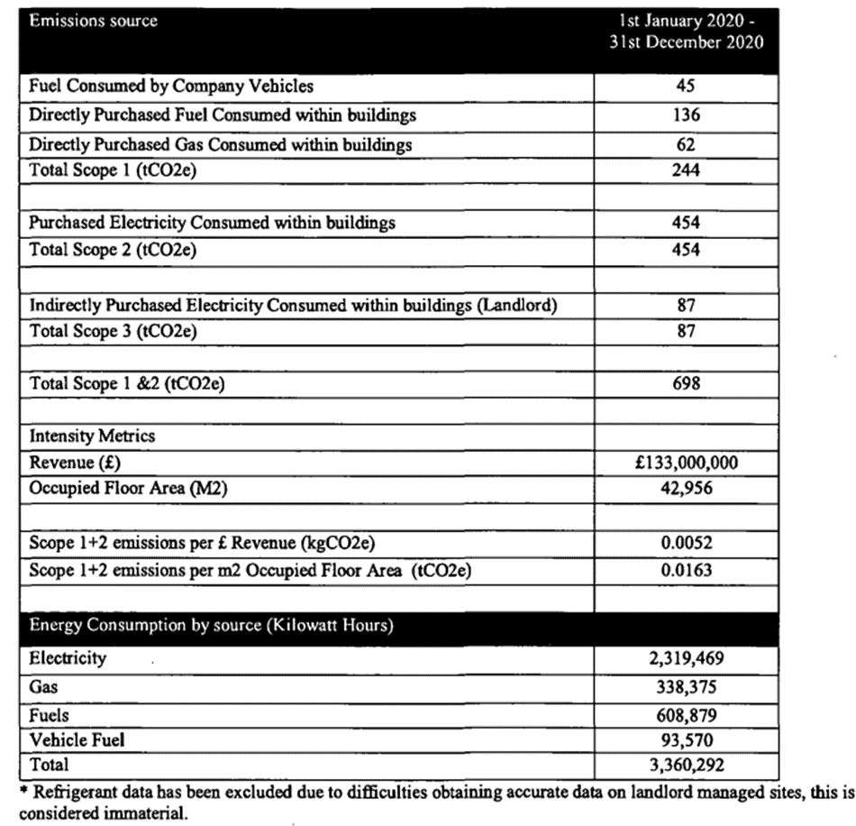 (Macmillan distribution MDL, 2020)
The company has taken steps to reduce its energy consumption, and carbon footprint, by creating sustainability committee, and has selected an energy supplier of 100% renewable energy since 01/01/2021, who is accredited by Ofgem.
Some of the factors used to see how sustainable a company is, is to see how they rank on the following key performance indicators, KPI’s.

- Carbon Footprint.
- Energy Consumption.
- Product Recycling Rate.
- Saving Levels due to conservation and improvement efforts.
- Supplier Environmental Sustainability Index.
- Supply Chain Miles.
- Water Footprint.
- Waste Reduction Rate.
- Waste Recycling Rate.

As a whole the company’s carbon footprint is quite low, however there is always scope for improvement.
While the company has made significant steps to becoming sustainable, there are many external factors that will limit its ability.
I would rate the company’s sustainability level as 6/10, but high paper usage, third party emissions around the site, and globally, still have a significant impact on the company’s footprint.

Conclusion.
A valiant effort so far, but there is always opportunity, technology, and a will to be better.
So let’s do so.

