Aled Charles (P151860)

Group Name – Moonshine
Project Name – Trash Can Empire.

Project Post Mortem.
Module Code – M6X01898

Contents
- Introduction
- Works Undertaken
- Research Evaluation
- Technique Evaluation
- Development Evaluation
- Analysis

Introduction.
Since September production team moonshine has been working on a game called Trash Can Empire, which is a strategy based tycoon game where the player is able to gather resources to expand outwards from their home territory to eventually conquer the three in game planets.
To create this game the tech team has been working in the Unreal Engine to ensure that the in game mechanics work as they should while the art team work on future designs to be added into the game, the role assigned to each student was as follows:
Tech
- Daniel Burns
- Owain Hillier
- Toby Wheeler
Design
- Aled Charles
Art
- Maxine Wynter
- Alex Sheldon
- Martyna Grek
The writer of this post mortem is Aled Charles the only member of the design team. In the early stages of production the team had to decide which game idea to follow and while a few were put forward it was ultimately Aled’s idea that was taken on, the current version of the game looks much different from its original form where as opposed to it being set in a backwater town it is now set on a planetary scale, though the core game mechanics are unchanged for the most part.

Works Undertaken
The following works described in the introduction was carried out by Aled Charles.
To help player immersion in the game sounds had to be added to the game, sounds such as feedback noises where a player will be able to get information about what he has just built or upgraded, the planet itself was given a music track with a theme matching its background, as the player progresses the music track will become more complex to give feedback to the player about his current status in game.
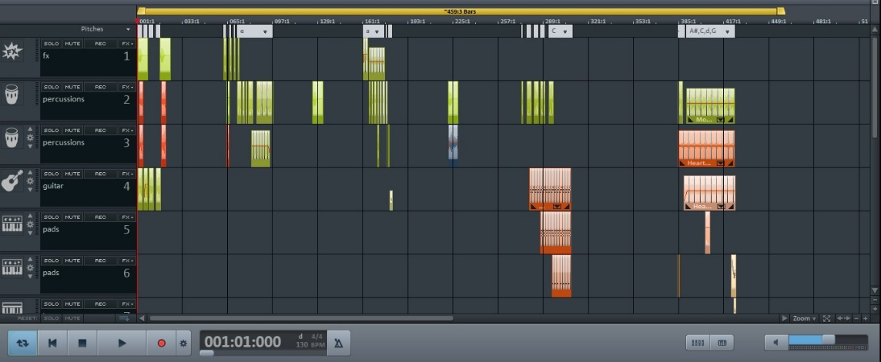
A games design document was required for a final artefact so that all team members understood what was required for the final game, in the first few weeks a rough version was made for all team members to read, however some team members found this version of the games design document difficult to understand and resulted many questions being asked regarding the designs and game setting. Whether this was due to some language barrier in the group or some other form of miscommunication is still undetermined, however it did result in some of the art team’s desire edit the games design document themselves and so while the majority of the games design document was made by the design team the character and game world sections were re written by a few members of the art team albeit being read over afterwards to ensure that it matched what was supposed to be done.
In order to keep the team organised and in communication with each other beyond the team’s Facebook messenger was set up and team meetings were held. On virtually every Tuesday team meetings were held where a team member’s progress on a certain task and the succeeding task was evaluated and put down on the team’s meeting minutes and afterwards uploaded onto the team’s google drive so everyone would be able to read it.
In order to have the game world function it required levels for it to be set in, to have these in the game a series of level designs were created that had level specific attributes that would be expected of a strategy game would be included, after these designs were created they were shown to each team member in the next team meeting, out all of the level designs that were created three were chosen, these three designs were then digitised with one version for showing the general layout of the game and another for more in depth features such as region resource yield and enemy movements.

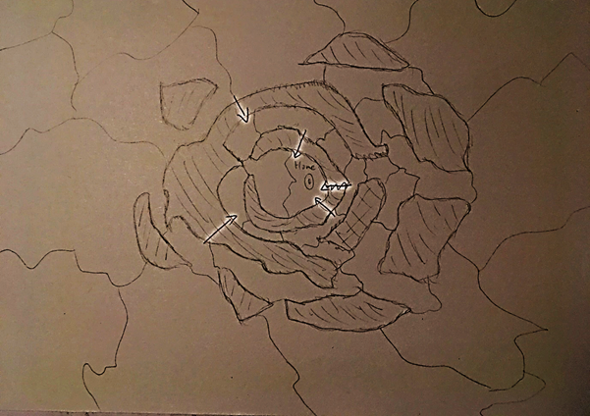
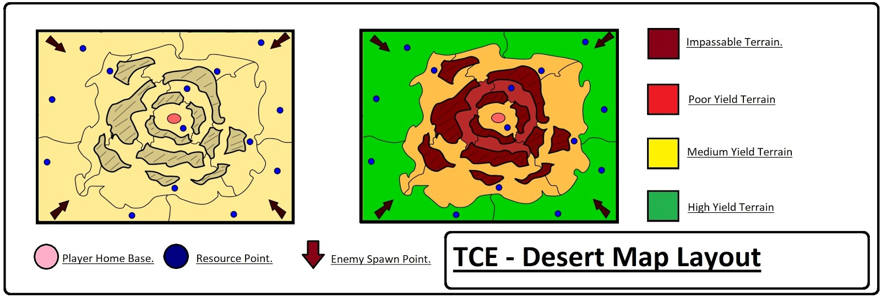
After being digitised these map designs were then made into whitebox levels in Maya, the first desert map created was not very well made with some tiles being taller that the others and the exact shape of the country tiles being inaccurate which resulted in holes in the world floor. This map had to be redone before being added into the game and so after finding out how to add the original digitised map into Maya as a plane the country tiles were able to be created much more accurately through effectively tracing them onto the map below, after their completion the tech team were then able to effectively create their levels in the Unreal Engine.
After whiteboxing, tests were needed to be done on the game to see how it would work on a gaming audience. In preparation for this some work had to be done first to let people know that a playtesting session was going to happen posters were designed and created, initially two designs were created, one with the older design of the main character and another that Maxine Wynter had created, after presenting both to the production team the older design was used. In addition to this a questionnaire was created for people to fill in and a discord server was created and a link was provided on the playtesting poster so people would be able to get any information that they wanted.
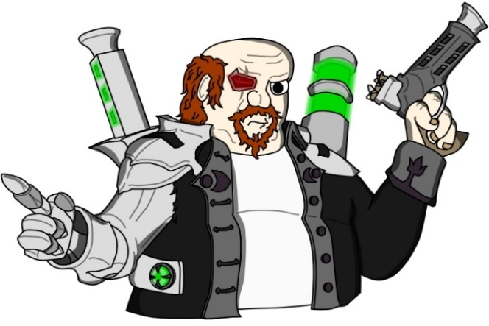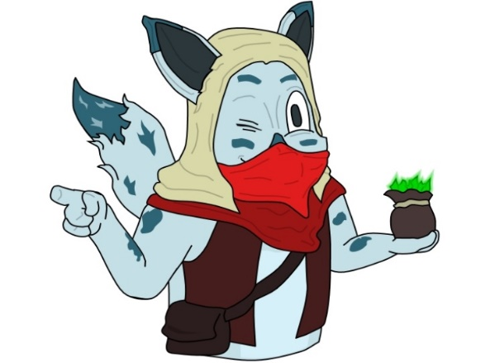
The first playtesting session went poorly with only two people turning up and with only two questionnaires filled in another had to be created, another was held in a Carmarthen Gaming Club called the Carmarthen Old Guard where the playtesting session was much more successful and the questionnaires that were filled in were increased to fourteen.
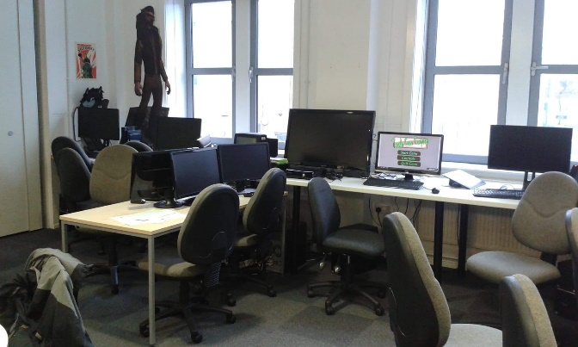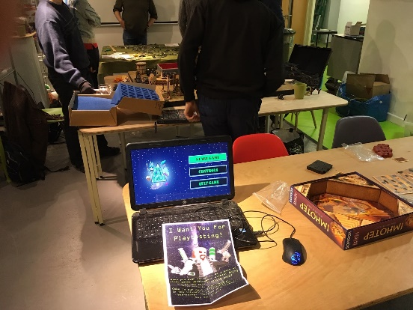

Research Evaluation
Whilst creating Trash Can Empire research was undertaken for a variation of reasons whether it was to see how to complete a certain task or to determine how a certain design should look in game for example as the initial whitebox map was poorly made research was undertaken to see how an image can be imported to Maya so that in game country tiles can be created much more accurately. For the most part the internet was used to gain this information however there were more practical examples used.
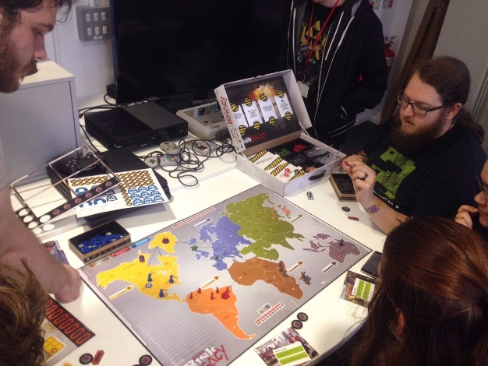
There was a problem during the early stages of development where most of the team were unfamiliar with strategy games and thus required experience with the genre to ensure that the designs that they made would be better implemented in game, initially Toby Wheeler offered to bring in his copy of Risk but as his copy was insufficient (capable of only having two players at a time) Aled decided to get his own copy of the game, after the entire team had met up in class they all had a game of Risk which would later help them with future designs for the game such as the in game tiles being country shaped as opposed to simple square tile shaped.
Some research was undertaken to create the music in the game, as it was only the first planet that had to be done in the first semester it only required the single music track. In designing this music track research was undertaken by listening to music from games with a similar setting to Trash Can Empire and while future tracks for different planets will differ the planet that required music was a desert planet and so it was decided that it would have a sort of Western feel to its music and so inspiration was taken from soundtracks for Starcraft and Fallout: New Vegas. In order to give the player feedback regarding their progression ideas were taken from Civilisations where the music will begin with only a few simple sounds but then become more complex as the player progresses through the game.
In order to create a successful level design for players, inspiration was taken from other strategy games such as Stronghold, Risk and Rise of Nations to make sure that the game’s level designs had all the features expected of a strategy game level.

Technique Evaluation
As the tasks required to complete the game’s initial stages varied greatly form task to task the techniques that were used to complete them varied just as much.
The first task that was required of the tech team was to create a games design document with which the whole production team would then use to understand what direction they would have to take in order to complete their tasks, as this was not the first time the production team had made a games design document they tended to follow the same techniques used to make the previous versions.
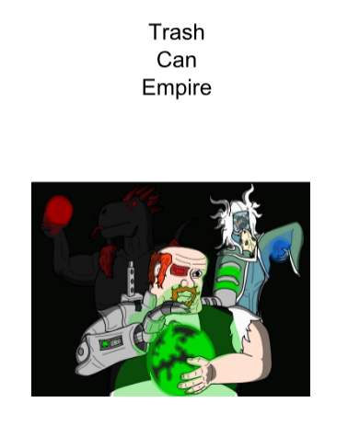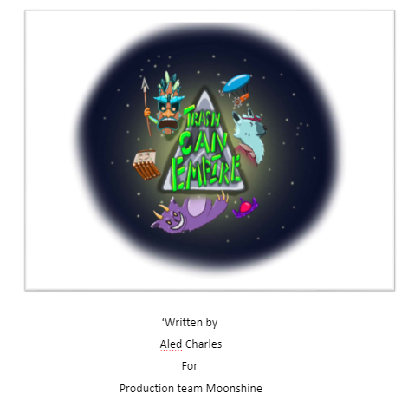
Though not the first time the tech team had to work on level designs they were the first to be used in the strategy genre and so more research was required to ensure that the level designs would match up with player expectations. After this was done the rough levels were planned out by simply drawing them onto paper, after this the designs were shown to the rest of the team and after some considerations some of the maps were chosen to go on to be implemented into the game. The next stage was to digitise the level designs this was done using a programme called I Can Animate which is an animation programme that also allows the user to create digitised drawings, after creating the initial digitised map designs another was immediately created with more technical information included such as region resource yield to in theory help increase the tech team’s efficiency in creating the map in game.
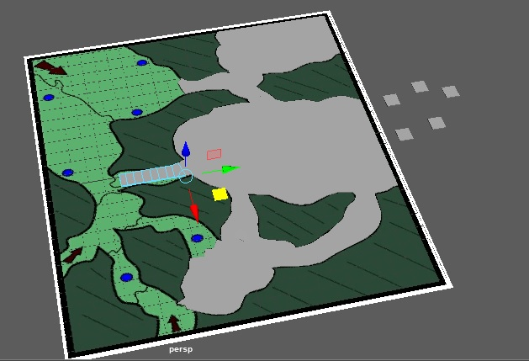
After designing the game’s levels they were then created in Maya to be used as whitebox levels. As this process was done before in second year the same technique was used again however this time the production techniques itself was different as opposed to the more solid game world created in previous years as this game world required several different country tiles to make up the larger game world and due to this required extreme accuracy regarding their shapes so as not to create any unintentional holes in the world. After some initial issues regarding accuracy the game levels were eventually created with each country tile being able to be accurately created through the importation the level design image into Maya allowing the shapes to be effectively traced onto the larger image.

Despite having to carry out playtesting in previous years very little was carried out in comparison to what was required for third year and so new techniques had to be carried out to make sure that it was done right. Firstly to advertise the playtesting sessions posters were created by using both the aforementioned animation programme and afterwards Photoshop to edit the poster these would also include the necessary information required by the reader to know when and where the playtesting session would be held and the link to a discord server where they would be able to receive further information regarding the playtesting session. Questionnaires were created so that people would be able to give feedback regarding the game.
The initial turnout for the playtesting sessions were poor with only two questionnaires being filled in, this was mostly due to the over reliance on using posters to spread word of the playtesting session. Thus the technique used to find playtesters had to be changed to avoid a second poor turnout and so a gaming club in Carmarthen was contacted where after hearing a positive response on their Facebook page the next playtesting session was held there where the design team found a much more acceptable turnout.
The music for the game was created using a programme called Magix which is a music creation programme for PC and after gaining a commercial license a music track was created for the game after creating a test sample it was determined that the track was much too fast paced and may provoke the player into thinking that the game is much more fast paced than it is. After doing some more research a second track was made which was much more suitable to the game type.
The main technique used to try and keep the team organised was communication, the main reason for this was to ensure that no team member was going off and doing their own work or wasting time on unnecessary things while there was more pressing work at hand. To do this two different team chats were created, one was Facebook messenger where the entire team could communicate with each other and a discord server where there were numerous sub chats where different sections of the larger team could talk to each other. Team meetings were held virtually every week to keep everyone up to date with what was going on in the group. In addition to help avoid the loss of work a team drive was set up.
Whilst some initial techniques left some to be desired they were quickly changed and improved to ensure good work production.

Development Evaluation
At the beginning of the semester each person in the production team was given a role and sorted into three different teams so as to concentrate more on their respective task at hand.
To ensure some creativity was used during development as opposed to simply ticking boxes some additional features were added to help evoke player enjoyment while playing the game this was done through level designs where inspiration was not only taken from different similar games but also slightly changed to give the designed levels their own feel while playing the game such as being able to approach a level in multiple ways such as taking a bottlenecked route for a more defence oriented game at the cost of less obtainable resources. Despite being largely ignored by passers-by posters were designed and created with the intention of reel people in to playtest the produced game. Music was specifically created and designed for the game level to help immerse a player in what they are playing.
The production team attempted to stay as close to the assignment brief as possible as to ensure that no points are lost in their final grade.
In order to communicate with the rest of the team group chats were created via the Facebook messenger and discord servers, in addition the design team held a group meeting almost every week where the other members of the wider group would be able to give an update on what they are working on with the meeting minutes then being uploaded to the team drive so that everyone was on the same page. Finally all team members were able to see and monitor their progress on teamgantt whilst also being able to see what the other team members were doing.
With all projects none of the work produced during this production process was perfect and required iteration, one example is after receiving criticism regarding the initial desert whitebox map where due to inaccurate country tile shapes they had to be redone to be more accurate, another example could be seen in the initial music track where due to it being too fast paced to be implemented into a strategy game it was redone to fit the tone of the gameplay style.
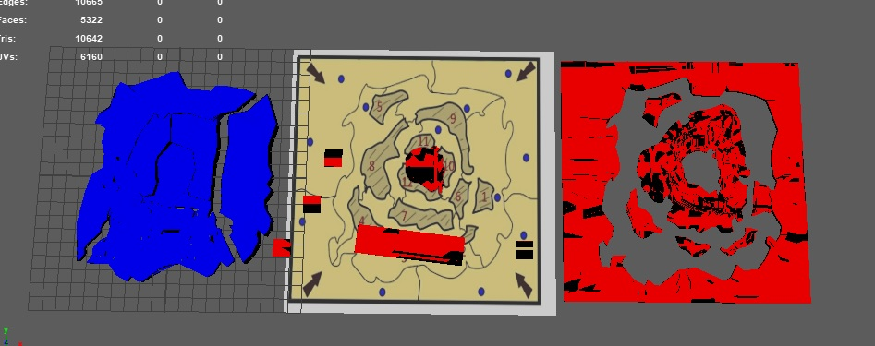
Regarding time management, as opposed to taking any days off during the week all days were used to work on any assigned tasks albeit at a much more relaxed pace where the idea was that due to the time used to do work being less frantic it allowed for more ideas to be developed which proved valuable with such tasks as level design.
Overall the time management technique used was very effective and resulted in higher quality work than was seen in previous years and if managed correctly will result in better work in the future.

Analysis
In many areas of the game’s creation several design theories were put into effect in the belief that they would help make the game better, one area in which this was one is in the games resource function in which the players resource count would go into the millions as opposed to smaller numbers, this was to try and give the player a better feeling of accomplishment when playing the game.
Another way in which the game’s design attempted to play with the player’s psyche was in the sounds section of the game where in the music track of the game the occasional wind howl and echoing wind chimes would play to try and give the player an idea of how desolate the desert planet is, in other areas the music would get more complex as the game progressed which would help give the player a feeling of progression beyond what he could see visually.
Many of the level designs were made with the intention of allowing the player to choose whether they wanted to play it safe by reinforcing chole points and making it difficult for the enemies to get at their base or a more resource farming method where they can take larger provinces for more resource intake but less defence potential.
Though despite all attempts there were some problems with the game such as with the tech side of the game where due to some bug the turrets would stop firing or in some cases fire blindly into the distance until they were destroyed by running out of ammunition.
In other areas there was some difficulty getting a point across the team during the initial stages of production, this can be seen when some members were not able to understand some parts of the original games design document, whether this due to the writing grammar of the original writer or limitations brought upon by a language barrier as there are a few people in the group upon which English is not their first language.
Despite completing all works required there were some areas which could see improvement, one such area was creating the whitebox level where even in the finished version there were some uneven areas which in the future needs to be rectified to have the game work as well as it does.
Some parts of the music could have a better balance to have them sound better to the player, such as with the feedback noise where for example the thud noise could be made louder to give more of an impression of the building being built.
Despite trying to keep things organised there are some areas in this regard where improvements could be made, one area was team meetings, some weeks were missed as the team members reasoned that everyone knew what the other was doing but as the meeting were also an opportunity for people to get together and communicate with each other regarding works and deadlines which is felt as an opportunity that was missed, in future this will be changed so that all members are on the same page regarding works being made.

