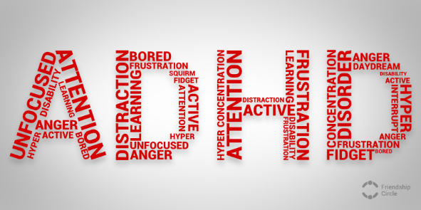
.
A Guide for Youth Workers
Image from Friendshipcircle.org, 2014

What is ADHD?
Attention Deficit Hyperactive Disorder or ADHD is classified as a neurobiological disorder that has a large effect on a person’s ability to control certain aspects of their behaviour, which is why it is also referred to as a behavioural disorder (aadduk.org, 2011). ADHD can be split into three main aspects, these are inattention, hyperactivity, the impulsivity. Inattention can include struggling to concentrate, being easily distracted, trouble completing tasks, and often jumping between tasks as well as trouble with following instructions (Dogra et al., 2009). Hyperactivity can include being physically restless or the inability to sit still which can result in fidgeting or getting up and moving around when they are not supposed to, it can also be displayed verbally through excessive talking and difficulty in being quiet (Dogra et al., 2009). Impulsivity is often displayed through a lack of patience both in conversation and in turn-taking in group situations, as well as risk taking behaviour without regard for safety (Dogra et al., 2009). The symptoms of ADHD are usually picked up on by those around the individual more then it being something the person themselves is aware of, especially at a young age, the child themselves will probably be unaware of their behaviour (aadduk.org, 2011). While ADHD is found to be more common in boys than girls it could be argued this is due to the symptoms most commonly being displayed in boys. Boys are more likely to be categorised under the hyperactive and/or impulsive type which would obviously be more noticeable then symptoms of inattentiveness, this being the most common diagnosis for girls (Horton-Salway, 2013) (Understood.org).
How does ADHD effect young people?
Most of the focus, especially with young people, when it comes to ADHD, is how it affects them with regards to their education. A child or young person with ADHD can be at a disadvantage when it comes to school, they may struggle to complete task such as homework, lose focus or become agitated during class and are more likely to engage in risky behaviour (Harpin, 2005). What needs to be remembered is that young people with ADHD need support in every aspect of their life as it can affect them not just within education but also their personal lives. Erik Erikson’s fifth stage of psychosocial development is believed to suggest that during adolescent this is when young people are discovering there sense of identity (McLeod, 2018), this is no different for young people with ADHD, however it has been reported that their perception of self is influenced by their disorder (Harpin, 2005). A small-scale study found that the young people’s views of themselves were rather negative or instilled negative emotions within them and towards others, all of which were extremely tied to their diagnosis (Krueger et al., 2001). For young people and adults alike there seems to be is far less support for them once they leave their childhood years, and yet during adolescent there is evidence to suggest that they still need it. During adolescent, young people with ADHD are at greater risk of substance misuse, risky behaviour, criminal acts and mental health issues (Hagell, 2012) which is why intervention is still needed to help young people manage and lower these difficulties.
How is ADHD officially managed in young people?
Following diagnosis there is no one way to treat ADHD, however, there are various ways that a young person can manage their disorder with the help and support of those around them including peers, family, teachers and other professionals. Research has suggested that medication can be helpful in reducing the main symptoms of ADHD (Dogra et al., 2009) but that a combination of both medication and therapy is likely to receive the best possible results (NHS.uk, 2018) although it is recommended that medication only be prescribed if symptoms are seen to be having a substantial influence on their day to day life (NICE, 2018). Within the UK there are five types of medication that someone diagnosed with ADHD could be prescribed, these include:
- methylphenidate
- dexamfetamine
- lisdexamfetamine
- atomoxetine
- guanfacine
(NHS.uk, 2018)
As well as medication there are several therapy options available including, cognitive behavioural therapy, which aims to change the way you see things and challenge the way you behave. Psychoeducation, which gives the individual and their family an opportunity to discuss what ADHD is and the effects it has in order to help make sense of what having the condition can mean. Other options include behavioural therapy, parent training and education programmes and social skills training but these seem more suited for children rather than adolescents. (NHS.uk, 2018).

ADHD can be a gift

There is often a lot of, if not complete, focus on the negative effects of ADHD when many people have found strength in the disorder. With a large number of young people being viewed as disruptive and disobedient the minute they are labelled with ADHD, making young people aware of the benefits of ADHD could help improve their mental health and well-being as well as improving their future prospects and the way ADHD is perceived. It is considered that the rise in ADHD diagnosis could be linked to the way in which school and work has become more tedious and monotonous, which doesn’t work for those with a more adventurous and creative mind (Understood.org, 2014). With that being the case, it is not always just a matter of a young person being unable to focus but more so struggling to focus on things that disinterest or bore them. If someone with ADHD discovers a task that they enjoy or excel at they can become intensely focused on it, this is known as, ‘hyper focus’ (Hupfeld et al., 2018). While there is not a lot of research evidence to support that people with ADHD are more creative or better at certain task, there is proof of individuals who have succeeded despite their diagnosis, including Olympic medal winning swimmer, Michael Phelps, Artist and Producer, Will.I.Am and Actor Bex.T.K (Understood.org) to name a few, all of whom have not let their ADHD be a hindrance and some who have attributed their success to their ADHD.
“For every obstacle there's some type of solution. So if you have ADHD it's your passion point” – Will.I.Am, MTV, 2013

Image from Livekindly.co, 2018


“I’m thankful that I am how I am. I look at myself every day and I’m so proud and so happy of who I am and who I’ve been able to become.” – Michael Phelps, Childmind.org, 2017


“Embrace it. It may be a nuisance, it may be hard to deal with sometimes, but you can learn to manage it. Don’t ever try to get rid of it entirely. Attention deficit makes you special.” – Bex TK, Additudemag.com, 2018
Image from si.com, 2016

If guided in the correct way, this can become a useful tool for young people along with other traits of those with ADHD that often go overlooked. this is where we as youth workers can come in.

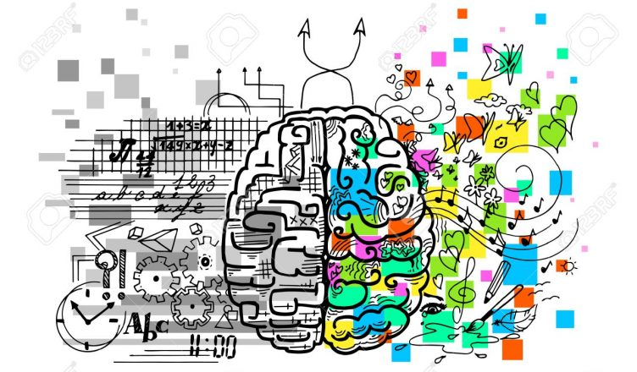
Image from engineering.eckovation.com, 2018
What can we as youth workers do?
We as youth workers hope to support young people at whatever point they are at in life and support them in reaching their full capability, we seek to aid young people in becoming aware of their responsibilities and how to successfully approach and resolve them (CWVYS, 2018). If we can consider this when supporting young people with ADHD, we, as youth workers, have the opportunity to find methods and activities that not only aid and support young people with ADHD but also activities that better suit their needs.
Johnson and Rosén (2000) produced a study looking at the difference between non-ADHD males and those with ADHD, noting that those with ADHD struggled more with team sport, recommending that, rather than allowing young males to be discouraged by sports, encourage them to be more involved in individual sports. Team sports are ones often seen within school settings and this is not always ideal for those with ADHD. Youth workers can play a considerable role in encouraging young people to be involved in activities such as running, swimming and other various individual sports. Youth workers can also plan more activities based on a one-to-one bases, that would be easier for young people with ADHD to engage with.
Studies have shown that those individuals with ADHD and those displaying symptoms often associated with ADHD are prone to being more creative thinkers (Boot, Nevicka et al. 2017). The results of the study that was conducted found that those with ADHD excelled creatively, especially in task they enjoyed and that rewards at the end of the task seemed to be a positive encouragement (Boot, Nevicka et al. 2017).
This suggests that when working with young people with ADHD youth workers should aim to identify interests that the young person has and encourage them to pursue it. If the young person is passionate about what they are doing, and their abilities are recognised and acknowledge this can go a long way to helping support young people with ADHD towards a better future.
Meditation can also be an effective way of managing ADHD as its is said to release serotonin and endorphins, both of which can help combat the effects of excess adrenalin often found in those with ADHD. It can also help improve concentration and discipline and therefore running meditation sessions could be used as an effective tool within youth work (EOC Institute, 2019)
Deruvo (2009) suggests that a common cause of anxiety for young people with ADHD is a lack of structure, routine and direction. When working with young people with ADHD it is important to ensure that a consistent approach is maintained, and instructions and boundaries are made clear. They also suggest that positive reinforcement is a far more effective tool than negative punishment and that more focus should be put on what they young person is doing right rather then what they are doing wrong (Deruvo, 2009). With that knowledge in mind, while it would be easy to punish a young person when they do wrong, it would be more effective to remind them that they can do better.

As one of the issues faced due to ADHD can be problems surrounding memory such as remembering tasks and staying on tasks as well as issues with organisation. Youth work can provide the opportunity to help young people manage these tasks and teach them how to organize themselves. This could be done through the use of bullet journals that can be created by the young person to make them more individual and personalized. By doing this it gives the young person the opportunity to be creative and manage tasks in a way that suites them. If working with the same young person on a regular basis, where possible, help them in making lists with small achievable tasks ensuring the objectives are clear, check in with them to see if they have achieved them and discuss the reasons and barriers that may have led to them not completing them. It is also worth being aware of whether the young person is on any medication, for ADHD, becoming familiar with what that medication is and does and if there are any side effects or any other issues. If remembering to take medication is a common problem for the young person, aim to remind them. (Hammerness, 2008)
Self-help tips
Not all young people with ADHD are the same, some display more prominent inattentive symptoms while others may display more impulsive or hyperactive symptoms and not all young people will have issues with every area normally associated with ADHD (Hammerness, 2008). This is why and individual approach should be taken with all young people, once the individual needs of a young person are established it is easier to support them. Regardless of this there are still some common tips for young people with ADHD that youth workers can incorporate into their practice and teach young people in order to empower them and help them manage the struggles they may face. (CWVYS, 2018)
- If it is common for them to fidget and be restless, encourage them to get resources such as fidget toys or even for them to create their own.
- If they have trouble with sitting still, encourage them to try moving around while completing tasks or take frequent breaks where they can move around
- Encourage them to make or create a diary, put up wall calendars to write down important dates and tasks and use colour coding to help certain goals stand out.
- Get them to keep reminders on their phone or ask to see if they can ask others to remind them such as a friend or family. Put days or certain time slots aside for completing specific things such as homework, paperwork and everyday task such as cleaning
- Get them to break things down into small achievable goals
- Plan journeys in detail to break down how long each individual aspect will take such as getting dressed and walking to the bus
- If the young person is comfortable with doing so, encourage them to inform the people around them of their ADHD and the behaviour they may exhibit because of it.
(King, McGuire et al, 2017)

It is often very common to find those suffering with ADHD also suffering from other disorders such as anxiety and depression. If this is the case for a young person, the following are some helpful tips on how to manage certain issues they may face because of this taken from an ADHD resource pack.
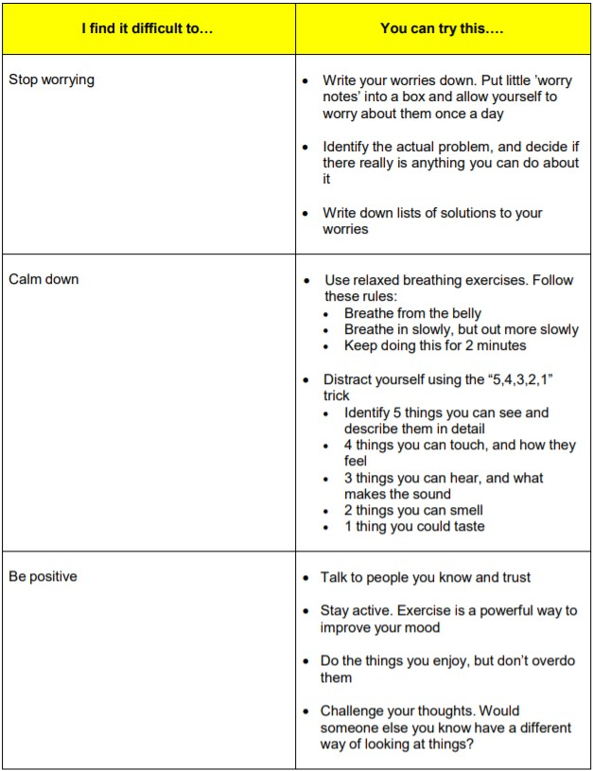
(King, McGuire et al, 2017)
The following are some helpful website that can be used as tool for young people with ADHD as well as their family, friends and others working with them.
- understood.org
- additudemag.com
- aadduk.org
- nhs.uk
- youngminds.org.uk
- mind.org.uk
- ukadhd.com
- adhdfoundation.org.uk

Conclusion
To summarise, ADHD can affect any person from any walk of life, both male and female, from childhood through to adulthood and there is no direct cause. Many of the issues young people face due to ADHD can affect them into adulthood and while it is recognised as a special learning difficulty and there is support within schools, ADHD does not just effect their academic life but their personal one and if support is not given early on this can have a negative effect on them in later life (Hammerness. 2008). There are a variety of issues that can come along with ADHD and youth work has the power to help guide young people and be more prepared for adult life. ADHD can have an extremely negative effect on a young person’s self-esteem and self-worth, and others perception and attitudes towards them can send them down a dangerous path but with the right guidance and support there is evidence that ADHD does not need to hinder their capabilities and when guided in the right way, can go on to be an asset. One of the main aspects of youth work is to work with them from the point in their life that they are at, what can often be the case with young people with ADHD is for them to be made to feel like their behaviour must be changed. Youth work has the perfect opportunity to change this perception and by discovering a young person’s capabilities and nurturing them, encouraging young people to pursue what they are good at and enjoy doing, they can go on to lead fulfilling and successful lives. There are a variety of methods and aids for those with ADHD and there is no ‘one size fits all’ answer on how to support them but as youth work works on an individualized basis, it is positioned perfectly within a young persons life in order to help them explore and discover what works for them.
Reference list
, ADHD Treatment1 Jun ., 2018-last update [Homepage of Department of Health], [Online]. Available: https://www.nhs.uk/conditions/attention-deficit-hyperactivity-disorder-adhd/treatment/ [May 6, 2019].
Will.i.am Credits Vegan Diet for Improved Health And Dramatic Weight Loss. 2018.
, Michael Phelps has ADHD9 May, 2017-last update. Available: https://childmind.org/blog/michael-phelps-myyoungerself/ [May 7, 2019].
, Michael Phelps shifts to new life after Rio haul16 august, 2016-last update. Available: https://www.si.com/olympics/2016/08/16/michael-phelps-rio-2016-olympics-career-retirement-family [May 7, 2019].
, 30 ADD/ADHD Resources you should follow on Facebook, Twitter, Pinterest and more! - Friendship Circle - Special Needs Blog-02-24T13:17:59+00:00, 2014-last update. Available: https://www.friendshipcircle.org/blog/2014/02/24/30-addadhd-resources-you-should-follow-on-social-media/ [May 6, 2019].
, The Right Environment for ADHD | In the News26 November, 2014-last update. Available: https://www.understood.org/en/community-events/blogs/in-the-news/2014/11/26/could-adhd-be-a-plus-in-the-right-environment [May 6, 2019].
What is ADHD? 2011.
, ADHD in Girls: What to Know. Available: https://www.understood.org/en/learning-attention-issues/child-learning-disabilities/add-adhd/adhd-in-girls [May 6, 2019].
, Will.I.Am: 'I've Got ADHD' | MTV UK. Available: http://www.mtv.co.uk/william/news/william-ive-got-adhd [May 10, 2019].
BOOT, N., NEVICKA, B. and BAAS, M., 2017. Creativity in ADHD: Goal-Directed Motivation and Domain Specificity. Journal of attention disorders, , pp. 1-10.
CWVYS, 2018. Youth Work in Wales: Principles and Purposes. Youth Work in Wales Review Group.
DOGRA, N., PARKIN, A., FRAKE, C. and GALE, F., 2002. Multidisciplinary Handbook of Child and Adolescent Mental Health for Front-line Professionals, A. 2nd edn. London: Jessica Kingsley Publishers.
EOC INSTITUTE, 2019-last update, Building Focus Naturally: How meditation helps ADHD and ADD. Available: https://eocinstitute.org/meditation/how-meditation-helps-with-adhd-and-add/.
GUPTA, S., 2018. Best Gift For High School Students.
HAGELL, A., 2012. Adolescent ADHD
Attention deficit and hyperactivity disorder
AYPH Research Summary No 12.
HARPIN, V.A., 2005. The effect of ADHD on the life of an individual, their family, and community from preschool to adult life. Archives of Disease in Childhood, 90(suppl 1), pp. i7.
HORTON-SALWAY, M., 2013. Gendering attention deficit hyperactivity disorder: A discursive analysis of UK newspaper stories. J Health Psychol, 18(8), pp. 1085-1099.
HUPFELD, K.E., ABAGIS, T.R. and SHAH, P., 2018. Living “in the zone”: hyperfocus in adult ADHD. ADHD Attention Deficit and Hyperactivity Disorders, .
JOHNSON, R.C. and ROSEN, L.A., 2000. Sports behavior of ADHD children. J Atten Disord, 4(3), pp. 150-160.
KESSLER, Z., 2014. Win with ADHD: Bex Taylor-Klaus.
KRUEGER, M. and KENDALL, J., 2001. Descriptions of self: An exploratory study of adolescents with ADHD. Journal of Child and Adolescent Psychiatric Nursing, 14(2), pp. 61-72.
MCLEOD, S.A., 03 May, 2018-last update, Erik Erikson's stages of psychosocial development. Available: https://www.simplypsychology.org/Erik-Erikson.html [04/05/19, .
NICE, 2018. Attention Deficit Hyperactivity Disorder: Diagnosis and Management.
PAUL GRAVES HAMMERNESS., 2008. Adhd. US: ABC-CLIO.
PETSKI, N.A.,Denise, ANDREEVA, N. and PETSKI, D., 2019. ‘Deputy’: Bex Taylor-Klaus Joins Fox Drama Pilot In Recasting.
RACHEL KING, JULIE MCGUIRE, DR BLANCA POVEDA, DR PREMAL SHAH, DR STEPHEN SMITH, KIRSTY SWEENIE, DR DEBORAH TINSON, DR FIONA WATSON, 2017. Adults with ADHD Self Help Resource Pack. NHS Lothian.
SILVIA L. DERUVO., 2009. Strategies for Teaching Adolescents with ADHD. 1st ed. edn. US: Jossey-Bass.

