Project Management Assessment 1

Unit Name: Project Management Assessment 1
Unit CODE: LCBB5005
Student Name: Stanislav Dragov
Student ID: 1919084

Contents
1.0 Introduction 3
2.0 Project Scope: 4
2.1 Objective and Parameter of the project: 4
2.1.1 Objectives of the project: 4
2.1.2 Parameters of the project: 4
2.2 Benefits or Expected outcomes of the project: 6
3.0 Budget assumptions: 6
4.0 Stakeholders and their involvement: 7
5.0 Constraints and Risks of the project: 9
5.1 Constraints of the Project: 9
5.2 Risks associated with the task: 10
6.0 Project control Mechanism: 11
6.1 way of controlling the project: 11
6.2 Person who is involved in the project and how project control is done: 12
7.0 Reporting framework: 13
8.0 Project Planning with Milestones: 14
9.0 Conclusion: 15
References 16

Introduction
Project management refers to leading any team to achieve the objective of the project. This project will solve one of the problems of the school by applying the tools, the project manager will try to achieve the objectives. As the number of students is increasing in the university, the authority of the University of Wales Trinity Saint David (UWTSD) London campus wants to add a new building block. The new building block will accommodate new students, teaching rooms, administrative office and reception space and many more. The main objective of this project is to build the new building in a way that will facilitate the new student properly and they feel comfortable studying in this new building. The success of the project depends on five stages. They are project scope, budget, stakeholder, project controlling framework and many more (Heerkens, 2012). A proper document for the project will be prepared before starting the work. The document will consist of below topics and aspects.
Figure: Project management diagram; Source: (Heerkens, 2012)

2.0 Project Scope:
The project scope consists of the specific activities that will take place to accomplish the project, the budget of the project, expenses, the deadline of the work and all other activities (Walker, 2015). The scope of the project is also known as the terms of reference of the project. The scope of the project will include the objectives and parameters of the project.

2.1 Objective and Parameter of the project:

2.1.1 Objectives of the project:
Every project is designed to achieve some aims and objectives. The aims and objectives work as the guideline for the project manager. The objectives of this project are illustrated below:
- To ensure that all the new students get admission and get the facility in the new building.
- To provide quality and up to the mark services in the new building.
- To ensure comfort and all kinds of digital facilities in the new building.
- To fulfil all the expectations of the stakeholders.

2.1.2 Parameters of the project:
Quality of the work, time and the cost of the project are the most significant factor of any project management plan. Quality, time and cost must be maintained so that the project finishes in time and within the given budget by ensuring the right quality (Schwalbe, 2019). Any mistake in this element can reduce the effectiveness of the project.
Diagram: Parameters of the project; Source: Schwalbe, 2019
Time: Time refers to when the task will be completed and plan the time scale of each significant activity of the project. The stipulated time of this project is 30th December of 2023. The beginning time of the project is 1 July 2022. If the project is accomplished within the given time it can be said that the project was in the right direction and execute all the planning properly (Gido and Clements, 2014). The time frame of the project is illustrated below:
Project Name | Timeframe ( Month)
Structural re-design | 2
Partition of the rooms | 2
Construction of the new rooms according to the new design | 6
Add Doors, windows | 3
Plumbing and joining | 1
Electricity line establishment | 2
Painting both inside and outside of the building | 1
Others | 1

Cost: Cost is the most significant matter in this project and the most complex one to calculate. The success of the project depends on the accurate cost calculation. The cost will include all the operational, administrative and actual costs of the project. The estimated budget for this project is set at £55,000,00. The project manager has to accomplish the project within the given budget.
Quality: The success and the brand value of the project manager depend on the quality of the work. The quality benchmarks must be set by the project manager and ensure that this quality is met in every part of the building. If any of the work failed to meet the quality, prevention and corrective measures must be taken by the project manager. The LIM (Leading indicator matrices and another measurement must be maintained by the project manager and must include in the final report of the project (White and Fortune, 2012).

2.2 Benefits or Expected outcomes of the project:
The project has been conducted to reach an outcome. This project also has some outcomes that must be met by the project manager. The outcome of the project is given below:
- The University of Wales Trinity Saint David (UWTSD) London can admit all the new students to the university.
- All the new students will get the same facility and environment in the new building for education and other university work.
- A new digital facility should be introduced in the new building so that a good brand image and reputation will spread in the London about the university.

Budget assumptions:
In this section, a proper breakdown of the full budget will be given. The given table will breakdown all the costs of incurring this project for finishing in time.
Project Name | Cost
Structural re-design | £5,000,00
Partition of the rooms | £5,000,00
Construction of the new rooms according to the new design | £18,000,00
Add Doors, windows | £5,000,00
Plumbing and joining | £2,000,00
Electricity line establishment | £7,000,00
Painting both inside and outside of the building | £5,00,000
Others | £8,000,00
Total budget | £55,000,00

The estimated budget is given though this is not the actual budget. More or fewer costs will be needed to accomplish the project.

4.0 Stakeholders and their involvement:
All project has several significant stakeholders. The project manager must count them as valuable decision-makers of the project. There are two types of stakeholders available one is an internal stakeholder and another external stakeholder (Alexander and Robertson, 2014). The given table will present the list of internal and external stakeholders of the project.
Internal stakeholders | External stakeholders
University governing body | Investors (Bank)
Employees of the university | Government
Students | Local communities
Teachers | Guardians
Management | New students Sponosrs
 | Labours and line managers

All the stakeholders can share significant plans and information with the project manager that can help to increase the quality and facility of the work. All the stakeholders are important to the project. The project outcome has both positive and negative effects on them and the stakeholder
can also affect the outcome of the project. The main stakeholder is those who have authority and decision-making power such as the management, university governing body, investors and government (Kordi et al., 2021). The project manager has to ensure that all the stakeholders are satisfied with the project. The stakeholder power grid is given below:
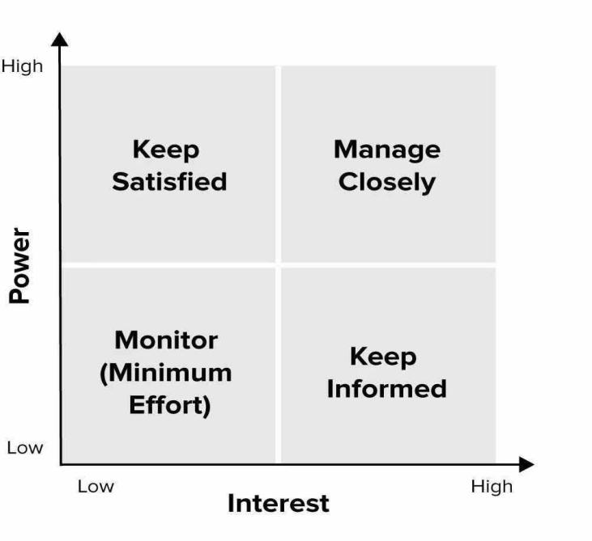
High power and low interest: The government and the local authority may have high power but do not have a high interest in the project (Fageha and Aibinu, 2016). So, the project manager must not include them in the decision making.
High interest and high power: The employees and the management of the university have high power and a high interest in this project. The project manager should consult with them while taking any decision.
Low power and Low interest: The employers of the university have low power and low interest in this project.
Low power and High Interest: The students have low power in the project but have high interest in the project. So, to consider them in the project manager should make the decision.

5.0 Constraints and Risks of the project:

5.1 Constraints of the Project:
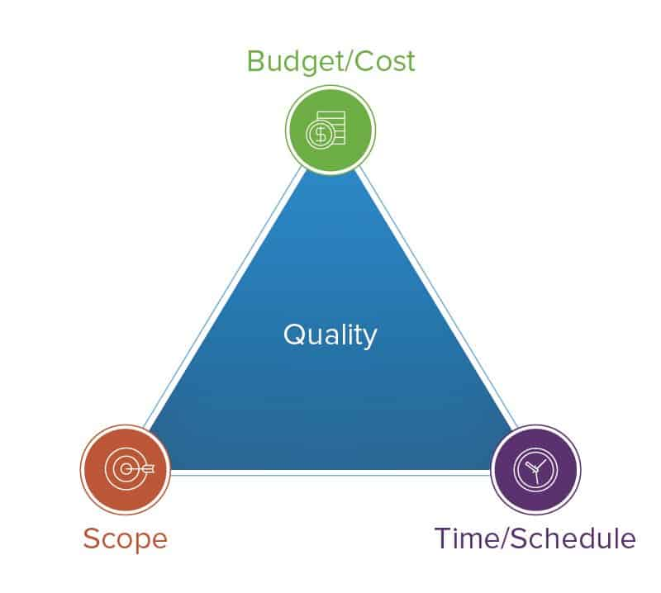
The project manager has to face a lot of constraints during the implementation of the plan. This section will describe the constraints of the project. The project limitation is the factor that constrains the project implementation (Chitkara, 2019). We have already discussed three important aspects of any project. These are time, cost and quality. So, there are three limitations which are known as the triangle of risk and constraints. The given figure shows the main constraints of the project.
Diagram: Constraints and Risks of the project; Source: Chitkara, 2019
This project has several steps among them demolition of the older one is the prime phase, the design of the new one and the conglomerate of the new one and the older one. These three are the basic division of the whole project (Van Wyngaard et al., 2012). The time frame will help the project manager to accomplish the project in time and allocate time for each stage. The total budget of this project is calculated at 5.5 million euros. The manager has to collaborate on the budget and objectives of the project so that both are achieved within the given time. The budget can be changed if needed but the time cannot be changed. As a new semester, the new student will start in 2023 January. So the renovation must be done within the given time (Wei et al., 2012). The manager has to consider the goal, stakeholder expectations and the overall budget of the project.

5.2 Risks associated with the task:
The risk refers to the happening of an accident in the project. The manager has to prepare a separate team for assessing and managing the risk of the project. Proper safety and precaution should be taken by the project manager. All the labour and the line manager must be trained with basic risk management techniques and tools (Cuellar, 2010). Proper awareness will reduce the chances of an accident in the project. An accident means increasing the project budget and costs and delays maybe happened to accomplish the project. The risk assessment of this project is given below:
Overview of the risk | Probability of Occurrence | Impact of the occurrence | Response Strategy | Proposed Response Plan
Vague purpose and objective of the project. | Low | High | Avoid | The project manager must revise the objective and purpose properly and prepare the breakdown of the strategic plan.
Exceed the budget of the project | Medium | High | Avoid | The budget must be made properly with all suppliers and providers and an additional budget may be added within the actual budget.
Exceed the time of the project | Medium | Medium | Mitigate | The time should be revised before starting the project and dividing the whole work accordingly. Two or three shifts may be introduced.
Failed to meet the promised quality of the work | Low | Medium | Mitigate | For proper benchmark and quality control, the team must be measured routinely and reported to the project manager (Chapman & Ward, 2018. ).
Communication lacking | Low | High | Avoid | Coordination and harmony must be maintained in all departments.
Material shortage Proicuremnet delay | Medium | High | Mitigate | The resource availability must be ensured by all the suppliers.
Miscellaneous Risks | High | Medium | Mitigate | The mechanical problem, dealy in presence of the labour must be mitigated by the line manager.

6.0 Project control Mechanism:

6.1 way of controlling the project:
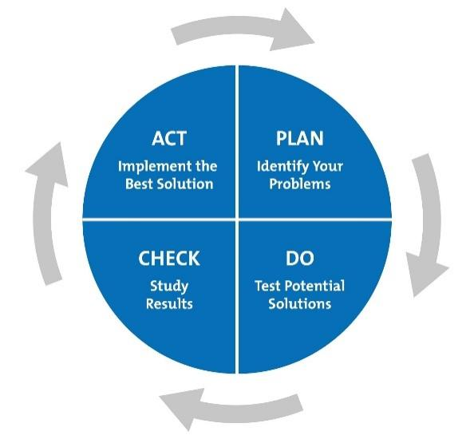
For controlling the project, the manager will use the plan, do, check and act model. By using the model, the manager can check whether everything goes according to the plan or not (Azimi, and AbouRizk, 2012). If anything goes the manager has to find it and take corrective action so that other departments can move together. The model graph is given below:
Figure: The way of controlling the project; Source: Azimi, and AbouRizk, 2012
Poor planning and execution can generate mistakes and failure in the project. Monitors and controllers will be liable for any mistake in the project and they have to take the responsibility of finishing the product in time.

6.2 Person who is involved in the project and how project control is done:
There is a project team that monitors the project now and then and they are the responsible person for controlling the project. The involved person must relate them with all the documents and check them continuously. They should check the deadline and progress of the work and push the labour and line manager to finish it in time (Sun and Aouad, 2019). Numerous techniques can be applied by the managers to control the project. These techniques are given below:
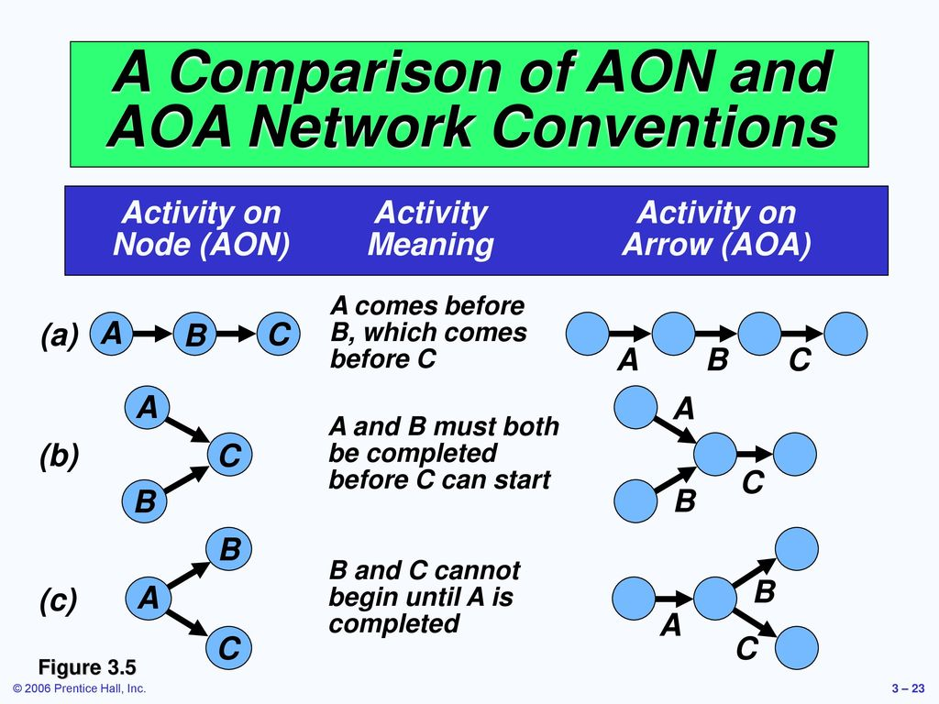
Network diagram: (AON and AOA): AON: AON is the project management tool that refers to the preceding diagramming method. It is used to denote the scheduled activities of the project. It means the project manager cannot move forward without completing the previous nodes and boxes. For moving forward all the tasks of the previous have to accomplish first. In the AOA the critical path and PEST will be used (Yang and Wang, 2010). The critical path refers to the shorter possible way to accomplish the project. The following figure of AOA and AON is given below:
Figure: Network diagram: (AON and AOA); Source: Yang and Wang, 2010

7.0 Reporting framework:
The project manager must manage the communication with parties and integrate all the subproject and their line manager into the framework. So, all the subprojects have harmony and communication with each other. The project manager is the middleman and hub among the communication channel of the subgroups. Communication simply refers to passing a message to each other. The message of the stakeholder must be propagated properly to all the subgroups and line managers. At the upper level, two-way communication and the written method will be used. So, any problem, with the site can be shared by the line managers. The project manager must ensure real-life feedback and response to the line managers so that work cannot be halted for a single time. In this way, any problems can be solved rapidly (Palaneeswaran and Kumaraswamy, 2012). Telecommunication, Email, mobile phone, and video conferencing can be used by the line managers. Walkie Talkie is useful for managing communication on the site.
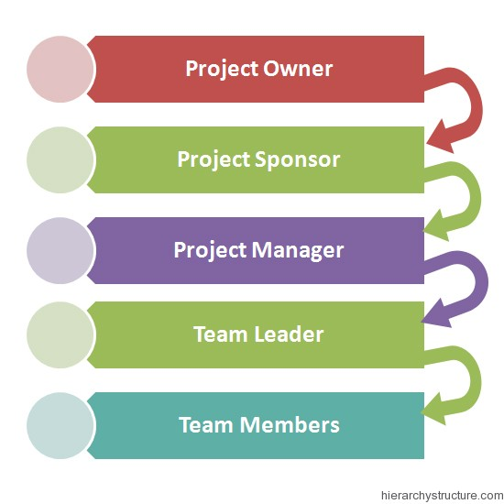
The written communication will be sent to all the line manager if any importance or emergency notice need to give. It will later be attached to the final project management file of the project. Later, notice in the pad of the university or company is the way to share written communication.
Figure: (Reporting Framework; Source: Palaneeswaran and Kumaraswamy, 2012)

8.0 Project Planning with Milestones:
This is the last phase where the project manager will track the progress and give feedback. This phase gives the notification of how much the project has already been completed and how much is left. What is going well and what is not going well must be visible. The project manager has to find the key milestone to know the total completion of the project (Wu and Simmons, 2010). If some big milestones are still incomplete the project manager can bring all resources and labour to that part and finish it as soon as possible. The manager must check out all the neglected work and keep them in work in time by seeing the planning and milestone chart. The milestone planning project of this project is presented below:
Project Name | Timeframe ( Month) | Start Date | Ending Date
Structural re-design | 2 | 1 July 2022 | 1 September 2022
Partition of the rooms | 2 | 1 September 2022 | 1 November 2022
Construction of the new rooms according to the new design | 6 | 1 November 2022 | 1 April 2023
Add Doors, windows | 3 | 1 April 2023 | 1 June 2023
Plumbing and joining | 1 | 1 June 2023 | 1 July 2023
Electricity line establishment | 2 | 1 July 2023 | 1 September 2023
Painting both inside and outside of the building | 1 | 1 September 2023 | 1 October 2023
Others | 1 | 1 October 2023 | 1 November 2023

9.0 Conclusion:
The project manager tries to move forward according to the plan. But some changes are always needed in this type of work. The manager must keep the plan flexible so that further renovation can be done in future. The number of students will be increased in the future and renovation may be needed. Every project manager tries to finish the work in time but it needs some extra time for delays in procurement and supplies. We have given 1-month extra time to finish all other activities which remain incomplete within the time.

References
Alexander, I. and Robertson, S., 2014. Understanding project sociology by modelling stakeholders. IEEE software, 21(1), pp.23-27.
Azimi, R., Lee, S. and AbouRizk, S.M., 2012. Applying basic control theory principles to project control: Case study of off-site construction shops. Journal of computing in civil engineering, 26(6), pp.681-690.
Chapman, C. and Ward, S., 2018. Project risk management: processes, techniques and insights. John Wiley.
Chitkara, K.K., 2019. Construction project management. Tata McGraw-Hill Education.
Cuellar, M., 2010. Assessing project success: Moving beyond the triple constraint.
Fageha, M.K. and Aibinu, A.A., 2016. Identifying stakeholders’ involvement that enhances project scope definition completeness in Saudi Arabian public building projects. Built Environment Project and Asset Management.
Gido, J. and Clements, J., 2014. Successful project management. Cengage Learning.
Heerkens, G.R., 2012. Project management. McGraw Hill Professional.
Kordi, N.E., Belayutham, S. and Che Ibrahim, C.K.I., 2021. Mapping of social sustainability attributes to stakeholders’ involvement in construction project life cycle. Construction management and economics, 39(6), pp.513-532.
Ng, S.T., Palaneeswaran, E. and Kumaraswamy, M.M., 2012. A dynamic e-Reporting system for contractor's performance appraisal. Advances in Engineering software, 33(6), pp.339-349.
Schwalbe, K., 2019. Introduction to project management. Boston: Course Technology Cengage Learning.
Sun, M. and Aouad, G., 2019. Control mechanism for information sharing in an integrated construction environment. CIB REPORT, pp.121-130.
Van Wyngaard, C.J., Pretorius, J.H.C. and Pretorius, L., 2012, December. Theory of the triple constraint—A conceptual review. In 2012 IEEE International Conference on Industrial Engineering and Engineering Management (pp. 1991-1997). IEEE.
Walker, A., 2015. Project management in construction. John Wiley & Sons.
Wei, C.C., Liu, P.H. and Tsai, Y.C., 2012. Resource-constrained project management using enhanced theory of constraint. International Journal of Project Management, 20(7), pp.561-567.
White, D. and Fortune, J., 2012. Current practice in project management—An empirical study. International journal of project management, 20(1), pp.1-11.
Wu, C.S. and Simmons, D.B., 2010, October. Software Project Planning Associate (SPPA): a knowledge-based approach for dynamic software project planning and tracking. In Proceedings 24th Annual International Computer Software and Applications Conference. COMPSAC2000 (pp. 305-310). IEEE.
Yang, Z.Y. and Wang, Z.F., 2010, October. Comparison between AON and AOA network diagrams. In 2010 IEEE 17Th International Conference on Industrial Engineering and Engineering Management (pp. 1507-1509). IEEE.

