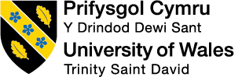

Is the marketing of anti-ageing products ethical?

Danielle Akira Wilson

Student number P148225

Submitted in partial fulfilment of the requirements for the degree of
BA(Hons) in Advertising and Brand Design, University of Wales Trinity St David, Swansea

17th March 2019

Word count: 5007

Contents

Summary 3

Introduction 4

Chapter 1 – Celebrity endorsement 6

Chapter 2 - Image manipulation 10

Chapter 3- Use of language 13

Chapter 4 – Evidence for L’Oreal Paris Skin Perfect 10 and Revitalift 16

Chapter 5 – Conclusion 19

Images 24

Bibliography 25

Summary

The marketing of anti-ageing products could be argued to be unethical. This dissertation has evaluated different marketing techniques including celebrity endorsement, language (in terms of made-up portmanteau words, positive and religious terminology) and image manipulation. To do this a number of anti-ageing products were examined and included campaigns by Dior and L’Oreal. In addition, evidence in the form of scientific studies were looked at, to see if the claims made for the products were substantiated. In general, there was a lack of evidence and the marketing techniques that were evaluated were viewed as being unethical. Perpetuating the anti-ageing myth on women can impact on older women’s mental health by praying on their fear of ageing.

Introduction

In this dissertation the ethics of marketing of anti-ageing products has been examined. This study was based on the idea that media-driven aspirations target all women’s (perhaps uncontrollable) greatest fear, that is the fear of ageing. The definition of ethics given by the Oxford Dictionary states that - ‘Moral principles that govern a person's behaviour or the conducting of an activity’ (Oxford Dictionary). Extending this, ethics relates to what benefits both individuals and society. For women to look older is frowned upon in today’s Western society – and they can feel pressurized to appear young, and these pressures can lead to psychological effects on the person’s body image (Diedrichs 2016). It can be argued that the mass media has negatively influenced societal attitudes to ageing, leading women to endeavour to try to slow-down the process of aging, and it has intensified the desire for treatments to do this or make them look younger (Vickers 2007). ‘Immersed in a world surrounded by the media, people in our society absorb impressions, ideas, images, and sounds that reflect societies attitudes towards aging’ (Hatch 2005). If this message is negative, then that is how society will view ageing. The ethics of encouraging women to try to hold back the process of ageing is an issue because of the number of people who are living longer. This is a growing problem: an estimate from the USA stated that the number of 65-year olds and older was expected to increase to 20% by 2030 (Gorouhi & Maibach, 2008), whilst according to a more recent estimate, the percentage of the world’s population who are 65 or older will have tripled from 8% in 2010 to 1.5 billion in 2050 (Suzman & Beard 2011).
The slowing down or creating a youthful appearance is not a scientific necessity for survival, but the media has cultivated it into a coveted desire. It has been said that ‘Skin aging will come no matter what, and this population obviously cannot remain young forever, but a youthful appearance and good health are essential’ (Ramos-e-Silva & Carneiro 2001).

The aim of the research in this dissertation is to consider the marketing strategies and copy of anti-ageing products in terms of celebrity endorsement, image manipulation, use of language and some scientific evidence regarding the claims of two such products. The ‘myth’ surrounding anti-ageing products is explored, using specific marketing campaigns and their products.
Chapter 1 looks at how the use of celebrities in advertising of anti-ageing products has been viewed. In Chapter 2 the illusion of perfection and how it is created by image manipulation is considered. The use of language in the ‘post-truth era’ (Helfand 2017) is discussed in Chapter 3 in terms of religiosity, the use of portmanteau words and ‘fake news’ (defined as ‘articles that are intentionally and verifiably false, and could mislead readers’ Allcott and Gentzkow 2017). The evidence used to promote L’Oreal’s Age Perfect Day Cream and Revitalift Repair 10 is considered in Chapter 4. Chapter 5 concludes the dissertation by discussing the ethicality of celebrity endorsement, photographic integrity and use of language against a background of ‘fake news’. The effect of perpetuating the anti-ageing myth on women is then further discussed in terms of its impact on the well-being of women, particularly their mental health in terms of the fear of ageing.

Chapter 1 - Celebrity endorsement

The target market for anti-ageing creams starts as young as twenty-year olds: last year fashion and cosmetic giant Dior were criticised for using the English model and actress, Cara Delavigne aged 25, to promote their Capture Youth product range that ‘can block the signs of aging before they appear’. This was claimed by Delavigne in the Campaign’s YouTube advert, and on their website (Delavigne 2018). In this commercial they promoted the idea that to look youthful is to be beautiful and that it can be ‘captured’. The error in this celebrity endorsement was quickly identified: Heart radio97-106 posted an item in the lifestyle tab of their website with the title ‘Can you see what's wrong with this "Anti-Ageing" advert?’
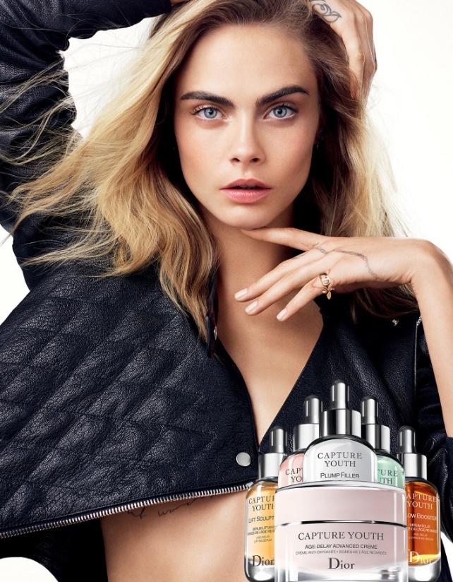

Figure 1. Image from Capture Youth - Dior Campaign 2018. This advertisement was controversial as it used a mid-20s celebrity to promote a product targeted at an older demographic.

Similarly, some anti-ageing products have even been marketed to an early teens age group, such as URBAN DECAY’s Anti-aging eyeshadow primer potion. URBAN DECAY’s Assistant Vice President for digital infrastructure, is quoted as saying that the marketing “sweet spot customer” is “between 18-24 years old” (Perasco 2015).

Cultural myths are propagated through colloquial phrases such as ‘he’ll be trading her in for a younger model’ when a woman is getting older, or reference to attractive older men with greying hair as ‘silver foxes’, but a similar usage for ‘silver vixens’ is less often used. This reinforces the idea that female ageing is something to be resisted. A survey of 559 American college students (mean age 20.5 years) revealed that the ‘greater internalization of standards of beauty from the mass media predicted more positive attitudes toward (cosmetic) surgery’ (Sarwer et al 2005). With such a view prevalent in young women, targeting this demographic to use anti-ageing treatments/creams by the cosmetics industry would seem relevant, but are ethically questionable.
An example of one anti-ageing cream that has been listed recently by The Independent newspaper (July 2018) as one of ten ‘best skincare products for your 20s and 30s’ was NIP+FAB Glycolic Fix Daily Cleansing Pads. Glycolic acid is an exfoliant treatment that removes superficial dead skin cells (keratinocytes) from the cornified layer of the epidermis, the stratum corneum (Figure 2). This product range has been advertised as ‘Containing glycolic acid, a key beauty ingredient when it comes to aiding skin exfoliation’. Side-effects have been reported from the use of this acid in products, such as skin irritation and the discolouration of skin getting worse over time: unusual side-effects for something that has been claimed to stop the discolouration of skin (Peragini et al 2000, Thomas et al 2013).
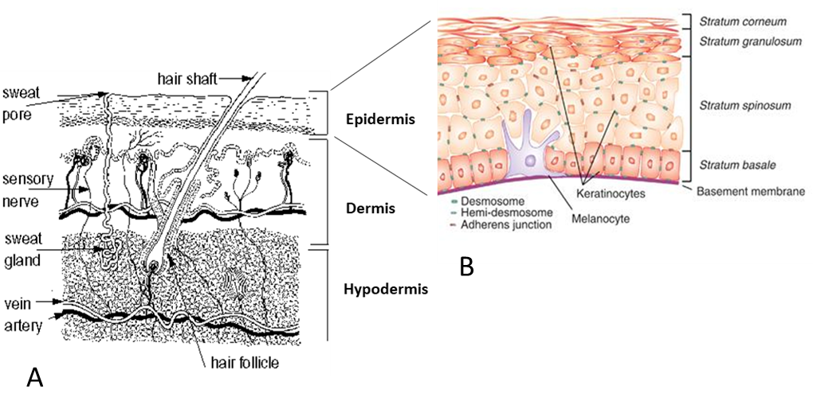
Figure 2: Diagrams of human skin. A. The main layers of skin showing epidermis, dermis and hypodermis and B. Detail of the strata that make up the epidermis (cornified, granular, spinous and basal layers). The layers of the epidermis are important to recognise as the evidence that describes the effect of anti-ageing products often refer to these layers.

Despite this, the product is very popular: the celebrity Kylie Jenner the reality TV star, model and in the top-ten most followed on Instagram, with 120 million followers (November 2018) has advertised ‘I love NIP+FAB Glycolic Pads’.
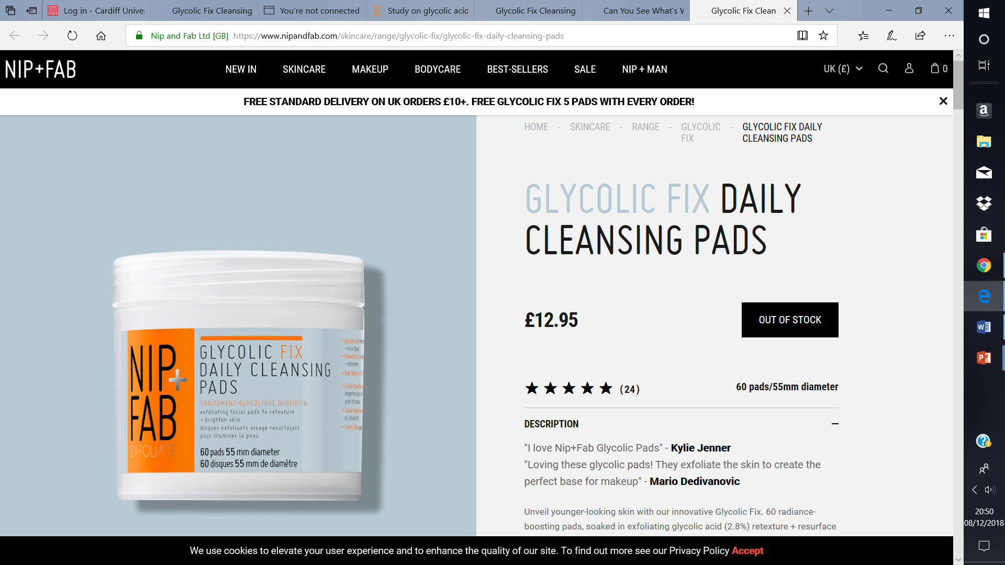
Figure 3. Website advertisement showing the endorsement from Kylie Jenner for this NIP+FAB product. Note also the endorsement from the make-up artist for Kim Kardashian, Mario Dedivanovic.

Having celebrities endorse products, such as Jenner did for Maria Hatzistefanis’ NIP+FAB, gets the celebrity’s fans excited: influencing them to believe that if they use the product they can be like their chosen celebrity. NIP+FAB product endorsement by Kylie Jenner (21 years-old in 2018) targeted a youth market in the same way as Cara Delavigne’s endorsement of Dior’s Capture Youth. It could be argued that targeting such a demographic is inappropriate as they do not need anti-ageing products. Despite this, fans will be influenced to buy such treatments, in the hope that the product might give them the same youthful appearance as the celebrity.

Promoting different products to different age ranges, means almost every product has a celebrity that is ‘the face’ of that specific product. At the other end of this age range is the 73-year-old Dame Helen Mirren. This celebrity actress has endorsed a similar product range for older women - Mirren was the face of L’Oreal Age Perfect line of products (advertised in 2016), but it was not advertised as ‘anti-ageing’. Mirren said in 2017, that ‘the anti-ageing era is over’. This was explained by her comment when she was appointed an ambassador for the brand ‘’this word “anti-ageing” – we know we’re getting older. You just want to look and feel as great as you can on a daily basis’. Earlier she was quoted as saying ‘I’m an eternal optimist – I know that when I put moisturiser on it probably does f… all, but it just makes me feel better’.

Older women identify with such an actress and as older women themselves, recognise that looking imperfect whatever your age may be, is a more pragmatic/realistic way to view products and their adverts, much like the face used for endorsement.
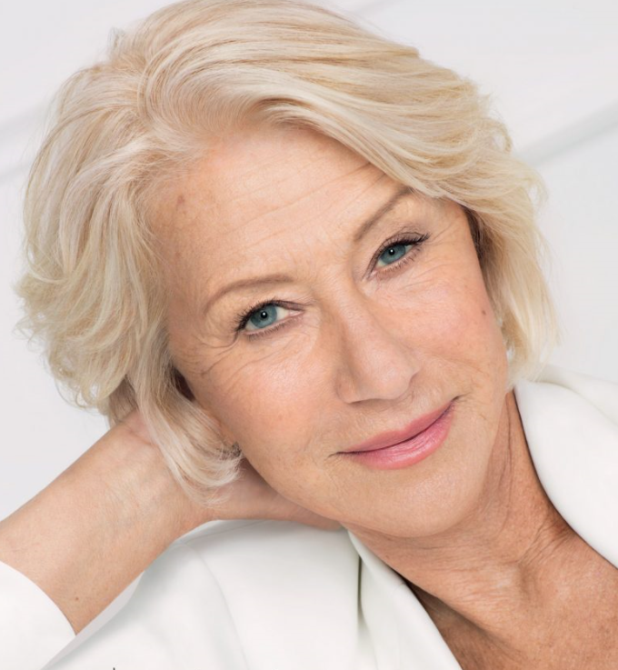
Figure 4. Image taken from Pure Production website showing the image featuring the actress Helen Mirren for L’Oreal Paris Age Perfect Campaign (2016). The image does not conceal the wrinkles, age spots or creases expected of a woman of a woman in her 7th decade.

Whatever the language used to describe anti-ageing products, whether viewed as negative or otherwise, it is the idea that the celebrity endorsements (whoever the celebrity may be and of whatever age), relies upon the consumer buying into ‘the myth’. This will be that the product is going to reduce the impact of ageing. In terms of advertising, the question that surfaces: what has been done to ‘the face’ that is promoting this product?

Chapter 2 - Digital image manipulation
In the era of digital image manipulation and the ‘post-truth era’ that some commentators claim now exists (Helfand 2017), there has been a growth of altered images, to the extent that it is claimed that images are conventionally manipulated and altered (MacCullum & Widdows, 2018). Have images had the laugh-lines (nasolabial folds) smoothed out, teeth and eyes whitened, blemishes and bags under the eyes (typical of the ageing process), removed, and have photographic angles been used that have flattered the subject? Often images are not what they appear – Instagram selfies are put through a variety of filters and edits to give them a better overall appearance. This is the same for any advertisement even though the industry does not necessarily want consumers to know because it can ruin the illusion of perfection especially when it comes to products such as those of anti-ageing. If image manipulation such as retouching is used, then it must raise in the minds of the consumer: do the products work?
Photoshop and airbrushing have been under scrutiny in recent years. Advanced graphics editing programmes allow changes to images to be made so that they end up looking unlike the original subject (Waller, 2015). This has led to the idea that this increased unrealism of advertised images should be countered by the provision of disclaimers to indicate when digital images have been enhanced (Tiggemann et al 2013). In the UK, the Advertising Standards Agency (ASA) have become increasingly concerned over the images used in advertising (Waller, 2015), but it was the landmark case in the USA where Coty’s CoverGirl mascara advertisement was banned for ‘excessive photoshopping’ (Krupnick 2011). However, a 2017 update in this source, stated that ‘CoverGirl’s PR agency let us know that the ad was not technically banned – just voluntarily discontinued in response to the USA National Advertising Division of the Council of Better Business Bureaus Claims’.
Similarly, L’Oreal were challenged in 2012 by claims relating to overuse of digitally enhancing techniques. L’Oreal Paris Revitalift 10 campaign used the 42-year old actress Rachel Weisz, but in the advertisement, she appeared to look considerably younger, and was argued to be an untrue representation, as her complexion was not a realistic portrayal of what the product could do (Zafar 2012). L’Oreal did not seem to appreciate the situation as women were aware of what was being done. As a result, at the Golden Globes in 2014, Diane Keaton, who received a lifetime achievement award on behalf of Woody Allen, appeared onscreen to all intents showing her age (68 years old); but then moments later, she appeared on television in an advertisement for L‘Oreal Paris Age Perfect, where her skin looked flawless, with little sign of the skin ageing evident in the Golden Globes programme. The Daily Telegraph showed the contrast between the ‘real’ Keaton (Figure 3A) and the digitally enhanced image, shown in the anti-ageing cream advertisement (Figure 3B). This has led to the appearance of celebrities demanding contractual ‘no photoshop’ clauses (Schirmer et al 2018).
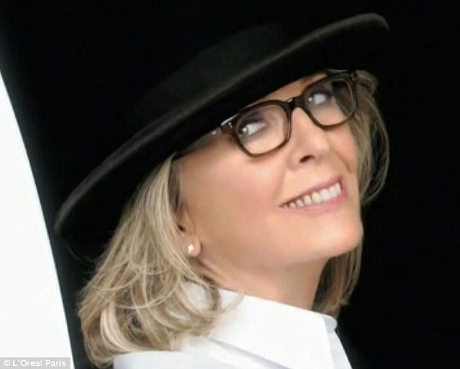
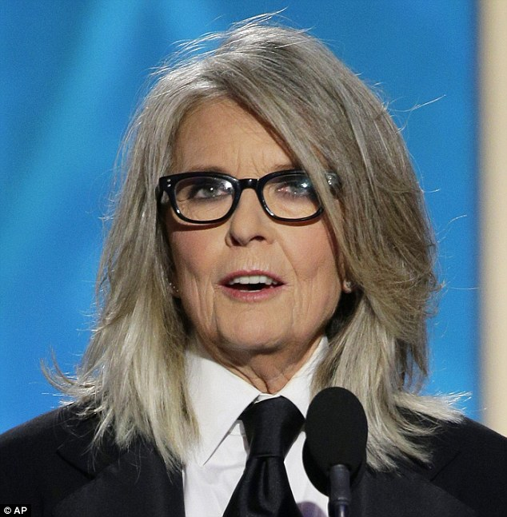
B
A

Figure 5: Images of Diane Keaton. A. Photograph taken at the Golden Globes in 2014 aged 68. B. Image taken from advert shown immediately after the Golden Globe Award Ceremony. Note the difference in skin tone and extent of wrinkles.

As a result of such behaviour and the negative reactions to images that have been digitally manipulated, there have been calls worldwide for regulation (Brown 2014). The proposals for regulation ranged from self-regulatory codes of conduct to heavy fines, but the effect of such proposals have not yet been assessed. The effect of the L’Oreal Golden Globes example was significant: people tweeted relentlessly about the event, not only with respect to the behaviour of the brand, but also Diane Keaton for allowing L’Oreal to manipulate the image.

Chapter 3 - Use of language
The language used in advertisements is important. It is used to capture attention and make the consumer consider more favourably the advertised product (Goddard 2002). Culture and religiosity has provided anti-aging product advertisers the opportunity to use words like ‘miracle’, ‘wonder’ and ‘regeneration’. For example, Garnier Miracle Skin Cream, evoked the Biblical imagery of God doing ‘extraordinary miracles through Paul’ (Acts 19:11-12) – where even cloth (aprons and handkerchiefs) that had been touched by Paul were then taken to the sick and were used to cure them of illness or possession by spirits. Similarly, This Works No Wrinkle Wonder Essence again used this type of copy with a strong link to ideas of believability – and echoes Biblical references ‘Unless you people see signs and wonders,” Jesus told him, “you will never believe”’ (John 4:48). This use of the word ‘wonder’ can be linked to biblical events such as turning water into wine and the healing of a child close to death and many other wonders. The linkage between religious copy such as ‘regeneration’ by Unilever’s Simple Regeneration Age Resisting Day Cream could be argued to link to the biblical idea of rebirth or being born again – concepts deeply rooted in Christian tradition.
In addition, the language used on packaging of anti-ageing products often claims to ‘restructure’, ‘brighten’, ‘hydrate’ skin, and also claims ‘anti-sagging’ and ‘anti-age spots’ effects (eg. L’Oreal Paris Age Perfect, Figure 6A). Using language such as this conveys a positive message to the consumer in that if they use the products, they could appear more youthful. In the context of this advertising the use of the words ‘sagging’ and ‘age spots’ are perceived as negatives but when the word ‘anti’ is placed in front of them, they are transformed into a positive term, which is a simple but effective use of language.
Portmanteau words are becoming increasingly common in day to day conversation, term ‘Brexit’ (Britain and Exit) being one of the most overused current example. A portmanteau word is one that stems from two different words being merged into one. These are also used in the marketing of anti-ageing products as in the case of ‘Revitalift’ suggesting both ‘revitalising’ and lifting together with ‘repair’ (L’Oreal Paris Revitalift Repair 10, Figure 6 B). Other examples of the use of portmanteau are often names for the anti-ageing products, for example ‘Prevage’ which combines the words prevent and ageing which is an anti-ageing product marketed by Elizabeth Arden. Less obviously Origins ‘Plantscription’ range of anti-ageing products uses the words plant and prescription, which implies it’s a plant-based, natural ‘prescription’.
Society today rarely believes something unless they see evidence, and advertisements are the primary way by which products can be seen to work. The use of scientific jargon together with diagrammatic imagery produces a form of pseudoscience where images alongside jargon can create the illusion of understanding and therefore fool consumers into believing that this ‘science’ is truth (Figure 7).
Figure 7. Example of diagrammatic imagery and jargon. The sequence of diagrams cleverly uses hexagons, arrows and graphics to portray ‘dead skin cells and residues’ being extracted by volcanic ash. The two other image represent Italian spring water penetrating and hydrating the skin and finally, ‘marine collagen’ being absorbed to restore elasticity. This image was used to promote Ischia’s Miracle Marine Collagen Concentrated Eye Cream. Note also the use of religious language (‘miracle’).

The election of the United States President, Donald Trump, has brought with it a growing awareness of the term ‘fake news’. This is a new phrase describing news that has little factual basis but is portrayed as truth. Recently Lazer et al. (2018) have argued ‘The rise of fake news highlights the erosion of long-standing institutional bulwarks against misinformation in the internet age.’ This is largely due to anybody whether expert or not, being able to spread false information as truth without verification. This is most commonly done through the internet and social media platforms.
It seems the cosmetics industry is not immune from this practice. Consumers are regularly presented with semi positive and upbeat messages and made-up portmanteau words. That can leave the consumer bewildered in a world of increasingly fake news. This is an addition to the lack of photographic integrity and digital image manipulation that is commonly used in the marketing of anti-ageing products.
While the ASA have guidelines they may be considered dated and perhaps not appropriate marketing environment that is increasingly aware of how to exploit media-savvy consumers.
The Advertising Standards Agency (ASA) guidelines state that low risk sensory claims such as ‘look fresher’, ‘skin feels smoother’ or ‘for more radiant looking skin’ are the most accepted methods of advertising anti-ageing products. (Advertising Standards Agency Guidelines: 2014). Using terms such as these give the impression of young skin without using the term ‘younger looking skin’ which is less likely to be approved because peoples’ perception of young looking skin is different. That is why many companies state that a percentage of women who have tried the product claim that they have seen a positive difference in their appearance. Due to these claims, when seeing an advertisement with a percentage of people claiming a benefit we mistakenly perceive it as a statement of truth, when in reality it is only an impression and that the effects of the products may only be short-lasting.
Although the ASA have a list of the acceptable and unacceptable materials on their website, there is nothing that states that adverts should be moral or ethical. It is perhaps time for the ASA to consider this and provide greater protection to society. France has already legislated in this area – in 2017 they introduced a law requiring advertisers to indicate when images have been manipulated, although the fine for infringing this law seems inadequate (a fine of up to around £35,000) given the fact that these are unhealthy representations. It is argued that the ‘ASA already has strong rules in place which enable us to take action where beauty ads break the ad codes’ (Scarpati 2018). The ASA have acted to ban advertisement images that were extensively manipulated, but is it an adequate deterrent? In terms of celebrity endorsement this can be viewed as a double-edged sword. When the ASA has ruled against advertisements featuring high profile individuals, these attract negative media attention such as the case with Cara Delavigne. In terms of religious language, the ASA are keen to encourage advertisers to be careful with such language, as blasphemies may be investigated if they are in copy that prompts complaints. In terms of anti-ageing creams, the ASA has a considerable amount of advice to advertisers about the claims that can be made for their products. Surprisingly, the advice does not contain specific comments on the pseudoscience that is evident in some of the marketing copy of anti-ageing products, but the advice explains that suggesting a cumulative effect ‘will require a much higher level of evidence’ and that marketers consider the robustness of their evidence. Finally, there is still some room for improvement in the ethical approaches used by the companies promoting anti-ageing products before women may feel less dreadful about ageing.

Celebrity endorsement, image manipulation and use of religious, upbeat and positively inspired copy have been discussed and it can be seen that all have been used to create the effect of perpetuating the ‘myth’ of anti-ageing products. L’Oreal Paris Skin perfect 10 and Revitalift were selected anti-ageing products to be assessed in terms of the evidence to support the claims made for these products.

Chapter 4 - Evidence for L’Oreal Paris Skin perfect 10 and Revitalift
Evidence on skin is relevant because it is the basis of how facts are generated. There is a deeply-held tradition that authors writing on a subject did so on the basis of specialised knowledge of the subject (Helfand, 2017) but others argue that the internet has led to ‘the death of expertise’ characterised by:
A Google-fuelled, Wikipedia-based, blog-sodden collapse of any division between professionals and laymen, students and teachers, knowers and wonderers - in other words, between those with any achievement in an area and those with none at all (Nichols 2014).
Nichols goes on to say that what he ‘fears has died is any acknowledgement of expertise as anything that should alter our thoughts or change the way we live’ (Nichols 2014). It is important for the expertise and the evidence that has derived from this, to be considered.

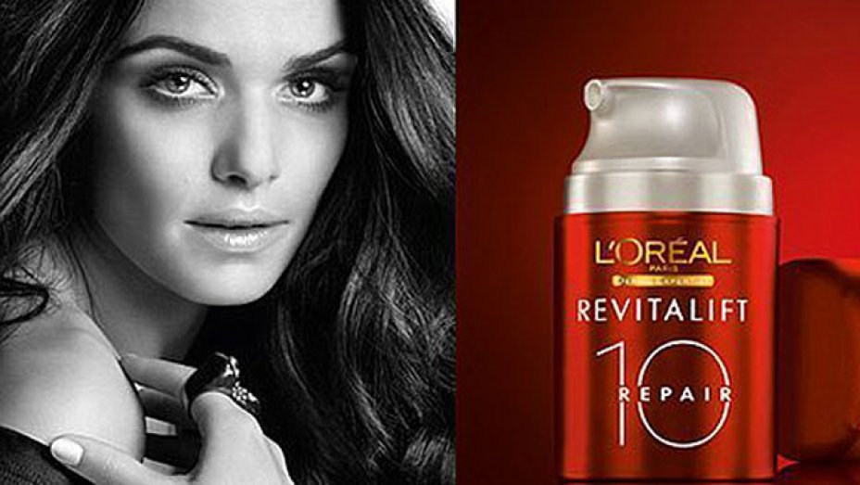
A
B
Figure 6. The products considered in terms of the evidence to support the marketing claims made for each of them. A- L’Oreal’s AGE PERFECT day cream, B- L’Oreal’s REVITALIFT REPAIR 10.

L’Oreal’s AGE PERFECT product is composed of ‘fibroxyl’, although there is no detail as to what this actually is, apart from that it is ‘derived from rye seed’ and ‘works together with hyaluronic acid (HA) and other ingredients’ to ‘help maintain volume and resilience over time’ (L’Oreal Paris USA).
Using databases such as Google Scholar and Web of Science, no scientific evidence was found reporting studies on ‘fibroxyl’, so it was not possible to verify the claims made by L’Oreal Paris for it in terms of skin anti-ageing properties (or any other properties). On this basis, it must be assumed that this is a made-up name, to provide the impression that it is a scientific ingredient with anti-ageing properties. The idea that it works ‘together with HA’ is an interesting claim made in the copy on the site. HA acts as a ‘plumping agent’ it is highly hydratable, holding huge amounts of water (Baumann 2007). As people age, the dermis thins by about 20 % of its original (younger) thickness. Sun causes the loss skin structure and this, together with the loss of HA and water, accounts for the changes seen in aged skin (Baumann 2007).

HA does not to penetrate the skin when applied to the skin surface so its effectiveness when applied this was maybe questioned. So how does ‘fibroxyl’ work together with’ HA?
The advertising copy seems to have merged two ingredients – HA which has factual support for its effectiveness in plumping up skin, and the other ‘fibroxyl’ for which there is no scientific evidence available.

The evidence for L’Oreal Age Perfect Day Cream
An active ingredient of L’Oreal’s Age Perfect Day Cream was stated to be ‘Soya peptide’ but nothing was found in a database search (Google Scholar) describing its use in anti-ageing, but the search string ‘soy peptide’ did. And it seems that ‘soya peptide(European term) and ‘soy peptide’(American term) are the same thing. A soy peptide contains small amounts of protein building blocks - peptides. ‘soy peptides’ use in anti-ageing has been reported by affecting production of HA (Schagen 2017).

The other main ingredient according to the product copy (Figure 6B), was something termed ‘Melanin-Block™’ and it is claimed that it ‘helps reduce appearance of existing age spots’. No articles were found on Google Scholar or on Web of Science databases using the search string ‘Melanin-Block’. The only evidence as to how this component might work is as a Sun Protection Factor (SPF) – essentially a sun cream. Without an SPF rating being provided, it was difficult to consider evidence for this idea. The inclusion of sun creams in anti-ageing cosmetics would be beneficial and reduce sun effects on skin, but this has a potential danger –the consumer may assume that the anti-ageing product may be an alternative to sun cream. The name Melanin-Block suggests that the ingredient may stop the production of melanin and although this may potentially reduce the appearance of age spots, it may be potentially harmful if it does block the skin’s production of melanin in sunlight.

The company have stated that ‘With more than 30 years of dedicated research, at L’Oreal Paris we know your skin inside and out – whether normal, dry, dull, ageing or combination. Our skin care products are developed and rigorously tested with leading skin experts and scientists worldwide. For beautiful skin today and more youthful looking skin tomorrow’. (L’Oreal Paris Australia a)
This promotes the idea that the products have been tested and reported in the scientific literature, but interestingly when looking through the ‘Science of Beauty’ (L’Oreal Paris, Australia b) there was only an editorial - with no direct link to L’Oreal Paris products, simply an account of premature skin ageing (Uitto 1997).

Chapter 5 - Conclusion
After considering different marketing strategies involving celebrity endorsement, digital image manipulation, the use of language (religious, Portmanteau or made-up words, jargon combined with diagrammatic imagery and fake news) it is clear that a myth has been created around the marketing of anti-ageing products. From the information gathered about celebrity endorsement that uses younger women to endorse a product that has an older demographic, it puts a young face in the mind of the consumer causing unrealistic expectations. With Christian Dior’s Capture Youth range the youthful complexion of Cara Delavigne did not match the target consumer, those with disposable income who might be persuaded to spend their ‘grey pounds’ on an anti-ageing product. It would be fair to conclude that using a much younger face is not an ethical practice and that using the face of Dame Helen Mirren for that target audience would have been more age-appropriate and realistic.
Language in advertising copy has been used very cleverly in the marketing of anti-ageing products. The combination of religious words alongside made-up, portmanteau words and pseudoscientific jargon can play on consumer’s belief systems. Generally, people believe in religion or science and maybe in some cases, both. The language used in marketing anti-ageing products appears to have been developed to appeal to most consumers that fit into one of these categories.
In society today, with advertising on all our technological devices and the use of social media increasing 13% year-on-year (Chaffey 2018), the amount of information being spread is almost constant. Women concerned about the ageing process are often targets for significant amounts of this information and this may lead to such women having lower self-confidence and self-worth. Professor Jaywant Singh one of the authors of Consumer Behaviour: Applications in Marketing, was recently quoted as saying that he:
believes that a lot of ads today trigger something referred to in psychology as ‘compensatory consumption’, which he explains is a behaviour in which individuals try to overcome this threatened perception of self by acquiring the product being advertised to them (Petter 2017).

He then went on to explain that by ‘Creating and highlighting insecurities about the female body has, as a result, become central to many ad campaigns in the cosmetics and personal care industry’ (Petter 2017).
If it is not possible to stop the aging process (Harouchi & Mailbach 2008), the question whether it is ethical to digitally manipulate images, use younger women to endorse products targeted at an older audience, or use language that is emotive has to be raised. Ethics are about what is beneficial for the individual and society, so are seeing these types of advertisements damaging to women’s mental health? In the UK, there is an increased awareness of mental health, with an annual Mental Health Awareness Week held in May of each year. Recently several high-profile women have spoken out about their mental health, such as the author JK Rowling and Kate Middleton the Duchess of Cambridge. There is a condition called ‘age anxiety’ and when a sample of 304 Canadian women were surveyed, it was shown that ‘greater aging anxiety and higher importance of appearance were related to greater likelihood of purchasing anti-aging products’ (Muise & Desmarais 2010). This leads to the conclusion that to feed off women’s fear or dread of ageing, as part of a product’s marketing strategy, is unethical.
The manipulation of images, whether by photo shopping or other image enhancements, is clearly misrepresentation and unethical. There is a general concern regarding how ‘fake news’ impacts upon society, with a recent House of Commons Select Committee suggesting that ‘technology companies be made responsible for harmful and misleading material on their sites’ (Parliament UK 2018). Extending this idea to the harmful impact of advertising that misrepresents products and feeds on the fear of ageing, future legislation may seek to curb this marketing behavior. This may also relate to the use of religious language in promoting anti-ageing products. To suggest, through this language, that the users of these products may have a religious experience such as a ‘miracle’ may be to deify the product and would be considered by some to be sacrilegious and unethical.
Finally, this dissertation has explored the use of scientific claims embedded in the marketing of anti-ageing products. Despite this being an increasing trend evident in the products described in this dissertation, Dodds et al (2008) found that skepticism of these claims exists in the minds of consumers. They have argued that ‘pseudoscientifically-based advertising claims’ led to negative reactions, particularly in cosmetics advertising. What has been shown in this dissertation is that the combination of celebrity endorsement, the need for more photographic integrity, inventive use of language and the lack of evidence for the claims made for many anti-ageing products, could be considered unethical. The ethicality could be improved by stronger ASA guidance.

Images
Figure 1. https://www.dior.com/diormag/en_us/article/the-time-now-%E2%80%93-capture-youth%E2%80%8B.

Figure 2. http://www.cancerindex.org/medterm/medtm5.htm
https://www.researchgate.net/publication/286092505_Mitotic_activity_of_keratinocytes_in_regeneration_and_tissue_homestasis/figures?lo=1

Figure 3. https://www.nipandfab.com/skincare/range/glycolic-fix

Figure 4. https://pureproduction.net/loreal-helen-mirren/
Figure 5. https://www.telegraph.co.uk/women/womens-life/10570532/LOreal-Photoshop-fail-Diane-Keaton-Golden-Globes-ad-exposes-major-airbrushing-moments-after-we-see-her-in-flesh.html. (accessed 23 November 2018).

Figure 6. A. https://www.lorealparis.com.au/products/skin-care/mature-skin-expertise/day-moisturisers/age-perfect-day-cream
B. https://www.hollywoodreporter.com/news/rachel-weisz-enemy-botox-sees-loreal-ad-banned-airbrushed-286467

Figure 7. https://www.kooding.com/Miracle-Marine-Collagen-Concentrate-Eye-Cream.html

Bibliography

Journal articles

Allcott H, Gentzkow M (2017) Social media and fake news in the 2016 election. Journal of Economic Perspectives 31: 211-236

Baumann L (2007) Skin ageing and its treatment Journal of Pathology 211: 241–251

Behm B, Kemper M, Babilas P, Abels C, Schreml S (2015) Impact of a glycolic acid-containing pH 4 water-in-oil emulsion on skin pH. Skin Pharmacology and Physiology 28, 290–295

Dodds RE, Tseelon E, Weikamp ELC (2008) Making sense scientific claims in advertising. A study of scientifically aware consumers. Public Understanding of Science 17, 211-230.

Draelos Z (2018) The science behind skin care: moisturizers. Journal of Cosmetic Dermatology, 17, 138-144.

Gorouhi F, Maibach HI (2008) Role of topical peptides in preventing or treating aged skin. International Journal of Cosmetic Science 31, 327–345.

Hatch LR (2005) Gender and ageism. Generations: Journal of the American Society of Aging, 29, 19-20.

Lazer, D M J et al. (2018) The science of fake news. Science, 359, 1094-1096.

MacCallum F, Widdows H (2018) Altered Images: understanding the influence of unrealistic images and beauty aspirations. Health Care Analysis, 26 (3), 235-245.

Muise A, Desmarais S (2010) Women’s perceptions and use of ‘anti-aging’ products. Sex Roles 63, 126-137.

O’Connor AA, Lowe PM, Shumack S, Lim AC (2018) Chemical peels: a review of current practice. Australasian Journal of Dermatology 59, 171–181.

Perugini P, Genta I, Pavanetto F, Conti B, Scalia S, Baruffini A (2000) Study on glycolic acid delivery by liposomes and microspheres. International Journal of Pharmaceutics 196, 51–61

Ramos-e-Silva M, Carneiro S (2001) Cosmetics for the elderly. Clinics in Dermatology, 19, 413-423.

Rieger M. (1998) Hyaluronic acid in cosmetics: a review of its chemistry and biochemistry. Cosmetics and toiletries, 113, 35-42.

Sarwer DB, Cash TF, Magee L., Williams E, Thompson JK et al (2005) Female college students and cosmetic surgery: an investigation of experiences, attitudes, and body image. Plastic and Reconstructive Surgery, 115, 931-938.

Schirmer NA, Schwaiger M, Taylor CR, Costello JP (2018) Consumer response to disclosures in digitally retouched advertisements. Journal of Public Policy & Marketing, 37 (1) 2018, 131–141.

Thomas JR, Dixon TK, Bhattacharyya TK (2013) Effects of topicals on the aging skin process. Facial Plastic Surgery Clinics of North America 21, 55–60.

Tiggemann M, Slater A, Bury B, Hawkins K, Firth B (2013) Disclaimer labels on fashion magazine advertisements: effects on social comparison and body dissatisfaction. Body Image, 10, 45-5.

Uitto J (1997) Understanding premature skin aging. New England Journal of Medicine 337, 1463-1465.
.
Vickers K (2007) Aging and the media: yesterday, today, and tomorrow. Californian Journal of Health Promotion 5, 100-105.

Waller DS (2015) Photoshop and deceptive advertising: an analysis of blog comments. Studies in Media and Communication, 3, 109-116.

Books

Goddard A (1998) The language of advertising: written text. London: Routledge.

Websites

Alderson-Tuck, L. (2018) ‘10 best skin products for your 20s and 30s’ The Independent, 5th July. Available at: https://www.independent.co.uk/extras/indybest/fashion-beauty/best-skincare-products-for-your-twenties-20s-and-thirties-30s-early-prevention-anti-ageing-10477519.html

Delavigne C (2018) Available at:https://www.youtube.com/watch?v=UgtYu_CRM44 (accessed 23 November 2018)

Heart Radio 97-106. Available at: https://www.heart.co.uk/lifestyle/beauty/cara-delevingne-dior-anti-ageing-advert/ June 2018 (Accessed 28 November 2018).

Helfand DJ (2017) Surviving the Misinformation Age. Skeptical Inquirer, 41.3 Available at:https://www.csicop.org/SI/show/surviving_the_misinformation_age

Parliament UK (2018) Available at: https://www.parliament.uk/business/committees/committees-a-z/commons-select/digital-culture-media-and-sport-committee/news/fake-news-report-published/

Jenner K. Available at: https://www.nipandfab.com/skincare/range/glycolic-fix

Krupnick E (2011) CoverGirl mascara ad banned – by CoverGirl – for excessive photoshopping. Available at:https://www.huffingtonpost.co.uk/entry/covergirl-mascara-ad-banned_us_1159957?guccounter=1&guce_referrer_us=aHR0cHM6Ly93d3cuZ29vZ2xlLmNvLnVrLw&guce_referrer_cs=FF7hjILKfO4M9cv2L3r0ag (accessed 1 December 2018

L’Oreal Paris USA. Available at: https://www.lorealparisusa.com/beauty-magazine/skin-care/anti-aging/the-science-behind-volume-filler.

L’Oreal Paris Australia a, Available at: https://www.lorealparis.com.au/products/skin-care (Accessed 23 November 2018).

L’Oreal Paris Australia b, Available at: https://www.lorealparis.com.au/inside-loreal-paris/the-science-of-beauty

Mirren H (2017) Available at: https://www.telegraph.co.uk/beauty/skin/helen-mirren-has-declared-anti-ageing-era-next-skincare/.

Nichols T (2014). The death of expertise. Available at: http://thefederalist.com/2014/01/17/the-death-of-expertise.

NIP+FAB Available at: https://www.lookfantastic.com/nip-fab-glycolic-fix-daily-cleansing-pads-60-pads/10634575.html

Oxford Dictionary. Available at:https://en.oxforddictionaries.com/definition/ethics

Perasco J (2015) Available at: https://www.essentialretail.com/news/56264bbe3f5af-how-urban-decay-is-using-content-to-engage-with-online-customers/ (accessed 28 November 2018).

Petter O (2017) Does the advertising industry feed off of women’s insecurities? Available at: https://www.independent.co.uk/life-style/advertising-women-female-insecurities-body-images-does-it-experts-sexism-weight-loss-gain-size-a7888901.html (Accessed 7 December 2018)

Scarpati B (2018) Why real beats fake - responsibility and truthfulness in beauty ads.
https://www.asa.org.uk/news/why-real-beats-fake.html

Suzman R, Beard J (2011) Global health and ageing. Available at: https://www.who.int/ageing/publications/global_health.pdf?ua=1 accessed 7 December 2018)

Unilever. Available at: https://www.simpleskincare.com/au/products/face-moisturisers-and-creams/regeneration-age-resisting-day-cream-with-spf-15.html

Zafar A (2012) Available at: http://newsfeed.time.com/2012/02/03/too-perfect-rachel-weiszs-loreal-ad-banned-in-britain-for-being-misleading/

