

A study of whether phishing simulations are effective in educating users identify malicious emails, or do they create a negative impact within the workplace?

by
Sarah Rule

Supervisor: Dr Carlene Campbell

Project submitted as part of the requirements for the award of
BSc (Hons) Computing (Computer Networks and Cyber Security)

April 2022

DECLARATION
I, Sarah Rule, declare that I am the sole author of this Project; that all references cited have been consulted; that I have conducted all work of which this is a record, and that the finished work lies within the prescribed word limits.
This work has not previously been accepted as part of any other degree submission.

Date: ...............................................

FORM OF CONSENT
I, Sarah Rule, hereby consent that my Project, submitted in candidature for the B.Sc. (Hons) Computing (Computer Networks and Cybersecurity) degree, if successful, may be made available for inter-library loan or photocopying (subject to the law of copyright), and that the title and abstract may be made available to outside organisations.

Date: ...............................................

Abstract
This research was aimed at identifying whether phishing simulations are effective. This report contains an introduction into the background of phishing simulations as well as aims and objectives for the project. Namely, to conduct a thorough analysis of phishing techniques and then to use that information to test on a selection of users to identify whether these techniques are beneficial.
The introduction followed a chapter on the methodology for the project including discussions with DHCW to define the parameters of the research and testing. The project continued on to run three phishing simulations to gather data for evaluation and analysis to determine whether phishing simulations have any benefit to the users or the organisations that use this testing technique.
Finally, the results show whether the use of a phishing simulation tool to send phishing emails for the purpose of user education is of benefit and to determine improvements if required. Results were analysed and problems and restrictions identified carefully at the end.

Table of Contents
Abstract 2
List of Figures 4
Chapter 1 5
1.1 Introduction 5
1.2 Aim 5
1.3 Objectives 5
1.4 Structure of the Project 6
Chapter 2 – Review of Literature 7
2.1 Introduction 7
2.2 What is Phishing? 7
2.2.1 Types of Phishing 8
2.3 Consequences of Successful Phishing Attacks 9
2.4 Why Users fall for Phishing? 10
2.5 Phishing Mitigation 10
2.5.1 Technical Solutions 11
2.5.2 User Education 11
2.5 Conclusion 12
Chapter 3 – Research Methodology 13
3.1 Introduction 13
3.2 Primary Research 13
3.2.1 Interview with Head of Cyber Security for DHCW 14
3.3 User Group 15
3.4 Quality of Data Analysis and Limitations 15
Chapter 4 – Data Analysis 15
4.1 Phishing Simulation 1 15
4.1.1 Agreed Date and Timeframe 15
4.1.2 Agreed Templates 16
4.1.3 Results 17
4.1.4 Immediate Feedback 19
4.1.5 Summary 20
4.2 Phishing Simulation 2 20
4.2.1 Agreed Date and Timeframe 21
4.2.2 Agreed Templates 21
4.2.3 Results 22
4.2.4 Immediate Feedback 24
4.2.5 Summary 25
4.3 Phishing Simulation 3 25
4.3.1 Agreed Date and Timeframe 26
4.3.2 Agreed Templates 26
4.3.3 Results 28
4.3.4 Immediate Feedback 29
4.3.5 Summary 30
4.4 Conclusion 31
Chapter 5 – Ethics behind Phishing Simulations 31
5.1 Are Phishing Simulations Ethical? 32
Chapter 6 – User feedback 32
6.1 End–User feedback 32
6.2 Head of Cyber Security Feedback 34
Chapter 7 – Reflection 34
References 34

List of Figures
Figure 1 - General Phishing Attack Process [7] 6
Figure 2 - Life Cycle of a Spear Phishing Attack [8] 7
Figure 3 - Monthly Reporting Volumes of Phishing Emails 7
Figure 4 - Example of a Phishing Education Poster [21] 10
Figure 5 - Template 1 for Simulation 1 14
Figure 6 - Template 2 for Simulation 1 14
Figure 7 - Simulation 1 - Total User Interactions Break Down 15
Figure 8 - Simulation 1 - Average Click Rate by Directorate Break Down 15
Figure 9 - Template 1 for Simulation 2 16
Figure 10 - Template 2 for Simulation 2 17
Figure 11 - Simulation 2 - Total Users Interaction Break Down 17
Figure 12 - Simulation 2 - Average Click Rate by Directorate Break Down 18
Figure 13 - Template 1 for Simulation 3 19
Figure 14 - Template 2 for Simulation 3 20
Figure 15 - Simulation 3 - Total User Interactions Break Down 21
Figure 16 - Simulation 3 - Average Click Rate by Directorate Break Down 21

Chapter 1

1.1 Introduction
Digital Technology is becoming a profound part of everyday life for every individual and organisation. Whilst ever evolving technology is having positive results in healthcare and other organisations, cyber-crime tools used by hackers are advancing at the same rate resulting in the same concerns in the security of personal and private information.
Healthcare Data has significant value and is a potential target for hackers. Phishing is a method of potentially gaining valuable information such as usernames, passwords, and medical data for malicious reasons. Phishing refers to this general approach, in which large amounts of untargeted communications are sent to a wide range of recipients in the hope that the minority will become victims. [1] Spear Phishing and Whaling are other forms of phishing approaches that are used.
Cybersecurity Ventures, a research company, expect global cybercrime to grow by 15 per cent over the next five years, reaching $10.5 trillion USD annually by 2025, this is up $3 trillion USD from 2015. Cybercrime will eventually become more profitable than the global trade of all major illegal drugs combined. [2]
Something that continues to play a key factor in the security of data is the employees of every organisation, from ‘malicious insiders’ to fresh out of school graduate, everyone is responsible for maintaining the security of the organisations data. [3]
This report is to research the level of cyber awareness within Digital Health and Care Wales (DHCW) and identify whether there is a requirement for further education in helping to mitigate the possibility of a data breach using phishing simulations as the method and analysing the data.

1.2 Aim
The main aim of this report is to evaluate and analyse the level of cyber security awareness for Digital Health and Care Wales (DHCW) staff, and if found unsatisfactory, produce, and implement a training plan that can be used to improve the overall cyber awareness.
The chapters in this report will identify the steps taken by the author to determine whether training materials are effective within the workplace, or whether they have a negative effect within the workplace.

1.3 Objectives
The objectives are to:
- Develop a detailed project plan for the project.
- Research and analyse current journals and articles and provide critical literature review.
- Determine a suitable methodology for the project.
- Conduct a meeting with the Head of Cyber Security to capture the requirements for the applications and determine acceptable expectations.
- Conduct primary research into the current applications capabilities and identify what the new application needs to include.
- Evaluate the application by running a series of Campaigns on DHCW users.
- Evaluate and investigate the impact of the application from a user’s point of view.
- Conduct the project under project management best practice and complete a reflective writing on the project completion.

1.4 Structure of the Project
The project is essentially in three parts. Firstly, the theoretical work already established is reviewed. This work relates to the reviewing of literature and former studies of Phishing Simulations that will expand your knowledge base and be fundamental in the overall outcome of the project.
The second part details the design and implementation process, it will outline the problem, and then detail the design implemented that will be used to perform an analysis of a Phishing Simulation. A Phishing Simulation tool will be utilised to perform this analysis. The software required to complete this project is all covered here.
Lastly, the third part detailing the results is presented. In this case, an analysis of the test simulations run within Digital Health and Care Wales will determine the answer to the main question: ‘Are Phishing Simulations effective in educating users identify malicious emails, or do they create a negative impact within the workplace?’ Also, a conclusion summary of previous chapters, a final conclusion and outline of any future work or development is included within this section.
Chapter One provides a background summary of the report, specifying the Aim and Objectives necessary for a successful outcome.
Chapter Two concentrates on the research and literature review on the history of Phishing Attacks and the many types that are used today. It will also research mitigation techniques and identify what solutions, if any are available to assist in this.
Chapter Three details the research approach and design that will ultimately be used to answer the question to this project.
Chapter Four examines and analyses the results from the experiment.
Chapter Five discusses the ethicality of using phishing emails as a training technique.
Chapter Six focuses upon the end user and the feelings they have after realising they’ve been ‘caught’ by clicking a simulated phishing email conducted by their own employer.

Chapter 2 – Review of Literature

2.1 Introduction
It is necessary that to meet the research aim, we first understand what is meant by the term Phishing. This literature review will identify what has already been researched in the field of Cyber Awareness and Phishing, exploring the types of Phishing used, the damage it can do to various organisations and ways it can be mitigated.
Phishing is when attackers attempt to trick users into doing ‘the wrong thing’, such as clicking a bad link that will download Malware or direct them to a malicious website using a dodgy link. [4]
Various reading materials including journals, articles, expert websites, academic books and journals will be used to gather research for this project.

2.2 What is Phishing?
Phishing attacks are commonly used in an attempt to extort personal information from victims and/or are used for financial gain. The Oxford English Dictionary (2009) definition of Phishing defines it as, the fraudulent practice of sending emails purporting to be from reputable companies in order to induce individuals to reveal personal information, such as passwords and credit card numbers.
According to Verizon, the earliest reported case of Phishing being used as a type of extortion was thought to have happened in the mid-1990’s. It was reported that a group of hackers posed as AOL employees to use instant messaging and email to steal users’ password and hijack their accounts. [5] The term ‘phishing’ is mainly used to describe attacks that arrive via email; however, phishing can be conducted in other forms like text messages, which is also known as ‘smishing’.
Symantec report that one in every 3,722 emails in the UK is a phishing attempt, with nearly 55% of all UK email is spam. Despite these high figures, 22% of UK organisations fail to provide their employees with regular security awareness training for emails. [6]

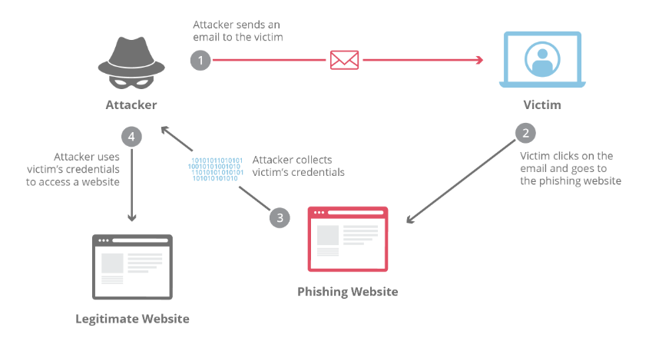
Figure 1 - General Phishing Attack Process [7]

2.2.1 Types of Phishing
There are four main types of phishing, and all four attacks are an attempt to extort personal information from victims and/or used for financial gain.
The four types of phishing are:
- Spear phishing
The act of sending emails to specific and well researched targets under the pretence of being a trusted sender. [8]

- SMS Phishing, also known as Smishing
The lesser-known variant of phishing, but equally perilous, employs text messages sent over mobile phones as bait.[9]

- Vishing
Vishing attacks attempt to trick victims into sharing personal information over the telephone. Vishing techniques exploit the fact that we’re more likely to trust a human voice and may target the elderly and those who have little to no experience with technology and other types of scams. [10]
- Whaling
These emails are usually more sophisticated than generic phishing emails as they often target chief executives. The contents of the email usually contains personalised information about the targeted organisation or individual, it conveys a sense of urgency and use a terminology crafted with a solid understanding of business language and tone. [11]

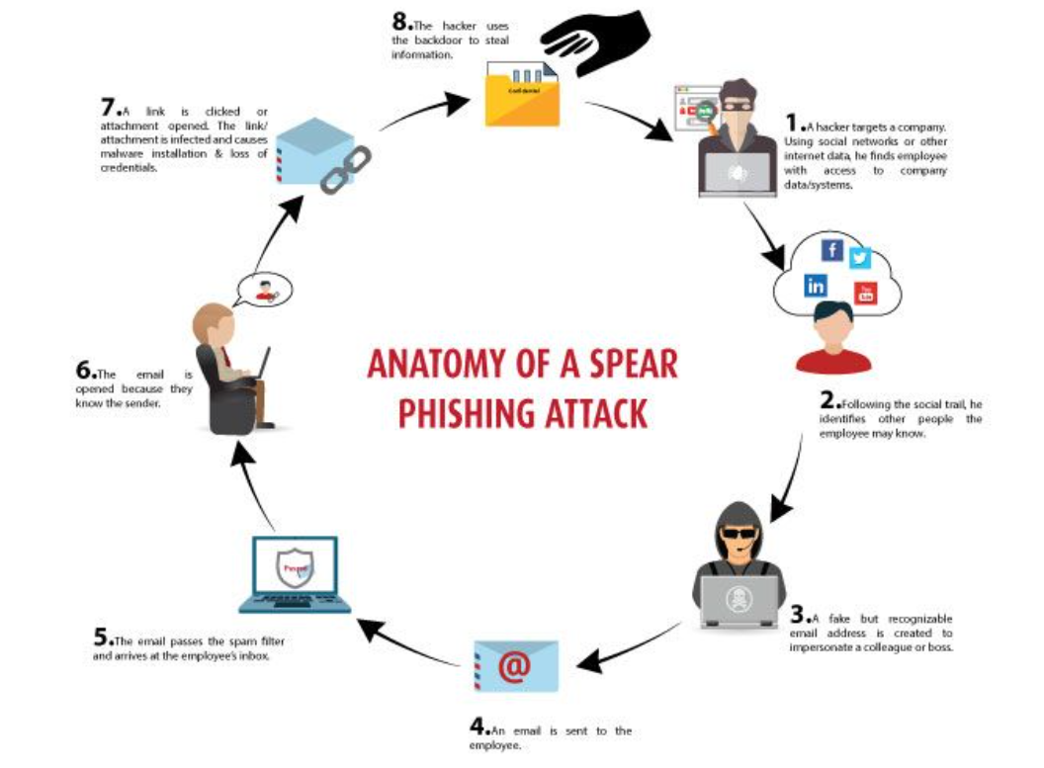
Figure 2 - Life Cycle of a Spear Phishing Attack [8]
Figure One above, demonstrates the lifecycle of a spear phishing attack. Spear-Phishing attacks begin with the attacker identifying a victim using publicly available tools, such as social media. Today’s increasingly digital world, so much of what we do is carried out online whether it’s for business or pleasure, resulting in a massive explosion in Cybercrime. [8]

2.3 Consequences of Successful Phishing Attacks
Every successful phishing attack can have multiple negative effects on an organisation. This may include malware infestation, data loss, ransomware, and compromised credentials.[12] A threefold increase on losses in the first six months of 2021 was reported by The National Fraud Intelligence Agency, compared to figures from the year before. [13]
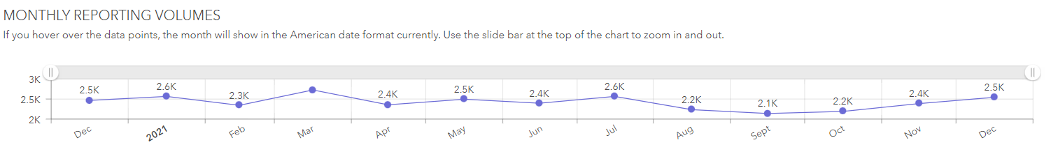
Figure 3 - Monthly Reporting Volumes of Phishing Emails
Figure Two, provided by the National Fraud Intelligence Agency, shows an average of 2.5K phishing emails are reported monthly. These figures show reported data for the whole of 2021. [14]
In March 2020, nation-state hackers believed to be from Russia, compromised a Dynamic-link Library (DLL) file linked to software update for the Orion platform by SolarWinds. The supply chain attack is thought to have impacted up to 18,000 SolarWinds customers. The attack was discovered in December 2020, whilst the compromise took place in March 2020. [15]
As mentioned previously, each successful phishing attack has a negative impact on the victim or company. One negative side for the victim of a phishing attack is that there is no certainty of how much of their details were leaked, which in turn means the victim needs to use their personal time to change their information, passwords for example, or cancel banks cards. The writer believes that the negative effects of a successful phishing attack from an organisational point of view is of course loss of money, this comes from two things, firstly, the money the organisation must pay in fines for the General Data Protection Regulation (GDPR) (2018) breach, and secondly the loss of customers following the data breach.

2.4 Why Users fall for Phishing?
Phishing Emails usually contain several factors that can help aid people in spotting a disingenuous email. The writer believes that most people get caught by phishing scams due to a lack of education.
As mentioned in section 2.2, phishing is primarily used to gather a victim’s data, usually for financial gain. The information gathered can vary depending on the technique used, it usually consists of names and email addresses, to credit card details and even hospital numbers. The ultimate is always for the attackers to obtain personal and sensitive data to sell on the dark web for financial gain.
An Osterman Research Report suggest that there are six causes of phishing:
- Users are the weakest link
- Organisations aren’t doing enough
- Criminal organisations are well funded
- Cyber criminals are shifting their focus
- Phishing tools are low cost and widespread
- Malware is becoming more sophisticated [16]

2.5 Phishing Mitigation
Research shows that several studies on tools to mitigate the impact of phishing attacks have been carried out questioning the effectiveness of phishing simulation tools to educate users and further their awareness and improve their capability in spotting a suspicious email.
An experiment published in 2012 IEEE International Conference on Intelligence and Security Informatics, conducted by Ahmed Abbasi; Fatemeh Zahedi and Yan Chen revealed that participants in the study using the high accuracy anti-phishing tool significantly outperformed those participants using the less accurate tool in their ability. Their results suggested that while the accuracy of anti-phishing tools is a critical factor, other considerations such as improving tool interface/warning design and enhancing users’ knowledge of phishing. [17]
Further research will investigate the technical solutions available to assist in the mitigating the impact of a successful phishing attack against the organisation.

2.5.1 Technical Solutions
Technical solutions assist the employer in creating actual emails that mimic real life, recent and relevant phishing style attacks. A phishing simulation is typically paired with a point-of-failure training when someone clicks on a link or opens an attachment. These usually come in the form of a short quiz and/or video meant to reinforce the practice of carefully reviewing emails and following organisation protocol. [18]
The author has researched and identified what she believes the top three Phishing Simulation tools and compared the features for each solution in Table 1, as shown below.
Feature Capabilities | ProofPoint | KnowBe4 | Barracuda
Templates | 700 | 5,000 | -
Languages | 35 | 34 | 20
Customisable Templates
Branding Approval |  |  | -
Email + SMS
Plugin | PhishAlarm | PhishAlert | Phish Reporting Button
Integration | Outlook & Gmail | - | Outlook, Exchange & Gmail
Training Programmes |  |  | -
Reporting Capabilities
Table 1 - Technical Tool Comparison [19]
For the purpose of this experiment, ProofPoint is the chosen supplier, and the solution has already been implemented across Digital Health and Care Wales, including the implementation of the Plugin for the ease of reporting.

2.5.2 User Education
A technical solution is beneficial for the reporting and auditing of the phishing simulations an organisation runs, and the training that is provided to any users who ‘fail’ the simulation is a bonus to the organisation as it removes the manual process of creating content to educate the users.
However, additional educational materials would benefit users and provide an opportunity to gain an understanding beforehand. Educational materials such as posters – physical and in email form, reminders, and top tips to stay alert on organisation pages and the facility for users to ask questions without judgement would be advantageous alongside a technical solution. An article by Dodge et al, raise that careful consideration should be taken when conducting phishing simulations and the trust between the security staff and the end user is very important and compromising this relationship should be avoided. [20]
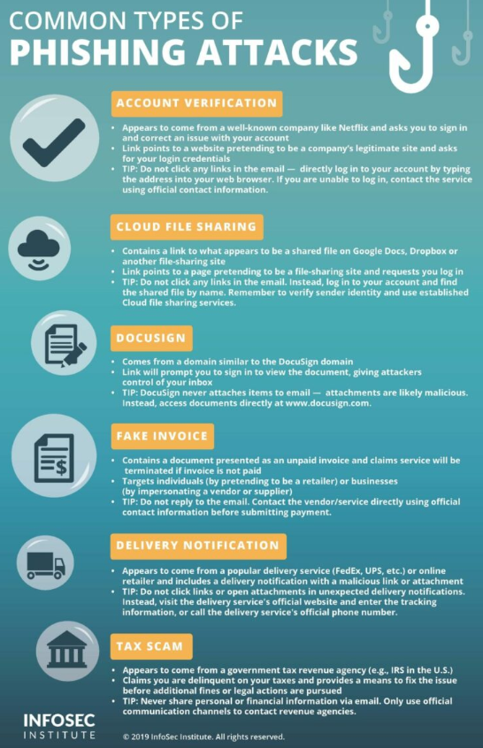
Figure 4 - Example of a Phishing Education Poster [21]
Some researchers suggest that exercises like phishing simulations might develop into a lack of trust of company emails. [20]

2.5 Conclusion
The research conducted and the statistics shown suggests that it is evident that there is continues to be a problem with phishing attacks and users’ abilities to distinguish a legitimate email from a malicious email.
The literature review carried out, detailed the four common phishing attacks and how they are used in a successful attack. Despite the sophistication of the malware, if the user is well educated in the obvious signs of a malicious email, whether it contains web links or documents, then the attacker has done no good.
“Awareness training is critical”, says Callow. “It’s also extremely important to create a better-safe-than-sorry culture in which your team feel completely comfortable reporting suspicious or confirmed spear phishing emails”. [22]
The following chapter will discuss the methods the author will use to answer the main question. The information that has been identified already will prove invaluable for the upcoming chapter.

Chapter 3 – Research Methodology

3.1 Introduction
The main aim of this research was to evaluate and analyse the level of Cyber Security Awareness within DHCW, and if required, produce, and implement a training plan to assist in the mitigation of a Cyber Attack from a Phishing email. The first step was to conduct a literature review to discover expert and user opinions on the use of Phishing Simulation Tools within the workplace.
Theis chapter describes the research methodologies used to fulfil the main aim of the research. The writer has agreed with the Assistant Director of Cyber Security in Digital Health and Care Wales (DHCW) that the employees for DHCW can be used to carry out this experiment. Firstly, to identify whether there is a lack of Cyber Awareness amongst staff, the writer will conduct primary research into the organisation using the approved solution called, Proofpoint.
For the purpose of this research, the simulated emails will only be delivered via email, and not via SMS or phone as mentioned in Chapter 2. A Verizon Data Breach investigation report in 2020, reports that 94% of malware was delivered via email, phishing was involved in 36% of breaches and 85% of breaches involved the human element. [23]
To ensure the results capture a true reflection of a user’s day to day behaviours, no one will be notified of the upcoming simulated email so the author can gain a true reflection of each user’s interaction when confronted with a malicious email and how they then respond.

3.2 Primary Research
As mentioned above, the primary research the writer has chosen to use is a fake email, otherwise known as a phishing simulation.
Phishing attacks are the practice of sending fraudulent communications that appear to come from a reputable source. It is usually done through email. The goal is to steal sensitive data like credit card and login information, or to install malware on the victim’s machine. [29]
The goal for the attacker is to imitate a reputable source, usually found out through reconnaissance work, then send an email with a malicious link or file attachment. The links and attachments are used to encourage users to click them and enter personal information or credentials, or download files which in turn download malware onto laptops the servers etc.
Common phishing email that are used to try and trick users are:
- Paypal
- HMRC
- Covid-19
- Microsoft O365
- Netflix
- Amazon

3.2.1 Interview with Head of Cyber Security for DHCW
The Assistant Director of Cyber Security was interviewed to gather an understanding of what he hopes the expected outcome to be. The questions the writer asked to gain a further understanding of the requirements and boundaries were:
Q1: Why do you want to test users’ cyber awareness within the organisation?
DHCW run critical systems for the whole of NHS Wales, I need to ensure that these systems maintain their integrity and aren’t tampered with in anyway to ensure the confidentiality of patient’s data isn’t at risk. A recent visit to HSE after they suffered an unfortunate cyber-attack caused me as the Head of Cyber Security to check that this does not happen to us at DHCW. If I can help in identifying our weakest links to make them the strongest link, I want to ensure that everything is done to make that happen. (Male, NHS - Cyber Security)
Q2: How long do you want the simulations to run for to gather enough data?
We have a solution called Proofpoint which allows the use of multiple templates to be used in the same simulation, as well as scheduling capabilities to ensure that not every user receives the email at the same time and informs their colleagues. Whilst this is encouraged, for this purpose it won’t help me in identifying users that could benefit from further education. (Male, NHS - Cyber Security)
I’d like to test the whole of DHCW for 3 months, running one simulation a month for around a week and then analyse the data, that way those who are on annual leave will have chance to receive the email. I think two templates for the number of users will be sufficient for this purpose. (Male, NHS - Cyber Security)
Q3: Do you want any training to be provided after each simulation?
I don’t want to allocate training videos or tests to the users just yet, the main aim of this for me, is to gain an understanding of where we are first. Immediate feedback would be beneficial, something like a poster with signs they could have spotted to identify that the email was malicious would be useful without causing animosity between the cyber staff and those affected. (Male, NHS - Cyber Security)

3.3 User Group
It has been agreed that the user group for this research will be the whole of DHCW, which is 1114 users in total. As the author is an employee of DHCW as a member of the Cyber Security Team, they will have knowledge of the simulation. As the Cyber Security Team respond to reports of suspicious email from DHCW users, they will require prior knowledge to ensure resources are allocated correctly and not wasted investigating simulated emails, however, the team are informed that these simulations are to remain confidential and not advertised within the workplace.

3.4 Quality of Data Analysis and Limitations
The use of the Proofpoint tool will provide the writer with high quality and useful data for end analysis. To maintain consistency for the research data, it has been agreed that all the simulated emails will be completed as follows:
- One simulation per month - all data entry type templates
- Two different templates each month to be sent at the same time
- Emails to be sent to all users within two days
- All simulations to end after 7 days and data reviewed
- Data Reported in a Dashboard for further analysis

Chapter 4 – Data Analysis
As agreed in Chapter Three, the experiment was conducted over three months and followed the agreed terms set out in Chapter 3.3.1 by the Assistant Director of Cyber Security.
This chapter will demonstrate how Proofpoint, the chosen phishing simulation tool, works, the email content and then provide an analysis of the data at the end of each simulation, as well as a report for an overall assessment of the current situation for DHCW.

4.1 Phishing Simulation 1
This section will detail the date and timeframe of phishing simulation one, using the Proofpoint tool and analyse the data at the end. It was agreed that immediate feedback should be provided to any users who clicked the link embedded in the email. This is in the form of a poster; the writer has named this ‘’Spot the Signs’.

4.1.1 Agreed Date and Timeframe
The first phishing simulation was scheduled for May 2022. It was agreed that the simulation would last one week and then a review of the results would take place. The writer followed the agreed parameters and set out the two emails to send out within the first two days. A naming convention was followed for ease of viewing, so phishing simulation one was called May 2022 – Data Entry. The following simulations will adopt this naming convention moving forward.
As mentioned previously, the phishing simulation tool ProofPoint was used to assist in this project. Once the emails were created, a summary of information was provided, as shown below in Figure 5.
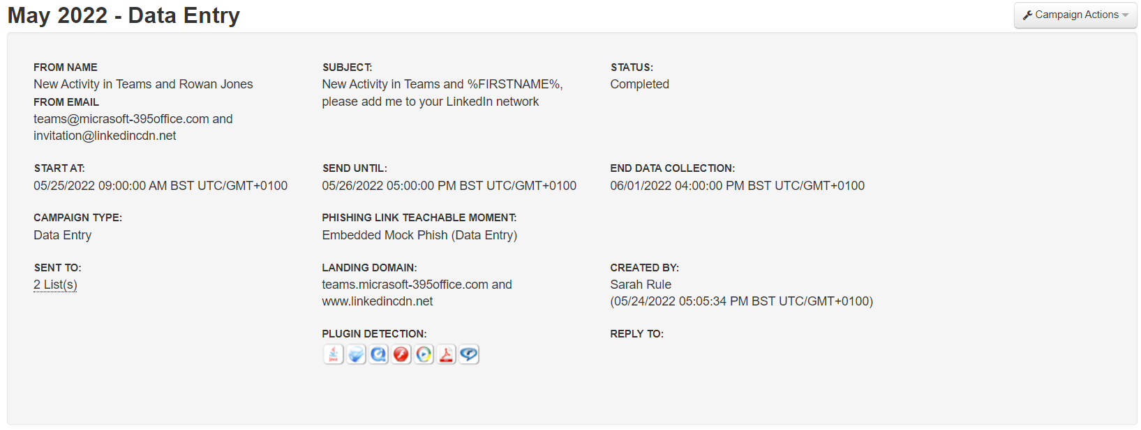
Figure 5 - Simulation 1 - Sending Summary provided from ProofPoint
As shown in the information in Figure 5, the first emails to be sent to the users of DHCW was scheduled for 25/05/2022 and 26/05/2022. All emails are to be sent between the working hours of 9am and 5pm, with the data collection ending on the 01/06/2022.

4.1.2 Agreed Templates
The agreed templates are shown in Figures 6 and 7. Each one of the 1114 DHCW users will either receive a Linkedin or Teams email over the two scheduled days as listed in Section 4.1.1.
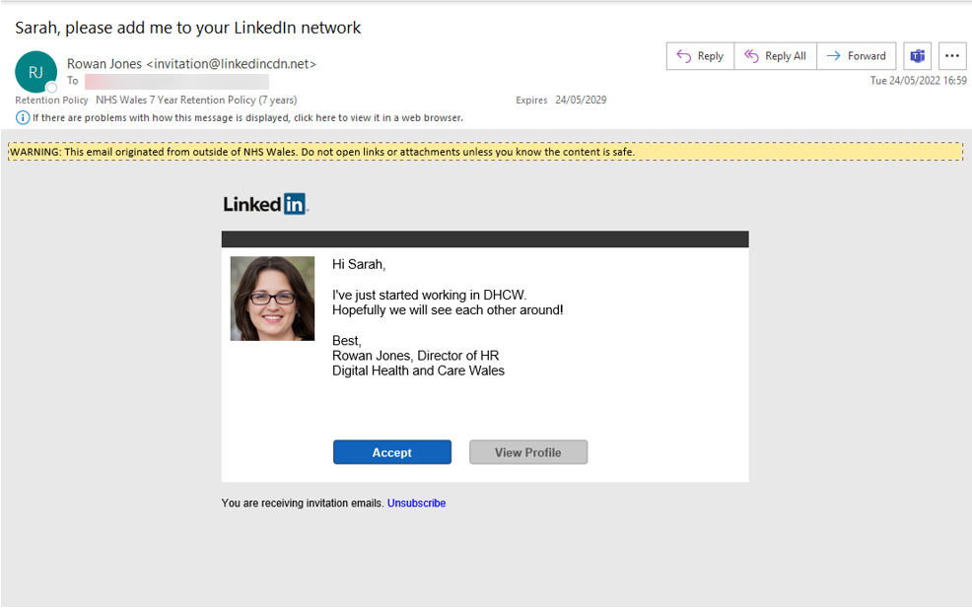
Figure 6 - Template 1 for Simulation 1
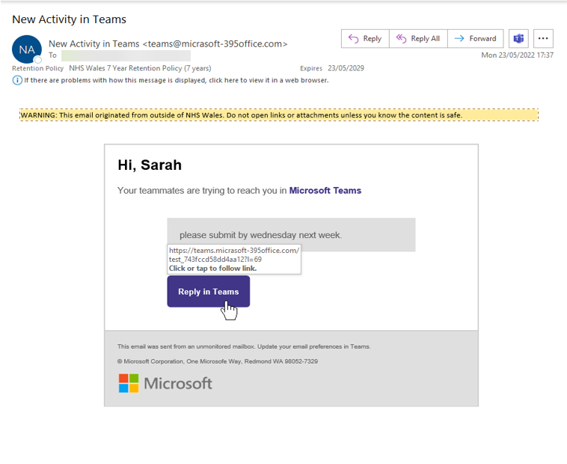
Figure 7 - Template 2 for Simulation 1
The email shown in Figure 7 is a commonly used service with DHCW, with the increase in work from home and hybrid working over the last two years, it is paramount that users are well informed on how malicious emails could present themselves and have the knowledge to spot one.
There are several errors in the email in Figure 7 that could assist the user in identifying that it is a malicious email. For example, the email domain is ‘teams@micrasoft-395office.com’, which is quite obvious that the email is not legitimate as Microsoft is a very well-known company and well used within DHCW and is Microsoft-365.

4.1.3 Results
The phishing simulation was run for one week and sent to all of DHCW, which totalled 1114 users, after which the links embedded in the email were deactivated, and the results produced in a Dashboard format for analysis.
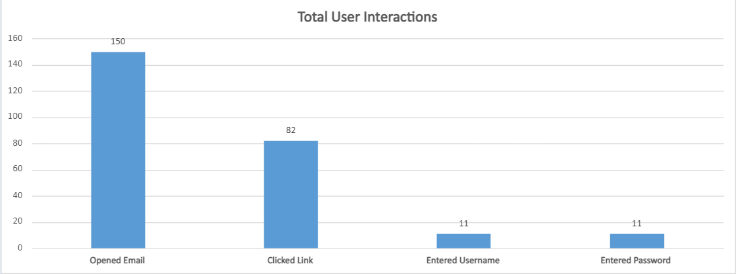
Figure 8 - Simulation 1 - Total User Interactions Break Down
The total user interactions are shown in Figure 8 and are categorised into 4 main areas that we will concentrate on throughout this project, they are:
- Users who opened the email
- Users who clicked the link
- Users’ wo entered their username (after clicking the link)
- Users who entered their password (after clicking the link)
Overall, the results indicate that a small portion of users require further education in identifying malicious emails, but out of 1114 users, 82 of those clicked the link, with only 11 entering both their username and password, it is evident that majority of users have the ability to spot obvious spelling mistakes within emails and therefore identifying that the email was illegitimate.

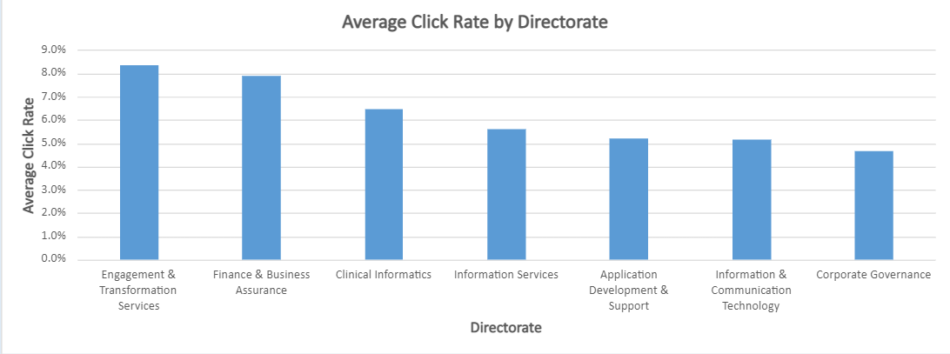
Figure 9 - Simulation 1 - Average Click Rate by Directorate Break Down
The writer has further identified the different directorates for the users which will help to understand whether there are certain departments that require more assistance than others, this could be due to their nature of work and computer security isn’t on their radar whilst working.
From these results, it is evident that with a click rate of over 8% that majority of victims for phishing simulation one work within the Engagement and Transformation Services Directorate, a close second with a click rate of just below 8% is Finance and Business Assurance.

4.1.4 Immediate Feedback
A study by A. Schmulian and S. A. Coetzee on the effectiveness of immediate feedback shows that the majority of students experienced the immediate feedback positively. They state that many students highlighted that they had constructed new knowledge and understanding of the content and practiced numerous skills during the team assessment and feedback phase. [24]
For this project, users who are identified as clicking the link will be provided with immediate feedback in the form of a poster as shown below in Figure 10. The writer will endeavour to gather feedback on the usefulness of this type of feedback at the end of the project.
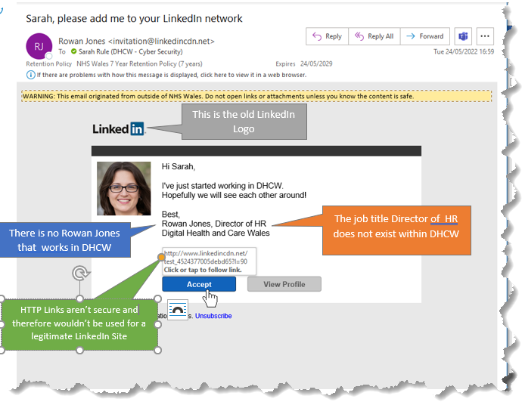
Figure 10 - Spot the Signs Poster - Linkedin

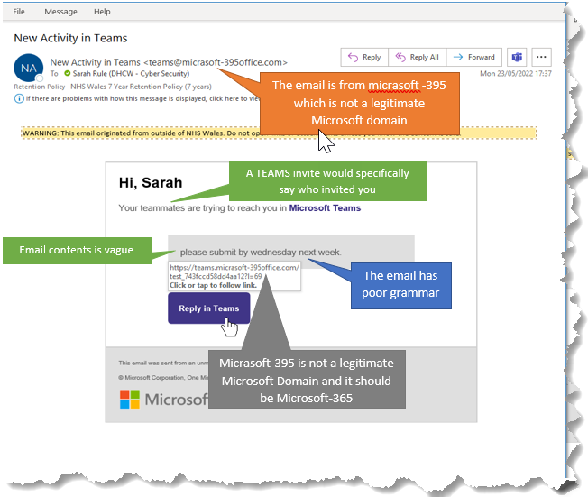
Figure 11 - Spot the Signs Poster – Teams

4.1.5 Summary
The data from phishing simulation One shows that a small number of users clicked the link embedded in the email they received. However, a data breach only requires one person to unknowingly give out their credentials and the attacker has access to sensitive systems.

4.2 Phishing Simulation 2
This section will detail the date and timeframe of phishing simulation two, using the Proofpoint tool to analyse data at the end. It was agreed that immediate feedback should be provided to any users who clicked the link embedded in the email. This is in the form of a poster detailing signs that the user could have spotted to identify whether the email was malicious or not.

4.2.1 Agreed Date and Timeframe
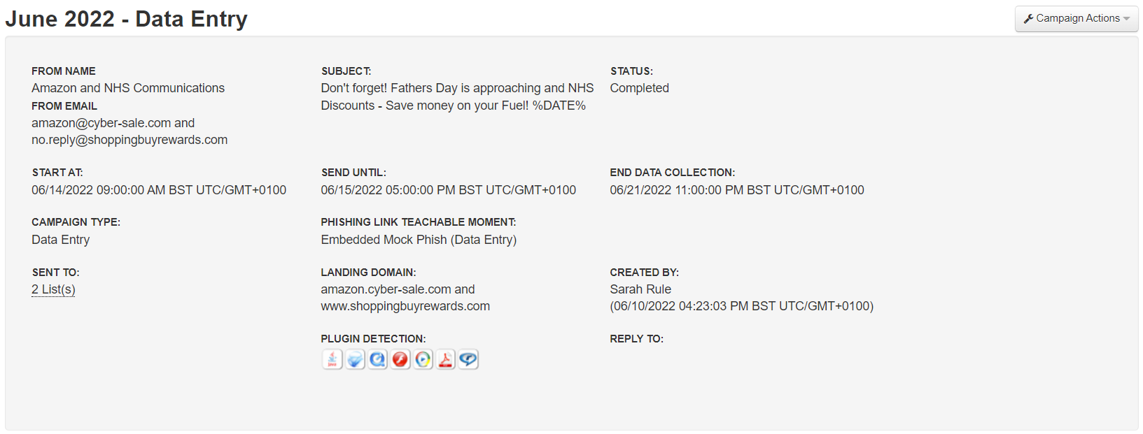
Figure 12 – Simulation 2 – Sending Summary provided by ProofPoint
As shown in the information in Figure 12, the emails for simulation two scheduled to be sent for 14/06/2022 and 15/06/2022. All emails are to be sent between the working hours of 9am and 5pm, with the data collection ending on the 21/06/2022.

4.2.2 Agreed Templates

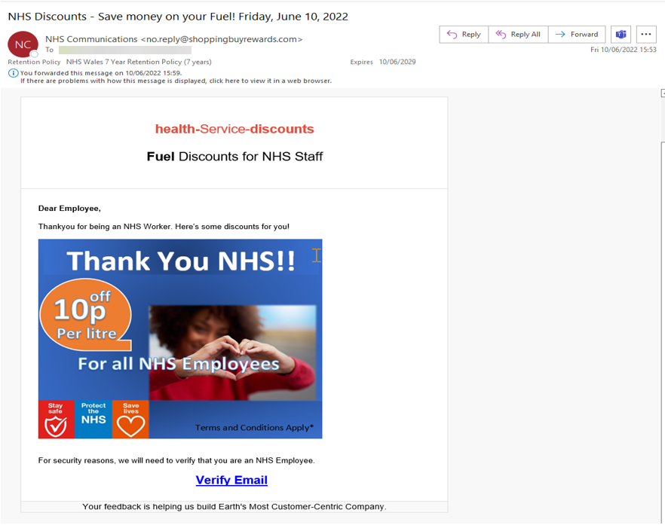
Figure 13 - Template 1 for Simulation 2

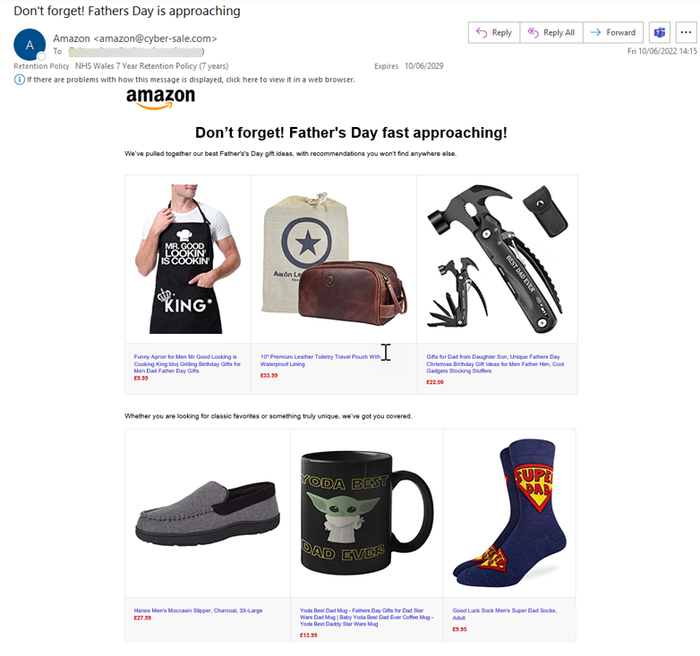
Figure 14 - Template 2 for Simulation 2

4.2.3 Results
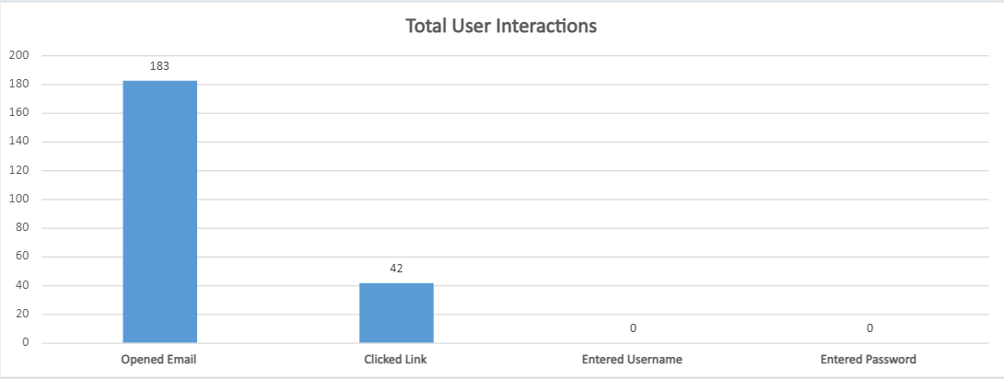
Figure 15 - Simulation 2 - Total Users Interaction Break Down
The results for simulation two were positive compared to simulation one, with no user entering their username or password and a 50% decrease in users clicking the embedded link of the email.
These results suggest three things:
- The immediate feedback provided after simulation one had a positive impact and gave users the knowledge to spot future simulations
- The emails used in simulation two were too easy
- Due to the nature of the emails, users are more likely to browse shopping sites and not log into their personal shopping accounts during working hours
Further investigation is required to identify the reasoning behind this potentially in the form of a workshop, so the feedback is from the users themselves.

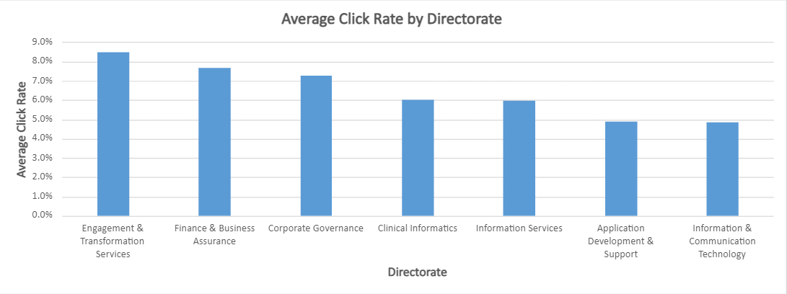
Figure 16 - Simulation 2 - Average Click Rate by Directorate Break Down
Following the results from simulation, it shows an increase across the organisation for majority of the directorates with significant increase in clicks from the Corporate Governance Directorate compared to simulation one.
The highest click rate is consistent with the results from simulation one, with Engagement & Transformation Services and Finance & Business Assurance maintaining the highest percentage.

4.2.4 Immediate Feedback
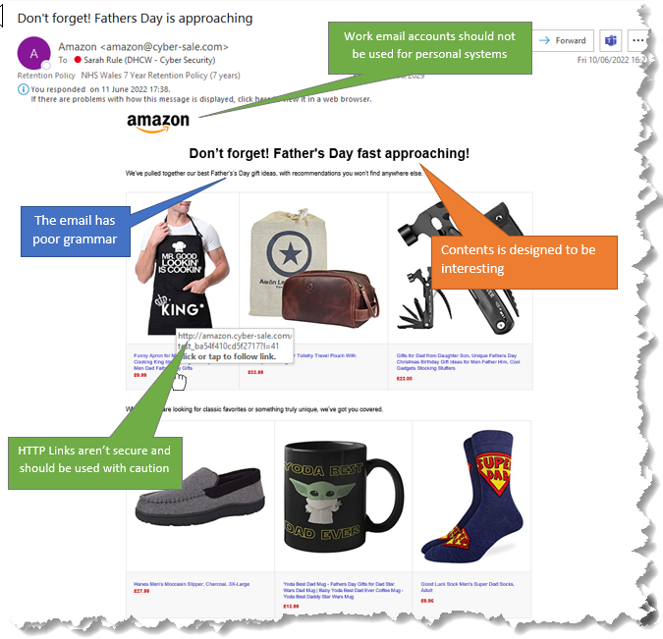
Figure 17 - Spot the Signs Poster - Amazon

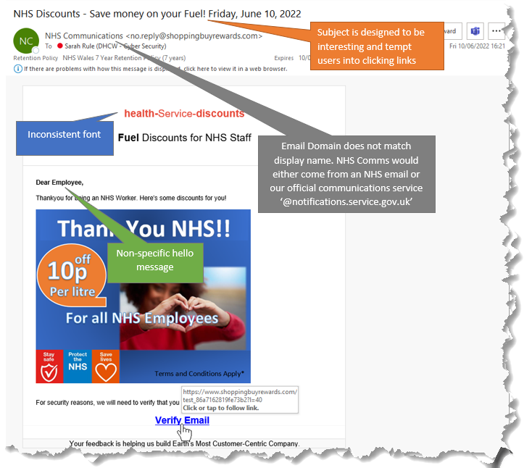
Figure 18 - Spot the Signs - NHS Communications

4.2.5 Summary
The results from phishing simulation two suggest that users are less susceptible to phishing emails with shopping content and have the tendency to browse shopping sites without logging in to make purchases. Further investigation and feedback from the users are required to gain a better understanding of why they are more proficient in the spotting of a malicious email IF the content is shopping, or rewards as opposed to a well-known company such as Microsoft-365 for example.

4.3 Phishing Simulation 3
This will be the final simulation for this project, and this section will detail the date and timeframe of the simulation, using the Proofpoint tool to analyse data at the end, the same as the first two simulations. It was agreed that immediate feedback should be provided to any users who clicked the link embedded in the email. This is in the form of a poster detailing signs that the user could have spotted to identify whether the email was malicious or not as per the previous simulations.

4.3.1 Agreed Date and Timeframe
This is the final simulation for the project, and as shown in the information in Figure 19, the emails for simulation three are scheduled to be sent for 18/07/2022 and 19/07/2022. All emails are to be sent between the working hours of 9am and 5pm, with the data collection ending on the 25/07/2022.
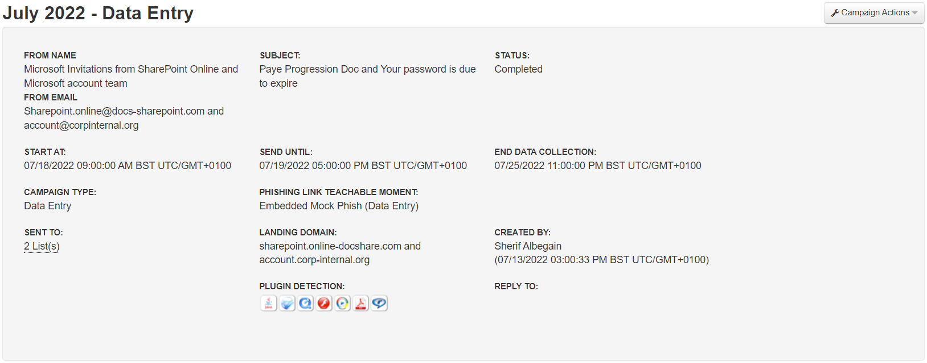
Figure 19 - Simulation 3 - Sending Summary provided by ProofPoint

4.3.2 Agreed Templates
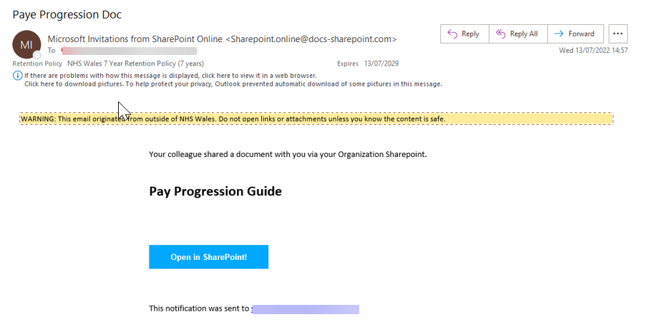
Figure 20 - Template 1 for Simulation 3

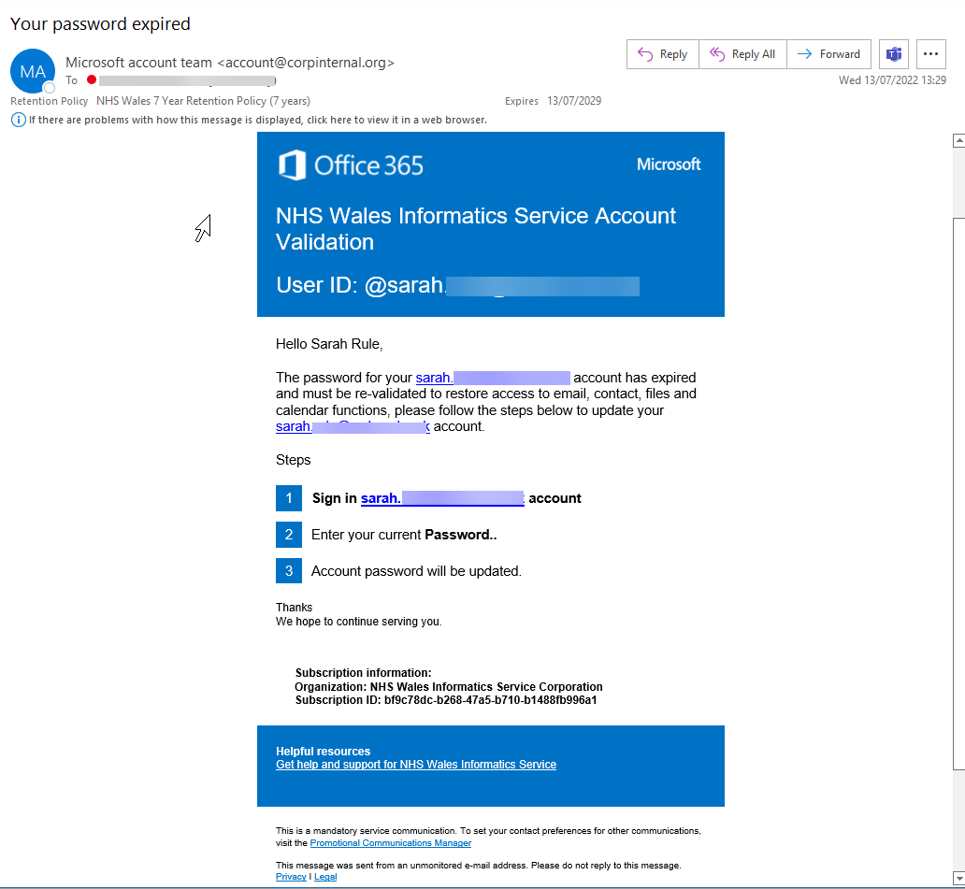
Figure 21 - Template 2 for Simulation 3

4.3.3 Results
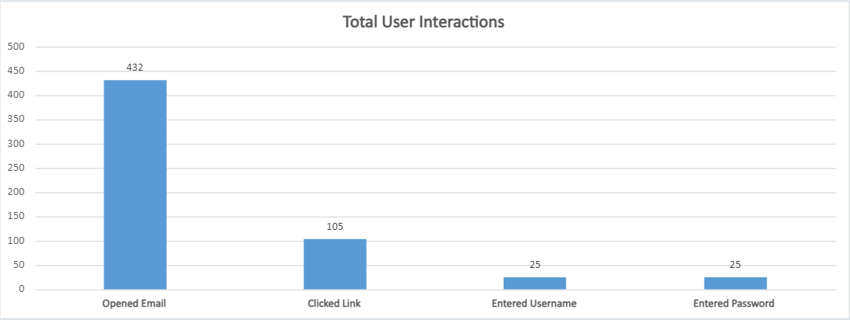
Figure 22 - Simulation 3 - Total User Interactions Break Down
The results for simulation three show a significant increase over all four categories for user interactions with each category doubling from the two previous simulations.
These results could suggest that:
- The email templates used were more difficult than previously used templates
- Users are more susceptible to emails relating to Applications that are well used such as Microsoft and immediately trust that any communications will be legitimate
- Users have a susceptibility to emails containing information on things that will personally affect them, for example money.

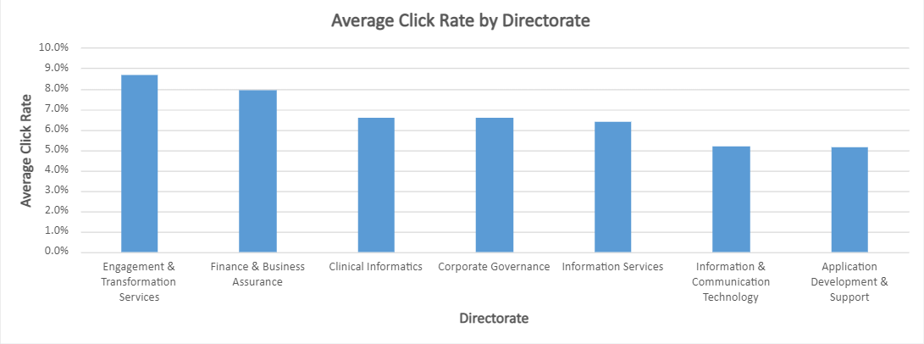
Figure 23 - Simulation 3 - Average Click Rate by Directorate Break Down

4.3.4 Immediate Feedback
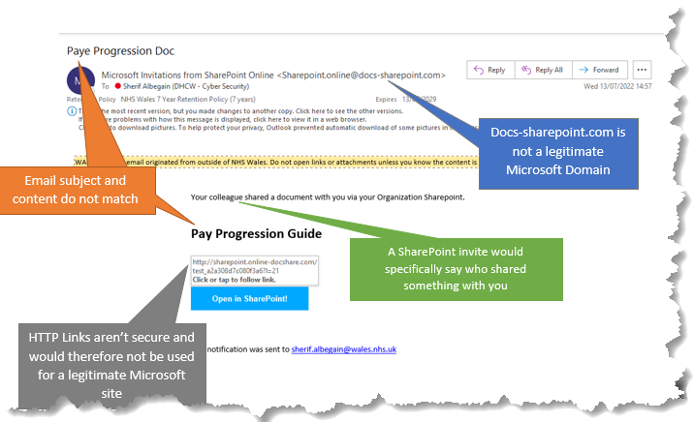
Figure 24 - Spot the Signs Poster - Paye Progression

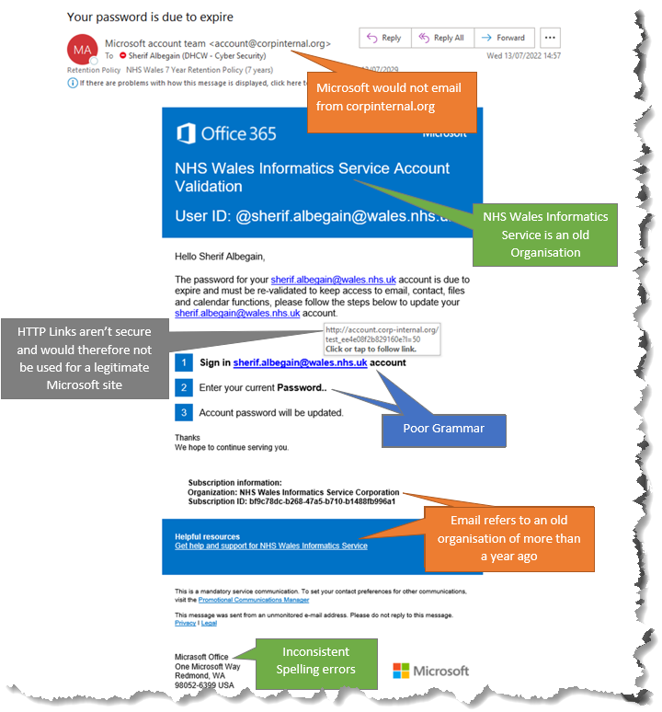
Figure 25 - Spot the Signs - Your password is due to expire

4.3.5 Summary
Of the three simulations run, this simulation had the highest numbers for all for categories that were monitored. The results showed that 38% of users opened the email compared to the first simulation where only 13% of users did, this would suggest that the email subjects from simulation three enticed more users in than previously.
Another reason for the increased interest for these emails is due to the timing of the simulations coincided with Pay Deal Announcements.

4.4 Conclusion

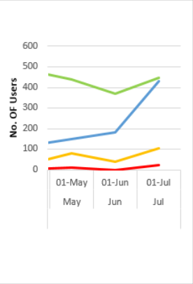
Figure 26 - Final Results
Analysis of the data following the three simulations suggests that DHCW would benefit from further education to improve their knowledge when it comes to identifying malicious emails. The write believes that whilst this data is beneficial, it’s inconsistent in providing 100% accurate results due to a number of reasons including:
- Not all email templates are the same level of difficulty
- It is not known whether those simply deleted the email had the knowledge that is was malicious, or whether they simply were not interested in the content
- It is unknown how many users were not in work for the week of the simulation so what number is unaccountable from the results
To gain a further understanding into these results, the writer will take a random sample of users, review their results over the three simulations and ask questions to understand the results.

Chapter 5 – Ethics behind Phishing Simulations
Research shows that organisations regularly suffer cyber-attacks that was initiated by a phishing email, but is it ethical to simulate an email to employees, classing it as training purposes, or does it constitute trickery? Clearly, conducting an ethical phishing campaign involves deception. In deliberately sending our employees a link that they shouldn’t click on or asking them to disclose sensitive data to an untrusted source, we raise questions of trust, self-control, self-awareness, responsibility, and accountability. [25]
Phishing simulations have become a popular feature of cybersecurity training programs in organisations of all sizes. Phishing tests allow security staff to craft and send emails to employees en masse that are designed to appear as authentic and enticing as the genuine malicious phishing emails that bombard businesses on a regular basis. These typically include lures such as missed delivery notices, invoice payment requests and celebrity gossip. [26] Organisations use emails relating to their current day to day work such as Teams to check users knowledge and alertness when it comes to keeping their network secure.

5.1 Are Phishing Simulations Ethical?
One of the largest providers of phishing training, Knowbe4, reported that in 2020. 17,000 organisations used their solution to provide 9.5 million phishing security test emails to over four million users. Whilst phishing tests can be helpful to protect users, questionable tactics – such as dangling perks or bonuses, for instance – has the potential to damage relationships between a company and its employees. [27]
There are regular disputes and debates around whether phishing simulations are ethical, with the writer herself acknowledging the benefits from an organisational point of view, but also the negative aspects and feelings of deception from an employee’s point of view. The purpose of regularly running phishing simulations needs to be maintained and the benefits shared with the whole organisation as to not do irreparable damage between the organisation and its employees.

Chapter 6 – User feedback
In this chapter, the write has randomly chosen 3 users from the simulations to provide feedback of their overall experience during the project.
To maintain confidentiality, no names will be used during the feedback process and the participants will be known as the following throughout the questionnaire.
- User X – Female, Core Services, NHS.
Clicked the link for simulation one, successfully passed simulations two and three.
- User Y – Male, Project Management, NHS.
Clicked the links in all three simulations but only entered data for simulation one
- User Z – Male, Information Services, NHS.
Clicked the link for simulation three only.

6.1 End–User feedback
The writer will ask five questions to users X, Y and Z and all feedback will be anonymized if shared wider than this report.
Q1: Before receiving the phishing emails, did you know what phishing is?
User X – I have a brief understanding of what phishing is and some knowledge that it can be done in various forms, such as text messages as I often receive scam messages from the bank. I thought all phishing emails requested money from you. Female, Core Services, NHS.
User Y – I don’t know what phishing is and had never heard of it before these emails, I didn’t realise they could look so genuine. Male, Project Management, NHS.
Q2: Do you think Phishing Simulations are beneficial?
User Z – I think they are beneficial to the organisation in identifying any weakest links, especially if those users have privileged permissions to sensitive systems. Male, Information Services, NHS.
User X – I agree, people say you’re only as strong as your weakest link, so its important that any gaps where we as an organisation could be attacked are plugged immediately. Female, Core Services, NHS.
User Y – It depends how they are presented I suppose and whether the user takes notice of the information provided. Personally, I feel that whilst I’m working, I’m too busy and rarely absorb the information I should which is the reasoning behind me clicking all three links for the emails I received. Male, Project Management, NHS.
Q3: Do you think there is a better way for us to educate users?
User Y – The training material could probably be more interactive so users have to acknowledge it, whereas an email can just be deleted and ignored. Male, Project Management, NHS.
User X – Personally I’m too busy to take part in games for training purposes, but I have an understanding of the importance of email security so ensure to keep this at the forefront of my mind when working. Female, Core Services, NHS.
Q4: How did you feel when you clicked on the email and realised it was a simulation and you were essentially ‘caught’?
User X – I was a little disappointed in myself as usually I always make sure I read the emails before I click anything just in case, but I put it down to being a little distracted and made sure to take some time out each day to give my full attention to my emails, so it doesn’t happen again. It does also feel great when you report the email and have a little well done message pop up, it’s like a little victory for you. Female, Core Services, NHS.
User Y – I don’t really care to be honest, I don’t feel I have the time to check each and every email that comes through, especially when it relating to things I do daily, like use Teams. There are measures in place to sort the problem if it affects me and my laptop so I’m not worried. Male, Project Management, NHS.
User Z – I was disappointed that I hadn’t spotted the blatant spelling mistake between the subject and the email content. With the recent announcement of a pay deal and the pay progression talk that WFOD has for DHCW staff, I just assumed it was legit and my own ignorance caught me off guard. Male, Information Services, NHS.
Q5: On one occasion, you clicked the link in the email, but then failed to report it. Why?
User Z - I didn’t realise that I hadn’t reported it after clicking, my apologies. I must have got side tracked and forgot to report the email. I usually try to report all suspicious emails just in case one has slipped through the net from another user, the security team have a chance to remediate any issues before they escalate. Male, Information Services, NHS.
User Y – I don’t know how to report the emails and who in the security team I should talk too. Maybe better communications could be done. Male, Project Management, NHS.
User X – I thought as it’s just a test it wouldn’t really matter whether I reported it or not, but thinking about it, its about forming healthy habits so if there was a real phishing email, I would routinely report it and help mitigate the chance of an attack on DHCW. Female, Core Services, NHS.

6.2 Head of Cyber Security Feedback
The results from all three simulations were provided to the Assistant Director of Cyber Security who was interested to see the difference in response depending on what emails were received. It was acknowledged that Microsoft and SharePoint related emails often caught out the most users and when it comes to anything controversial, such as pay or money, users susceptibility increases.
Overall, the results were beneficial and identified that further investigation is needed to help users understand the importance of recognising and reporting suspicious emails.

Chapter 7 – Reflection
The research has been conducted in the way it was expected and the main aim of the project was partially achieved. Throughout this project a variety of skills have been developed to improve my career progression, to mention a few:
- Working under pressure. It was not easy to stick to the schedule I planned out at first with other coursework and work from my employer, but eventually I managed to balance everything out.
- The ability to prioritise tasks without affecting the project negatively. This took a while to learn but eventually I got there.
There were several things I identified that could have done better, such as:
- Time management – I should have started earlier so the last test wasn’t left until late
- How to meet all project objectives
- To give myself time to re-read and change we necessary the wording in the report more than once
Things I could have done differently:
- As mentioned above, I could have started the testing for my project earlier to give myself more time for analysis.
- Research work – this needed to be more structure and organised better to produce better quality work.

References
[1] W. Priestman, T. Anstis, I. G. Sebire, S. Sridharan, and N. J. Sebire, “Phishing in healthcare organisations: Threats, mitigation and approaches,” BMJ Heal. Care Informatics, vol. 26, no. 1, Sep. 2019, doi: 10.1136/BMJHCI-2019-100031.
[2] S. Morgan, “CyberCrime to Cost the World $10.5 Trillion Annually by 2025,” CyberCrime Magazine, 2016. https://cybersecurityventures.com/hackerpocalypse-cybercrime-report-2016/.
[3] Verizon, “Verizon Data Breach Investigations Report - 2018,” 2018.
[4] “Phishing attacks: defending your organisation - NCSC.GOV.UK.” https://www.ncsc.gov.uk/guidance/phishing (accessed Dec. 10, 2021).
[5] “The History of Phishing Attacks | Verizon Business.” https://www.verizon.com/business/resources/articles/s/the-history-of-phishing/ (accessed Jul. 06, 2022).
[6] D.Swinhoe, “UK cybersecurity statistics you need to know | CSO Online.” https://www.csoonline.com/article/3440069/uk-cybersecurity-statistics-you-need-to-know.html.
[7] “What is a phishing attack? | Cloudflare.” https://www.cloudflare.com/en-gb/learning/access-management/phishing-attack/ (accessed Jun. 24, 2022).
[8] “The Ultimate Guide to Phishing - MetaCompliance.” https://www.metacompliance.com/lp/ultimate-guide-phishing (accessed Dec. 16, 2021).
[9] “What is smishing? | IT PRO.” https://www.itpro.co.uk/security/phishing/361625/what-is-smishing (accessed May 29, 2022).
[10] “Vishing explained: How voice phishing attacks - ProQuest.” https://www.proquest.com/docview/2404178260?accountid=130472&parentSessionId=Gyk1h3DnKe3i3L%2FPMIJuKOtBTjWhWBzfiRO%2FZoAfcEw%3D&pq-origsite=primo&forcedol=true (accessed Jul. 29, 2022).
[11] “Whaling: how it works, and what your organisation can do... - NCSC.GOV.UK.” https://www.ncsc.gov.uk/guidance/whaling-how-it-works-and-what-your-organisation-can-do-about-it (accessed Apr. 15, 2022).
[12] M. Morris, “8 Harmful Effects of Phishing on Business,” 2021. https://www.sdtek.net/8-harmful-effects-of-phishing-on-businesses/. (accessed Dec. 27, 2021).
[13] A. Scroxton, “UK loses £1.3bn to fraud and cyber crime so far this year,” 2021. https://www.computerweekly.com/news/252505825/UK-loses-13bn-to-fraud-and-cyber-crime-so-far-this-year (accessed Dec. 27, 2021).
[14] “National Fraud Intelligence Agency,” 2021. https://colpolice.maps.arcgis.com/apps/opsdashboard/index.html#/60499304565045b0bce05d2ca7e1e56c (accessed Dec. 01, 2021).
[15] A. T. Tunggal, “The 61 biggest data breaches.” https://www.upguard.com/blog/biggest-data-breaches. (accessed Jan. 03, 2022).
[16] M. Samarati, “Phishing Attacks: 6 reasons why we keep taking the bait.” .
[17] Y. C. A. Abbasi, F.Zahedi, “Impact of anti-phishing tool performance on attack success rates,” Impact anti-phishing tool Perform. attack success rates, pp. 12–17, 2012, doi: 10.1109/ISI.2012.6282648.
[18] “Phishing Simulation Tool | Defendify.” https://www.defendify.com/phishing-simulation-tool (accessed Jun. 12, 2022).
[19] “The Top 10 Phishing Simulation And Testing Solutions | Expert Insights.” https://expertinsights.com/insights/the-top-10-phishing-simulation-and-testing-solutions/ (accessed Jun. 21, 2022).
[20] R. C. Dodge, C. Carver, and A. J. Ferguson, “Phishing for user security awareness,” doi: 10.1016/j.cose.2006.10.009.
[21] “Top 20 security awareness posters with messages that STICK - Infosec Resources.” https://resources.infosecinstitute.com/topic/top-20-security-awareness-posters-messages-stick/ (accessed May 10, 2022).
[22] M. Stone, “Why a Phishing Attack is Still Profitable - And How to Stop One.” https://securityintelligence.com/articles/phishing-attack-profitable-stop/ (accessed Jan. 15, 2022).
[23] PhishingBox, “Phishing Facts,” 2020. https://www.phishingbox.com/resources/phishing-facts (accessed Jan. 01, 2022).
[24] A. Schmulian and S. A. Coetzee, “Students’ experience of team assessment with immediate feedback in a large accounting class,” https://doi.org/10.1080/02602938.2018.1522295, vol. 44, no. 4, pp. 516–532, May 2018, doi: 10.1080/02602938.2018.1522295.
[25] “The ethics of ethical phishing.” https://www.thesecuritycompany.com/insights-measurement/the-ethics-of-ethical-phishing/ (accessed Jan. 01, 2022).
[26] M.Hill, “5 best practices for conducting ethical and effective phishing tests.” https://www.csoonline.com/article/3619610/best-practices-for-conducting-ethical-and-effective-phishing-tests.html. (accessed Feb. 04, 2022).
[27] R. Wright and J. B. Thatcher, “Phishing Tests Are Necessary. But They Don’t Need to Be Evil.,” 2021.

