
LCMB7010- Digital Marketing
COMPANY NAME : TESCO
STUDENT ID : 2215786
STUDENT NAME : SUHAIB VELLIYATH

Table of Contents
1. Introduction 1
2. Brand Mission and Values 2
3. Current digital marketing strategy 3
4. PESTLE analysis of UK market 7
5. Consumer insights 11
1.1 POEM MODEL 11
1.2 Customer Lifecycle Management (CLM) 16
1.3 RACE Framework Overview 18
6. Buyer personas 20
7. Competitor analysis 24
8. New Strategies 25
9. SMART Objectives 28
10. TOWS Matrix 30
11. Strategy 33
12. Tactics and tools for implement new changes 35
13. METRICS AND KPI 38
14 Conclusion 43
15 References 44

Introduction
In the ever-evolving landscape of business, the formulation and execution of an effective digital marketing strategy have become imperative for companies seeking to thrive in the digital age. At the heart of this strategic process lies the identification of business goals and objectives, serving as the compass that guides the organization towards success. This assessment delves into the realm of digital marketing strategy development, focusing on the UK market. The task at hand involves crafting a comprehensive digital marketing strategy for a company with a prominent online presence within a selected industry. This strategy will harness the power of digital tools, including AI-driven algorithms, to engage the target audience, optimize user experiences, and achieve measurable outcomes. Through a meticulous exploration of brand elements, market dynamics, consumer insights, and competitive landscape, this assessment aims to showcase how a well-informed, data-driven digital marketing strategy can shape a company's trajectory in the modern business landscape.

Brand Mission and Values
Tesco's brand mission centres around enhancing the lives of its customers by providing them with high-quality products, exceptional value, and a convenient shopping experience. The company's commitment to delivering a personalized, customer-centric approach is aligned with its core values of:
No one tries harder for customers: Tesco's dedication to customer satisfaction is a driving force behind its digital marketing strategy. Through data-driven insights and personalized recommendations, Tesco tailors its online interactions to meet individual preferences and needs.
Treat people how we like to be treated: This value underscores Tesco's approach to digital marketing, emphasizing empathy and respect in all customer interactions. It guides in creating user-friendly interfaces, providing helpful information, and resolving customer issues promptly in the digital space.
Every little help makes a big difference: Tesco's commitment to making a positive impact extends to its digital marketing initiatives. The company employs its online platforms to promote sustainable practices, share nutritional information, and support local communities, aligning its digital presence with its broader societal contributions (TESCO, 2022).

Current digital marketing strategy
Their current digital marketing strategy encompasses a holistic approach that focuses on various online channels, personalized experiences, and data-driven insights. The following sections provide an overview of Tesco's current digital marketing strategy:
1. Omnichannel Presence
Tesco has established a strong omnichannel presence, ensuring that customers can seamlessly interact with the brand across various digital platforms. Their strategy integrates online channels with physical stores, allowing customers to shop through the Tesco website, mobile app, and in-store kiosks. This aims to provide a consistent and convenient shopping experience regardless of the channel customers choose. Tesco.com, which receives over 25 million visits each month and has the second-highest conversion rate of any UK grocery website at 28%, is the second-most visited grocery website overall(Kar, Bansal and Mishra, 2021).
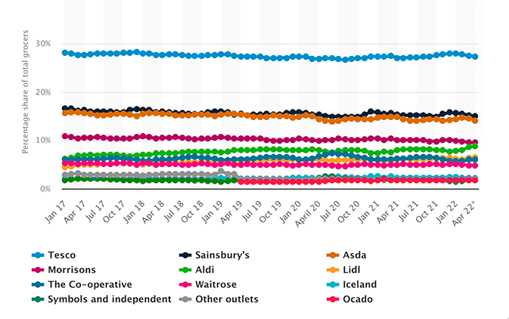
Supermarket sales source(Statista, 2022)
2. Personalization and Customer Segmentation
One of the key strengths of Tesco's digital marketing strategy is its emphasis on personalization. The Tesco Clubcard loyalty program serves as the foundation for customer segmentation and personalization. By analysing purchasing behaviour, browsing history, and preferences, Tesco tailors marketing messages, recommendations, and promotions to individual customers owes to enhanced customer satisfaction and drives repeat purchases(Palmer, 2005).
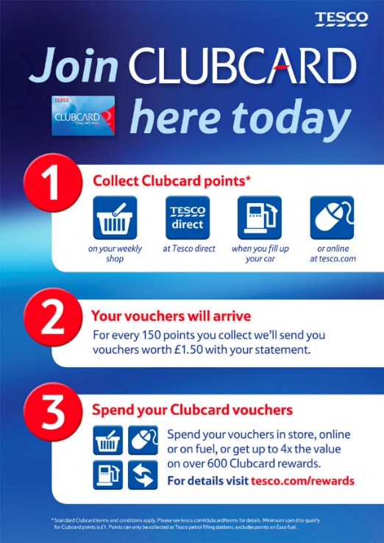
Tesco's Clubcard program
3. Data-Driven Insights
Tesco leverages data analytics to gain insights into customer behaviour and preferences. They use this data to refine their product offerings, pricing, and marketing campaigns. Through advanced analytics, Tesco can identify trends, predict demand, and optimize their inventory management, leading to more efficient operations and customer experiences(FATRICIA, 2016).
4. Social Media Engagement
Tesco maintains an active presence on various social media platforms, including Facebook, Twitter, Instagram, and YouTube. They use these to share promotions, new product launches, recipes, and engage with customers in real-time. Social media enables Tesco to create a sense of community, respond to customer queries, and gather feedback directly from their target audience(Giannini, 2023).
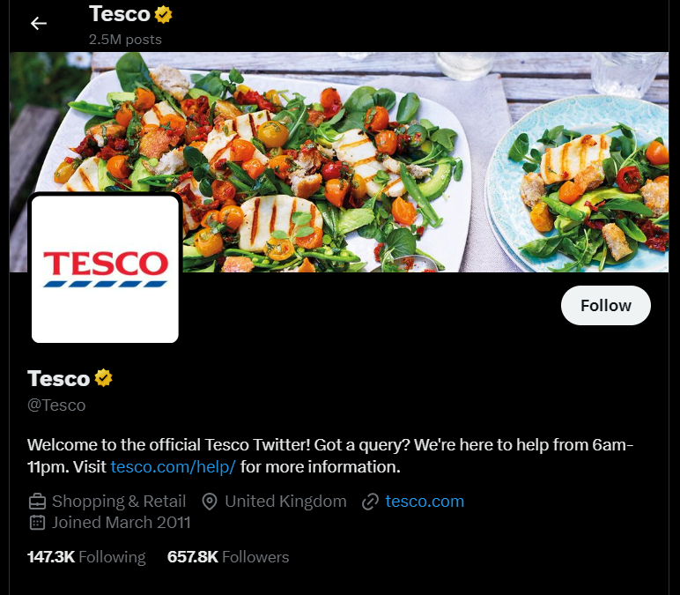
Tesco official Twitter account
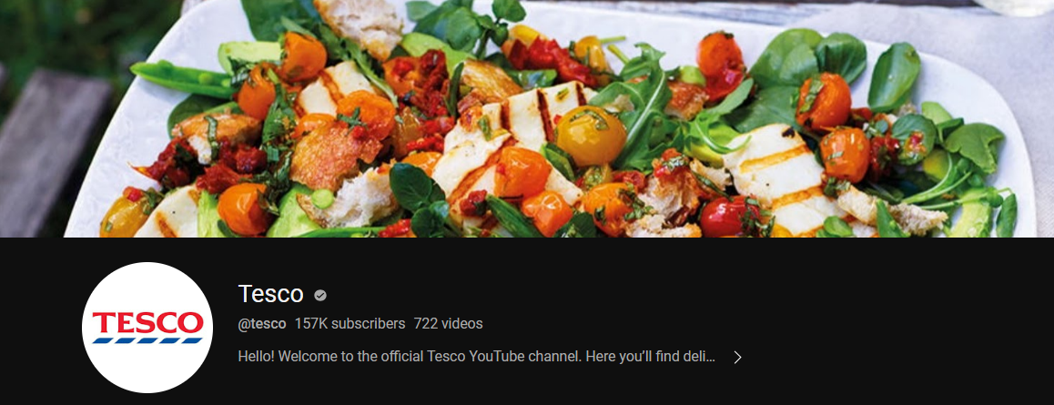
Tesco official YouTube channel
5. Content Marketing
Tesco employs content marketing to provide value to its customers beyond traditional product listings. They create and share relevant content, such as cooking tips, recipes, and health-related articles, positioning themselves as a trusted source of information. This approach establish a deeper connection with customers and encourages them to engage with Tesco's digital platforms regularly(Awadari and Kanwal, 2019).
6. Mobile App and E-commerce
The Tesco mobile app offers a comprehensive shopping experience, enabling customers to browse products, manage shopping lists, make purchases, and even schedule deliveries. The app's user-friendly interface, coupled with features like barcode scanning and personalized recommendations, enhances customer convenience and encourages mobile shopping(Ryu and Simpson, 2011).
7. Influencer Collaborations
Tesco occasionally collaborates with influencers and bloggers to showcase their products and recipes. These collaborations help tap into the influencer's followers, expand brand reach, and create a buzz around Tesco's offerings.
Marketing strategy of TESCO
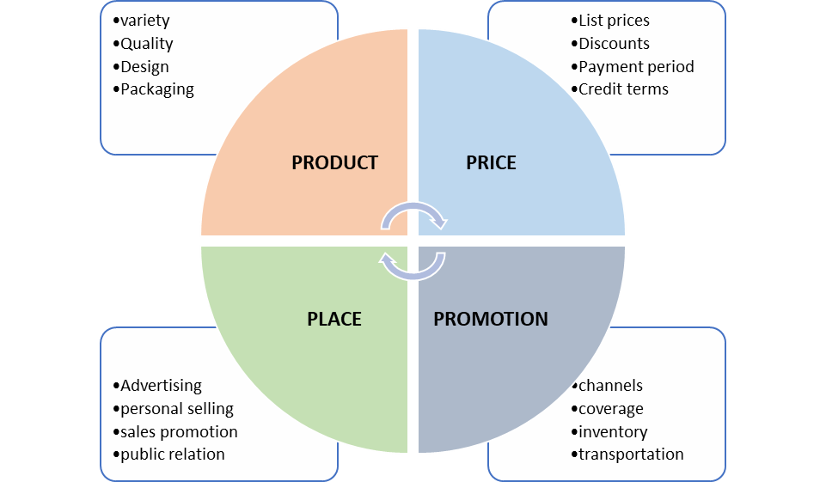
4-Ps of Marketing mix source (self-made)

PESTLE analysis of UK market
The PESTLE analysis provides a comprehensive overview of the factors influencing the online grocery market in the UK.
Political Factors | Government Regulations: The UK government's regulations related to data privacy, consumer protection, and online advertising can impact the strategies and operations of digital marketing for groceries.  Brexit Implications: Changes in trade agreements and regulations due to Brexit may affect supply chains, import/export of groceries, and overall market dynamics(MONTE Francesca, 2021).  Taxation Policies: Taxation policies, such as VAT (Value Added Tax), can impact pricing strategies and overall profitability of online grocery businesses.  Source:(Ryu and Simpson, 2011)
Economic Factors | Economic Growth: The overall economic performance and disposable income levels of consumers influence their spending behaviour on groceries, both online and offline(Pajni, Sharmaa and Jain, 2022).  Inflation Rates: Fluctuations in inflation rates can affect pricing strategies and consumer purchasing power, impacting the demand for online grocery shopping(Awadari and Kanwal, 2019).  Unemployment Rates: High unemployment rates may lead to reduced consumer spending, affecting the growth of the online grocery market.  Source:(Awadari and Kanwal, 2019)
Sociocultural Factors | Changing Consumer Preferences: A shift towards healthier eating, organic products, and convenience-driven shopping behaviours can impact the types of groceries being marketed online(Amankwah-Amoah and Osabutey, 2020).  Demographic Trends: An aging population and increasing multiculturalism can influence the types of products, marketing messages, and languages used in digital campaigns.  Lifestyle Changes: Busier lifestyles and urbanization can drive the demand for online grocery shopping, emphasizing convenience and time-saving aspects(Sharif, 2014).  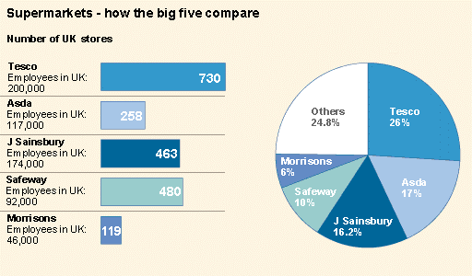  Source(Statista, 2021)
Technological Factors | Digital Infrastructure: The UK's well-developed digital infrastructure, including high-speed internet and widespread smartphone usage, provides a conducive environment for digital marketing in the grocery sector(Palmer, 2005).  E-commerce Platforms: The availability and functionality of e-commerce platforms and apps impact the ease of online grocery shopping and the effectiveness of digital marketing efforts(Farndale et al., 2011).  AI and Data Analytics: Integration of AI-driven personalization, chatbots, and data analytics can enhance the customer experience and optimize digital marketing strategies(Khirbat and Ramanjaneyulu, 2018).  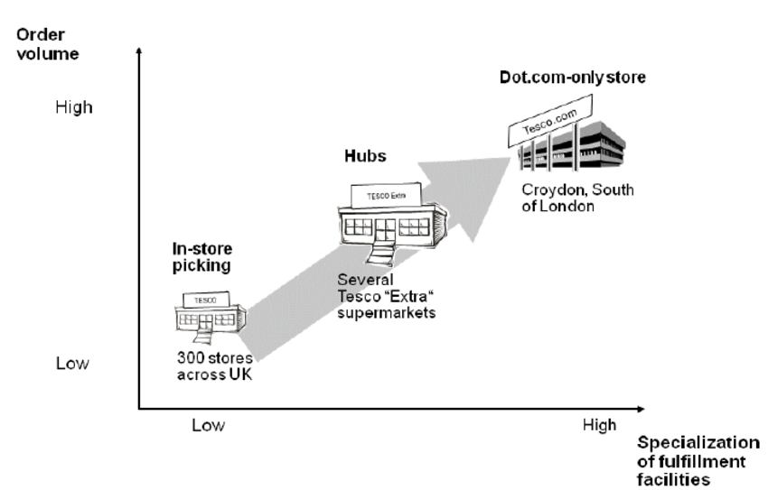  Source: (Jamil et al., 2022)
Legal Factors | Data Privacy Regulations: Compliance with data protection laws, such as GDPR, is crucial for maintaining consumer trust and ensuring legal digital marketing practices(MONTE Francesca, 2021).  Advertising Regulations: Adherence to advertising standards and regulations set by authorities like the Advertising Standards Authority (ASA) is necessary to avoid legal issues in digital marketing campaigns.  Competition Law: Regulations related to fair competition and anti-trust laws can impact market dynamics and the strategies used by online grocery businesses.  Source:(Sharif, 2014)
Environmental Factors: | Sustainability Concerns: Growing consumer awareness about environmental issues can influence marketing strategies, emphasizing eco-friendly packaging, local sourcing, and sustainable practices(Berquier, 2019).

Consumer insights
Understanding consumer behaviour is a critical aspect of effective marketing and business strategy, and the United Kingdom's market is no exception. The dynamic landscape of the UK market necessitates a comprehensive approach to gather and leverage consumer insights for strategic decision-making. In this context, the POEM Model (Paid, Owned, Earned Media), Customer Lifecycle Management, and RACE Framework (Reach, Act, Convert, Engage) emerge as valuable tools to comprehend and engage with consumers throughout their journey.

POEM MODEL
The POEM model is a framework used in the field of marketing to categorize different types of media channels based on how a brand or company interacts with them. POEM stands for Paid, Owned, and Earned Media, and it helps businesses strategize their marketing efforts by understanding the distinct characteristics of each type of media(Rosengren, 2019).
Paid Media:
Tesco's paid media efforts in the UK market involve various digital marketing initiatives, including online advertisements, social media promotions, and sponsored content. Tesco invests in paid media to reach a wider audience, drive traffic to its online platforms, and promote its products and services(Marketline, 2017). Through targeted advertisements on platforms like Google Ads and social media channels (Facebook, Instagram, Twitter), Tesco aims to create brand awareness and attract potential customers. Paid media campaigns also include email marketing, where Tesco sends promotional offers and updates to its customer base(TESCO, 2022).
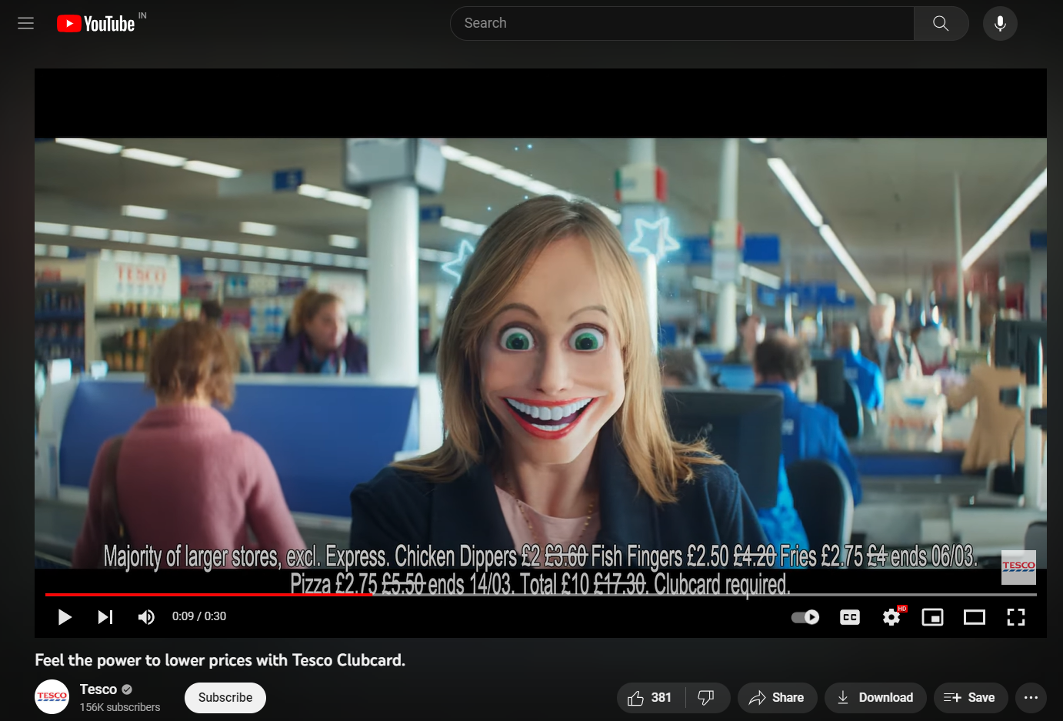
Online marketing: Tesco ad on YouTube
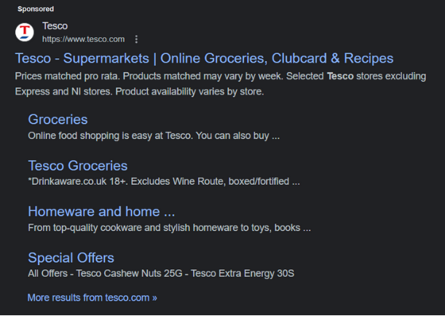
Search engine marketing: Sponsored post on google.
Owned Media:
Tesco's owned media consists of its own digital assets and communication channels. This includes its official website, mobile app, social media profiles, and email lists. Tesco strategically uses these owned media platforms to engage with its customers, provide information about products, offer personalized recommendations, and promote loyalty programs like the Tesco Clubcard. The Tesco website and app serve as digital storefronts, allowing customers to explore products, check prices, and make purchases. The use of owned media helps Tesco maintain control over its brand messaging and customer interactions(TESCO, 2022).
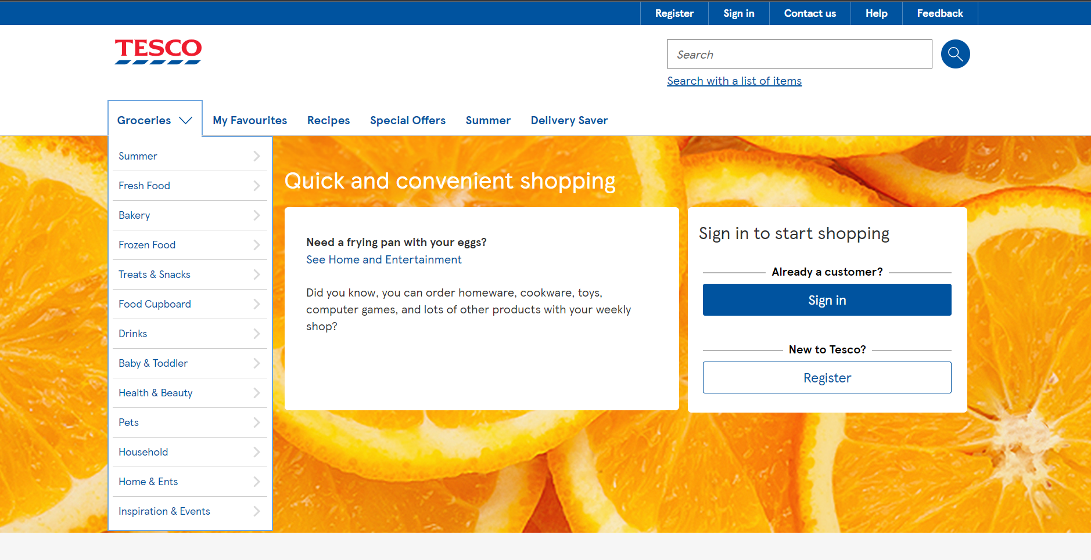
Official website
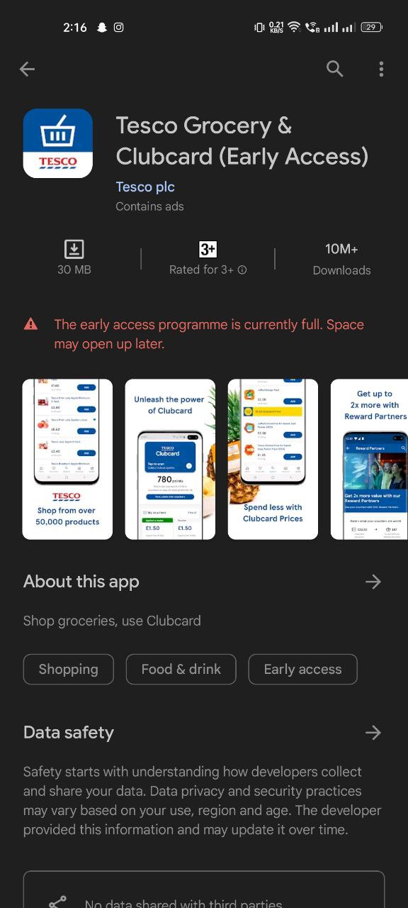
Tesco official app
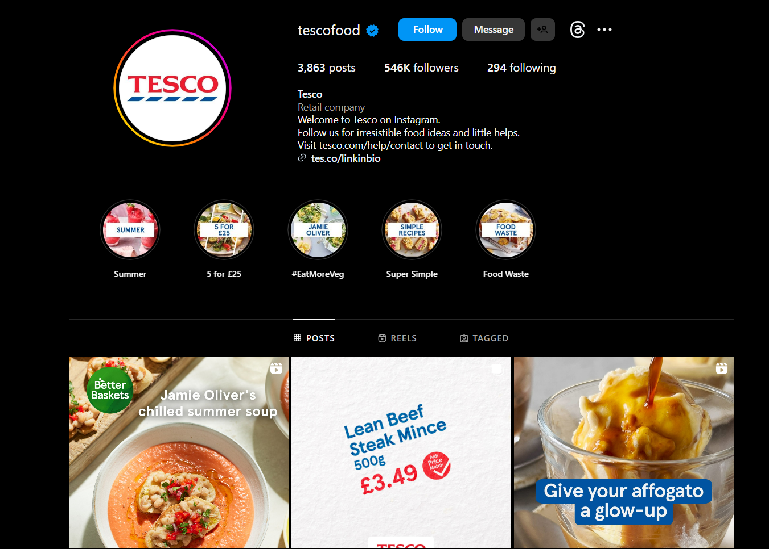
Tesco official social media account
Earned Media
Earned media refers to the organic mentions and discussions about a brand that are generated by customers, media outlets, influencers, and other third parties. Tesco's earned media in the UK market often involves customer reviews, social media posts, and news articles. Positive reviews and recommendations from satisfied customers contribute to Tesco's reputation and credibility. Additionally, Tesco's engagement with social issues, sustainability efforts, and community initiatives often lead to earned media coverage, further enhancing its brand image(Vasan and Gupta, 2021).
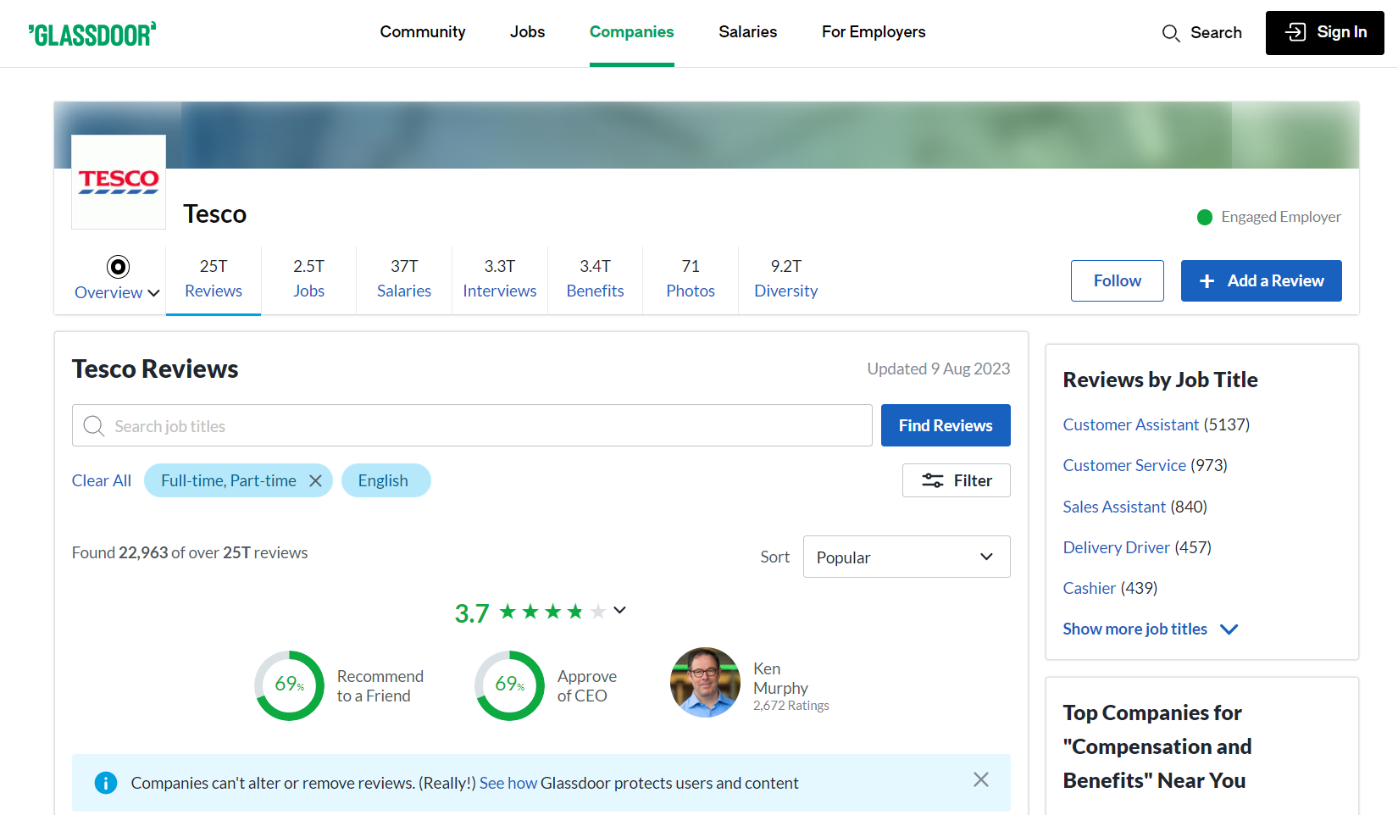
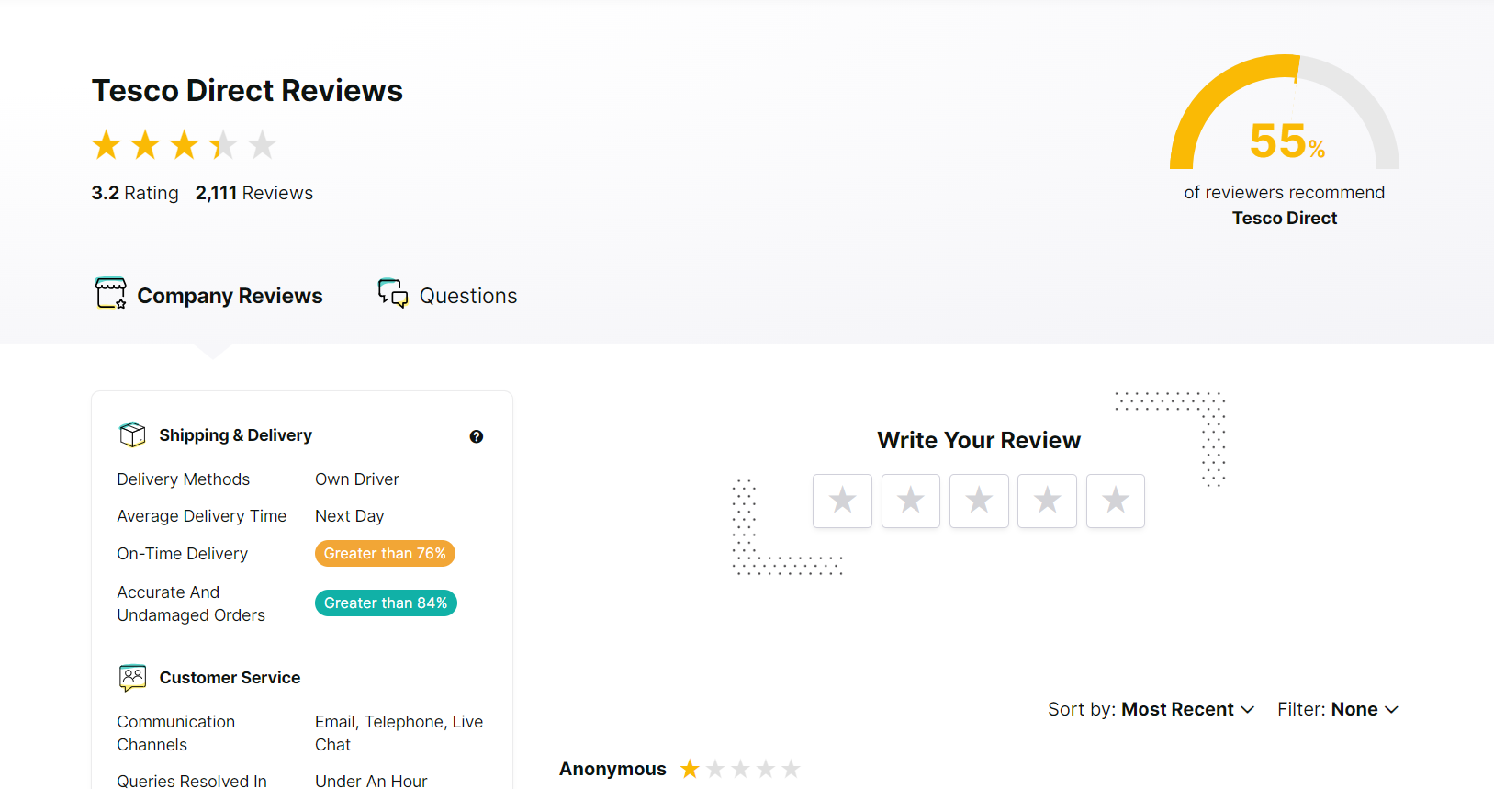
TESCO review on Popular online sites

Customer Lifecycle Management (CLM)
Customer Lifecycle Management (CLM) is a strategic approach that businesses use to effectively manage their interactions and relationships with customers throughout the entire lifecycle of their engagement with the company(Vasan and Gupta, 2021).
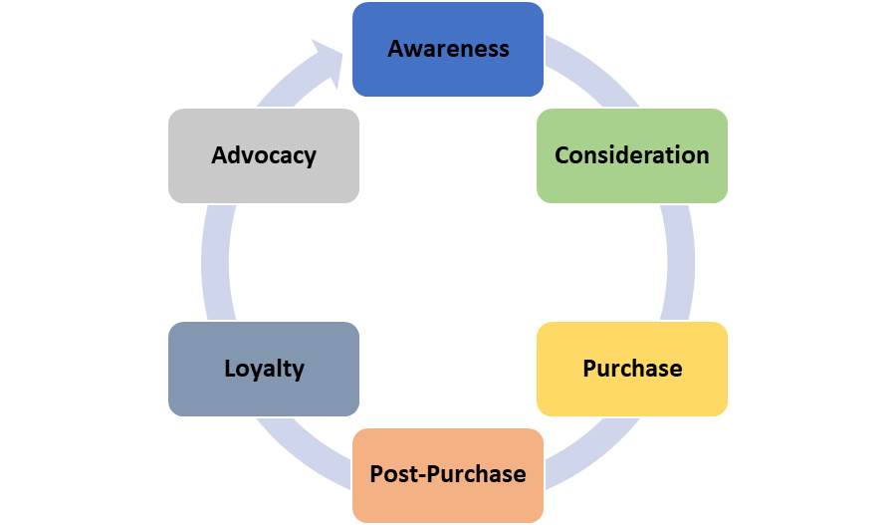
CLM source(self-made)
Awareness | Tesco employs a multifaceted approach to building awareness among potential customers. While conventional offline strategies such as in-store displays and traditional advertising remain pivotal, Tesco also harnesses the power of digital marketing. The latter includes dynamic endeavours like social media campaigns and online advertisements, which significantly amplify the visibility of the Tesco brand(MONTE Francesca, 2021).
Consideration | During the consideration stage, Tesco strategically deploys digital marketing strategies to engage and influence potential customers. Tailored social media advertisements and meticulously crafted email campaigns furnish prospective patrons with comprehensive information about products, special offers, and the convenience quotient. By doing so, Tesco adeptly guides these consumers towards making well-informed decisions(Pajni, Sharmaa and Jain, 2022).
Purchase | Both digital and offline marketing channels intricately weave together at the purchase juncture. Tesco's online platform is designed to facilitate effortless product exploration and seamless online transactions. In parallel, offline efforts are manifested through ingenious tactics such as promotions tied to loyalty cards and alluring in-store discounts. These tactics synergistically incentivize customers to proceed with purchases(Singh et al., 2021).
Post-Purchase | Tesco's post-purchase engagement strategies are predominantly executed through digital marketing channels. Post-purchase emails enriched with personalized recommendations constitute an endeavour to heighten customer satisfaction subsequent to the transaction. Meanwhile, offline facets like customer service available within the physical store premises and a hassle-free return policy collectively contribute to shaping the overall post-purchase experience(Berquier, 2019).
Loyalty | Tesco's Clubcard loyalty program assumes a pivotal role in fostering customer allegiance. This program operates by conferring personalized rewards based on individual shopping behaviour, encompassing both the online and offline domains. Tesco leverages digital mediums such as the Tesco app to dispense exclusive offers, thus further solidifying the bedrock of customer loyalty(FATRICIA, 2016).
Advocacy | Tesco seamlessly bridges the digital and offline realms when it comes to advocacy. The supermarket capitalizes on digital platforms to encourage content customers to share their favourable reviews and experiences online. Complementing these endeavours are offline strategies including community engagement events and strategic partnerships, which collectively augment the potency of positive word-of-mouth marketing(Fairlie, 2004).

RACE Framework Overview
The RACE framework, developed by Smart Insights, stands for Reach, Act, Convert, and Engage(Sestino et al., 2021). It's a comprehensive approach to digital marketing that covers the entire customer journey. Let's apply this framework to Tesco's marketing strategies.
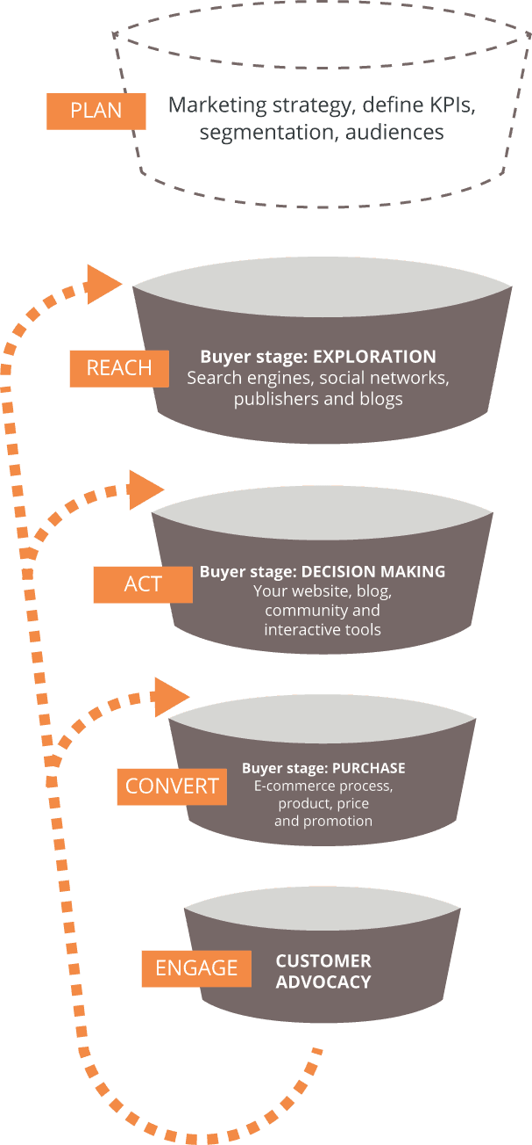
Race framework source(Rautela, 2021)
Reach | In terms of reaching their target audience, Tesco has a strong presence both online and offline. Online, they utilize various channels including their official website, social media platforms, email marketing, and even online advertising(Tian, 2021).
Act | Tesco's digital marketing strategy encourages actions from their customers. Online, they use compelling visuals and user-friendly interfaces on their website and mobile app to prompt users to browse products, add items to their carts, and engage with their offerings(Pawar, 2019).
Convert | To convert interest into sales, Tesco employs effective strategies. Online, they provide a seamless checkout process, various payment options, and personalized product recommendations based on browsing and purchase history(Heller, 2017).
Engage | Tesco places emphasis on engaging with their customers even after the sale. Through personalized email marketing and notifications on their app, they keep customers informed about special offers, new products, and loyalty rewards(Ustinova, Karpova and Turbanov, 2019).

Buyer personas
The success of any business depends heavily on providing excellent client experiences in the dynamic retail environment of today. Understanding and meeting the varied requirements and preferences of its clients is crucial for a well-known store like TESCO. In this situation, creating well-defined buyer personas is a key technique for creating customer experiences that strongly connect with different consumer categories(Dwivedi et al., 2021). TESCO can create specialised strategies that not only cater to each customer's specific needs but also promote enduring brand loyalty by learning about their lives, aspirations, and behaviours. In the parts that follow, we'll go over four thorough buyer personas, each of which represents a certain sort of consumer, and how TESCO can use these revelations to improve its customer experience strategy(Giannini, 2023).
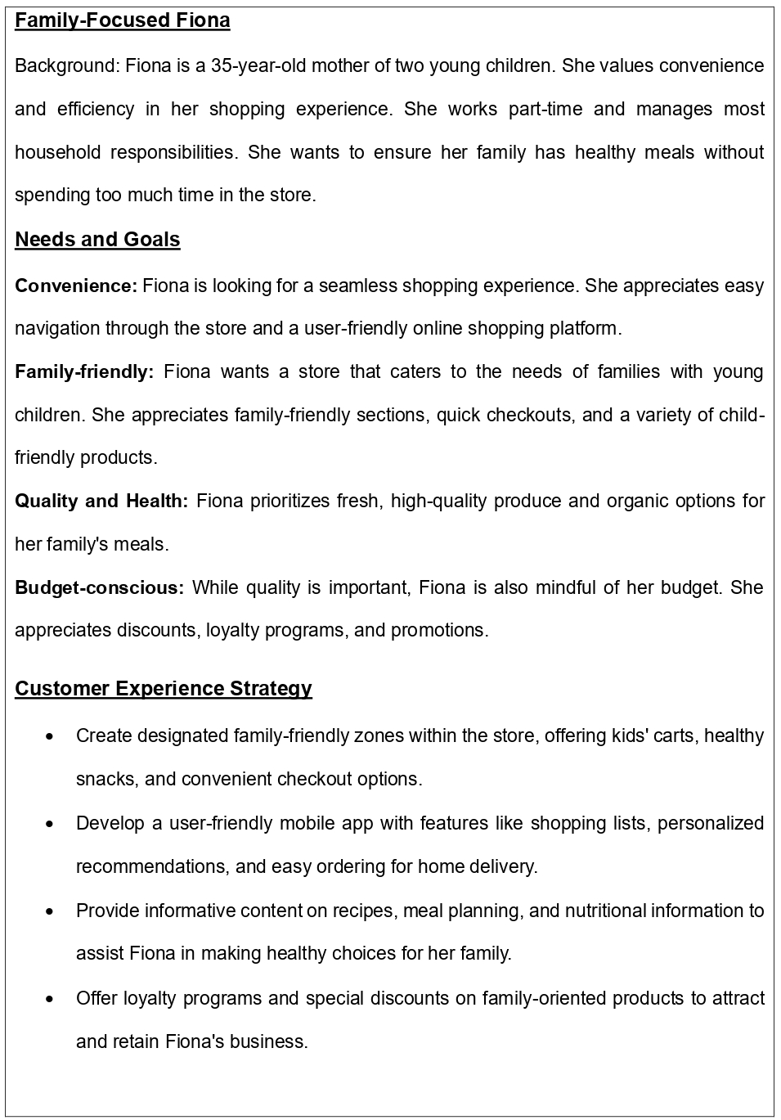
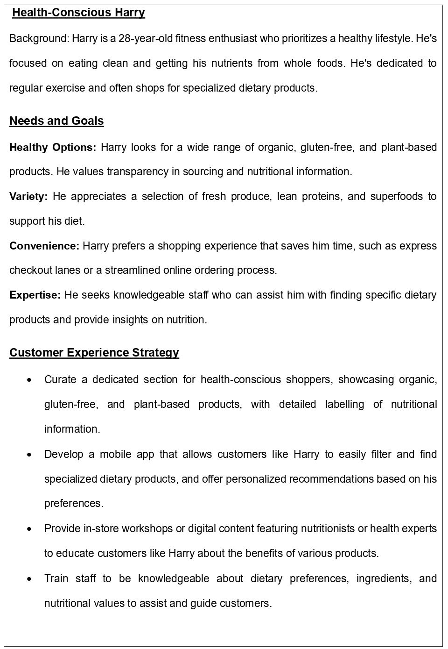
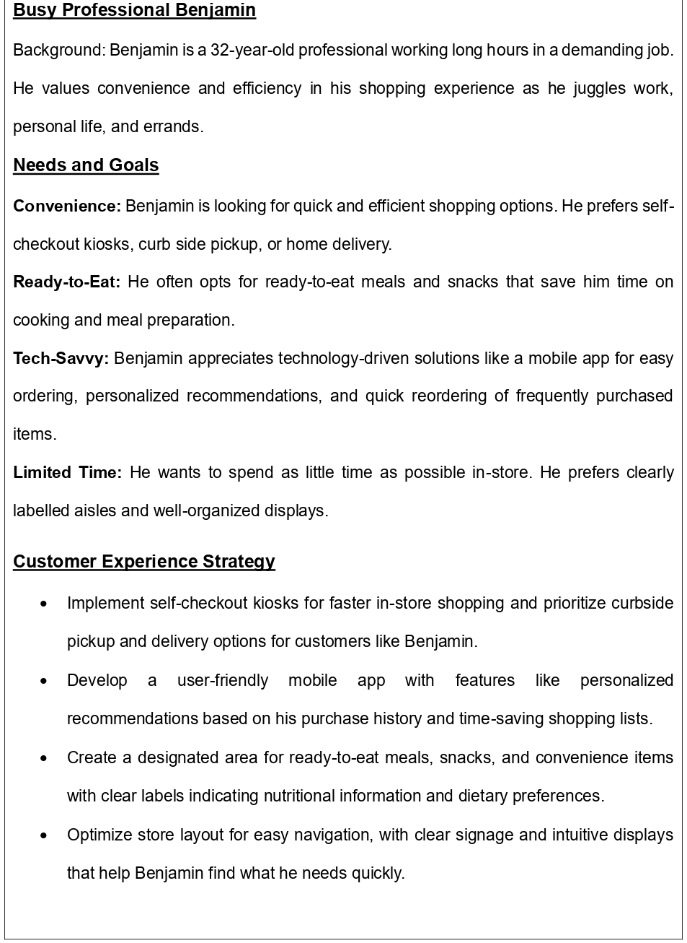

Competitor analysis
In the realm of digital marketing, Tesco faces competition from several key players in the UK retail sector. One notable competitor is Sainsbury's, which has established a robust digital presence through its user-friendly website and mobile app. Sainsbury's utilizes personalized marketing strategies, employing customer data to tailor product recommendations and promotional offers. This approach enhances customer engagement and fosters brand loyalty(Klaus, 2014).
In the UK retail market, Tesco faces several key competitors, including:
Sainsbury's: Sainsbury's is a major supermarket chain in the UK. It competes with Tesco across a range of products and services, including groceries, clothing, and financial services.
Asda: Asda is another prominent competitor, offering a wide range of products, including groceries and non-food items, at competitive prices.
Morrisons: Morrisons is a supermarket chain known for its focus on fresh food offerings. It competes with Tesco in terms of product quality and customer service.
Aldi and Lidl: These German discount retailers have gained a significant foothold in the UK market by offering low prices and a limited selection of products. They target price-conscious consumers and compete with Tesco on price and value.
Waitrose: Positioned as a higher-end supermarket, Waitrose competes with Tesco in the premium segment, offering quality and specialty products.
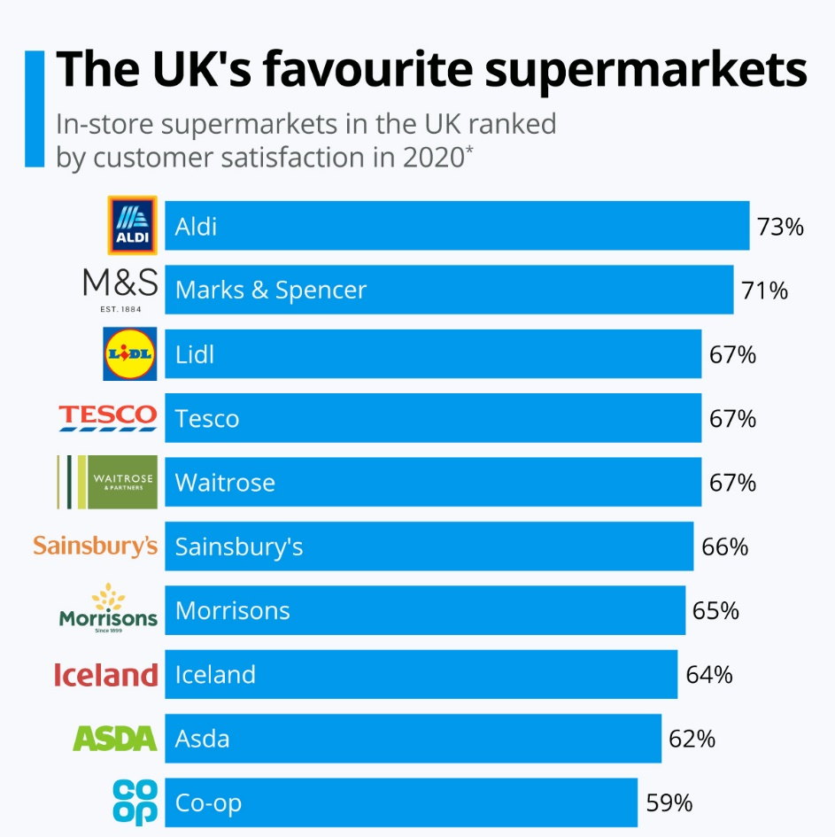
Source(Statista, 2022)

New Strategies
I discovered the issue with the company's digital marketing during my analysis of TESCO from customer reviews, and I came up with some solutions to enhance the user experience and address their issues.
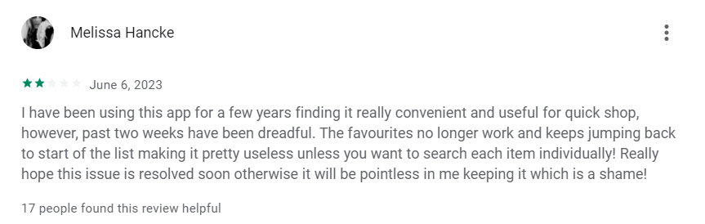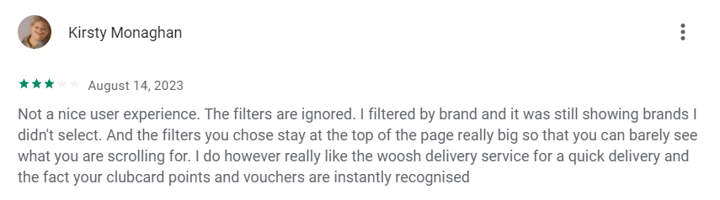
Source (google-play store)
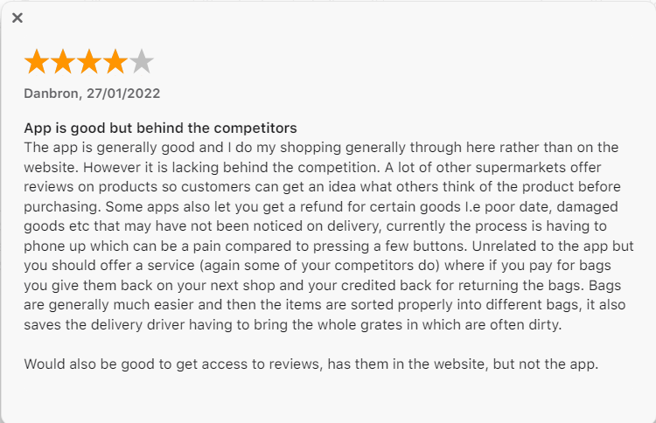
Source (Appstore)
In response to the evolving landscape of digital marketing and consumer preferences, TESCO is poised to implement a cutting-edge digital marketing strategy. This strategy leverages AI-powered algorithms to create a highly personalized shopping experience for its customers.
AI Algorithm Integration:
The heart of this strategy lies in the integration of AI algorithms. These algorithms will meticulously analyse a user's purchase history, browsing behaviour, and the information stored in their profile. For instance, if a customer consistently opts for organic produce, the AI will intelligently prioritize showcasing new organic arrivals and related products. By adapting to customer preferences, TESCO will amplify its ability to satisfy unique consumer needs(Giannini, 2023).
AI-Powered Virtual Assistant:
The integration of an AI-powered virtual assistant stands as a pivotal component of this strategy. Designed to facilitate real-time engagement, the virtual assistant will engage users in dynamic conversations. Whether aiding in product discovery, suggesting recipes that match their preferences, or guiding them through the shopping journey, this assistant will elevate the shopping experience to new heights of convenience and assistance(Deveau, Griffin and Reis, 2023).

SMART Objectives
Specific Objective: | Implement AI algorithms to analyse customer purchase history, browsing behaviour, and profile information to enhance personalized product recommendations.
Measurable Objective: | Achieve a 15% increase in customer engagement with AI-generated product recommendations within the first six months of implementation.
Achievable Objective: | Develop and integrate AI algorithms that can accurately analyse and interpret customer data, enabling the system to provide relevant and timely product suggestions.
Relevant Objective: | Align AI-generated recommendations with TESCO's commitment to customer satisfaction and providing tailored shopping experiences that cater to individual preferences.
Time-Bound Objective: | Complete the integration of AI algorithms and commence personalized product recommendations within three months. Monitor and analyse customer engagement for the subsequent six months to assess the impact on sales and customer satisfaction.

Specific | Launch an AI-powered virtual assistant capable of engaging users in dynamic conversations and aiding in various aspects of their shopping journey.
Measurable | Achieve a 20% reduction in customer support inquiries related to product discovery and shopping assistance through successful utilization of the AI-powered virtual assistant within the first year of deployment.
Achievable | Develop and train the virtual assistant to effectively understand user queries, provide accurate responses, and adapt to user preferences during interactions.
Relevant | Enhance customer experience by offering real-time, AI-driven assistance that aligns with TESCO's dedication to convenience and support.
Time-Bound | Complete the development and testing of the AI-powered virtual assistant within six months and launch it on TESCO's digital platforms. Continuously monitor its performance and customer feedback over the following year to ensure its effectiveness in improving the shopping experience.

TOWS Matrix
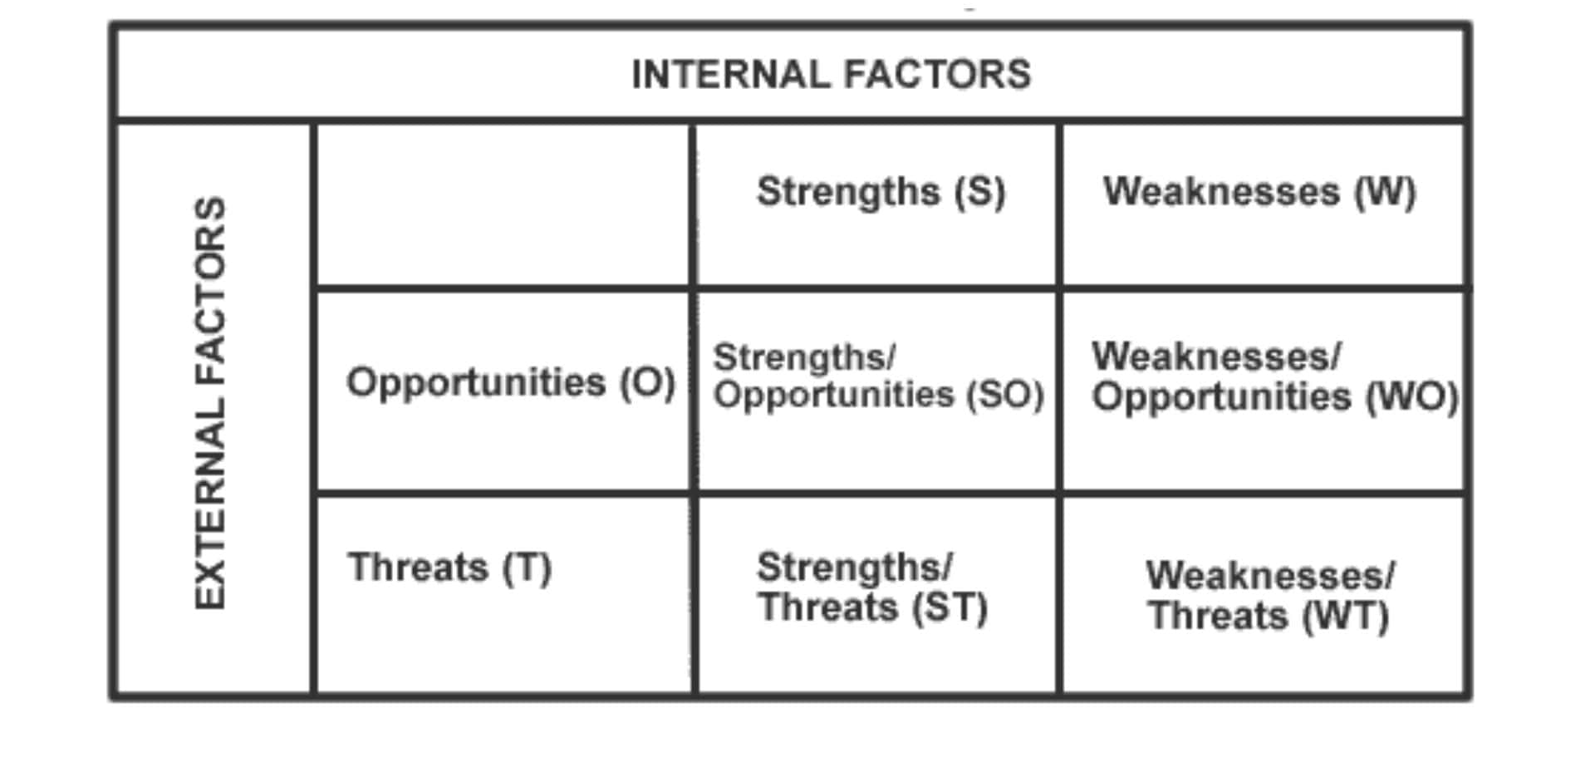
TOWS matrix source(self-made)
1. Strengths
- Strong brand reputation and customer base.
- Access to vast amounts of customer data.
- Financial resources to invest in AI technology.
- Established physical store network.
2. Weaknesses
- Potential resistance to change from traditional methods.
- Need for proper data privacy measures to handle customer data.
- Employee training and adaptation to new technology.
3. Opportunities
- Growing trend towards personalized shopping experiences.
- Increasing consumer reliance on digital channels for shopping.
- Potential for differentiation through advanced AI technology.
4. Threats
- Intense competition in the retail and e-commerce sectors.
- Data security and privacy concerns.
- Rapidly evolving technology landscape.
5. Strategy Formulation
SO Strategies (Strengths-Opportunities)
- Develop an AI-powered recommendation engine that provides personalized product suggestions based on customer data.
- Capitalize on the trend of personalized shopping by prominently marketing the AI-driven shopping experience.
- Leverage the existing physical store network to offer seamless integration between online and offline shopping experiences.
WO Strategies (Weaknesses-Opportunities)
- Invest in comprehensive employee training programs to ensure a smooth transition to the new AI-driven strategy.
- Strengthen data privacy measures and communicate them transparently to build customer trust.
- Collaborate with technology partners to develop innovative solutions that align with customer preferences.
ST Strategies (Strengths-Threats)
- Utilize the strong brand reputation and customer base to position TESCO as a leader in AI-powered shopping experiences.
- Establish partnerships with cybersecurity firms to enhance data security and alleviate customer concerns.
- Differentiate from competitors by showcasing the advanced AI technology through marketing campaigns.
WT Strategies (Weaknesses-Threats):
- Mitigate resistance to change by gradually introducing AI features while maintaining traditional shopping methods.
- Monitor and adapt to the evolving technology landscape to remain at the forefront of innovation.
- Collaborate with industry associations to collectively address data security and privacy challenges.
6. Strategic Framework:
Vision: To redefine the shopping experience by seamlessly integrating AI technology with customer preferences, ensuring convenience and personalization.
Mission: To provide customers with a dynamic and personalized shopping journey through the integration of AI algorithms and an AI-powered virtual assistant, while prioritizing data security and privacy.

Strategy
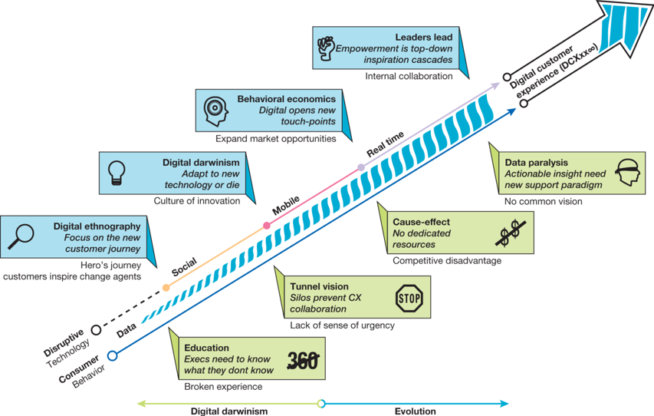
Source (Cource material Week 4, 2023)
Recognize and Embrace Digital Evolution:
- Acknowledge the dynamic nature of the retail industry and the transformative power of digital technologies.
- Embrace change as a constant factor and understand the consequences of failing to adapt.
- Continuously monitor industry trends, consumer behaviours, and emerging technologies to remain at the forefront of digital evolution.
Source:(Deveau, Griffin and Reis, 2023)
Education and Learning from Broken Experiences:
- Foster a culture of experimentation and risk-taking within the organization.
- View failures as valuable learning opportunities and extract insights for improvement.
- Encourage teams to iterate on digital initiatives based on lessons learned from setbacks.
Source(Pawar, 2019)
Avoid Tunnel Vision and Sense of Urgency:
- Continuously assess the competitive landscape and consumer preferences.
- Guard against becoming internally focused by maintaining a forward-looking perspective.
- Cultivate a sense of urgency to respond swiftly to market shifts and capitalize on emerging opportunities.
Source(Basimakopoulou, Theologou and Tzavaras, 2022)
Cause-Effect Analysis for Competitive Advantage:
- Implement a cause-and-effect approach to evaluate the impact of digital initiatives.
- Define key performance indicators (KPIs) aligned with business objectives.
- Measure the effects of AI-driven personalization and virtual assistant integration on customer engagement, sales, and loyalty.
Source(Ustinova, Karpova and Turbanov, 2019)
Overcoming Data Paralysis with Common Vision:
- Gather and analyse data from various sources while avoiding data paralysis.
- Establish a shared vision and strategic goals for the digital strategy across departments.
- Ensure data is actionable and aligned with specific business objectives, fostering collaboration and informed decision-making.
Source(Haleem et al., 2022)
Leveraging Digital Ethnography and Behavioural Economics:
- Utilize digital ethnography to gain deep insights into customer behaviours and preferences.
- Understand customer decision-making processes and pain points to inform user experience design.
- Apply principles of behavioural economics to design online experiences that drive desired customer actions.
Source(Amesho et al., 2021)
Addressing Digital Darwinism through Leadership:
- Empower leaders to lead the digital transformation journey at all levels of the organization.
- Foster a culture of innovation, adaptability, and continuous learning among leadership.
- Provide resources for ongoing digital education and skill development to equip leaders for navigating the evolving digital landscape.
Source(Kreutzer and Land, 2015)

Tactics and tools for implement new changes
In the pursuit of implementing a cutting-edge digital marketing strategy, TESCO recognizes the significance of employing a diverse range of tactics and tools to effectively engage its customer base and provide a highly personalized shopping experience(Kraus et al., 2021). These tactics and tools encompass various facets of digital communication, including Search Engine Optimization (SEO), Search Engine Marketing (SEM), Display Advertising, Email Marketing, and Social Media Marketing. In addition, TESCO is committed to incorporating AI-powered algorithms to enhance its strategies and create a seamless and tailored journey for its customers.
Search Engine Optimization
TESCO's digital marketing strategy begins with a comprehensive SEO approach. Through meticulous keyword research, content optimization, and on-page enhancements, TESCO aims to secure higher rankings on search engine results pages (SERPs). By aligning its website content with relevant customer queries, TESCO can attract organic traffic and enhance its online visibility. This approach involves creating valuable and informative content that addresses customer needs, incorporating strategic keywords, optimizing meta tags, and improving site architecture to ensure an optimal user experience(Spais, 2010)
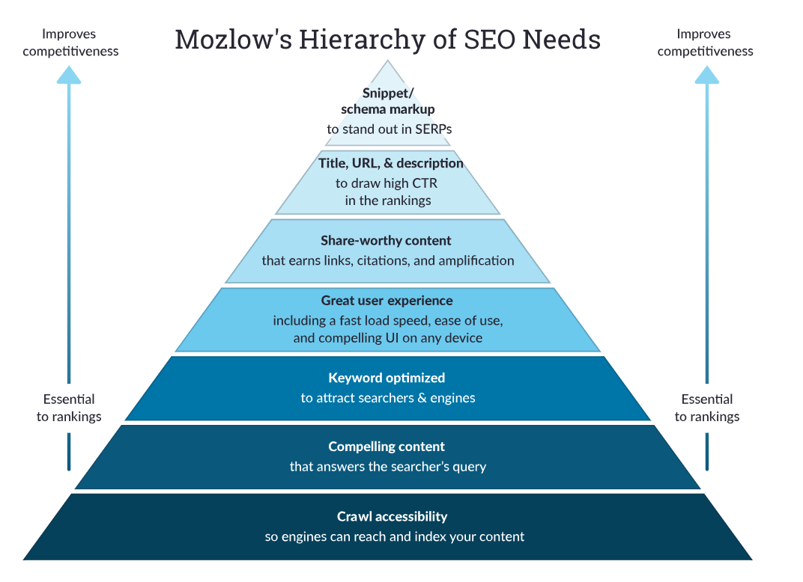
Mozlow’s Hierarchy source(Hoo et al., 2023)
Search Engine Marketing
TESCO understands the value of immediate visibility on search engines. Through SEM, TESCO can employ paid search advertising to display its products and services prominently on search engine results. By strategically bidding on keywords related to its offerings, TESCO can target specific audience segments and capture their attention when they are actively searching for relevant products. This tactic ensures immediate visibility, drives traffic to the website, and maximizes conversions(Kushwaha, 2020).
Display Advertising
Incorporating display advertising allows TESCO to extend its reach beyond search engines and target potential customers across a vast network of websites and platforms. Through visually appealing and targeted banner ads, TESCO can reinforce its brand presence and engage users on websites that align with its offerings. Utilizing data-driven insights, TESCO select the most relevant websites and demographics to display its ads, ensuring a high probability of capturing the attention of potential customers(Choi et al., 2019).
Email Marketing
Email marketing remains a powerful tool for engaging existing customers and fostering brand loyalty. TESCO can leverage its customer database to deliver personalized and relevant content directly to users' inboxes. This content could include personalized product recommendations based on past purchases, exclusive offers, and informative content that adds value to the customer's shopping experience. By segmenting the email list and tailoring content to each segment, TESCO can enhance customer engagement and drive repeat purchases(Venugopal, 2012).
Social Media Marketing
TESCO recognizes the immense potential of social media platforms in reaching a broad audience and building brand awareness. Through engaging content, visual storytelling, and interactive posts, TESCO can connect with its customers on platforms such as Facebook, Instagram, Twitter, and LinkedIn. By utilizing AI algorithms, TESCO can analyse user behaviour and preferences to deliver highly targeted ads and content that resonate with individual users. This approach not only strengthens brand loyalty but also encourages user-generated content and organic sharing, amplifying TESCO's online presence(Jamil et al., 2022).
Integration of AI-Powered Algorithms:
TESCO's cutting-edge digital marketing strategy sets itself apart by incorporating AI-powered algorithms to create a hyper-personalized shopping experience. By analysing customer behaviour, purchase history, preferences, and browsing patterns, these algorithms can predict and recommend products that align with everyone’s interests.

METRICS AND KPI
Organic Search Metrics
- Organic Traffic: Measure the number of visitors coming to the website through organic search results.
- Keyword Rankings: Track the ranking positions of targeted keywords on search engine results pages (SERPs).
- Organic Click-Through Rate (CTR): Monitor the percentage of clicks the website receives out of the total impressions in search results.
- Bounce Rate: Assess the percentage of visitors who navigate away from the site after viewing only one page, indicating the relevance and engagement of the content.
- Conversion Rate: Measure the percentage of organic visitors who complete a desired action, such as making a purchase or signing up.
Source(Ghose and Yang, 2008)
Paid Search Metrics
- Click-Through Rate (CTR): Monitor the percentage of clicks an ad receives out of the total impressions.
- Conversion Rate: Measure the percentage of users who take the desired action after clicking on the ad.
- Cost Per Click (CPC): Track the cost incurred for each click on a paid advertisement.
- Return on Ad Spend (ROAS): Calculate the revenue generated from ads compared to the cost of running the ads.
- Quality Score: Assess the relevance and quality of keywords, ad copy, and landing pages, which impacts ad positioning and cost.
Source(Yang et al., 2020)
Display Advertising Metrics
- Click-Through Rate (CTR): Monitor the percentage of users who click on display ads out of the total impressions.
- Conversion Rate: Measure the percentage of users who take the desired action after interacting with a display ad.
- Viewability: Evaluate how often display ads are viewable to users.
- Cost Per Mille (CPM): Calculate the cost per one thousand ad impressions.
- Return on Investment (ROI): Measure the revenue generated from display advertising compared to the cost.
Source(Filiopoulou, Rigou and Faliagka, 2019)
Email Marketing Metrics
- Open Rate: Monitor the percentage of recipients who open the marketing emails.
- Click-Through Rate (CTR): Measure the percentage of recipients who click on links within the email.
- Conversion Rate: Evaluate the percentage of recipients who complete the desired action after clicking.
- Unsubscribe Rate: Track the percentage of recipients who opt out of future emails.
- Revenue per Email: Calculate the revenue generated from email campaigns.
Source(SABBAGH, 2021)
Social Media Metrics
- Engagement Rate: Measure the interaction (likes, comments, shares) per post relative to the number of followers.
- Click-Through Rate (CTR): Evaluate the percentage of users who click on a link or call-to-action within social media posts.
- Follower Growth Rate: Track the rate of increase in social media followers.
- Social Share of Voice: Monitor the brand's share of the overall social media conversation in its industry.
- Social Return on Investment (SROI): Measure the revenue generated from social media efforts compared to the cost.
Source(S.K., 2019)
AI-Powered Algorithms Metrics
- Personalization Effectiveness: Measure the percentage of recommended products that result in conversions.
- Conversion Uplift: Calculate the increase in conversion rates attributed to AI-powered recommendations.
- Customer Satisfaction: Collect feedback and ratings from customers on the personalized shopping experience.
- Average Order Value: Measure whether AI recommendations lead to higher spending per order.
- Repeat Purchase Rate: Track how often customers return for more purchases due to personalized recommendations.
- By regularly analysing these metrics and KPIs, TESCO can assess the performance of its digital marketing strategy and make data-driven decisions to continuously enhance the personalized shopping experience for its customers.
Source(Ochella and Shafiee, 2021)
Estimate
the potential costs involved in implementing a cutting-edge digital marketing strategy like the one you described for TESCO.
Technology and AI Infrastructure: This can range from tens of thousands to several hundred thousand dollars, depending on the complexity and scale of the AI infrastructure. Licensing fees, hardware costs, cloud computing expenses, and data storage can contribute to this budget(Giannini, 2023).
Data Collection and Analysis: Data collection tools, storage, and analysis platforms might range from a few thousand to tens of thousands of dollars, and even more if sophisticated data analytics tools are employed(Whitepaper, 2019).
AI Development and Integration: Hiring AI specialists, data scientists, and developers could cost anywhere from $80,000 to $150,000+ per year for each expert, and development costs for AI algorithms can vary greatly. The total cost might be in the hundreds of thousands to millions of dollars(Deveau, Griffin and Reis, 2023).
Content Creation and Management: Content creation costs can vary widely based on the type and volume of content required. It's conceivable that this could range from tens of thousands to hundreds of thousands of dollars annually.
Digital Advertising: Advertising budgets can be substantial. A mid-range estimate might be anywhere from $50,000 to $200,000 per month or more, depending on the platforms, target audience, and campaign scale(SABBAGH, 2021).
Staff Training and Education: Training costs depend on the number of employees and the training methods used. It could range from a few thousand to tens of thousands of dollars.
Testing and Optimization: Ongoing testing and optimization costs can be around 10-20% of the initial development costs per year, depending on the complexity of the AI algorithms and the pace of changes required.

Security and Privacy Measures: Security investments can vary widely. Budgeting a few tens of thousands of dollars for cybersecurity measures, audits, and legal consultations would be a reasonable estimate.
Change Management: Implementing a new strategy organization-wide involves change management efforts to ensure a smooth transition and adoption. This could involve additional costs for training, communication, and employee engagement.
Considering the various components mentioned earlier, here's a rough breakdown of potential costs and their ranges:
Technology and AI Infrastructure: $100,000 - $500,000+
Data Collection and Analysis: $10,000 - $100,000+
AI Development and Integration: $500,000 - $2,000,000+
Content Creation and Management: $50,000 - $200,000+
Digital Advertising: $600,000 - $2,400,000+ (annually)
Staff Training and Education: $10,000 - $50,000+
Testing and Optimization: 10-20% of initial development costs annually
Security and Privacy Measures: $20,000 - $100,000+
Change Management: $50,000 - $200,000+
Adding these ranges together gives you a rough estimate of the total implementation cost, which can be anywhere from $1.3 million to $5.5 million or more for the first year. Remember that some costs, like AI development and infrastructure setup, may be higher initially but decrease in subsequent years, while costs like digital advertising and ongoing optimization are recurring expenses.

Conclusion
In conclusion, the process of formulating a robust digital marketing strategy is not merely a journey but a strategic voyage that requires a deep understanding of the company's core values, the intricacies of its industry, and the nuances of its target market. The case study of Tesco's cutting-edge digital marketing strategy demonstrates the transformative potential of embracing advanced technologies, particularly AI-powered algorithms, to curate personalized shopping experiences that resonate with customers on a profound level. As technology continues to advance and consumer behaviours evolve, businesses must recognize that the foundation of a successful digital marketing strategy remains rooted in a firm grasp of their present context, a profound insight into their audience's needs, and a keen awareness of the competitive landscape. By weaving together these crucial elements, a data-informed, agile digital marketing strategy can chart a course towards growth, customer loyalty, and market leadership in the dynamic digital realm.

References
Amankwah-Amoah, J. and Osabutey, E. L. C. (2020) ‘New challenges and opportunities in the global marketplace: learning from developed-country multinationals’ failures’, International Studies of Management and Organization, 50(1), pp. 43–56. doi: 10.1080/00208825.2019.1703377.
Amesho, K. T. T. et al. (2021) ‘Managing competitive advantage through technology and innovation systems and its impacts on service delivery within the Kaohsiung City Government in Taiwan’, SA Journal of Information Management, 23(1), pp. 1–12. doi: 10.4102/sajim.v23i1.1348.
Awadari, A. C. and Kanwal, S. (2019) ‘Employee participation in organizational change: A case of Tesco PLC’, International Journal of Financial, Accounting, and Management, 1(2), pp. 91–99. doi: 10.35912/ijfam.v1i2.93.
Basimakopoulou, M., Theologou, K. and Tzavaras, P. (2022) ‘A Literature Review on Digital Marketing: The Evolution of a Revolution’, Journal of Social Media Marketing, 1(1), pp. 30–40. doi: 10.33422/jsmm.v1i1.901.
Berquier, R. (2019) ‘Accounting, Performance Measurement and Fairness in UK Fresh Produce Supply Networks’, Social and Environmental Accountability Journal, 39(3), pp. 204–205. doi: 10.1080/0969160X.2019.1670376.
Choi, H. et al. (2019) ‘Online Display Advertising Markets: A Literature Review and Future Directions’, SSRN Electronic Journal. doi: 10.2139/ssrn.3070706.
Cource material Week 4 (2023) ‘Cource material Week 4’.
Deveau, R., Griffin, S. J. and Reis, S. (2023) ‘AI-powered marketing and sales reach new heights with generative AI’, (May).
Dwivedi, Y. K. et al. (2021) ‘Setting the future of digital and social media marketing research: Perspectives and research propositions’, International Journal of Information Management. Elsevier Ltd, 59(June 2020), p. 102168. doi: 10.1016/j.ijinfomgt.2020.102168.
Fairlie, R. (2004) ‘Tesco.com: Defining the online shopping experience for the UK consumer’, Interactive Marketing, 5(4), pp. 373–377. doi: 10.1057/palgrave.im.4340256.
Farndale, E. et al. (2011) ‘Final Report A study of the link between Performance Management and Employee Engagement in Western multinational corporations operating across India and China’, Cass Business School, pp. 1–37.
FATRICIA, R. S. (2016) ‘Strategic Management of TESCO supermarket’:, Ivory Research, p. one. Available at: http://www.ivoryresearch.com/samples/economics-essay-example-strategic-management-of-tesco-supermarket-pestle-analysis-porter-5-forces-analysis-critical-success-factors-swot-analysis-value-chain-analysis-tesco-strategic-options-core-comp/.
Filiopoulou, D., Rigou, M. and Faliagka, E. (2019) ‘Display Ads Effectiveness’, in Advances in E-Business Research Series, pp. 205–230. doi: 10.4018/978-1-5225-7262-6.ch012.
Ghose, A. and Yang, S. (2008) ‘Comparing performance metrics in organic search with sponsored search advertising’, Proceedings of the 2nd International Workshop on Data Mining and Audience Intelligence for Advertising, ADKDD’08, (September 2007), pp. 18–26. doi: 10.1145/1517472.1517475.
Giannini, S. (2023) ‘Generative AI and the future of education’.
Haleem, A. et al. (2022) ‘Artificial intelligence (AI) applications for marketing: A literature-based study’, International Journal of Intelligent Networks, 3, pp. 119–132. doi: https://doi.org/10.1016/j.ijin.2022.08.005.
Heller, F. K. (2017) ‘Technological Innovation Applied to Walmart and Tesco’s Supply Chain’, pp. 1–14.
Hoo, W. et al. (2023) ‘Impact of Search Engine Optimization Dimensions on SME Companies using Online Promotion in Malaysia’, WSEAS TRANSACTIONS ON BUSINESS AND ECONOMICS, 20, pp. 998–1007. doi: 10.37394/23207.2023.20.92.
Jamil, K. et al. (2022) ‘Role of Social Media Marketing Activities in Influencing Customer Intentions: A Perspective of a New Emerging Era’, Frontiers in Psychology, 12(January), pp. 1–12. doi: 10.3389/fpsyg.2021.808525.
Kar, S., Bansal, R. and Mishra, D. (2021) ‘Tesco: Entry and Expansion Strategy in India’, Emerging Economies Cases Journal, 3, p. 251660422110384. doi: 10.1177/25166042211038465.
Khirbat, S. and Ramanjaneyulu, R. (2018) ‘Analysis Of Trends, Challenges And Best Practices In Contemporary Retailing:A Case Of TESCO Group’, International Journal of Business and Management Invention (IJBMI) ISSN, 7(12), pp. 9–14. Available at: www.ijbmi.org.
Klaus, P. (2014) ‘Towards practical relevance-Delivering superior firm performance through digital customer experience strategies’, Journal of Direct, Data and Digital Marketing Practice, 15(4), pp. 306–316. doi: 10.1057/dddmp.2014.20.
Kraus, S. et al. (2021) ‘Digital Transformation: An Overview of the Current State of the Art of Research’, SAGE Open, 11(3). doi: 10.1177/21582440211047576.
Kreutzer, R. and Land, K.-H. (2015) Digital Darwinism: Branding and Business Models in Jeopardy. doi: 10.1007/978-3-642-54401-9.
Kushwaha, B. P. (2020) ‘Search Engine Marketing a New Way of Marketing in Digital Age’, PalArch’s Journal of Archaeology of Egypt/ Egyptology, 17(6), pp. 2053–2065. Available at: https://archives.palarch.nl/index.php/jae/article/download/1097/1147.
Marketline (2017) ‘Millennial Consumers: Understanding key trends driving consumer behaviors’, (October), p. 1. Available at: http://advantage.marketline.com.libproxy.wlu.ca/Product?ptype=Theme+Reports&pid=ML00026-017.
MONTE Francesca (2021) ‘A study of Value Chain Reconfiguration processes under Covid-19 pressures: the case of Tesco PLC in the United Kingdom’, (261361), pp. 2–70.
Ochella, S. and Shafiee, M. (2021) ‘Performance Metrics for Artificial Intelligence (AI) Algorithms Adopted in Prognostics and Health Management (PHM) of Mechanical Systems’, Journal of Physics: Conference Series, 1828, p. 12005. doi: 10.1088/1742-6596/1828/1/012005.
Pajni, N. S., Sharmaa, A. and Jain, R. (2022) ‘Risk Identification Techniques In Retail Industry: A Case Study Of Tesco Plc’, Journal of Corporate Governance, Insurance, and Risk Management, 9(1), pp. 201–214. doi: 10.51410/jcgirm.9.1.13.
Palmer, M. (2005) ‘Retail Multinational Learning: A Case Study of Tesco’, International Journal of Retail & Distribution Management, 33. doi: 10.1108/09590550510577110.
Pawar, A. A. (2019) ‘The Evolution of Digital Marketing: Past Present and Future’, International Journal of Science Technology and Management, 08(09), pp. 29–33.
Rautela, S. (2021) ‘Social Media for New Product Launch: A Study of Social Media Platforms Across the RACE Planning Framework’, International Journal of Interactive Mobile Technologies, 15(5), pp. 187–204. doi: 10.3991/ijim.v15i05.18147.
Rosengren, M. I. (2019) ‘Paid, owned and earned media’, 13(3), pp. 1–3.
Ryu, J. S. and Simpson, J. J. (2011) ‘Retail internationalization: lessons from “Big Three” Global Retailers’ failure cases’, Journal of Business and Retail Management Research, 6(1), pp. 1–11.
S.K., S. (2019) ‘Social Media Metrics’, in, pp. 131–149. doi: 10.4018/978-1-5225-0846-5.ch007.
SABBAGH, F. (2021) ‘Email Marketing: The most Important Advantages and Disadvantages’, Journal of Economics and Technology Research, 2, p. p14. doi: 10.22158/jetr.v2n3p14.
Sestino, A. et al. (2021) ‘The future of online marketing strategies and digital tools: new challenges and contributions to RACE framework’, International Journal of Trade and Global Markets, 1, p. 1. doi: 10.1504/IJETRADE.2021.10042594.
Sharif, A. (2014) ‘The Impact of Relationship Marketing On Customer Loyalty At Tesco Plc , UK’, European Journal of Business and Management, 6(3), pp. 21–55.
Singh, P. et al. (2021) ‘Service Quality Dimension and Customers’ Satisfaction: An Empirical Study of Tesco Hypermarket in Malaysia’, International Journal of Applied Business and International Management, 6(3), pp. 102–114. doi: 10.32535/ijabim.v6i3.1333.
Spais, G. S. (2010) ‘Search Engine Optimization (SEO) as a dynamic online promotion technique: The implications of activity theory for promotion managers’, Innovative Marketing, 6(1), pp. 7–24.
Statista (2021) e.
Statista (2022) No Title.
TESCO (2022) ‘TESCO - Annual Report 2022’, Annual Report 2022, p. 176.
Tian, Q. (2021) ‘Analysis on the Business Strategy of Tesco in the Chinese Market’, Modern Economics & Management Forum, 2(1), pp. 33–36. doi: 10.32629/memf.v2i1.280.
Ustinova, O., Karpova, S. and Turbanov, K. (2019) ‘Evolution of technologies in marketing: leading trends’, 359(Icsbal), pp. 113–122. doi: 10.2991/icsbal-19.2019.21.
Vasan, S. and Gupta, N. (2021) ‘Paid-owned-and-earned-media-poem-in-marketing’, Business Studies Journal, 13, pp. 1–3.
Venugopal, P. K. (2012) ‘Issn : 2278-6236 Email Marketing : a Paradigm Shift To Marketing’, International Journal of Advanced Research in Management and Social Sciences, 1(1), pp. 101–116.
Whitepaper, E. Y. (2019) ‘Customer lifecycle in the digital age EY and Pegasystems’, (September).
Yang, Z. et al. (2020) ‘Effects of paid search advertising on product sales: a Chinese semantic perspective’, Journal of Marketing Management. Routledge, 36(15–16), pp. 1481–1504. doi: 10.1080/0267257X.2020.1765001.

