Zara-Marketing Plan



May 2020

Module Name：Marketing Planning&Practice
Module code:M6X00884
Student Name:Yanan zheng
Student number：1900319
Executive summary
In the recent few years, the trend of fast clothes has increased immensely because of the need of the time. People always want to wear new clothes and post pictures on social media sites. The demand is now managed through the trends on social media whatever is trending on social media is high in demand. Zara took advantage of it and started a clothing brand that bought assistance to people and getting trendy clothes as soon as a design got popular.

Contents
Executive summary 1
1.0 Introduction 3
2.0 ZARA’s external environment analysis 3
Timely leadership 3
Globalization of Brand 4
Differentiation 4
Cost leadership 4
2.1 Internal Environment Analysis of Zara 4
2.2 SOSTAC ANALYSIS 5
2.3 SWOT Analysis 5
2.3.1 Strengths 5
2.3.2 Weaknesses 6
2.3.3 Opportunities 6
2.3.4 Threats 6
3.0 Marketing Plan for Zara 7
3.1 Target Market 7
3.2 Unique Selling Position 8
3.3 Marketing Mix 8
3.3.1 Product Design Strategy 8
3.3.2 Pricing and Positioning Strategy 8
3.3.3 Promotions Strategy 9
3.3.4 Distribution Plan 10
3.4 Objectives of the Plan 11
3.5 Implementing McKinsey’s framework 11
3.6 Competitive review 12
3.7 Budgeting 14
3.8 Implementation and limitation of the plan 14
4.0 Conclusion 15
5.0 References 16

1.0 Introduction
Zara is one of the biggest retail stores for fashion clothes. It originated in Spain and has now spread its branches all over the world (Christopher, 2016). Their speciality is fast fashion, and they come up with almost twenty collections a year. They have cut down their supply chain time, what takes other companies six months to manufacture and transfer Zara does it in just three months, half the time that other takes and this has given them a competitive advantage over the other fashion brands (Ghemawat, 2013). After manufacturing, the clothes are inspected and sent to warehouses and then delivered to the retail stores. Sometimes the delivery is done in as fast as 48 hours. This is an exceptional time, and it is the basic need of today's fashion stores if they want to stay in the market. Zara produces over four hundred and fifty million times per year (Ferdows, 2015). For this report, being appointed as a marketing manager of Zara, this report will propose the Marketing plan for Zara which will help the brand to improve and also, an environmental analysis will be conducted which will help in the implementation of the proposed marketing plan.

2.0 ZARA’s external environment analysis
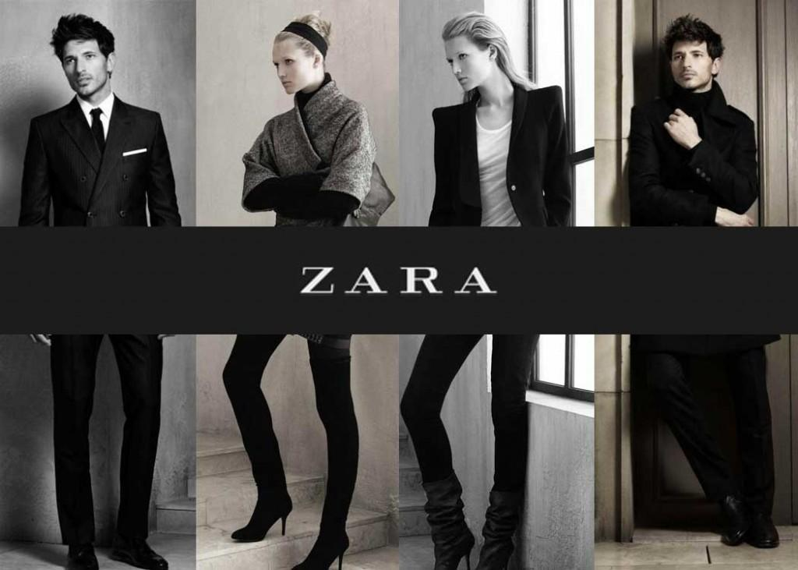
Timely leadership: The collection of materials is completed in maximum three weeks; this makes Zara’s products to come much sooner on the market with new collections than the traditional average retailer which needs around 9 months to present a replacement collection on the market.
Globalization of Brand: The brand has gained recognition all over the world due to the new designs and different quality standards. Their products are of high quality and have a demand all over the globe (Mo, 2015). They have made sure that their product is available to everyone by opening their stores in almost all the big cities of the world.
Differentiation: Zara incorporates a creative design team who give differentiation.
Cost leadership: Zara manufactures 60% of its products. By owning its in-house production, Zara is ready to be flexible within the variety, amount, and frequency of the new styles they produce (Wardani and Gustia, 2017). Also, 50% of the assembly is completed on client demand, which allows the chain to provide its customer with updated products continually.
Although Zara has some undeniable strengths, still there are points where they lack. The most significant setback for the company is the low amount of advertisement for their products (Ferdow, 2013). If the company had done better promotional campaigns for their products, they could have gained more revenue.
To have a much better understanding of the company's business model, it is necessary to require a glance to the other external factors. Exchange currency has become a treat for Zara, as Zara has activities in other continents (other than Europe), whereas exchange rate becomes significant for several companies (e.g. Swatch) is that the exchange currency rate the corporate could register losses thanks to the rate (Barnes, 2010). Swatch may be a company that's attentive to this treat, and it began to use several financial tools to prevent the losses caused by the rate, but it is not a simple thing to try and even the measures put in can backfire.

2.1 Internal Environment Analysis of Zara
Looking at the internal working capacity of Zara, it showed that their resources are utilized in the best possible manner. They keep a keen view on their exchange of resources.
Their business model is designed in integration to their needs and the external factors affecting their needs. Zara is a customer-driven brand, and their products are entirely according to the needs of the customers (Tungate, 2017). They have designed a marketing mix that is set accordingly. Their speciality is that they deliver 2-6 times per week in their stores.
Their marketing strategy relies on direct communication with the customers, and they deliver whatever their customers need. It could be seen from a recent example when Kim Kardashian wore a dress to a fashion show, and within 48 hours, a very similar design was available in Zara's store for people to buy. It became the most sold item in the store, and it was a matter of talk in the market for a very long time (Ho, 2014). This shows the promptness of their supply chain and their respond to their customer’s needs.
They have set up their internal working in a way that is dependent on their response to their customers.

2.2 SOSTAC ANALYSIS
We can conduct a SOSTAC analysis of Zara by focusing on their current situation and analysing where would they stand in next coming years. For that purpose we would conduct a swot analysis. Then the objectives of the company for the coming year and strategic planning of tactics, action and control through marketing mix.

2.3 SWOT Analysis

2.3.1 Strengths
Zara uses traditional design strategy to attract the market. In this modern world, where is everyone is hooked with social media and most of the things, they do in their lives is to post on social media, Zara has made it their strength. They make designs that are most popular on social media. They usually take inspiration from costly designers who design clothes for models and bring it to their customer's reach that too in reasonable price limit. This has been their biggest strength in gaining customer loyalty (Valentin, 2011). Their production strategy is done in a way that empowers them to follow the demand patterns they respond quickly to any new fashion trend.
Zara has a strict policy of In-House Production. They do not consider it appropriate to outsource their production and compromise their production in any manner possible. Zara should never settle for a lesser quality article just by saving some money that they would otherwise give to their employees, who are involved in the production. Instead of outsourcing their work to places in Asia where they would get better wage rates and most probably cheaper ones (Østergaard, Hermansen and Fitchett, 2015). Compared to most of their competitors in the market, such as H&M and Gap, focus more on transporting their goods instead of finding ways of reducing their cost for these purposes.
Zara has very effective production management. They deliver more designs in a month than any other fashion clothing brand. Most brands are seen to produce just two thousand articles that they consider are the best of their production. They then advertise only those articles on social media, and billboards. However, Zara makes 10,000 unique pieces, and instead of advertising them on social media, they make sure that these are according to their customer's needs (Zhang, 2008). In this way, they would easily gain more customers.
To adapt the structure of prompt decisions and huge articles of clothing, they need a vast Distribution Network and Greater Reach (Wang, 2007). Zara has done it by opening 1923 stores across 88 nations in Africa, America, Asia-Pacific and Europe. The more the number of stores, the more is the attraction of customers and easy availability.
Globalization: there is a huge chain of stores that Zara has commenced over the years. They started out with Spain, a single store in 1990. Then moved their market outside Spain in Portugal and went further to New York and France. By this time, their brand had globalized by opening stored in high profile markets. They also opened their store in Hong Kong, India, Bulgaria, Japan, and Kazakhstan (Hilletofth, and Hilmola 2019). The locality of their stores is a significant strength. As they do not spend more on an advertisement, there was a need for these stores to be in the primary market where almost everyone could see them, so they spent a lot to get their stores opened in most visited markets.

2.3.2 Weaknesses
A problem that Zara is facing in India regarding its product is that of lack of seasonal variations in their range. Moreover, they lack traditional designs that are demanded by the people of India, so they have to work on it to bet their products for their right customers (Yuwan, 2014). Cultural difference is a big weakness for them.

2.3.3 Opportunities
Zara has already globalized a lot since its first store's opening. But there is still much room for them to expand. They have their markets in Europe, but there is still an opportunity for them to increase their business in Asia and Africa. They have very lesser stores in both these continents, and there is a huge potential market for their products in these areas. They can expand and open their stores there. Asia is a huge market with countries like China and Japan (Yuwan, 2014). They already have their stores there but are not enough. They can open new stores in other areas also.

2.3.4 Threats
The biggest threat to this brand in the market is competition. Zara has many competitors in the market such as H&M, Gap, Massimo Dutti and Stradivarius. No Collaboration with International Designers, Zara produces products after making changes to the designs of prominent designers (Garcia, 2015). Most importantly, they do not collaborate with any other company for their production. Most clothing brands usually collaborate with big designer names just so that they can get recognition in the designing market.

3.0 Marketing Plan for Zara
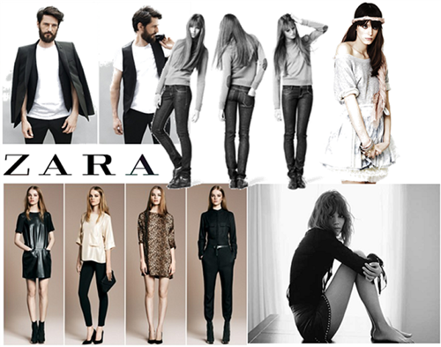
Zara has strong competitive advantages that have taken Zara to the point it is at the moment. These certain unique corporate strategies are what makes them so popular among a specific group of people. The top on the list is the ability to respond quickly to the demand variations among the customers (Lopez and Fan, 2017). However, their competitors have also used the same strategies but still failed. This led us to a perfect combination that exists between human resource and technical advancements in the company. This is a continuous transformational process for the employees at Zara, where their training department have collaborated with learnings for software (Carugatti, 2008). As a marketing manager, it would be suggested the following marketing plan for them for the forthcoming year.

3.1 Target Market
Their target population should target people between the ages of 10-45 as compared to the existing target market of 18 to 40. This age group is the one who is most conscious about their fashion and who are willing to buying every new thing that is in trend more than anything else does (Khare, 2014). Another thing that attracts the people of this age is the outlook of their stores. Their stores should be a living example of the dedication of their work (Carugatti, 2008). Their stores have a unique and sleek trendy design that attracts people from outside the windows.

3.2 Unique Selling Position
Almost 90% of Zara's stores are in America, Asia, Europe and the Middle East. Rest of their activities are either joint ventures or outsources to not so populated areas with lesser demand for their product. It is suggested to them to have the upper hand on their competitors at all times by having stores at the most convenient places and in the biggest cities of the country (Ferdows et al., 2003).

3.3 Marketing Mix
Marketing mix is used by organizations as a strategy to make their marketing plan effective. A marketing mix includes what type of product will the company produce? How would they determine the price of the product? What should be the most suitable place for their product and how will they promote their product (Srivastava, 2012). All these questions, are answered form a marketing plan for a company.


3.3.1 Product Design Strategy
Product is anything sold in the market for the purpose of customer satisfaction and for earning revenue (Budimčević, 2015). It is recommended to Zara to have a very adaptable Product Design Strategy. Unlike other brands who produce their goods in one season and sell it in another. This causes distress for the customers because sometimes, the style goes out of fashion and other times; customers just change their mind about certain styles. As a manager, It is suggested them to produce only 15 to 25% of their products in the season (Piercy, 2014). This will spare them the loss that occurs when a trend goes out of fashion or when the customer's demands shift noted on daily basis.

3.3.2 Pricing and Positioning Strategy
The aim of the company, Zara, should be to provide its products at a reasonable price to its customers because customers are attracted towards a brand that gives them trendy clothes at a reasonable price (Pulido, 2018). Some customers find their prices reasonable because they compare them to other high-profile brands like Gucci, but the target that Zara has pointed is the lower upper class who can afford these clothes as a daily routine. Zara should have a premium pricing strategy that could be made possible by reducing the production and transport cost.
Zara has a rare technique when it comes to retailing. It is not like any other brand who does normal promotions to sell their product and to make their brand famous. Zara has taken the job of producing its products, and this has become successful in following this trend because it has become the widely accepted fashion brand in Spain and the rest of the world also. They can improve the positioning of their products by opening more stores and in more countries. If their product is readily available everywhere, they will gain more profit. Easy availability of their products will also add to their competitive advantage (Lopez and Fan, 2017). There will increase the chance of seeing more of Zara stores in our homelands.

3.3.3 Promotions Strategy
Zara has opted a different way of promotion other than the most commonly used way that is advertising. Unlike other brands, that are also competitors of Zara, Zara has a different and unique marketing policy of "Zero investment in marketing". Instead of that, they claim that they do what affects the customers more. They say their competitive advantage is their product. They provide best-designed clothes to their customers at a reasonable price, and that is their promotion, and their products speak for themselves. Its vital marketing strategy is based on exclusivity, experience, differentiation and affordability (Pulido, 2018). It is suggested to them to continue with this strategy and promote their products only by putting annual sales.


If they are not opting for advertisements, then another thing that could help them promote could be the outlook of their stores. Zara’s stores are a living example of the dedication of their work. Their stores have a unique and sleek trendy design that attracts people from outside the windows. Attractive and large glass walls is an invitation for the customers to have a look inside and look for whatever they need (Carugatti, 2008). They can bring innovations in their stores and place some unusual painting or quotes about their clothes or promotional advertisements of their brand. This could help attract more and more customer.
Talking in terms of marketing, Zara relies on the word of the mouth advertising strategy, they satisfy their customers with the best products, and they expect their customers to spread the word for them. Their only way of promotion is through their customers. The more the customers, the more will be their name.

3.3.4 Distribution Plan
As a marketing manager, the biggest challenge faced would be regarding the distribution plan that is the sole system holding the whole company at the moment. A strategy should be implemented of the independent distribution system, unlike the present system of centralized distribution where the whole distribution is under the responsibility of the company. Having a Centralized system of production is the most serious issue faced by Zara (Bhasin, 2019). There is no doubt that this helps them keep their quality control, but this is at the same time weakness for them. If a little inconvenience occurs in their system, their whole system will fall apart.
Other companies have their work divided among multiple sub-companies just in case anything happens to one sector the whole of the company's production will not stop. These unpredicted issues should be considered.
Zara has been a fast-fashion company, and it has its weaknesses. They cannot stand out in the market for their own creation or designs. They usually pick up designs from other brands and make little changes to it and send it to the market (Bhasin, 2019). Instead of coming up with something unique, they would just make changes to other people’s designs. However, they make sure that the quality is up to the mark.

3.4 Objectives of the Plan
First-year Objective: Being a marketing manager, the sole aim is that the company should prosper and in a way which is more profitable than the previous years. The objective for the first year would be to generate revenue by improving the base of the working system of the whole company. It is suggested to implement the McKinsey framework that would solve all the issues related to the structure and staffing of the company.

3.5 Implementing McKinsey’s framework
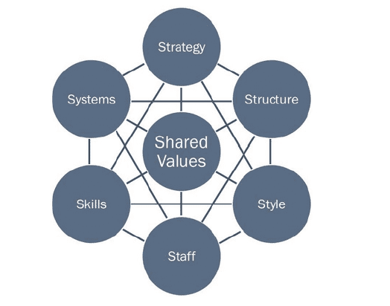
7S's of McKinsey are implemented by companies to evaluate their position in the market. Strategy, structure and system are the elements of the framework that can directly impact the decisions made by the managers. Structures are the organizational framework. Zara's structure shows that they reflect on only one part of the strategy. They focus on opening stores and providing the latest trend of fashion clothes to the customers. Their workers are adapted to this form of working. Their whole system is designed in this manner. The allocation of jobs and the division of labour is done, keeping in view the strategy of the company to fulfil every day's objectives (Demir and Kocaoglu, 2019). Style, staffing, skills, standard value are other aspects of the framework implied that show how the company works. The style of leadership adopted at Zara should be transformational.
Transformational leadership style should be practice at Zara where there is continuous guidance of the employees. The working style at Zara is quite open, as all the employees are open to all sorts of communication (Hutchinson and Jackson, 2012). They are given an orientation before every task, and big consignments and then managers indulge with the employees themselves to help them perform better. Staffing is also a severe matter when a company's position is to be judged. Transformational style of leadership would be successful if implemented in the right ways. Hiring the right person for the right job is very important for the company because they are the base of every project. If the employees perform their best, they can elevate the company's position just by their working. If a person lacks those skills that are needed to be in Zara, they are trained to gain those skills. Employees are looked after in the company because they are the backbone of the company and the reason for its success (Hanafizadeh and Ravasan, 2011). Zara's aim has always been growth, and they carry forward this aim and work on that. However, they have been really successful in achieving their aim by focusing on opening more and more stores and enhance their business activities all around the world.

3.6 Competitive review
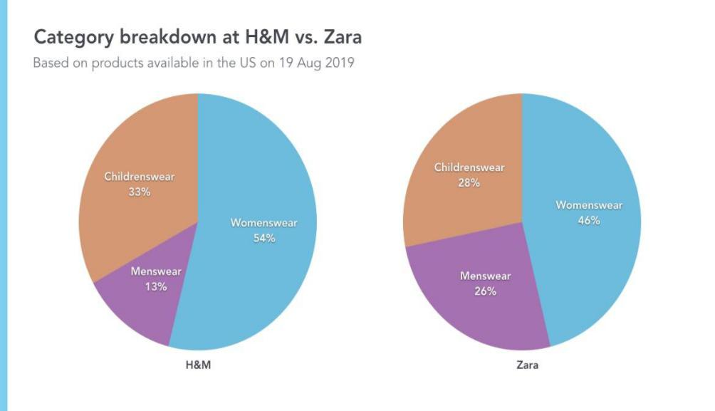
Zara has multiple competitors who are producing the same products in the market. It should strengthen their online selling through their website. In today's world, most of the businesses are working through online communication with customers. Zara could improve their sales if they come up with a very efficient website for their customers and post regularly on their social media sites (Gupta, 2013). Unlike their competitors, Zara does have an online website for the convenience of their customers, but there is still a chance for them to improve. They can increase their market on the internet also.
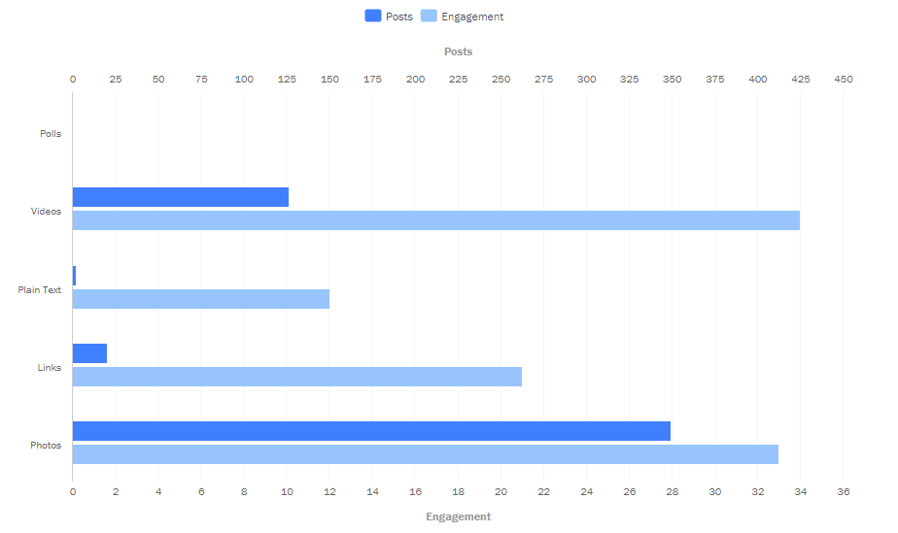
Things promoted on social media sites sell within no time. There can be a chance of expansion if they move their selling through e-commerce.

Zara’s competitors have made alliances with prominent designers like Karl Lagerfeld, Lanvin, and Alexander Wang. This could be a significant threat to the organization. It is suggested to promote their brand’s name by collaborating with big names in the designer industry. People prefer buying from brands who have a designer collaboration with them. A competitive advantage that Zara has is its unique stores. The parent company owns almost ninety percent of the stores, and the rest of ten percent are owned by franchisees (Caro, 2010). Owning stores means the environment of all the stores is maintained to quality of standard. The type of stores in London is the same as the stores in New York. The stores in Paris look familiar to the stores in New Delhi.
Their stores are designed in a unique way that makes them stand out. The architecture of the store is modern with white theme and mirrors all around the store. The only asset that is close to the company is their culture, which cannot be traded for anything. They hire young designers and train them to learn the specific style of the company and then work on enhancing their skills
Another competitive advantage that the company has is that the Zara takes one week to produce a new design and send it to the stores. Most of the market for their clothes are in Spain, where they initiated. They usually outsource most of their products to Asia. Their most basic designs are outsourced to Asia, and hence they have a somewhat small market in Asia. This helps them widen their markets because Zara has no advertisement policy. They advertise their products the least (Tokatli, 2018). They have this belief that whatever is saved from the advertisements could be used in the growth of the business. Zara should open new stores new products should be produced, or they can even introduce a new line of apparel.

3.7 Budgeting
Zara has maintained its uniqueness in advertising by avoiding any promotional campaigns. It only spends 0.3% of its sales on advertising. As compared to the market, where the companies spend 3.5% of their retailed earnings on marketing. They have settled very less budget for advertising. When the company started, it had kept only $50,000 for financing marketing (Berthon, 2012). They save the money from there and invest it in their stores and built up a new store or start a new collection. In this way, their clothes stay in demand, and they gather their customer's confidence that they will only buy from them. A company having a net worth of 13 million dollars should take a step toward getting involved in the marketing race too, by starting advertising campaigns (Carugati, Liao, and Smith, 2017). A larger part of the budget, almost 3.5% of the revenue earned from sales should be spent on advertising and promotions because no matter how big a brand is, advertising is essential as it helps the brand to retain in the consumer's mind.

3.8 Implementation and limitation of the plan
Zara has been doing well with their present strategy; however, as a marketing manager, for them, it is suggested to consider the recommendations presented above in the marketing plan. This is a bulletproof marketing plan that will only help them grow. However, there are some limitations when the implementation of this plan is considered. The company is processing on these production ways for years now. It would be difficult for them to divert from centralized production to independent production. However, being a market manager, the company could start with the less complicated things such as introducing new apparels and allocating a larger part of the budget for marketing. A comprehensive advertising campaign on social media that would give the brand the real recognition that it deserves will also be started.

4.0 Conclusion
Zara is a leading brand in the fashion industry. They have been in the market for a very long period and have created a brand of their own. They conduct all business ventures themselves. They have a very efficient and robust supply chain that acts up fast according to the needs of the customers. Due to their no advertising strategy, they focus more on customer satisfaction. They grow as a business on word of mouth. However, they are currently working on bringing diversity in their working styles. They are forming collaborations with business entities and organizations to get assistance with their production chain. In this way, if anything happened to one sector, the whole production would not stop. Despite the lack of promotions, they still have attained a very good position in the market.

5.0 References
Barnes, L. and Lea‐Greenwood, G., 2010. Fast fashion in the retail store environment. International Journal of Retail & Distribution Management.
Berthon, P.R., Pitt, L.F., Plangger, K. and Shapiro, D., 2012. Marketing meets Web 2.0, social media, and creative consumers: Implications for international marketing strategy. Business horizons, 55(3), pp.261-271.
Bhasin, H., 2018. Marketing Mix Of Zara - Zara Marketing Mix And 4 Ps Of Zara Brand. [online] Marketing91. Available at: <https://www.marketing91.com/marketing-mix-zara/> [Accessed 17 April 2020].
Budimčević, K., 2015. Impact of integrated brand communications on the image of Etihad
Airways. Ekonomski pogledi, 17(4), pp.1-16.
Caro, F., Gallien, J., Díaz, M., García, J., Corredoira, J.M., Montes, M., Ramos, J.A. and Correa, J., 2010. Zara uses operations research to reengineer its global distribution process. Interfaces, 40(1), pp.71-84.
Carugati, 2017, September. Speed-to-fashion: managing global supply chain in Zara. In 2008 4th IEEE International Conference on Management of Innovation and Technology (pp. 1494-1499). IEEE.
Christopher, M., 2016. Marketing and logistics — A new area of management concern. Industrial Marketing Management, 2(2), pp.131-144.
Cohen, W.A., 2005. The marketing plan. John Wiley & Sons.
Demir, E. and Kocaoglu, B., 2019. Maturity assesstment in the technology business within the
Mckinsey s 7S framework. Pressacademia, 6(3), pp.158-166.
Ferdow, K., 2015. Zara. [online] Taylor & Francis. Available at: <https://www.tandfonline.com/doi/abs/10.1080/16258312.2003.11517121> [Accessed 17 April 2020].
Ferdow, K., 2013. Zara. [online] Taylor & Francis. Available at: <https://www.tandfonline.com/doi/abs/10.1080/16258312.2003.11517121> [Accessed 17 April 2020].
Ferdows, K., 2015. Zara's Secret For Fast Fashion. [online] HBS Working Knowledge. Available at: <https://hbswk.hbs.edu/archive/zara-s-secret-for-fast-fashion> [Accessed 17 April 2020].
García-Álvarez, M.T., 2015. Analysis of the effects of ICTs in knowledge management and innovation: The case of Zara Group. Computers in Human Behavior, 51, pp.994-1002.
Ghemawat, 2013. ZARA: Fast fashion (Vol. 1). Boston, MA:
Harvard Business School.
Gupta, A., 2013. Environment & PEST analysis: an approach to the external business environment. International Journal of Modern Social Sciences, 2(1), pp.34-43.
Hanafizadeh, P. and Ravasan, A.Z., 2011. A McKinsey 7S model-based framework for ERP
readiness assessment. International Journal of Enterprise Information Systems (IJEIS), 7(4), pp.23-63.
Hilletofth, P. and Hilmola, O.P., 2019. Supply chain management in fashion and textile
industry. International Journal of Services Sciences, 1(2), pp.127-147.
Ho, J.K.K., 2014. Formulation of a systemic PEST analysis for strategic analysis. European academic research, 2(5), pp.6478-6492.
Hutchinson, M. and Jackson, D., 2012. Transformational leadership in nursing: towards a more
critical interpretation. Nursing Inquiry, 20(1), pp.11-22.
Khare, A., 2014. How cosmopolitan are Indian consumers?: a study on fashion clothing involvement. Journal of Fashion Marketing and Management.
Lopez, C. and Fan, Y., 2017. Internationalisation of the Spanish fashion brand Zara. Journal of
Fashion Marketing and Management: An International Journal, 13(2), pp.279-296.
Mo, Z., 2015. Internationalization process of fast fashion retailers: evidence of H&M and Zara. International Journal of Business and Management, 10(3), p.217.
Østergaard, P., Hermansen, J. and Fitchett, J., 2015. Structures of brand and anti-brand meaning:
A semiotic square analysis of reflexive consumption. Journal of Brand Management, 22(1), pp.60-77.
Piercy, N.F. and Morgan, N.A., 2014. The marketing planning process: behavioral problems compared to analytical techniques in explaining marketing plan credibility. Journal of Business Research, 29(3), pp.167-178.
Pulido, M., 2018. Acts or events? A perspective from the marketing mix. IROCAMM
International Review Of Communication And Marketing Mix, (1), pp.56-66.
Sabbaghi, A. and Vaidyanathan, G., 2014. SWOT analysis and theory of constraint in information technology projects. Information systems education journal, 2(23), pp.3-19.
Srivastava, R., 2012. Shift of Marketing Mix to E-Marketing Mix: The Birth to New Era. SSRN Electronic Journal,
Tokatli, N., 2018. Global sourcing: insights from the global clothing industry—the case of Zara,
a fast fashion retailer. Journal of economic Geography, 8(1), pp.21-38.
Tungate, M., 2017. Fashion brands: branding style from Armani to Zara. Kogan Page Publishers.
Valentin, E.K., 2011. SWOT analysis from a resource-based view. Journal of marketing theory and practice, 9(2), pp.54-69.
Wang, K.C., 2007, July. A process view of SWOT analysis. In Proceedings of the 51st Annual Meeting of the ISSS-2007, Tokyo, Japan (Vol. 51, No. 2).
Wardani, D. and Gustia, R., 2017. Analysis of Brand Experience, Brand Satisfaction and Brand
Trust Relationship to Brand Attachment. Jurnal Ilmu Manajemen & Ekonomika, 9(1), p.59.
Yuwan, M., 2014. Customer-driven Design Management Strategy Of SPA Fashion Brand
Focusing on H&M & Zara. Journal of Korea Design Forum, null(45), pp.287-298.
Zhang, Q., 2008, October. Analysis on the successful case of efficient supply chain in ZARA. In 2008 4th International Conference on Wireless Communications, Networking and Mobile Computing (pp. 1-4). IEEE.

