Weekly Progress Tracker: Managing Guest Service Operations at Ibis Portsmouth Centre Hotel

Student name: Alina Elena Craciun
Student number: 2212851
Module title: Hotel Placement – Managing Guest Service Operations
Module code: BMIH6003
Lecturer name: Jessica Newport BA (Hons)

Level 6 Hotel Placement – Weekly Progress Tracker
Task: Maintain a weekly progress tracker documenting your experiences, tasks performed, challenges faced, and lessons learned. Bullet points format is welcome. You must submit this document to the designated Turnitin link by [Friday 7th March 2025] at 23:59pm.

Week 1 and Week 2
Experiences/Tasks/Challenges/Lessons  (outline hotel department) | Shift  (Date/Time) | Student Signature | Hotel Mentor Signature
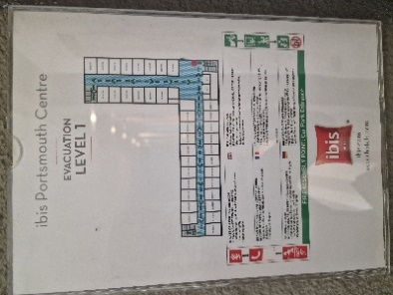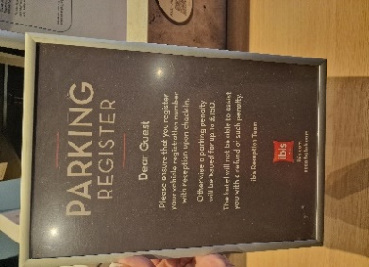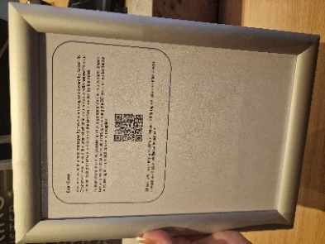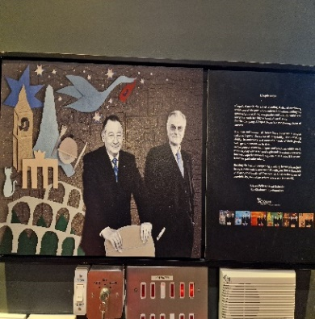  Induction Day  On January 14, 2025, at 1:00 PM, I arrived at Ibis Portsmouth City Centre for my induction. Working alongside the hotel manager, I completed and approved the "Induction Day Forms," officially confirming my placement for the next ten weeks. This placement will involve work in multiple hotel divisions, including Reception, Housekeeping, and Food & Beverage (Breakfast and Bar), allowing me to experience different operational areas.  Following the paperwork, the manager provided a full tour of the hotel. The Ibis facility consists of 144 identical rooms, the only difference being whether they are twin or double. The fourth floor is reserved exclusively for VIP guests. Even-numbered rooms overlook the main road, while odd-numbered rooms are situated at the rear, offering a quieter environment but without a scenic view. I noted that this could be a potential disadvantage for some guests, especially after reviewing guest feedback.  A TripAdvisor review from January 2025 by user Elizajane510 stated: "We were on the 4th floor at the front – a nightclub/bar kept their music running until 1:30 AM, which wasn’t great."  The Assistant Manager then provided a breakdown of fire safety procedures, including designated Fire Exit Doors and Assembly Points. It was pointed out that elevators should never be used in case of emergency and that stairways should always be the primary exit route.  The tour continued through key operational areas, including the kitchen, maintenance room, reception, back office, managerial and staff offices, housekeeping locker rooms, the bar, and the dining area, where breakfast, lunch, and dinner take place.  As part of the induction, I met the Hotel Manager and staff members scheduled for that shift. We also reviewed the hotel’s parking facilities, which are available for guests arriving by car. A blue panel in the back hallway caught my attention, displaying the hotel’s Eco Sustainability and Green Key Certification, signifying its commitment to environmentally friendly practices.  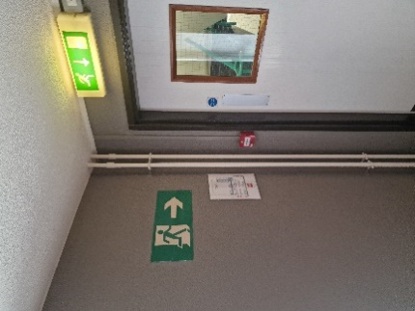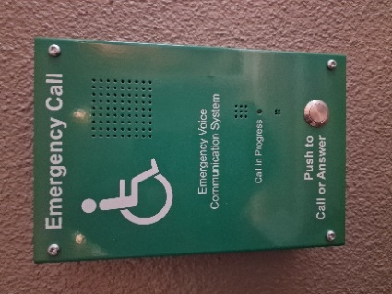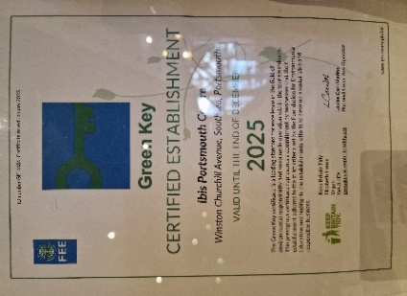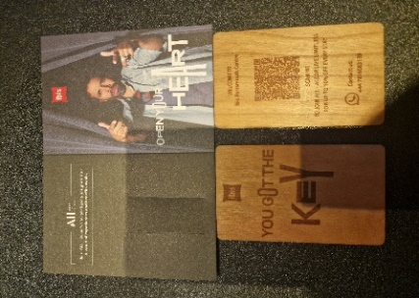  Day 1 - Reception Basics  Observing the operational dynamics at Reception dominated the first day of my placement. Ibis uses a well-established platform in the hospitality industry, the OPERA Cloud system by ORACLE HOSPITALITY.  One of the unique aspects I noticed was the use of wooden key cards, which are activated using the SAFLOK system by the KABA Group. I observed a team member, following a structured routine to manage guest check-ins and check-outs.  During check-in, the first question asked of guests was: "Are you here by car?" If they confirm, their license plate number must be registered in the system, and they are informed of the £12 per 24-hour parking charge. Next, the system is checked to verify whether payment was completed online through Booking.com or another platform. If the payment is confirmed, further details are gathered, including:  - The duration of the stay  - Whether breakfast is included in the reservation  - If all charges are covered by the initial payment  A brief introduction to key card usage is provided for first-time guests, explaining that it must be scanned for elevator access. Additionally, guests receive information regarding:  - Breakfast and bar operating hours  - 24/7 reception availability for inquiries or assistance  - Check-out time at 12:00 PM and late check-out fees (£10 per extra hour, with a maximum extension until 5:00 PM)  By the end of my shift, I had gained a strong understanding of how reception staff manage check-ins and check-outs, ensuring a fluent and professional process for guests.  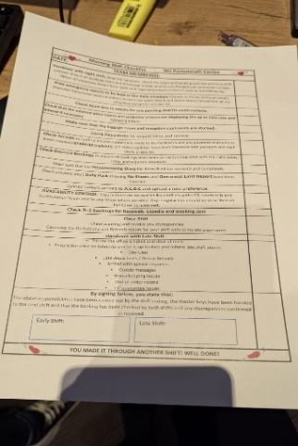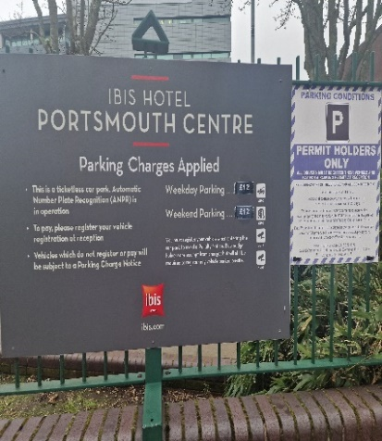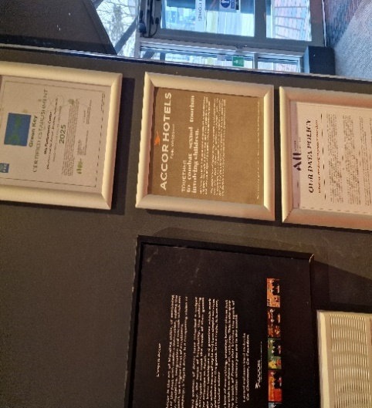 | 14.01.25/13:00-14:30  21.01.25/ 07:00-15:30
Day 2 – Group Bookings and Reception Tasks  On my second day at Reception, I gained hands-on experience managing group bookings. Under a team member’s guidance, I created key cards for a group reservation covering seven rooms on the second floor. The standard practice is to assign rooms on the same floor and close to each other whenever possible to improve the accessibility for guests. Once the key cards were activated, each was sealed inside an envelope labelled with either the company name or the primary booking contact’s name. These were then secured in the back office until check-in.  Another key task I learned was handling early check-ins. If a guest arrives before their room is ready, they are given the option to store their luggage in the baggage room. Each piece of luggage is tagged with a Red Claim Tag, which must be presented when retrieving their belongings.  Later in my shift, I reviewed the Handover Document, an internal shared file where team members log essential updates to ensure a smooth transition between shifts. This document plays a crucial role in maintaining operational continuity.  Email correspondence is essential for handling booking confirmations and payment requests at Reception. For instance, Brittany Ferries regularly reserves rooms for staff and crew members, requiring Reception to print booking details and process payments through company credit cards.  Moreover, I became familiar with the various booking types used at Ibis, including:  - Guaranteed Credit Card – Booking.com BV (EUR NL)  - Online Prepayment – Booking.com VCC  - Guaranteed Credit Card – Expedia.com  - Deposit Received – Flight Centre (UK) Ltd  - Guaranteed Credit Card – AGIITO Ltd  - Guaranteed Credit Card – Agoda Company PTE Ltd  Another key feature of hotel operations is the "Go Green" initiative. Guests who opt out of daily housekeeping contribute to the hotel's sustainability efforts. Members of the ACCOR Loyalty Program also earn reward points when choosing this environmentally friendly option.  By the end of the shift, I had strengthened my understanding of group check-in procedures, early arrivals, and the importance of internal communication.  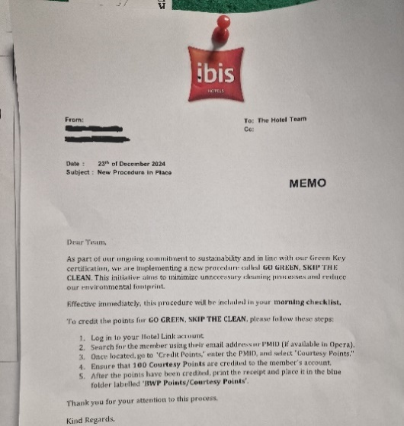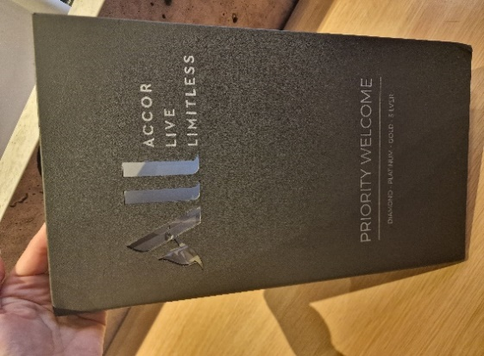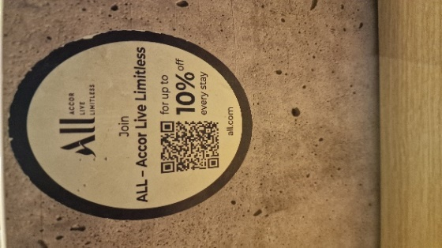  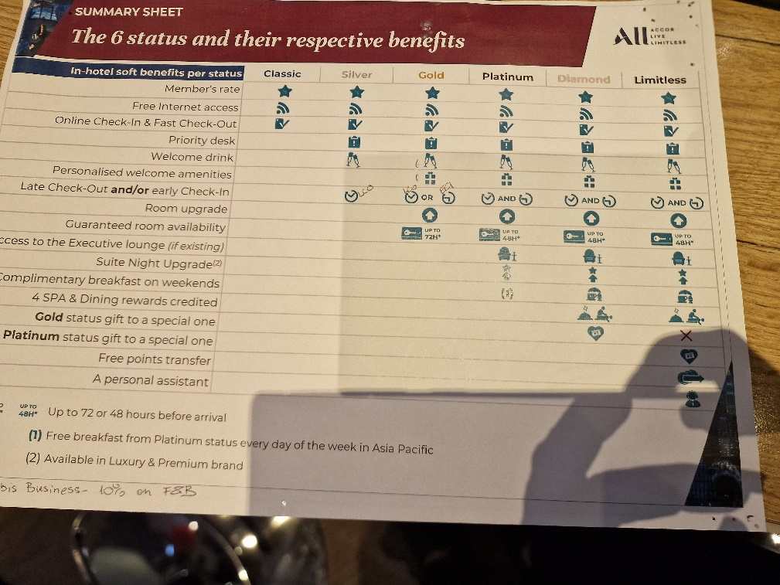  Comparison Between Ibis and Premier Inn  Having worked at Premier Inn, I immediately noticed several key differences between the two hotels regarding operations and guest experience. Interestingly, Ibis Portsmouth and Premier Inn are located 5-6 minutes apart on foot, yet their approach to hospitality is quite different.  One of the most noticeable contrasts is the size of the hotels.  - Ibis Portsmouth has a total of 144 rooms, making it significantly larger than Premier Inn, which operates with half that capacity.  - Ibis is located right next to Portsmouth University, which often accommodates student groups, sometimes booking blocks of 7 rooms at a time.  - Because of their affordable pricing, Ibis is almost always fully booked. This makes it popular for budget travellers, students, and short-term guests.  Another key difference is their pet policy.  - At Ibis, guests are allowed to bring their pets for a small additional fee, which is something I personally appreciate. I’d love to find a hotel where I could stay with my dog.  - At Premier Inn, only assistance dogs are allowed, and guests need to provide proof that their pet is a service animal, such as a guide dog for the visually impaired or a support animal for medical conditions.  Regarding food and beverage services, I also noticed some essential differences.  - Breakfast at Ibis feels a bit limited compared to Premier Inn. While the basics are covered, Ibis doesn’t offer the same variety of food options.  - Premier Inn offers a more diverse breakfast selection, which, in my opinion, is more generous and well-balanced.  - Ibis does not have a Meal Deal for lunch and dinner. At Premier Inn, for £26.32, guests can purchase a Meal Deal, which includes both breakfast and dinner, making it a better value option for guests looking for a complete package.  Another location-based advantage that Premier Inn has is its proximity to the train station.  - Many guests have told me that staying at Premier Inn is convenient because they don’t have to drag their luggage through the city.  - Meanwhile, Ibis guests might have to walk a bit further, which can be inconvenient, especially for those carrying heavy suitcases.  Finally, the check-in and room assignment process are another significant difference.  - At Premier Inn, rooms are pre-assigned before the guest even arrives. This means that everything is sorted in advance if a family books a twin room for siblings or a quad room for a family.  - Ibis does not assign rooms until the guest arrives at the front desk. This can lead to complications, especially when dealing with different types of guests. For example, Council guests (including homeless individuals) are usually placed on the first floor, while VIP guests are given rooms on the fourth floor.  Overall, both hotels cater to different types of travellers and operate with different priorities. Ibis is more flexible, budget-friendly, and pet-friendly, but Premier Inn offers a more structured check-in system, better breakfast options, and a more convenient location. | 23.01.25/ 07:00-15:30

Week 3
Experiences/Tasks/Challenges/Lessons  (highlight hotel department) | Shift  (Date/Time) | Student Signature | Hotel Mentor Signature
Day 3 – Reception and Food & Beverage  My shift began at 7:00 AM at Reception, where I shadowed morning check-ins and assisted guests with various inquiries. By 10:00 AM, I was asked to assist in the kitchen while the Food & Beverage (F&B) team held a meeting. This provided an opportunity to observe and experience the operational flow of the department.  Under the chef’s supervision, I participated in the post-breakfast cleanup, ensuring the dining area was properly sanitised and tables were reset for the following day. I also learned about food safety standards, particularly the three-day labelling rule for breakfast ingredients. This rule ensures that all food items are used within a designated timeframe to maintain quality and compliance with food safety regulations.  Once my kitchen duties were completed at noon, I returned to Reception and resumed observing check-in and departure procedures. This further reinforced my familiarity with front desk responsibilities while improving my ability to assist guests efficiently and professionally.  By the end of the shift, I had gained valuable experience balancing Reception and Food & Beverage duties, understood the importance of hygiene and food safety protocols, and ensured easy coordination between departments.  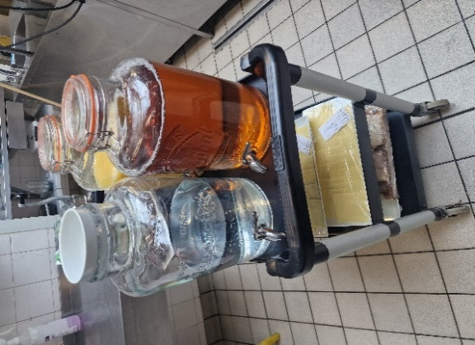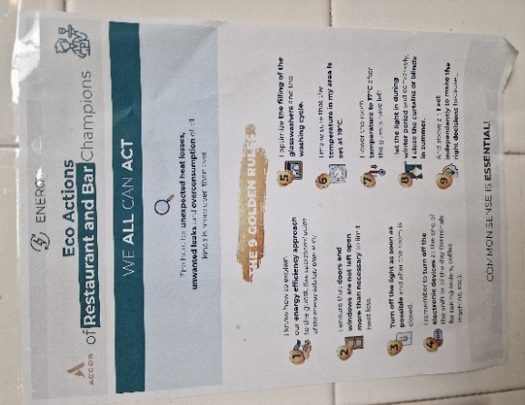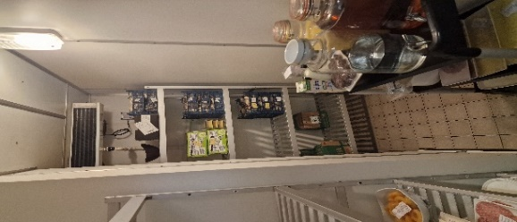  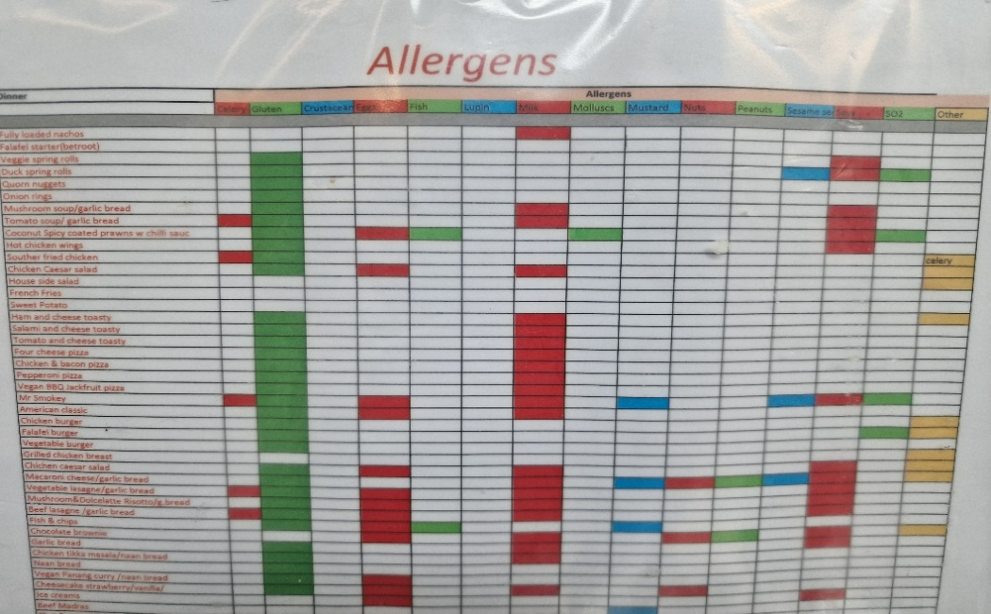  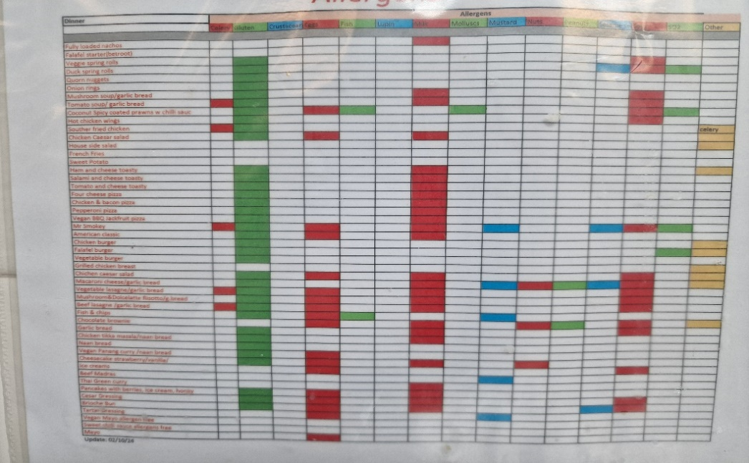  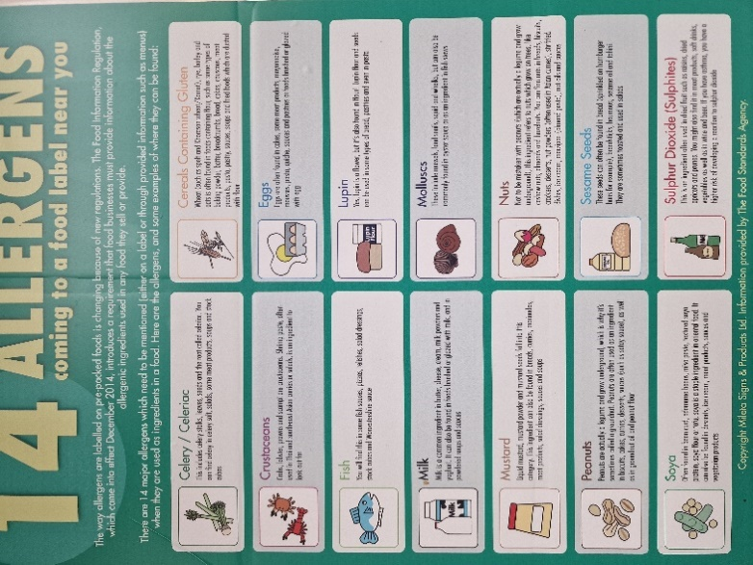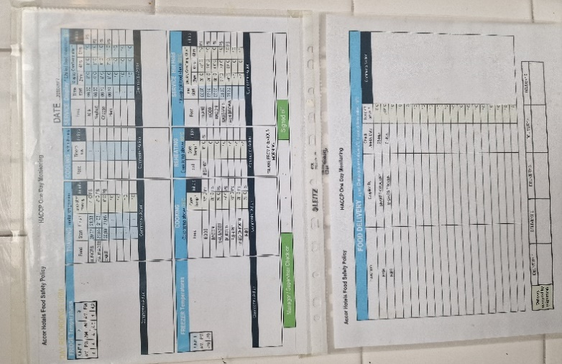  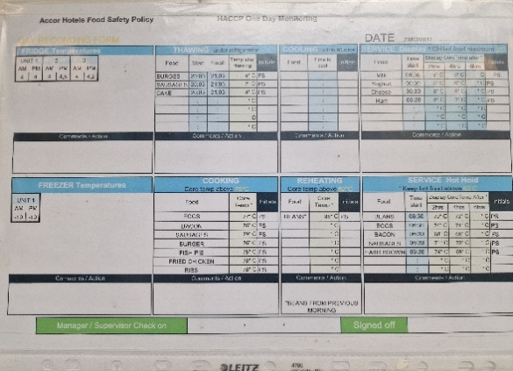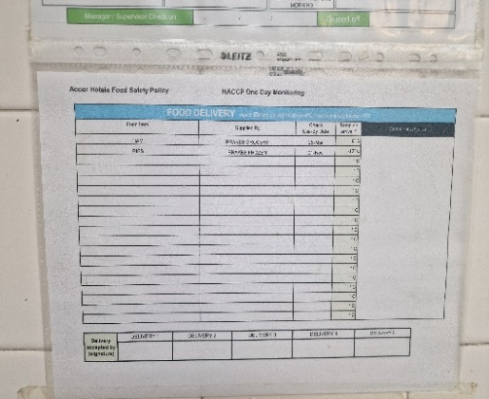  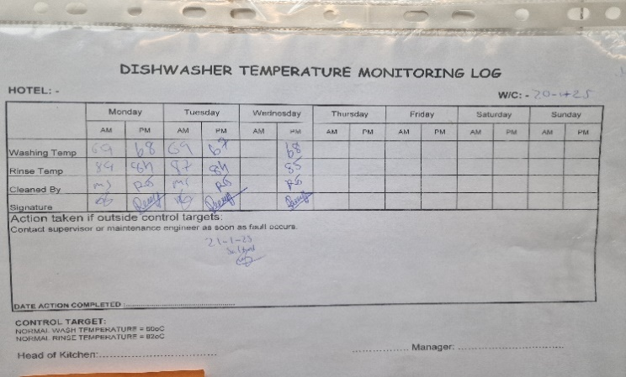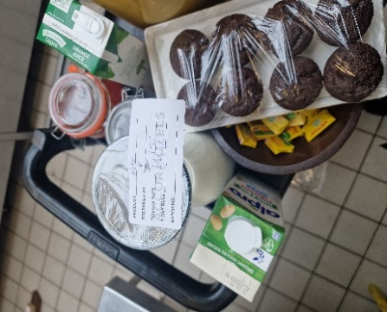  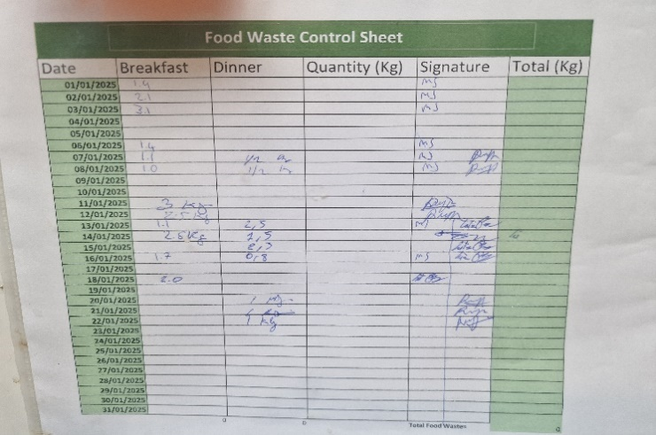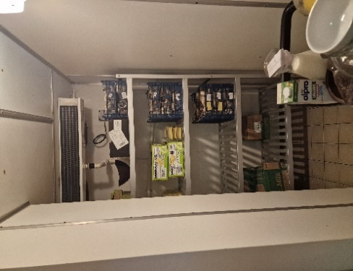  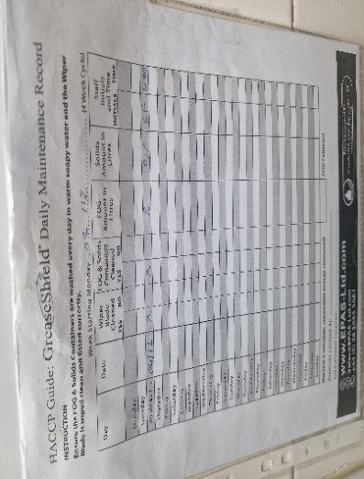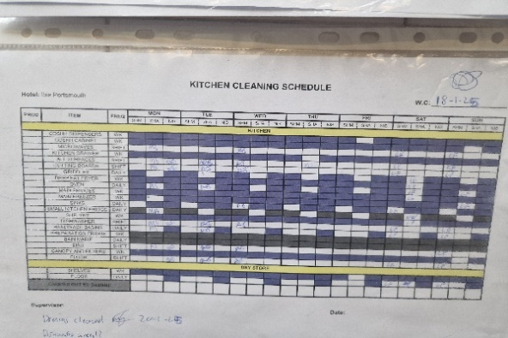  Day 4 – Difficult Guest  On my fourth day, I encountered my first difficult guest-related situation. A guest staying in Room 110 exceeded the check-out time of 12:00 PM without requesting an extension. Despite multiple reminders and knocks, there was no response. A team member and the Housekeeping Supervisor were called in to directly intervene and address the issue.  When confronted, the guest became verbally aggressive and refused to vacate the room. The situation escalated further when they proceeded to Reception and displayed hostility toward staff members. At this point, the Assistant Manager was required to intervene and attempt to de-escalate the conflict.  The incident reinforced the importance of managerial presence when handling such cases and demonstrated the necessity of a dedicated security team to assist in conflict resolution. It also highlighted how incidents like these, if not handled properly, could impact guest satisfaction and online reviews.  By the end of the day, I had gained valuable insight into handling challenging guest interactions and the role of clear communication and professionalism in resolving conflicts.  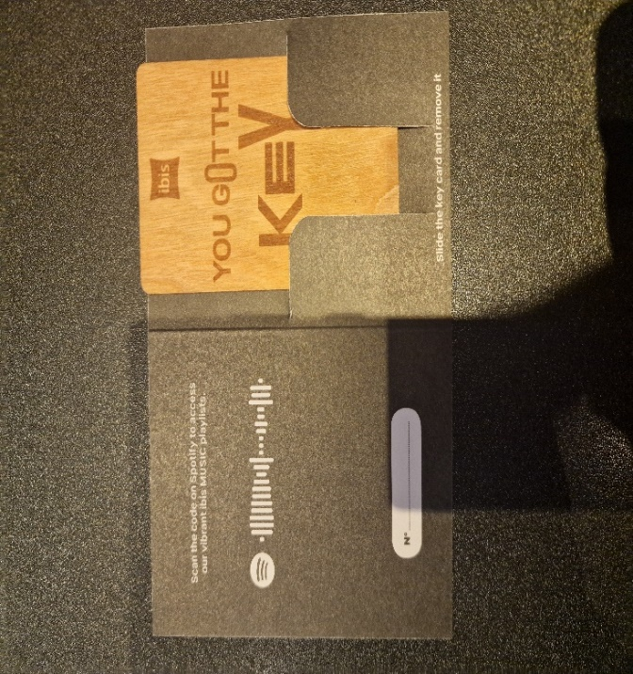 | 27.01.25/ 07:00-15:30  28.01.25/ 07:00-15:30
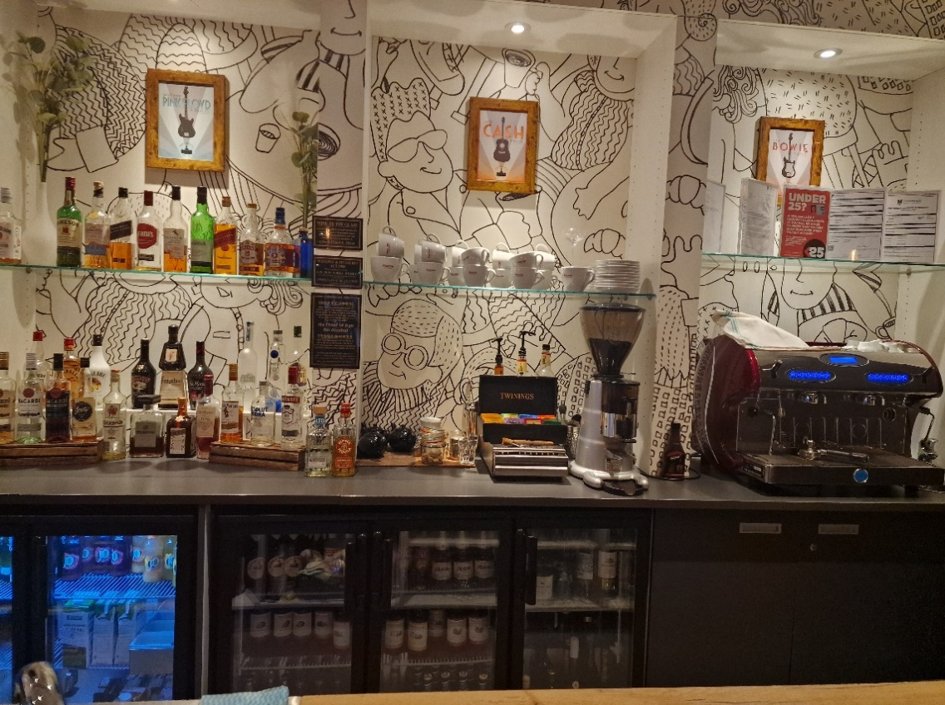

Week 4
Experiences/Tasks/Challenges/Lessons  (highlight hotel department) | Shift  (Date/Time) | Student Signature | Hotel Mentor Signature
Day 5 – Breakfast Service and Bar Setup  I was assigned to the Food & Beverage department for the breakfast shift today. My morning started with clearing the breakfast area, wiping down tables using D10 spray and blue roll wipes, and taking the used dishes, cups, and cutlery to the kitchen for washing.  I also worked in the bar area, where I was responsible for washing mugs and glasses and polishing the cutlery. One task that stood out was setting up the bar with alcohol bottles. However, I quickly realised that Ibis does not have a locked display case for alcohol, meaning all bottles must be manually removed and stored at the end of each day. I personally see this as a significant drawback because:  - It is time-consuming, as bottles must be put away and set up again daily.  - It increases the risk of breakage if someone is not careful when handling them.  We also prepared the breakfast buffet in the bar area as part of the morning setup. Guests were offered a variety of food, including:  - Hot Items: Scrambled eggs, baked beans, hash browns, oven-baked mushrooms, sausages, and bacon.  - Cold Items: Sliced tomatoes, cucumbers, ham, brie cheese, salami, mild cheese slices, fresh berries, yoghurt, cereals, and toast.  - Pastries and Bread: Croissants, chocolate muffins, and other assorted pastries.  - Fruits: Apples and other fresh selections.  - Drinks: Coffee, cappuccino, latte, tea, water, orange juice, apple juice, and cold milk.  Later in the shift, I observed a new initiative at Ibis called "Too Good To Go." This app allows customers to purchase a takeaway meal for £10, which includes scrambled eggs, baked beans, two sausages, hash browns, fried mushrooms, and three slices of bread. The F&B staff prepared these meals in containers for guests to pick up and take away. I found this concept innovative and practical, as it helps reduce food waste while providing guests with an affordable meal option.  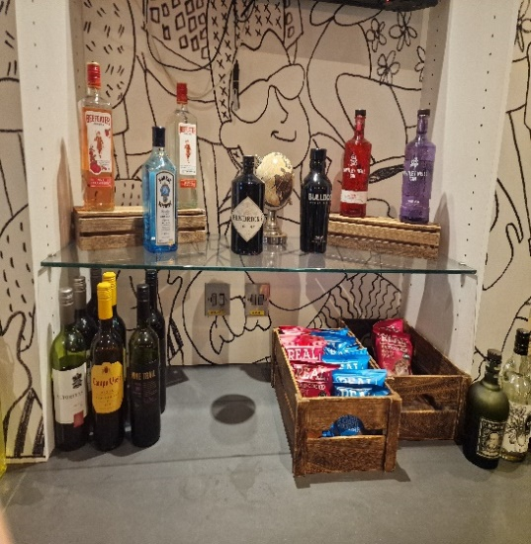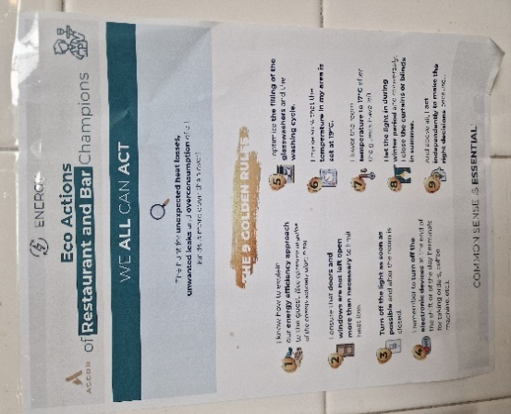  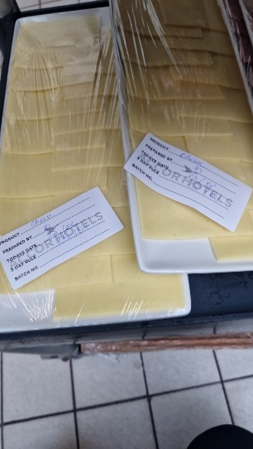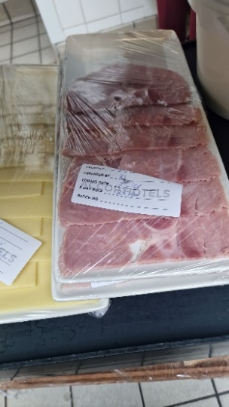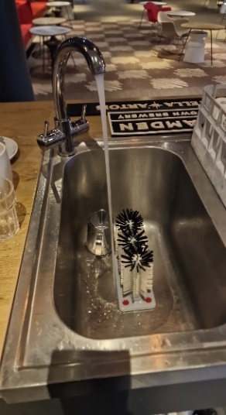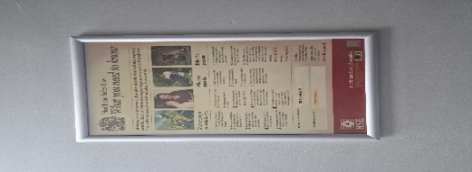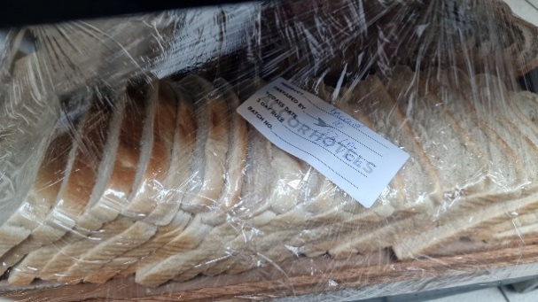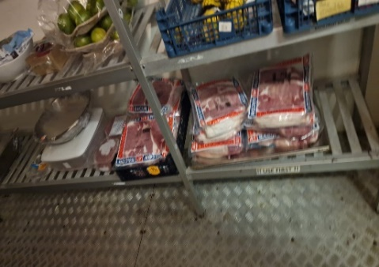  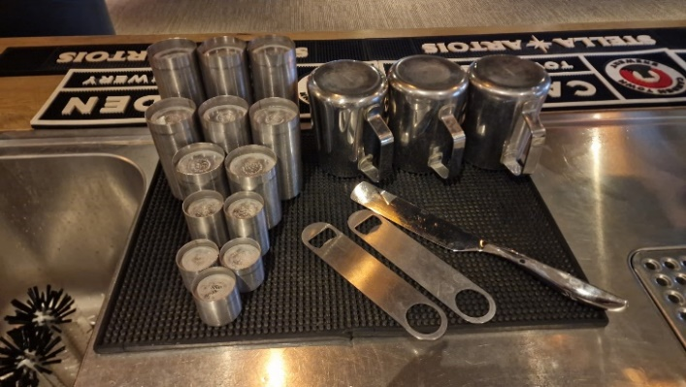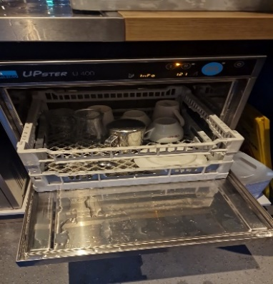  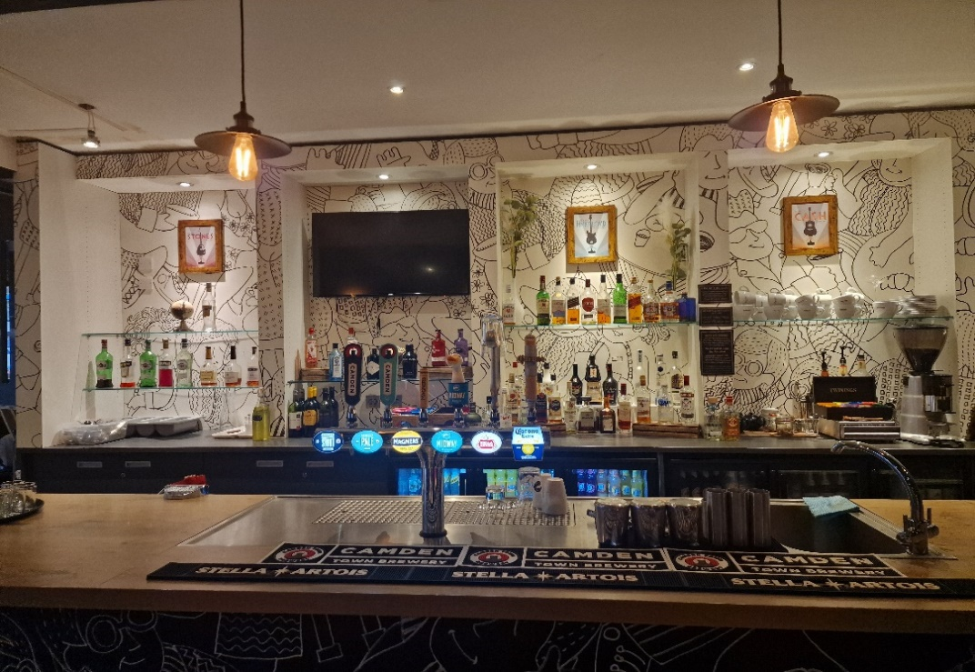 | 03.02.25 / 07:00-15:30
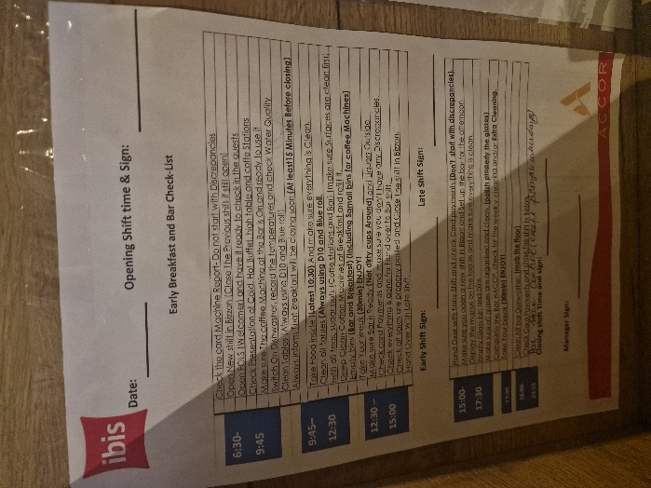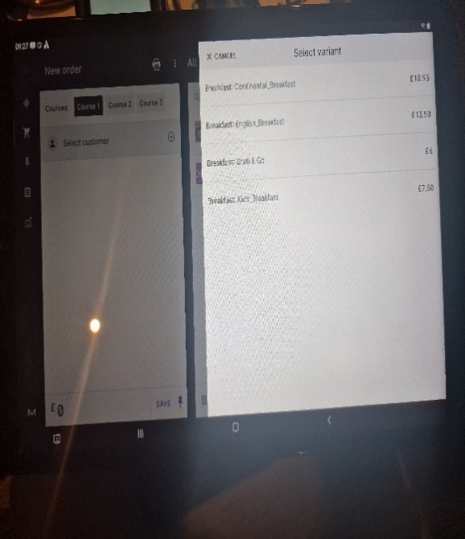
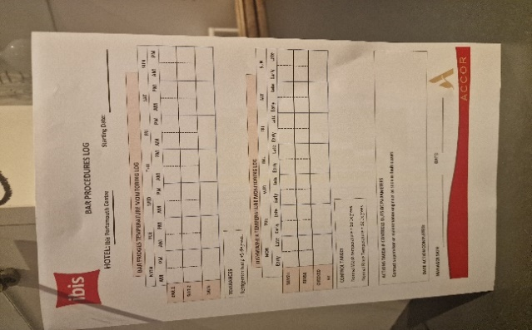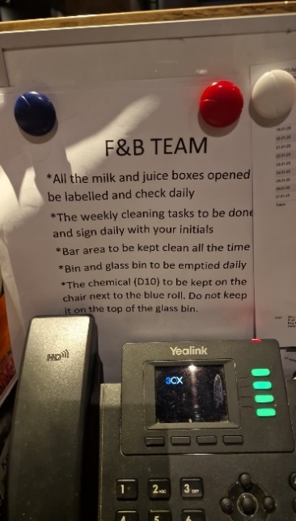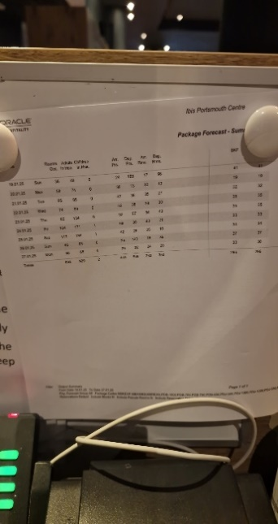
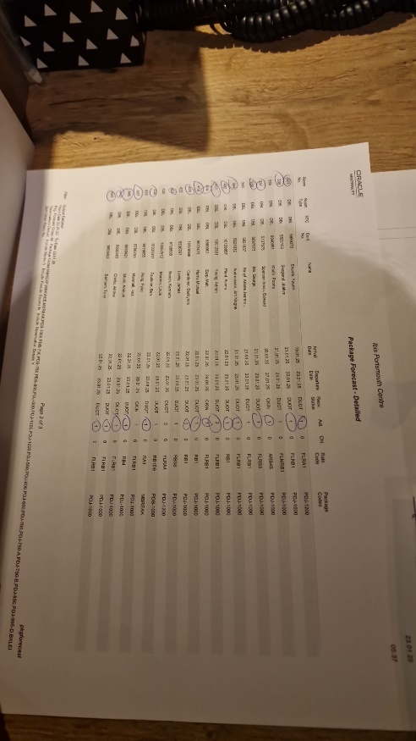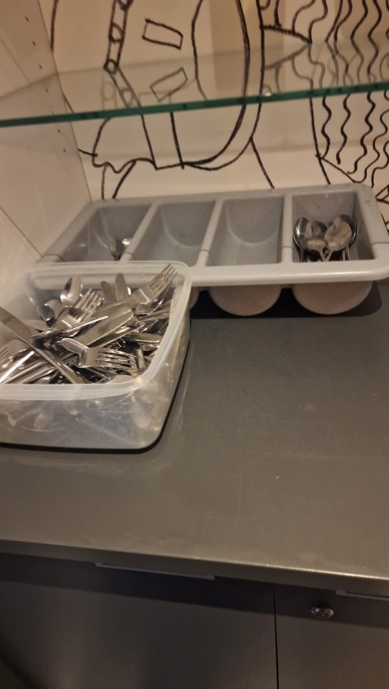
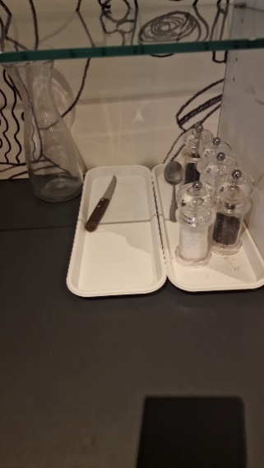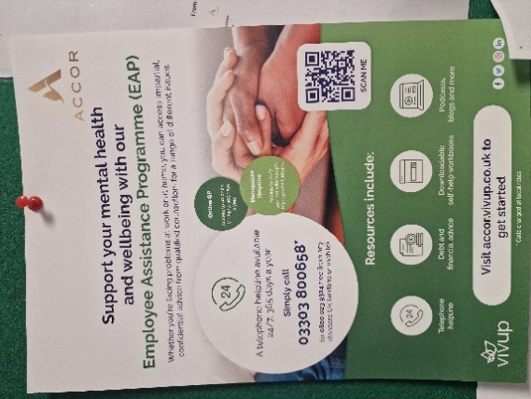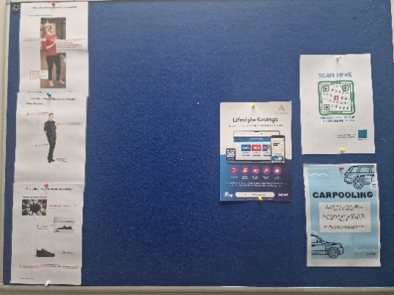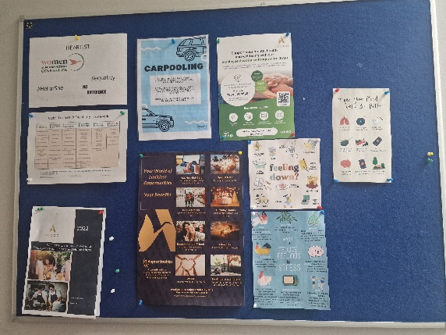

Week 4
Experiences/Tasks/Challenges/Lessons  (highlight hotel department) | Shift  (Date/Time) | Student Signature | Hotel Mentor Signature
Day 6 -Reception and Handling Guest Payments  Today, I worked at Reception, where I was entirely responsible for guest check-ins and check-outs for the first time, under the supervision of the Ibis staff. I also handled card payments for parking for guests staying 3 nights.  One key observation was that guests can pay for breakfast directly at check-in rather than booking it online. I also had the opportunity to witness a refund process in action:  - A guest had prepaid for 3 days of breakfast but later realised that they had an early departure on their third morning and wouldn’t have time for breakfast.  - They requested a refund of £12 for the unused breakfast.  - The system allowed the hotel to adjust their total charge accordingly.  I found this to be a fair and guest-friendly policy, as it ensures that customers only pay for the services they use.  Additionally, I learned more about the ACCOR Loyalty Program, which offers different membership tiers. Guests who select the "Go Green" option (opting out of daily room cleaning) earn loyalty points, which can be redeemed for future stays or benefits.  ACCOR Membership Levels Include:  - A5 – Diamond (highest tier)  - A1 – Classic (entry-level membership)  This was another essential learning experience, as I gained hands-on practice with guest payments, refunds, and loyalty program benefits. I also realised how important flexibility and adaptability are for hotel staff, as guest needs can change unexpectedly.  Day 7 - Food and Beverage  In the F & B department, today was a quiet and enjoyable day. We set out the cold and cooked buffet and made breakfast for guests. Our duties included ensuring the coffee maker always had condensed milk and coffee grounds so guests could serve themselves as many times as they wanted. We also ensured guests could easily access the tea box, white and brown sugar cubes, saccharin sweeteners, and hot chocolate powder for breakfast.  Breakfast runs from 6:30 AM to 10:00 AM. We started clearing the breakfast setup at 10:00 AM. Every now and then, a Too Good To Go customer would show up at around 10:25 AM. At that point, we could make a takeout dinner in a container with scrambled eggs, baked beans, mushrooms, hash browns, sausages, and bacon.  After breakfast service ended, between 12:00 PM and 5:00 PM, we could serve mini pizzas and cheese toast. Alcohol is not served during breakfast hours; guests can purchase alcoholic beverages from the bar after noon. Still, guests can find soft drinks available all morning.  We always ask customers for their room number and name during breakfast so we may cross payment status with the breakfast page. Guests can pay directly at the bar if breakfast is not prepaid or included in the booking. They can pick between a Continental Breakfast or a Full English Breakfast; payment can only be made with cards.  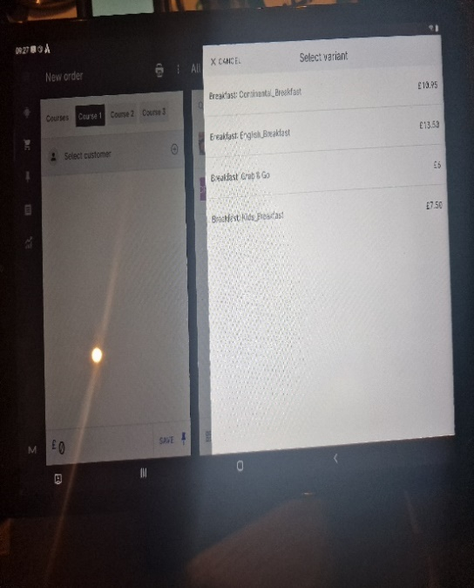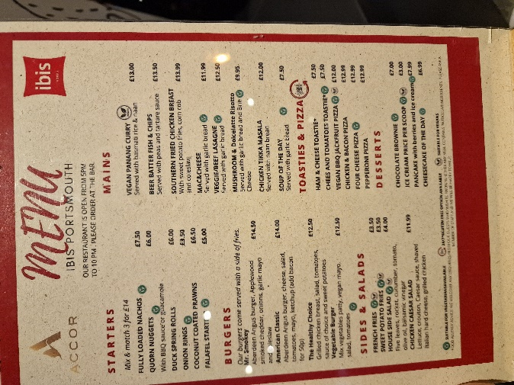  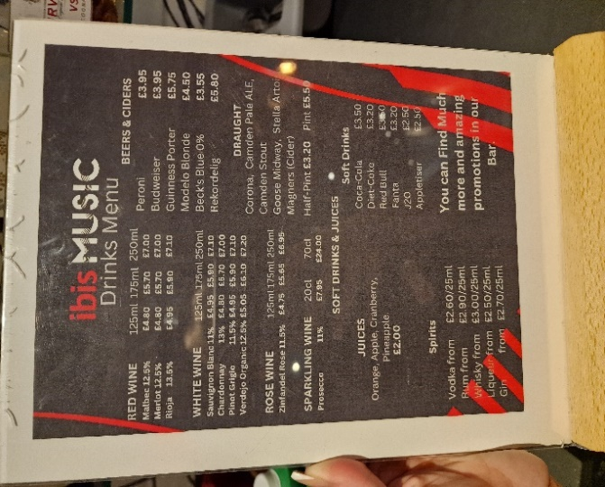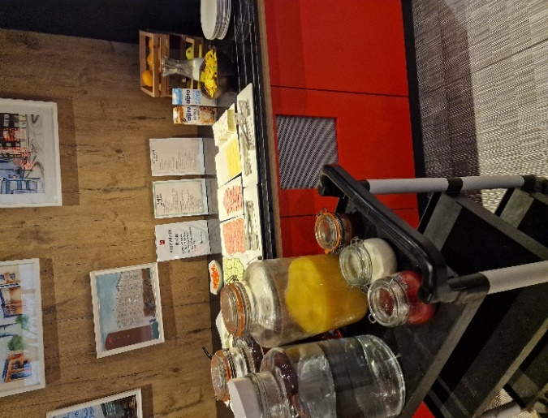  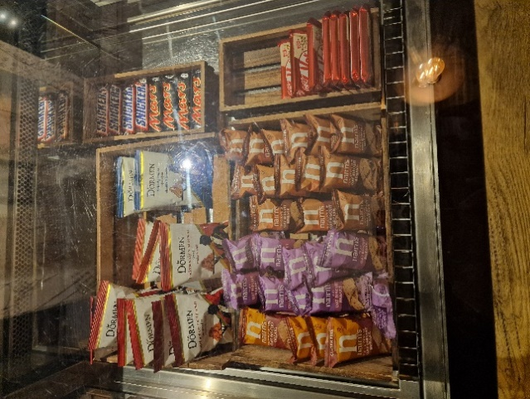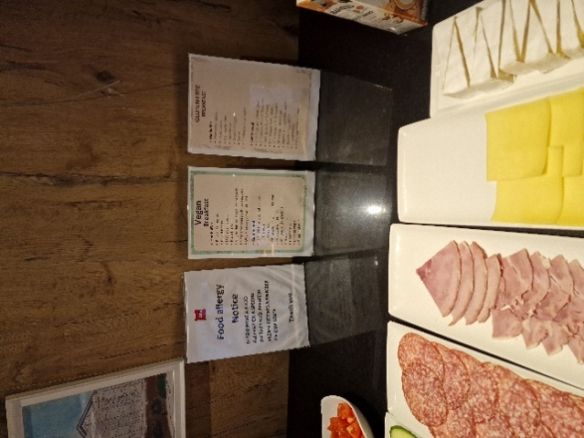  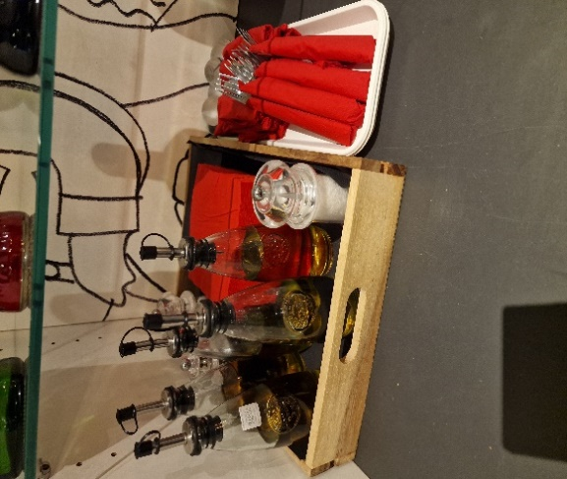  Day 8 - Reception  I worked at the Reception Desk today, primarily handling departures and check-ins. Early check-outs comprised visitors from rooms 316 and 317.  I took payments for the car parking, helped with guest check-ins at the front desk, and ran them through the OPERA system. For check-outs at 12:00 PM, I conducted room checks for 234 and 109 to inform guests of their departure time and check if they wanted to extend their stay or proceed with check-out. We also inform the housekeeping staff about these requests for easy transition.  One particularly noteworthy event occurred when a Room 109 guest returned to the reception desk at 11:00 AM after realising she had left her toothbrush case in the bathroom behind sight. The item was not found when a staff member searched the area for missing goods with the housekeeping supervisor. Then, given hotel regulations, it was presumed that housekeeping personnel had probably thrown it alongside other personal hygiene products. | 05.02/25- 07:00-15:30  10/02/25-07:00-15:30  11/02/25-07:00-15:30

Week 5
Experiences/Tasks/Challenges/Lessons  (highlight hotel department) | Shift  (Date/Time) | Student Signature | Hotel Mentor Signature
Day 9 - Breakfast and Reception  I first worked in the Food & Beverage section, where we served breakfast between 07:00 and 12:30; then I moved to the Reception Office.  At the reception, I helped guests check-in and observed how bookings through Booking.com evolved. These bookings are prepaid online, meaning no additional payment is required at check-in unless guests choose to add extra services.  One key aspect I learned was that breakfast could be added to a booking if it was not initially included:  If this service is paid during check-in, the amount comes out to be £12 per person.  If purchased the following day, the cost increases to £13.50 per person.  I also observed how front desk staff process pre-authorizations for payments. This stage guarantees that the hotel secures a payment option before confirming a guest's stay.  I also learned that visitors bringing dogs into the hotel pay a £10 fees.  Day 10 - Maintenance Operations and Guest Requests  I had the chance this morning to watch the hotel's maintenance staff's work and how repair requests are processed. The Reception staff report a guest's complaint about a problem in their room in an Excel report in the handover section of the Reception system. Accessible to maintenance, housekeeping, and office management departments, this report guarantees a coordinated response to guest issues.  For instance, a visitor from Room 222 attended Reception Tuesday, February 18, at 10:00 AM to report a faulty showerhead leaking water. The Reception staff sent the handover report with the problem straight to the repair staff. Not too long after, Thierry, the maintenance guy, grabbed his toolkit and went to fix the problem in the room.  During this procedure, the guest questioned whether they would be ready to wait for the repair to be finished or would instead be transferred to another room. The guest decided to stay in the room until the problem was fixed.  One key observation was the efficiency and prompt response time between the guest’s complaint, the log report, and the maintenance team addressing the issue. This flawless cooperation guarantees that operational problems are fixed without causing significant disturbance and that guest satisfaction is maintained. | 17/02/25-07:00-15:30  18/02/25-07:00-15:30

Week 6
Experiences/Tasks/Challenges/Lessons  (highlight hotel department) | Shift  (Date/Time) | Student Signature | Hotel Mentor Signature
Day 11 - Housekeeping Operations and Go Green Program  This morning, I watched the Housekeeping Department in action, including the Go Green program and the Housekeeping Supervisor's responsibilities. Go Green rooms are designated in the OPERA system so that guests can earn loyalty points. Over time, guests can progress from Silver membership to Diamond status, benefiting from the hotel's rewards program.  The Housekeeping staff arrive at the hotel around 10:00 AM and usually work until 2:00 PM, perhaps until 2:30 PM when many departures ask for it. Every housekeeping staff member gets a departure room list outlining the cleaning needed. Whether the room is a twin or a double, it can involve deep cleaning or preparing it for the next booking. The list also notes any requests (like rooms set aside for visitors with pets).  One such instance happened today when a guest from Room 311 stayed another day. They asked to remain in the same room without checking out or having to relocate their bags and possessions. The handover Excel file recorded this request, ensuring that the Housekeeping team was advised that Room 311 did not need cleaning that day.  This situation proved the effectiveness of internal communication between Reception and Housekeeping, providing a straightforward and well-coordinated workflow. The ability to quickly update the system and relay information directly contributed to an efficient and guest-friendly experience. | 27.02.25-07:00-15:30
Day 12 - Handling Walk-in Guests and Hotel Management  Today, Friday, February 28, I saw the Management Department handle a walk-in guest issue involving four university students needing accommodation. They asked for two rooms for a five-night stay while waiting for their University of Portsmouth student accommodation to be completed; they had not booked lodging ahead.  The hotel manager looked for room availability at the nearby Ibis Budget and utilised the operational system since the Ibis Hotel was completely booked. Luckily, Ibis Budget had rooms, and the students accepted the offer. This was a more affordable and practical choice for them since Ibis Budget rooms include bunk beds, which let up to three people in each room.  In addition to securing the rooms, the Manager and Reception Team Leader organised transportation to Ibis Budget at no additional cost to the students. They set up a cab through Aqua, a nearby taxi firm contracted with the hotel.  From this experience, I saw that competent customer service, strong organisational skills, good management and empathy significantly resolved the students' housing problem. The hotel and the management's dedication to customer satisfaction and effective problem-solving was reinforced by the fast decision-making and guest-oriented approach, which guaranteed an excellent result. | 28.02.25-07:00-15:30

