

Leading and Managing Projects (MBA)


PROJECT INITIATION DOCUMENT (PID)

INSTRUCTIONS:
- Give as much justification as possible for every question asked. This means, you must not limit yourself to just stating WHAT you believe is an appropriate response, but WHY.
- ALWAYS provide an outline of the financial and cost imperatives associated with your project aim and objectives. Remember, you must be able to SELL your project idea.
- Put effort into your PID and you will benefit when it comes to undertaking your project and writing your final report.

PID submission date detailed on module schedule

- Your name: | Nicole Williams 1802680
- Name of (client) organisation | Results or Excuses
- Aim of project:
In no more than twenty words, state the overall aim of the project.

The overall aim of this project is to attract new clients to the gym.

- Objectives of project:
Lists up to four objectives that are each directly from the project aim. The objectives should be S.M.A.R.T (specific, measurable, achievable, realistic, time bound).

Objectives:
- To identify strengths and weaknesses of the current marketing efforts to determine areas for improvement using a internal and external analysis frameworks.
- To explain to Results or Excuses the advantages and the importance of consistency of social media marketing.
- To provide recommendations which will ensure efficient and effective social media marketing for Results or Excuses in order to attract new clientele prior to the 24th April 2020.
- To use Key Performance Indicators to measure the increase of gym memberships.

- What is the business case for considering undertaking the project? Justify how achieving the project aim will advantage and benefit the business and its stakeholders.
The aim of this project is to attract new clients to the gym by evaluating the internal and external environments and by providing recommendations concerning social media marketing. Furthermore, the use of KPI’s to measure the uptake of memberships will allow an accurate measure of success.
Issues will be rationalised using both external and internal analysis frameworks (Aaltonen, K, 2011). The main reason for undertaking this project is the lack of participation in physical exercise (Booth, Roberts and Laye, 2010). This project will help lower the risk of obesity, as well as other health problems which result as a lack of physical activity. Additionally, research has illustrated that physical exercise has numerous positive benefits on the health and well-being of those who partake (Warburton, 2006).
Results or Excuses was created in 2018 as a Personal Training business. Over time, the participation rates meant that the owner was able to rent a space which he turned into a gym. In May 2019 Results or Excuses officially opened as a gym offering Personal Training sessions. The success of the small gym led the owner to rent a larger space to accommodate more clients. With the larger space, the owner was able to offer a private Personal Training room, a Hot Room (for Yoga and Pilates), a private Physiotherapist, a Beautician, as well as Training and Diet plans. With the increase of services, the gym looks more desirable to those who wish to look after themselves. Therefore, the owner is seeking to attract numerous new clients whose interests lie within self-care and physical exercise. The main competitors of the gym include more established gyms. For example, Simple Gym is the main competitor due to it being the closest gym in the area with a large customer base. The potential market size for Results or Excuses within the next year would stand at approximately 400 people; this consists of those looking to join a gym which are not already tied into a membership contract, as well as those in the local area which have been directly marketed to.
The key stakeholders for the business include the owner, customers, competitors, and suppliers.
The business would benefit from attracting new clients by:
- Increased revenue
- Heightened exposure through word-of-mouth
- Peer motivation to partake in physical exercise
The above factors are desirable outcomes of successfully achieving the project aim. These advantages also contain sub-factors; increased revenue could be reinvested in the business, used to improve equipment, or to hire more staff. Subsequently heightened exposure is good marketing for the business, or it could attract other businesses to work in partnership with. Therefore, the above factors are not limited to a single outcome; one main result could contain numerous advantages.
The stakeholders would benefit from attracting new clients by:
- Peer motivation to partake in physical exercise
- Building a profitable business and ensuring longevity
- More equipment will be needed to satisfy more clients
- Healthy competition ensures focus and best practice
The above factors are generalised benefits to the business’s key stakeholders; such factors could differ between clients. However, the more the aim is satisfied (the more clients attracted), the more the advantages gain weight for the stakeholders.
The project will be completed to benefit the community as well as clients, encouraging customers to engage in physical activity in order to improve their health and well-being (Warburton, 2006).

- Identify the risks associated with the project and how these could be overcome.
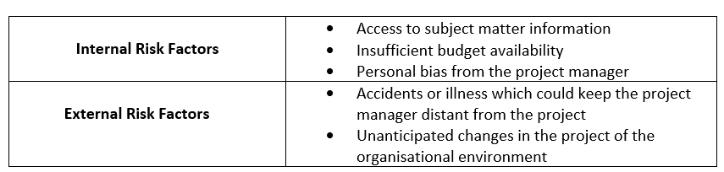
Risk Analysis (Ali, et al., 2020 and Dowding, et al., 2020).
The main risks to this project include personal bias from me as I have a personal relationship with the business owner. This could be overcome by remaining in a professional capacity when the project is concerned to eliminate such bias; this could be achieved through the introduction of a third-party during meetings. Additionally, lack of knowledge and experience within the business sector could be a downfall. This could be overcome through the project manager setting targets to familiarise with the health and fitness business environment; using journals and textbooks. Furthermore, unforeseen changes to the immediate business environment could disrupt the workflow and focus. Although such factors cannot be controlled, measures can be put in place to manage such situations; for example, taking a systematic project management approach in order to deal with issues as they arise in a timely manner.

- List the resources you will need to make your project a success. These may include, people, time, cash, technology, data. Say why you need them and identify any constraints that you may encounter and explain how you would overcome these.
The main resources which will need to be utilised for this project will be time to gather information, the business owner in order to supply said information and to attend regular meetings, and a laptop in order to design the marketing plan, GANTT charts, and the final report.
The project manager will need time to gather information from the business owner to identify the desired outcome and time to construct a cohesive external evaluation of the business. This could be achieved through an initial meeting whereby expectations are clearly outlined, followed by regular meetings thereafter.
The business owner will need to be available for regular touchpoints during the process of formulating the report in order to ensure scope. A constraint for this would be the availability of the business owner at amicable times. The project manager will overcome this by agreeing times and dates in advance to avoid disruption.
Technology will be at the centre of all design processes such as the external evaluation, GANTT chart and the final report. The Project Manager has volunteered their own laptop to be appropriate for this task.
Money will be needed in order to physically market the business in the form of flyers and discount vouchers. Additionally, a small cost will be attached to the website domain of the gym.

- If primary research is involved, state what method you intend to use to collect your primary data. Outline why a particular research method was chosen over alternatives.
There will be no need for primary research in this project.

- State from whom you plan to collect primary data and detail any challenges you anticipate.
N/A

- Operationalisation

Give a brief outline how you will operationalise this project, including a rationale for a project management approach if appropriate, and as a minimum an appropriate time and task plan.

In order to put this project into use, a meeting will be held with the business owner to discuss the completed plan and illustrate how the plan could benefit the business if utilised appropriately.
A systemic project management approach will be used for this project in order for focus to remain on the aim of attracting new clients to the gym (Song, 2012). This approach will ensure that each segment of the project is working in unison with others to achieve the project aim. Together with the internal and external frameworks to analyse the business, this approach will ensure success.

A GANTT chart (Tonchia, 2018) has been used in order to visualise a breakdown of workload and structure (Cohen, 2018).

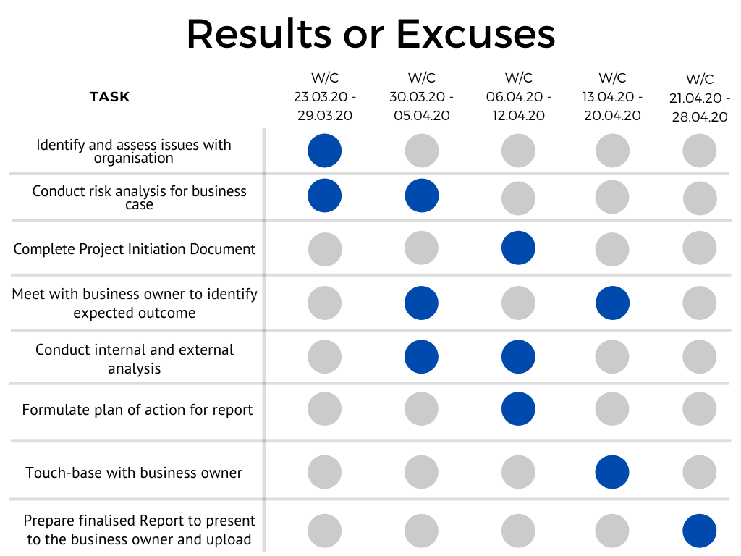

References
Aaltonen, K., 2011. Project stakeholder analysis as an environmental interpretation process. International journal of project management, 29(2), pp.165-183. Available at: https://doi.org/10.1016/j.ijproman.2010.02.001 [Accessed 09 Apr. 2020]
Ali, S., Altaf, N., Shah, I., Wang, L. and Raza, S.M.M., 2020. On the Effect of Estimation Error for the Risk-Adjusted Charts. Complexity, 2020. Available at: https://www.hindawi.com/journals/complexity/2020/6258010/ [Accessed 09 Apr. 2020]
Booth, F., Roberts, C. and Laye, M., 2012. Lack of Exercise Is a Major Cause of Chronic Diseases. Comprehensive Physiology, [online] 2(2), pp.1143-1211. Available at: <https://www.ncbi.nlm.nih.gov/pmc/articles/PMC4241367/> [Accessed 13 March 2020].
Cohen, E. (2018). A Beginner-Friendly Guide to Work Breakdown Structures (WBS). [online] Workamajig.com. Available at: https://www.workamajig.com/blog/guide-to-work-breakdown-structures-wbs [Accessed 09 Apr. 2020].
Dowding, M., Mugridge, T., Swift, C., Jackson, K. and Hancock, J. (2020). Risk Impact/Probability Charts: Learning to Prioritize Risks. [online] Mindtools.com. Available at: https://www.mindtools.com/pages/article/newPPM_78.htm [Accessed 09 Apr. 2020].
Song, Y., 2012. Systemic project management. Journal of Project, Program & Portfolio Management, [online] 2(2), p.78. Available at: <https://doi.org/10.5130/pppm.v2i2.2453> [Accessed 13 March 2020].
Tonchia, S., 2018. Project time management. In Industrial project management (pp. 117-129). Springer, Berlin, Heidelberg. Available at: https://link.springer.com/chapter/10.1007/978-3-662-56328-1_10 [ Accessed 09 Apr, 2020]
Warburton, D., 2006. Health benefits of physical activity: the evidence. Canadian Medical Association Journal, [online] 174(6), pp.801-809. Available at: <https://www.ncbi.nlm.nih.gov/pmc/articles/PMC1402378/> [Accessed 13 March 2020].

The form has 334 words in instructions, these are not to be included in your word count of 1000 words +/- 10%

