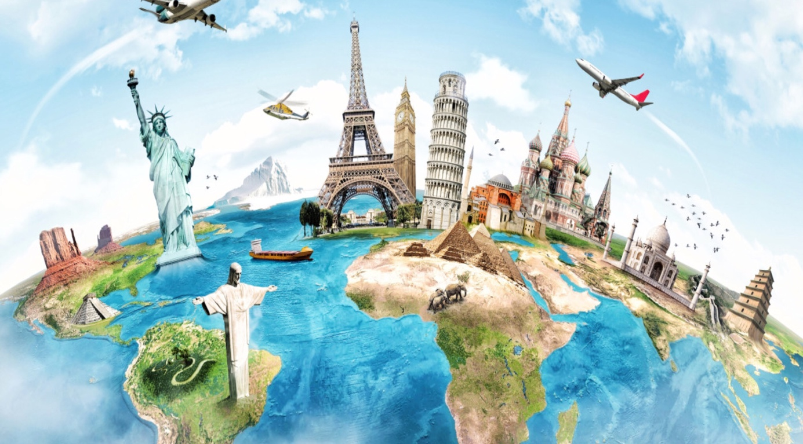

Foreign Languages & Cultural Awareness

(M4X01923)

Carmina Lorena Cornea Lecturer : Dale Clarke
1815046

Content Page

Introduction .............................................................................................1

Italy .........................................................................................................2

France ....................................................................................................3

England ..................................................................................................4

China ......................................................................................................5

Conclusion ..............................................................................................6

References .............................................................................................7

Introduction

The Hospitality organisations which are operating internationally train their employees and managers to interact efficiently with customers from different cultural environments.In the international hospitality industry the cultural awareness become very important in relations with guests and are several reasons to justify why the organisations have to be aware of those interactions and the possibilities to managing them.
The commonalities and differences which exist between culture are provided to understand costumers behaviours and perceptions in the hotel industry.
Foreign languages are one of the most important factors in the development of the international hospitality and the most spoken languages are english,french,spanish,portuguese,russian,arabic and chinese.
Cultural awareness is showing the cultural differences as a issue for the businesses success.The language barrier can be a problem in the hospitality which can generate a understanding situation and can lead to dissatisfaction of the costumers which is coming from a different background .
“The role of foreign languages in the delivery of quality service is significant in that they are an important tool to make a guest feel at home,hence draw more brand loyalty and larger cash flows (Torres & Kline,2013).”
Culture has a strong impact on costumers,expectation and evaluation of service quality,customers from different cultural backgrounds are having higher expectations related to their standards of service quality,that why is imperative to look at the service cultures of each country and from which hotel operators can determine what guests from each culture expects from their services.If the hoteliers are aware and are investing each culture helps to customise and design their services for each culture beliefs and traditions.

Italy

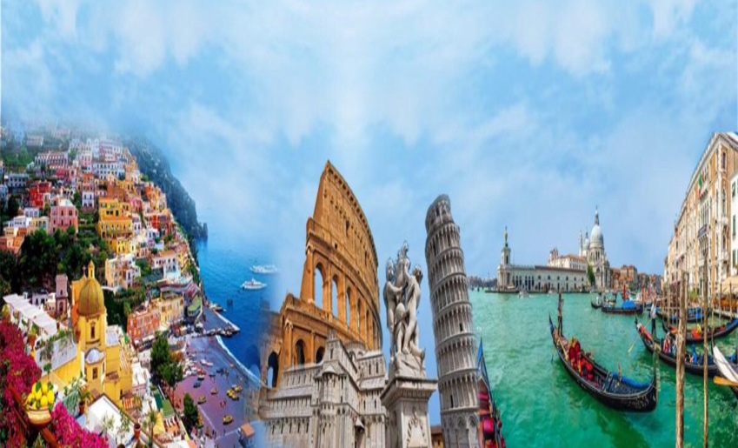
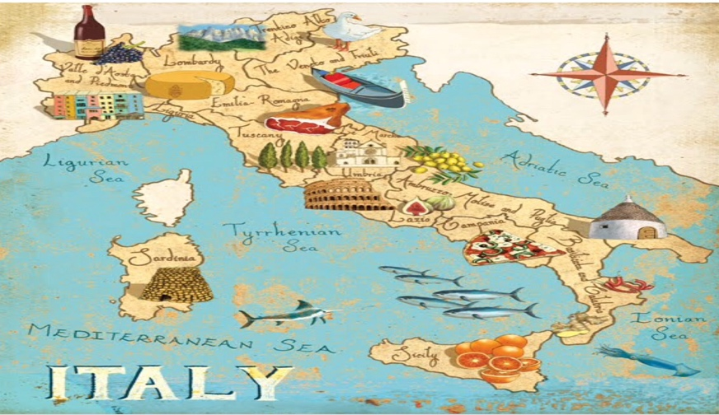
Italy official language is Italian and is spoken by 93% of the population,there are also spoken on dialects and most of the population is Catholic about 88%. For the Italians the family is very important in their culture and they are supporting each other and ,travel together and spend a lot of time with their families. Italian culture is famous as fast cars,high fashion,arts,family,architecture,music,food and wine.Italy is also well known for some less positive aspects of its culture as organised criminal organisation known as the Mafia.
Italy is home for a number of fashion brands like Armani,Gucci,Versace,Prada and other famous brands.
The Italians are using must of their local products and Italians cuisine has influenced food culture around the world.Wine,cheese and pasta which comes in different shapes,widths and lengths are important part of Italians meals.Food is life for Italians and they always heaving their meals with their family. Each region of Italy are having different common ingredients as for central Italy the most famous dishes are spaghetti and pizza,for the North of Italy the most common ingredients are fish,rice,potatoes,sausages,pork and different types of cheeses.Pasta dishes with tomatoes are popular,as are many kinds of stuffed pasta,polenta and risotto. In the South the fresh or cooked tomatoes are dominating the dishes and also includes on their dishes capers,peppers,olives and olive oil,garlic,artichokes,eggplant and ricotta cheese.
Wine is also a big part of Italian culture,and the country is producing a lot of famous quality wines in especially from the southwest coast near Sicily.
“ The archaeological implications of this new data are enormous,especially considering that the identification of wine is the first and earliest attested presence of such product in an archaeological context in Sicily (Microchemical Journal,2017).”
The Italians are respecting the old people and also their habit to have their lunch break of two hours doesn’t matter what.
The Italians are mostly travelling on the month off August and they prefer to travel to cooler climates also and they are mostly conformists in their holiday habits as having a proper lunch,visiting the attractions of the city and museums.They are very social and they like to do things together and to interact with other peoples .
Italians are great communicators,very open with a sense of humour,using many gestures and loud ,therefore,avoid ambiguity and indirect speech.The first impression counts a lot for Italians and they usually use to shake hands and have a eye contact when they are having a conversation.

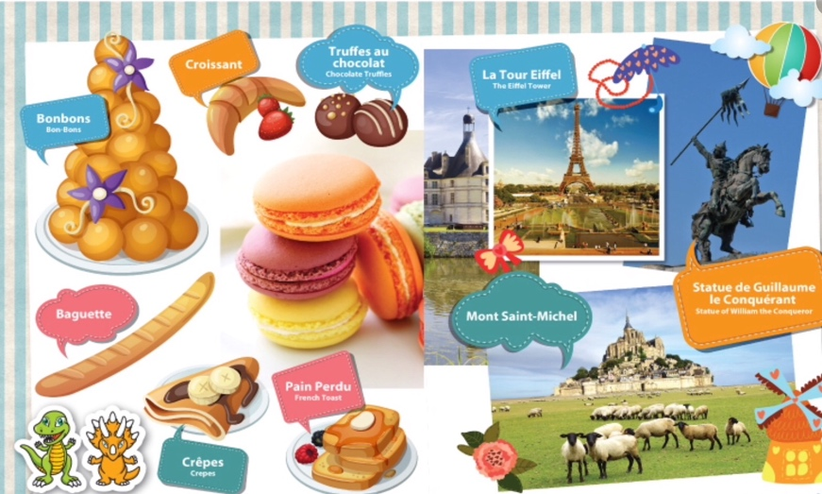
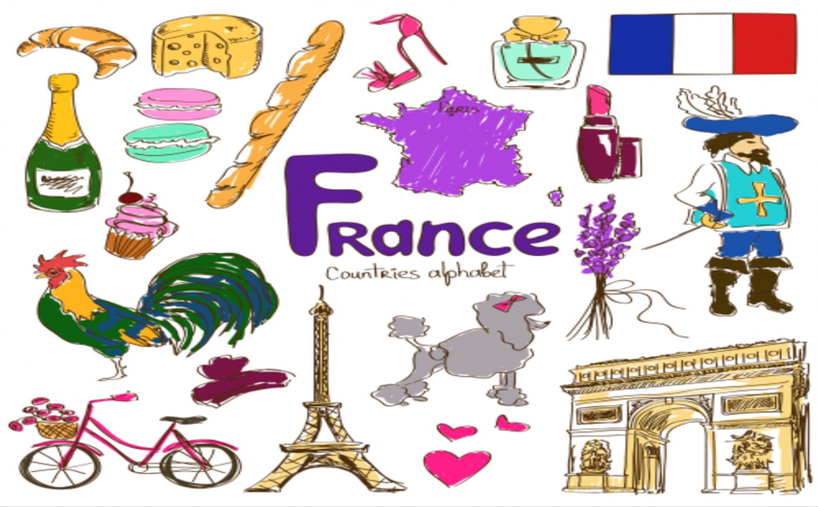
France
French is an official language of many international organisations including the United Nations and the European Union and is the third most useful language after English and Mandarin.France is the land of wine and cheese producing those more than any other countries,french gastronomy is having the most intangible cultural heritage from the world.France varies by the region and they are mostly using their locally grown products,how the cooking is refined and involves careful preparation,attention to details and always are using fresh quality products .For the french people is very important to be on time for dinner,the cutlery’s has to be organised in the right order and the guests have to have a right position on the table.
Table manners are important for them also and the seating plan .
France is associated with Paris,which is the center of fashion,cuisine,art and architecture,but can be also very different and varies by the region.
Caholicism is the most predominant religion of France.The french people are very proud of their nation and government and they can be offended about any negative comments about their country.They are embracing style and sophistication and are proud that their public strikes a regal tone and they are very open minded.
Paris is known as the home of fashion like there are so many fashion brands like Dior,Hermes,Louis Vuitton,Chanel any many other important and famous brands. The people dress in a sophisticated and fashionable style but not fussy,the typical outfits as dresses,suits,long coats,scarves and berets and the most common word which is associated with french fashion is haute couture .
The Louvre Museum in Paris is the largest museum from the world and is home of many famous works of art,like Mona Lisa.
The french people mostly travel on July and August having their summer holidays.
The family for the french is an social adhesive of the country and each member has duties and responsibilities,they are supporting each other and they are known like romantics,having a practical approach towards marriage and taking their role of parents like guardians and providers for their children.
Always is important to know when approaching french people that they are handshaking like a common form of greeting,they are very polite and they are different rules and behaviours for people from their social circles and those who are not.
The politeness is one of the most important value for the french and everyone deserves respect and to be treated equal.French people communication is mostly direct and they are not afraid to share their options but also thei are can be hard to be understood because of their communication can be difficult to interpret,leading to ambiguity.

England
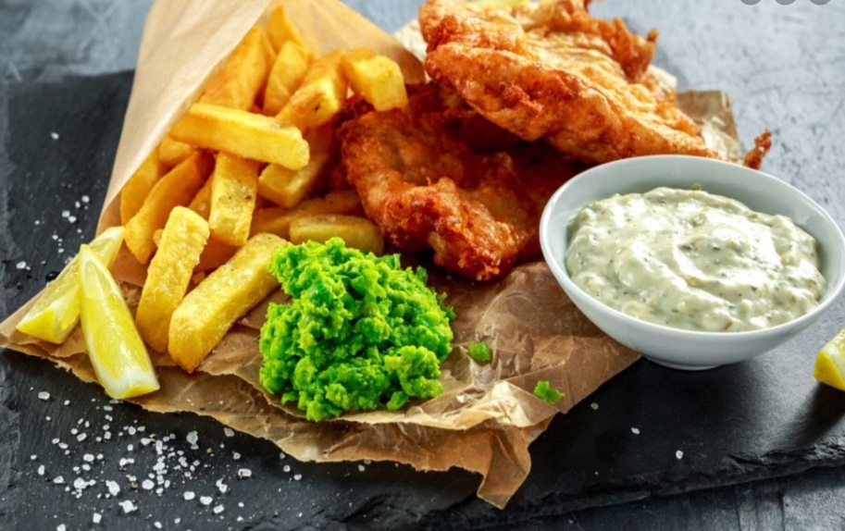
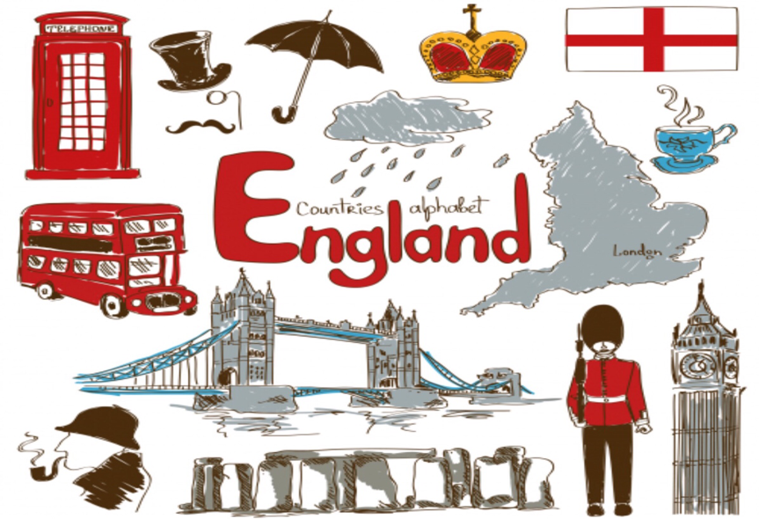

English is an official language spoken in the UK like a main language and is used like a International language around the world but there are also other languages spoken across the country that has envolves during the history of UK.Some of those languages are Welsh,Gaelic,Irish and Cornish,each of those languages are having their own dialects and accents.The official state religion in the UK is the Church of England which is of the Christian Protestant faith,there was a huge decline in the role of the Church in Britain and is estimated that is the third population who do not have religious connection. United Kingdom is a constitutional monarchy but the monarch can act just with the approval of Parliament,the English people are respecting the Queen and always celebrate her birthday.
British culture is rich in history as art and architecture,food,fashion,music,education and sports.
Sometimes comes the confusion about England because they favourite dish is Indian chicken curry and people drive on the wrong side of the road and in Uk is fined a diversity of culture and people and the English peoples are open to try any different cultures dishes.
The British traditions in food are so diverse because of the different cultures of countries,the most associated dishes with the UK cuisine are Yorkshire Pudding and Roast beef,fish and chips,Eccles cake,black pudding,laverbread, scotch eggs,shepherd pie,English breakfast and the famous tea.
The fashion trending is reflecting the western society,but the young people my follow the actual global fashion as jeans,T-shirts,jackets and sneakers, and for those which are working in the office their usual wear will be elegant as businesses suits.UK is mostly know about the rainy weather and the British people always having to carry umbrellas across.
The British also are known about their beer and traditional pubs and the global history of music ,for them is important to have fun and to listen a good music.
The sports is very popular among the British people like football,cricket,tennis and boxing.
Probably the most recognisable British icons is the red telephone boxes there are around 2000 of them and have been listed as proper buildings and the other icon is the double buss and the black cab.
In England the people are excessively polite and are using the sarcasm on daily basis.
The English people like to travel anywhere and anytime and they travel for the business interests also.They like to be punctual,never jumping the queues,in interacting with other people they shake the hands and always keeping the eye contact with a smile and a bow of the head.Also they respecting a lot the old and disabled people and they are calm and polite.

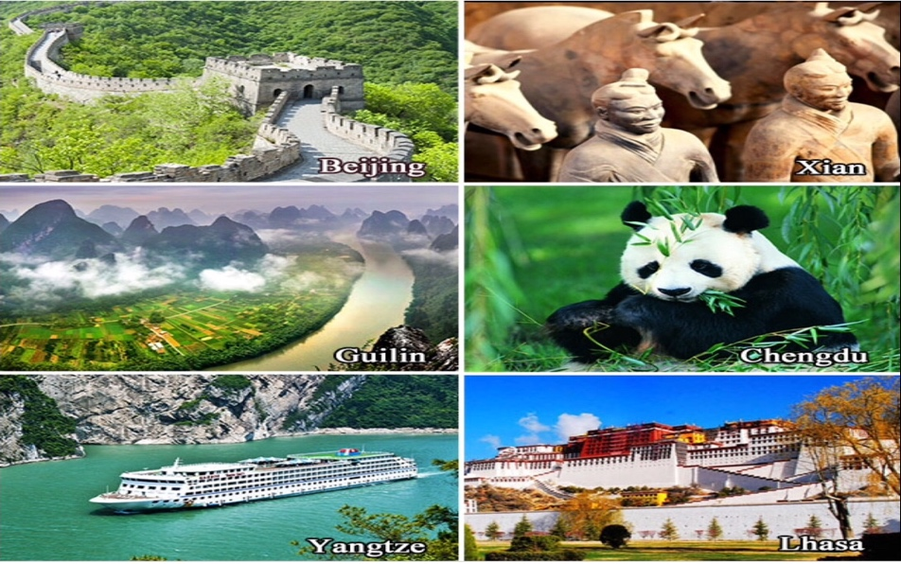
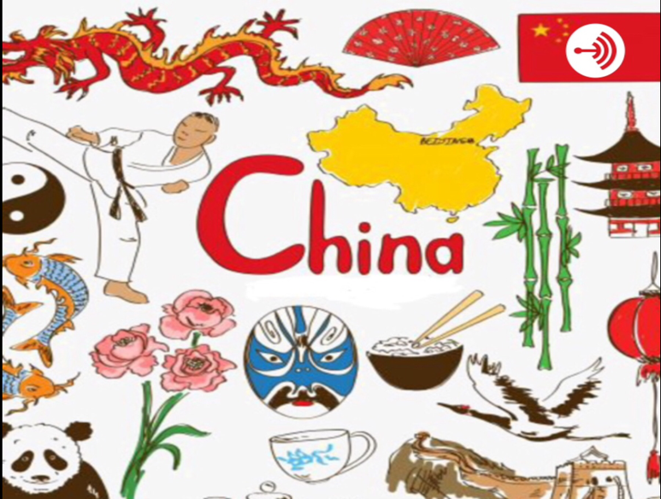
China

The common language in China is Mandarin , Cantonese and many dialects,but the Mandarin language is the most useful language which is used internationally also.The most common religion of China is Taoism or Daoism,and became of the diversity of population from all over Asia in China can also have religions as Buddhism,Christian and Islam.China is a communist country and there is a big gap between rich and poor people.For the Chinese people the family is very important and is been placed upon hierarchy and the Chinese values are based upon Confucianism culture which stresses duty,sincerity,loyalty,piety and honour.
The history of the culture of China is rich in art,literature,architecture,kungfu,festivals.
China has his symbols like long coiling dragon,the red flag,pandas,the Great Wall and others.
The Chinese food is so much influenced by geography and ethnic diversity,the rice is almost not missing from their dishes,the Chinese breakfast contain noodles or wheat bread,rice porridge,vegetables and pickles.People mostly cook in a wok,the most populate dishes include duck,seafood,sweet and sour sources ,spring rolls,frog legs,pork and chicken and most of their dishes are spicy.The Chinese are known about the diversity of flavour,spices,colours and taste of the food any complementary ingredients such as,bamboo shoots,string beans,water chestnuts,Chinese mushroom,ginger root,garlic,chillies and coriander.The beef is prohibited in their culture food because is sacred for them.
The expression saving face is important for them and mean that the first impression counts or the right to please someone is more important than honesty and is cunsiderered rude or offended to refuse a request.
China is the thirteen largest country from the world with the biggest population and is the second biggest economy from the world also.
The Chinese people are collective society,they also like to travel for holidays or business interests,the communication is indirect,they avoid the eye contact,and like the privacy ,handshake is the most common form of greeting and the oldest person is always greeted first.The gifts are always given with two hands , are very punctuals,the table manners are very important also for the Chinese people.
Always in a formal situation with the Chinese people,should be addressed by their title followed by their last name and is not appropriate to be send to them an email or message in the red colours because red colour for them mean protests.
“Pathways to Asian Civilisation:Tracing the origins and Spread of Rice and Rice Cultures,”(Dorian Q. Fuller,2011).

Conclusion

Hospitality Industry and especially the Hotels are becoming so competitive and are facing many challenges in delivering quality,flawless and satisfactory services to all costumers from around the world this is why those organisations should know the essentials characteristics of culture and traditions of each region.
Diversity mean the difference between the people from around the world and that includes gender,race,age,religion,culture and traditions.It is indicated also for the hotel strategy which can improve the level of guest and staff satisfaction,hiring people from different backgrounds.Also the greeting is important for each individual and de food selection,in general the people which are travelling are open to try new things but they also prefer to have some familiar options,this is why the hotel have to collect data from the guests.
The management of the hotel needs to be aware of the majority of the guests which they are having them in their hotel and to can provide and create a traditional and authentic option. The staff needs to be aware of the religion of the guests also because many religions are very strict and the guest need to adhere to even on holidays.
Dinning and religion are the most important cultural awareness which the hotel and the staff have to consider but the room and the interactions with the guests are very important to.
The way how the staff is interacting with the international guests is the most important which is the first impression of the guests and the staff need to be aware and to learn the greeting forms of each country,the manners,behaviours and traditions.
The staff need to be well trained about that and to be motivated also,because always a satisfied associate will provide a great service to the guest and that mean the guest will give a positive review which means that the guest is satisfied also.

References

- Busby G. D., Gibson P. (2001), Tourism and hospitality internship experiences overseas: A British perspective,”Journal of Hospitality,Leisure,Sport and Tourism Education “, 9(1),pp. 4-12.

- Barry T. (2013), France- Culture Smart! : The Essential Guide to Customs and Culture.

- Essay, UK. (November 2018). “Foreign Language In The Hospitality Industry Tourism Essay.” https://www.ukessays.com/essays/tourism/foreign-language-in-the-hospitality-

- Gao Qi. (2005) The treasure Hall of China’s Science and Technology. Jinan Shangdong University Press.

- Morgan C., Cain A. (2000), Foreign Language and Culture: Teaching from a Dialogic Perspective. Clevedon: Multilingual Matters.

- Commisceo Global Consulting Ltd. (2019). Afghanistan- Language,Culture,Customs and Etiquette. https://commisceo-global.com/resources/country-guides/afghanistan-guide

- Jen G. (2007), Focus on Italy. : World in focus. World Almanac Library

- Tomalin B., Stempelski S. (1993), Cultural Awareness.Oxford: Oxford University Press.

