Training and Development needs for a HR officer

Student Name: ADRIANA TRIFU
Student ID: 812538
Module Title: DEVELOPING RELATIONSHIPS AND WORKPLACE ACHIEVEMENT
Lecturer Name: ZEE ZOOK

Table of Contents
Introduction 3
Main body 5
Key expectations of HR Officer Roles 5
Knowledge and Behaviour Capabilities 5
Knowledge, skills and behaviours of a HR Officer 6
Personal Skills Audit 7
Benefits of developing a HR Officer 9
Conclusion 11
Reference List 12
Appendix A 14
Appendix B 15

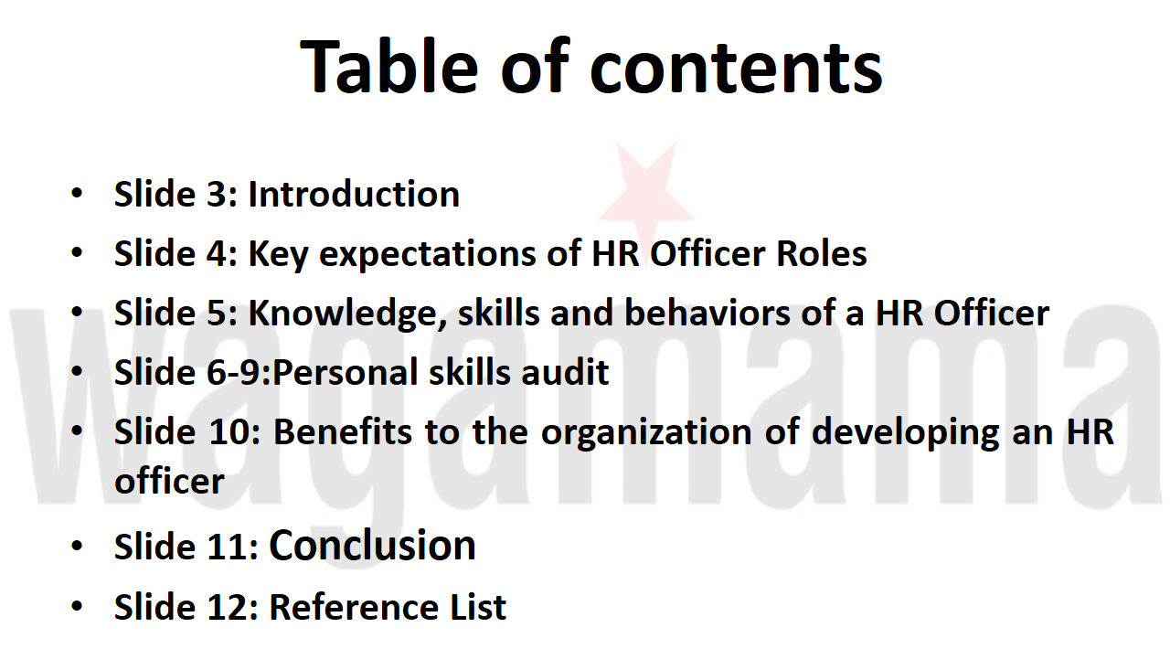

Introduction
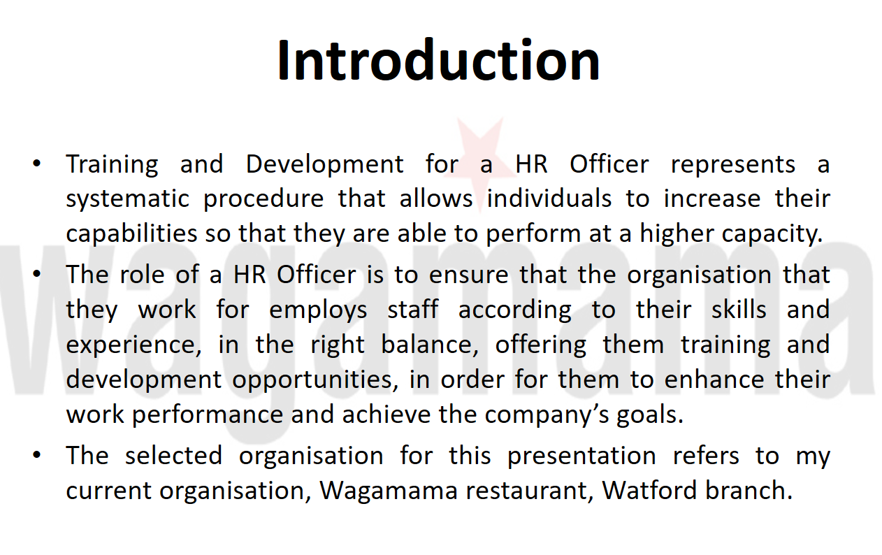

Training and Development is a systematic procedure that allows an individual is to increase their capabilities so that they are able to perform at a higher capacity. It is imperative for development and training to take place as it allows the scope of providing high level of quality for the products and services that are being produced in the business. In this analysis, the organisation, which has been selected, is Wagamama restaurant. This is our Watford based organisation that specialises in providing Asian and Japanese specific cuisine (wagamama.com, 2020). In this analysis, a variety of knowledge, skills, and other aspects will be analysed for the HR professionals operating in Wagamama.

Main body

Key expectations of HR Officer Roles
In an organisation, it is important for the human resource individuals to demonstrate a wide knowledge about several different areas in an organisation. The main expectations of a HR Officer are as follows:
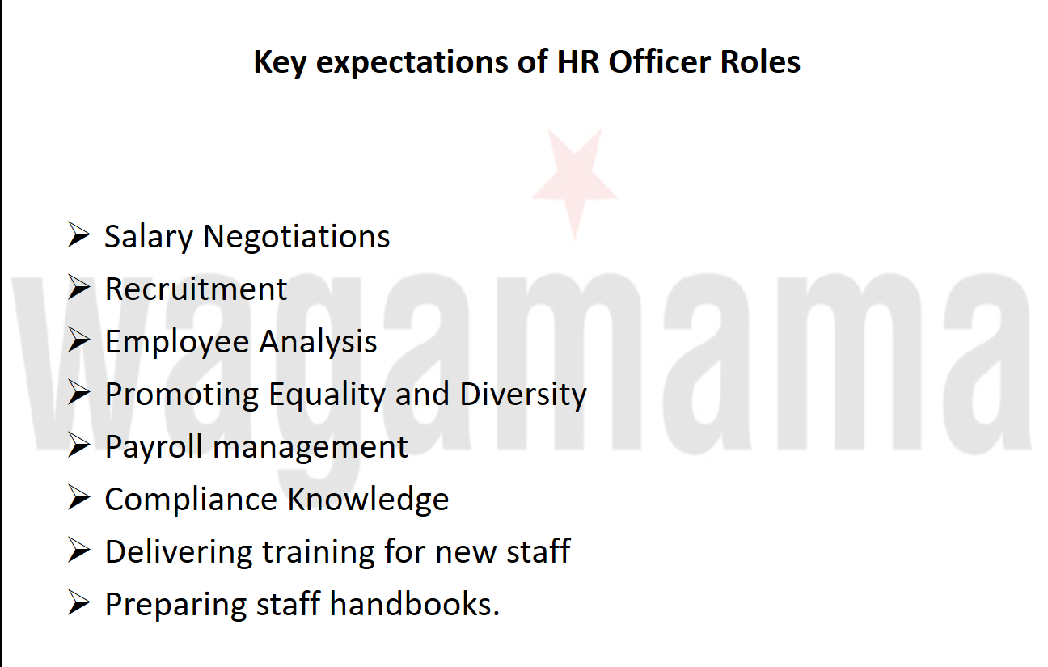

Knowledge and Behaviour Capabilities
Salary Negotiations: An HR Officer must be able to negotiate a specific amount of salary with new candidates that are coming into the organisation so that appropriate remuneration can be provided to employees as well as more revenue can be pulled back for the organisation in a long term (Noe et al., 2018).
Employee Analysis: HR individuals must be able to analyse the capabilities of subordinates that are operating in the organisation and provide good training and development programs and tasks through which they are able to operate at a better capacity (Marchington et al., 2016).
Promoting Equality and Diversity: HR individuals must be able to adhere to different types of equality acts, trade union acts and other aspects that will help in implementing no discrimination amongst subordinates (Noe et al., 2017).

Knowledge, skills and behaviours of a HR Officer
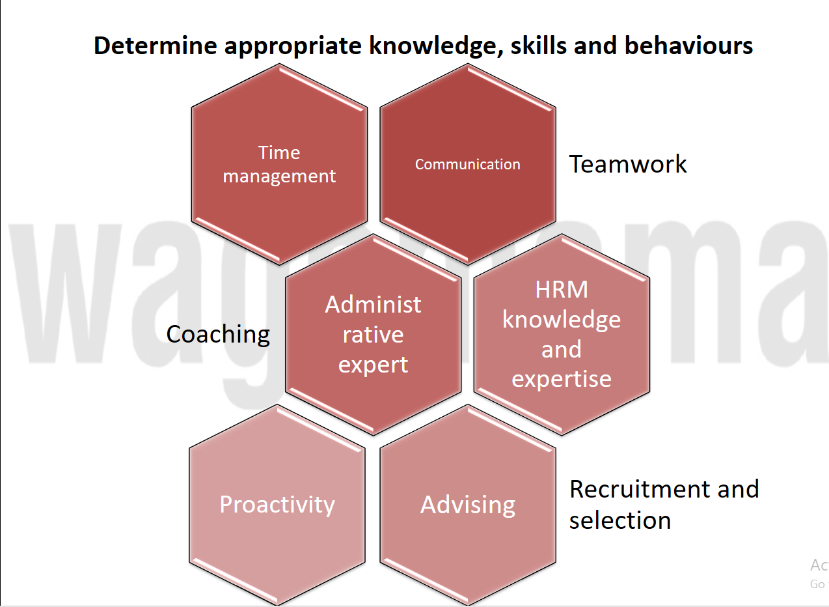

Communication Skills: It is necessary for a HR individual to have a variety of communication skills such as written, verbal, body language, and other types of verbal interaction abilities. This helps in interacting with clientele individuals and executive heads inside organisation as well.
Time Management Skill: HR individuals should be able to manage their professional time adequately so that a large number of candidates can be evaluated appropriately and hiding procedures can be implemented in Wagamama at an optimal level as well.
All of the above aspects in Wagamama restaurant, are helping with creating an inclusive environment, assisting in subordinate development, and in increasing the knowledge capability and retaining profits within the business.

Personal Skills Audit
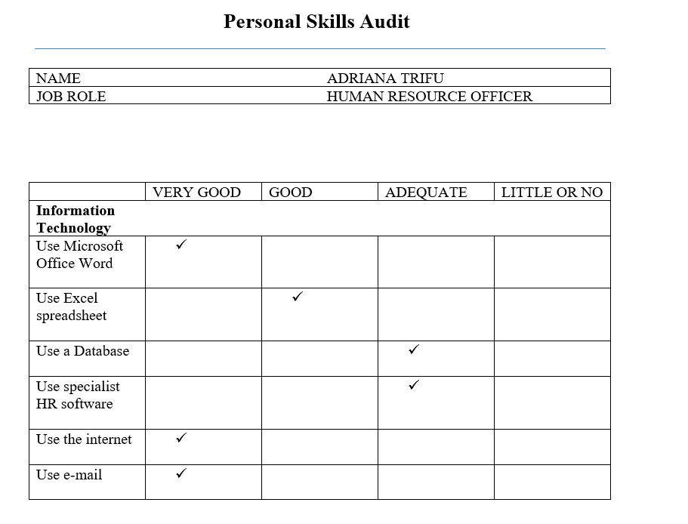
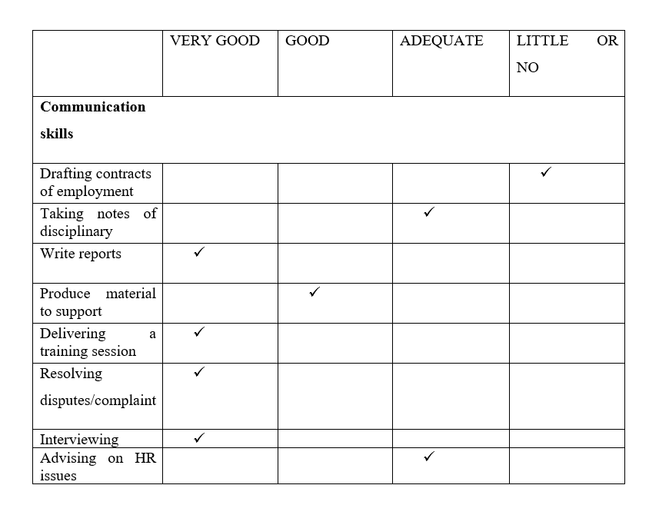
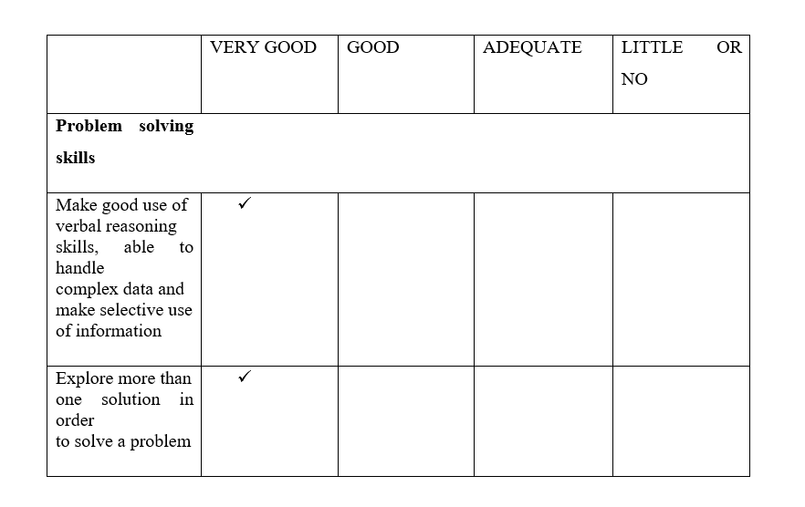
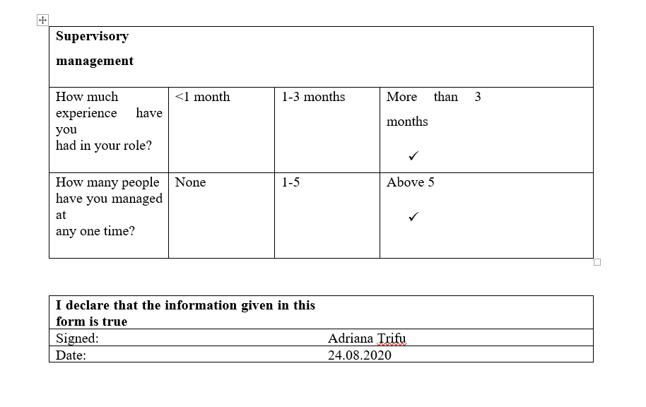

Benefits of developing a HR Officer
From the above analysis, it can be understood that there are various aspects in which improvement is required for me, in order to evolve as a HR Officer. It is necessary providing good support material to employees so that they are able to understand what skills they need to improve, in order for them to perform their duties. Apart from this, a crucial area in which improvement is required as well, includes being able to handle complex data and verbally communicate to a large number of individuals. However, it can be understood that there are a higher number of fields in which HR individuals needs improvement, for example, being able to create contractual documents, and having a good margin of experience in the field. Apart from this, having a well-to-do understanding of computers is essential as well. At Wagamama, a good understanding of computers represents a must.

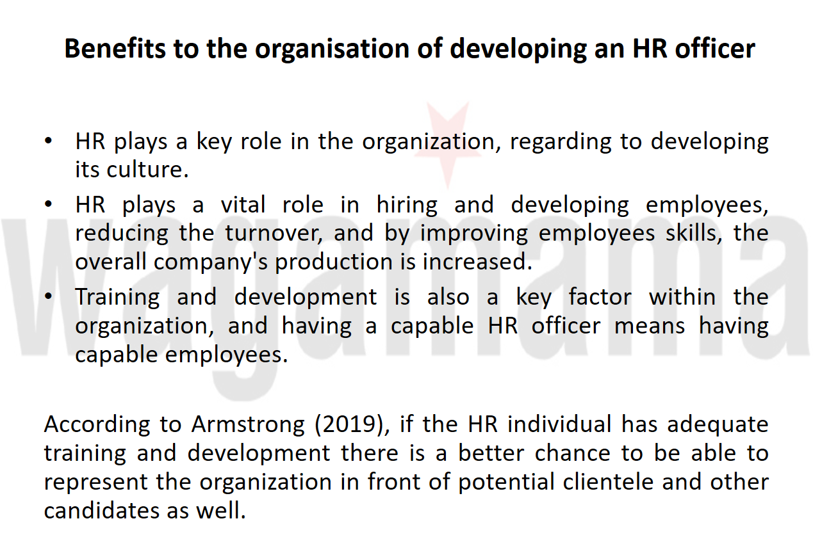

As postulated by DeCenzo et al. (2016), a HR individual can provide better communication, employee performance, subordinate recruitment, and other aspects through appropriate training and development. Training and development processes are required in order for me to become a HR Officer for this company, but there are also benefits for the company. In the context of Wagamama, training and development allows the scope of hiring experienced chefs, waiters, and other individuals who will help in assisting the customer’s needs, and the business goals. I am working for this company for less than one year, and I have already become a black belt, whose role is to train other people. This shows a lot of commitment, many working hours and my desire to evolve and learn as fast and as much as I can, but also the ability of doing so.
In the words of Bratton and Gold (2017), an HR individual has the potential of increasing the profit rates of the company if they are more capable as they have an experience in what other businesses are providing as well. I agree, and I must say that I do have this capacity already. It has been proved that I am able to increase the profit rates of the company more than once, in our weekly challenges between all employees. I won 5 competitions in a raw, having the higher selling rate on desserts and drinks, together with the highest amount of money on the bill, with more than 30% tip. This proves the fact that I am able to communicate well, and empathise with the customers. Many surveys and a lot of amazing comments from our customers shows that they are coming into the restaurant because they really enjoy the way I am connecting with them. However, in order for HR individuals to have such a wide amount of knowledge, they must have industrial experiences, which not all individuals have. In Wagamama, it is imperative that training and development takes place as it will help in better cultural orientation and enhance the probability of providing enhanced experience to clients that come into the restaurant.

As mentioned by Armstrong (2019), if the HR individual has adequate training and development there is a better chance to be able to represent the organisation in front of potential clientele and other candidates as well. However, extensive resilience and persistence is required for individuals so that they can be welcomed into the business. In Wagamama, it is mandatory for optimal mannerism to be promoted as the nation culture relies on such type of conduct in order to provide food to consumers. This helps in providing a more authentic experience.

Conclusion
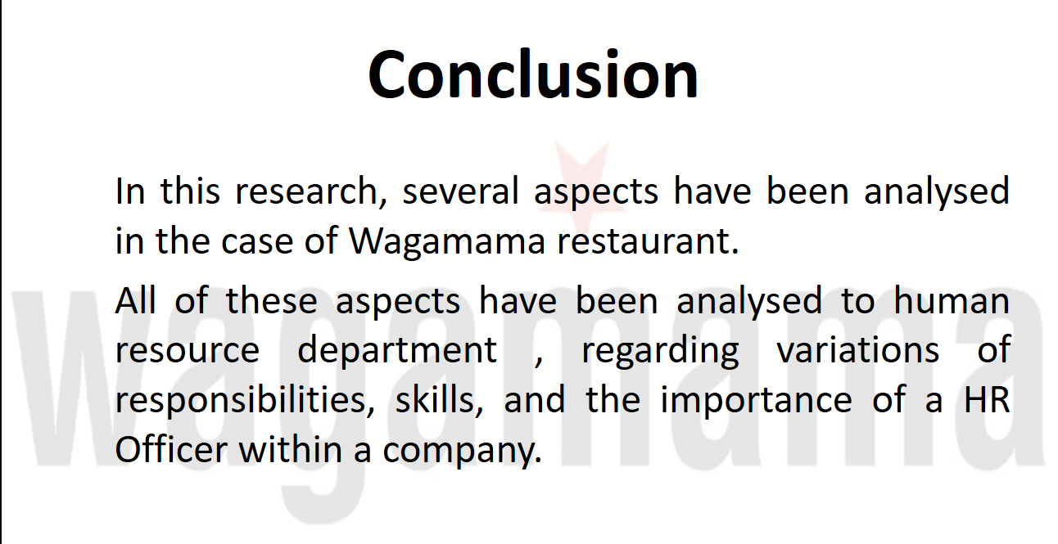

In this research, several aspects have been analysed in the case of Wagamama restaurant. All of these aspects have been analysed from the human resources point of view, discussing several topics such as: variations of responsibilities, skills, behaviours and a personal audit has been conducted as well. The purpose is that the duties and values which are provided by these individuals, are understood. In the finances of this analysis, a critical overview has been provided on the positive and negative aspects of the type of productivity human resource individuals can bring, if training and development is provided to them. Furthermore, a presentation has been created, through which comprehension is enhanced, and helps understanding all these aspects in a visual manner.

Reference List

Marchington, M., Wilkinson, A., Donnelly, R. and Kynighou, A., 2016. Human resource management at work. Kogan Page Publishers.
Noe, R.A., Hollenbeck, J.R., Gerhart, B. and Wright, P.M., 2017. Human resource management: Gaining a competitive advantage. New York, NY: McGraw-Hill Education.
Noe, R.A., Hollenbeck, J.R., Gerhart, B. and Wright, P.M., 2018. Fundamentals of human resource management. McGraw-Hill.
wagamama.com, 2020. wagamama | home Available at: https://www.wagamama.com/ (Accessed: 17 August 2020).

Appendix A
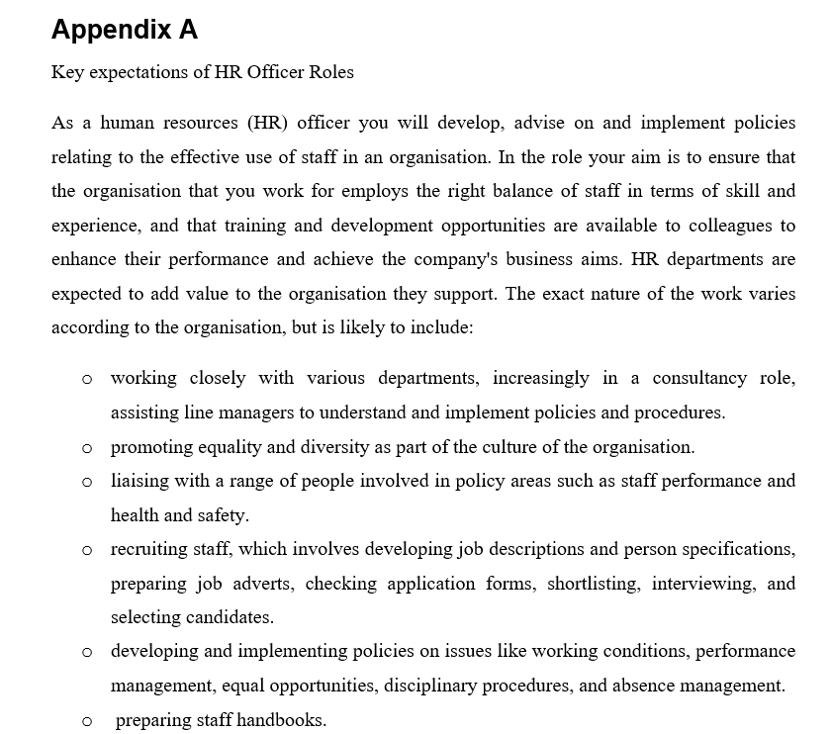
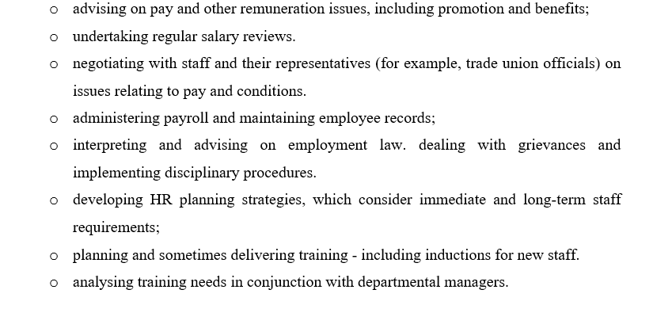

Appendix B

Personal Skills Audit
NAME | ADRIANA TRIFU
JOB ROLE | HUMAN RESOURCE OFFICER

 | VERY GOOD | GOOD | ADEQUATE | LITTLE OR NO
Information Technology
Use Microsoft
Office Word

Use Excel
spreadsheet

Use a Database

Use specialist
HR software

Use the internet

Use e-mail

 | VERY GOOD | GOOD | ADEQUATE | LITTLE OR NO
Communication skills
Drafting contracts
of employment
Taking notes of disciplinary
Write reports
Produce material to support
Delivering a training session
Resolving disputes/complaint
Interviewing
Advising on HR issues

 | VERY GOOD | GOOD | ADEQUATE | LITTLE OR NO
Problem solving skills
Make good use of
verbal reasoning
skills, able to handle
complex data and
make selective use
of information
Explore more than
one solution in order
to solve a problem
Consider the ideas
of others to help
solve problems

Supervisory management
How much  experience have you  had in your role? | <1 month | 1-3 months | More than 3 months
How many people  have you managed at  any one time? | None | 1-5 | Above 5

I declare that the information given in this form is true
Signed: | Adriana Trifu
Date: | 24.08.2020

