Community Engagement

Student ID:1814714
Student name: Ioana-Alexandrina Luchian

Topic: Managing a difficult Customer

Welcome everyone. Today I’m going to present some ideas and strategies on how to manage a difficult customer. It can become a real struggle as a manager, to keep calm and sort things out properly with a customer, specially if the customer is behaving in an unacceptable way. But if we keep few key factors in our mind, then managing a difficult customer will not be a tough job.
Business nowadays is not solely depended on good quality products, but a combination of quality goods and premium customer service. If as a manager, I can build proper relationship with customers and listen to their quarries and complaints, then it will benefit the business in many ways.
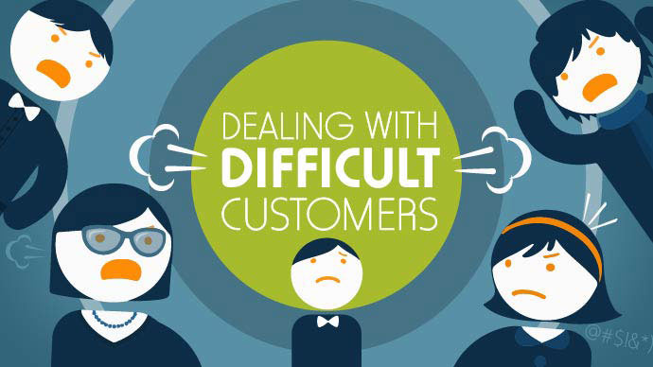
Suppose, a customer bought a Gucci handbag and returned to the store the following day with a complaint that the handbag is defected, and she wants her money back. It can be a downright difficult situation to handle if the customer becomes furious and starts arguing. But I can sort out the situation by following few key strategies. These basic steps will help to sort things out no matter what complaint the customer comes up with.


The First Step is to Listen:
I will listen to the customer what she has to say. Even if I know that her claims are not justifiable, I will listen to her with all my attention and never argue with her. I will try to put myself in her shoes and try to sort things out accordingly.


Showing the Customer, I Care:
I will show my utmost care toward her problem. I will maintain my concern and sincere interest throughout my tone and specially body language. I will nod while listening to her problems which will indicate how invested I am to the cause. Gucci customers are always treated with proper care and their problems are always addressed.

Repeating Customer’s concerns:
After listening to the customer’s issue, I will repeat the issue to her in order to make sure I have understood her problem properly. If I feel the need then I would ask questions to make sure I am addressing the correct issues. Repeating the issue will also makes sure that I was actively listening to the customer which can help to lower the stress level of the customer according to Lipow (2019). I can use phrases like, “Yes madam, I understand. I am very sorry your purchased handbag was defected.”


Being Empathetic:
I will be empathetic about the whole situation. I will make her feel that I understand her reasons for being furious, and I will do everything in my authority to help her. It’s very necessary to pay more attention to the customers when they are difficult to handle. Being apologetic will help them to calm down as stated by Haynes (2017).

Solving the Issue:
The main purpose is to solve the issue the customer came up with. After addressing the issue properly, I will check if Gucci policies in order to find a solution for the problem. For the scenario I presented, if her claims are true and Gucci supports money return policy, I will make sure to get the procedures done as soon as possible. But if the issue is not fixable then I will make sure to the customer that I am trying my best to offer the best solution possible.

Not Getting Angry or Upset:
I will be very careful not to take anything personally. If a customer uses abusive language, I will make sure not to take it personally and be calm about the whole situation. It’s very important not to get angry or upset. I will handle the whole procedure of conversing and solving of the issue professionally.

Not Making False Promises:
Sometimes, for solving an issue with a customer, managers make promises they can’t keep. This will hamper the goodwill of the company. So, I will make sure not to make any promise that I cannot keep. I will only follow what Gucci policy supports and act accordingly to solve the customer’s issue as quickly as I can.

Moreover, I will comfort the customer by providing necessary steps. As a Gucci manager, I firmly believe that a customer is our first priority. I will try to understand the complaint and do the best I can to resolve it. Dealing with difficult customers can be a very challenging thing to do. However, if the customer gets appropriate solution, it will bring more opportunities for the company.

References
Gucci.com. (2019). Gucci Official Site – Redefining modern luxury fashion.. [online] Available at: https://www.gucci.com/int/en/ [Accessed 16 Apr. 2019].
Haynes, C. (2017). 3 Ways to Deal with Difficult Customers. [online] Zapier. Available at: https://zapier.com/blog/how-to-deal-with-difficult-customers/ [Accessed 16 Apr. 2019].
Lipow, V. (2019). How to deal with difficult customers. [online] Monster Career Advice. Available at: https://www.monster.com/career-advice/article/how-to-deal-with-difficult-customers [Accessed 16 Apr. 2019].

