

Chronic Obstructive Pulmonary Disease (COPD) Booklet

Programme: MSc Public Health and Social Care in Practice
Module name: Community care and Management of Longer-term Condition
Module code: LCHS7003
Student name: Drashti Patel
Student ID: 2439716
Lecturer: Dr Aishat Bakre

Chronic Obstructive Pulmonary Disease (COPD)
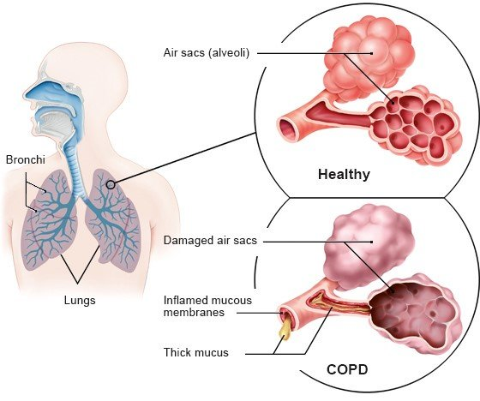

Introduction and Definition of Chronic Obstructive Pulmonary Disease (COPD)
A chronic respiratory disease that worsens with time and has a major influence on lung function and general quality of life is chronic obstructive pulmonary disease (COPD). Chronic respiratory symptoms and airflow restriction brought on by abnormalities of the airways and alveoli are its hallmarks. These conditions are frequently brought on by prolonged exposure to dangerous particles or gases, such as tobacco smoke, air pollution, or dust and chemicals from the workplace (Lange et al., 2021). COPD is a leading cause of morbidity and mortality worldwide, affecting millions of people and posing a substantial burden on healthcare systems. The condition typically develops slowly, and its symptoms worsen over time, making early recognition and management essential for reducing complications and improving patient outcomes (MacLeod et al., 2021).
COPD occurs when the airways become narrowed and damaged, resulting in obstruction of airflow and difficulty in breathing (Lu et al., 2021). Common clinical manifestations include chronic cough, wheezing, breathlessness, and increased mucus production, which can interfere with daily activities and reduce exercise tolerance (Celli et al., 2022; Lange et al., 2021). Exacerbations, often triggered by infections or environmental factors, can lead to hospitalisation and further deterioration of lung function (Lu et al., 2021). Management strategies focus on symptom relief, slowing disease progression, preventing exacerbations, and improving quality of life through a combination of pharmacological interventions, lifestyle modifications, and patient education (MacLeod et al., 2021). Understanding the nature and impact of COPD is critical for implementing effective care and supporting individuals living with this chronic condition (MacLeod et al., 2021).

Causes and Risk Factors
Smoking is one of the most significant risk factors for developing Chronic Obstructive Pulmonary Disease (COPD). Individuals who smoke regularly are at a much higher risk, as cigarette smoke damages the airways and lung tissue over time, leading to inflammation and narrowing of the bronchial tubes (Holtjer et al., 2023). Long-term exposure to polluted air, chemical fumes, or dust in the workplace or living environment can also contribute to the development of COPD. Such exposure irritates the lungs and accelerates tissue damage (Murgia and Gambelunghe, 2022). Genetic predisposition plays a role as well, particularly in individuals who inherit a rare genetic condition known as alpha-1 antitrypsin deficiency, which increases lung vulnerability to damage and raises COPD risk even among non-smokers (Zou et al., 2022). Furthermore, frequent or severe chest infections during childhood may impair lung development, thereby increasing susceptibility to COPD later in life (Holtjer et al., 2023).
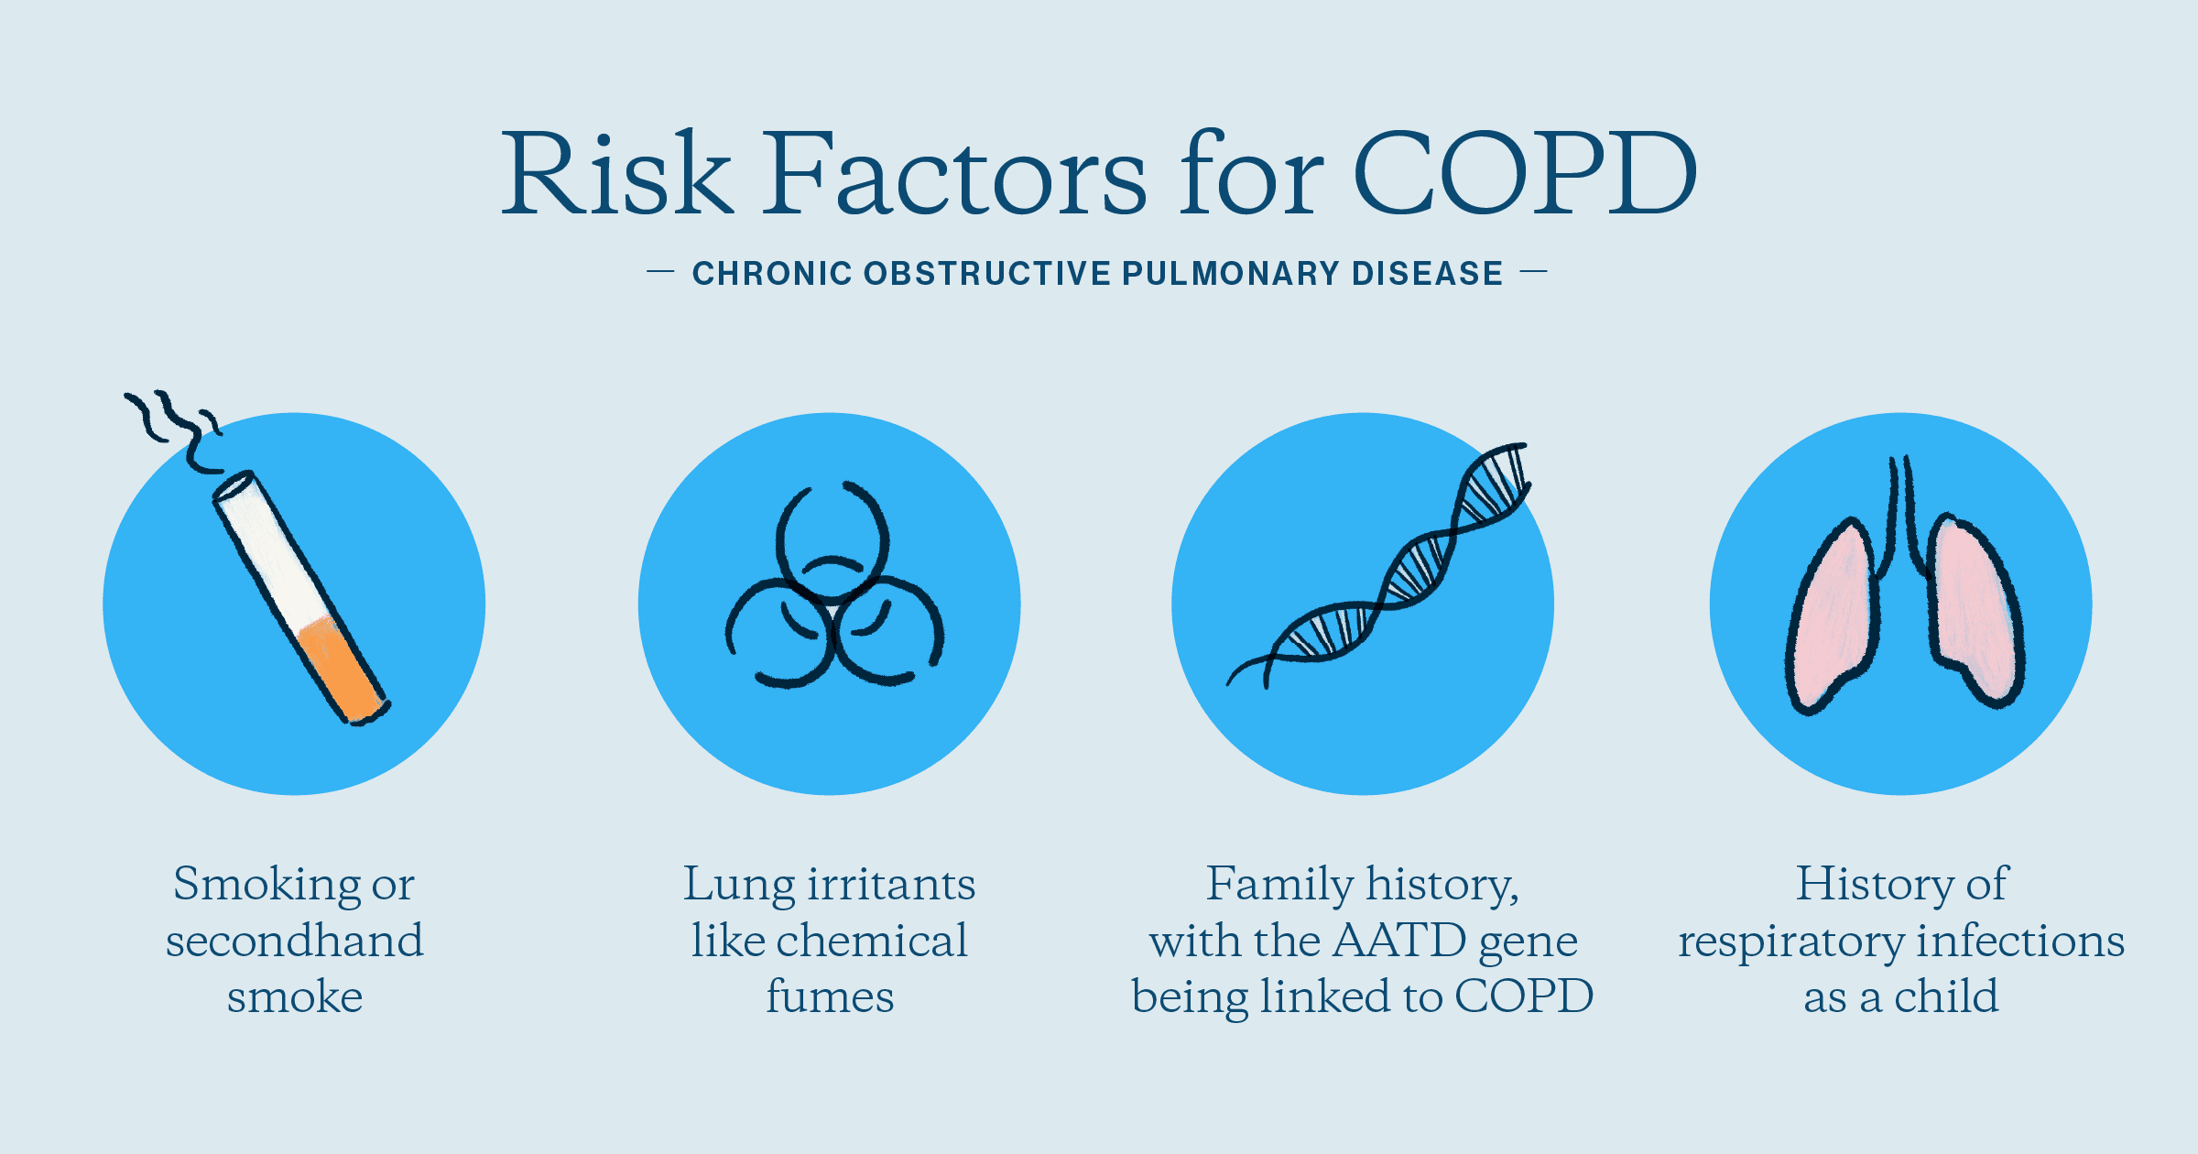
Age and gender also influence the likelihood of developing COPD. The disease is more commonly diagnosed after the age of 40, as lung function naturally declines with age. Although COPD affects both males and females, men have historically shown higher prevalence rates due to greater smoking habits (Zou et al., 2022). Occupational exposure represents another key factor, particularly for individuals working in industries such as mining, construction, or manufacturing, where inhalation of dust, chemicals, or vapours contributes to lung damage and COPD progression (Holtjer et al., 2023). Socioeconomic conditions further exacerbate risk, as people living in deprived areas or with limited access to healthcare and smoking cessation resources face increased vulnerability to COPD (Murgia and Gambelunghe, 2022).
Global Prevalence
Globally, COPD is one of the leading causes of illness and death. According to the World Health Organisation (WHO, 2024), over 380 million people are affected by COPD, making it the third leading cause of death globally. The disease imposes a substantial burden not only on individuals but also on healthcare systems, due to frequent hospitalisations, long-term management needs, and associated comorbidities (Wachami et al., 2024). The impact of COPD is particularly pronounced in low- and middle-income countries, where risk factors such as exposure to biomass smoke, air pollution, and occupational pollutants are more prevalent. Limited access to healthcare services in these regions further exacerbates the disease burden, often resulting in delayed diagnosis, inadequate treatment, and higher mortality rates (Boers et al., 2023). Addressing COPD globally requires coordinated public health strategies, including prevention, early detection, patient education, and equitable access to effective treatments and support services (Wachami et al., 2024).

Prevalence in the United Kingdom
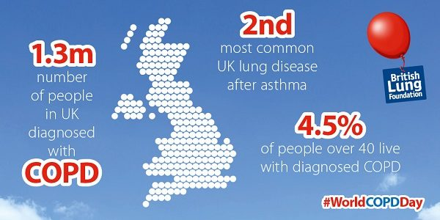
In the UK, approximately 1.3 million people have a formal diagnosis of Chronic Obstructive Pulmonary Disease (COPD), although many cases likely remain undetected (NHS, 2025). The condition contributes to thousands of hospital admissions annually and is a leading cause of emergency admissions (Song et al., 2020). Smoking is the primary risk factor for COPD in the UK, significantly influencing disease prevalence and progression. However, national efforts in smoking cessation, early detection, and targeted interventions are helping to mitigate its impact (Song et al., 2020). Early diagnosis and effective management are essential to reduce hospitalisations, improve quality of life, and slow disease progression (Song et al., 2020).
Implications of COPD
Physical Implications
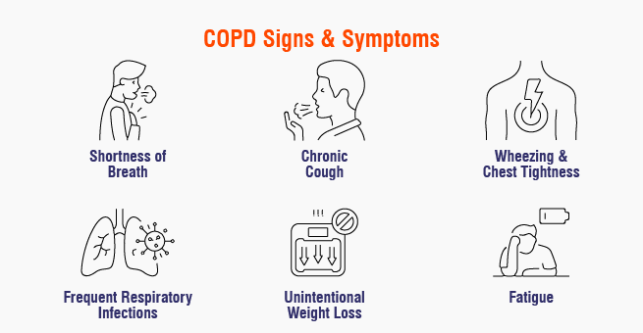
Physical implications of Chronic Obstructive Pulmonary Disease (COPD) include breathlessness (dyspnoea), which often causes shortness of breath during walking or simple daily tasks, leading to fatigue and restricted physical activity (Bamonti et al., 2022). Chronic cough and mucus production are also common, with persistent phlegm causing discomfort and potentially disturbing sleep and social interactions (Bamonti et al., 2022). Over time, exercise tolerance tends to decrease, resulting in reduced stamina and difficulty engaging in hobbies, work, or household activities (Bamonti et al., 2022). In addition, individuals with COPD are more susceptible to frequent chest infections, which can trigger exacerbations requiring hospital treatment or antibiotics (Celli et al., 2022). Fatigue and muscle weakness are also prevalent symptoms, as the body must work harder to maintain adequate oxygen levels, contributing to overall physical exhaustion (Celli et al., 2022).
Psychological Implications
Psychological implications of COPD include anxiety and panic, which often arise when individuals experience breathlessness or a sense of being unable to catch their breath (Yohannes et al., 2022). Depression is also common, as living with COPD can significantly affect mood, leading to feelings of sadness, isolation, or frustration due to reduced independence and limitations in daily activities (Christiansen et al., 2023). Many individuals may experience a loss of confidence, particularly in social settings, as concerns about coughing or breathlessness in public can lead to withdrawal from social interactions (Yohannes et al., 2022). Sleep disturbances are another major psychological effect, as persistent coughing, discomfort, and breathing difficulties can disrupt rest, further impacting emotional well-being and quality of life (Christiansen et al., 2023).
Social Implications
Social implications of COPD include reduced social interaction, as individuals often withdraw from social events or gatherings due to fatigue, embarrassment, or fear of experiencing breathlessness in public (Zhang et al., 2024). Employment challenges are also common, particularly for those whose occupations involve physical activity or exposure to respiratory irritants, making it difficult to maintain consistent work performance (Yi et al., 2021). Financial pressure may arise from reduced work capacity or the need for ongoing medical care, including medications and equipment, which can lead to economic strain on both the individual and their family (Yi et al., 2021). Additionally, dependence on others tends to increase as the disease progresses, with individuals relying more on family members, friends, or carers for daily activities and emotional support (Zhang et al., 2024).
Wider Implications on Families and Carers
Implications of COPD on families and carers include significant emotional strain, as family members experience worry, anxiety, or helplessness when witnessing the challenges of daily tasks or frequent hospital visits (Yi et al., 2021). Caring responsibilities often increase, leading to both physical and emotional fatigue for those providing support (Zhang et al., 2024). The illness can also alter family dynamics, requiring loved ones to adjust routines and assume new roles and responsibilities (Zhang et al., 2024). Financial and lifestyle impacts are common, as families may face economic challenges or need to make changes in housing or employment to accommodate care needs (Yi et al., 2021). Additionally, access to education and support resources, such as learning about the condition, attending support groups, and utilising community services, can help families manage stress and provide effective care (Zhang et al., 2024).
Evidence-based Treatments
According to the National Institute for Health and Care Excellence (NICE, 2018) and the National Health Service (NHS, 2025), evidence-based treatments for Chronic Obstructive Pulmonary Disease (COPD) in the UK encompass pharmacological interventions, non-pharmacological therapies, and lifestyle modifications.
Pharmacological Treatments:
Pharmacological management of Chronic Obstructive Pulmonary Disease (COPD) primarily involves inhaled medications as first-line treatment. Short-acting bronchodilators, such as salbutamol, provide rapid relief of symptoms, while long-acting muscarinic antagonists, such as tiotropium, help maintain open airways and improve lung function over time (NICE, 2018). For patients with more severe COPD or frequent exacerbations, combination inhalers containing a long-acting beta-agonist and an inhaled corticosteroid are recommended to reduce inflammation and prevent flare-ups (NHS, 2025). In cases of advanced disease with chronic bronchitis, triple therapy, which combines a long-acting beta-agonist, a long-acting muscarinic antagonist, and an inhaled corticosteroid, may be prescribed to optimise symptom control and reduce exacerbation frequency (NICE, 2018).
Additional pharmacological options are available for patients who continue to experience symptoms despite inhaled therapy (NHS, 2025). Roflumilast, a phosphodiesterase-4 inhibitor, may be used in individuals with severe COPD and chronic bronchitis who have had multiple exacerbations in the previous year (Aaron et al., 2024). Short courses of oral corticosteroids are often prescribed during acute exacerbations to reduce airway inflammation, while antibiotics may be administered if a bacterial chest infection is suspected (Aaron et al., 2024). For individuals with COPD, these therapies are intended to control symptoms, avoid complications, and enhance general quality of life (NICE, 2018).
Non-Pharmacological Therapies
It includes pulmonary rehabilitation, which is a structured program combining physical exercise, education, and behavioural interventions designed to enhance the physical and psychological condition of individuals with chronic respiratory disease (NICE, 2018). Oxygen therapy is also recommended for those with very severe COPD (FEV1 below 30% predicted) and low oxygen saturation levels, as long-term oxygen therapy can help improve survival and enhance quality of life (Aaron et al., 2024).
Lifestyle Modifications
It includes smoking cessation, which is the most crucial intervention for those who smoke, with NHS services providing support and resources to aid in quitting (NICE, 2018). Vaccinations, including the annual influenza vaccine and pneumococcal vaccine, are recommended to prevent respiratory infections (NHS, 2025). Engaging in regular physical activity is also advised, as it can improve overall health and help reduce COPD symptoms (NHS, 2025).
International Model: The Chronic Care Model (CCM)
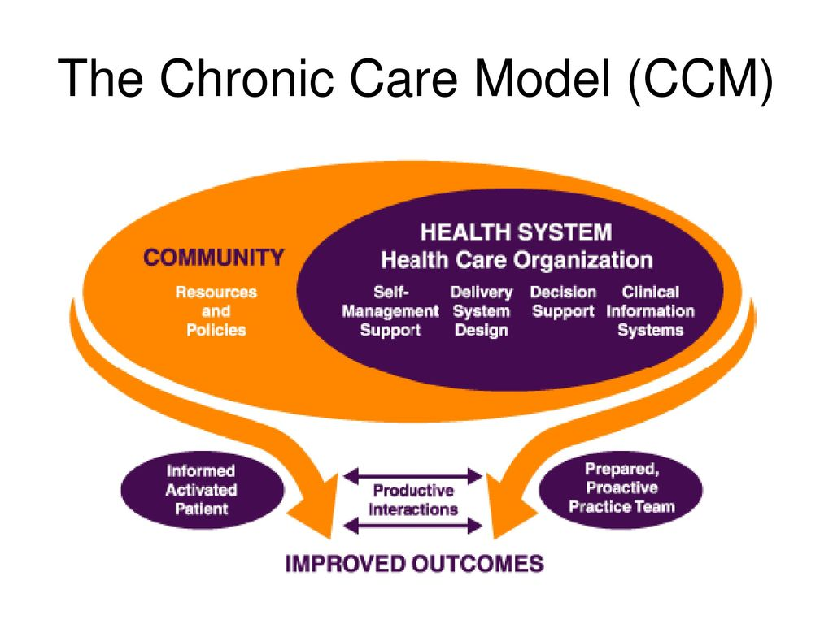The Chronic Care Model (CCM), developed by Wagner, is widely recognised as an effective framework for managing chronic diseases, including COPD. It emphasises a proactive, patient-centred approach to care, focusing on several key components (Ghiyasvandian et al., 2021). Self-management support involves empowering patients to manage their condition through education and skills development. Delivery system design ensures healthcare services are organised to meet the needs of chronic disease patients (Sazak and Olgun, 2025). Decision support provides evidence-based guidelines and clinical decision tools, while clinical information systems utilise registries and electronic health records to track patient data (Sazak and Olgun, 2025). The model also emphasises the importance of community resources by linking patients to support services, and health system organisation by aligning healthcare policies and resources to support chronic disease management. Implementing the CCM has been associated with improved patient outcomes, including better symptom control, reduced hospital admissions, and enhanced quality of life for individuals with COPD. For instance, a study by Ghiyasvandian et al. (2021) demonstrated that operationalising the CCM with goal-oriented interventions led to improved health outcomes for patients with chronic conditions (Sazak and Olgun, 2025).
UK Model: NHS Patient-Centred Care for COPD
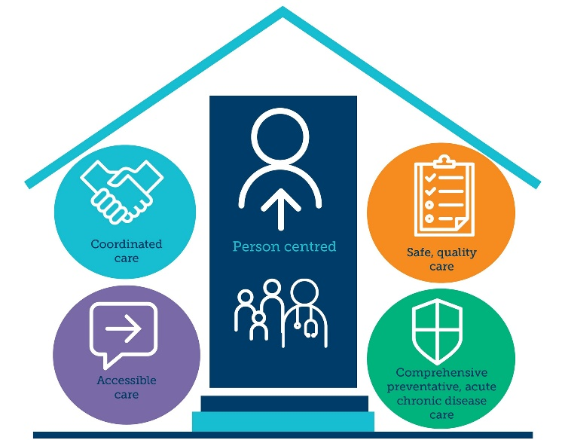
Comprehensive guidelines for the treatment of Chronic Obstructive Pulmonary Disease (COPD) in people 16 years of age and older are provided by the National Institute for Health and Care Excellence (NICE) in the United Kingdom. These guidelines emphasise a patient-centred approach that integrates various aspects of care to enhance patient outcomes (Burke and Wilkinson, 2021).
The NICE guidelines advocate for a multidisciplinary approach involving healthcare professionals such as general practitioners, respiratory specialists, nurses, and physiotherapists (Schmidt et al., 2024). This collaborative model ensures that all aspects of a patient's health are addressed, from pharmacological treatments to lifestyle modifications (Schmidt et al., 2024). Key components include smoking cessation support, pulmonary rehabilitation, and regular monitoring of lung function (Burke and Wilkinson, 2021). Additionally, the guidelines stress the importance of patient education, enabling individuals to manage their condition effectively and make informed decisions about their care (Burke and Wilkinson, 2021).
By focusing on the individual needs and preferences of patients, the NICE guidelines aim to improve the quality of life for those living with COPD, reduce hospital admissions, and promote long-term health and well-being.
National Political Health and Social Care Agendas Influencing COPD Management
At the national level, political health and social care agendas set strategic priorities that shape the management of Chronic Obstructive Pulmonary Disease (COPD) across the UK. Initiatives led by bodies such as NHS England, the Department of Health and Social Care (DHSC), and the National Institute for Health and Care Excellence (NICE) provide evidence-based guidance for the care of COPD (Landers et al., 2024). For instance, the NHS Long Term Plan emphasises early detection, proactive disease management, and patient-centred care, highlighting the importance of structured care pathways, pulmonary rehabilitation programs, and smoking cessation initiatives (Nigris et al., 2022). National vaccination programs, integrated care systems (ICSs), and investment in specialist respiratory services are also key elements that support COPD management (Landers et al., 2024. By establishing standardised protocols, national agendas promote consistent, high-quality care, reduce hospital admissions, and enhance patient outcomes, while also fostering innovation in service delivery and preventative strategies (Nigris et al., 2022).
Local Implementation and Developmental Initiatives for COPD
At the local level, political agendas are operationalised through Clinical Commissioning Groups (CCGs) and Integrated Care Boards (ICBs), which tailor national directives to meet the specific needs of their populations (Hudson et al., 2024). Local initiatives may include community-based pulmonary rehabilitation, home-based monitoring programs, and collaborations with voluntary organisations to provide education and self-management support for COPD patients (Hudson et al., 2024). Local strategies also consider social determinants of health, such as socioeconomic deprivation, housing conditions, and environmental exposures, which can exacerbate COPD symptoms (Hudson et al., 2024). Challenges such as limited resources, workforce constraints, and variations in adherence to guidelines can impact implementation (Hudson et al., 2024). Effective local adoption of national agendas allows for flexibility and innovation, ensuring that policy priorities translate into improved care delivery, patient engagement, and sustainable long-term management of COPD (Hudson et al., 2024).
Person-Centred Care
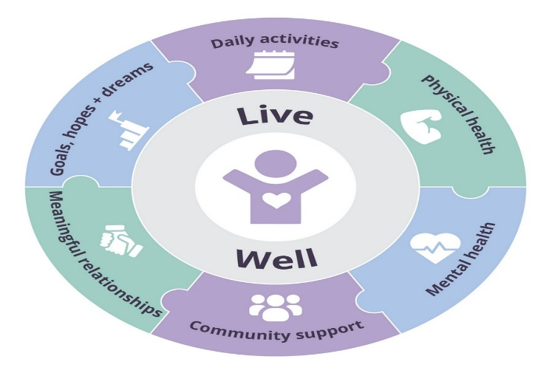
To improve person-centred care for individuals with long-term conditions such as COPD, healthcare services should focus on tailoring care to the preferences, values, and needs of each patient (Kolltveit et al., 2023). This includes promoting shared decision-making, where patients actively participate in developing their care plans and setting realistic goals (Eeles et al., 2023). Multidisciplinary team approaches involving doctors, nurses, physiotherapists, and social care professionals should be strengthened to ensure holistic care that addresses physical, psychological, and social aspects of health (Kolltveit et al., 2023). Regular patient feedback and care reviews can be implemented to continually refine care strategies and ensure they remain aligned with the patient’s evolving needs. Integrating digital tools, such as telehealth consultations and electronic care records, can enhance communication and continuity of care across services (Eeles et al., 2023).
Self-Management
Enhancing self-management strategies is essential for long-term condition management. Patients should be equipped with education on disease understanding, symptom recognition, and appropriate use of medications, such as inhalers for COPD (Bourne et al., 2022). Structured programs, including pulmonary rehabilitation or chronic disease self-management workshops, can support patients in building confidence and skills to manage daily challenges effectively (Bourne et al., 2022). Technology-enabled self-monitoring tools, such as mobile health apps or home spirometry, can provide real-time feedback and facilitate early intervention during exacerbations (Bourne et al., 2022). Encouraging lifestyle modifications, including smoking cessation, balanced nutrition, and regular physical activity, should be embedded into self-management plans. Healthcare providers should offer ongoing support and coaching to reinforce adherence, problem-solving, and behavioural change (Bourne et al., 2022).
Recommendation for Improvement
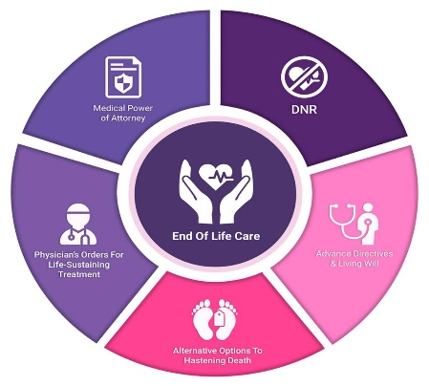
To improve the management of Chronic Obstructive Pulmonary Disease (COPD), several strategies can be implemented. First, enhancing patient-centred care through shared decision-making and tailored care plans can ensure that treatment aligns with individual needs and preferences (Miravitlles et al., 2023). Second, expanding access to structured self-management programs, including pulmonary rehabilitation and education on symptom monitoring, can empower patients to manage their condition effectively (Miravitlles et al., 2023). Third, integrating digital health tools, such as remote monitoring and telehealth consultations, can improve continuity of care and early detection of exacerbations (Miravitlles et al., 2023). Fourth, increasing support for smoking cessation and lifestyle interventions can reduce disease progression and improve overall health outcomes (Miravitlles et al., 2023). Finally, strengthening end-of-life care planning and palliative services can ensure that patients with advanced COPD receive compassionate, holistic care that prioritises comfort, dignity, and quality of life (Miravitlles et al., 2023).

End-of-Life Care
End-of-life care for patients with advanced long-term conditions should be proactive, compassionate, and tailored to individual preferences. Advance care planning discussions should be initiated early, involving patients and their families, to clarify goals of care, treatment priorities, and preferred care settings (Casal-Guisande et al., 2025). Palliative care services should be integrated with routine management to address symptom control, psychological support, and social needs (Iyer et al., 2022). Multidisciplinary coordination between primary, secondary, and community care providers ensures seamless support and continuity during disease progression (Casal-Guisande et al., 2025). Training healthcare professionals in communication skills, ethical decision-making, and cultural competence can improve the quality of end-of-life care, ensuring that patients experience dignity, comfort, and autonomy throughout their final stages of life (Iyer et al., 2022).

References
Aaron, S.D., Montes de Oca, M., Celli, B., Bhatt, S.P., Bourbeau, J., Criner, G.J., DeMeo, D.L., Halpin, D.M., Han, M.K., Hurst, J.R. and Krishnan, J.K., (2024). Early diagnosis and treatment of chronic obstructive pulmonary disease: the costs and benefits of case finding. American Journal of Respiratory and Critical Care Medicine, 209(8), pp.928-937. https://www.atsjournals.org/doi/full/10.1164/rccm.202311-2120PP
Al Wachami, N., Guennouni, M., Iderdar, Y., Boumendil, K., Arraji, M., Mourajid, Y., Bouchachi, F.Z., Barkaoui, M., Louerdi, M.L., Hilali, A. and Chahboune, M., (2024). Estimating the global prevalence of chronic obstructive pulmonary disease (COPD): a systematic review and meta-analysis. BMC Public Health, 24(1), p.297. https://link.springer.com/article/10.1186/s12889-024-17686-9
Bamonti, P.M., Robinson, S.A., Wan, E.S. and Moy, M.L., (2022). Improving physiological, physical, and psychological health outcomes: a narrative review in US veterans with COPD. International journal of chronic obstructive pulmonary disease, pp.1269-1283. https://www.tandfonline.com/doi/abs/10.2147/COPD.S339323
Boers, E., Barrett, M., Su, J.G., Benjafield, A.V., Sinha, S., Kaye, L., Zar, H.J., Vuong, V., Tellez, D., Gondalia, R. and Rice, M.B., (2023). Global burden of chronic obstructive pulmonary disease through 2050. JAMA Network Open, 6(12), pp.e2346598-e2346598. https://jamanetwork.com/journals/jamanetworkopen/article-abstract/2812622
Bourne, C., Houchen-Wolloff, L., Patel, P., Bankart, J. and Singh, S., (2022). Self-management programme of activity coping and education—SPACE for COPD (C)—in primary care: a pragmatic randomised trial. BMJ Open Respiratory Research, 9(1). https://bmjopenrespres.bmj.com/content/9/1/e001443
Burke, H. and Wilkinson, T.M.A., (2021). Unravelling the mechanisms driving multimorbidity in COPD to develop holistic approaches to patient-centred care. European Respiratory Review, 30(160). https://publications.ersnet.org/content/errev/30/160/210041.abstract
Casal-Guisande, M., Represas-Represas, C., Golpe, R., Comesaña-Campos, A., Fernández-García, A., Torres-Durán, M. and Fernández-Villar, A., (2025). Improving End‐of‐Life Care for COPD Patients: Design and Development of an Intelligent Clinical Decision Support System to Predict One‐Year Mortality After Acute Exacerbations. International Journal of Intelligent Systems, 2025(1), p.5556476. https://onlinelibrary.wiley.com/doi/abs/10.1155/int/5556476
Celli, B., Fabbri, L., Criner, G., Martinez, F.J., Mannino, D., Vogelmeier, C., Montes de Oca, M., Papi, A., Sin, D.D., Han, M.K. and Agusti, A., (2022). Definition and nomenclature of chronic obstructive pulmonary disease: time for its revision. American journal of respiratory and critical care medicine, 206(11), pp.1317-1325. https://www.atsjournals.org/doi/full/10.1164/rccm.202204-0671PP
Christiansen, C.F., Løkke, A., Bregnballe, V., Prior, T.S. and Farver-Vestergaard, I., (2023). COPD-related anxiety: a systematic review of patient perspectives. International journal of chronic obstructive pulmonary disease, pp.1031-1046. https://www.tandfonline.com/doi/abs/10.2147/COPD.S404701
de Nigris, E., McEwan, P., Marshall, J., Holmgren, U. and Foos, V., (2022). POSB65 economic burden of COPD in the United Kingdom (2021–2040) estimated with the COPD health outcome policy and intervention (CHOPIN) model. Value in Health, 25(1), pp.S72-S73. https://www.valueinhealthjournal.com/article/S1098-3015(21)02133-1/fulltext
Eeles, J., Ellison, S., Jones, C. and Huntington, C., (2023). Early experiences of telehealth monitoring for patients with COPD and implementation of person-centred care plans. British Journal of Community Nursing, 28(4), pp.172-178. https://www.magonlinelibrary.com/doi/abs/10.12968/bjcn.2023.28.4.172
Ghiyasvandian, S., Shahsavari, H., Matourypour, P. and Golestannejad, M.R., (2021). Integrated Care model: Transition from acute to chronic care. Revista brasileira de enfermagem, 74(suppl 5), p.e20200910. https://www.scielo.br/j/reben/a/G5kG5K7Mq5tKKGxHSPbhqbq/
Holtjer, J.C., Bloemsma, L.D., Beijers, R.J., Cornelissen, M.E., Hilvering, B., Houweling, L., Vermeulen, R.C., Downward, G.S. and Maitland-Van der Zee, A.H., (2023). Identifying risk factors for COPD and adult-onset asthma: an umbrella review. European respiratory review, 32(168). https://publications.ersnet.org/content/errev/32/168/230009.abstract7
Hudson, R., DSouza, M. and Valmas, B., (2024). HSD118 Mapping the Variability in Management of Asthma and Chronic Obstructive Pulmonary Disease (COPD) in England With Regards to Short-Acting BETA2 Agonists (SABA) and Oral Corticosteroids (OCS) Use. Value in Health, 27(12), pp.S347-S348. https://www.valueinhealthjournal.com/article/S1098-3015(24)04664-3/abstract
Iyer, A.S., Sullivan, D.R., Lindell, K.O. and Reinke, L.F., (2022). The role of palliative care in COPD. Chest, 161(5), pp.1250-1262. https://www.sciencedirect.com/science/article/pii/S0012369221042586
Kolltveit, B.C.H., Graue, M., Borge, C.R. and Frisk, B., (2023). Patients’ experiences with participating in a team-based person-centred intervention for patients at risk of or diagnosed with COPD in general practice. Pilot and Feasibility Studies, 9(1), p.164. https://link.springer.com/article/10.1186/s40814-023-01398-9
Lange, P., Ahmed, E., Lahmar, Z.M., Martinez, F.J. and Bourdin, A., (2021). Natural history and mechanisms of COPD. Respirology, 26(4), pp.298-321. https://onlinelibrary.wiley.com/doi/abs/10.1111/resp.14007
Landers, A., Pitama, S.G., Green, S.C. and Beckert, L., (2024). Policy, system and service design influence on healthcare inequities for people with end-of-life chronic obstructive airways disease, their support people and health professionals. BMC health services research, 24(1), p.1190. https://link.springer.com/article/10.1186/s12913-024-11705-6
Lu, H.H., Zeng, H.H. and Chen, Y., (2021). Early chronic obstructive pulmonary disease: A new perspective. Chronic diseases and Translational medicine, 7(02), pp.79-87. https://mednexus.org/doi/abs/10.1016/j.cdtm.2021.02.003
MacLeod, M., Papi, A., Contoli, M., Beghé, B., Celli, B.R., Wedzicha, J.A. and Fabbri, L.M., (2021). Chronic obstructive pulmonary disease exacerbation fundamentals: diagnosis, treatment, prevention and disease impact. Respirology, 26(6), pp.532-551. https://onlinelibrary.wiley.com/doi/abs/10.1111/resp.14041
Miravitlles, M., Bhutani, M., Hurst, J.R., Franssen, F.M., van Boven, J.F., Khoo, E.M., Zhang, J., Brunton, S., Stolz, D., Winders, T. and Asai, K., (2023). Implementing an evidence-based COPD hospital discharge protocol: a narrative review and expert recommendations. Advances in therapy, 40(10), pp.4236-4263. https://link.springer.com/article/10.1007/s12325-023-02609-8
Murgia, N. and Gambelunghe, A., (2022). Occupational COPD—The most under‐recognized occupational lung disease?. Respirology, 27(6), pp.399-410.
NHS (2025), Advances in lung health since the advent of the NHS https://www.rbht.nhs.uk/blog/advances-lung-health-advent-nhs
NICE (2018), Chronic obstructive pulmonary disease in over 16s: diagnosis and management, https://www.nice.org.uk/guidance/ng115
Sazak, Y. and Olgun, N., 2025. The effect of Chronic Care Model-based follow-up on self-efficacy and patient-reported outcomes in COPD patients: a randomized controlled study. BMC nursing, 24(1), p.578. https://link.springer.com/article/10.1186/s12912-025-03247-x
Schmidt, C.W., Wegener, E.K. and Kayser, L., (2024). Needed competence for registered nurses working at a patient-centred telehealth service aimed to engage and empower people living with COPD: A five-month participatory observational study. Applied Nursing Research, 79, p.151828. https://www.sciencedirect.com/science/article/pii/S0897189724000661
Song, F., Elwell-Sutton, T. and Naughton, F., (2020). Impact of the NHS stop smoking services on smoking prevalence in England: a simulation modelling evaluation. Tobacco control, 29(2), pp.200-206.
WHO (2024), https://www.who.int/news-room/fact-sheets/detail/chronic-obstructive-pulmonary-disease-(copd)
Yi, M., Jiang, D., Jia, Y., Xu, W., Wang, H., Li, Y., Zhang, Z., Wang, J. and Chen, O., (2021). Impact of caregiving burden on quality of life of caregivers of COPD patients: the chain mediating role of social support and negative coping styles. International journal of chronic obstructive pulmonary disease, pp.2245-2255. https://www.tandfonline.com/doi/abs/10.2147/COPD.S311772
Yohannes, A.M., Murri, M.B., Hanania, N.A., Regan, E.A., Iyer, A., Bhatt, S.P., Kim, V., Kinney, G.L., Wise, R.A., Eakin, M.N. and Hoth, K.F., (2022). Depressive and anxiety symptoms in patients with COPD: a network analysis. Respiratory medicine, 198, p.106865. https://www.sciencedirect.com/science/article/pii/S09546111220013057
Zhang, N., Tian, Z., Liu, X., Yu, X. and Wang, L., (2024). Burden, coping and resilience among caregivers for patients with chronic obstructive pulmonary disease: An integrative review. Journal of Clinical Nursing, 33(4), pp.1346-1361. https://onlinelibrary.wiley.com/doi/abs/10.1111/jocn.16954
Zou, J., Sun, T., Song, X., Liu, Y.M., Lei, F., Chen, M.M., Chen, Z., Zhang, P., Ji, Y.X., Zhang, X.J. and She, Z.G., (2022). Distributions and trends of the global burden of COPD attributable to risk factors by SDI, age, and sex from 1990 to 2019: a systematic analysis of GBD 2019 data. Respiratory research, 23(1), p.90. https://link.springer.com/article/10.1186/s12931-022-02011-y

