Faster Than Light (FTL)

INTENDED PLATFORMS | Windows 10

TARGET AGE / DEMOGRAPHIC OF PLAYERS
This game will be targeted towards teenagers as the game will be a rogue like adventure.

INTENDED PEGI / ESRB RATING
PEGI 12/ ESRB Everyone 10+

CONTRIBUTING TEAM MEMBER: | Justin Brighton

SECTION 2: GAME OUTLINE

GAME STORY SUMMARY
The point of the story is you’re controlling a ship with 3 other occupants as you travel across space and gateways to explore different territories controlled by other gangs/pirates.

GAME FLOW
A rogue like adventure that the player will control a crew through space. They will encounter difficulties along their travels as they proceed deeper through space and different territories, managing their resources along the way.

CONTRIBUTING TEAM MEMBER: | Justin Brighton

SECTION 3: MAIN CHARACTER(S)
& PLAYER CONTROLS

CHARACTER APPEARANCE
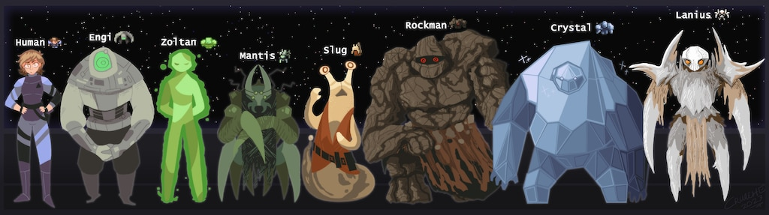

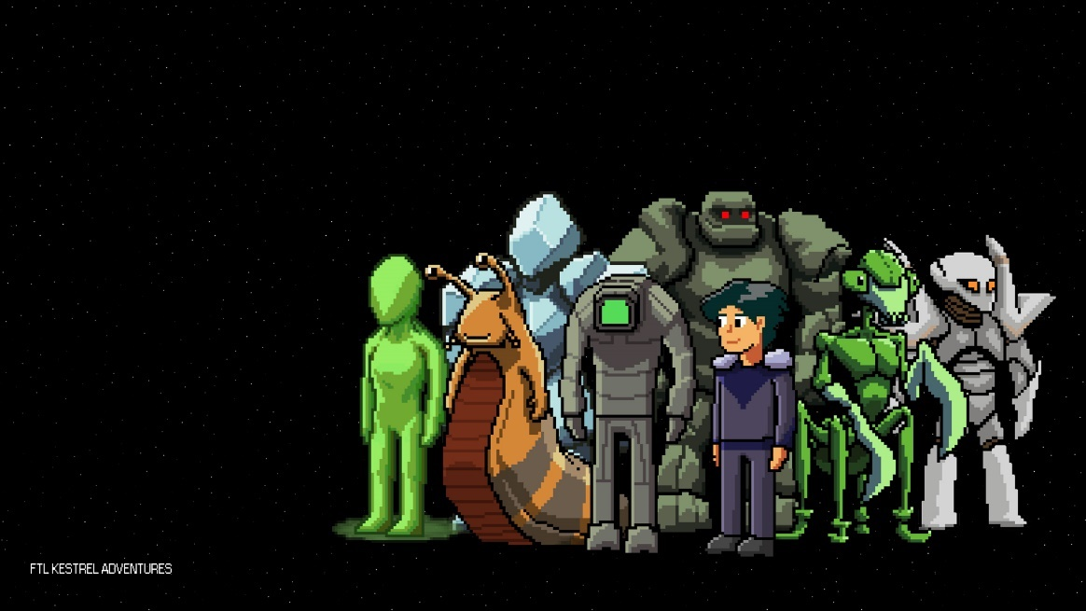


CHARACTER DOSSIER / DETAILS (Add/adjust categories as appropriate)
NAME: | Admiral Tully
GENDER: | Male
SPECIES: | Human
AGE: | 20+
FACTION: | Galactic federation
Title: | Admiral of the Federation fleet

CHARACTER’S BACKSTORY
Admiral Tully is a Human that works within the Galactic Federation. He is an Admiral who is friends with a General.

He will join the players team when completing a mission as they gain a Package from another admiral to then deliver to Tully. When this package is delivered, it is discovered to be empty and to have just been a token of faith.

When the player delivers this package, admiral Tully will then join the player’s crew.

CHARACTER CONTROLS / PLAYER CONTROLS
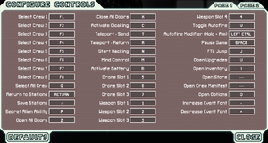

CONTRIBUTING TEAM MEMBER: | Justin Brighton

SECTION 4: GAMEPLAY

SEQUENCE OF PLAY
You start off with getting into a new game with selecting what to take with you along your expedition and selecting what difficulty you want the expedition to be.

The player is allowed to choose between 2 ships to their preference before they start off their journey.

The player is then shown a map of beacons, the more beacons visited, more beacons will then show.

Each beacon has different scenarios as it could be either an enemy encounter, distress signals, the shop or the end beacon.

As the player explores, a red zone will slowly appear, slowly taking over beacons from the left.

Once the player reaches the end beacon, they are able to travel to another sector with new challenges awaiting as these sectors are controlled by different territories. These are Civilian, pirates, etc.

While all this, the player must manage and strategies their resources and crew as you start off with 3 crew members and you can increase the amount crew you have or you can lose those members as well

UNIQUE SELLING POINTS (USPs)
Faster than Light has an expansion mode which allows the player to enable it to add new content for the game.
The player is allowed to pause the game to assess the situation and plan ahead so it lessens some of the stress

PLATFORM-SPECIFIC FEATURES
Faster than light will use mouse and keyboard as the keyboard can be used to select different sectors of different areas and pause while the mouse is the main point as u can select different icons with the mouse.

CONTRIBUTING TEAM MEMBER: | Justin Brighton

SECTION 5: GAME WORLD

GAME WORLD
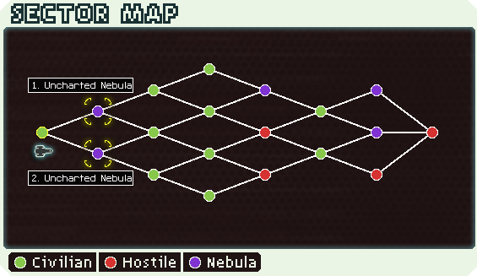
This is what the sectors will look like to the player. It shows different sector until they reach the end.

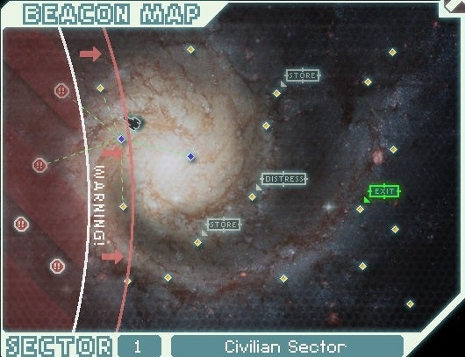
This map is within the sector. It shows different beacons within the sector as a danger zone will start to creep up towards the player.

LOCATION DETAILS
NAME: | Nebula
WHAT DOES IT LOOK LIKE? | A Purple cloud within the map
WHAT MOOD IS BEING INVOKED IN THIS LOCATION? | When the player enters this nebula, they’re electronics will be disrupted, this means that power will be halved.
WHAT KIND OF MUSIC WILL BE USED FOR THIS LOCATION? | Tense music will be used as there is always a enemy encounter through traversing through the nebula
HOW ARE THE LOCATIONS CONNECTED IN THE GAME WORLD? | The map is connected as beacons throughout the gameplay as the player can choose this beacon for high risk for high rewards.

GAME FLOW
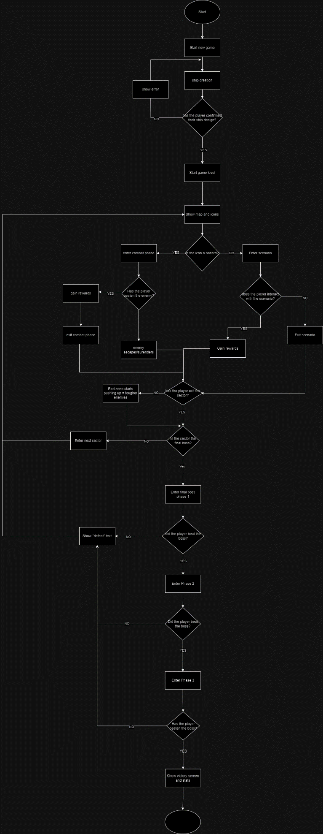

CONTRIBUTING TEAM MEMBER: | Justin Brighton

SECTION 6: GAME EXPERIENCE

GAME EXPERIENCE
The theme of FTL is that it is a resource rogue like space adventure as the player will experience resource management and loss while on their journey across space.

HOW IS THIS FEELING GOING TO BE PRESENTED TO THE PLAYER?
This will be presented through scenarios that the player will encounter throughout their travels as they will spend fuel to travel as they start with a certain amount and must find more fuel along the way, they will also encounter enemies throughout their travels who are mostly violent towards the player and sometimes, but not all the time, will plead to surrender and the player has a choice to do so.

ARE THERE ANY SPECIAL MODES OR INTERFACES FOR GAMEPLAY?
The player can access the tutorial to learn about the game, so they know what they’re doing when they start a new game. This will show the player the mechanics of the game and how different scenarios work.

They are also able to check their stats screen to check their stats before/after their run.

WHAT DOES THE PLAYER FIRST SEE WHEN THEY START THE GAME?
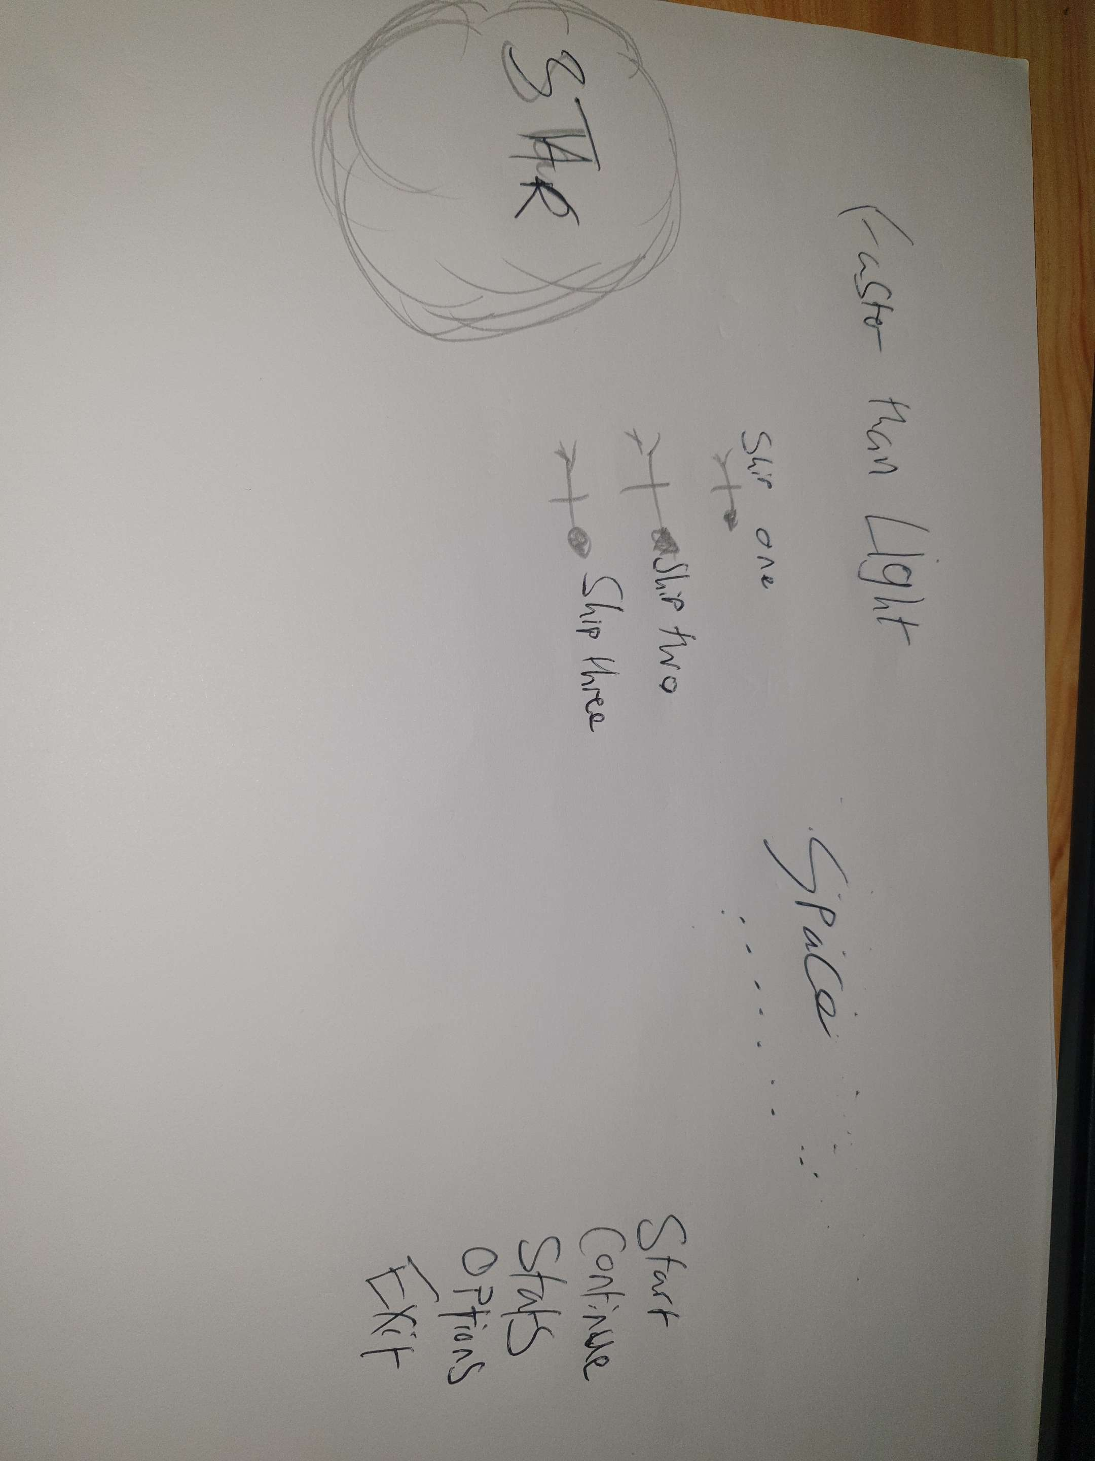

WHAT EMOTIONS ARE MEANT TO BE INVOKED BY THE GAME?
Faster than light gameplay should make the audience feel stressful and thoughtful through their actions throughout the game as they have to make decisions that could benefit their travels or enter combat with an enemy AI.

HOW ARE MUSIC AND SOUND GOING TO BE USED?
When in combat, when hitting a shield, it will play a sound of the shield being temporarily disabled. It will prompt the player that the shield has been knocked out and can deal damage towards the enemy. After defeating the enemy, the sounds of destruction can be heard and a little victory sound will be heard after defeating the enemy.

HOW DOES THE PLAYER NAVIGATE THE SHELL MENUS/ SCREENS OF THE GAME?
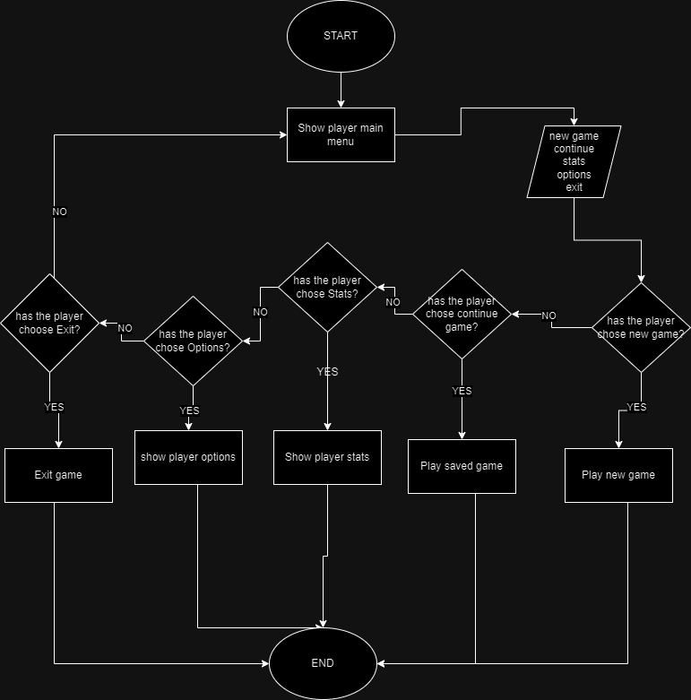

CONTRIBUTING TEAM MEMBER: | Justin Brighton

SECTION 7: GAMEPLAY MECHANICS

GAMEPLAY MECHANICS
MECHANIC: Something the player interacts with to create or aid gameplay e.g. moving platforms, opening doors, slippery ice.
The player can open doors on their ship and it can also help if the ship is on fire as the player can open the doors towards space since space is a vacuum, the fire will go towards it.

HAZARD: A mechanic that can harm or kill a player but doesn’t possess intelligence e.g. spike pits, swinging blades, jets of fire. Describe SOME – not every one!
Fire is a hazard in faster than light as when the enemy damages the players ship, it can start a fire within the ship where has damaged and can spread throughout the ship but can be contained through the doors of the ship

Enemies can also damage your ship to a certain extent to the point that they are able to board the players ship

POWER-UP: e.g. Ammo, extra lives, invulnerability, etc. Provide examples of power-ups and what they do.
Fuel is a power up as the player can gain more fuel throughout their travels. It can be obtained from distress scenarios and enemy scenarios as well. It can also be bought from the shop as well.

MECHANIC DETAILS
NAME: | Ship doors
WHAT DOES IT LOOK LIKE? | Grey Rectangular shape that appears like doors
EFFECT ON PLAYER: | keeps the crew safe and can be open manually and contain oxygen and divert hazards out.
WHEN WILL IT FEATURE IN THE GAME? | When the player has started their journey through space.

HAZARD DETAILS
NAME: | FIRE
WHAT DOES IT LOOK LIKE? | It’s a fire sprite, a mix of red and orange, that will appear on the ship.
EFFECT ON PLAYER: | Damages the occupants/equipment in proximity of the fire.
WHEN WILL IT FEATURE IN THE GAME? | When the ship gets damaged to a certain extent.
POWER-UP DETAILS
NAME: | Fuel
WHAT DOES IT LOOK LIKE? | It will look like an energy ball like design that represents the ships fuel
EFFECT ON PLAYER: | Allows the player to traverse deeper into space or different beacons.
WHEN WILL IT FEATURE IN THE GAME? | It will feature when the player starts their space journey

COLLECTIBLE ITEMS
The player is able to collect different weapons along their journeys. There will be different weapon types but it’s the players choice on what weapon to use.

COLLECTIBLE DETAILS
NAME: | Lazer
WHAT DOES IT LOOK LIKE? | A laser weapon attached to the ship.
BENEFIT FOR PLAYER: | Lazer damage towards the enemy ship
WHEN WILL IT FEATURE IN THE GAME? | It will feature when in combat scenarios.
CAN IT BE USED AS CURRENCY? | It can be sold.
WILL IT EARN PLAYERS AN ACHIEVEMENT? | No

GAME ECONOMY
The economy of Faster than Light is called scraps. These scraps are the currency and used to buy items from the shop. Scraps are able to be obtained from certain scenarios such as destroying an enemy ship, aiding in a distress signal and selling items in the shop.

The shop is a beacon within a game, showing with a shop sign on top of the beacon. This is a safe spot for the player to check the store for items.

CONTRIBUTING TEAM MEMBER: | Justin Brighton

SECTION 8: ENEMIES

LIST OF ENEMIES
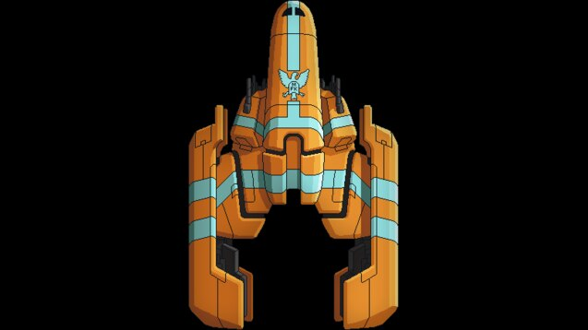
This is an enemy that the player might encounter deeper in their journey of space. they will act hostile and attack the player upon arrival. This will appear later on in the journey.

ENEMY DETAILS
NAME: | Rebel Elite
WHAT DOES IT LOOK LIKE? | A orange ship with blue stripes and the enemy logo.
ATTACKS: | has a massive firepower and very fast.
WHEN WILL IT FEATURE IN THE GAME? | It will appear the deeper the player goes in space.
HOW DOES THE PLAYER DEFEAT IT? | Attacking the shields and using other weapons to attack the ships weakpoints
WHAT DOES THE PLAYER EARN FOR DEFEATING THEM? | The player can get awarded with fuel and resources to upgrade their ships.

LIST OF BOSS CHARACTERS
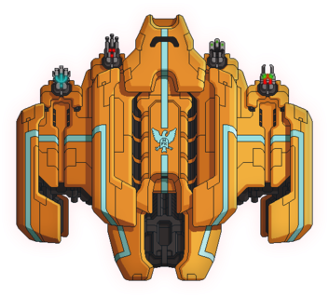

A final boss within FTL is a ship more powerful than other ships that the player had encountered. This boss will have 3 phases as the player fights through all 3.

BOSS CHARACTER DETAILS
NAME: | The Rebel Flagship
WHAT DOES IT LOOK LIKE? | An orange ship with a blue stripe going along the ship with the logo of the rebels
ATTACKS: | Has 4 weapons to disable shields and damage the players ship and has 3 phases.
WHEN WILL IT FEATURE IN THE GAME? | This boss will show at the very end of the players expedition.
HOW DOES THE PLAYER DEFEAT IT? | Using their resources, the player gains from their expedition, they will use that and their crew to defeat the boss.
WHAT DOES THE PLAYER EARN FOR DEFEATING THEM? | When the player beats this boss, a victory will appear upon the destruction the ship and shows the crew names that have survived

CONTRIBUTING TEAM MEMBER: | Justin Brighton

SECTION 9: CUTSCENES

CUTSCENES
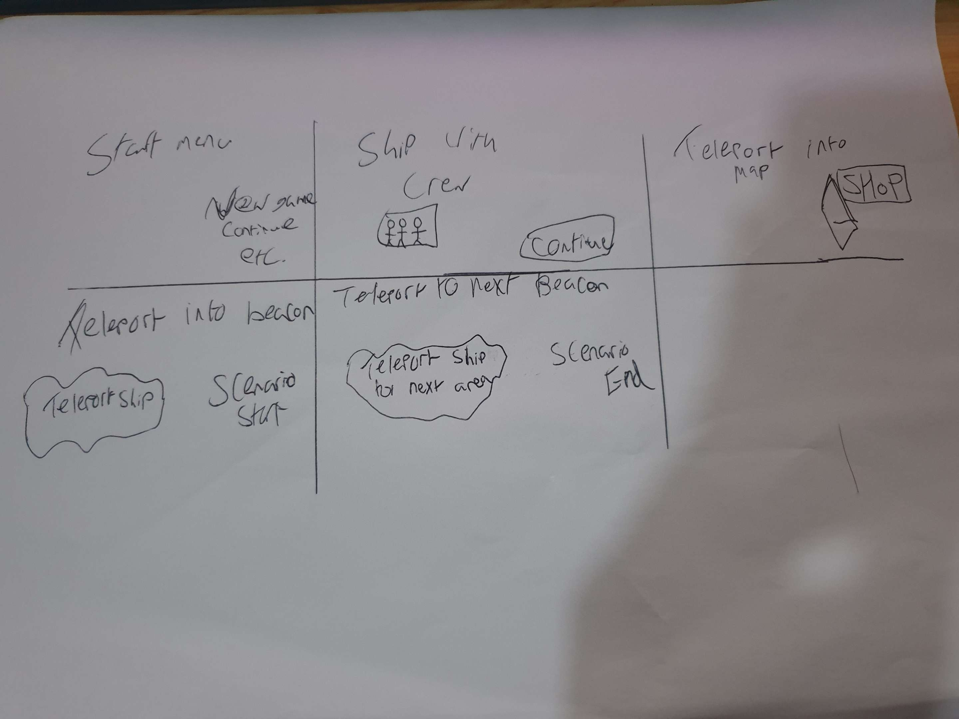

CUTSCENE DETAILS (use this table for each unique cutscene you include)
VISUAL STYLE: | The style of the cutscene will be 8 bit style.
BRIEF DESCRIPTION OF SCENE: | Starting of the game, the player will teleport to the first beacon which will be the introduction
WHEN WILL IT FEATURE IN THE GAME? | It will be featured every time the player chooses a new area
PURPOSE: | This scene is used to show the player teleporting away from the beacon and entering a new beacon

(NOTE: Copy-paste the tables in this section as necessary for each cutscene you wish to feature.)

CONTRIBUTING TEAM MEMBER: | Justin Brighton

SECTION 10: BONUS MATERIALS

BONUS MATERIALS
The player can access the expansion as its available along the game. The expansion allows the player to access extra content. This will include more weapons, enemies, species and scenarios as well.

REPLAY VALUE
There are different areas with different scenarios that the player will encounter along their journeys. Sometimes the enemies will attack the player but, in some instances, the enemy will surrender. The player can also choose to enable the expansion to their journey as this expansion is free.

CONTRIBUTING TEAM MEMBER: | Justin Brighton

References
https://steamcommunity.com/app/212680/images/

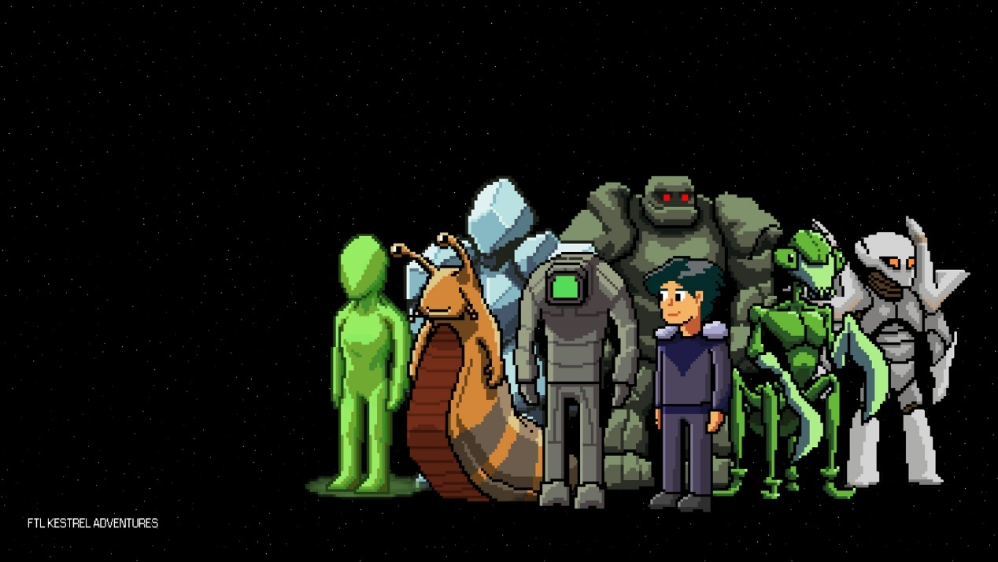
https://www.deviantart.com/wonderwig/art/FTL-Faster-Than-Light-All-Races-545682776

https://ftl.fandom.com/wiki/Sectors

https://www.ign.com/wikis/ftl-faster-than-light/Beacon_Map

https://ftl.fandom.com/wiki/The_Rebel_Flagship

https://store.steampowered.com/app/212680/FTL_Faster_Than_Light/

https://steamcommunity.com/sharedfiles/filedetails/?id=251817939

https://www.pcgamingwiki.com/wiki/FTL:_Faster_Than_Light

