Student name: Orla White
Student Number:
Programme Name: Surface Pattern And Textiles
Module: ADAD4018 Ways of Thinking

Task one (Manifesto): 495 Words
Task two (Semiotics): 452 Words
Task three (Practice based writing):

Manifesto
- Art/textiles may not always have a purpose behind it and can be made by one’s imagination for their enjoyment.
- I will make sure to try the composition of outcomes more than once to explore the possibilities of one outcome.
- If possible, I will create more than one variation of an outcome.
- I will focus my work on my strengths.
- I will showcase my skills to the best possible ability.
- I will try and make sure that all parts of an outcome link together like the fabric and colour to the theme of the piece so it all correlates.
- I will try to reuse fabric and minimise wastage.
- I will use a range of fabrics in my work to explore the differences in outcomes.

One of my main strengths I would say is my ability to create abstract imagery. Throughout my work I have had issues with creating real life drawings so instead have been focusing on creating more abstract drawings through my style of drawings. This then works well being heat pressed onto fabrics or sown in with free machine embroidery which are also two skills that I would consider my strengths. Abstract art can be tracked from the early 20th century where artists attempted to break away from traditional forms of art in a way of expressing themselves in a new form of art. However along with this new form of art comes criticisms, one of the main ones being the “my kid could do that” criticism. This stems from the idea that due to abstract forms of art being less detailed and some would describe as simple and easy to do.Book and art.com share this as “implying that the work lacks the depth and skill associated with traditional art forms”.This outlook causes some to think less of this art form and believe that a child could create the same outcome. Book and art. Com also argue this point in saying “critiques fail to acknowledge the thought, intention and artistic exploration that goes into abstract works. Arguing that although the outcomes may look less detailed there is a lot more thought that goes into an abstract piece than what meets the eye and that isn’t seen by critiques. Therefore, I feel it suitable to use this practise in my work because there is more behind the scenes reasoning rather than the detailed showing of my work there is a lot that isn’t shown in the final piece but has been thought through. It also works well to link to my other wants for my work as you could argue it would be easier to reuse and recycle an abstract piece and add to it to create a new outcome rather than a really detailed piece and having to start another.
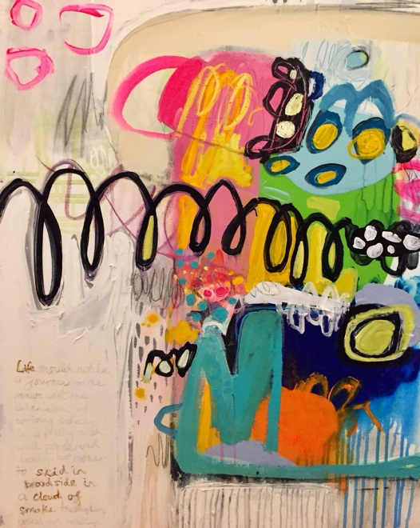
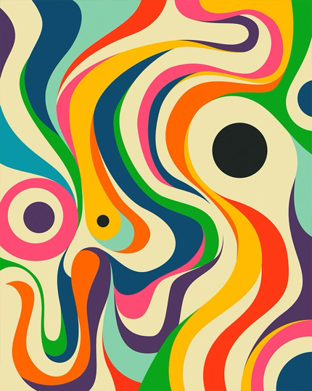
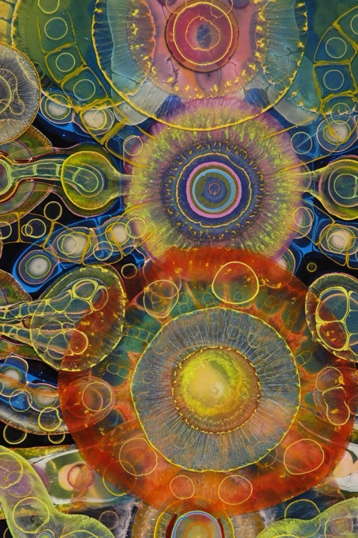
Chandler (2007) stated that semiotics are the study of signs and that semiotics imply that every aspect of a product is there for a purpose and holds a meaning. Through signs it allows semiotics to be a powerful aspect of decoding and analysing images or texts to gather the meaning and representation of the semiotics through advertising, art and texts. Chandler also believes that there is no direct correlation between a name and a physical object or individual, instead naming things the way of categorising objects as an attempt to make sense of the world. Along with this idea, names are used as an attempt for humans to build and identifying for an individual. This allows people to become their individual selves, they are also used as a form of signs which contribute to other identities. Signs suggest that content analysis allows readers to identify and understand the main meaning and themes in text and images, whereas semiotics delve deeper into providing the meaning of the overall image or text whilst also giving the reader a reason for decisions made in the creation process of the outcome.

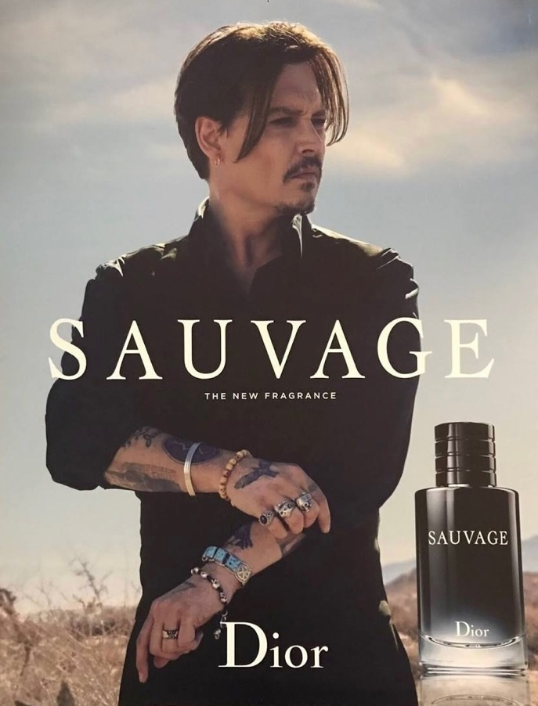
Gillian Rose (2023) states that many writers would argue that the meaning of things go so deep as the state the technologies used to create certain pieces themselves add to the meaning of the piece. For example, an artist's creating a piece will choose their technique used dependant on effect they want to achieve in their outcome. Like an artists will choose an acrylic paint to create a more solid look in contrast to a water colour or oil pastel to create a more textured outcome. Or for a photographer in an advert for example, when analysing it would be important to understand the type of camera, film and developing process used to create that certain outcome and why it was done.

In 2017, Dior released the advertisement for Dior Sauvage with the main feature being Johnny Depp. The advertisement focuses on Johnny Depp and his dark features which could be seen as a representation of the scent itself as a form of advertisement. One example of a semiotic shown in this advert is the stance that Dior placed Depp in, this having its own meaning being it’s shown in a Z shape that allows viewers to follow his stance from the lower part of the image to the top and across to the writing itself.

Semiotics can be used to analysis an image or art piece to give a deeper meaning. Through adverts specially as it allows the viewer to understand the meaning as to why certain aspects have been using through any features, hair and makeup, backgrounds, props e.c.t.

Practice based writing.
A high heel is a staple accessory in many going out/ classy looks in fashion. To define a high heel from another shoe would be “a women’s shoe with a small thin heel” by Oxford languages. You can tell that this definition is quite dated as it only describes one very simplistic design of a heel which was the first to be created, whereas now there are a lot of designs that don’t fit this definition due to having a wider heel or wedge. Some see the high heel as a capture of femininity as there sophisticated and a crucial part for a woman portraying a put together image. Some would argue high heels became a symbol of women for a period of time when boys had football women would have an image of a little high heel.

