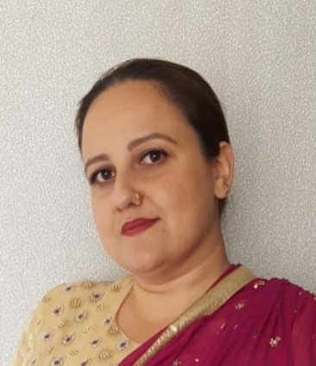
Dear Tayo,
YASMIN AZAM
T R AI N E E MI D W I F E
YASMIN AZAM
77 PROFFITT STREET WALSALL WS2 8AR
2013925@STUDENT.UWTSD.AC.UK
07305754441.

I am delighted to notice that you are advertising for the position of trainee midwife, and I would like to take advantage of this chance to apply. I've worked in this industry for almost 20 years and am well- versed in many aspects of medicine. I go above and above in my career and take it seriously, but I also enjoy giving it my all at all times. I have a strong desire to advance and am always eager to learn new things. I am eager to take on new challenges and gain new skills. I work well in groups but can also work alone if necessary. I have excellent communication skills and can speak several languages, including Urdu, English, and Punjabi, Hindi, Patwari, and working in the medical field requires me to be able to translate and understand a patient's needs and requirements.
I can recognise changes that can occur with patients and recognise they may require assistance from other members of staff professionals, and I know to report to the senior member of staff if intervention is required. I am already working in the mental health area alongside professional nursing staff, therefore working alongside skilled team members will not be a problem for me.
I am up to date on my training and have knowledge of the most recent rules and procedures, as well as a level 2 & 3 health and social care certificate and English functional skills level 1. I have a level 3 diploma in health and social care, which is higher than the criteria for this position, I have a certificate in higher education BSC level 4 and am currently almost completing level 5 bachelors of science degree which will be completed within another 4 weeks time.
I have always wanted to be a midwife, so having the opportunity to work alongside one would be a fantastic way for me to advance with the love I've always had and learn first hand. So, now that you've read this, I hope there's no need for you to go any further for someone to fill this position and will give me the chance to demonstrate my abilities to you, as you can see from my enclosed resume, I meet all of the qualifications and more.
To plan an interview time, please contact me at the above phone number; you can leave a note or email me if that is more convenient. I've included my email address at the top of the page, and I'll get back to you as soon as I get your email.
Thank you for taking the time to read this and I will be looking forward to hearing from you soon.

Y AZAM.

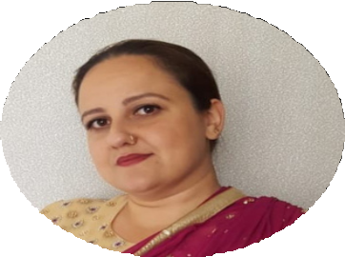
YASMIN AZAM

Trainee Midwife

CONTACT

2013925@student.uwtsd.ac.uk

77 Proffitt Street Walsall WS2 8AR
07305754441

EDUCATION

ABOUT
I have 20 years of experience in the
medical sector, I work well as a team and enjoy meeting new people, i am punctual hard working and reliable . I am confident and always like to complete a task that i start. I am a team player and also
work well under pressure .

ENGLISH GRADE B MATHEMATICS GRADE B SCIENCE GRADE B GERMAN GRADE C
CHILD DEVELOPMENT LEVEL 2
HEALTH AND SOCIAL CARE DIPLOMA LEVEL 2 AND 3 MEDICATION LEVEL 3
INCONTINENCE COURSE PASS FIRST AID PASS
MANUAL HANDLING PASS HEALTH AND SAFETY PASS INCONTINENCE COURSE PASS ADULT PROTECTION PASS DEMENTIA PASS
HEALTH AND SOCIAL CARE LEVEL 4
WORK EXPERIENCE

I am training to be a midwife in the next year and hopefully work my way up to a manager. Also i have 20 years of experience in the health care sector. I have been working in the mental health sector for 7 years . I have experience working with autistic children and
disabilities .

s



