Global Business
Challenges
BMSP4012
Anthony Burns
Mark Jones 2120040

Coronavirus

Coronavirus History
Coronavirus more commonly known as Covid – 19 was a Global pandemic that started out in the first quarter of 2020. World health organization Declared the Covid – 19 outbreak a Global Pandemic on March 11, 2020. This Pandemic was a Global crisis that affected everyone and everything. Covid – 19 was a fast-spreading disease caused by the SARS-CoV-2 virus according to world health organization (WHO) (2020, January 10). Covid-19 disease at first was unknown. Doctors didn’t realise the extent of the illness as it was new and fast spreading. The common symptoms where coughing, temperature and a sore throat. Due to the lack of knowledge and the uncertainty of the seriousness of the disease, On 23rd March 2020, British Prime minister Boris Johnson announced that the Government will enforce a nationwide lockdown. Ordering the population of Britain to remain in their homes and closing all unessential Business sectors (2022, November 8). Countries around the world enforced some level of lockdown some with different restrictions. The following image is a list of countries in Europe that enforced some form of lockdown to try and reduce the spread.
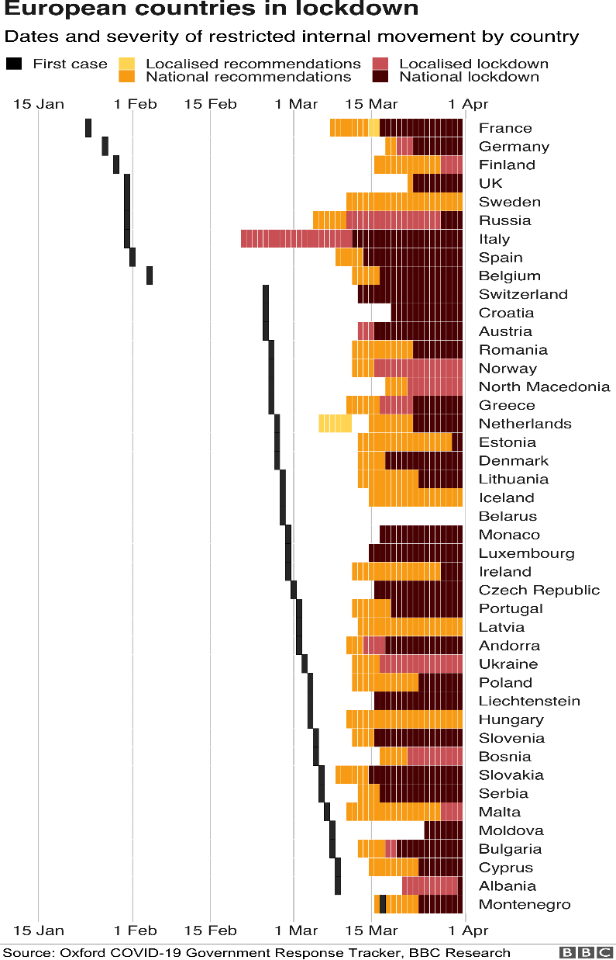

Included in the lockdown unessential businesses were forced to close. The only Businesses that where aloud to stay open were organisations with an essential need such as hospitals, grocery stores and a few selected others. Business that sold both essential and non-essential products were forced to section off the non-essential part of the store so it was not accessible to the public with the main aim to not entice the public to stay out from their homes shopping.

Impact on Businesses during Covid – 19 Negative
A short year into the Global pandemic statistics show that nearly every business in the world was affected by Covid – 19. The affects of Covid – 19 were not necessarily all negative, in fact, in some cases it was proven to be beneficial to some organisations (2021, February 17). Covid – 19 outbreak was responsible for causing the worst Global recession since 1930. Resulting in many countries suffering from several corporate bankruptcies. There was an enormous strain on public health services in this tough economic time. The recent recession is mainly caused by the mandatory policies of the continuous lockdowns during the coronavirus pandemic. The full impact of the pandemic is still currently being investigated. Since January 20202 more than seven million people have been confirmed to have suffered from the disease. This has affected businesses all over the world. Individuals safety has had more concern than sales and revenue. Organisations revenue had a very quick decline due to the implementations of the lockdowns (Shen 2020). Businesses were out under a lot of strain for many different reasons. Employees that were affected by the virus were unable to attend work and had to isolate due to regulations for sometimes two weeks at a time, Even if a family member was suffering in the same house hold it would cause them to have to isolate. Organisations had to come up with more creative ideas in order to make the business work during this time. Following are just some of the complications businesses had to face during this time,
Work from home
Working from home became the new normal during the pandemic. During the transition from being in work physically and working from home businesses had to find funds and resources to provide their employees (when applicable) with equipment and software to be able to continue to complete their duties from home. This was proven to be very costly and required great management skills to enable a smooth transition.
Government guidelines
Businesses had to enforce all constant changing government guidelines through the covid – 19 pandemic. The guidelines included, Hand sanitizer stations – giving the public and staff a place to keep their hands sanitised to prevent the spread of infection. Social distancing guidelines - These were enforced to stop to may individuals being in the same area for their health and safety to prevent the spread of infection. Protective barriers – The barriers were enforced to protect the staff and customers from when payment is taken as it is the closest contact they needed at the time. Refurbishing – In some businesses this was essential to maintain the social distancing guidelines.
Customer control
Customer control had more of an effect on retail organisations. There were limits put in place where only a small number of individuals were aloud in a shop at one time. Some organisations such as Tesco brought in a traffic light system at the door. Meaning when it was red the shop was at its full capacity for its size and you were to que outside while implementing social distancing, and a green light would indicate that there is space for you to enter (Stevens B 2020).
Stock issues
Due to constant lockdowns the public panicked and this resulted in the majority of the population to bulk buy. Due to the uncertainty of the extent the lockdowns people all around the world were buying products to last them through causing a massive stock decrease. Not only were the population bulk buying there was also a struggle with getting the stock in the first place. Due to border restriction and lack of employees able to work who had been affected there was a shortage of transporting stock to stores.
Impact on businesses during Covid – 19 Advantages
Working from home
Although working from home was seen as a disadvantage it also has many advantages from a business perspective. Employers sending employees home to work through the pandemic has been seen to prove as a positive thing. It has been proven to produce higher productivity as employees have a much better work home life balance. This is seen to cause a lot let stress and the work load may seem a lot less with regular breaks at home. This also makes the job role more attractive for future employees if the compromise is still in place at the organisation. Not only does working from home benefit the businesses employees and the job role in general it also saves the business a lot of expenses. The organisation overheads are reduced from not having as many individuals physically in the building.
Online businesses
Online businesses have been seen to sore with their profits during Covid – 19. With the public not being able to leave their homes they have relied on ordering items with a click of a button, and it being delivered to their door with no human contact to reduce the spread of the disease. With the pandemic driving shoppers online, businesses such as Amazon have seen their profits soar up over 220%. Amazon announced a profit of $8.1 Billion. Not only did Amazons profits soar the pressure of the pandemic abled Amazon to work a lot more efficiently. They used their ware houses to their full capacity and even delivery drivers were more efficient being able to do more deliveries with less stops (2021, April 29). Many more businesses have taken the advantage of being online based.

Opportunities to expand
During the Covid – 19 pandemic many businesses had the opportunity to expand online. The Global pandemic caused shop closure and forced the public and businesses to order and shop online to limit human contact. More jobs become available due to the high demands of packing and deliveries. This helped with local job losses and put more people back into work.
Environment
From the start humans have gradually manipulated nature to cater for the rapidly increasing population. Destroying nature in many different ways not helping towards Global issues such as Climate change and environmental pollution. During the recent decades the human race has been facing huge challenges in order to restore the environment. Even though progress has been seen in a small amount the efforts have been no where near as effective as the results of the Covid – 19 pandemic. The coronavirus pandemic as stated earlier has forced most of the world into various lockdowns. The lockdowns have restricted the world in many ways. The guidance of the lockdowns forced people to stay in their homes, not to go unessential shopping and not to travel unless absolute necessary. These guidelines have done amazing things to the environment (Verma,A.K 2020). The advantages of coronavirus and its lockdowns are as follows
Reduction in emissions
After many analysis it has been confirmed that in London alone the carbon dioxide (CO2) emissions have reduced almost 60%. From the time period 8am-8pm for the first five weeks of lockdown in March 2020 the co2 emissions was reduced by 58%. According to Dr Eiko Nemitz of UK centre for ecology and hydrology (UKCEH) the BT tower of central London at the hight of 190m is the best place for pollution monitoring. Lockdown has significantly reduced daytime population and activity resulting in a huge decrease in emissions in London alone (n.d).
Air quality
As of March 2020’s lockdown the rules of the government was that individuals were not aloud to leave their homes other than for, One short daily exercise, essential shopping for food and supplies or for key work (delivery drivers, medical staff ect). This caused most vehicles to be off the road and a lot less people on the streets. The air quality was measured as normal through the Global pandemic. The UK currently have 170 active monitoring stations in urban and rural areas providing measurements of pollutants generated. The measurements through lockdown were compared against 2017-2019. Following is a graph stating the results

Site Type | 5-week average daily concentrations, covering April 2020 in μg/m³ (AURN count)ª |  |  |  | % change on the 5-week average daily concentration measured in 2017–19ª |  |  |  | Absolute change on the 5-week average daily concentration measured in 2017–19 (μg/m³)ª |  |  |  | % days below the 5-week average daily concentration in 2017–19
Site Type | NO₂ | NO_{X} | O₃ | PM_{2.5} | NO₂ | NO_{X} | O₃ | PM_{2.5} | NO₂ | NO_{X} | O₃ | PM_{2.5} | NO₂ | NO_{X} | O₃ | PM_{2.5}
Rural Background | 5.7 (9) | 10.1 (11) | 73.7 (16) | 11.5 (3) | −23.9 | +17.5 | +0.1 | −2.6 | −1.8 | +1.5 | +0.1 | −0.3 | 78.4 | 73.5 | 48.9 | 67.6
Suburban Background | 15.0 (3) | 18.5 (3) | 68.1 (2) | 14.5 (2) | −14.8 | −18.6 | −0.4 | −12.0 | −2.6 | −4.2 | −0.3 | −2.0 | 71.4 | 76.2 | 52.9 | 72.9
Urban Background | 12.6 (41) | 16.6 (41) | 66.4 (31) | 10.9 (28) | −36.7 | −37.8 | +7.4 | −17.3 | −7.3 | −10.1 | +4.6 | −2.3 | 84.1 | 85.6 | 33.7 | 74.2
Urban Traffic | 17.5 (47) | 30.0 (47) | 57.8 (3) | 10.4 (11) | −47.9 | −57.3 | +34.1 | −18.1 | −16.1 | −40.3 | +14.7 | −2.3 | 93.5 | 95.6 | 11.4 | 75.8
Suburban Industrial | 10.4 (2) | 14.0 (2) | 63.3 (1) | – | −50.5 | −49.6 | +2.9 | – | −10.6 | −13.8 | +1.8 | – | 98.6 | 98.6 | 34.3 | –
Urban Industrial | 11.0 (5) | 13.4 (6) | 68.3 (3) | 10.5 (3) | −30.6 | −33.3 | +7.4 | −15.3 | −4.9 | −6.7 | +4.7 | −1.9 | 86.2 | 85.6 | 36.2 | 69.5
All Sites | 14.1 (107) | 21.5 (110) | 68.1 (56) | 10.9 (47) | −38.3 | −38.0 | +7.6 | −16.5 | −8.8 | −13.2 | 4.8 | −2.2 | 87.8 | 88.6 | 37.7 | 73.8

The graph shows a significant drop in pollutants resulting in better air quality (Jephcote 2021).

Reference

Coronavirus. (2020, January 10). https://www.who.int/health-topics/coronavirus

How COVID-19 is Affecting Companies Around the World. (2021, February 17). World Bank. https://www.worldbank.org/en/news/infographic/2021/02/17/how-covid-19is-affecting-companies-around-the-world

Jephcote, C., Hansell, A. L., Adams, K., & Gulliver, J. (2021). Changes in air quality during COVID-19 ‘lockdown’in the United Kingdom. Environmental Pollution, 272, 116011.

nytimes.com. (2021, April 29). https://www.nytimes.com/2021/04/29/technology/amazons-profits-triple.html

Shen, H., Fu, M., Pan, H., Yu, Z., & Chen, Y. (2020). The impact of the COVID-19 pandemic on firm performance. Emerging Markets Finance and Trade, 56(10), 2213-2230.

Stevens, B. (2020, October 6). Tesco to introduce automated traffic light system across all stores as COVID-19 cases continue to spike. Latest Retail Technology N
London’s CO2 emissions cut by almost 60% during lockdown. (n.d.). UK Centre for Ecology & Hydrology. https://www.ceh.ac.uk/press/london%E2%80%99s-co2-emissions-cut-almost-60-during-lockdown

News From Across the Globe - Charged. https://www.chargedretail.co.uk/2020/10/06/tesco-to-introduce-automated-traffic-light-system-across-all-stores-as-covid-19-cases-continue-to-spike/

Verma, A. K. (2020, May 31). Impact of COVID-19 on Environment and Society. https://papers.ssrn.com/sol3/papers.cfm?abstract_id=3644567

Wikipedia contributors. (2022, November 8). COVID-19 lockdowns by country. Wikipedia. https://en.wikipedia.org/wiki/COVID-19_lockdowns_by_country

