Addressing Table
Device | Interface | IP Address | Subnet Mask | Default Gateway
PC 1 | NIC ( Fa ) | 192.168.1.4 | 255.255.255.0 | 192.168.1.1
PC 2 | NIC ( Fa ) | 192.168.1.3 | 255.255.255.0 | 192.168.1.1
Server 1 | NIC ( Fa ) | 192.168.1.2 | 255.255.255.0 | 192.168.1.1
Laptop 1 | WPC300N | 192.168.1.5 | 255.255.255.0 | 192.168.1.1
Router 1 | NIC ( Gi 0/0 ) | 192.168.1.1 | 255.255.255.0 | n/a
Switch 1 | NIC ( Fa ) / VLAN | 192.168.1.6 | 255.255.255.0 | 192.168.1.1

Ping from PC1 ( 192.168.1.4 )
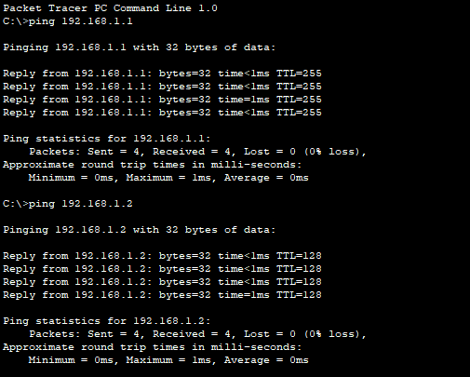
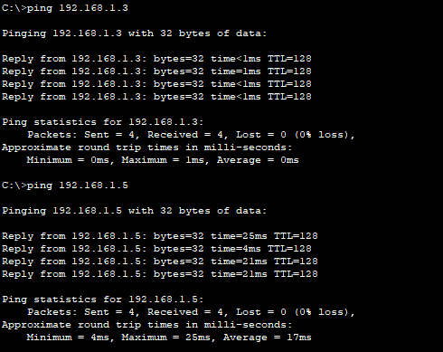
Ping from PC 2 ( 192.168.1.3 )
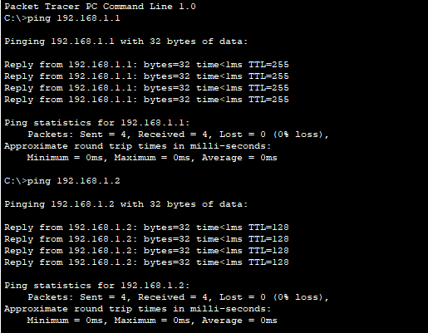
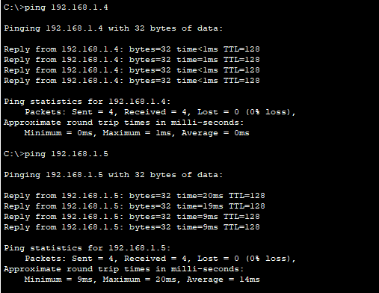

Ping from Laptop 1 ( 192.168.1.5)
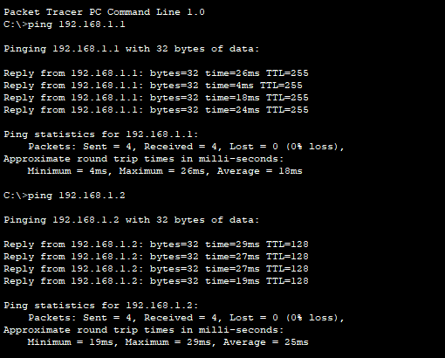

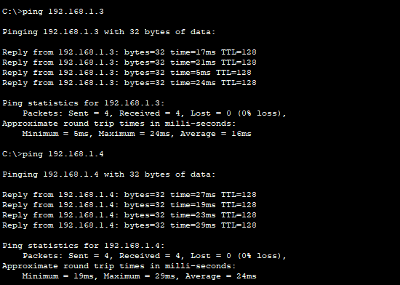

Ping from Server 1 ( 192.168.1.2 )
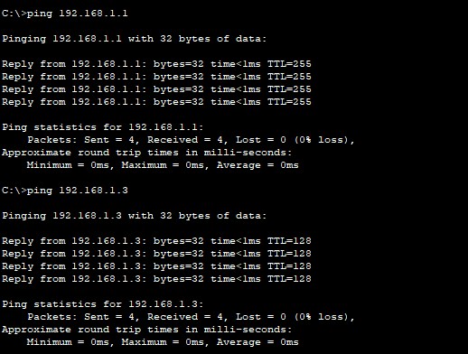

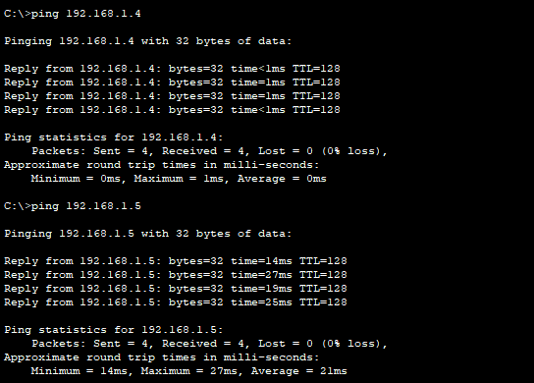

Logical Topology
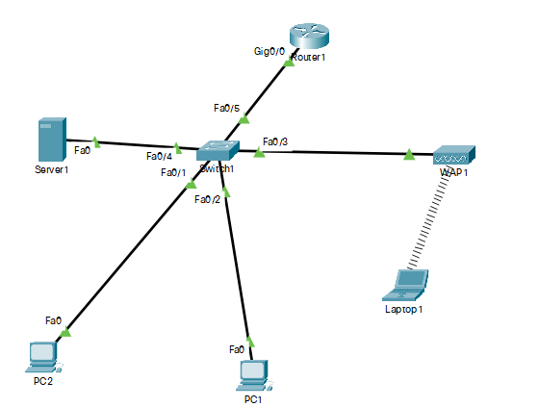

Physical Topology


