

Cert HE Business Skills for the Workplace
Employability and Career Development

Mock Interview

Student Name: Bogdan Theodor Apreutesei

Introduction
This portfolio will represent my professional life, highlighting my five-year experience as a handyman and proficiency in various fields, including maintenance, plumbing, electrical service, and painting. I have worked as a residential and commercial properties property services worker in central London and Birmingham, providing high-quality and attention to detail in high-density areas. The contents of this portfolio show that I am dedicated to quality, problem-solving skills, and want to uphold the maintenance and improve the facilities that I will be working on.

Job Advertisement
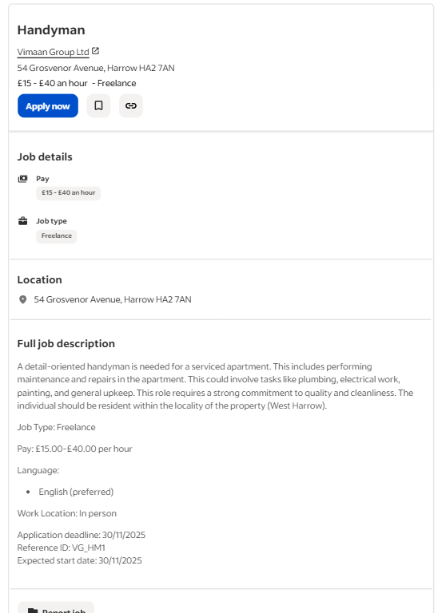
Figure 1 Job advertisement (Indeed, 2025).
The job opportunity here is of freelance handyman at Vimaan Group Ltd located at 54 Grosvenor Avenue, Harrow HA2 7AN. The job has a pay rate of GBP15 to GBP40.00 per hour according to experience and will involve the holder of the job do repairs and maintenance of a serviced apartment. One should work on plumbing, electrical maintenance, painting and overall maintenance of the apartment. The main one is attention to details and a strong sense of quality and cleanliness which is a necessity in this role. The handyman will be headquartered in West Harrow, where the location to the premises is at convenient of the handyman. The job is a freelance one and will involve the face to face work. The application date is 30th November 2025 and the anticipated date is also 30th November 2025. Communicating in the job would require knowledge of English.

CV

Name | Bogdan Theodor Apreutesei
Contact Information | Mobile: 07719224423  Email: Theodorapreutesei19@gmail.com
Personal Profile | - Highly experienced handyman with 5 years of experience and 1 year as a laborer.  - Specialized in plumbing, electrical work, painting, and general maintenance.  - Skilled in delivering quality work with attention to detail in central London and Birmingham.
Skills | - Plumbing  - Electrical Work  - Painting  - General Maintenance  - Problem-Solving  - Attention to Detail  - Time Management
Work Experience | Handyman  Freelance, Central London & Birmingham (2018 - Present)  Performed repairs and maintenance in residential properties  Specialised in plumbing, electrical work, and painting  Laborer  - Various construction sites (2017 - 2018)  - Assisted with basic construction tasks and site management
Education | High School - Completed Secondary Education,  Additional Training: Handyman skills training, safety certifications
Languages | English (Fluent)
References | Available upon request

Cover letter

Bogdan Theodor Apreutesei  Mobile: 07719224423  Email: Theodorapreutesei19@gmail.com | Hiring Manager  Vimaan Group Ltd  54 Grosvenor Avenue  Harrow HA2 7AN
Dear Hiring Manager,
Having an advertised position of a handyman in Vimaan Group Ltd, it was stated in an advertisement that there is an available position. I am thus writing to inform you of my interest in the position. I also possess a well-balanced background due to my over five years of experience as a handyman, and a year of experience as a labourer, which contributed to the development of my abilities in the areas of general maintenance and plumbing, electrical work, and painting, which are similar to the main responsibilities of the position presented in the job description. My experience at work, which is accompanied by attention to detail and quality, makes me a good candidate for this job.

All my professional life, I have been working at various residential and commercial buildings in the centre of London and Birmingham. This exposure has also enabled me to acquire a host of skills, from plumbing repairs to electrical work to painting assignments. My strong appreciation of work is an aspect I can proudly proclaim, and hence, all the work I engage in is effectively and satisfactorily done to the perception of my clients. I also would never hurry my job and would pay much attention to cleanliness and maintenance of the properties I am working at. This, in my view, is the most important detail in this business, and I strive to exceed expectations with every project.

I am also readily adaptive and can handle various forms of maintenance in addition to my technical skills. I also like working independently, scheduling my working time, and ensuring that nothing is postponed. This ability to solve problems and troubleshoot has been a major asset to my career, and I will always have a tendency to accept the emerging issues that require creativity. The broken pipe, the new electrical fittings or repainting a room, but then I am sure that anything I could do is of a good quality, and would be precise. Particularly, the fact that it will provide me with an opportunity to work in the residential setting, including assistance in upkeep and improvement of the quality of serviced apartments, makes this job at the Vimaan Group Ltd attractive to me. The other quality that attracted me to the job is that it is freelance work and with that comes the flexibility of the place of work, where I can provide the required skills and knowledge in the properties surrounding and within the West Harrow area.

Moreover, I am also in the West Harrow locality, which implies that I can be easily reached anywhere in case of any maintenance work that might be needed. I understand the need to be relied upon and ready to serve as a handyman, and I suppose the proximity of the place will be a chance of delivering any job-related request promptly. My CV, which you can take into consideration, is provided and attached below. It gives more information regarding my working experience and skills. I would like to get an opportunity to discuss in detail my qualifications and how I would work to maintain the high standards of the Vimaan Group Ltd. You may interview me at any time that you wish to do so, and you may reach me on the phone at 07719224423.

Thanks, and thank you very much for reading my application. I hope to get a chance to serve your team.

Sincerely,
Bogdan Theodor Apreutesei

Conclusion
The portfolio demonstrates that I am good at and interested in the process of providing the most efficient handyman services. The diverse nature of my skills is what has enabled me to perform maintenance work in different properties because I have a keen eye for detail and am a hard worker. I am also anticipating my continued practice in the field where I will contribute my knowledge towards the creation of high-quality of living and working environments that are well-maintained. I am also willing to have potential opportunities in collaboration with the aim of developing my work experience in this profession.

References
Indeed (2025). Handyman jobs in England. [online] Indeed. Available at: https://uk.indeed.com/q-handyman-l-england-jobs.html?vjk=be98e9e7ad9386ae [Accessed 13 Nov. 2025].

Question | Answer
1. Could you tell me something about your background and relevant experience? | My general maintenance experience as a handyman, electrical work, plumbing, and painting experience exceeds five years. I have been carrying out various residential buildings in Central London and Birmingham. Moreover, I also have one year of working experience as a labourer in which I assisted with construction labour work. My background is broad, thus making me master a lot in problem solving, attention and efficiency in handling various maintenance problems.
2. What skills or experience do you have that will help you succeed in this role? | Practical skills which I have are plumbing and electricity, painting and general repairs. I am adaptable and experienced in most settings of maintenance works hence am capable of approaching undertakings flexibly and proficiently. I am an organizer who has activities which are executed to the maximum ability. What is more, I am used to work independently, time management, and the ability to prioritize jobs by their urgency, which would ensure my success in this role, to maintain and fix the structures.
3. What are your strengths and weaknesses? | My high point is that I am a hardworking person, detail-oriented and possess problem solving skills. My services will be of high quality and in all my responsibilities, all will be carried out efficiently. I am also overcommitted and this is my weakness since I commit more projects than I am at times able to handle. I am, though, attempting to improve on the area of time management and mastering the skill of delegating in case of necessity to achieve the optimal balance of quality and workload.
4. Could you tell me about a problem that occurred at work and how you dealt with it? | One incident involved the fact that I was assigned the duty of fixing a leaking pipe in one of the apartments but the damage was not minor and took me a long time to fix. I reviewed the case, gave the client the new provisions and successfully made the necessary repairs. My ability to be relaxed when faced with stress and flexibility in trying to find a solution to the unanticipated roles allowed me to fix the problem quickly with minimum inconvenience to the client and restore the house in the original form.
5. Are there any questions you would like to ask me? | Yes, I would like to know more about the team that I am to cooperate with and what sort of projects I am going to deal with. What is more about the work culture, how does the company make quality control in maintenance tasks? What are the greatest challenges that you think you face in this job, and how do you make your team overcome them? This would help me in a better understanding how I can contribute towards the success of the teams.

