

Travel Agency – Eleni travel
(Business plan)

Student name: Elena Rumenova Sotirova
Student number: 2028225
Module name: Entrepreneurship
Module code: LCBB5001
Lecturer: Vasilios Tavlaridis
Date deadline: 18th July 2022

Contents: page
Introduction – overview of Eleni Travel and business plan……………………………...3
Ownership and legal format of Eleni Travel………………………………………………..3
Management of Eleni travel………………………………………………………………....4
Evaluation of the business idea by SWOT analysis………………………………..……..4
PESTLE analysis of tourism industry……………………………………………………….6
Identification of the critical marketing factors by 4Ps marketing mix model…………….8
Target market and the marketing strategies……………………………………………….9
A cash flow forecast for the first 12 months…………………………………………….…10
Reference list………………………………………………………………………………..11

Introduction – overview of Eleni Travel and business plan
Entrepreneurs see opportunities and convert them into profitable businesses. A valuable collection of circumstances that produces a demand for a new product, service, or business is an opportunity that an intelligent innovator must extract and turn into a successful business (Barringer and Ireland, 2018, p.65). This opportunity to become a workable idea with a profit for the owner needs a detailed plan of action, which can be named a business plan for a travel agency. A business plan is a document that outlines a company’s objectives and strategies for achieving goals. It is like a roadmap that describes the organisation’s marketing, financial, and operational strategies on paper. Both new and established enterprises utilize this business model (Investopedia.com, 2022).
The travel and tourism sector contributes significantly to the united kingdom's economy (UK). That industry generated an estimated 237bilion British pounds to the UK's GDP in 2019, but this amount decreased by more than fifty percent in 2020 due to the coronavirus (COVID-19) pandemic (statista.com, 2022). The number of UK citizens traveling outside the country fell by 20% in 2021, primarily due to the ongoing limitations on travel. To see the world in 2021, British citizens will spend £15.5 billion more than they did in 2020, a 13% rise. The forecast for 2022 is that the travel industry will try to recover and reach the levels of traveling people before the pandemic (Office for National Statistic, 2021).
In the travel industry, a travel agency is a business that represents hotels, airlines, cruise lines, and other service providers in the marketing of travel-related products and services to the general public. By charging consumers a fee or collecting commissions from providers, this company creates profits for independent agents, brick-and-mortar storefronts, and internet travel agencies (OTAs) (Statista,2022). Eleni Travel is a new, independent travel agent headquartered in Sutton Coldfield, which will offer a high level of service, along with good product knowledge and competitive pricing. The crew at Eleni Travel has over twenty years of travel experience, a real passion for the industry they work for, and the countries they frequently travel to and promote.

Ownership and legal format of Eleni Travel
Possession of total legal authority over the status of anything is called ownership. Eleni Travel is planning to be a limited company, small – medium enterprise (SME), where the owner will be the manager and main office presenter, plus another staff member to support all the works processes. Thus, help us to understand what it means ‘limited company’ - is a separate legal entity. A limited liability business has one or more members, often known as shareholders or owners, who make investments privately. Undoubtedly, starting a business as a sole trader is the simplest way to do it in the United Kingdom, but the limited organisation has some advantages. One of the significant benefits of operating an SME as a limited liability company is the ability to pay less personal tax than a self-employed person legally. Another significant advantage is that the owner of a restricted firm will not be personally responsible for any financial losses incurred by the business. Therefore, a limited organization can provide additional protection if something goes wrong. Indeed, for this SME, it may be slightly easier to obtain business financing than it would be for a sole trader (bytestart.co.uk, 2022).

Management of Eleni Travel
There is no universally agreed description of ‘management’ as an activity. However, Henri Fayol’s (1916) definition is still widely accepted: “To manage is to forecast and plan, to organize, to command, to coordinate and to control.” (Cole and Kelly, 2011, p12). The enterprise's management style, structure, and culture influence employee behavior. Eleni Travel is an SME with manager Elena Sotirova and another staff member; thus, the manager will hold and separate all the primary duties. Management is the collection of operations that involves planning, leading, making decisions, and controlling the organisational's resources, such as human, financial, informational, and physical resources, to achieve the firm's objectives effectively and efficiently (Weick, 2014). The organisation must always have a formal structure to achieve its objectives successfully.
In addition, Eleni Travel will have an accountant, who will be contacted monthly for regular reviews of the ledger book and other accounting activities. Daily responsibilities and activities will be done mainly on the computer with specific software; thus, Eleni Travel will have an IT specialist support, available in case of disruption or weekly renewal on the website and support any other office equipment.

Evaluation of the business idea by SWOT analysis
Organisations should comprehend their capabilities and connect them to the opportunities and threats they face. This is achieved through the SWOT analysis. While options and threats could be generalized for most organisations in an industry, a firm’s strengths and weaknesses are unique. As far as strategic positioning and surrounds are concerned, the SWOT analysis is the most often used instrument. One of the most important aims of the business model canvas is to establish strategies that will allow a company’s resources and competencies to meet operational environmental requirements. (Venugopal, 2010).
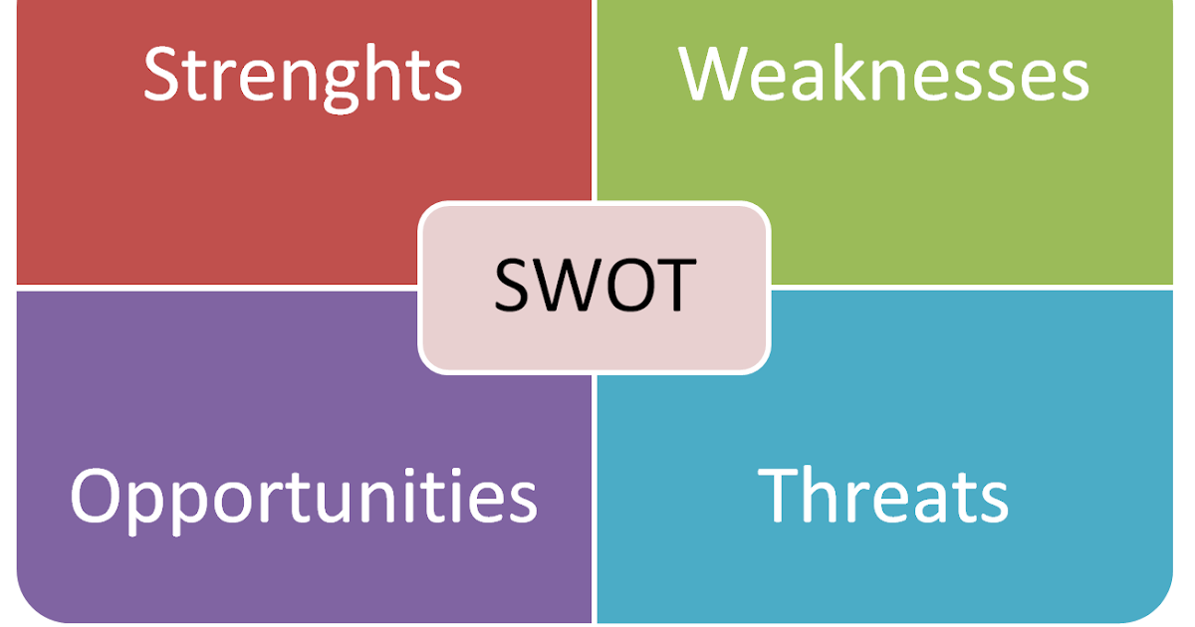
Lazyselesxpert.blogspot.com, 2016

SWOT analysis Eleni travel agency:
STRENGTHS | WEAKNESSES
Enthusiastic and confident small team.  Good location with parking space.  Modern interactive system in the office to show our travel products.  New unique products on the market.  Direct communication with GR and CY contributors- better prices. | No reputation, low number of current customers.  Short staff.  Small database of potential customers.  Not booking apps
OPPORTUNITIES | THREATS
Strengthening culture tourism.  Development of related products.  Private trips with an individual program. | Competition from other destination  Alternative ways of booking  Increasing oil prices leading more expensive flights

Since Eleni travel is an entirely unknown name in the travel sector, the tiny team of two is very motivated to reach a vast objective, and the expectation is that within a year, it will be the most well-known travel agency in Sutton Coldfield. Eleni Travel will offer some particular products like culture tourism in unfamiliar and adventure destinations.
The significant weakness of Eleni travel is that not planning to have its app for online booking because more of the products will be created according to customers' needs. The attention will be mainly on the private trips organized by Eleni Travel.

PESTEL analysis of the tourism industry
Analyzing the market conditions is critical to the creation of a marketing plan. The PESTEL framework is a concise acronym for all significant aspects that affect the organisation's capacity to fulfill its strategic objectives but are outside its direct control (Housden, 2010).
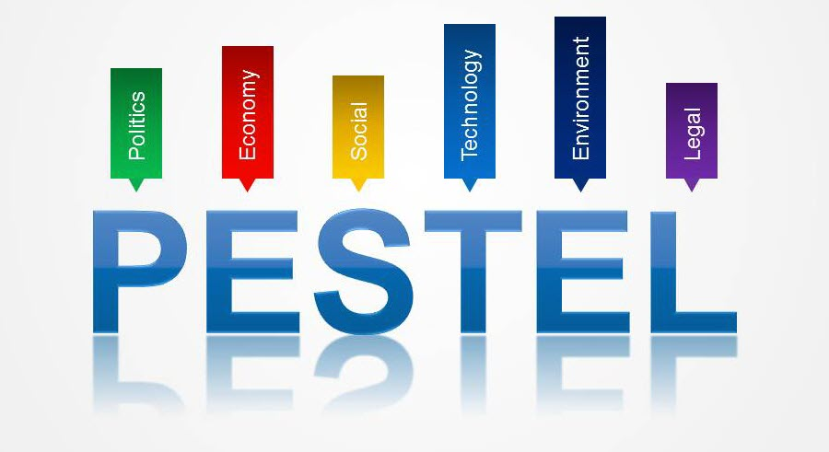
Freesampleassignments.com, 2022

Political – Most governments across the globe have open borders for people of other nations. This has offered an enormous benefit to the tourism sector, as most of the world is now accessible to tourists with sufficient funds. Certain countries do not require a visa to enter or any additional COVID pass, creating an even more tourist-friendly environment.

Economic – Those who were previously unable to afford foreign tourism are now able to do so as the global economy expands. Since living costs are increasing at a lower rate than purchasing power, individuals may afford luxuries such as travel. Companies like Uber and Airbnb are altering the way that individuals travel. They have presented consumer-friendly economic strategies, making tourism more widely available. Sharing economies are businesses based on such a framework. The research anticipates increased use of these economies in the future.

Social – people's awareness of different cultures in the world is increasing, and as a result, they desire to go to and experience these civilizations. For instance, some people are learning Spanish to travel to South America, whereas those in Russia are learning Chinese to visit China. In former ages, it was uncommon for middle-class individuals to travel with a focus on acquiring new knowledge.

Technological – in recent years, the transport industry has undergone a significant upgrade due to introducing new and enhanced transport services. There are currently more airplanes offered to consumers. In addition, there is a solution that is more accessible to travelers with middle-class incomes. Furthermore, airports have become more modern, and flying tickets may now be purchased online from a mobile phone.

Environment – airplanes, ships, and other vehicles have caused an enormous increase in pollution levels due to the global tourism boom. Many climate change supporters accept reducing tourism as a solution to the problem. The transport industry is currently being extensively criticized for using the environmentally destructive solution.

Legal – acquiring a visa was a time-consuming and legal procedure. However, practically everyone on the planet may now apply for and obtain a visa. Furthermore, because most of the world’s borders are accessible to travelers, governments frequently grant tourist visas to promote the global economy. Other tourism-related legal procedures are also becoming easier for customers to use.
Several banks now provide loans for tourism-related purposes. These loans greatly enhance the ordinary person’s capacity to go overseas.

There are the most influential pestle analysis elements in the tourist sector. There is little doubt that this industry will expand soon due to several economic, technological, and political benefits. Nonetheless, the population is a significant concern that must be addressed if this sector becomes more ethical (marketingtutor.net, 2022).

Identification of the critical marketing factors by 4Ps of the marketing mix model.
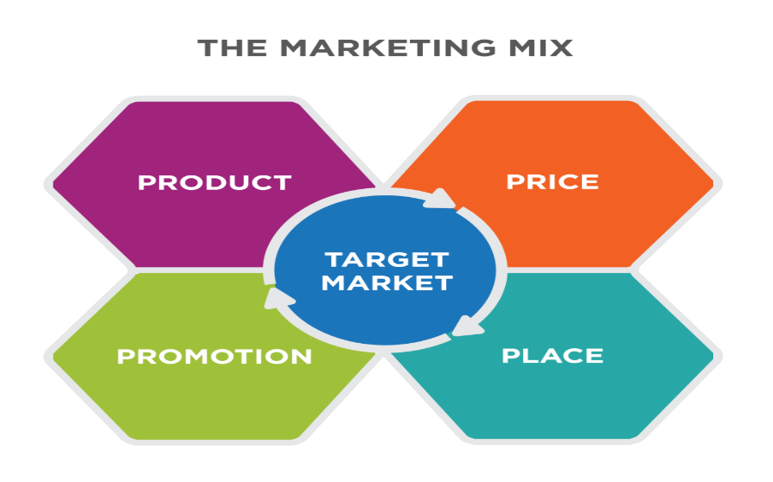
The Marketing Society defines marketing very simply: 'The creation of customer demand, which is the only sustainable form of business growth' (Housden, 2010, p.4). Marketing is a corporate operation that identifies consumer requirements. It finds target markets and offers products and services to serve them. Entrepreneurs who intend to begin a firm, regardless of size, should acquire marketing knowledge.

Coursehero.com, 2022

A marketing mix is a collection of marketing tactics that an institution utilizes to generate the desired reaction from its target markets. It includes everything the organization can do to affect its ability to meet the needs it provides, and it is called '4Ps'. The four Ps relate to the product, pricing, promotion, and place (location). It is considered a mix because a successful marketing effort requires a combination of all four components. To succeed, Eleni Travel should have the correct product at the right price, excellent advertising, and a suitable location for customers to buy (Franklin et al. 2009, p.129). In the travel industry, there are 7Ps of marketing, which are extremely useful for attracting attention and motivating people to take action. In addition are added packaging, people, partnership, and programming. Tourism service is characterized by its intangibility, variability, transient ownership, quality, and inseparability (academia.edu, 2014).

Target market and the marketing strategies
In recent years, the travel industry has increased its focus on finding new sectors, demonstrating the growing maturity of the industry. This decision examines six markets frequently cited by travel vendors, travel agents, and travel media as promising prospects for expansion and financial success. This business strategy details the market size, travel habits, leisure travel expenditures, vacation activities, reasons for traveling, demographics, and psychographics for each group. To help with a conceptual grasp of how to target each group, the review's conclusion includes a summary profile of each section. To demonstrate how the segment deviates from the norm, trends and patterns displayed by the travel market are compared with the part. According to this standard, the following are the proportions of the adult travel market’s various components:
- Adventure travelers – 15%
- Budget travelers – 13%
- Family travelers – 55%
- Gay travelers – 2%
- Luxury travelers – 10%
- Baby boomers – 5% (Theobald, 2004).
Tourism operators and service providers can leverage the concept of customers’ satisfaction capability to increase tourism activities and customer loyalty. Client satisfaction capability is delivering customer pleasure by attracting more fascinating and distinctive destinations that meet the client’s wants and wishes via the marketing mix strategy. This requires hospitality businesses to offer a product that meets specific customer requirements. Improving marketing performance for tourism service providers should involve increasing customer happiness and loyalty. Consumer loyalty will increase due to the company's capacity to produce particular and unique services in response to customers' needs (Tevian et al., 2017).
Eleni Travel will attract mostly family travelers, luxury travelers, and adventure travelers. The travel agency will specialize in adventure tourism, so the primary strategy will be to expand this present from 15% to 20%-25% of its sold products.

Sales per month | Sep | Oct | Nov | Dec | Jan | Feb | Mar | Apr | May | Jun | Jul | Aug
Capital -£50000 | £50,000 | £21,400 | £16,300 | £12,200 | £8,400 | -£4,000 | -£3,400 | -£2,800 | -£2,800 | -£1,300 | £800 | £1,000
Revenue | £1,500 | £1,800 | £2,100 | £2,100 | £2,400 | £2,700 | £3,300 | £3,900 | £3,900 | £5,400 | £7,500 | £7,500
Sale | £5,000 | £6,000 | £7,000 | £7,000 | £8,000 | £9,000 | £11,000 | £13,000 | £13,000 | £18,000 | £25,000 | £25,000
Rent | £700 | £700 | £700 | £700 | £700 | £700 | £700 | £700 | £700 | £700 | £700 | £700
Equipment | £10,000
Employees’ wages (add here how many employees) | £4,000 | £4,000 | £4,000 | £4,000 | £4,000 | £4,000 | £4,000 | £4,000 | £4,000 | £4,000 | £4,000 | £4,000
External advisers/professionals (accountant, web designer) | £1,500 | £300 | £300 | £300 | £300 | £300 | £300 | £300 | £300 | £300 | £300 | £300
Bills | £1,000 | £1,000 | £1,000 | £1,000 | £1,000 | £1,000 | £1,000 | £1,000 | £1,000 | £1,000 | £1,000 | £1,000
License | £1,000 | £200 | £200 | £200 | £200 | £200 | £200 | £200 | £200 | £200 | £200
Add other costs | £500 | £500 | £500 | £500 | £500 | £500 | £500 | £500 | £500 | £500 | £500 | £500
£50,000
Total Cost: | £18,700 | £6,700 | £6,700 | £6,700 | £6,700 | £6,700 | £6,700 | £6,700 | £6,700 | £6,700 | £6,700 | £6,500
A cash flow forecast for 12 months Eleni Travel
Reference:
Academia.edu (2014) Tourism Marketing 7P’s. Available at: (PDF) Tourism Marketing 7 P's | Sukhdeep Kaur Sran - Academia.edu
(Accessed: 5 July 2022)
Barringer, B. and Ireland, D. (2018) Entrepreneurship Successfully Launching New Ventures. 5th edn. Pearson Education
Bytestart (2022) 10 advantages of setting up a limited company. Available at: http://www.bytestart.co.uk/limited-company-advantages
(Accessed: 14 June 2022)
Cole, G.A. and Kelly, P. (2011) Management theory and practice. South-Western
Coursehero.com (2022) The Marketing Mix. Available at: The Marketing Mix | Introduction to Business [Deprecated] | | Course Hero
(Accessed: 14 July 2022)
Franklin, B., Hogan, M., Langley, Q., Mosdell, N. and Pill, E. (2009). Key Concepts in Public Relations. SAGE Publications Ltd, London
Freesampleassignments.com (2022) External Trends -CREST, PEST, PESTEL. Available at: External Trends - CREST, PEST, PESTEL - Free Sample Assignments
(Accessed: 14 July 2022)

Housden, M. (2010) Market information and research. 2nd ed. Amsterdam ; Elsevier.
Investopedia (2022) Business plan. Available at: https://www.investopedia.com/terms/b/business-plan.asp
(Accessed:14 June 2022)
Lazysalesxpert.blog.com (2016) THE SWOT ANALYSIS. Available at: Lazy salesxpert: THE SWOT ANALYSIS
(Accessed:14 July 2022)
Marketingtutor. Net (2022) PESTLE Analysis of The Tourism Industry. Available at: PESTLE Analysis of The Tourism Industry | Marketing Tutor
(Accessed: 24 June 2022)
Office for National Statistics (2021) Travel trends:2021. Available at: https://www.ons.gov.uk/peoplepopulationandcommunity/leisureandtourism/articles/traveltrends/2021
(Accessed:15 June 2022)
Statista (2022) Travel Agency Industry – statistics & facts. Available at: https://www.statista.com/topics/1859/travel-agencies/
(Accessed: 08 June 2022)
Available at: https://www.statista.com/topics/3269/travel-and-tourism-in-the-united-kingdom-uk/#topicHeader_wrapper
(Accessed: 15 June 2022)
Tengku Teviana et al. (2017) ‘Antecedents of Tourism Destination Image and Customer Satisfaction in Tourism Industry’, European Research Studies, 20(3A), p. 435–.
Theobald, W.F. (2004) Global tourism. 3rd ed. Oxford: Elsevier Butterworth-Heinemann.
Venugopal, P. (2010) Marketing management a decision-making Approach. Delhi ; Response.
Weick, K. E. (2014). The Nature of Managerial Work.

