MODULE CODE: Digital skills for personal development and business BMSW4008
Assessment Components: Portfolio
Student name: Aimee Zupkova
Student number: 2512683

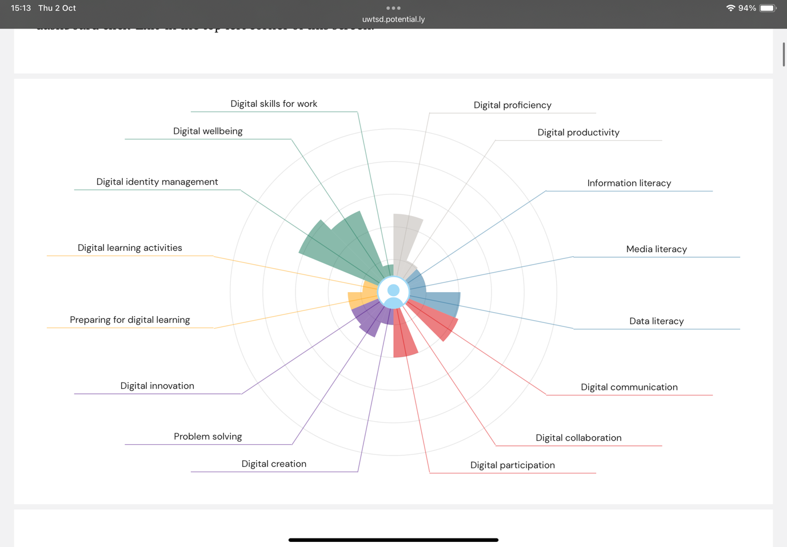
Digital skills is an ability to use digital software, devices, networks and how to manage and find information. It is important because now and moving forward these skills are essential for careers and daily tasks as we are digitally driven. Digital skills are essential for most jobs and is key for education as it improves productivity like streamlines studies, enhances learning because of using technology like assignments, virtual classrooms, and collaborations. It creates critical thinking to evaluate online information and identify misinformation. To improve digital skills, you need to have a process that requires commitment and a defined strategy like taking online courses and seeking mentors. (Sánchez C,2023). Another thing is understanding safety and ethics like cyber bullying and learn how to interact responsibly. Key parts include date protection, digital wellbeing, ensuring technology and preventing algorithmic bias. Algorithmic bias happens when systematic errors in machine learning produce unfair or discriminatory outcomes. (Jonker, A, Rogers, J)
As you can see, in my Jisc report my strengths are digital identity management, digital wellbeing, digital proficiency and digital participation however I have way more weaknesses like digital literacy, digital collaboration, media literacy, digital creation and many more. This is because I have never had to exclusively use digital tools for anything I have done before in school or college, so there is a lot of improvement that needs to be done. Over the next couple of weeks, I will be working on different skills that I find myself weak in and making sure I improve on it slowly and efficiently. Another thing I need to work on is my digital collaborations according to the JISC report. I did not know that was one if my weaknesses as it is a thing I am quite confident in using as in teams, google classroom, word collaborations, zoom etc. I used to use these digital sites when I was both in high school and college, so I did not think I had many problems with it. A way I might slack in it is choosing the right tool for the project so to improve that I will think more about the project I am doing and what site is needed.
A weakness of mine I will improve on is media literacy, this is how I will work on it. I will first evaluate credibility of sources, I will also make a checklist of the authors and their findings, Then I will dedicate at least 2 and a half hours a week to finish the task. This will help me understand the difference between facts and opinions online which will help me avoid the incorrect information. I will complete this process until the deadline. Digital literacy is a transformative tool as it creates vital critical thinking and interpersonal understanding (Toval D, 2024)
Another weakness of mine I will improve is my digital creations. The way I will go about this is by defining what I want to make and study higher quality examples of digital creations. Then I will focus on learning a tool at a time and break it into smaller sections for example, shading, layouts, effects, and shading. I will then build a simple workflow that I can reuse for projects and practise smaller manageable creations. I will also use references to guide my work and ask for feedback from random people. If I have consistent practice my digital creations will improve naturally. 92 percent of educators believe that creative literacy magnifies students learning and prepares them for better careers (Wyld V, 2025). This shows how much creative literacy is important for students and their future. It is a tool that can help them build a better understanding and abetter image of themselves to employers
Digital identity management is a system known for processes, policies, and technology which is used to manage, create and secure. The risks students must know about digital identity is digital breaches which is storage of sensitive information that makes digital identity systems a target for cyberattacks. Around 83 percent of surveyed organisations has experienced multiple data breaches (IBM, 2023). Another risk is identity fraud which is weak authentication mechanisms that can lead to impersonation or sell your data. To prevent this from happening you must use strong passwords with two factor authentication.

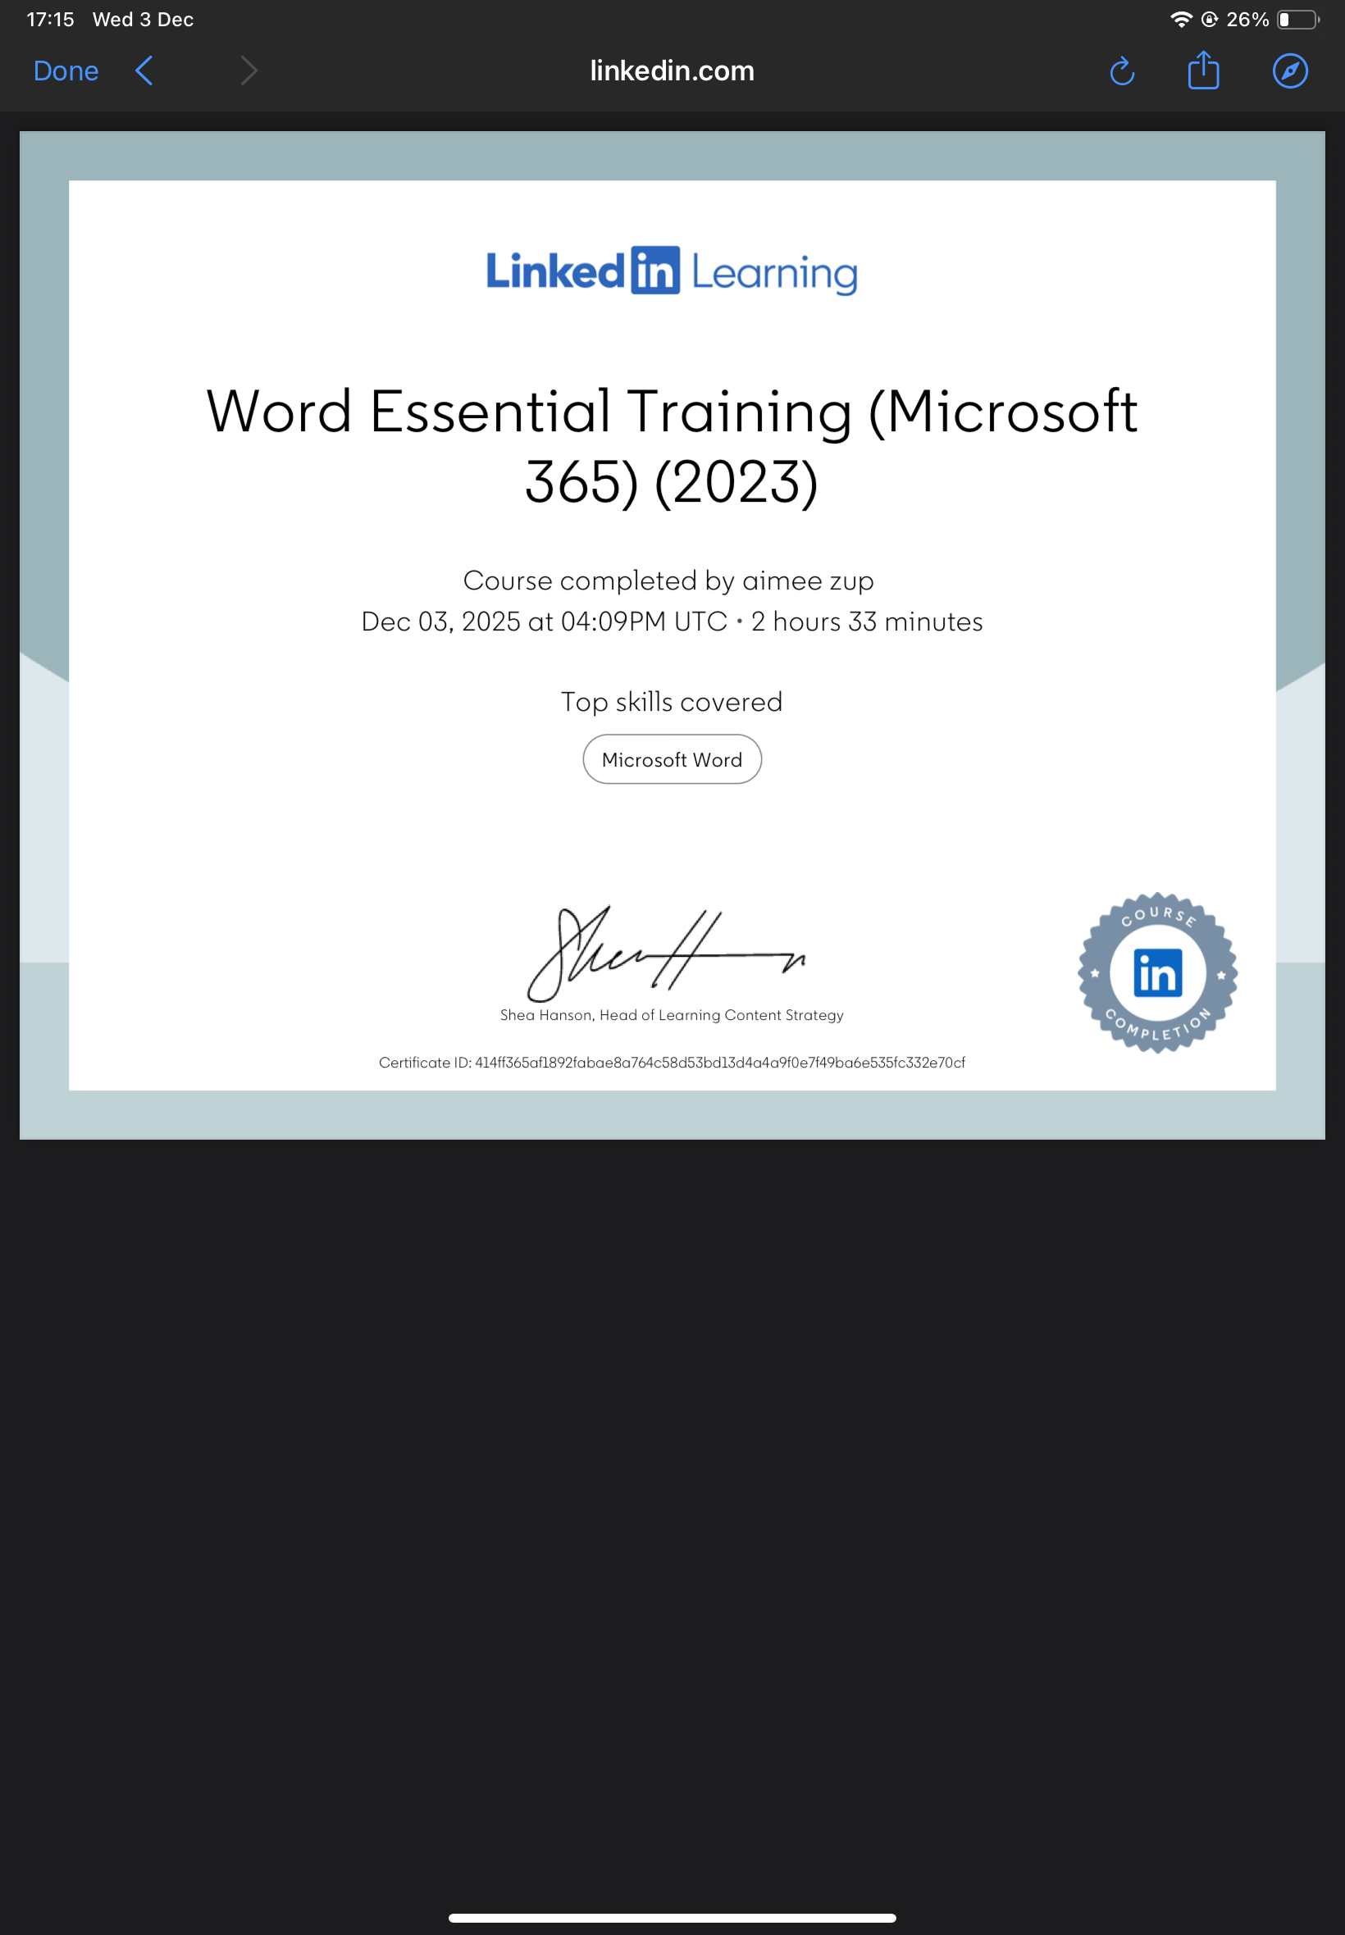

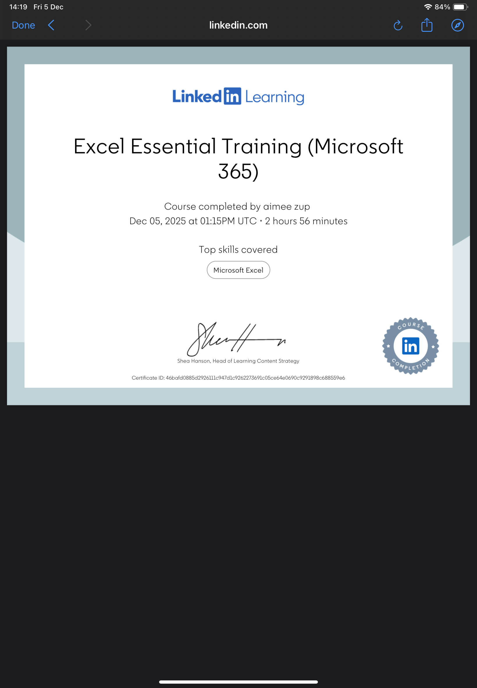

Part 3
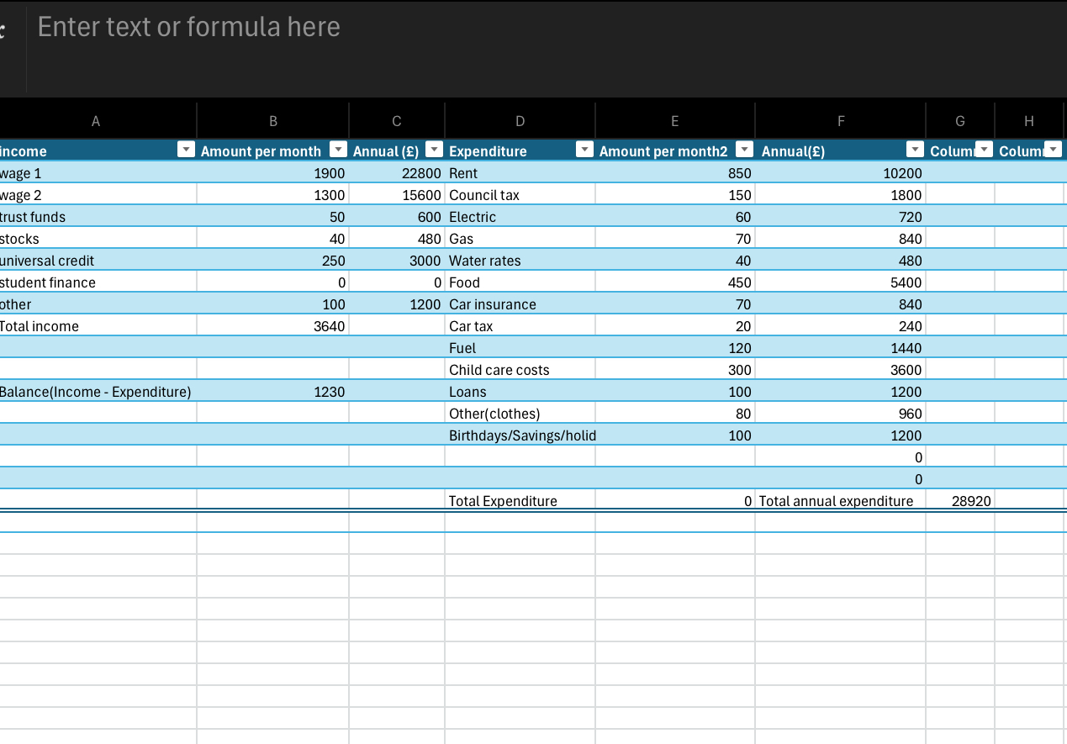

Microsoft Excel is a spreadsheet editor for organising data in grids and columns for calculations. It is usually a tool for budgeting, financial modelling, data entry and creating charts and graphs. It is done by applying different formulas for automatic calculations for example like ‘SUM’ or ‘AVERAGE.’ The formulas speed up the process of making whatever chart/ table needed. Excel can be used in personal and professional life even though people think its just for professional purposes. This report will be bout how you can use excel in professional and personal life and the different opportunities available to a person whilst using excel.
Using excel in personal life you can do many different charts and tables with it. For example, budgeting, tracking expenses, planning events (meals, trips, parties), tracking investments, and organising data. Budgeting and financial tracking, to do this you can start off by listing income like salaries and investments in one column. In the next column categorise expenses like bills, groceries, transportation etc. Lastly you will go in the other column you set up a description of expenses, categories and how much has been spent. Then you use excels sorting and filtering capabilities to see spending habits and find areas where you can cut back. This will help to see whether you are spending too much money on things that are not essential for daily life and then you can figure out whats taking up most of your money and cut off whats not needed. Tris will help save money and spend the money on something more useful. You can use excel to do meal planning and grocery lists. By creating a simple spreadsheet weekly or monthly, input ingredients and create corresponding grocery lists. This saves time and money. (Georgiev A, 2023)
When it comes to planning events, you can make a spreadsheet on who RSVP’D and seating arrangements (Georgeiv A, 2023). This is another useful way to use excel spreadsheets, it helps with the day flow calmly and there being no confusion on the day of the event. Dietary restrictions are another way that spreadsheets help incase of allergies etc. You can make a column and then tick off who has allergies and who can not eat certain things. The use of excel spreadsheets helps in the personal life a-lot when it comes to organisation and planning.
In a professional setting Excel is useful for project managements, advanced budgeting, professional guest, and attendee management, vendor and supplier coordination, data analysis etc. However, to manage doing all these things you must be quite advanced in using excel. As in knowing how to formulate properly for the charts to look more professional and everyone to be able to understand. That means that even if you make spread sheet for your personal life and then try doing it in a professional manner in your chosen career your employer may not understand it. This is because you could be setting everything out in an unusual way than it should have been.
Excel can help most careers out a lot whether they work in healthcare, marketing, or finance, it significantly boosts your employability. (Ciabatti V, 2023). One of the things Excel is useful for is Time and task management because it streamlines the tasks and saves time. This is because it speeds up the process of the calculations. For example, in finance and accounting it automates the calculations and reduces the risk of errors. (Ciabatti V, 2023)
Here are some formulas to use whilst doing a spreadsheet. Excel formulas usually start with the ‘= ’sign this is so it lets the computer know that you are ready ton formulate. To perform calculations, you will use words like ‘SUM’ ‘AVERAGE’ ‘COUNT’ and ‘MAX’ for more of the basic calculations. For dates you would use words like ‘TRIM’ ‘CONCAT’ ‘TODAY’ and ‘NOW.’ If unsure about certain formulas, you can always google what to do or what formula to use for a certain thing. Excel formulas are important because it helps with efficiency, data analysis, accuracy, and data manipulation (Awan A A, 2025). On excel you can also select what the spreadsheet is for to have the right layout. For example, there is a section for budgets, lists, calendars, schedules, invoices, and household. You can find this on the create button. Each section you get a bunch of types of templates that can be used for different things that I have listed above.
Some may say Excel is hard to use for beginners especially the more advanced things you can do on Excel (Coursera staff, June 2025). Excel is challenging to use for people with no experience with it but if they put the right amount of work into understanding it, they will get the hang of it faster. Excel also can find errors in spreadsheets but sometimes there might be a malfunction and you need to understand the software to actually correct your own work.
In conclusion excel is useful in many ways for both personal and professional ways. It has been showed that it is possible to use it even with little knowledge on how to use it. At the start of this year, I barely had any knowledge on how to use Excel but throughout the term I learned how to effectively use it. I also did the online course and that helped a lot on how to use Excel. There are a lot of great ways to use excel and to make your personal and professional life easier and flow better for them. Excel is time effective for busy people as a sheet could take up to 10 to 20 minutes to complete depending on what the sheet is about. If your sheet is about something personal it will take the 10 to 20 minutes but if its in a professional way it would take longer like 20 to 30 minutes.

Reference list
Sánchez C,2023, ‘Digital Skills’
Jonker A, Rogers J, ‘What is algorithmic bias’
Georgiev A, 2023
Toval D, 2024, ‘ The importance of media literacy’
Wyld V, 2025, ‘Digital creativity is a must-have skill for career-ready students’
IBM, 2023
Georgiev A, 2023
Ciabatti V, 2023 ‘Excel your career: Mastering the art of spreadsheets’
Awan A A, 2025 ‘The 15 basic formulas everyone needs to know’
Coursera staff, 2025 ‘qp Excel functions for data analysis’

