

Assessment 1
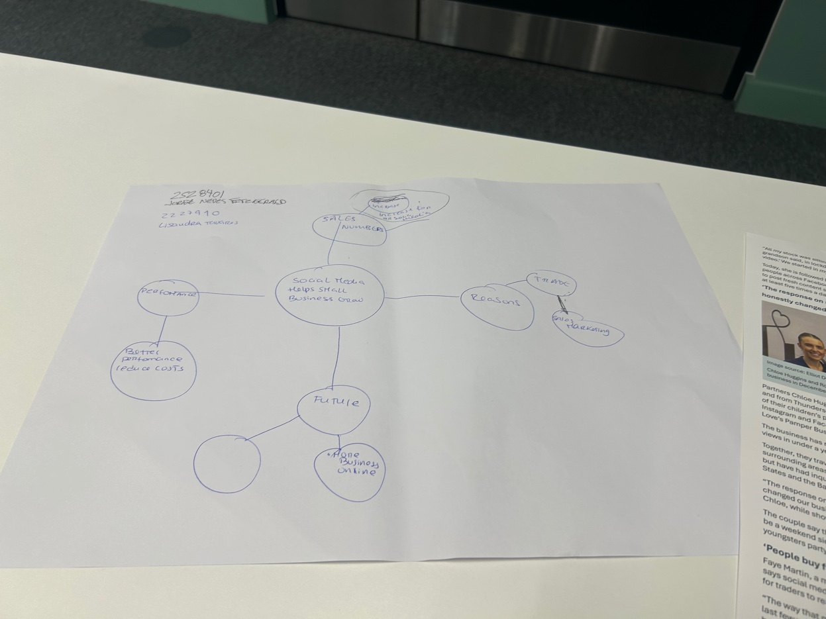
1. Answer these questions using the sentence starters below
a. What is the main idea of the text?
The main idea is that social media helps small businesses grow.
b. What are two key points?
One key point is that social media can increase sales numbers
c. What part of the text did you find most important? Why?
The most important part is the reasons for using social media.
d. Was anything unclear or difficult to understand?
I was confused tell people until reading the BBC article 10 times
about how businesses online in the future.
e. How did your group help you understand the text better?
My group did not help me much I watched the recording lessons
2. One sentence reflection
Question: What did you find challenging about this task?
The hardest was turning my mind map into full sentences.

