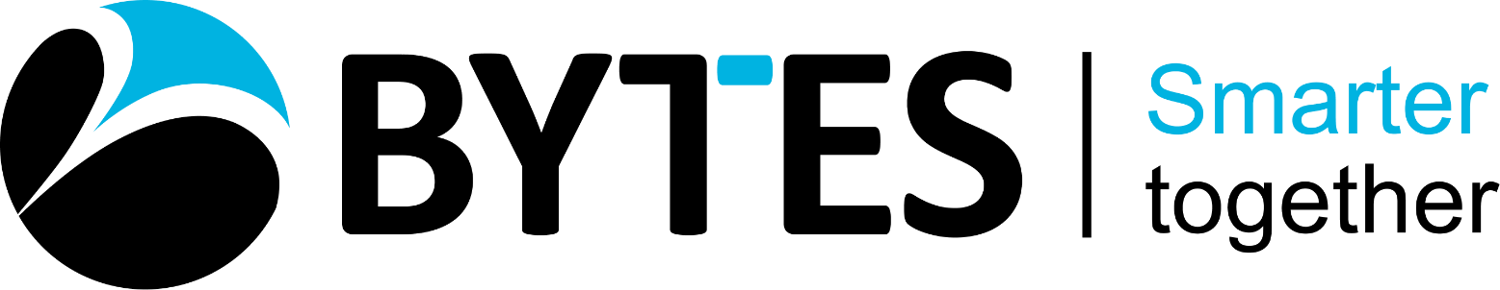

NAME: Jamuthra Srikumar
MODULE: Design Thinking and innovation
LECTURER: Dr. Akash Puranik
TITLE: LCLM6002

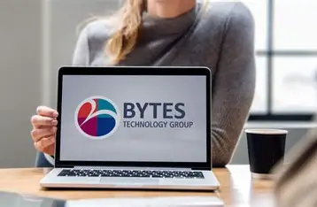

Introduction of BYTES software solutions
BYTES software solutions established in 1982. BYTES opened their first shop of computer supplies at Surrey United Kingdom. In1998, BYTES acquired by the south African based Allied Electronics Corporation (Alton) Group. BYTES grew up steadily and strongly as IT solutions and partnership with Security like specialist in cyber security business. BYTES located their headquarters in Leatherhead Surrey. The BYTES Technology Group demerged from ALTRON and successfully listed on the London and Johannesburg Stock exchanges with an Initial Public offering (IPO) in December. BYTES stepped in to FTSE 250 index in 2021.

This era, BYTES lead its operations in two main paths; they are Software services (Serves to Pubic and corporate) and Phoenix Software (focusing primarily on the public sector). Nowadays BYTES is one of leading IT solutions provider focused on software, security, licencing, SAM, storage, virtualisation and cloud services. BYTES has more than 700 employees in the UK and Ireland. BYTES employees passionate about their services and help hundreds of top brands to transform, grow and adapt to the changing technology landscape. BYTES focuses on IT, software and security. Their fast-moving industry brings constant fresh challenges and opportunities for organisations of all types. BYTES explore of their customers issues and find the solutions that will work for competitive advantage. Their satisfaction is to be achieved when their customers reached the goals.
BYTES has long achieved recognition for our corporate social responsibility and working environment. BYTES team is the most important asset they have, so they ensure they are supported and rewarded for their hard work. In 2024 BYTES received a recognition of ‘Great place to work’. This firmly establishes us as an enjoyable, healthy and ethical workplace. As a big business of BYTES, providing support to community by reducing the environmental impact. BYTES recognise that their operations could result in waste energy consumption and emissions. To fight this, they have strong sustainability policies in place and commit to cutting their carbon footprint wherever possible. (www.bytes.co.uk)
Values of BYTES:
- Be passionate about their employees, vendors and customers.
- Always act with integrity.
- Work together and collaborate across teams.
- Always be kind and respectful to all people.
- Get business done and have fun doing it.

Key consumer and industry trends and data that affect the organisation
- Providing software licensing, security, cloud and IT services to customers in the corporate and public services.
- Building portfolio of professional and managed services including security, software asset management and cloud solutions.
- Focusing on six key areas: subscription software, security, IT services, AI, cloud-based solutions and hybrid infrastructure.
KEY CONSUMERS – Public Sector
- BYTES mainly focus on public sector. (NHS partners including NHS shared Business services and East Suffolk and North Essex NHS Foundation Trust)
- Local Authorities (London city council and Norfolk County council)
- Central government Departments includes ministerial departments, non-ministerial departments and executive agencies.
- Educational institutions including Southern universities purchasing consortium and the University of Essex)
Corporate Sector
At corporate level BYTES has the range of customer from small, medium large industries and FTSE companies.
- HS2 projects are establishing by the department of transport which is developing the most ambitious infrastructure project seen in the United Kingdom. HS2 projects technologies included from Microsoft, oracle, Service now and much more. But they choose BYTES as their trustworthy partner to provide expertise and the latest technology which HS2 want to implement to develop the project. So HS2 turned to company, And BYTES gave HS2 a clear view of current products, Business requirements for HS2 and consolidation options. Expertise explained how to drive from current licencing including cloud. Also, it helped the project to identify the risks and opportunities.
- Battersea Dogs and cats: Battersea is UK based animal welfare charity. They aim to stop animals no turn away a dog or cat in need. BYTES charity projects support through Battersea donations, volunteering and fund raising.
- Media and construction:
- Legal
- Finance
- Retails

TRENDS
- Migration to cloud: Switching from on premise applications to third-party hosted software offers more flexibility, scope for analytics and sustainable credentials.
- Cyber security: As the risk and sophistication of cyberattacks increases, so does the need for multilayered protection.
- AI and DATA: AI enabled tools have the potential to help people become more productive and creative.
- Digitalisation: Organisations are looking to digital technology to improve their operations and creative efficiencies.
- Cost optimisation: Vendor price rises and economic pressures mean customers are demanding greater value from their technology solutions and services.

CUSTOMER JOUNEY MAP:
Every business has different customer journey map. This customer journey map will show the status of the company. It is called as visual story or how a consumer interacts with a brand from start to finish. It shows every step they take from first discovering the product to making a purchase and beyond – along with what they think, feel and experience along the way. Instead of focusing on what business does, a journey map looks at the experience through the customer’s eyes. It highlights key stages like awareness, consideration, purchase and retention as well as the touch points and channels where those interactions happen such as websites, advertisements, emails or customer support. There are so many benefits to create a customer journey map.
- Customer journey map give a clear picture of what a customer feel, think and do each stage and empathize with their needs, goals and frustrations. Company will understand the customer in better ways.
- It will identify the pain points and gaps. If you identify the pain points you can fix it before it become as big issue. When you fix your issues, it will help you to hold your customers in decently.
- Customer journey map brings all departments together to solve a problem in a productive way.
- This customer journey map will enhance the customer experience and improve the communication, processes and interactions, making every touch point will smoother and more enjoyable.
- When a customer feel satisfaction, it will help to drive the business growth and make customers to purchases repeatedly, will recommend your brand verbally or social media, and it will contribute for a long term success of a company.
There are some kinds of customer journey map. They are.
- Current customer journey map: It is a common type and capture how customers currently experience the brands and their actions, thoughts, emotions and pain points at every stage.
- Future customer journey map (enhanced): It focuses on how the journey should look once company have made improvements or introduced new services. It is a long-term strategy and great for teams to share their visions.
- Day in the life customer journey map: This type of customer journey map looks beyond the product or service and explores a customer overall daily experiences, challenges and routines.
- Service blueprint customer journey map: It expands the customer journey map by adding what happens behind the scenes – like internal processes, systems and team interactions that support the customer journey. Especially, it is useful for improving operations and ensuring that internal workflows align with what customers actually experience.

CUSTOMER JOURNEY MAP
 | Awareness Stage | Consideration stage | Decision Stage | Implementation Stage | Retention Stage | Advocacy Stage
Customer actions | Research providers online, read reviews and rating, Visit BYTES webpage. | Engage with sales rep, Read brochures and flyers and request product demos and consultations. | Negotiation of price and terms, finalise agreements. | Participate onboarding and training sessions, collaborate with project team. Test and give feedback | Use software regularly, report issues and seeking enhancements | Refer new customers, engage partner events and provide success stories.
Touch points | Social media, YouTube, events and fairs | Mail and email, Live chat and chatbot, Website product pages. | Quotation, meetings and follow ups | Technical support channels, Training sessions and documentation | Product updates and newsletters. Customer support and helpdesk active | Referral programs and case study collaborations.
Pain point | Trustworthiness  reliability | Price comparison and features | Assurance of delivery and support | Expecting disruptions and concerned about customers | Evaluation of long-term performance | Proud to be associated with BYTES. Strongly believe in partner with them.
Solutions | Success stories, customer testimonials. | Transparency on pricing and promotion | Understand the contract, Keep in touch for updates | Find out the smooth implementation | Appreciates responsive support. Maintain consistent communication | Build community ambassadors and showcase successful stories. Encourage advocacy through incentives.

This customer journey map explains how to discover a software solutions provider to address the business challenges. How can a customer evaluate BYTES as a potential partner for software development and IT Solutions. If a customer choose BYTES as their software partner what kind of steps, they want to do it? How to deploy BYTES successfully within the organisation? Next step to maintain a productive relationship and maximise software value. This BYTE’S software solutions customer journey map emphasizes trust, transparency and long-term partnership. By optimising each stage from awareness to advocacy BYTES can enhance customer satisfaction, retention and brand reputations.
INNOVATION AMBITION MATRIX
Innovation refers to the process of creating new ideas, products or methods that bring significant improvements or solve problems in novel ways. (Lecturer slide) Innovation is very important in business; businesspeople can’t leave innovation as an option. If they are not continuously innovating the business can’t just survive. Innovation shape the future of the business.

Importance of innovation in business
- Productivity and efficiency
- Customer satisfaction and loyalty
- Market growth and expansion
- Competitive advantage
- Talent attraction and Retention
- Resilience and adaptability.

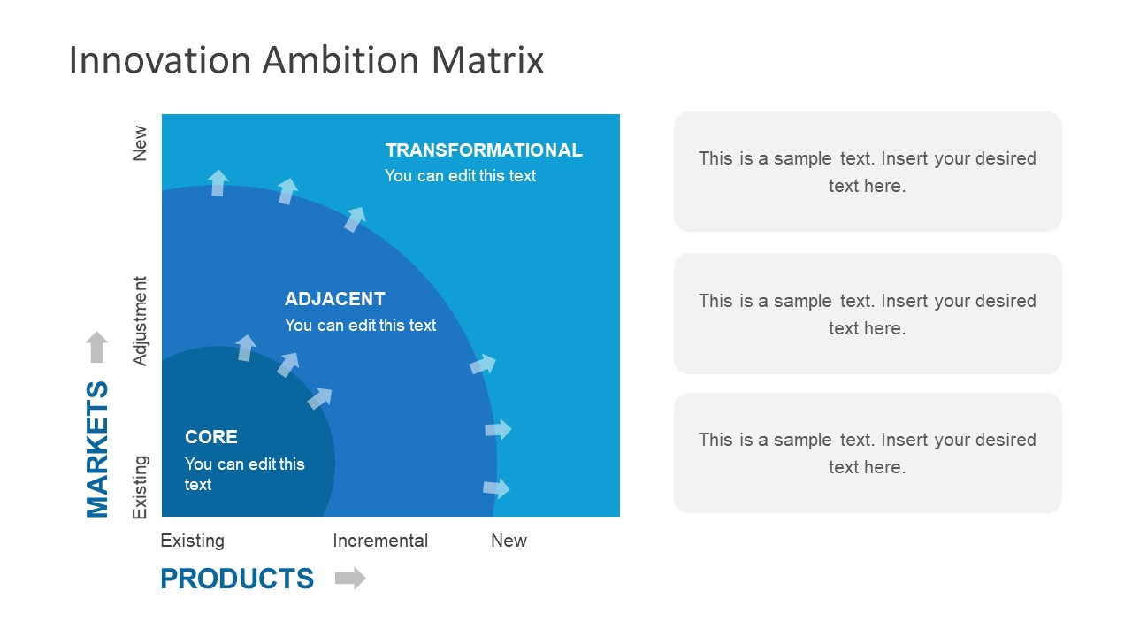

Products
New | Always on call on tap, hassle free advice | Implement of Azure specialised knowledge | Microsoft AI tool, Azure specialist with security skills
Modified | Extension of IT services, | Cloud management, software asset management | Quick efficient advice
Existing | Norfolk council, HMRC, Surrey County council, Tesco, University of Essex, United utilities much more. | Utilities company, Legal and finance, corporate companies, Manufacturing industries, more public bodies etc | Technical colleges, IT departments, Banks, Finance companies, Universities etc.
 | Existing | Modified | New
Customers

BYTES is investing in customers and capabilities. BYTES expands their team to fulfil its customers potential needs. BYTES hired new sales talents and created new teams. They are broadening their technical resources through new hires. BYTES opened a new office in Portsmouth to accommodate current and future growth. BYTES expand their security services, innovating with more solutions and services offerings. BYTES culture blueprint strongly focused on diversity and culture as they grow. (Annual report 2024/2025)
BYTES cyber security growth is massive and become as a trusted advisor in IT solutions. They provide integrated cyber security solutions to their clients. Offing integrated cyber consultancy, solutions, managed services and insights across to the clients. BYTES has nearly 80 members in the security team and represent more than 75 security vendors. BYTES growth was $36billons in 2024. But they predicted in 2029 their growth will be $76billion. (annual report 2024/2025)
BYTES income analysis explain the growth and development. Software sales made up to 96.5% of gross invoice income (GII) and 91% of gross profit (GP). Hardware sales have shrunk to made up 1% of GII and 2% of GP. Services establish2.5% of GII and 7% of GP. Public sector sales growth is amazingly increased than corporate sales which represent 70.1%GII.
BYTES set a target of zero carbon reduction. Also, BYTES recommended and expanded electric vehicle scheme across the group. BYTES wants to always be environmentally friendly; make a sense of it they installed solar panel at their office and assets further self-generating energy options which not harmful for environment.
BYTEs environmental policy is committed to minimising its environmental impacts because they recognise that their operation, products and services have direct or indirect effects on the environment and BYTES attempt to manage them responsibly and transparently. BYTES volunteering to help restoration of nature even though they don’t have direct impact on nature restoration. Bytes measure and report their environmental performance, including greenhouse gas emissions, energy usage, water usage and waste generation and recycling to use recognised frameworks and methodologies on an annual basis.

How BYTES support to the environment? They continue to purchase 100% renewable energy for their owned offices. They support active travel through a ride to work scheme and public transportation. They tried to remove a single piece of plastic from their operations and tried reusable or biodegradable alternatives.

BYTES promote recycling and waste reduction across their offices and facilities and aim to achieve zero waste to landfill. They donate used laptops to give them an extended life with employee nominated non-profit organisations and charities that support digital inclusion and education. BYTES organise meetings with their staff to explain carbon literacy and sustainability awareness and encourage them to adopt environmentally friendly behaviours at work and at home. BYTES policies are available to their stake holders including investors, customers. Employees, suppliers and subcontractors as well as public. BYTES expect their stakeholders to follow similar guiding principles with commitment to adhering to environmental regulations, reducing carbon emissions, minimising waste and promoting biodiversity.

BYTES social responsibility is something different according to their staff choices. They offer rewarding fun environmental and an engaging for all of their people. They workforce is experienced and dedicated. It means a lot for their business and become as a key asset. They take care of their employee’s personal wellbeing, investment in personal development and career progression, support for flexible working, diversity and inclusion in everything they do, and open and honest leadership communications.
BYTES expand apprenticeship scheme into more areas of the business and into degree level apprenticeship programmes.
BYTES governance explains about sustainability strategy, and it’s reviewed by their ECG committee.

CAPITAL ALLOCATION OF BYTES
BYTES has maintained a strong balanced sheet through the cycle. They divided their capital into four parts and keep maintain it. These are:
Organic growth:
- BYTES has a continuous growth both in customer base and shares of their clients. It is a prove of BYTES strategy and indicate the organic growth.
- It is increased the sales capacity. (Mention the new intakes and regional growth)
- Develop the expertise of technical site and broaden vendor partners.
- Solutions capacity was expanded with knowledge and expertise.
Shareholders returns
- Expectation that excess cash following organic investment and any M & A is returned to shareholders via dividend.
- Method of any excess capital return kept under periodic review.
- Dividend policy is to distribute between 40% and 50% of post-tax pre-exceptional earnings.
Interim dividend
- The board is pleased to approve an interim dividend of 3.1 pence per share, payable in late November.
- 14.8% increase on H1 FY24 interim dividend.
Mergers and Acquisitions
- High quality bar with cultural alignment key.
- Focus on cross-sell potential, vendor specialism and solutions expertise.
- Attractive financial profile.
- Actively monitoring acquisition opportunities to accelerate the strategy.

Bytes is one of the most qualified and highly accredited global partners for many of the leading technology vendors. BYTES is one of the just 2 resellers to share Check point’s $ Star Elite accreditation due to their deep understanding of the market and BYTES strategy and solutions. BYTES stands with the test of time and change, because BYTES ensure the security infrastructure, procedures and policies of their vendors because they have to stand the test of time and constant change is one that BYTES meets commence on. Last 10 years of technology er, BYTES become a trusted solutions of software to its customers and BYTES work with global companies and small fast-growing organisations to provide a consistent approach to practical security solutions.

BYTES provide:
- Strategy and planning: Customers benefit from C level Security strategy days, whiteboarding sessions with senior technical consultants, on site security training and sessions to map out future infrastructure needs.
- Project design: It is a competitive world with lots of new business ideas. In that case BYTES provide comprehensive business solutions that match their customer

- specific requirements
Proposed new digital transformation initiative and how it will add value to the organisation (including the new and enhanced customer journey map)
BYTYES maintain customer service excellence and focus on depth and strength of their capabilities. BYTES increases technical capabilities. BYTES market growth is steady and strong. They have good market coverage with the presence of all sectors and regions. Expansion of cloud migration, security software, AI solutions _ copilot and Azure and endpoint management are the strong capabilities.
BYTES has a growing customer base with regular new sales intakes. BYTES opened new offices in new places, and it helped to pull new customers as well as regional sales capacity and have plans for future. Their expertise and experience is one of the capitals and they execute the knowledge very well to develop the programmes. Industry experts also join BYTES operations to enable deep customer alignment.
BYTES has broader vendor partnerships. These partnerships ties top and growth vendors. Their vendors are highly certified and accredited. BYTES services offerings continually evolved and developed. They make technical alignment in house and through partnerships. BYTES keep on eyes for regular review and onboarding of new relevant software publishers and partners.
New and enhanced customer journey map (Recommendations)
Learning and implementing the technology in 2025 in BYTES software make improvements in below ways. Software businesses in 2026, will face rapidly evolving expectations shaped by Artificial Intelligence (AI), personalization and immersive digital experiences. I will recommend this enhanced, futuristic map tailored to BYTES.
Stage | Customer Aims | BYTES actions | Touch points | Opportunities
Awareness | Discover solutions to pain points. | AI driven marketing campaigns, thought leadership content | Website, podcasts, webinars and linked in. | Use AI personalization to target industries.
Consideration | Compare providers and evaluate trust | Case studies, demos and transparent pricing | Bytes.co.uk case studies sales consultations | Highlight security first approach and sustainability commitments.
Onboarding | Smooth setup of services | Guide onboarding with copilot AI, dedicated success managers | Digital workplace setup and licencing portal. | Reduce handoff friction with unified digital assistants.
Engagement | Maximize productivity and security | Proactive monitoring, AI alerts, customer success check-ins | Bytes support portal, Microsoft success check-ins | Deliver situational personalization
Retention | Reliable long-term partnership | Quarterly reviews, loyalty programs and innovation update. | Customer success reviews and newsletters | Build trust-cantered design with transparent governance.
Advocacy | Share positive experiences | Encourage testimonials and referral programmes | Social media, conferences and customer councils | Turn loyal clients into brand advocates with measurable ROI stories
In 2026 is going to change the world massively in technology. Tring AI to prove with AI is going to be one of the trends. So, BYTES must measure ROI in customer success. Hopefully Copilot-AI will guide onboarding and support. Concentrate on situational personalisation with tailoring dashboards and alerts by the industries. Keep maintain transparency in using data and security governance. BYTES ensure smooth transitions between marketing, sales and onboarding. I will highly recommend one of the stages of engagement. Because cyber security is an essential part of all industries it doesn’t matter it will be small or corporate level. In 2024 BYTES didn’t have a single data breech or hacking. BYTES has a situation to maintain this in future fir their sustainability in software business. Otherwise, day by day the growth of software is dealing and playing important role in all areas. Especially BYTES work with NHS trust, universities and councils where these departments store all their customers, clients and patients.

Collaboration with NHS, it is a nationwide trust providing service to people in all levels. BYTES delivered a comprehensive consultancy programme, leveraging fast track funding to provide four structured knowledge share sessions. These are the approaches.
- Initial scoping to understand the trust’s requirements and current environment.
- Workshops covering the capabilities and features of Microsoft Defender for endpoint, comparison with the existing solution and high-level migration planning.
- Guide on networking prerequisites, trouble shooting and deployment methods.
- Train to administrative staff to use Device tapping and Device groups.
- Exploration of endpoint security policies in both Microsoft Intune and group policy.
- Provided training in incident management training including advanced investigations and hunting with KQL.
- Support in creating custom KQL and PowerShell queries. (Using Microsoft Graph API) for device reporting.
NHS engagement with BYTES has significantly improved the trust’s cyber security maturity. NHS enhanced the understanding of defender for endpoint’s platform and capabilities. It increased the confidence and efficiency in incident response and platform usage. BYTES training with staffs transfer the wide knowledge to them according to support adoption and operational autonomy. It has improved ability to investigate incidents and create custom queries, boosting both security and operational efficiency. Finally tap go donate service to the NHS trust, introduced recently.
As a team NHS took advantage of the fast track MDE sessions offered by BYTES. Every session covered different topic, they were all informative and well structured, demonstrating functionality within MDE an Intune. One of the staff from NHS Trust said highly recommend BYTES for anyone looking to deepen their understanding or get expert advice and training in the products. (University hospitals of Derby NHS foundation Trust)

Conclusion.
Technology growth endlessly is in this era. You must be ready to adopt and connect with experts in software development who will support and guide you in a correct path. It will help your company to stay successful and strong. Always choose a right software can lead your team to work better by cutting inefficiencies and keeping your company on top in today’s competitive market.

References
http://www.analytics8.com
http;//www.bytes.co.uk/customers/case-study

