Utilising the Entrecomp Framework, critically evaluate your own creativity and enterprise and consider how you might be able to develop the creative and enterprising skills of primary learners through your own pedagogy.
Creativity is a term that can be defined in many different ways, with a single clear definition being difficult to determine. Treffinger, Renzulli and Feldhusen (1971) claimed it was due to this lack of defined meaning that difficulties arise among educators in relation to how they can best define ant therefore implement creativity. On reflection, I believe creativity is generating valuable ideas using prior knowledge, imagination and understanding to create something new and innovative for a purpose or to solve a problem (Johnson-Laird, 1988; NACCCE, 1999; Kaufman and Sernberg, 2007). Enterprise overlaps with creativity. It is having the capacity to generate ideas and having the skills to not only decide upon ideas, but act upon them by making them happen. Within schools in Wales, these skills are deemed to play a significant role in pupils education moving forward. Professor Graham Donaldson produced Successful Futures in 2015 to highlight how the curriculum in Wales will be changing over the upcoming years. He created 4 purposes for the whole curriculum, with one stating that children and young people should be “enterprising, creative contributors, ready to play a full part in life and work” (Donaldson, 2015, pg. 29). For this to take place, pupils and teachers have a role to ensure this creativity is developed to its best potential. Enterprising pupils are something each school should promote as it allows pupils the opportunity to be self-motivated and able to act upon opportunities. In 2014, Lord Young discussed the importance of enterprise in education, and while the report does link enterprise to entrepreneurship, it is not only in that thread that it exists as he stated “I don’t just mean the enterprise that creates entrepreneurs but also the enterprise that creates a positive outlook on life that enables you to succeed in any endeavour” (Lord Young, 2014). This supports Donaldson view that enterprise plays a key role in providing pupils with beneficial lifelong skills. In an IBM global survey of more than 1500 CEOs from 60 countries and 33 industries worldwide, conducted in 2010, it was creativity that was selected as the most vitally crucial factor for employees to have to navigate future success in an ever evolving employment landscape (IBM, 2010). We must ensure that our future generations are equipped efficiently.
There is a discussion among theorists which focusses on whether creativity can actually be taught. Michele and Robert Root-Bernstein (2011) believe that it cannot be taught owing to the notion that creativity is not a set of specific skills, and instead creativity can only be emulated and modelled. Costa and Kallick (2000) believe that you can indeed develop creativity as it is not something anyone is born with. However, Land and Jarmin (1993) are of the opinion that creativity is something you are born with and lose while you grow up, and furthermore state that non-creative behaviour is learned. Land goes on to discuss in his TEDx Talk ‘The Failure of Success’ (2011) that he developed a test to determine genius on behalf of NASA to help discover exceptional scientists based on their creativity. He emulated the test among 1600 children and repeated the test at various ages. The results are as follows: When tested at 5 years old, 98% achieved genius level. At 10 years old, only 30% achieved the genius score, while at 15 years old, this dropped to 12%. While their testing stopped here, over 1,000,000 adults with the average age of 31 have been tested and astonishingly just 2% scored genius level. Fried (2001) states that a child begins their life filled with curiosity and their education should serve to enhance this passion for creativity. Robinson (2006), however, claims that schools are ‘killing creativity’ by educating children out of creativity and allowing a hierarchy of subjects, with creative subjects featuring at the bottom with low status. This attitude to learning must change to allow children to realise that being creative can have a huge impact throughout their lives, by teaching them that to access such creativity, they must not fear the stigma of being wrong. The process of creativity is just as rewarding as the end product (Jeffrey and Craft, 2004). For such teaching to take place, teachers themselves must be facilitators and role models (Craft, Cremin and Burnard, 2008). There is a belief that this is difficult to achieve within schools. Clegg (1999) believes that the education system leaves no room for creativity due to time constraints and the notion that educators conform to demands to perform well. Pressures still exist in terms of results, paperwork and evidencing work (Siraj-Blatchford, 1993; Brooker et al, 2010). However, there is some debate over whether teaching creatively actually develops a child’s creativity (Craft, 2005; Jeffery and Craft, 2004). There is a significant emphasis on the role of the pupil in their own learning. “Pupils have control over their own learning processes, and ownership of the knowledge produced, which is relevant to their concerns” (Woods, 1995, pg3). This itself highlights a limitation to the role of the teacher. With pupils having such creative control, a teacher may compromise the pupils creativity, which places teachers in a difficult position in relation to how much involvement they should have.

The European Commission believes that we are facing particular challenges in relation to acquired skills.
“The aim is that everyone should have a key set of competences needed for personal development, social inclusion, active citizenship and employment. These competences include literacy, numeracy, science and foreign languages, as well as more transversal skills such as digital competence, entrepreneurship competence, critical thinking, problem solving or learning to learn” (Bacigalupo et al, 2016, pg2)
The European Entrepreneurship Competence Framework (Entrecomp) was devised as part of the Science for Policy report in 2016 by Bacigalupo et al, 2016, to allow users to determine their own performance of these competencies. While heavily focussed on entrepreneurship and business skills, there is scope to adapt this framework from a teachers point of view and use it as a launchpad to refer to and self-reflect via its 3 interconnected competency areas; ideas and opportunities, resources and into action. By using Entrecomp, you are able to determine not only where you may be within the framework, but furthermore identify steps to progress further which would allow you to thrive in particular areas. While not a perfect system to use, it is certainly considered to be a valuable aid to evaluate both strengths and weaknesses with a view on discovering how to improve. These 3 competence areas are then split into 15 competencies with 60 threads in total with each having 8 progression levels to determine where you may be. However, they are down to personal judgement and subjective and there is always a possibility that a person identifies as better or indeed worse compared to the reality.
In relation to determining your own creative ability, within ideas and opportunities creativity lies as a specific competency with 5 threads which enable users of the framework to determine their abilities in this specific area. It allows me to delve into each thread and determine my own abilities and furthermore, determine how I can adapt and move forward according to the framework. Here I will examine each thread within creativity with the view to critically self-reflect upon my abilities and determine how I can progress further.

- Be curious and open
After evaluating the levels, I decided that the most fitting description was level 5, which states ‘I can actively search for new solutions that improve the value-creating process’. Putting this into the context of my creative and enterprising teaching methods, I identify myself as someone who emulates this by using brainstorming methods to determine a number of potential lesson ideas using divergent thinking. Developed by Joy Paul Guilford, it is the process of identifying many solutions to a problem (Guilford, 1962). Cleverism (2015) highlights the eight elements to divergent thinking; originality, imagination, elaboration, risk taking, complexity, curiosity, flexibility and fluency. I am always open to developing each element to benefit the pupils education, and as a result will always begin each topic with spider diagrams detailing any potential lesson ideas, from the obvious to the obscure (Appendix1). However, to push myself further moving forward, I believe I would benefit from making more connections between my thinking, as well as also applying metaphorical thinking to my brainstorming in order to generate even more ideas. From personal experience through my university studies, I have been exposed to such ideas and found them beneficial in expanding my viewpoints. During a challenge to determine ‘how many uses can you think of for a shoe?’, I was open to the idea of determining a variety of ways and noted original as well as elaborative ideas (Appendix2).

- Develop ideas
As for developing ideas, I would deem myself to be working at level 6; ‘I can set up processes to involve stakeholders in finding, developing and testing ideas’. I believe that to develop ideas, collaboration is essential. Having differing ideas and viewpoints opens up possibilities, especially as working with others accesses different skills and knowledge within certain areas. While on placement, I found it extremely beneficial to collaborate with teachers, teaching assistants and phase leads to discuss potential lesson ideas and enhanced provisions for example (Appendix3). To help me develop further, I need to focus on introducing convergent thinking to my decision process. Guilford (1967) created the notion of a convergent thinker to oppose the divergent thinker. Convergent thinking uses logic to determine a solution to a problem. It requires more of a focussed, rational approach. Often, I find I can develop a vast array of ideas, but I then have difficulty in choosing what would work best. I need to be proactive in not allowing my divergent thinking to completely overrun my thoughts and distract from the goal which is to provide an engaging lesson. To do this, I intend to marry together divergent and convergent thinking so that I am able to not only determine a vast amount of ideas, but develop the skills to narrow down ideas, which is essentially what problem solving is (Young Baldwin, 2010). I am showing development of this skill, as demonstrated in a collaborative task within university, which challenged groups to create the biggest freestanding tower using 20 pieces of spaghetti, string and tape which needed to hold a marshmallow at the top, within a time limit. We quickly discussed a variety of ideas but knew we needed to use convergent thinking to focus on one logical idea. As a result we won the challenge (Appendix4) Moving forward. I also intend to work with a wider range of stakeholders including parents and outside creative practitioners to help awaken my own creativity (Cremin et al, 2009). By using valued members of the local community allows me to access a wider range of support for any gaps in my own creativity as well as creating links that promote community relationships (Donaldson, 2015)

- Define problems
In relation to defining problems, I believe I am at level 6 which is ‘I can help others create value by encouraging experimentation and using creative techniques to approach problems and generate solutions’. Similarly to above, it highlights an area I feel competent in which is brainstorming and collaborating with others to find solutions to the problems. During my placement within year 6, I was tasked with recapping prior knowledge of angles. To make the lesson more engaging, I decided that pupils would complete the work by drawing angles on the desks with wipeable markers and rulers (Appendix5). The pupils were immediately engaged and excited to complete the task of drawing angles then walking around the class to music. When the music stopped, they had to find the nearest angle and firstly determine the name of the angle based on prior knowledge and then this continued into other lessons where they drew the angle for the other person to estimate the angle and then the following lesson to measure the angles drawn. The pupils were thoroughly engaged and the simple notion of drawing on the desks was deemed exciting. However, on reflection, I think that my lessons are heavily based on teaching creatively as opposed to teaching to enhance pupils creativity. Enjoyable and memorable they may be, but pupils must benefit from an education which fosters and promotes their creativity. It is more than a teacher merely teaching creatively, teachers must teach to provide creative opportunities for the child (Grainger and Barnes, 2006). To develop this further, I believe that I need to harness grit and resilience to the notion that while I aim to develop a child’s creativity, some ideas may simply not work in real life classroom situations due to many factors ranging from time constraints to feasibility. Confidence is another factor which I aim to develop as I believe I will then feel able to deal with any arising issues when dealing with a variety of problems.

- Design value
This thread is more difficult to ascertain my position as it does not obviously link to teaching in my opinion. Nonetheless, after consideration I believe I can identify most with the notion of level 5 which states ‘I can describe and explain different approaches to shaping open-ended problems and different problem-solving strategies’. Again this overlaps with divergent thinking along with collaboration as discussed above. De Bono’s ‘6 thinking hats’ (de Bono, 2000) is a good theory to focus on here (appendix6). The green hat is used here as it focuses on nurturing ideas in an innovative manner. However a move towards the blue thinking hat may be beneficial to progress within this thread. The blue thinking hat looks at the idea of developing ideas further and using logic to determine what can be done to progressively adapt to solve the given problem and also add more value to the learning experience. However, this theory does have its opposition, with critics questioning the value this approach adds (Bennett, 2013; Pugh, 2009)

- Be innovative
In relation to innovation, I believe that I take the time to think of, develop and apply innovative ideas to certain lessons and topics, therefore I place myself at level 7 which states ‘I can identify the steps needed to research the potential for an innovative idea in light of its development into an existing enterprise, a new venture or an opportunity for social change’. I believe that innovative ideas harness a child’s enthusiasm for the subject and therefore, a good hook to the lesson is extremely beneficial. Within year 6, the theme was evacuees and I instantly knew that I wanted to provide as many engaging opportunities to help stimulate creativity as I found massive differences in the way that foundation phase pupils are taught in comparison to key stage 2. I decided that my initial introduction to the topic would be a role play session where pupils found out that they were being evacuated, waiting at the train station, the train journey, and meeting their new families (Appendix7). This immersive experience captivated pupils and allowed them to experience how children would have felt in World War II. The creative writing that followed on from this experience was fantastic and the benefits were evident as it helped to produce some exceptional work. This topic also encouraged me to develop another immersive lesson focussing on what children did in their spare time in WWII. The pupils had the opportunity to try different things including creating their own PE based game given various equipment that would have been available at the time (Appendix8). Pupils delighted in completing this task and taking responsibility, without realising the benefits of such a task such as communication, team work etc. By creating such immersive learning environments and providing secure knowledge of the topic itself (Prentice, 2000), I believe I was able to fuel pupils imagination. Another lesson with Reception pupils involved me discussing bike safety. To inform pupils of the importance of wearing a helmet, I decided to use an egg to replicate their heads and experimented by dropping an egg with no head support compared to dropping an egg which had been protected by pupils using a variety of materials (Appendix9). This allowed pupils to develop relevant understanding via practical and motivating experiences (Johnston and Nahmad-Williams, 2008; Bruce, 2009). However, it is to be noted that although I used innovative ideas, they were still meticulously planned for and heavily directed by myself. To expand on my innovative lessons, I must allow for flexibility and be aware that there may be occasions where not all pupils are engaged and participating fully. I must develop resilience in order to stay focussed on encouraging all pupils to be fully immersed in the lesson, while also allowing the direction of the lesson to change depending what the pupils are engaged with.

The framework has various other threads that also relate to teaching creatively to provide the best environments for pupils to thrive. If, as discussed, there is a more fluid approach to creative teaching and pupil led learning with less of a constraining curriculum as proposed by Donaldson (2015) and seen in the Draft Curriculum for Wales 2020 (WAG, 2019) then teachers must be prepared for the unknown. Therefore I thought it would be beneficial to my development if I also identified my competencies relating to ‘coping with uncertainty, ambiguity and risk’.
- Cope with uncertainty and ambiguity
This is certainly an area in which I can identify that I lack confidence in. Level 3 is where I would currently place myself as I believe ‘I can actively look for, compare and contrast different sources of information that help me reduce ambiguity, uncertainty, and risks in making decisions’. By providing pupils with curiosity, they are able to reflect upon the various sources provided to aid their learning. I must ensure that there are no gaps in learning or instruction which may otherwise allow for ambiguity of the task. Efficient communication with pupils is vital. I believe that while I am able to communicate effectively, my confidence in dealing with uncertainty needs developing. I am conscious of ensuing that I do not play it safe in terms of my approach to creativity and innovative ideas (Grigg, 2015).
Another thread I believe is important to focus on is learning through experience. Nothing allows for more personal development than analysing positive and negative experiences and using them to develop.
- Learn from experience
In relation to this, I would place myself at level 3 which states ‘I can filter the feedback provided by others and keep the good from it’. All good and bad feedback is beneficial as you can learn what to change and adapt from the bad while always developing upon good practice. A good area of feedback during my foundation phase placement was the use of KWL grids to determine what the pupils knew and what they would like to find out. This helped guide my teaching plans in Foundation phase, but I found pupils were not as engaged as I hoped. However I identified how I needed to improve and as a result I decided to adapt it in key stage 2 (Appendix10). To begin I set the pupils the task of creating a list of what they would like to learn about at the start of the topic. This gave me the opportunity to collate ideas and formulate my lessons and planning determined by pupils voice. The United Nations Convention on the Rights of the Child (1989) legally gives children the right to freely express their views. Experience can also enhance your creativity. Personally, I have already learned through placement that I need to develop and marry together my divergent and convergent thinking in order to brainstorm a variety of ideas while still having the skill to filter out the most beneficial ideas. Through expanding my own education in relation to creativity, I must not only learn from experience, but adapt my teaching to incorporate different techniques. Scamper, created by Bob Eberle in 1972, is one way to determine different ways to incorporate thinking in a more creative way (Mishalko, 2001) –
S – Substitute something
C – Combine a subject with something else
A – Adapt
M – Modify/Magnify
P – Put it to a different use
E – Eliminate something
R – Rearrange something
These are techniques that can also be taught to children as a way of them reflecting on their ideas and how to evolve their ideas.
Entrecomp does have potential to aid teachers, however, given its business and entrepreneurship viewpoint, not every aspect is applicable to the role of a teacher. It could be argued that a specific teaching framework with more teacher/pupil specific learning outcomes could be extremely beneficial for teachers to self-assess and continually evaluate their own performances. This is something that could be developed within schools to determine how teachers are able to progress along the same continuum.

On reflection, I believe that my level of creativity and what I infiltrate into my lessons is increasing, which has a direct correlation to my confidence levels rising in the role of a student teacher. On my first placement, I felt uneasy about stepping out of the box and somewhat overwhelmed by the experience in general. I found myself focussing too much on making sure I had evidence of work being completed. By trying my utmost to keep all pupils on track, I was not allowing for any creative freedom to take place, even curbing creativity at times. Personally, the correct level of teacher involvement is an area that I have initially felt uncomfortable with. As a teacher, you want to facilitate every opportunity but there is an art to determining when to step away and allow the child to feel able without your support. I was aware that on occasion, perhaps I was directing creativity far too much to begin and as a result, stifling and steering pupils in a particular direction that they may not have initially led. Within the prescriptive learning environment I found myself in, I felt further pressure to ensure the same outcomes were reached by all pupils, where in reality, that defers from creative learning by its definition. Moving forward, I certainly aim to have a more relaxed approach in regards my involvement. I aim to ensure that while I initially scaffold and cooperate with learners, equipping them with specific skills, (Bruner, 1978: Vygotsky, 1978) pupils will have confidence to exercise creativity as they choose. However there is still a place for planning. ‘Occasionally, teachers failed to grasp that creative learning was not simply a question of allowing pupils to follow their interests; careful planning was needed for enquiry, debate, speculation, experimentation, review and presentation to be productive’ (Ofsted, 2010). However, Handy (1997) believes that creativity needs a level of untidiness, and that freedom from structure should be encouraged.
Sharp (2004) states that there are 5 ways that a teacher is able to encourage creativity and moving forward I aim to incorporate each into my teaching -
- Asking open ended questions
- Tolerating ambiguity
- Modelling creative behaviour
- Encouraging experimentation and persistence; and
- Praising children who provide unexpected answers
Moving forward, I aim to ensure that I am offering a fully immersive, creative, educational environment in order to encourage a ‘state of flow’ of learning (Csikszentmihalyi, 1997), allowing ambiguity with pupils so engaged that the concept of time and learning becomes non-existent due to their enjoyment (Basford and Hodson, 2008)
From a personal point of view, some subjects generate apprehension when I consider how I may approach them creatively, with mathematics being one in particular. Mathematics relies on convergent thinking in order to find the answer and there is no fluidity to a mathematical sum. However, mathematics in its very nature is based on problem solving, allowing for a level of exploring the task, estimating and explaining how you reached the conclusion that you have (Sakshaug et al, 2002). Certain mathematical tasks pose open ended questions, encouraging creative thinking in how they are approached. I found a successful creative approach to allow pupils to step away from textbooks and engage with mathematics by simply drawing on desks. Some problems may appear daunting for pupils to undertake as they fear being incorrect. As teachers, we must not only make tasks understandable and engaging, but in terms of problem solving, we must encourage pupils to see it as a creativity activity, where they have the freedom to try and adapt more divergent thinking to a problem (Fox and Surtees, 2010). On reflection, I still have room to improve the creative elements of mathematics which I can then reflect in all areas of learning.
Interestingly, as a teacher I also aim to rethink my approach to rewards in terms of rewarding creativity. I always believed reward promoted good work, however, Glucksberg (1962) looked into the power of incentives and found that once a reward is offered, it adds pressure to the situation and according to Glucksberg, only serves to promote more convergent thinking alone in order to try and get to the right answer in the fastest time to reap the rewards. This in turn only serves to dull a child’s thinking and block their creative flow in order to win the incentive (Pink, 2010).

Creative learning is a term that first emerged in a report by the National Advisory Committee on Creative and Cultural Education (NACCCE, 1999). It was within this government commissioned report that the importance of creativity within a child’s learning was highlighted as imperative, making the distinct emphasis of the difference between creative teaching and teaching for creativity. In the report they stated that creativity is an “imaginative activity fashioned so as to produce outcomes that are original and of value” (NACCCE, 1999, pg29). Children need creative skills in order to create excellent ideas as well as the practical skills to carry out such ideas to in turn have a positive impact on the world (Sternberg, 2008) However, creativity is still not at the forefront of the curriculum, with the view that due to lack of academic nature it does not have value within the education system. With pupil and school performance being such an important aspect of education, more significance is given to subjects such as Mathematics and English (Ball, 2003) which then pushes creative subjects and creativity on the whole out of the curriculum. We must adopt an approach which embeds such creativity among all subjects, so that it is not a stand-alone element of the curriculum.
A child’s creativity can be enhanced in variety of ways, but importantly we must look at their approach to creativity in terms of thinking. Divergent and convergent thinking (Guilford, 1962;1967) is something that not only applies to the role of the teacher. Pupils must be encouraged to use these thinking models to determine solutions to problems and also encouraged to use their imagination to discover a wide range of creative solutions to problems. Costa and Kallick (2000), believe that it is important to examine how pupils behave when they are faced with a problem that they do not know the answer to. As a result, they created a list of 16 ‘habits of mind’ (Appendix11) to help enhance and develop how someone responds. To encourage this, the 16 habits of mind should be on display as a point of reference for pupils to refer to daily. One of the habits of mind to reflect on is ‘thinking interpedently’, where teamwork aids results. Personally, collaboration helps me develop ideas, however, while collaborative environments can be beneficial, some pupils may not feel heard in such situations, therefore, individual work for personal creativity and development must also be encouraged at times.
Children should be encouraged to share ideas without the fear of ridicule. However, some believe that during brainstorming sessions, ideas should be debated and criticised if needs be in order to promote discussion and better ideas and in turn more creative thinking to solve the problem (Nemeth in BBC Futures, 2014). The idea of any idea being a good idea does have its opposition. “Creativity is not a licence to be bizarre” (Puccio in BBC futures, 2014), suggesting there should be a cap to peoples creativity which dispels the notion of divergent thinking. Duncker (1945), however, believes that for someone to become successful, the must overcome ‘functional fixedness’. This is the mental block of believing that there are just conventional ways for things to be used. Bizarre ideas are encouraged to expand a person’s viewpoint and remove any barriers to their creativity. These mental blocks can create limitations to a child’s creativity. Van Oech (1983) discussed an additional 10 mental blocks that children may face while developing their creativity (Appendix12) including ‘that’s not logical’ and ‘avoid ambiguity’ which we must dispel within the classroom. Teachers and pupils must have an awareness of any challenges that could arise to the detriment of a child’s creative flow and discuss ways to identify and develop coping strategies to deal with such blocks so that they no longer hinder a child’s performance. There is a myth that creativity only stems from creative people. Amabile (2001) believes that everyone is capable of working creatively, so we must work to instil the confidence in children that they have the power to be creative.
An emerging element of good creative learning is to give pupils more power to direct their own learning, to feel empowered by determining the direction of their own education. An example of good practice (Estyn, 2015) can be found at Ynystawe, Swansea. Here, children take ownership of their own learning, which sees teachers performing less direct teaching, instead guiding pupils where needed. Adopting the ‘Leonardo Effect’ (Hickey and Robson, 2012), allows for a more skills-based approach to education which is meaningful and engaging, with subjects intertwining. A focus of the new curriculum in Wales is a cross-curricular approach, with the areas of learning and experiences allowing more fluidity among areas, allowing creativity to be developed. While this is very different to the education I received, I can certainly recognise the benefits. However it raises concerns over how learning may be assessed. Torrance Tests of Creative Thinking (Torrance, 1974) were previously widely used to decipher a person’s creative thinking. However, testing introduces the dilemma of teaching to pass a test rather than allow creativity to flow. I believe that constant dialogue is a way to determine a child’s understanding and help guide them in real time to aid development.
A beneficial way of introducing both cross curricular learning as well as fostering the Leonardo effect is by introducing thematic learning, with pupils guiding the choice of theme as well as what exactly they wish to discover. However, there are concerns that fostering thematic approaches can create “fragmented and superficial teaching and learning” (Alexander et al, 1992, pg. 2). There are concerns that not all areas of the curriculum would be covered via creative learning. Here the teacher must act to ensure that any gaps in knowledge and understanding are revisited.
Creative environments must engage pupils and we as teachers must look beyond the four walls of the classroom. Outdoor learning provides an opportunity to use nature as their canvas, encouraging immersive sensory experiences (Tovey, 2007). Within classrooms, continuous provisions are an enticing way to encourage pupils creativity and should not be limited to foundation phase learning. However, it is worth noting that quiet areas are an essential aspect as some pupils work better in such conditions.

Moving forward, it is imperative to remember that creativity plays a vital role in a child’s life, but also provides them with skills that will benefit them throughout their lives and through their careers as we move forward to a more diverse working environment. We as teachers of the future must approach our roles with the knowledge that creativity must be harnessed at any given opportunity.
Einstein stated that ‘imagination is greater than knowledge’. While I agree that knowledge can be limited compared to imagination which has no boundaries, I believe the notion that knowledge and creativity are juxtaposed is harmful to the promotion of creativity within education. The two go hand in hand, with knowledge being vital to allowing imagination to develop existing knowledge into something else. Willingham (2009) believes factual knowledge is the basis of critical thinking. Pupils should be encouraged to think outside of the box; however it is vital that pupils have sound knowledge of what is inside the box in order to thrive in a creative and enterprising manner.
By using the Entrecomp, I have been able to reflect on my own creativity and creative teaching, despite it not being a failproof method of doing so. Furthermore, I can identify pathways to improve my creative abilities. While there are certainly avenues to explore and improve, I am confident that with experience, I will be able to not only teach creatively, but teach for creativity by promoting and encouraging a child’s creativity and enterprise.

Word count – 5493

Reference List

Alexander, R., Rose, A. J. and Woodhead, C. (1992) Curriculum Organisation and Classroom Practice in Primary Schools: A discussion Paper. London: DES.

Amabile, T. M. (2001) Beyond talent: John Irving and the passionate craft of creativity. The American Psychologist, 56, 333-336.

Bacigalupo, M., Kampylis, P., Punie, Y., Van den Brande, G. (2016). EntreComp: The Entrepreneurship Competence Framework. Luxembourg: Publication Office of the European Union.

Ball, S. (2003) The teacher’s soul and the terrors of performativity, Journal of Education Policy, 18:2, 215-228.

Basford, J. and Hodson, E. (eds) (2008) Teaching Early Years Foundation. Exeter: Learning Matters.

BBC Futures (2014) Can you learn to be creative?
Available at: https://www.bbc.com/future/article/20140314-learn-to-be-creative
(Last accessed: 2nd January 2020)

Bennet, T. (2013) Teacher Proof. Abingdon: Routledge.

Brooker, L., Rogers, s., Ellis, D., Hallet, E., and Roberts-Holmes, G. (2010) Practitioners Experiences of the Early Years Foundation Stage. Research Report DFE-RR029. UK: Department for Education.

Bruce, T. (2009) Early Childhood (2nd edn). London: Sage.

Bruner, J. (1978). The role of dialogue in language acquisition. In A. Sinclair, R., J. Jarvelle, and W. J. M. Levelt (eds.) The Child's Concept of Language. New York: Springer-Verlag.

Clegg, B. (1999) Instant Brainpower. London: Kogan Page.

Cleverism (2015) Idea Generation: Divergent vs. Convergent Thinking
Available at: https://www.cleverism.com/idea-generation-divergent-vs-convergent-thinking/
(Last accessed: 4th January 2020)

Costa, A. L., and Kallick, B. (2000) Activating and Engaging Habits of Mind. Alexandria, VA: ASCD.

Craft, A. (2005) Creativity in schools: Tensions and Dilemmas. London: Routledge.

Craft, A., Cremin, T. & Burnard, P. (2008) Creative Learning 3-11 and How We Document It. Stoke-on-Trent: Trentham.

Cremin, T., Barnes, J. and Scoffham, S. (2009) Creative Teaching for Tomorrow: Fostering a Creative State of Mind. Margate: Future Creative.

Csikszentmihalyi, M. (1997) Finding Flow: The Psychology of Engagement with Everyday Life. New York: Basic Books.

De Bono, E. (2000) Six Thinking Hats. London: Penguin.

Donaldson, G. (2015). Successful Futures: Independent review of curriculum and assessment arrangements in Wales. Cardiff: Welsh Assembly Government.

Duncker, K. (1945). On problem solving. Psychological Monographs, 58:5 (Whole No. 270).

Estyn (2015) Best Practice in Teaching and Learning in the Creative Arts at Key Stage 2.
Available at: https://www.estyn.gov.wales/sites/www.estyn.gov.wales/files/documents/Best_practice_in_teaching_and_learning_in_the_creative_arts_at_key_stage_2_-_May_2015.pdf
(Last accessed: 4th January 2020)

Fox, S. and Surtees, L. (2010) Mathematics across the curriculum – Problem solving, reasoning and Numeracy in Primary Schools. London: Continuum.

Fried, R. (2001) The Passionate Learner. Boston, MA: Beacon Press.

Glucksberg, S. (1962). The inﬂuence of strength of drive on functional ﬁxedness and perceptual recognition. Journal of Experimental Psychology 63, 36–41.

Grainger, T., & Barnes, J. (2006). Creativity in the Primary School Curriculum. In J. Arthur, T. Grainger, & D. Wray (Eds.), Learning to Teach in the Primary School (pp. 209-252). London: Routledge.

Grigg, R. (2015) Becoming an outstanding Primary School Teacher (2nd Edn). Oxon: Routledge.

Guilford, J. P (1962) Potentiality for creativity. Gifted Child Quarterly, 6, 87-90.

Guilford, J. P. (1967). The Nature of Human Intelligence. New York: McGraw-Hill

Handy, C. (1997) The Hungry Spirit. London: Hitchinson

Hickey, I and Robson, D. (2012) The Leonardo Effect: Motivating Children to Achieve Through Interdisciplinary Learning. London: Routledge

IBM (2010) IBM 2010 Global CEO Study: Creativity Selected as Most Crucial Factor for Future Success
Available at: https://www.ibm.com/news/ca/en/2010/05/20/v384864m81427w34.html
(Last accessed: 29th December 2019)

Jeffrey, B and Craft, A (2004) Teaching Creatively and Teaching for Creativity: Distinctions and Relationships. Educational Studies 30(1) p77-87

Johnson-Laird, P. N. (1988) ‘Freedom and constraint in creativity’, in Sternberg, R. J. (ed.), The Nature of Creativity: Contemporary Psychological Perspectives. Cambridge: Cambridge University Press.

Johnston, J. and Nahmad-Williams, L. (2008) Early Childhood Studies. Harlow: Pearson

Kaufman, J.C. and Sternberg, R.J. (2007) ‘Resource review: Creativity’, Change, 39:55-8

Land, G. (2011) The Failure of Success. TEDx Talks Video.
Available at: https://youtu.be/ZfKMq-rYtnc (Last accessed: 2nd January 2020)

Land, G. and Jarman, B. (1993) Breaking Point and Beyond. San Francisco: Harper Business.

Lord Young (2014) Enterprise for all – The Relevance of Enterprise in Education. HM Government: Crown Copyright.

National Advisory Committee on Creative and Cultural Education (NACCCE) (1999) All Our Futures: Creativity, Culture and Education. London: Department for Education and employment

Ofsted (2010) ‘Learning: Creative Approaches that Raise Standards’. Available at: https://dera.ioe.ac.uk/1093/1/Learning%20creative%20approaches%20that%20raise%20standards.pdf (Last accessed: 29th December 2019)

Pink, D. H. (2010). Drive: The surprising truth about what motivates us. Canongate: Edinburgh

Prentice, R. (2000) Creativity: A reaffirmation of its place in early childhood education, The Curriculum Journal, 11 (2):145-58.

Pugh, R. (2009) ‘Put your thinking hat on; How Edward de Bono’s ideas are transforming schools’, The Independent, 29 January.

Robinson, K (2006) Do Schools Kill Creativity? TED Talks.
Available at: https://www.ted.com/talks/sir_ken_robinson_do_schools_kill_creativity
(Last Accessed: 2nd January 2010)

Root Bernstein, M, and Root Bernstein, R. (2011) Can Creativity Be Taught? Available at: https://www.psychologytoday.com/us/blog/imagine/201104/can-creativity-be-taught
(Last accessed: 4th January 2020)

Sakshaug, L., Ollson, M. and Olson, J. (2002) Children are Mathematical Problem Solvers. Reston, VA: National Council of Teachers of Mathematics.

Sharp, C. (2004) ‘Developing young children’s creativity: What can we learn from research?’ Topic, 35: 5-12.

Siraj-Blatchford, I. (1993) ‘Race’, Gender and Education of Teachers. Buckingham: Open University Press.

Sternberg, R. J. (2008) ‘Leadership as a basis for the education of our children’ in Craft, A., Gardiner, H., and Claxton, G. (eds.), Creativity, Wisdom and Trusteeship: Exploring the role of education. Thousand Oaks, CA: Corwin Press.

Torrance, E. P. (1974) Torrance Tests of Creative Thinking: Norms-technical manual. Princeton, NJ: Personnel Press/Ginn.

Tovey, H. (2007) Playing Outdoors – Spaces and places, risk and challenge. Berkshire: Open University Press

Treffinger, D. J., Renzulli, J. S., and Feldhusen, J. F. (1971) Problems in the assessment of creative thinking. The Journal of Creative Behavior, 5, 104-111.

Vygotsky, L. (1978) Mind in Society. Cambridge, MA: Harvard University Press.

Young Baldwin, A. (2010) Creativity: A look outside the box in classrooms, in Beghetto, R. A., and Kaufman, J. C. (ed.) Nurturing creativity in the Classroom. New York: Cambridge University Press.

UNICEF (1989) Convention on the Rights of the Child. Available at: www.unicef.org/crc/ (Last viewed: 6th January 2020).

Van Oech, R. (1983) A Whack on The Side of The Head: How You Can Be More Creative. New York: Warner Books.

Welsh Assembly Government (2019) Draft Curriculum for Wales 2022. Cardiff: Welsh Government. Available at: https://hwb.gov.wales/draft-curriculum-for-wales-2022/?_ga=2.249648705.671614229.1578789364-1297314399.1518993099 (Last accessed: 4th January 2020)

Willingham, D. T. (2009) Why don’t students like school? New York: Wiley.

Appendices
Appendix 1 – Evidence of my initial planning relating to the Autumnal theme in reception in PTE2
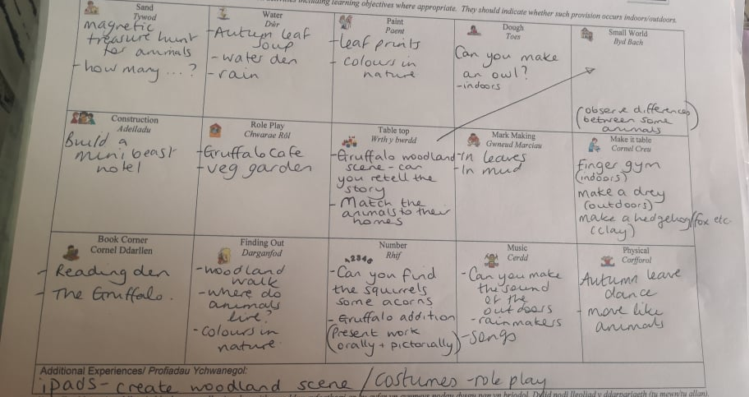

Appendix 2 – Evidence of a task set in University to list as many uses of a shoe. We were encouraged to look at any common themes to link ideas
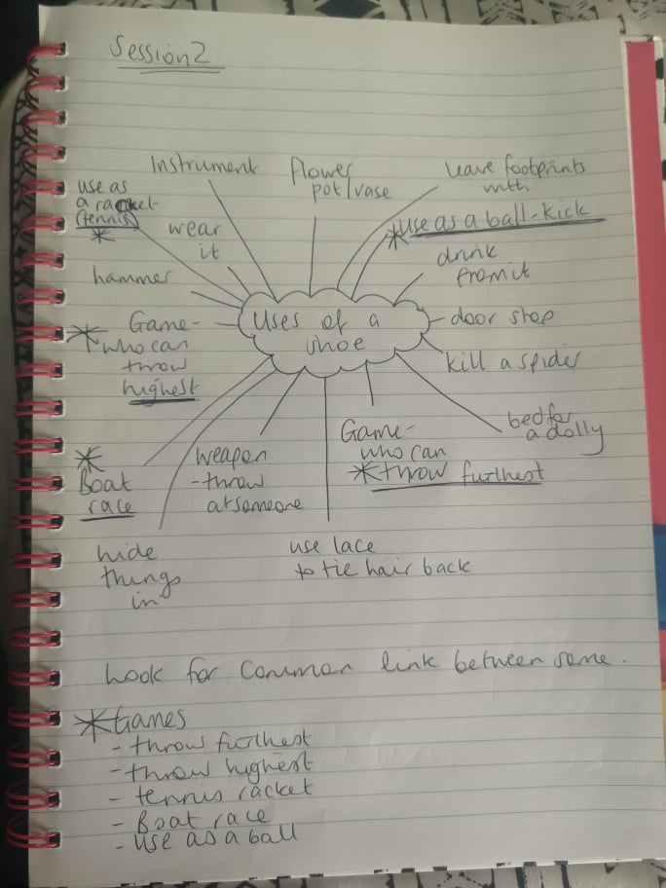

Appendix 3 – This is a comment on SWWCTE by my PTE2 mentoring relation to my collaboration with staff.
Collaboration & Reflection - Exceeding expectations
- Comments and Evidence
- Targets for improvement and suggested ways forward
You have shown enthusiasm and commitment by helping with our Christmas production rehearsals. You are making useful and relevant suggestions and demonstrate good organisational skills. I have also been impressed that you have shown flexibility throughout this week as out timetable has been changing due to Christmas rehearsals. You engage with the teaching assistants and share your ideas as well as 'taking on board' some of their suggestions.

Appendix 4 – Here is a picture of our winning solution in the marshmallow task. Collaboration as well as divergent and convergent thinking aided our success.
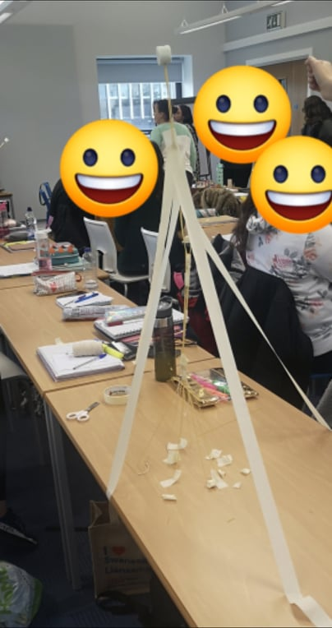

Appendix 5 - Lesson plan detailing my idea to allow pupils to draw angles on a desk to aid their understanding by providing a memorable creative experience
 |  |  |  |  |  |  |  |  |  |  | 1B

Session Plan – Key Stage 2
Name of trainee: |  | Rebecca Coslett |  |  |  | Session ref:
Personal target(s) in relation to QTS:
Year group: | 6 |  | No. of learners: |  | 24 |  | ALN: | 2 x EAL
Additional Adults:
Learning objective(s):  Identify various types of angles correctly |  |  |  |  |  |  | Success criteria:  Recognise the names of angles and their properties  Label angles correctly
Links to previous learning:
Curriculum coverage (range, skills)
Maths
Angle names
Recognise reflex angles

Literacy (LNF) |  |  |  |  |  | Numeracy (LNF)  IPC1  IPC2  IPC3  IPC4  IPC6RC1  RC3  LWMC1
DCF |  |  | Thinking  What are the names of certain angles?  How do we measure angles? |  |  | ESDGC |  |  |  | YCC
Key vocabulary (English/Welsh):
Acute Obtuse Right-Angle Reflex Protractor Degrees

Time | Session activities, organisation and management | Key questions & Assessment for Learning opportunities
 | Introduction
 | Discuss prior knowledge of angles with the class  Acute  Obtuse  Right angle  Reflex angle  Measuring angles  Protractor  Degrees  Following a discussion and a PowerPoint, each pupil, with a ruler and a white board pen, will draw an angle on their desk. Pupils will walk around the classroom to music and when the music stops, they have to  - Write their name next to the angle  - State if the angle is acute, obtuse, right angle or reflex  Then the music will play again. This time when the music stops, the pupil must stop by the nearest drawing and become the teacher, working out if the answer the person has given is correct. If not, they must call that pupil back to the angle to explain the error and show them how it needs to be corrected.  Repeat twice |  | What are the names of certain angles?
 |  |  | How do we measure angles?
 |  |  | Estimate, mark
 |  |  | You are the teacher
 |  |  | Think pair share
 |  |  | Traffic light
 | Main activities
Pupils will be given worksheets to further develop their understanding

Gwyrdd – Angles worksheet – name the angles
Coch – Stick men worksheet – name various angles
Glas – Stick men worksheet – name various angles. Extension task - Estimate the angles and measure the angles

 | Plenary
Pupils will recap the key points of the various angle names

Traffic light

Ask for feedback regarding their self-assessment and reasons for their traffic light

Appendix 6 – de Bono’s 6 thinking hats in more detail

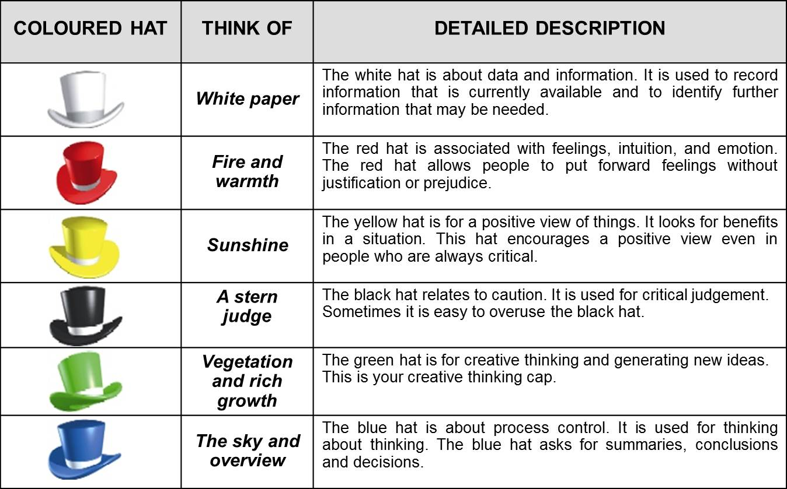
Image https://www.bing.com/images/search?view=detailV2&ccid=psGSDOFJ&id=0B0FD3F6D7C9808BEF6C61712D521A8033EA8D85&thid=OIP.psGSDOFJ51DCM8luirHkoAHaEn&mediaurl=http%3a%2f%2f1.bp.blogspot.com%2f-aJrfhBX6jvM%2fUd3X1wGRO2I%2fAAAAAAAAAGA%2fGrNQ2l_SXOc%2fs1600%2fSix-Thinking-Hats1.jpg&exph=839&expw=1348&q=de+bono+thinking+hats&simid=607996016522690816&selectedIndex=0

Appendix 7 - Evacuee Lesson plan which detailed to exciting use or role play to encourage engagement and participation
 |  |  |  |  |  |  |  |  |  |  | 1B

Session Plan – Key Stage 2
Name of trainee: |  | Rebecca Coslett |  |  |  | Session ref:
Personal target(s) in relation to QTS:
Year group: | 6 |  | No. of learners: |  | 24 |  | ALN: | EAL x 2
Additional Adults: |  |  | 0
Learning objective(s): |  |  |  |  |  |  | Success criteria:
Links to previous learning:
Curriculum coverage (range, skills)
English
Oracy
Developing and presenting information and ideas
Speaking
Express issues and ideas clearly, using specialist vocabulary and examples
Explore challenging or contentious issues through sustained role play
Express opinions clearly about topics and written texts and include supporting reason
use varied and appropriate vocabulary, including subject-specific words and phrase
Choose and use a wide range of adventurous and imaginative vocabulary with precision
Literacy (LNF)  Express issues and ideas clearly, using specialist vocabulary and examples  Explore challenging or contentious issues through sustained role play  use varied and appropriate vocabulary, including subject-specific words and phrase |  |  |  |  |  | Numeracy (LNF)
DCF |  |  | Thinking  How would you feel if you were an evacuee in WW2 |  |  | ESDGC |  |  |  | YCC
Key vocabulary (English/Welsh):
Evacuee

Time | Session activities, organisation and management | Key questions & Assessment for Learning opportunities
 | Introduction
 | The lesson will begin with little introduction, with children informed that they should enter the classroom and sit on the floor. We shall discuss previous learning and what pupils already know about evacuees. Then I shall read a letter explaining that the pupils are becoming evacuees
 | Main activities
Pupils will be asked to line up in pairs and make their way to the hall. In the hall there will be 2 rows of chairs set up to resemble a train. Pupils will be asked to sit on the chairs. Whilst on the train, pupils will be given an evacuee label with a destination on it. I will then call out the destinations one at a time and ask pupils who had that destination to stand on the stage. I will explain the children were then chosen by their new families and that preference was given to boys/ only children etc and discuss reasons why. Pupils will be given a card each detailing the family that they will be going to. I will ask them to read them ready to discuss later and then they will be asked to sit down ready for the next group to go up on the stage and repeat the above.
Once completed, I will ask the pupils to sit with their eyes shut and listen to an extract from an evacuee and try to relate to the emotions felt.
Following this I will ask the pupils to quietly return to class, imagining that they are evacuees walking to their new homes, thinking of how they would feel about the future.
On returning to class, I will ask pupils to read their card and list some positive and negative emotions that they may feel about moving to that particular area/family.
I will then explain that next lesson, I want pupils to write a diary entry on their first day as an evacuee. We will discuss what points of the day pupils could talk about and key words that could be used.
Pupils will then be set the task to write these thoughts and feelings down in their book and importantly add why they would feel like that. I will inform pupils that this information will aid their diary writing next lesson.
At this point the pupils will be introduced to the LO and SC. I will ask pupils to create the LO and SC by inputting what they think we need to achieve.
Differentiation
Gwyrdd – pupils will be provided with a worksheet to fill in which will have the headings of certain times of the day that I want the pupils to discuss
Coch – pupils will be provided with the headings of certain times of day and complete the task in their books
Glas – pupils will be expected to complete the task using the words on the board to prompt them and be reminded to think of different points of the day in sequence.

 | Plenary
 | Following the completion of their work, I will pick pupils at random to discuss their work. I will remind pupils that this work will be used next lesson to help write a diary entry. Pupils will be asked to traffic light their work based on how well they think they completed the task.

Appendix 8 – Feedback on SWWCTE provided by my PTE2 tutor regarding this lesson
PEDAGOGY – Advancing learning (through effective application of subject knowledge and discipline) - On track
- Comments and Evidence
- Targets for improvement and suggested ways forward
You have a classroom presence Rebecca which pupils respect. You gave clear direction this afternoon, in English and in Welsh. The introduction was managed very well, and pupils were expected to complete the mind maps in a short time, which they did successfully. When another member of staff came in to talk to pupils about an incident at lunchtime, you regained control and resumed immediately. Each activity was explained clearly, and you maintained an overview of the whole class. The You Tube video was excellent and the finger knitting was a popular task. All the resources had been organised in advance, the net activity had been differentiated, based on your knowledge of abilities and you grouped pupils to enable them to offer peer support, well done. There were no behaviour issues of any kind and there was a buzz of excitement in the classroom as pupils completed the tasks. All the conversation was linked to the activity and I liked the way that you set the scene in relation to children knitting in poor lighting, possibly in air raid shelters etc. Target: To continue to challenge pupils by providing well planned, well-resourced activities which engage them fully.

Appendix 9 – Feedback on SWWCTE relating to my lesson about the importance of earing a helmet when riding a bike.
Professional Learning - On track
- Comments and Evidence
- Targets for improvement and suggested ways forward
The lesson in small groups started inside and she led the pupils to the outside to test egg wrapping. She used a story of Mr Egg as a hook and they were immersed in the challenge, waiting on their turn to protect the egg. It was evident from the children faces that they were enjoying and actively involved. She linked past learning from the road safety to present experiences. Reinforced learning goals consistently throughout the lesson and children knew what to test

Appendix 10 – An ARC I completed on PTE2 regarding the use of KWL grids
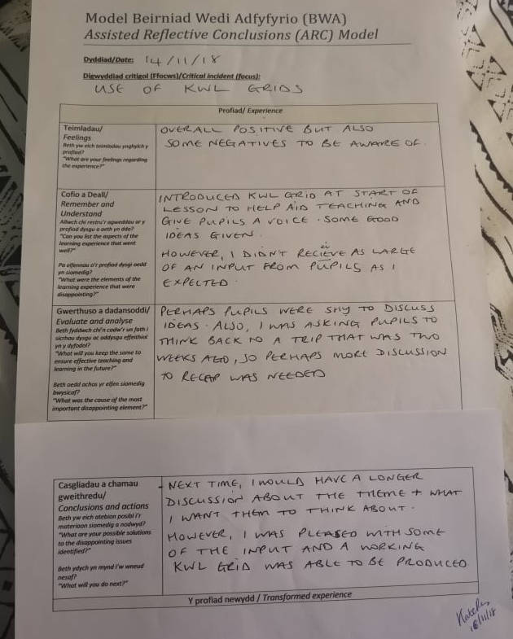

Appendix 11 – Further detail about Costa and Kallicks Habits of Mind (2000)
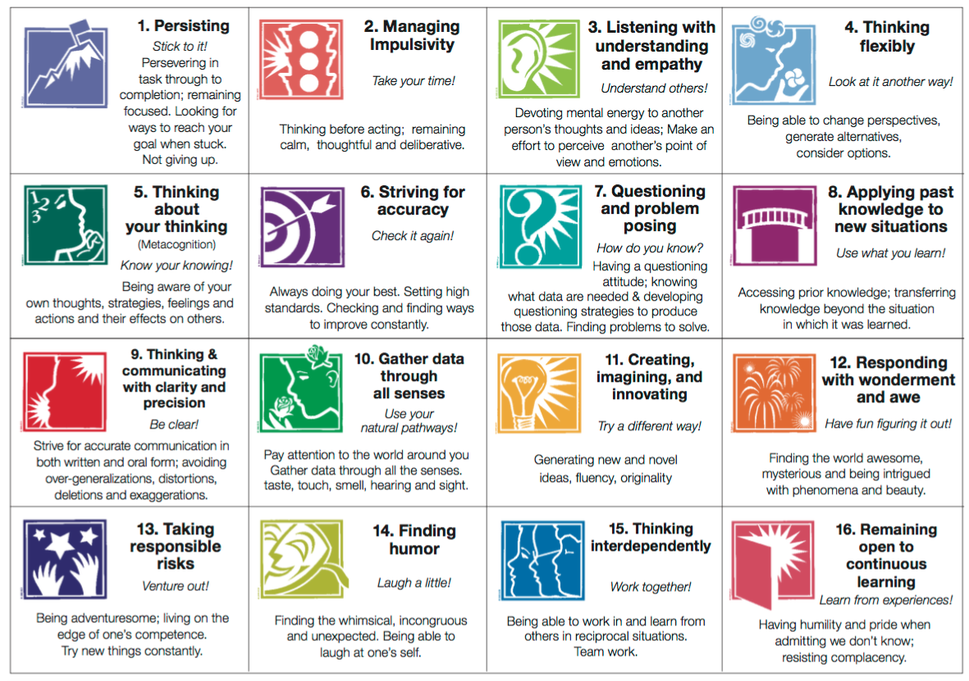
https://www.bing.com/images/search?view=detailV2&ccid=xs039qlC&id=DFE46A194305134D03D30F2FA8A61DCB42FDB090&thid=OIP.xs039qlCm8eHl8oSaFZatwHaFN&mediaurl=http%3a%2f%2fwww.pikespeakgifted.org%2fwp-content%2fuploads%2f2015%2f12%2fHabitsofTheMindChart.png&exph=831&expw=1181&q=habits+of+mind&simid=608032622480068452&selectedIndex=4

Appendix 12 – Van Oechs 10 mental blocks as noted in A Whack on The Side of The Head: How You Can Be More Creative (Van Oech, 1983)

- That’s not the right answer
- That’s not logical
- Follow the rules
- Be practical
- Play is frivolous
- That’s not my area
- Don’t be foolish
- Avoid ambiguity
- To err is wrong
- I’m not creative

