
University of Wales Trinity Saint David
Master of Business Administration
LCMB7034 International Business Concepts
Report
“A Critical Evaluation of Starbucks Corporation’s Potential Market Entry into Bangladesh”
Name: Md Asif Hosen
ID: 2506161
Lecturer: Gladius Kulothungan

Executive Summary
The report critically explored the opportunity for Starbucks Corporation to enter the Bangladeshi market and suggests an international market entry strategy for the company. The transnational strategy logic was the political, economic, legal and cultural evaluation used for this analysis, whereas Dunning's OLI framework and the current theory on entry are applied to the analysis of the entry mode logic. Starbucks had several ownership advantages, such as its global branding, service systems, product innovation, training ability and licensed-store model. In Bangladesh, there was a long-term potential owing to the high population density in the urban areas, development of modern food service, and growing demand for social and experience-centric retail outlets. However, the market has its own problems, including growing inflation, exchange-rate pressure, complexity of regulations, import costs, high tea drinking culture and price sensitivity.
The report found that a 100% ownership entry would be too risky in terms of capital and operations, while a loose franchising would put brand control at risk. Hence, it is recommended to take a step-by-step approach of a licensed partnership with a good retail/hospitality company in Bangladesh. To begin with, Starbucks should open two or three stores in quality locations in Dhaka, make some changes in the quality of products and services and in the price of the products and services, and keep the rights of approving the designs, sourcing, training, marketing, and quality of the stores. Expansion should be based on repeat visits, customer satisfaction, supplier reliability, regulatory compliance and commercial performance. The pilot model should only be considered as an option in the context of the later equity joint venture.
Table of Contents
Executive Summary 2
1. Introduction 5
2. Organisational Classification and Global Strategy 5
2.1 Company and international strategic position 5
2.2 Strategic classification and global configuration 6
3. Macro-Environmental Appraisal and Market Attractiveness 7
3.1 Political and institutional environment 7
3.2 Economic and industry environment 8
3.3 Legal and regulatory environment 9
3.4 Cultural and consumer environment 10
3.5 Market-attractiveness synthesis 11
3.6 Dunning’s OLI framework 12
3.6.1 Ownership advantages 12
3.6.2 Location advantages 13
3.6.3 Internalisation advantages 14
3.6.4 OLI-based entry judgement 14
4. Entry Mode Strategy and Strategic Synthesis 15
4.1 Historical pattern of international entry 15
4.2 Suitability of the historical mode for Bangladesh 17
4.3 Conclusion and Recommendations 18
5. Reflective Account Using Gibbs Reflective Cycle 19
5.1 Description 20
5.2 Feelings 20
5.3 Evaluation 21
5.4 Analysis 21
5.5 Conclusion 22
5.6 Action Plan 22
Reference List 23

1. Introduction
As of 1 June 2026, Starbucks Corporation has very little presence in Bangladesh; this report critically examines its potential to be present in Bangladesh. Starbucks is a relevant case for international expansion of retailing because it is a global brand, has a licensed-store model and provides an experiential retailing experience. The report suggests using the Bartlett and Ghoshal, PELC and Dunning's OLI and entry-mode theory; Bangladesh has long-term urban opportunity but needs a careful entry with a phased licensed partnership, followed by joint venture opportunities in the future, if proven successful (Starbucks, 2025).

2. Organisational Classification and Global Strategy

2.1 Company and international strategic position
While Starbucks is part of the specialty coffee and foodservice marketplace, its edge doesn't just lie in coffee. The company sells an experience through store atmospherics, service protocols, digital interactions, brand community and positioning as a premium brand (Starbucks, 2025). Starbucks (2025) has identified 40,990 stores worldwide, of which 22,679 are international, indicating that international operations are at the core of value creation, not as an add-on to the domestic business. This scale not only supports sourcing and brand visibility and operating standardisation, but can also cause pressure to ensure quality consistency in culturally different markets (Hill and Hult, 2022).
The international stature of Starbucks can be a boon in Bangladesh, but not a given. It also has a licensed-store model that enables the company to scale without having to bear high operating and investing costs, as local partners assume the primary responsibilities (Starbucks, 2025). This is relevant strategically as Bangladesh has unique issues related to regulations, property rights, labour and consumer adaptation issues which a local partner might be better suited to handle than a fully foreign-controlled entity (BIDA, 2026; UNCTAD, 2026). But if the licensee becomes too dependent on the licensor, the quality of the service, the quality of the stores or the standard of supply is not well controlled, the control of the brand can be lost (Abdul Ghani et al., 2022).

2.2 Strategic classification and global configuration
Starbucks, then, would be considered to be following a transnational approach, according to Bartlett and Ghoshal's reasoning, as it integrates the local with the global. Its brand identity, store design principles, beverage routines, training systems and quality expectations are all standardised internationally, which aids in efficiency and brand consistency (Starbucks, 2025; Hill and Hult, 2022). However, in terms of menus, formats and market development, Starbucks is not a completely standardised company but tailors them to local tastes and institutional context (Wild and Wild, 2022). Hence, it was not the case that Bangladesh was to follow the model of the USA or the United Kingdom, but rather a model of controlled adaptation of the USA or the United Kingdom model.
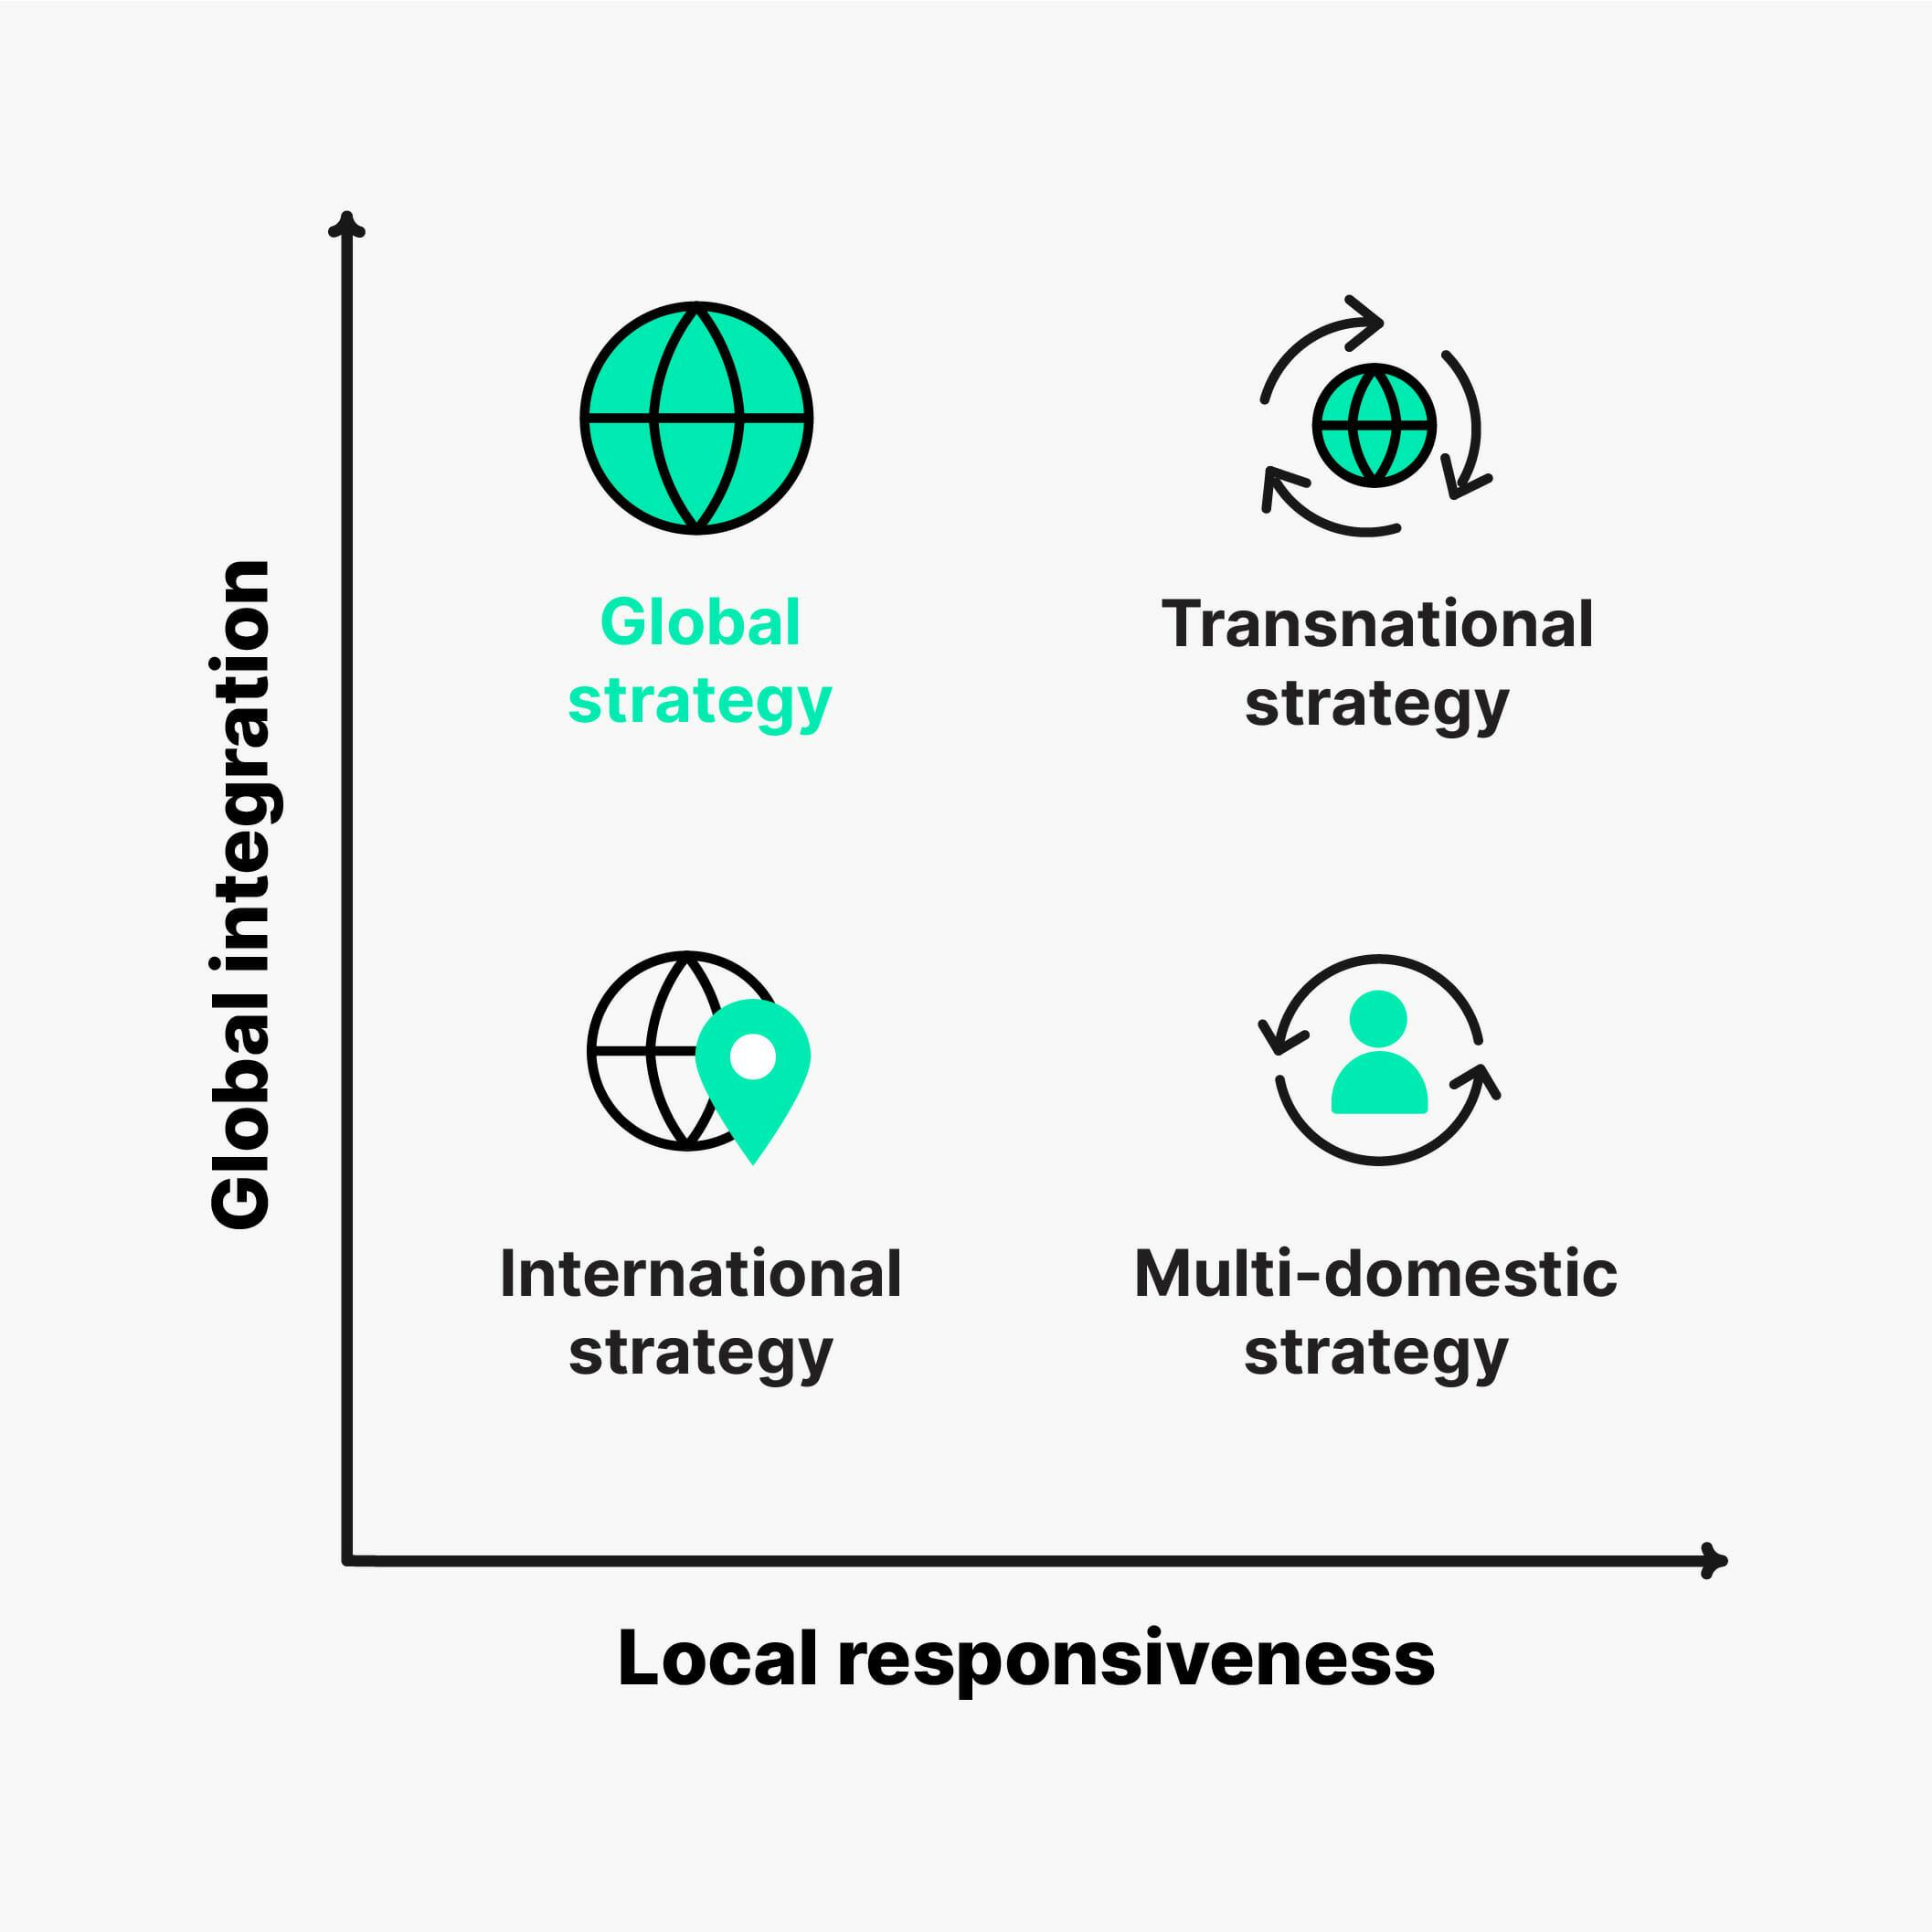
Figure 1: Global Integration–Local Responsiveness Strategy Matrix
Source: Adapted from Hemingway (2026).
Based on this, Starbucks could be considered a transnational enterprise as it merges global branding and quality with localised adaptations (see Fig. 1). The international brand image should be maintained and the products, pricing and communication strategies adapted to local preferences in Bangladesh.
Starbucks' global setup is an advantage just when global routines are aligned with host country realities. The place of the coffeehouse, the conduct of employees, cultural acceptance, and consumer willingness to pay premium coffee prices (Starbucks, 2025; Meyer et al., 2023) also play a role. Some of the cultural differences and the availability of low-cost tea alternatives in Bangladesh, along with the price sensitivity and variable purchasing power of urban customers (Ahamed et al., 2024; USDA, 2025), can become Starbucks' drawbacks. A key feature of achieving competitive advantage is to find a balance in the global system and localised pricing, food and communication at Starbucks.

3. Macro-Environmental Appraisal and Market Attractiveness

3.1 Political and institutional environment
The institutional structure in Bangladesh remains unbalanced, as it is open to foreign investment formally. BIDA provides registration and One Stop Service for WFO / JV projects, which clearly suggests that Starbucks can enter by various ownership models (BIDA, 2026). UNCTAD (2026) also acknowledges the progress made in four other areas: digitalisation; investment promotion; and regulatory reform. It yet again calls for better coordination of efforts and better precision of rules and less onerous procedures on investments.
One factor that is critical is institutional distance, as Starbucks would have to manage lease agreements, building approvals, trade licences, food permits, imports, signage, operating hours, and staffing agreements. The administrative uncertainty and local learning costs would be borne by the firm if it made a greenfield entry. Studies indicate that institutional variations can result in higher information asymmetry and operating risk, but local partners can also cause governance and control issues (da Silva, Ogasavara and Pereira, 2023). Having a credible Bangladeshi partner would reduce the hurdles in the process and improve access to regulators and property networks, but it would require Starbucks to obtain contractual rights to train, property standards, supplier approval, reporting and compliance audits.
The political climate is thus in a position to assist in both slow and fast direct investment. The findings from the studies carried out in Bangladesh show that institutions and macroeconomic conditions are also responsible for the performance of FDI in addition to market size (Hossain, 2021; Morshed and Hossain, 2022; Islam et al., 2024). Starbucks should leverage the initial stores as a “learning lab” to help educate on regulation and operation.

3.2 Economic and industry environment
In the country of Bangladesh, there is a high potential for the future, but the real customer base for Starbucks will be less than the country's population. An average of US$456 billion in the economy by 2025 and an average of US$2,597 per capita GDP economic scale but not so much purchasing power (World Bank, 2026). The initial demand would then come mainly from the upper middle classes in the towns and cities, from the professions, from students at the universities, from expatriates and from groups that have contact with the outside world. Modern retail, hospitality & foodservice is also a growth sector according to USDA (2025).
Inflation, exchange-rate pressure and financial instability dampen the appeal of short-term attractiveness. There is uncertainty about the macroeconomic outlook, with the World Bank expecting 3.9% growth for FY2026 and the IMF predicting around 4.7% (World Bank, 2026; IMF, 2026). If inflation persists, then wages will rise, home heating and electricity costs will go up, rent costs will go up, local food costs will go up, and the cost of imported coffee and espresso equipment, as well as packaged goods, will go up as well. Persistent inflation will increase the cost of wages, home heating and electricity, rent, local food, imported coffee, espresso equipment and syrup, and branded packages. This may lead to the reduction of Starbucks profit margin or force Starbucks to squeeze a price out of its product. But with the competition from tea stalls, local cafes, and restaurants offering tea at affordable prices, the initial excitement for names might not be enough if the price is excessive to convince consumers to go back and buy the Starbucks brand.
The economic argument is based on customer frequency, value perception and location discipline. Bangladesh consumers take into account multiple factors like price, taste, convenience and service when choosing food services (Ahamed et al., 2024). Revisit intention is also known to be closely related to experience, satisfaction and habit in the case of coffee shops (Deloitte, 2024; Lee, 2022; Meeprom and Kokkhangplu, 2025; Mohd Hanafi et al., 2025).
Table 1: Market attractiveness summary for Starbucks entering Bangladesh
Dimension | Opportunity | Risk | Strategic implication
Political/institutional | FDI facilitation and BIDA support for foreign and joint-venture projects | Procedural delays and regulatory fragmentation remain possible | Use an experienced local licensee or JV partner
Economic | Large urban consumer base and growth in modern retail/foodservice | Inflation, exchange-rate pressure and discretionary spending constraints | Begin with limited Dhaka pilot stores and cautious pricing
Legal/regulatory | Foreign and joint-venture project registration routes exist | Food safety, import duties, labour law and brand protection must be managed | Conduct legal due diligence before site and supplier commitments
Cultural/consumer | Young consumers and urban café culture support experiential consumption | Tea culture and price sensitivity may restrict mass adoption | Localise menu and communication without diluting Starbucks standards
Source: Author synthesis from World Bank (2026), IMF (2026), UNCTAD (2026), BIDA (2026), USDA (2025), Ahamed et al. (2024) and Starbucks (2025).

3.3 Legal and regulatory environment
They would be required to comply with the company registration requirements, taxation, labour law, food safety, leasing and data management requirements, as well as import requirements, that apply to Starbucks. BIDA outlines the document requirements of foreign-owned and joint venture projects, and UNCTAD provides information on advances and coordination and regulatory issues (BIDA, 2026; UNCTAD, 2026). Before selecting a site and entering into public use, therefore, due diligence should be performed in the legal aspects. If the local partner were not to comply with the obligations of employment, tax, food-safety or consumer-protection laws, Starbucks would still suffer reputational and financial damages. There is no way to vacate legal obligations by virtue of operations being licensed.
Import regulation is of special importance because the first stores can use imported coffee, espresso machines, coffee syrups, packaging and specialty ingredients. Tariff information from the WTO and USDA market analysis indicate that duties, documentation, logistics and infrastructure can contribute to landed costs and delay supply (WTO, 2025; USDA, 2025). Reliance on imports could have a detrimental impact on profitability and product uniformity. Thus, the main control of the significant parts of the coffee product and the equipment should also be retained by Starbucks and the bakery, packages, milk, and selected snacks should be gradually decentralised. Some aspects of suppliers' approval should include an audit of hygiene, traceability, storage, allergens, labour conditions and delivery performance to ensure a cost-effective and quality product.
The second significant protection is one of its assets: its intellectual property and contractual protection, which is also crucial, as Starbucks' assets consist of trademarks, store design, recipes, training systems, digital platforms and customer data (Starbucks, 2025). Unless the franchise is well-made, these assets may be susceptible to being copied, misused, or misallocated. It is also noted that marketing decisions involve brand equity, brand franchise performance, and that the legal governance is not in administration, but is an integral component of brand management (Lee, Kim and Rhee, 2021). Therefore, the following controls and audit rights, performance milestones, access to data or territorial use specifications and termination clauses should be included in the licence agreement. Slightly less flexibility in how it operates, but brand value would be preserved for the long-term.

3.4 Cultural and consumer environment
The culture of drinking tea in Bangladesh both poses a challenge and a chance for Starbucks. Tea is perceived as a good social beverage and extremely cheap, whereas Starbucks is a coffee bar that has a storefront and is considered a luxury drink. It is not assumed that just because the company is well-known worldwide, consumers will necessarily be willing to switch from tea to coffee. One of the points raised by research on cross-cultural management is the need to grasp the meanings and communication and consumption patterns of the local culture before simply importing a foreign format into it without adapting it to the local context (Doh, Luthans and Gaur, 2023). Starbucks must then be marketed as an extra social, study and working place and not as a better alternative to the consumption of other drinks.
This would require selective adaptation. Minimising cultural distance may be possible through the use of halal-ready food, clear and transparent information about ingredients, tea-based drinks, cold drinks, familiar sweetness and locally relevant snacks. In the evaluation of foodservice, consumers consider the taste, price, convenience and service (Ahamed et al., 2024; Meeprom and Kokkhangplu, 2025), and in the evaluation of coffee, the factors that consumers consider are wider consumption experience. There's a possibility, however, that too much localisation can remove the personality of the brand from its global audience and make operations more difficult. What is better is to change those things that impact acceptance and keep a global community of rituals, coffee knowledge, systems and visual identity. This will ensure cultural sensitivity and brand quality will be balanced.
The communication, design and service of the store should also be modernised, and include urban life. This positioning can cause questions about the luxury brand, but can also stop customers from returning, and will have adverse effects on brand equity if the discount is given frequently (Lee, Kim and Rhee, 2021). Starbucks can offer students buying incentives to promote purchases; convenience for the office to facilitate purchases; local seasonal products to encourage preference for the store; and regular service to foster consumer behavior. The experience of the customer and routines greatly influence the revisit intention (Lee, 2022; Mohd Hanafi et al., 2025). Stores should therefore provide cleanliness, privacy, safe seating and reliable and local communication. Cultural success would not be based on the attention users would receive on the launch day but rather if the social meaning of the environment would entice customers to come back regularly.

3.5 Market-attractiveness synthesis
Political, economic, legal and cultural indicators indicate that Bangladesh is a medium to high potential market, but a high execution risk. Investment reforms and BIDA support improve the formal accessibility of investment, but the institutional coordination is not fully realised (BIDA, 2026; UNCTAD, 2026). While Dhaka provides a concentrated consumer market, inflation and pressure of exchange-rate costs and prices of imported inputs pose threats to affordability (World Bank, 2026; IMF, 2026). Compliance with legal requirements is a possibility but must be well controlled with regard to imports, food safety, employment and intellectual property. Starbucks can learn from the adaptation of urban life in cultural aspects, while the price sensitivity and tea culture should be adapted selectively. The situation is right for a gradual approach rather than rolling out across Bangladesh.

3.6 Dunning’s OLI framework
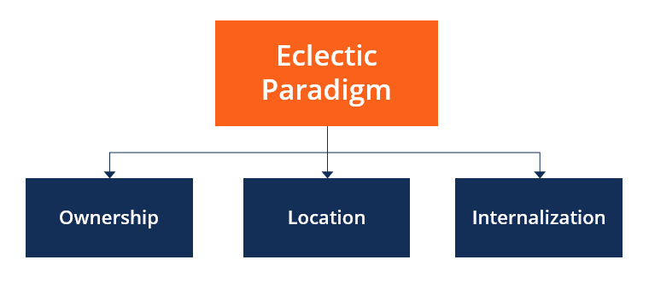
Figure 2: Dunning’s OLI framework (Abd Aziz et al., 2021)

3.6.1 Ownership advantages
Starbucks has a lot of assets or resources which are unique to its ownership, including its reputation, knowledge of coffee, its innovative capability, its design and training ability, and its capacity to create a supply chain that meets the Starbucks standards, as well as its repeatable service experience (Starbucks, 2025). These resources can be a differentiator between a Starbucks and a standalone Bangladeshi Starbucks and give more justification for premium pricing. The company's size also enables the development of its products, management of its suppliers, digital interaction with its customers and overseas learning. Starbucks announced that by 2025 they would have more than 40,000 Starbucks stores in the world, with both their own stores and licensed outlets, so their systems are applicable to a variety of business models.
Ownership advantages are not necessarily transferable, however. While global strategies are still being formulated by national institutions, as Meyer and her colleagues (2023) argue, and foreign-market entry focuses on customer-centred adaptation, as Eskiyerli and Ewertz (2024) claim, the question remains whether this is a prerequisite for the other. If Starbucks has to set its prices in Bangladesh to exorbitant levels, with products that are culturally insensitive, operating models that are inflexible, etc., then it can create a problem in the world. The benefits of ownership would only be enhanced if they could be transformed into a suitable menu design, local communication, suitable site selection and reliable service. What remains to be determined, therefore, is whether or not Starbucks has valuable capabilities and whether they can be transferred without losing their value.

3.6.2 Location advantages
Bangladesh has very localised yet significant location advantages. It has a large economy, youthful population, a growing hospitality industry and a maturing modern retail market, all of which offer potential for demand in the future (USDA, 2025; World Bank, 2026). Dhaka has universities, corporate areas, upmarket residential neighbourhoods, shopping centres and shoppers with knowledge of foreign brands. The two can be conducive to a high-quality, experience-focused coffee shop. However, wide-based entry is constrained by inflation, foreign-exchange pressures, regulatory tensions, logistics constraints and limited average purchasing power (IMF, 2026; UNCTAD, 2026).
The location advantage thus needs to be determined at the city and neighbourhood level, rather than the national level. In many of the secondary areas selected, the cost structure may not be met but may be met in selected districts of Dhaka city with respect to income, foot traffic and lifestyle factors. Rental value, traffic, the proximity of universities and offices to the site, the competitive density, the transport access and customer income of each location should be taken into consideration. The short-term best location advantage is thus in a few high-potential dense urban micro-markets, while in the longer term, Bangladesh is an attractive strategic location.

3.6.3 Internalisation advantages
The internalisation analysis revolves around the amount of control that Starbucks should have. Packaged coffee exports would be low-touch and would not provide the Starbucks store experience. With loose franchising, the quality, IP and customer information may be even more influenced by partner selection, and the expansion is more likely to ramp up. The highest level of control would be achieved through a wholly owned subsidiary, but would result in a higher capital exposure, regulatory learning costs and macroeconomic instability. In contrast to this, da Silva, Ogasavara and Pereira (2023) show that the institutional distance influences the governance decision, while Brouthers et al. (2022) find that there are flexible and non-traditional arrangements behind the shifting risks and opportunities.
The circumstances are conducive to a highly regulated licensed partnership. The initial stores will be financed and managed by the Bangladeshi partner, Starbucks will retain control or approval rights over the use of the brand, location, design, staff training, recipes, critical procurement, marketing and auditing. In addition to expansion overseas, the study on franchising recommends that the quality of the partner is also an important factor, as is the market readiness and alignment of incentives (Abd Aziz et al., 2021; Abdul Ghani et al., 2022; Sun and Moon, 2023). Accepted suppliers, data access, quality audits, geographical restrictions, performance goals, termination and conversion provisions should be included in the agreement.

3.6.4 OLI-based entry judgement
All three OLI elements are conducive to phased entry. The location advantages are genuine, but very local in Bangladesh, and there are enough ownership advantages to attract customers and control a partner, and some degree of internalisation is needed to ensure the quality, but not all Bangladesh risk. It is recommended that there are two or three pilot stores in Dhaka for which the average transaction value, repeat visits, customer satisfaction, product mix, staff turnover, food safety compliance and supplier reliability will be assessed for about eighteen months.
If the pilot is successful, it may warrant more licensed stores or even equity-based, which would give Starbucks more control and long-term commitment. If there is a low repetitive demand (or regulatory difficulty, or unreliable supply), then it would be appropriate to slow down the expansion of the model. Dunning's theory suggests that the only two possible courses of action for Starbucks in Bangladesh are either to be a part of the country by managing a close relationship in a licensed partnership arrangement, or to expand its operations in the country if market evidence indicates that there is potential to sustain its global ownership advantages in the local market.

4. Entry Mode Strategy and Strategic Synthesis

4.1 Historical pattern of international entry
Starbucks' traditional strategy for growth has been through stores, licensed stores, strategic partnerships and selective acquisitions. A large portion of its overseas expansion is from licensed stores, which provide capital and property and have the ability to operate, while Starbucks provides the brand, the product, the training, and the operating standards (Starbucks, 2025). This helps minimise upfront resource investment and helps to enter new markets that the institutions are not familiar with. It also creates dependency on its partners, as in the event of poor service, unreliable delivery of products or failure of its employees, it can adversely affect Starbucks' brand, even though its stores are not owned by Starbucks.
The company's track record, in other words, is more of a controlled licensing system than a typical loose-type franchise. Starbucks has a strong influence over the store design, expectations, coffee quality, training and the customer experience that they provide, and thus retains the ownership benefits and places part of the operational and financial responsibility on the local partner (Starbucks, 2025). The results of the franchising research indicated that besides low capital investment, the ability, incentive compatibility and support systems of the partner and market readiness are factors that are more influential in achieving success in international expansion (Abd Aziz et al., 2021; Abdul Ghani et al., 2022). It also makes perfect sense in the context of Starbucks' model because licensing is a means to keep the Starbucks brand consistent and yet responsive to local markets.
There are a number of strategic benefits to this historical mode. It helps Starbucks gain access to markets where local knowledge, property, and regulatory relationships are important, and provides flexibility in case performance is deficient. It also helps to ensure that your business isn't subjected to new labor, real estate and supply chain risks. The impact on the day-to-day service, however, is restricted to licensing, and the returns on the investment are reduced. Starbucks' partnerships and internal stores found in some markets provide evidence that the permanent is not necessary, as successful business partnerships reduce uncertainty and the market becomes strategic, leading to internalisation of the business (Starbucks, 2025).
Table 2: Comparison of possible entry modes for Starbucks Bangladesh
Entry mode | Strengths | Weaknesses | Fit for Bangladesh
Exporting packaged products only | Low capital risk and quick test of brand awareness | Does not create the Starbucks coffeehouse experience | Low: useful only as supporting channel
Loose franchising | Fast growth and low investment | High risk of service-quality inconsistency and brand dilution | Low-to-medium: risky for premium positioning
Licensed partnership | Shares investment risk; gives local market knowledge; preserves contractual control | Requires careful partner selection and monitoring | High: best initial mode
Equity joint venture | More control and stronger commitment than licensing | Higher capital exposure and governance complexity | Medium-to-high: suitable after pilot success
Wholly owned subsidiary | Maximum control and full capture of returns | Highest capital, political, operational and learning risk | Low initially; possible long-term option
Source: Author synthesis from Starbucks (2025), Brouthers et al. (2022), Abdul Ghani et al. (2022), Abd Aziz et al. (2021), da Silva, Ogasavara and Pereira (2023) and Sun and Moon (2023).
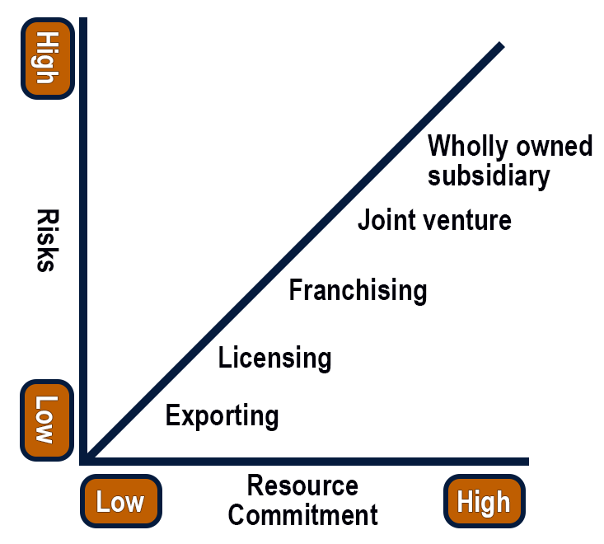
Figure 3: Entry Modes by Risk, Control and Commitment
Source: Adapted from Pennsylvania State University (2026).
Figure 3 will serve to support a Licensing arrangement as it will allow Starbucks some control over the method of operation of the store, with less risk to them than if it were one that they owned outright. Therefore, it is appropriate to strike a balance between local knowledge, flexibility and brand protection in Bangladesh.

4.2 Suitability of the historical mode for Bangladesh
The first one could be Bangladesh, as it has high long-term demand potential and is highly uncertain in terms of political, financial, and operational aspects, so it is highly suitable for the mode of entry, which is a licensed partnership. Foreign-owned and JVs are welcomed, and the regulatory coordination and implementation are not uniform (BIDA, 2026; UNCTAD, 2026). The 100% greenfield entry would mean Starbucks has to register, gain permits, lease, deal with food regulations, import the food, etc., build the staff and develop the suppliers, and have no country expertise. By contrast, a well-equipped local licensee may be able to reduce information and coordination costs, reduce time to market, improve access to the property, regulators and labour networks.
Financial factors are also favorable for licensing. However, there is a huge urban consumer market in Bangladesh; however, uncertainty in consumer demand and operating margins due to inflation pressures, exchange-rate weakness and fragilities in the banking sector and limited consumer purchasing power (World Bank, 2026; IMF, 2026). Starbucks will be dependent on coffee imports and equipment, syrups and packaging, which are also priced in foreign exchange, and extra trade expenses will affect the price of the coffee products. Starbucks will rely on imported coffee beans, equipment, syrups, and packaging, meaning that its costs will be sensitive to the depreciation of the exchange rate and trade-related costs (USDA, 2025; WTO, 2025). The local business partner would make most of the investments in the store and would assume a greater operating risk, freeing up funds for Starbucks to try out and see if there are more repeat customers to be gained by offering greater premiums.
But it's essential to choose a partner carefully. Institutional-distance research shows that collaboration can help to decrease uncertainty, but can also create uncertainties about control, knowledge protection and conflicting goals (da Silva, Ogasavara and Pereira, 2023). Starbucks must therefore be looking for a partner that has brand retail experience, a robust food safety and staff training system and clear governance. The terms of the contract shall explicitly transfer to Starbucks all the power to approve the store's site, layout, product, vendors, Employee Training, etc., along with its marketing plan and digital approach.
Going through a phased rollout will work better for Starbucks' business plan and goals than an all-of-the-market rollout would. Starbucks need to begin their business at two or three stores in premium areas with good demand in Dhaka, like Gulshan, Banani or Dhanmondi. Evaluations should be conducted on average transaction value, food-safety compliance, supplier reliability, product mix, customer satisfaction, staff turnover and repeat visits. This evidence-based approach ensures adaptation is customer-centred and is flexible for wider expansion (Brouthers et al., 2022; Eskiyerli and Ewertz, 2024). While still a possibility, if done right, Starbucks may decide to make a leap into an equity joint venture, and the benefits of the arrangement could be realised over time.

4.3 Conclusion and Recommendations
Starbucks should be introduced in Bangladesh in a gradual way by licensing it from a well-established local retail or hospitality institution. The mode has a better balance of control, flexibility, and risk than the other two modes because it offers access to local property, skills, regulatory knowledge and labor, as well as suppliers, but without a high degree of direct financial risk. Starbucks, however, should still have tight control in the areas of store design, training, sourcing, food safety, marketing, customer data and quality control to avoid brand dilution.
The first phase should be two or three good stores in Dhaka, and then it should be expanded. Expansion should be determined based on repeat visits, average transaction value, customer satisfaction, supplier reliability and regulatory compliance. Starbucks should explore the possibility of turning the relationship into a joint venture, or an equity joint venture, if the pilot is successful, to gain greater control and value for the long term. So, the solution is to first license and then to expand based on evidence and only extend the ownership after commercial and operational success.

5. Reflective Account Using Gibbs Reflective Cycle
The Gibbs Reflective Cycle is a structured framework designed to guide individuals through the process of reflecting on experiences in a systematic way (Meyer et al., 2023).
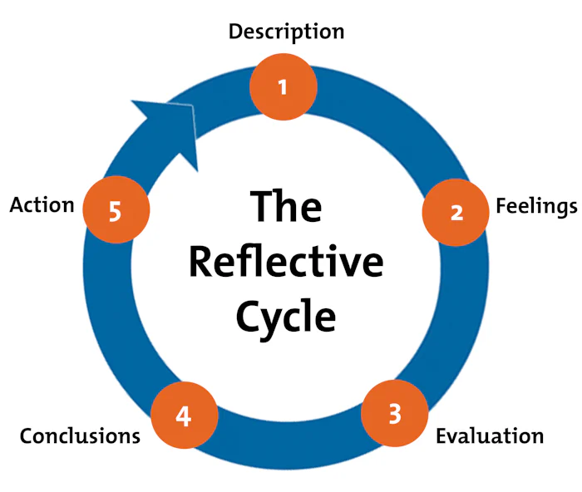
Figure 4: Gibbs' Reflective Cycle (Meyer et al., 2023)

5.1 Description
I started the evaluation process by analysing the brief, and the main components of the brief were identified: Organisational classification, host-country analysis, Dunning's OLI framework, entry-mode evaluation and reflection. I have selected Starbucks in Bangladesh because it was a problem that can be encountered during the expansion of the business to an international level, and there was evidence of the company, governmental body, institution, and academia. Next, I organised my work into the following steps: the overall business strategy of Starbucks and their historical strategy of entering new markets, the political, economic, legal and cultural context in Bangladesh. Lastly, I used Bartlett and Ghoshal and OLI for comparing alternatives and argued for a phased licensed partnership, but always aimed to maintain a more analytical than descriptive report for the entire research exercise.

5.2 Feelings
I started out with confidence since I knew the name Starbucks and it was a well-known brand. But I realised that with familiarity, there would be a tendency towards bias. I figured that given the reputation and the systems that Starbucks had just go do it because I thought they would be the best to guarantee quality. As I was reading the evidence, I was further confused by the mixed messages that I received from Bangladesh. BIDA and UNCTAD focused on investment reform and foreign-investment support, the World Bank and IMF on inflation, exchange-rate pressure, banking weakness and implementation challenges (BIDA, 2026; UNCTAD, 2026; World Bank, 2026; IMF, 2026).
This was initially somewhat confusing mixed evidence; there was no clear yes or no answer to the question. It also made the analysis more meaningful, however. I realised that there is not much that is decided in the world of international business, and it is done with complete certainty. Rather, managers must assess if the potential benefits outweigh the potential risks and if the chosen entry mode is capable of dealing with the risks. I got more confident when I realised that this was no ideal market, and I should try to find the best governance model to exploit this market before the market is even sure, but has the potential of being very promising.

5.3 Evaluation
I think the best thing that I did was equating different types of sources and different types of questions. The annual report by Starbucks provided an informative source of information to find out about Starbucks' store portfolio, licensed model, and its international operating logic (Starbucks, 2025). The institutional sources were more suitable and provided up-to-date information on growth, inflation, procedures for investment, trade and foodservice conditions, and were used as a source for the macroeconomic analysis and regulatory analysis. The peer-reviewed articles have been useful to me in understanding the three concepts of franchising, institutional distance, and consumer experience/revisit intention. This mix proved to be useful in the report, since no one source was able to address all the questions.
When choosing a source, I was motivated by Saunders et al. (2023) to consider both credibility and relevance, as well as methodological appropriateness. I did not include the references for the sake of additional references, but I picked the references as they had specific elements to them that I wanted to add. A drawback was that not all of the consumer studies were directly focused on consumption of premium coffee in Bangladesh. Thus, I had to limit my use of general information on foodservice preferences as conclusive proof for Starbucks demand. The constraint reduced the certainty of the results of the analysis, but increased the honesty and credibility of the analysis.

5.4 Analysis
Useful learning was the application of theories one at a time, and not synthesis as used in International Strategy. Bartlett and Ghoshal were able to help in my categorisation of Starbucks as transnational, and the political, economic, legal and cultural analysis determined whether or not that strategy would be successful in Bangladesh. Why Starbucks' systems and trademark did not automatically make it their right to have an absolute ownership stake was then uncovered by Dunning's OLI framework, which separated ownership, location and internalisation advantages. The threats to urban growth and foodservice potential in Bangladesh are inflation, regulation and cultural differences. So, I knew licensing to be more about balance of control and flexibility, local knowledge and cautious commitment than it was a weak compromise in general.

5.5 Conclusion
This assessment was useful to me in making suitable decisions based upon conflicting and incomplete data. I discovered critical analysis involves discovering options, the trade-off and why one is preferable in a particular circumstance. The report showed that the quality of partners and localisation, the pricing, supply reliability and operational discipline of Starbucks are more important than brand recognition in Bangladesh. I also learned about the effect of visual synthesis. The market attractiveness and entry mode tables provided evidence to support strategic implications, while avoiding disconnected description and highlighting the benefits of licensing through a thoughtful, systematic comparison of other modes of entry to the market.

5.6 Action Plan
I will create an evidence matrix for future assignments that will help organise the ways each requirement connects with theories, data sources and arguments before drafting. This should be able to identify gaps in the text, identify repetition and distinguish between direct evidence and contextual information and inferences. I will check/harvey the Harvard referencing while I am writing, not at the end. For future analysis, indicators will be compared across a number of years and state limitations if there is a lack of evidence from consumers. In the job world, I will follow the same steps to make entry decisions: identify the problem, consider governance structures, conduct pilots to assess if I can make the expectations work, and only scale up once I can gain confidence that the expectations are being met.

Reference List
Abd Aziz, N.A., Ramdan, M.R., Nik Hussin, N.S., Abdul Aziz, Z., Osman, J. and Hasbollah, H.R. (2021) ‘The determinants of global expansion: A study on food and beverage franchisors in Malaysia’, Sustainability, 13(18), p. 10328. doi:10.3390/su131810328.
Abdul Ghani, M.F., Hizam-Hanafiah, M., Mat Isa, R. and Abd Hamid, H. (2022) ‘A preliminary study: Exploring franchising growth factors of franchisor and franchisee’, Journal of Open Innovation: Technology, Market, and Complexity, 8(3), p. 138. doi:10.3390/joitmc8030138
Ahamed, S., Tabassum, N., Moniruzzaman, Md., Hasan, Md.M. and Hasif, Md.A.M. (2024) ‘Consumer preferences of fast-food items in Mymensingh, Bangladesh’, Archives of Agriculture and Environmental Science, 9(1), pp. 69-75. doi:10.26832/24566632.2024.0901011.
BIDA (2026) Foreign and Joint Venture Projects / One Stop Service. Available at: https://bida.gov.bd/foreign-joint-venture-projects (Accessed: 9 July 2026).
Brouthers, K.D., Chen, L., Li, S. and Shaheer, N. (2022) ‘Charting new courses to enter foreign markets: Conceptualization, theoretical framework, and research directions on non-traditional entry modes’, Journal of International Business Studies, 53(9), pp. 2088-2115. doi:10.1057/s41267-022-00521-x.
da Silva, F.M., Ogasavara, M.H. and Pereira, R. (2023) ‘Institutional distances and equity-based entry modes: A systematic literature review’, Management Review Quarterly, 74, pp. 1723-1790. doi:10.1007/s11301-023-00346-4.
Deloitte (2024) Deloitte Coffee Study 2024. Available at: https://www.deloitte.com/ch/en/Industries/consumer/perspectives/coffee-study.html (Accessed: 9 July 2026).
Doh, J.P., Luthans, F. and Gaur, A.S. (2023) International Management: Culture, Strategy, and Behavior. 12th edn. New York: McGraw Hill. ISBN: 9781266061318.
Eskiyerli, D.Y. and Ewertz, S. (2024) ‘Foreign market entry with circular business models: A customer-centric approach’, Frontiers in Sustainability, 5. doi:10.3389/frsus.2024.1344801.
Mohd Hanafi, M.F., Mohd Shahril, A., Gaffar, V. and Abdul Rahman, A.R. (2025) ‘Exploring the coffee shop experience: The impact of customer experience on revisit intentions in urban specialty coffee shops’, Journal of Nusantara Studies, 10(2), pp. 417–448. doi:10.24200/jonus. vol10iss2pp417-448.
Hemingway, J. (2026) ‘How to embrace the global positioning strategy advantage’, Phrase, 12 February. Available at: https://phrase.com/blog/posts/global-strategy/ (Accessed: 1 August 2026).
Hill, C.W.L. and Hult, G.T.M. (2022) International Business: Competing in the Global Marketplace. 14th edn. New York: McGraw-Hill Education. ISBN: 9781398923720.
Hossain, M.R. (2021) ‘Inward foreign direct investment in Bangladesh: Do we need to rethink about some of the macro-level quantitative determinants?’, SN Business & Economics, 1(3), pp. 1-23. doi:10.1007/s43546-021-00050-z.
IMF (2026) Bangladesh: 2025 Article IV Consultation - Press Release; Staff Report; and Statement by the Executive Director for Bangladesh. Available at: https://www.imf.org/en/publications/cr/issues/2026/01/30/bangladesh-2025-article-iv-consultation-press-release-staff-report-and-statement-by-the-573579 (Accessed: 9 July 2026).
Islam, Md.M., Jannat, A., Aruga, K. and Rashid, M.M. (2024) ‘Forecasting foreign direct investment inflow to Bangladesh: Using an autoregressive integrated moving average and a machine learning-based random forest approach’, Journal of Risk and Financial Management, 17(10), p. 451. doi:10.3390/jrfm17100451.
Lee, E., Kim, J.-H. and Rhee, C.S. (2021) ‘Effects of marketing decisions on brand equity and franchise performance’, Sustainability, 13(6), p. 3391. doi:10.3390/su13063391.
Lee, H.-J. (2022) ‘A study on the effect of customer habits on revisit intention focusing on franchise coffee shops’, Information, 13(2), p. 86. doi:10.3390/info13020086.
Meeprom, S. and Kokkhangplu, A. (2025) ‘Customer experience and satisfaction in coffee consumption: An experiential marketing perspective’, Cogent Business & Management, 12(1), article 2450296. doi:10.1080/23311975.2025.2450296.
Meyer, K.E., Li, J., Brouthers, K.D. and Jean, R.-J.B. (2023) ‘International business in the digital age: Global strategies in a world of national institutions’, Journal of International Business Studies, 54(4), pp. 577-598. doi:10.1057/s41267-023-00618-x.
Morshed, N. and Hossain, M.R. (2022) ‘Causality analysis of the determinants of FDI in Bangladesh: Fresh evidence from VAR, VECM and Granger causality approach’, SN Business & Economics, 2(7), p. 64. doi:10.1007/s43546-022-00247-w.
Pennsylvania State University (2026) ‘Market entry modes: The micro “how”’. Available at: https://courses.worldcampus.psu.edu/welcome/mbadm571/001/content/02_lesson/05_topic/06_page.html (Accessed: 1 August 2026).
Saunders, M.N.K., Lewis, P. and Thornhill, A. (2023) Research Methods for Business Students. 9th edn. Harlow: Pearson Education Limited. ISBN: 9781292402727.
Starbucks (2025) Starbucks Fiscal 2025 Annual Report. Available at: https://s203.q4cdn.com/326826266/files/doc_financials/2025/ar/Starbucks-Corporation_2025-Annual-Report-Web-Ready.pdf (Accessed: 9 July 2026).
Starbucks (2026) ‘Welcome, Wi-Fi’. Available at: https://about.starbucks.com/history/welcome-wi-fi/ (Accessed: 3 August 2026).
Sun, K.-A. and Moon, J. (2023) ‘Franchisors’ strategic pricing approaches for franchise fee decisions and the moderating role of the competitive condition: Evidence from the Korean franchising market’, Administrative Sciences, 13(9), p. 194. doi:10.3390/admsci13090194.
UNCTAD (2026) Report on the implementation of the Investment Policy Review of Bangladesh. Available at: https://unctad.org/publication/report-implementation-investment-policy-review-bangladesh (Accessed: 9 July 2026).
USDA (2025) Bangladesh Exporter Guide Annual. Available at: https://apps.fas.usda.gov/newgainapi/api/Report/DownloadReportByFileName?fileName=Exporter+Guide+Annual_Dhaka_Bangladesh_BG2025-0008.pdf (Accessed: 9 July 2026).
Wild, K.L. and Wild, J.J. (2022) International Business: The Challenges of Globalization. 10th edn. New York: Pearson. ISBN: 9780137653126.
World Bank (2026) Urgent Reforms Needed to Restore Macro Stability, Sustain Growth, and Create Jobs in Bangladesh. Available at: https://www.worldbank.org/en/news/press-release/2026/04/08/urgent-reforms-needed-to-restore-macro-stability-sustain-growth-and-create-jobs-in-bangladesh (Accessed: 9 July 2026).
WTO (2025) WTO Tariff and Trade Data: Bangladesh. Available at: https://ttd.wto.org/en/profiles/bangladesh (Accessed: 9 July 2026).

