Iyesha Thomas Iyesha Thomas (1714914)
1714914@student.uwtsd.ac.uk

Task 1: 2500 (+/- 10%) essay. Innovative service plan, the concept structure, and its implementation
BA Leadership and Management Skills BMSW6102
Dr.Charles Vincent

Contents
Introduction 2
Emerging public need and wants 2
Innovation in the market 2
Toogoodtogo 3
Olio 3
Imitation innovation, the concept of Shelf-Life Line 3
Fig.(1) 4
Target Customers and USP 4
Fig.(2) 5
USP 5
SWOT 6
Accessibility 7
E-commerce 7
Marketing 8
Advertising and screening 8
Summary 8
References 10

Introduction
This essay will identify and conceptualize an innovative service to be used by customers with specific needs, the service will aid those who are in low-income families and families who are deemed as vulnerable by the local authorities, by providing low budget, high quality foods, the service will be available online and comes with paid and free delivery, subject to government allowances. The service will help reduce the food wastage within the UK and provide families with fresh healthy options, fit to their dietary needs and household occupancies.

Emerging public need and wants
The United Kingdom is amid a food-poverty increase, food poverty is defined as; a lack of food access and lack of the sufficient quantity needed, (Sustain, 2022). Statistics from 2019/2020, reported that there are 5million people within the UK that meet that criterion. 26% of the households in food-poverty contained children, (Francis-Devine, et al., 2021). The Guardian, (Butler, 2022), reported that a staggering 1million adults in the UK have endured a full 24 hours without consuming a single meal, due to the increased living cost, with the rise of energy bills in April 2022, estimated to increase by £700 on average, per household, per year, these numbers are expected to increase, as low income families are predicted to be hit the hardest financially.
With the drastic increase in the average living cost and the rise of food-poverty within the UK, the need for an alternative solution is in demand. Money Saving Expert founder Martin Lewis, a much-respected advocate of public interest and renown money saving expert, has publicly announced that he has “run out of ideas” to help the British public deal with the new living cost, calling on government intervention to help with the increased poverty, (Goodwin, 2022). With such high demand for sufficient food within the UK, its alarming that charity FareShare, (2022), have documented a stagering 3.2million tonnes of food is wasted every year from the food industry, and estimate that 2million tonnes of this is edible “Surplus Food”, enough to create 1.3billion meals. By applying for government grants and loans, a new concept will be developed which will help to reduce as much of this waste as possible.

Innovation in the market
Online apps such as OLIO and Toogoodtogo have developed out of this ongoing crisis, they are taking on the food-poverty epidemic independently of the government, setting up charities to redistribute food deemed as surplus.

Toogoodtogo
Togoodtogo, is an online platform which allows the public to sign up and take advantage of restaurants and supermarkets surplus and end of shelf-life produce. This free platform allows members to set up alerts at local supermarkets, stores and restaurants, which notify them of food available at discounted prices, however, this services does not allow the customer to choose the food they are collecting, instead they are handed a “Surprise bag”, the contents revealed after purchase, (TooGoodToGo, 2022). This means, certainty dietary needs may not be meet on a regular basis, (allergies customers may have can restrict them after purchase), and the sufficient quantity available to meet customer needs.

Olio
Olio is a similar platform as Togoodtogo, they derive from the same concept, they share similar ideals, the redistribution of surplus food, decreasing the amount of annual food waste within the UK and providing a platform which allows the public to access and take advantage of the food available. Olio do take a different approach, they also collect from supermarkets, however, their main aim is the collection and redistribution of food within the community, the community is how their app functions. Their online platform allows members to upload pictures of food they have available and the members local are alerted, giving them the option to choose specifically what they are collecting and when, within a specific milage (Olio, 2022).
Both Olio and Toogoodtogo do not specify their members be in food-despair in order to access the platforms, this means that those not in need, but with better means to travel and access to the communities can take advantage of the food redistribution potentially taking food away from someone deprived.

Imitation innovation, the concept of Shelf-Life Line
Research has revealed that there is a huge need for sustainable food sources, with an increase in foodbank usages of 46% to 86% over varying charities in the last 12 month, families need more help for an extended amount of time, (Tyler, 2021). By adapting the concepts set by Olio and Toogoodtogo, Shelf-Life Line will create a platform targeted at the 22% of the British public, who currently live in poverty, (Foundation, 2022), by adding additional restricting criteria’s, incorporating the concepts of similar platforms, collecting from the source and the addition of a Unique Selling Point (USP).
A service which provides discount vouchers for food, small fee access to surplus food on a regular basis, help with use-by date and sell-by date understanding, run through the benefits system, accessible by those claiming specific benefits. Shelf-Life Line will provide delivery to their members with mobility issues and have collection from multiple local pick-up points.

Fig.(1)
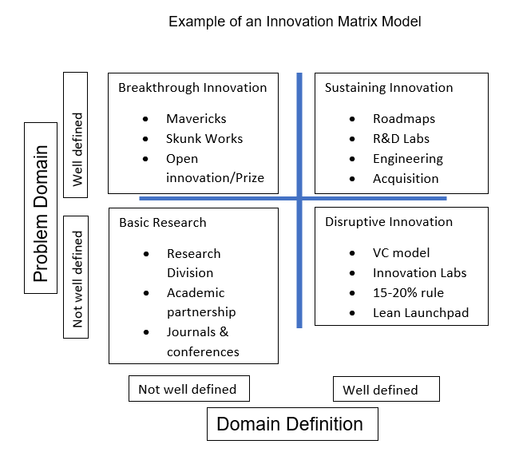
Interpreted from (Gregor & Hevner, 2014)
This concept is a disruptive innovation, it occurs outside of the typical food distribution industry as it is a low profit organisation, prioritising the charitable and sustainability of the company over the profits, profits which are used to pay staff and fuel cost, maintain the website and app and enable the vulnerable to access adequate food. It will change how other apps apply and market themselves, as Shelf-Life Line is cheaper, easier to access and provides a suitable service. It creates a cheaper platform for members and is accessible to a wider range of clients due to the delivery aspect.

Target Customers and USP
Shelf-Life Line has specifications of their customer (members), unlike Olio and Toogoodtogo, it aims to target those most vulnerable, not the generic British public. This way there can be a guarantee that those who are within the food-poverty category and those flagged by local governments and authorities as high risk, receive priority over just the everyday saver. With an average of 22% of the UK population in poverty and 5,100 food parcels being distributed nationwide everyday by just one of the hundreds of charities with foodbanks, (TrusselTrust, 2021), in 2020/2021 a staggering 2.5million people used foodbanks, this number is increasing yearly by an estimated 600,000 more than the previous year 2019/2020 which also rose by 300,000 more than 2018/2019, (Clark, 2021).

Fig.(2)
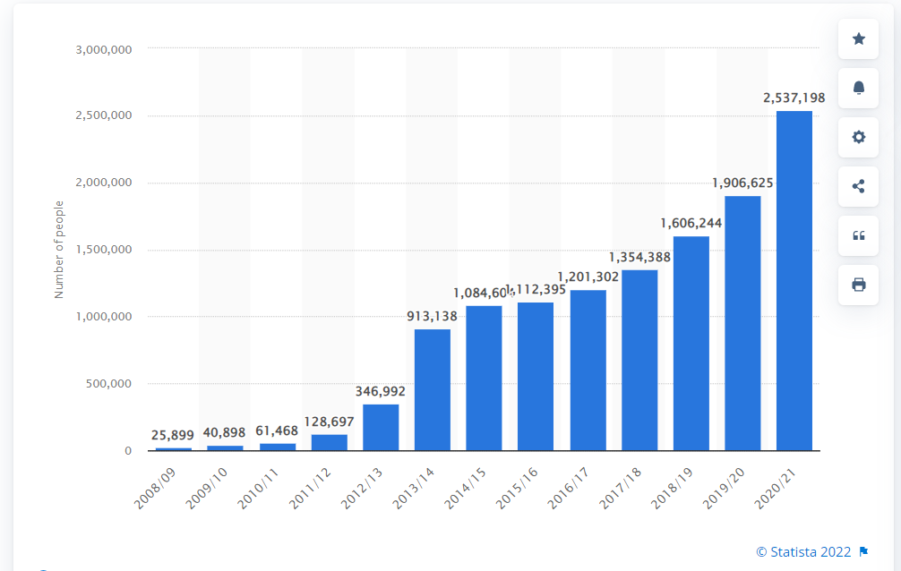
Number of people receiving three days' worth of emergency food by Trussell Trust foodbanks in the United Kingdom from 2008/09 to 2020/21 (Clark, 2021), © Statista 2022.
Based on these statistics (Fig.1), Shelf-Life Line will aim to accumulate a fraction of the 2.5million people in this category as customers.

USP
Shelf-Life Line has more than one USP, these are the defining points between the new innovative idea and the originals.
- The platform will have options to create shopping list and list allergies
This enables the members to specify what it is they require help acquiring, avoiding redistribution of food that could potentially be wasted in the household. Keeps members dietary needs to avoid allergic reactions and health problems. List of produce will be uploaded, and members will be able to add items to a cart.
- Deliveries are available for those with limited mobility or those unable to travel due to personal or childcare circumstances.
Apart from volunteers within certain charities, deliveries are not available for most customers from foodbanks (Scope, 2022),or on the Olio or Toogoodtogo platforms. Shelf-Life Line will be able to provide deliveries for a small fee, this can be taken from certain benefits via the Government, their gateways or paid online prior to deliveries for those whose benefits do not cover it. More than 6% of the population are unable to walk to a shop for groceries within 15 mins, that equates to approximately 3.4million people nationwide, (Lucas, et al., 2019).
- Recurring deliveries and collections
Members can specify the days on which they will need deliveries or to pick up groceries, this helps them to manage the amount of food the have access to and project days on which they will not have sufficient means. Single people can book 2x a week families 4x a week subject to household capacity.
- Applicants apply based on their benefits and household income.
By specifically targeting those who are registered to certain benefits, some qualifying categories are as followed; JSA, Universal Credit, PiP/DSA/DSS, Child tax Credits, Houses who qualify for FMS (Free School Meals), Civil servants withing rank wage catchments and pensioners, Shelf-Life Line is ensuring the most vulnerable have priority access.
Shelf-Life Line is an incremental innovation, classed as open-innovation, an imitation of an existing concept with its own unique delivery (Busarovs, N.D). The current poverty crisis in the UK, which is predicted to continue without government intervention, ensures there will always be a market for this idea. People will always need access to food and there will always be poverty in every community and district, the customer’s needs, and demands are sustainable, however, the aim of Shelf-Life Line is to reduce the wastage of food within the UK and help improve the standards of living for those in food-poverty, advise and teach their customers the difference between use-by and sell by-date and a provide them with food tips and meal prep ideas.

SWOT
The following graph is a SWOT analysis on Shel-Life Line (Fig.(2)), it shows room for expansion and can also act as a way of creating a competitive advantage in the market, by examining the points working on the threats and weaknesses and getting in front of any potential competition.
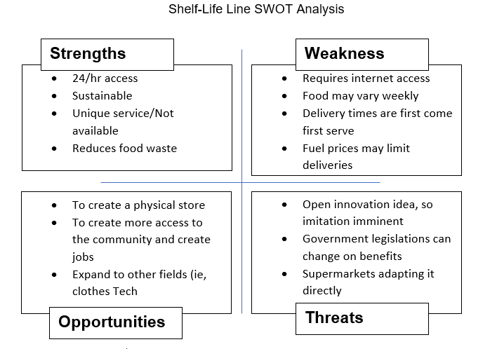

Accessibility
In order to be come a member of Shelf-Life Line, as well as meeting the government and social needs criteria, members must have access to the internet, due to it being SaaS, it will run on a website which will allow the members to set up profiles and register their households, once they have been verified, (Doctors, Social workers and HMRC proof submitted and checked), they will be able to create virtual list and arrange pick up, payment and delivery. This requirement is easily obtainable due to smartphones, laptops, computers, and public online services readily available. By not having a brick-and-mortar business, members will access customer services online or via phone SMS. This will eradicate the need for a call centre as messages can be sent via the online platforms.

E-commerce
It will cost £8,000 to set up the website and £45/per month to maintain the domain, the cost includes PCI-DSS certification, to protect card data and transactions, the app will cost approximately £40,000 as it will be a two way platform, allowing access to the members HMRC verification and the profile for Shelf-Life Line, these estimates are inclined to change, market dependant (Dogtiev, 2022).
Staffing will be sourced within the local communities as church halls, government accessible buildings and free use spacing will be used as collection points, opening job opportunities and helping to combat poverty from the community out. Shelf-Line Line will directly source the produce from a variety of companies, ranging from farms, supermarkets, restaurants, SME withing the food and food distribution industry, creating relationships with businesses and gain contractual rights to access anything deemed as food-wastage and/or surplus food and recover it if food standards are met.

Marketing
In order to correctly market Shelf-Life Line, there must first be and know the market you are getting into, then the customers, without this information, we take the risk of attracting the wrong consumer, who will not be retainable. It is disadvantageous to a company that does not understand the relationship between the two. By dividing the market up into sections and focusing on a specific target, you can find you niche market, eliminating unnecessary variables, (Park, 2020).
This concept will be marketed to the 22% of the British population who have been recognised by their local government, to be in food-deprivation or food-poverty.

Advertising and screening
Advertising will be mainly done through doctor surgeries, referrals and promotion, HMRC websites, schools (onsite promotional posters and newsletter mentions) and charities such as Citizens advise and The Trussel Trust. By choosing to promote it on these platforms, the need to monitor social media and pay for promotions are eradicated. Doctors, government departments and schools will be able to directly verify the required criteria and opt to make direct referrals to the Shelf-Life Line team. It allows the service to remain discreet if the customer wish to do so.
Prior to the website being launched, a sampling of 10,000 people nation wide will be used as a test-run and data collection process, this is expected to take place 3 calendar month prior to the launch, this will provide insight into any faults that may be on the website and app, it also allows enough time to correct and defaults and re-run a trial multiple times, if required.

Summary
To conclude, the current food-industry are in need of ways to redistribute surplus-food to the nation, this will help reduce the overall level of food-deprivation and wastage per year, there is room on the market for this concept to flourish, develop and evolve with the ever-changing world. As an online platform, cost of maintenance are low and staff levels reduced. The concept is familiar with the public due to the rival apps and their success, this will allow customers to switch with ease, not having to learn new ways of access, instead have a replicated format they are familiar with. Once launched Shelf-Lie Line will improve the lives of every customer, help build communities and create jobs.

References
Busarovs, A., N.D. Open Innovation: Current Trends and Future Perspectives Humanitues_Social-sciences-2013_2.pdf. [Online]
Available at: http://dspace.lu.lv/dspace/bitstream/handle/7/2839/Humanitues_Social-sciences-2013_2.pdf?sequence=1&isAllowed=y#page=103
[Accessed 28th March 2022].
Butler, P., 2022. The Gaurdian. [Online]
Available at: https://www.theguardian.com/society/2022/feb/07/1m-uk-adults-go-entire-day-without-food-in-cost-of-living-crisis
[Accessed 14th March 2022].
Clark, D., 2021. Number of people receiving three days' worth of emergency food by Trussell Trust foodbanks in the United Kingdom from 2008/09 to 2020/2. [Online]
Available at: https://www.statista.com/statistics/382695/uk-foodbank-users/
[Accessed 21st March 2022].
Dogtiev, A., 2022. Business of Apps. [Online]
Available at: https://www.businessofapps.com/app-developers/uk/#:~:text=The%20UK%20has%20some%20of,app%20can%20reach%20%C2%A342%2C000.
[Accessed 29th March 2022].
FareShare, 2022. Food waste and hunger in the UK. [Online]
Available at: https://fareshare.org.uk/what-we-do/hunger-food-waste/
[Accessed 14th March 2022].
Foundation, J. R., 2022. Overall UK Poverty rates. [Online]
Available at: https://www.jrf.org.uk/data/overall-uk-poverty-rates
[Accessed 27 March 2022].
Francis-Devine, B., 2021. Poverty in the UK: Statistics. [Online]
Available at: https://researchbriefings.files.parliament.uk/documents/SN07096/SN07096.pdf
[Accessed 27th March 2022].
Francis-Devine, B., Tyler, G. & Danechi, S., 2021. Food poverty: Households, food banks and free school meals. [Online]
Available at: https://commonslibrary.parliament.uk/research-briefings/cbp-9209/
[Accessed 14th March 2022].
Goodwin, H., 2022. The London Economic. [Online]
Available at: https://www.thelondoneconomic.com/politics/watch-martin-lewis-is-out-of-tools-to-help-brits-in-cost-of-living-crisis-316900/
[Accessed 29th March 2022].
Gregor, S. & Hevner, A. R., 2014. The Knowledge Innovation Matrix (KIM):. Informing Science: the International Journal of an Emerging Transdiscipline, Volume 17, pp. 217-239.
Lucas, K., Stokes, G., Bastiaanssen, J. & Burkinshaw, J., 2019. Inequalities in Mobility and Access. [Online]
Available at: https://assets.publishing.service.gov.uk/government/uploads/system/uploads/attachment_data/file/784685/future_of_mobility_access.pdf
[Accessed 20th March 2022].
Olio, 2022. Olio. [Online]
Available at: https://olioex.com/businesses/
[Accessed 12th March 2022].
Park, S., 2020. Marketing Management. In: Marketing Management. s.l.:Seohee Academy, pp. 1-21.
Scope, 2022. Getting food and essentials. [Online]
Available at: https://www.scope.org.uk/advice-and-support/food-and-essentials-during-coronavirus/
[Accessed 22nd March 2022].
Sustain, 2022. What is food poverty?, London: Sustainweb.
TooGoodToGo, 2022. Toogoodtoogo. [Online]
Available at: https://toogoodtogo.co.uk/en-gb/
[Accessed 12th March 2022].
TrusselTrust, 2021. Trussel Trust. [Online]
Available at: https://www.trusselltrust.org/2021/11/24/more-than-5100-food-parcels-given-to-people-facing-crisis-across-the-uk-every-day-in-past-six-months-says-the-trussell-trust/
[Accessed 21st March 2022].
Tyler, G., 2021. Food Banks in the UK. [Online]
Available at: https://commonslibrary.parliament.uk/research-briefings/cbp-8585/
[Accessed 20th March 2022].

