ACCA7028: Data Security, Governance and Compliance
MSc Data and Artificial Intelligence

Student Number: 2212275
Student Name: Jure Jurcevic
Lecturer: Dr Vijeyananthan Thayananthan
Date: 31/03/2026

Contents
Introduction 3
Research into Security Frameworks and Models 4
ISO/IEC 27001:2022 - Information Security Management System (ISMS) 4
NIST Cybersecurity Framework (CSF) 2.0 5
ITIL 4 – Information Security Management Practice 6
Proposed Security Framework for FinSure Bank 8
Assumptions 8
Integrated Security Governance Architecture 8
Pillar 1: Governance and Strategic Planning 9
Pillar 2: Compliance and Legal Alignment 10
Pillar 3: Risk Management 10
Pillar 4: Security Operations and Protection Mechanisms 11
Pillar 5: Contingency Planning and Business Continuity 12
Service Level Agreements 12
Critical Analysis: The Imperative for Evolving Regulations and Standards 13
The Dynamic Threat Landscape 13
Regulatory Response to Technological Advancement 13
Compliance as a Driver of Organisational Maturity 13
Harmonisation and Cross-Border Challenges 14
The Role of Security Management Models and Practices 14
Conclusion 15
References 16

Introduction
As global reliance on digital infrastructure increases, the financial services sector finds itself at the epicentre of an escalating cybersecurity crisis. The explosion of Internet based banking, cloud computing, and mobile financial applications has expanded the threat surface exponentially, exposing organisations to sophisticated cyberattacks from individual hackers, organised criminal networks, and state sponsored adversaries [1]. FinSure Bank (FSB), a rapidly growing digital first financial services provider, symbolises the modern challenges facing such institutions. Operating predominantly through cloud-based platforms with over 90% of its infrastructure externally hosted, FSB faces compounding security risks arising from its Bring Your Own Device (BYOD) policy, multinational operations, and the absence of comprehensive security governance frameworks [1].
This report conducts a systematic examination of established IT security frameworks and models, including the Information Technology Infrastructure Library (ITIL), the International Organization for Standardization’s ISO/IEC 27001, and the National Institute of Standards and Technology (NIST) Cybersecurity Framework. Drawing upon the knowledge gained from this research, the report proposes a personalised security framework tailored to FSB’s operational context, encompassing governance structures, compliance mechanisms, risk management strategies, and contingency planning. Also, it provides a critical analysis of why continuous regulatory updates and evolving standards constitute essential good practice in the information security landscape.

Research into Security Frameworks and Models

ISO/IEC 27001:2022 - Information Security Management System (ISMS)
ISO/IEC 27001 is the internationally recognised standard for information security management systems (ISMS). First published jointly by the International Organization for Standardization (ISO) and the International Electrotechnical Commission (IEC) in 2005, it has undergone subsequent revisions in 2013 and most recently in 2022 [2]. The standard establishes a systematic, risk-based framework that any organisation can adopt to establish, implement, maintain, and continually improve its approach to securing corporate information [3]. With over 70,000 certificates issued across 150 countries, ISO 27001 represents the de facto global benchmark for information security governance [2].
The 2022 revision introduced significant updates reflecting contemporary business practices and emerging cyber threats. The updated Annex A now contains 93 controls organised into four domains: organisational controls, people control, physical controls, and technological controls [4]. Eleven new controls were added, addressing critical areas such as threat intelligence (A.5.7), cloud services security (A.5.23), data leakage prevention (A.8.12), and web filtering (A.8.23) [4]. These additions are particularly relevant to FSB, given its heavy reliance on cloud infrastructure and digital service delivery.
The core structure of ISO 27001:2022 comprises ten clauses, of which Clauses 4 through 10 contain the mandatory requirements for ISMS certification [5]. These clauses cover organisational context analysis, leadership commitment, planning for risk treatment, resource allocation and support, operational implementation, performance evaluation, and continual improvement. The standard follows the Plan-Do-Check-Act (PDCA) cycle, ensuring that security management remains a dynamic and iterative process rather than a static, one-time implementation [2].
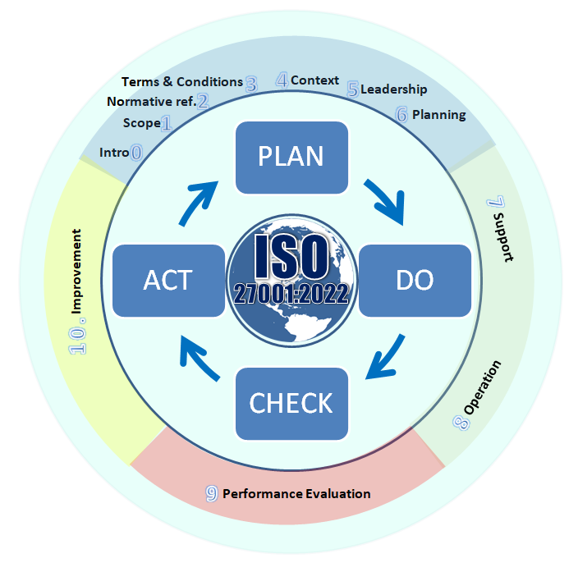
Figure 1 ISO 27001:2022 PDCA Cycle and ISMS Structure [20]

NIST Cybersecurity Framework (CSF) 2.0
The NIST Cybersecurity Framework, originally published in 2014 following a presidential executive order to secure critical infrastructure, underwent its most significant revision with the release of version 2.0 in February 2024 [6]. Unlike ISO 27001, the NIST CSF is a voluntary guidance framework rather than a certifiable standard; however, its adoption has become widespread across industries globally, and its principles are increasingly referenced in regulatory enforcement actions [7].
The most notable enhancement in CSF 2.0 is the introduction of a sixth core function, Govern, joining the existing five functions of Identify, Protect, Detect, Respond, and Recover [6]. The Govern function elevates cybersecurity governance to the strategic level, emphasising the need for executive leadership oversight, risk management integration with enterprise strategy, and accountability structures [8]. This addition recognises that effective cybersecurity cannot exist in isolation from broader organisational governance and risk management practices.
CSF 2.0 also broadens its scope significantly, extending applicability from critical infrastructure entities to organisations of all sizes and sectors [9]. The framework provides organisational profiles that enable institutions to prioritise cybersecurity actions aligned with their specific risk environment and business objectives. Also, enhanced guidance on supply chain risk management addresses the growing threats posed by third party dependencies, a concern directly relevant to FSB’s reliance on external cloud service providers [6].
Table 1 NIST CSF 2.0 Core Functions
Function | Description | Relevance to FSB
Govern (GV) | Establish and monitor cybersecurity risk management strategy, expectations, and policies at the organisational level | Addresses FSB’s lack of unified governance model
Identify (ID) | Understand and manage cybersecurity risk to systems, people, assets, data, and capabilities | Asset inventory across cloud platforms and BYOD
Protect (PR) | Implement safeguards to ensure delivery of critical services | Encryption, access controls for mobile banking
Detect (DE) | Develop activities to identify cybersecurity events in a timely manner | Intrusion detection for cloud infrastructure
Respond (RS) | Act regarding a detected cybersecurity incident | Incident response for data breaches and fraud
Recover (RC) | Maintain plans for resilience and restore capabilities impaired during an incident | Business continuity for digital banking services

ITIL 4 – Information Security Management Practice
The Information Technology Infrastructure Library (ITIL) is a comprehensive set of best practices for IT service management (ITSM) that has been widely adopted across industries since its inception [10]. ITIL 4, the most recent iteration, treats Information Security Management as a general management practice that is continuous and extensive, rather than an ad hoc or project-based activity [11]. The ITIL 4 information security management practice is grounded in the RESILIA framework, which focuses on building cyber resilience skills and integrating security into the fabric of IT service delivery and support [12].
ITIL 4’s approach to information security centres on three core activities: prevention, detection, and correction [12]. Prevention contains measures such as securing network devices, centralising firewalls, and training end users to recognise external threats. Detection involves deploying monitoring tools including antivirus software, intrusion detection systems, and defined incident response capabilities. Correction addresses the recovery process, including incident review meetings, lessons learned documentation, and network auditing to prevent recurrence. This triple approach aligns with the broader ITIL service value system, ensuring that security considerations are embedded throughout service design, transition, and operations [11].
A distinguishing feature of ITIL’s approach is its integration of security management with service level management through Service Level Agreements (SLAs). Security requirements are explicitly defined within SLAs, establishing measurable key performance indicators (KPIs) for security performance [13]. This contractual approach to security management is particularly valuable for FSB, where third party cloud providers and contractors require clearly defined security obligations and accountabilities.
Table 2 Comparative Analysis of Security Frameworks
Criterion | ISO 27001:2022 | NIST CSF 2.0 | ITIL 4
Type | Certifiable Standard | Voluntary Framework | Best Practice Framework
Scope | ISMS establishment and certification | Cybersecurity risk management | IT service management including security
Structure | 10 Clauses + 93 Annex A Controls | 6 Functions, 22 Categories | 34 Management Practices
Risk Approach | Risk assessment and treatment plan | Risk based organisational profiles | Risk integrated into service lifecycle
Governance | Leadership commitment (Clause 5) | Govern function (new in 2.0) | Service governance and continual improvement
Certification | Third party accredited certification | No formal certification | Foundation to Master level certifications
Best For | Formal compliance and certification | Flexible risk management | Service oriented security management

Proposed Security Framework for FinSure Bank

Assumptions
Before presenting the proposed framework, the following assumptions are stated to contextualise the recommendations. It is assumed that FSB employs between 500 and 2,000 staff across multiple countries, with a moderate annual IT security budget that can be incrementally increased. The organisation is assumed to have a basic existing IT infrastructure including firewalls, antivirus software, and email filtering, but lacks formalised security policies, governance structures, and compliance monitoring processes. FSB is assumed to be subject to GDPR as its primary data protection regulation due to operations involving EU residents, alongside financial services regulations such as PCI DSS for payment card processing and AML/KYC requirements [14]. The cloud service providers are assumed to offer industry standard security features including encryption-at-rest and role-based access control, but shared responsibility models require FSB to configure and manage many security aspects independently. Finally, FSB’s security maturity is assumed to be at Level 1 (Initial/Ad Hoc) on the Capability Maturity Model, with aspirations to reach Level 3 (Defined) within 24 months.

Integrated Security Governance Architecture
The proposed framework adopts a layered governance architecture that synthesises elements from ISO 27001, NIST CSF 2.0, and ITIL 4 into a unified model tailored to FSB’s digital first operating environment. The framework is designated the FinSure Integrated Security Governance (FISG) Framework and is structured around five interdependent pillars: Governance and Strategic Planning, Compliance and Legal Alignment, Risk Management, Security Operations, and Continuity and Resilience.
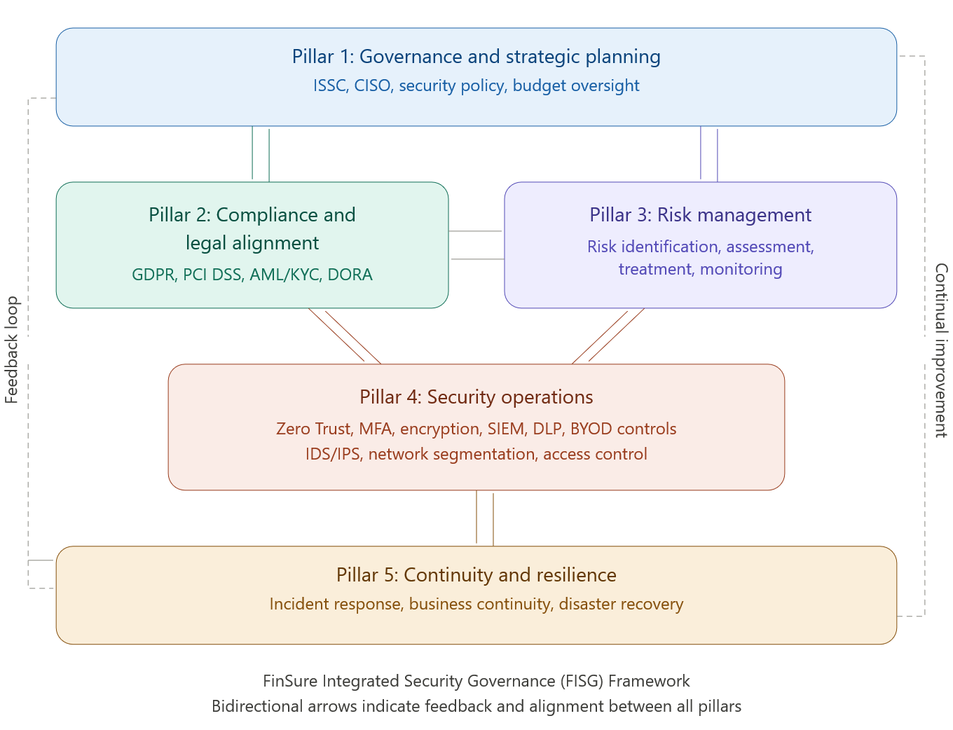
Figure 2 FISG Framework Architecture

Pillar 1: Governance and Strategic Planning
Effective security governance requires executive level accountability and strategic integration of cybersecurity into the organisation’s business objectives [8]. The FISG Framework proposes the establishment of an Information Security Steering Committee (ISSC), chaired by the Chief Information Security Officer (CISO) and comprising representatives from executive management, IT operations, legal and compliance, human resources, and business unit leaders. The ISSC will set up quarterly to review security posture, approve policy changes, allocate budget resources, and oversee the implementation of the security programme.
A comprehensive Information Security Policy (ISP) will be developed as the foundational governance document, articulating the organisation’s commitment to information security, defining roles and responsibilities, and establishing the scope of the ISMS. Supporting policies will address specific domains including acceptable use, BYOD security, data classification, incident response, remote working, third party access management, and cryptographic controls [15]. All policies will undergo annual review and be disseminated to all personnel through mandatory security awareness training programmes.
Table 3 Proposed Governance Structure for FSB
Role / Body | Composition | Responsibilities | Frequency
ISSC | CISO, CTO, CFO, Legal, HR, Business Unit Heads | Strategic oversight, budget approval, policy ratification | Quarterly
CISO | Senior executive reporting to CEO/Board | Day-to-day security leadership, risk reporting, incident escalation | Continuous
Security Operations Team | Security analysts, engineers, incident responders | Monitoring, threat detection, vulnerability management | 24/7
Data Protection Officer | Qualified GDPR practitioner | GDPR compliance, DPIA oversight, regulator liaison | Continuous
Security Champions | Nominated staff from each department | Departmental security awareness, policy compliance support | Monthly meetings

Pillar 2: Compliance and Legal Alignment
FSB operates across multiple jurisdictions, imposing a compliance framework that matches diverse regulatory requirements. The GDPR constitutes the primary data protection obligation, requiring FSB to implement appropriate technical and organisational measures to protect personal data, maintain records of processing activities, conduct Data Protection Impact Assessments (DPIAs) for high-risk processing, and appoint a Data Protection Officer (DPO) [16]. Given that FSB processes financial data including account credentials, transaction histories, and identification documents for KYC purposes, the organisation must ensure that processing activities have documented lawful bases, typically contract performance, legal obligation, or legitimate interests [14].
Beyond GDPR, FSB must comply with the Payment Card Industry Data Security Standard (PCI DSS) for cardholder data protection, Anti Money Laundering (AML) regulations requiring transaction monitoring and suspicious activity reporting and potentially sector specific requirements such as the Digital Operational Resilience Act (DORA) for EU financial entities [17]. The compliance function will maintain a regulatory obligations register, mapping each requirement to specific controls within the FISG Framework, and conduct bi-annual compliance audits to identify and remediate gaps.
Ethical considerations extend beyond mere legal compliance. FSB intend to adopt a privacy-by-design and security-by-design philosophy, embedding data protection and security considerations into the development lifecycle of all products and services. This approach ensures that customer privacy and data security are treated as fundamental design requirements rather than retrospective add-ons [16].

Pillar 3: Risk Management
Risk management forms the analytical backbone of the FISG Framework, following the risk assessment and treatment methodology prescribed by ISO 27001:2022 (Clause 6.1.2) and supplemented by the NIST Risk Management Framework [2][6]. The proposed risk management process comprises four iterative phases: risk identification, risk assessment, risk treatment, and risk monitoring.
Risk identification will employ a combination of asset based and threat-based approaches. All information assets will be catalogued in an asset register, classified according to a four-tier data classification scheme (Public, Internal, Confidential, and Restricted), and assigned ownership to designated information asset owners. Threat modelling exercises shall identify potential threat actors (external hackers, insider threats, nation state actors, and automated malware), threat vectors (phishing, credential compromise, supply chain attacks, and physical intrusion), and vulnerabilities specific to FSB’s cloud centric and BYOD enabled environment [1].
Risk assessment will utilise a quantitative-qualitative hybrid methodology, combining likelihood and impact scores on a 5x5 risk matrix to produce risk ratings that inform treatment priorities. Risk treatment options follow the standard taxonomy of avoidance, mitigation, transfer (such as cyber insurance), and acceptance, with residual risks formally documented and accepted by the ISSC. Continuous risk monitoring mean to be achieved through automated vulnerability scanning, penetration testing conducted at least bi-annually, and real-time security information and event management (SIEM) analytics [18].
Table 4 Risk Matrix for FSB
Likelihood / Impact | Negligible (1) | Minor (2) | Moderate (3) | Major (4) | Critical (5)
Almost Certain (5) | 5 Medium | 10 High | 15 Very High | 20 Critical | 25 Critical
Likely (4) | 4 Low | 8 High | 12 High | 16 Very High | 20 Critical
Possible (3) | 3 Low | 6 Medium | 9 High | 12 High | 15 Very High
Unlikely (2) | 2 Low | 4 Low | 6 Medium | 8 High | 10 High
Rare (1) | 1 Low | 2 Low | 3 Low | 4 Low | 5 Medium

Pillar 4: Security Operations and Protection Mechanisms
The operational pillar implements the technical and procedural controls necessary to protect FSB’s information assets. Drawing upon ISO 27001 Annex A controls and NIST CSF’s Protect and Detect functions, the FISG Framework prescribes a defence-in-depth strategy with controls implemented across multiple layers [4][6].
Access control constitutes the first line of defence. FSB shall implement a Zero Trust architecture predicated on the principle of never trust, always verify. All access requests, whether originating from corporate networks, BYOD devices, or third-party connections, will be authenticated through multi factor authentication (MFA) and authorised based on role-based access control (RBAC) policies [19]. Privileged access management (PAM) will enforce just-in-time provisioning for administrative accounts, with all privileged sessions recorded and audited.
Data protection mechanisms will include encryption of data at rest (AES-256) and in transit (TLS 1.3), data loss prevention (DLP) tools monitoring for unauthorised exfiltration of sensitive data, and pseudonymisation techniques applied to personal data in development and testing environments. BYOD devices accessing corporate systems will be enrolled in a Mobile Device Management (MDM) solution enforcing minimum security baselines including device encryption, screen lock policies, remote wipe capabilities, and containerisation of corporate data [1].
Network security will be enforced through next-generation firewalls, network segmentation isolating production, development, and management environments, and a cloud access security broker (CASB) providing visibility and control over cloud service usage. Intrusion detection and prevention systems (IDS/IPS) shall monitor network traffic for anomalous patterns, feeding alerts into the centralised SIEM platform for correlation, analysis, and automated incident response workflows [18].

Pillar 5: Contingency Planning and Business Continuity
Contingency planning ensures FSB’s operational resilience in the face of security incidents, system failures, and natural disasters. The FISG Framework mandates the development and maintenance of three interconnected plans: an Incident Response Plan (IRP), a Business Continuity Plan (BCP), and a Disaster Recovery Plan (DRP) [15].
The Incident Response Plan will follow a six-phase lifecycle: preparation, identification, containment, eradication, recovery, and lessons learned. A dedicated Computer Security Incident Response Team (CSIRT) will be established with clearly defined roles, escalation procedures, and communication protocols. GDPR’s requirement for breach notification to supervisory authorities within 72 hours will be embedded into the incident response workflow, with pre drafted notification templates and a designated point of contact for regulatory communications [16].
The Business Continuity Plan will identify critical business functions, define recovery time objectives (RTOs) and recovery point objectives (RPOs) for each function, and specify alternative operating procedures during disruption. Given FSB’s cloud centric infrastructure, the BCP will include provisions for cloud provider failover, geographic redundancy across multiple availability zones, and offline capabilities for essential banking operations. The DRP will detail technical recovery procedures including backup restoration, system re-imaging, and network reconfiguration, with full disaster recovery exercises conducted annually.

Service Level Agreements
Aligned with ITIL 4’s service management approach, all third-party relationships will be governed by Service Level Agreements (SLAs) incorporating explicit security requirements [13]. SLAs with cloud service providers will specify minimum encryption standards, data residency requirements, incident notification timeframes, audit rights, and data portability provisions. Security specific KPIs will include system uptime guarantees (minimum 99.9%), mean time to detect (MTTD) and mean time to respond (MTTR) thresholds for security incidents, and vulnerability remediation timelines. SLA compliance will be monitored continuously through automated dashboards, with formal reviews conducted quarterly and noncompliance triggering escalation procedures defined in the underlying contracts.

Critical Analysis: The Imperative for Evolving Regulations and Standards

The Dynamic Threat Landscape
The cybersecurity threat landscape is characterised by relentless evolution, with threat actors continuously developing new attack methodologies, exploiting emerging technologies, and targeting previously unforeseen vulnerabilities. The proliferation of ransomware-as-a-service, supply chain attacks such as the SolarWinds incident, and the weaponisation of artificial intelligence for social engineering and automated exploitation demonstrate that static security frameworks rapidly become outdated [7]. So, regulatory bodies and standards organisations must continuously update their guidance to address emerging threats and incorporate lessons learned from real world incidents.
The transition from NIST CSF 1.1 to CSF 2.0 exemplifies this evolutionary imperative. The addition of the Govern function in CSF 2.0 directly responded to the recognition that cybersecurity failures frequently stem from governance deficiencies rather than purely technical shortcomings [6]. Similarly, ISO 27001’s 2022 revision introduced controls for cloud security, threat intelligence, and data leakage prevention that were absent from the 2013 version, reflecting the dramatic shifts in enterprise IT architecture over the intervening decade [4].

Regulatory Response to Technological Advancement
Technological advancement creates new categories of risk that existing regulations may not adequately address. The emergence of cloud computing, Internet of Things (IoT) devices, artificial intelligence, and blockchain technologies has fundamentally transformed the attack surface available to threat actors. Regulations must evolve to provide guidance on securing these technologies and managing their associated risks [8]. For instance, the European Union’s Digital Operational Resilience Act (DORA) was specifically developed to address the unique cyber risks facing the financial services sector in an era of increasing digital dependency, requiring financial entities to implement comprehensive ICT risk management frameworks, conduct regular resilience testing, and manage third party ICT service provider risks [17].
The rapid adoption of BYOD policies, as exemplified by FSB, introduces security challenges that traditional perimeter-based security models were not designed to address. Updated standards that incorporate Zero Trust architecture principles, mobile device management requirements, and identity centric security models provide organisations with the guidance necessary to secure increasingly distributed and heterogeneous computing environments [19].

Compliance as a Driver of Organisational Maturity
Beyond their protective function, evolving regulations serve as catalysts for organisational security maturity. Compliance obligations require organisations to formalise their security practices, allocate dedicated resources, and submit to external scrutiny through audits and assessments [3]. For an organisation like FSB with a fragmented security posture, the structured requirements of ISO 27001 certification or GDPR compliance provide a roadmap for systematic improvement, transforming ad hoc security measures into a coherent, documented, and measurable security programme.
Also, updated regulations increasingly emphasise accountability and transparency. GDPR’s accountability principle requires organisations not merely to comply but to demonstrate compliance through documented evidence of their data protection measures, impact assessments, and processing records [16]. This shift from prescriptive compliance to demonstrable accountability encourages organisations to embed security and privacy into their operational culture rather than treating compliance as a tick box exercise.

Harmonisation and Cross-Border Challenges
For multinational organisations like FSB, the multiplicity of regulatory requirements across jurisdictions presents significant compliance challenges. Evolving international standards play a crucial role in matching these requirements, providing a common framework that can satisfy multiple regulatory obligations simultaneously. ISO 27001’s global recognition enables organisations to demonstrate baseline security compliance across jurisdictions, while framework mappings between ISO 27001, NIST CSF, and regional regulations such as GDPR facilitate integrated compliance approaches that reduce duplication of effort and inconsistency of controls [2][6].
Still, regulatory evolution also carries risks. Rapid or frequent changes can impose significant compliance burdens on organisations, particularly smaller institutions with limited resources. The transition period between ISO 27001:2013 and ISO 27001:2022, with certified organisations required to complete their transition by October 2025, illustrates the operational impact of standard revisions [3]. Effective standards development therefore requires careful balancing of the need for currency against the practical implementation capacity of adopting organisations.

The Role of Security Management Models and Practices
Security management models such as those provided by ITIL 4 and COBIT contribute to the practical operationalisation of regulatory requirements. ITIL 4’s emphasis on embedding security as a continuous practice within the service value system, rather than a standalone process, reflects the modern understanding that security is not a destination but an ongoing journey [10][11]. The integration of security management with service level management ensures that security obligations are contractually enforceable and measurable, providing accountability mechanisms that pure regulatory compliance may lack.
The continuous improvement philosophy embedded in all three frameworks examined in this report (ISO 27001’s PDCA cycle, NIST CSF’s organisational profiles, and ITIL 4’s continual improvement practice) underscores that effective security management requires perpetual vigilance and adaptation [2][6][11]. Organisations that view compliance as a point-in-time achievement rather than an ongoing commitment inevitably fall behind the evolving threat landscape and expose themselves to increasing risk.

Conclusion
This report has examined three leading security frameworks and models, namely ISO/IEC 27001:2022, the NIST Cybersecurity Framework 2.0, and ITIL 4, evaluating their structures, strengths, and applicability to the operational context of FinSure Bank. The research demonstrates that no single framework provides a comprehensive solution; rather, the most effective approach integrates complementary elements from multiple frameworks to address the full spectrum of governance, compliance, risk management, and operational security requirements.
The proposed FinSure Integrated Security Governance (FISG) Framework synthesises the certifiable rigour of ISO 27001, the strategic governance emphasis of NIST CSF 2.0, and the service management integration of ITIL 4 into a five-pillar architecture tailored to FSB’s digital-first, cloud centric, and multinational operating environment. The framework addresses FSB’s identified deficiencies including the absence of unified governance, fragmented security policies, lack of formal risk management, and insufficient compliance controls, providing a structured pathway from its current ad hoc security posture to a defined and measurable security programme.
The critical analysis confirms that the continuous evolution of security regulations and standards is not merely beneficial but essential for maintaining effective protection against an ever-changing threat landscape. However, this evolution must be balanced against the implementation capacity of adopting organisations, with standards bodies providing adequate transition periods and practical implementation guidance. For FSB, the immediate priority should be establishing the governance structures and baseline controls prescribed by the FISG Framework, progressing towards ISO 27001 certification as a medium-term objective that will provide both operational security improvement and demonstrable compliance assurance to regulators, customers, and stakeholders.

References
[1] M. E. Whitman and H. J. Mattford, Management of information security, 6th ed. Boston, Ma: Cengage Learning, 2019.
[2] International Organization for Standardization, "ISO/IEC 27001:2022 – Information security, cybersecurity and privacy protection – Information security management systems – Requirements," ISO, Geneva, Switzerland, 2022.
[3] GRC Solutions, "ISO/IEC 27001:2022 – The Information Security Management Standard," 2025. [Online]. Available: https://grcsolutions.io/iso27001/. [Accessed: Mar. 2026].
[4] DataGuard, "ISO 27001 Controls: Overview of all measures from Annex A," 2025. [Online]. Available: https://www.dataguard.com/iso-27001/annex-a/. [Accessed: Mar. 2026].
[5] J. Tillu, "The Core Structure of ISO 27001:2022 – Everything You Need to Know," Medium, Aug. 2025. [Online]. Available: https://jaytillu.medium.com/the-core-structure-of-iso-27001-2022-everything-you-need-to-know-03330b8ecb93. [Accessed: Mar. 2026].
[6] NIST, “The NIST cybersecurity framework (CSF) 2.0,” The NIST Cybersecurity Framework (CSF) 2.0, vol. 2.0, no. 29, Feb. 2024, doi: https://doi.org/10.6028/nist.cswp.29.
[7] Ropes & Gray LLP, "NIST Publishes Long-Awaited Cybersecurity Framework 2.0," RopesDataPhiles, Mar. 2024. [Online]. Available: https://www.ropesdataphiles.com/2024/03/nist-publishes-long-awaited-cybersecurity-framework-2-0/. [Accessed: Mar. 2026].
[8] NextLabs, "What You Should Know About NIST CSF 2.0: Five Key Takeaways," 2024. [Online]. Availabe: https://www.nextlabs.com/intelligent-enterprise/nist-cybersecurity-framework/nist-csf-2-0-five-key-takeaways/. [Accessed: Mar. 2026].
[9] HIPAA Journal, "NIST Cybersecurity Framework 2.0 Released," Feb. 2024. [Online]. Available: https://www.hipaajournal.com/nist-cybersecurity-framework-2-0/. [Accessed: Mar. 2026].
[10] D. Berger, N. Shashidhar, and C. Varol, “Using ITIL 4 in Security Management,” IEEE Xplore, Jun. 01, 2020. https://ieeexplore.ieee.org/abstract/document/9116257
[11] ISE OBLUE, "ITIL Information Security Management," May 2025. [Online]. Available: https://iseoblue.com/post/itil-information-security-management/. [Accessed: Mar. 2026].
[12] InvGate, "Information Security Management in an ITIL 4 World," May 2021. [Online]. Available: https://blog.invgate.com/information-security-management-in-an-itil-4-world. [Accessed: Mar. 2026].
[13] Wikipedia, "ITIL security management," Sep. 2025. [Online]. Available: https://en.wikipedia.org/wiki/ITIL_security_management. [Accessed: Mar. 2026].
[14] InnReg, "GDPR for Financial Services: Best Practices for Compliance," Oct. 2025. [Online]. Available: https://www.innreg.com/blog/gdpr-for-financial-services. [Accessed: Mar. 2026].
[15] O. R. Arogundade, “Network security concepts, dangers, and defense best practical,” Computer Engineering and Intelligent Systems, vol. 14, no. 2, Mar. 2023, doi: https://doi.org/10.7176/ceis/14-2-03.
[16] GDPR Local, "GDPR for Financial Institutions: Compliance Roadmap," Jul. 2025. [Online]. Available: https://gdprlocal.com/gdpr-for-financial-institutions/. [Accessed: Mar. 2026].
[17] LevelBlue blog, "Navigating the Complex World of Cybersecurity Compliance," May 2023. [Online]. Available: https://www.levelblue.com/blogs/levelblue-blog/navigating-the-complex-world-of-cybersecurity-compliance. [Accessed: Mar. 2026].
[18] M. Sampaio, Cryptography and Network Security. CRC Press, 2022.
[19] S. Lincke, Information Security Planning. Springer Nature, 2024.
[20] Available: https://media.licdn.com/dms/image/v2/D4D12AQHyT33EREckew/article-cover_image-shrink_720_1280/article-cover_image-shrink_720_1280/0/1677434549488?e=1776297600&v=beta&t=hDkv6JuhiDatbQcgrxfdyYJw8fAhZxBcU0aOxGWDO-c

