Sharise Jonathan (2306013)
2306013@student.uwtsd.ac.uk
Abstract
This project describes the development of a networked chat application in C++ using socket programming. The system uses a client-server architecture, where a central server manages communication between multiple clients over TCP to ensure reliable message delivery.
The application supports real-time messaging, multiple users through multithreading, and additional features such as private messaging and user commands. Testing confirmed that the system functions correctly, demonstrating key concepts including socket communication, concurrency, and client-server design.
Socket programming and concurrency implementation
Socket Programming and Concurrency

Contents
Introduction 2
2. Design Overview 2
3. Implementation 2
3.1 Server Setup 2
3.2 Multithreading 3
3.3 Synchronisation 3
3.4 Messaging System 3
3.5 Command Handling 4
3.6 Client Design 4
4. Testing and Results 4
5. Limitations and Future Improvements 5
6. Conclusion 6

Introduction
This project involved the development of a networked chat application using C++ and socket programming. The aim was to design and implement a client-server system that allows multiple users to communicate in real time over a network. The application was developed using the Winsock API on a Windows platform within Visual Studio.

2. Design Overview
The application follows a client-server architecture, where a central server manages communication between all connected clients. This design simplifies the coordination of multiple users and reflects real-world systems. By centralising communication, the server can control how messages are distributed, maintain consistency, and enforce rules such as user identification and command handling.
The system is divided into two separate programs: a server and a client. The server is responsible for accepting connections, managing users, and distributing messages, while the client provides an interface for sending and receiving data. This improves modularity, as each component can be developed and tested independently.
The communication protocol used is TCP rather than UDP. TCP was selected because it guarantees reliable, ordered, and error-checked delivery of data. In a chat application, message accuracy and sequence are important, as lost or disordered messages would negatively impact usability. Although TCP introduces additional overhead compared to UDP, its reliability makes it the more appropriate choice for this type of application.

3. Implementation

3.1 Server Setup
The server begins by initialising the Winsock library using the WSAStartup function. This step is required to prepare the networking environment before any socket operations can be performed. A socket is then created using the socket() function, specifying IPv4 addressing and TCP communication.
The server binds the socket to a specific port using bind(), allowing it to listen for incoming connections on that port. After binding, the listen() function is called to place the socket into a listening state. A continuous loop then calls accept(), which waits for incoming client connections. Each successful connection returns a new socket that is used exclusively for communication with that client. This design allows the server to maintain multiple independent connections simultaneously.

3.2 Multithreading
To support multiple clients at the same time, the server uses a multithreaded architecture. Each time a client connects, a new thread is created using std::thread. This thread is responsible for handling all communication with that specific client, including receiving messages and responding to commands.
This approach is necessary because network operations such as recv() are blocking. Without multithreading, the server would pause execution while waiting for data from one client, preventing it from serving others. By assigning each client to its own thread, the server can handle multiple users concurrently, improving responsiveness and scalability.
Threads are detached using the detach() function, allowing them to run independently. While this simplifies implementation, it means the server does not explicitly manage thread lifetimes. For larger-scale systems, more advanced techniques such as thread pools or asynchronous I/O could be used to improve efficiency and control.

3.3 Synchronisation
Since multiple threads access shared data, synchronisation is essential to maintain system stability. The server stores information about connected clients and their nicknames in a shared data structure. Without proper control, simultaneous access could result in race conditions, where multiple threads attempt to modify the data at the same time.
To prevent this, a std::mutex is used to protect the shared resource. Threads lock the mutex using std::lock_guard before accessing or modifying the data. This ensures that only one thread can interact with the shared structure at a time, maintaining consistency and preventing errors. Without synchronisation, the system could become unstable or produce incorrect results, especially as the number of connected clients increases.

3.4 Messaging System
The messaging system is based on broadcasting messages to all connected clients. When a client sends a message, the server receives it and forwards it to every other connected client. This is implemented using a loop that iterates through all active client sockets and sends the message individually.
Messages are formatted to include the sender’s nickname allowing users to identify who sent each message. In addition, the server generates system notifications when users join or leave the chat. These notifications enhance the user experience by providing context and maintaining awareness of active participants.

3.5 Command Handling
A command system was implemented to extend the functionality of the application. Commands are identified by checking whether user input begins with a forward slash. This allows the application to distinguish between normal messages and special instructions.
The /users command displays a list of currently connected users, allowing clients to see who is online. The /msg command enables private communication by specifying a target nickname and message. The /quit command allows a user to disconnect cleanly from the server.
Command parsing is handled using string manipulation and input streams, which break the input into components. This approach provides flexibility while keeping the implementation relatively simple. Basic error handling ensures that invalid commands or missing arguments are handled appropriately, preventing unexpected behaviour.

3.6 Client Design
The client application connects to the server using its IP address and port number. Once connected, the user is prompted to enter a nickname, which is sent to the server and used to identify them within the system.
To ensure smooth communication, the client uses a multithreaded design. One thread continuously listens for incoming messages from the server, while the main thread handles user input and sends messages. This separation is essential because both sending and receiving operations are blocking. Without it, the client would not be able to receive messages while waiting for user input.
This design ensures that the application remains responsive and provides a real-time communication experience.

4. Testing and Results
The application was tested by running the server alongside multiple client instances. Clients were able to connect successfully, choose unique nicknames, and communicate in real time.
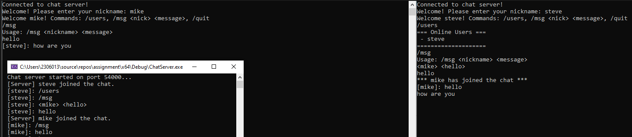Figure 1: Multiple clients connected to the server demonstrating real-time communication and message broadcasting

Broadcast functionality was verified by observing that messages sent from one client appeared on all others. The /users command correctly displayed connected users, and /quit allowed clients to disconnect without affecting others.
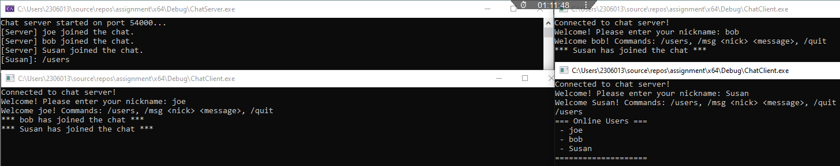
Figure 2: Display of connected users using the /users command, showing successful client tracking on the server

The server console provided logs of all activity, including connections, disconnections, and messages. These logs were useful for debugging and confirmed that the system behaved as expected under normal usage.
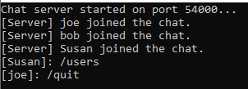
Figure 3: Server console log showing client connections, command usage, and a user disconnecting from the chat

5. Limitations and Future Improvements
Although the application meets its core objectives, there are several limitations. The interface is console-based, which limits usability compared to graphical applications. Communication is not encrypted, meaning the system would not be secure in a real-world environment. Additionally, the application does not store message history, and error handling is relatively basic.
Future improvements could include implementing a graphical user interface to enhance usability and adding encryption to secure communication. Additional features such as file transfer, user authentication, and persistent message storage could further extend the application. Thread management could also be improved by using more advanced techniques such as thread pools or asynchronous programming models.

6. Conclusion
In conclusion, this project successfully demonstrates the development of a networked chat application using C++ and socket programming. The system supports multiple simultaneous users through multithreading and ensures safe access to shared data using mutexes.
The implementation highlights key concepts such as TCP communication, client-server architecture, and concurrent programming.

