Module Name: Problem Solving and Decision Making
BMSW4004

University Name: Wales Trinity Saint David

POOR COMMUNICATION IN THE WORKPLACE
Busaba Thai Restaurant

Lecture Name: Husam Helmi

Student name: Lavio Nobre Espirito Santo
Student ID: 1816717

Date:05/05/2020

TABLE OF CONTENTS

- Introduction ---------------------------------------------------1-2
- Impact of Poor Communication-----------------------------3-4
- Generating Alternative Solution-----------------------------4-5
- Decision Making Techniques--------------------------------6
- Develop a Plan for Implementing the Solution------------7-8-9
- Communicate the Plan to Stakeholders --------------- ----9-10
- Monitoring and Review Techniques ----------------------11-12-13
- Conclusion ----------------------------------------------------14
- Reference ------------------------------------------------------15
- Appendices ---------------------------------------------16-17

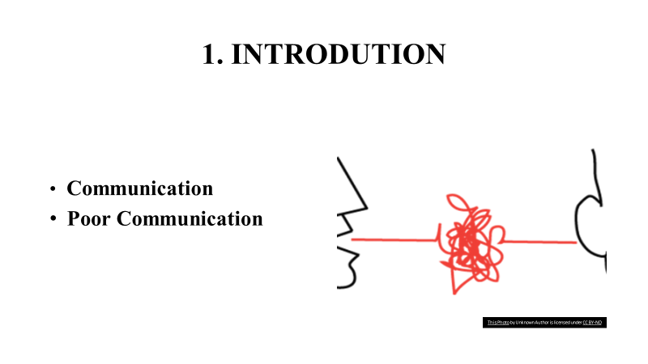

My name is Lavio Nobre Espirito Santo, in this report I will describe about Poor Communication in my workplace Busaba Eathai - Thailand Restaurant in London. I working as a Chef within the Busaba Restaurant I have worked there for nearly one year and I have taken note a continuous issue with communication. I find issues that may have been effortlessly anticipated with legitimate communication. I as of now attempted to conversation with my directors to communicate superior with the whole division, additionally there are poor communication between staff. It also shows up that they are as well active to resolve continuous issues, in any case, frantically got to illuminate this issue (https://www.vitalsmarts.com).

- Communication
Communication is the trade of contemplations, data, or thoughts that comes about in common understanding between two or more individuals. It begins with a thought or concept within the intellect of the sender. He or she encodes the thought into significant images within the frame of words, pictures, or motions. The sender at that point chooses a medium to transmit those images so the collector can access them through one or more faculties. When the recipient gets the message, he or she must translate the images in arrange to decipher the message and get it the aim of the sender, as delineated below (Maund, A. et. al., 2017).
- Poor Communication
Could be a lack of communication, erroneous informing, inadequate bearings, and other issues related to talking, composing, and tuning in. A survey of common examples of destitute working environment communications can assist you take steps to strengthen your capacity to remain on the same page along with your directors, workers and providers to maintain a strategic distance from issues and maximize productivity (https://yourbusiness.azcentral.com).

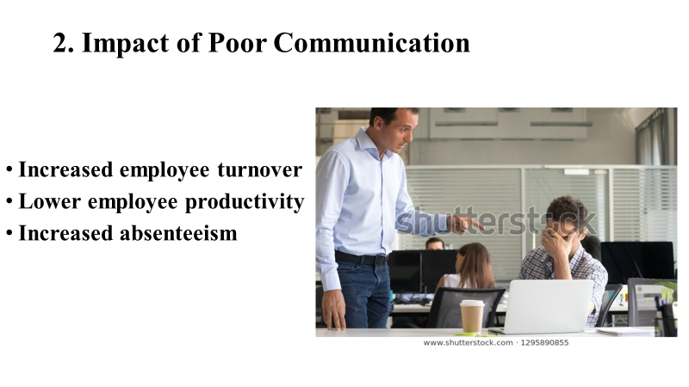
Poor communication has been a major problem in business, in Busaba it has been quite evident the negative impact this has caused, for example: stress, unhappy employees, goals not reached, turnover, low productivity, absenteeism, etc.
- Increased employee turnover
Employee maintenance could be gigantic metric since it is not as it were expensive but too impacts the company is capacity to serve its clients. Inquire about gauges that supplanting a worker can fetched be taken 3 times the person is compensation.
- Lower employee productivity
With poor communication within work environment get less efficiency since representatives do not have get way to the individuals, information, and assets that offer assistance them do their employments and do not have the energy and inspiration to perform well or indeed surpass expectations.
- Increased absenteeism
Effect poor communication within work environment appears essentially worker fulfilment and engagement rates. In case workers are not up and taking off the company, investigate appears that numerous of them will select to basically not appear up for work (https://fsd.servicemax.com).
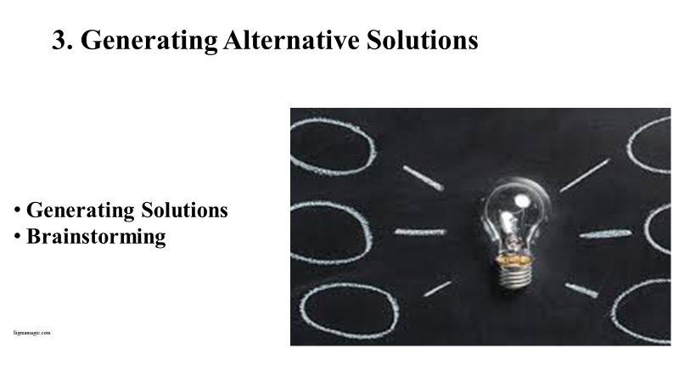
- Generating Solutions
After identifying poor communication and its impact on Busaba, I analysed the possible solutions. When an issue is clearly caught on, managers could start producing conceivable arrangements. Dodge hurling around a couple of ideas; discover the better adequate, and after that go on to the following step. Do not halt with an affirm arrangement. Managers look for inventive arrangements that cover of an issue.
Result of getting thousands of multiple-choice exams in your existence is that you simply have ended up gifted at showcasing the proper reply and after that moving to another address. This ability is valuable when attempting to think fundamentally and create inventive solutions.
Although there are many, like Brainstorming, Role Playing, Synectics, Adopt, Adapt, Improve etc. I will use brainstorming for this situation (Maund, A. et. al., 2017).
- Brainstorming
Combines a loose, casual approach to issue fathoming with sidelong considering. It empowers individuals to come up with contemplations and concepts that can, at to begin with, appear a bit insane. A few of these thoughts can be created into unique, imaginative arrangements to an issue, whereas others can start indeed more ideas. This makes a difference to induce individuals unstuck by "shocking" them out of their typical ways of thinking. Therefore, amid conceptualizing sessions, people ought to maintain a strategic distance from scrutinizing or fulfilling thoughts. You are attempting to open up conceivable outcomes and break down erroneous suspicions around the problem is limits. Judgment and investigation at this organize stunts thought era and restrain creativity. When utilized amid issue fathoming, conceptualizing brings team members diverse experience into play. It increments the abundance of thoughts explored, which suggests merely can regularly discover way better arrangements to the issues that you simply face (https://www.mindtools.com).
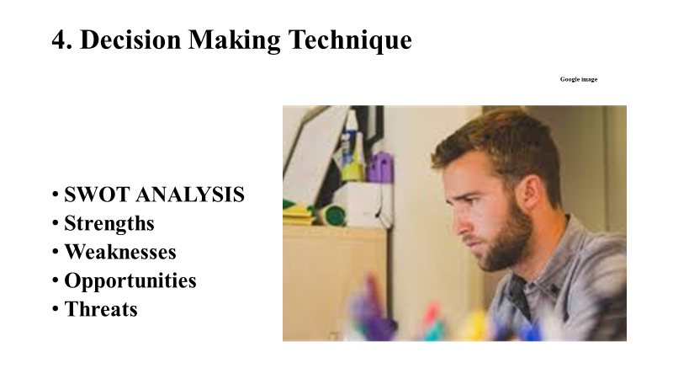
Although there are several techniques that help in decisions, like: Pestle, Swot, Mind Mapping, Fishbone, Ishikawa etc. In this case, as the problem is about Busaba employees, the Swot Analysis would be ideal.
Swot Analysis – this is a technique that help company to understand own situation in the market and make plan. Allow the company to know things we do very well, what need to improve, know all external factors, stay ready. Very important in all business (look appendix 1).
- Strengths – this internal factor, everything the company make very well, help company to achieve the goals, put the company in from of other competitors, can be location, technology, skills.

- Weaknesses – internal factor, things that company do not make well, and need to improve, for example poor communication.

- Opportunities – external factor, situation that company can get to give a competitive advantage for example opening hours.

- Threats – this an external factor, things that affect the smooth running of the company, for example competitors. (https://www.investopedia.com).
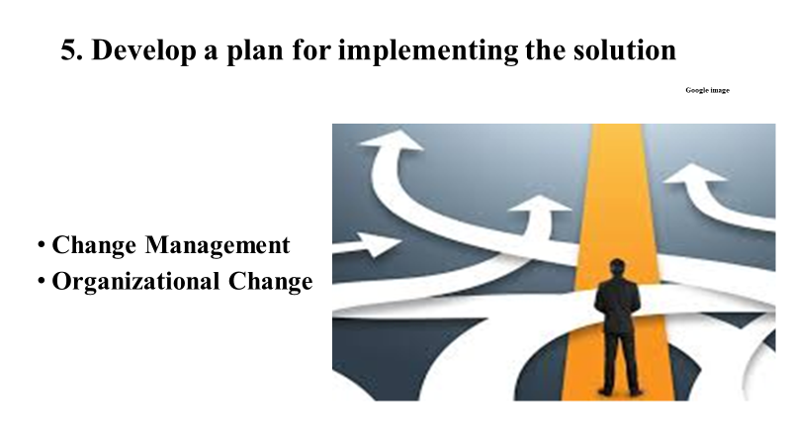

- Change Management
This is the teach that guides how we get ready, prepare and bolster people to effectively receive alter in arrange to drive company success. The representatives (staff) of your company that need to eventually alter how they do their occupations.
If personal are not change in their personal moves, in the event that they do not learn another way to do the task, the activity will come up short. In the event that representatives receive changes required by the activity, it will provide the anticipated comes about (https://www.prosci.com).
Whereas alter are one of a kind and people are one of a kind, decades of inquire about appears there are activities able to get to impact individuals in their person moves. Change management gives a company margin for supporting the people in your structure to drive to their, possess actual position to their, possess next position (https://www.prosci.com).

One of good method that help company to make change successful is ADKAR model, because organizations do not change, individuals do.
ADKAR MODEL the first step in overseeing any sort of organizational alter is understanding how to oversee alter with a single person. A person needs: Mindfulness of the require for alter, Crave to require portion in and back the alter, Information on how to alter, Capacity to actualize required capacities and behaviors, Fortification to back the alter. ADKAR depicts effective alter at the person level. When an organization embraces an activity, that alter as it were happens when the representatives who ought to do their employments differently can say with certainty, "I have the mindfulness, want, information, capacity and support to form this alter happen (https://www.prosci.com).

- Organizational Change
The alter never come immediately, least demanding, fundamental to comprehension alter like prepare is to divide it in unmistakable, reasonable components. there are three main types of alter give capable system: Current State, Transition State, and Future State.

Current State – is as things are made nowadays. It is the gathering of forms, practices, instruments, advances, authoritative composition, and work parts that make how task is created. It cannot be working extraordinary, then it is commonplace and comfortable since we understand what to anticipate. Overall other, the Current State is known.

Transition State – is muddled and disrupted, erratic and continually in flux. Frequently candidly charged, with feelings extending in lose hope and uneasiness to outrage, panic or alleviation, amid this organise efficiency typically decays. Requires us to acknowledge unused angle and get other ways of continuing, whereas still to follow our day-to-day endeavours. The Transition State is stimulating.

Future State – is the position we try to achieve, regularly not completely characterised, and could really move whereas we are walking over the Transition State. Is gathered to be superior to the Current State in terms of execution, can regularly be troubling. May not coordinate our individual and professional objectives, and there is an opportunity that we cannot be fruitful within the Future State. Overall else, the Future State is obscure (https://blog.prosci.com).

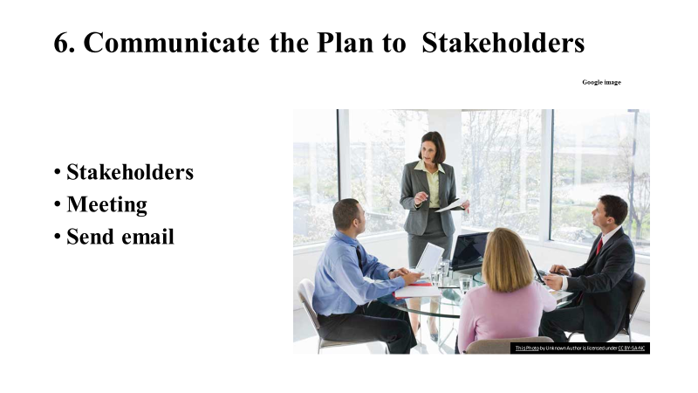
- Stakeholders
Stakeholder might be a party that has a captivated in a company and can either impact or be affected by the trade. The basic stakeholders in a conventional undertaking are its theorists, specialists, client, and providers. Stakeholders can be internal or external. Internal stakeholders are people whose, captivated in a company comes through a facilitate relationship, such as work, ownership, or investment. External partners are those people who do not particularly work with a company but are affected in some ways by the exercises and comes about of said exchange. Suppliers, leasers and open bunches are all considered exterior accomplices ( https://www.investopedia.com).

- Plan a meeting
Gathering are the foremost common communication strategy in put for enterprises, particularly since they can spare time in passing on the message to a huge number of individuals. Best ways to communicate the message would be PowerPoint, Prezi, or any of the intellect mapping program solutions available online. Being within the same room with partners ought to dodge distortion issues (https://www.celoxis.com).
- Send email
Nowadays technology is very useful in business, everyone has an email account, a mobile phone, a laptop etc, so you can use this technology to delivery stakeholders the information needed for the respective change. and very quick and safe.
There is any way to communicate with the stakeholders, like letter, newsletter, screen to screen, summary report, conference call. But, for this problem in my workplace, the stakeholders in question are employees. I scheduled a meeting and sent an email to everyone informing them of the changes.

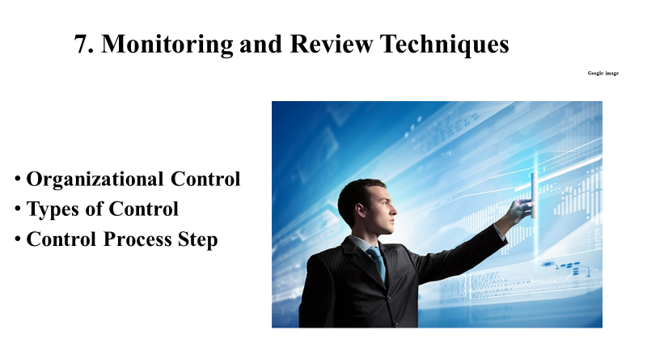
- Organizational Control
The method of relegating, assessing, and controlling assets on a progressing premise to achieve an organisation goal. To effectively control an organization, supervisors got to not as it were knowing what the execution benchmarks are, but too figure out how to share that data with employees.

Control can be characterized barely as the method a manager takes to guarantee that genuine execution acclimates to the organization is arrange, or more broadly as anything that directs the method or movement of an organization (https://www.cliffsnotes.com).

- Types of Control
There are three types of controls utilized by managers: feedforward, concurrent, and feedback. Each sort offers noteworthy openings and benefits for high performances. The use of feedback in this situation is good, it helps to understand if the problem is improving or is already over.

Feedforward controls (input stage) - they guarantee that all objective for a venture are clear, which the correct assets are made accessible for those who require them in arrange to accurately finish any relegated errands. The objective of these controls is to unravel problems before they are able to happen.

Concurrent controls (conversion stage) - center on what is happening amid the genuine work prepare. These are some of the time alluded to as controlling controls, since they make beyond any doubt all things are being done agreeing to the initial or changed plans. The objective of this sort of control is to unravel issues as they happen, it is important to undertake to illuminate issues right absent so that other ones do not happen.

Feedback controls (output stage) - are too called post-action controls basically since these takes put after the work is total. This can be the ultimate major sort of control that directors utilize; criticism controls center on the quality of the conclusion result. The most objectives at this organize are to fathom issues after they have happened, and to anticipate future ones (https://managementplanningandcontrolling.weebly.com).

- Control Process Steps
The legitimate execution of the administration regulate job is very important to the success of a company. Behind the project are decided, manager ought to implement a lot of steps to guarantee that the project is effect. The essential regulate prepare incorporates the taking after steps:
Establish standards performance: Supervisors must decipher plans into execution benchmarks. These performance measures can be within the shape of objectives, such as income from deals over a period of time. The benchmarks ought to be attainable, quantifiable, and clear.
Measuring actual performance: In case execution is not measured, it cannot be discovered whether benchmarks was achieved.
Comparing actual performance: Acknowledge or dismiss the item or outcome.
Evaluate result and Take correct action: Supervisors must decide why measures were not met. This step too includes deciding whether more control is essential or on the off chance that the standard ought to be altered. After the reasons for deviations have been decided, directors can at that point create arrangements for the problem with assembly the guidelines and make alteration to forms or conduct (https://courses.lumenlearning.com).

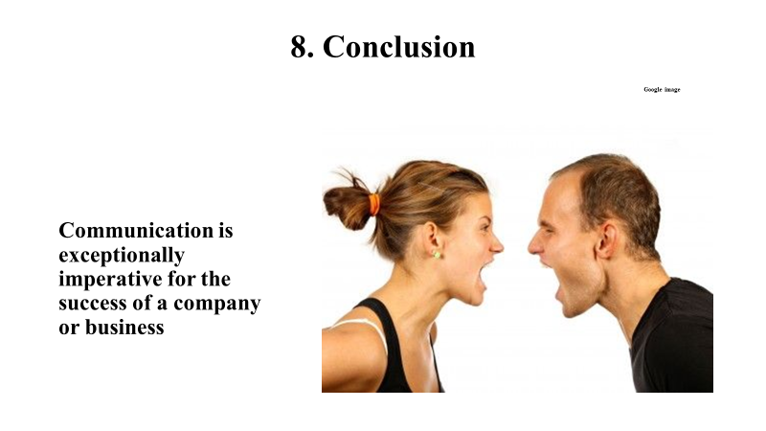

Finally, for me it became clear and I also recommend to everyone that poor communication is a big problem and cannot be ignored. It is necessary that all managers and employees are attentive to create a pleasant environment in the workplace. Managers cannot continue to see and ignore this problem, nor be the focus of this problem, just because they do not see or feel it. Communication must be always good, we must know how to listen, be assertive and respect each other. Good communication is an indispensable element for the success of any business. The poor communication, reduces productivity, stress, discontent, bad environment in the workplace, as has happened in the specific case of Busaba restaurant where I am working. The knowledge acquired in this module helped me to identify the problem of poor communication and inform those responsible for the restaurant. I also presented the impacts of this problem and solution. As a decision-making technique, I chose Swot Analysis, taking into account that this is an internal problem, despite having its external reflexes. The organizational change was prepared in three states, current, transition and future, we inform the stakeholders through meeting and by emails. We are currently monitoring and review techniques through Feedback control and also CCTV. We are very happy because the feedback is being positive and we are building an effective teamworking, thus increasing our productivity.
- Reference
- Available at: https://fsd.servicemax.com (accessed 04th April 2020).
- Available at: https://www.umassd.edu (accessed 04th April 2020).
- Available at: https://www.investopedia.com (accessed 06th April 2020).
- Available at: https://www.projectmanager.com (accessed 02sd April 2020).
- Available at: https://www.sportbop.co.nz (accessed 04th April 2020).
- Available at: https://www.celoxis.com (accessed 04th April 2020).
- Available at: https://www.vitalsmarts.com (accessed 24th April 2020)
- Available at: https://www.prosci.com (accessed 27th April 2020)
- Available at: https://blog.prosci.com (accessed 27th April 2020)
- Available at: https://courses.lumenlearning.com (accessed 27th April 2020
- Available at: https://managementplanningandcontrolling.weebly.com (accessed 28th 2020)
- Available at: https://www.cliffsnotes.com (accessed 28th 2020)
- Available at: https://yourbusiness.azcentral.com (accessed 28th 2020)
- Available at: https://www.mindtools.com (accessed 1st May 2020)
- available at: https://marinecuisineau.weebly.com (accessed 5th May 2020
- Maund, A. Schriek, M. and Tinkler, P. (2017). Certificate in Higher Education: Skill for the Workplace Student Yearbook.

Appendices 1

Strengths: We possess good competent group with encounter in these helping visitors, give to our visitors have wide menu with parts of choice of Thai nourishment. Furnish is recognise know company, area is in city centre in Oxford Road, aperture time is profitable for everybody from 9 am by 11 pm at workdays and from 9 am by 12 pm at ends of the week, whereas another closing at 9 p.m. Too environment and plan permits us give marriages, anniversary and commerce assembly, Wi-Fi get to and for kids game and numerous other highlights, that you could discover profitable for everyone in our eatery.
Weaknesses: we have a little area, the eatery is not expansive, our area greatest for hundred individuals and our activity is given for a little feast, strange/young eatery for the business, we have small brand, in any case we working hard to become familiar eatery and we are going open our bunch in another towns in Britain. But our greatest concern and weakness at the moment is poor communication. There is a communication gap produced by directors till the workers. Because everything has got to do with awful attitudes, lack of respect for others, people came from different background etc. That has created discontent, stress, lack of help, low production, unfocused personal goal.
Opportunities: There are many of Asian individuals in London, that is why the request on this sort of nourishment is gigantic, moreover Thai nourishment is prevalent inside the earth, individuals appreciate it. Implies our clients will be not fair Thai individuals, but too individuals from different background. Produce a lot of alternatives of menu and we react for our virtue, since our item continuously new and the cost is appropriate for everybody, be decide by on choice of our visitors. Besides, referring not almost financial figure, but moreover natural and social as well.
Threats: Outside variables, that we cannot control, as concurrent, government policy, technology etc. In any case, we are in an open market and at any time someone can open a modern Thai eatery in London and particularly near to us. The truth that we as it were serve Thai food and the need of client believe for us is additionally a risk. But we are arranged to reply to these dangers, they are portion of the business. (https://marinecuisineau.weebly.com)

