MSc Software Engineering and AI
Research Methods and Professional Development
Component 1 - Research Methods
Rabeya Begum
2209407
Dr Vijeyananthan Thayananthan
18th November 2025
University of Wales Trinity St David – Quay place

Table of Contents

Evaluating Birmingham’s Carbon Reduction Initiatives Using Artificial Intelligence 3
Abstract 3
1. Introduction 3
1.1 Context and Background 3
1.2 Research Problem 4
1.3 Research Aim and Objectives 5
1.4 Significance of the Research 5
2. Literature Review 6
2.1 Carbon Reduction and Net Zero Initiatives in the UK 6
2.2 Challenges in Evaluating Carbon Reduction Initiatives 6
2.3 Artificial Intelligence in Environmental Sustainability 7
2.4 Integrating AI into Urban Emission Evaluation Frameworks 8
2.5 Theoretical and Technical Frameworks 9
2.6 Literature Summary 9
3. Research Design and Methodology 10
3.1 Research Design 10
3.2 Research Methods and Materials 10
3.3 Data Analysis and Evaluation 11
3.4 Ethical Considerations 12
4. Expected Outcomes 13
4.1 Anticipated Results 13
4.2 Implications 14
4.3 Limitations 14
5. Timeline 14
Conclusion 15
References 17

Table of Figures
Figure 1 - Overview of net zero: balancing emission reduction and removal strategies. 5
Figure 2 - Overview of the United Kingdom highlighting Birmingham’s leadership 7
Figure 3 - Visual comparison of traditional and AI-based approaches to evaluating carbon reduction initiatives. 8
Figure 4 - Forecasted emissions under baseline, moderate, and AI-optimised policy scenarios 9
Figure 5 - Design Science Research process applied in this study 12
Figure 6 - AI-based framework illustrating the data flow, analytical models and decision-support process 14
Figure 7 - Projected emissions pathways aligned with Birmingham’s net zero targets. 14
Figure 8 - Gantt chart of project 16

Evaluating Birmingham’s Carbon Reduction Initiatives Using Artificial Intelligence

Abstract
Climate change is widely recognised as one of the most pressing global challenges, with rising carbon dioxide levels contributing to long-term environmental, economic and social pressures [1]. In response, the United Kingdom has made a legal commitment to reach net zero greenhouse gas emissions by 2050, while Birmingham has set a more ambitious local target of achieving net zero by 2030 [2]. To support this goal, the city has introduced a range of interventions, including the Clean Air Zone, home energy retrofit schemes, investment in renewable energy and the promotion of low-emission transport options [2], [3].
While these initiatives are active, there remains limited clarity about their combined effectiveness. Traditional evaluation methods often rely on static or self-reported indicators, which are reviewed infrequently and fail to reflect how conditions evolve over time [4]. These approaches also tend to assess each policy in isolation and rarely offer meaningful forecasts to guide long-term planning.
This research proposes an Artificial Intelligence (AI) based framework to evaluate Birmingham’s carbon reduction initiatives. The study will integrate datasets covering transport, energy use, industrial activity, weather and policy interventions, and apply machine learning techniques such as Random Forest, Gradient Boosting and Neural Networks to uncover relationships and forecast emission trends [4], [5]. The performance of these AI models will be compared with traditional assessment methods to determine which approach provides more reliable, timely and actionable insights. The overall aim is to support Birmingham’s progress towards its 2030 net zero target and to develop a transferable framework that could be adapted by other UK cities pursuing similar climate goals [1], [2].
This study will design and test an AI-led evaluation framework to assess whether this approach can offer decision support to local authorities by identifying which policies deliver the most meaningful reductions in emissions.

1. Introduction

1.1 Context and Background
Climate change continues to pose serious environmental, social and economic risks at global, national and local levels. Rising temperatures, more frequent extreme weather events and long-term biodiversity loss have all been linked to increased carbon dioxide emissions. As a result, reducing emissions has become a central policy objective for governments and local authorities alike [1]. The United Kingdom has committed in law to reaching net zero greenhouse gas emissions by 2050 [1], while Birmingham, one of the country’s largest urban and industrial centres, has set a more ambitious local target of achieving net zero by 2030 [2].
To work towards this target, Birmingham City Council has introduced a series of interventions across housing, transport, energy and industry. These include the Birmingham Clean Air Zone, home energy retrofit and insulation schemes, local renewable energy projects and incentives to encourage more sustainable modes of transport [2], [3]. These measures are outlined in the Birmingham Net Zero Action Plan, which serves as a roadmap for city-wide decarbonisation [2]. Figure 1 illustrates the net zero concept, showing the balance between reducing emissions and removing residual emissions through mitigation and offsetting.
Despite visible progress, the real-world impact of these interventions is not always clear. Local and national reporting tends to be annual and descriptive, and by the time figures are published, they may already be outdated [4]. Evaluations are often conducted sector by sector for example, transport is assessed separately from housing even though behaviour in one area can significantly influence outcomes in another. Traditional analysis also tends to focus on what has already happened, rather than exploring what might happen next under different policy scenarios [4]. These limitations make it difficult for local authorities to plan strategically.
Artificial Intelligence and machine learning offer a promising alternative. These techniques are well suited to handling large, multi-source and constantly evolving datasets, and can uncover relationships that are difficult to detect using manual or purely statistical methods [4], [5]. This proposal explores whether AI can be used to evaluate Birmingham’s carbon reduction strategy more effectively than current approaches.
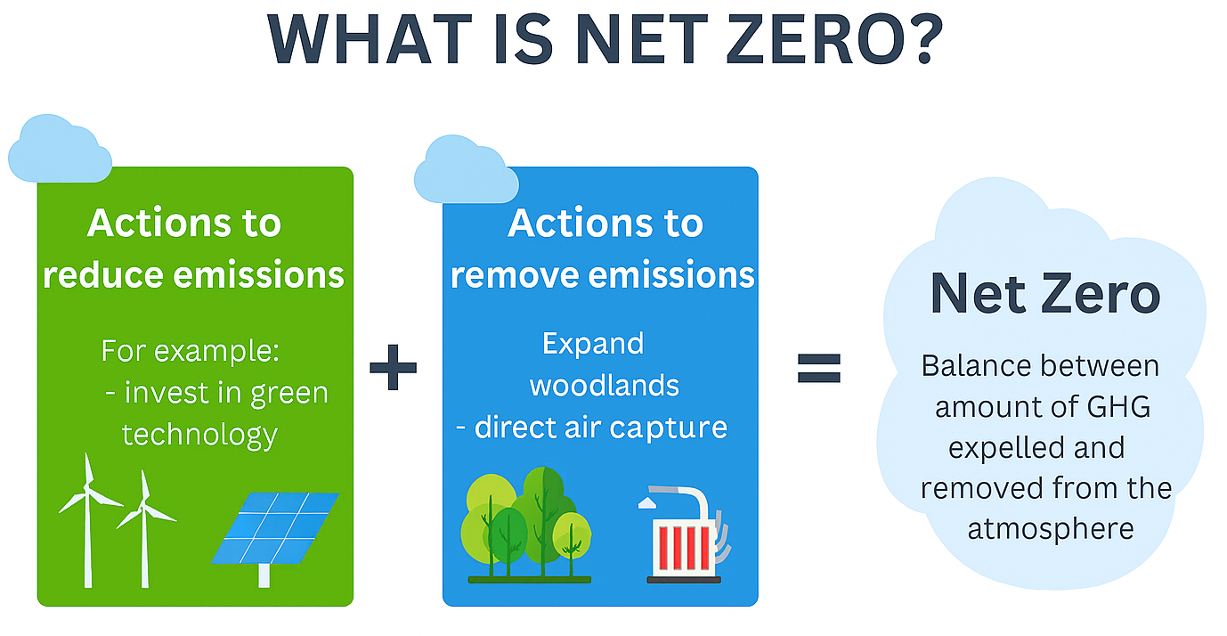
Figure 1 - Overview of net zero: balancing emission reduction and removal strategies.

1.2 Research Problem
Birmingham has introduced a wide range of carbon reduction initiatives, yet there is currently no integrated, data-driven method for evaluating their combined impact. Traditional evaluation techniques face three key limitations [4], [6].
Firstly, most existing approaches rely on static or infrequently updated datasets, making it difficult to track how emissions evolve over time, particularly in response to new policies.
Secondly, policies are often assessed in isolation. For instance, a transport intervention might be evaluated without considering its influence on household energy consumption, industrial activity or local air quality. This fragmented approach limits understanding of cross-sector interactions [6], [7].
Thirdly, conventional methods tend to be retrospective. They focus on reporting past trends and rarely offer reliable forecasts for future emissions under alternative scenarios. This restricts strategic planning and reduces the ability of local authorities to adjust policies before targets are missed [4].
Artificial Intelligence offers a way to address these gaps by integrating diverse datasets, modelling complex interdependencies across sectors and generating predictive insights. However, AI is still not widely adopted in local government policy evaluation in the UK, especially at the city level [4], [8]. There is therefore a clear need to design and test an AI-driven framework capable of evaluating the overall impact of Birmingham’s carbon reduction strategy.

1.3 Research Aim and Objectives
The aim of this study is to evaluate the effectiveness of Birmingham’s carbon reduction initiatives using AI-based predictive and analytical models [5].
This aim will be achieved through five linked objectives:
- To collect and prepare relevant datasets for Birmingham, including transport emissions, household and industrial energy use, local industrial activity and air quality.
- To develop and train machine learning models that can identify relationships between specific policy actions and observed changes in emissions across sectors [4], [5].
- To compare the outputs of these AI models with those generated by traditional evaluation methods, assessing which approach provides more reliable and actionable insights.
- To evaluate whether AI-generated evidence can serve as a practical decision-support tool for local policymakers and climate planners.
- To produce recommendations that support Birmingham’s progress towards its 2030 net zero target [2].

1.4 Significance of the Research
This research is significant both academically and practically [8], [9].
From an academic perspective, it contributes to the growing field of computational sustainability by applying AI techniques to a real-world urban policy challenge. It also addresses a gap in the literature by integrating multi-sector data into a unified analytical framework, rather than evaluating each sector in isolation.
Practically, the proposed framework is designed to support evidence-based decision-making. By identifying which interventions deliver the greatest emissions reductions, Birmingham City Council and similar authorities can allocate resources more effectively, plan future actions with greater confidence and justify decisions to stakeholders [2], [8]. The study also holds broader societal relevance: reducing urban emissions contributes not only to climate targets but also to cleaner air and improved public health outcomes [9]. Importantly, the framework is adaptable, allowing other UK cities to apply a similar approach in pursuit of their own net zero goals.

2. Literature Review

2.1 Carbon Reduction and Net Zero Initiatives in the UK
The United Kingdom has positioned itself as a global leader in climate governance by enshrining its net zero by 2050 target in law [1]. Local authorities are expected to play a central role in meeting this commitment, as urban areas account for a significant share of national emissions [2]. Birmingham has responded by setting a more ambitious 2030 net zero target and launching a citywide Net Zero Action Plan that addresses transport, housing, energy and industry [2], [3]. Key interventions include air quality controls, building retrofit programmes, investment in renewable energy and schemes to encourage a shift away from private car use.
National policy analysis has emphasised that achieving net zero is not solely a technological challenge, it also requires behavioural change and effective governance [10]. Research suggests that local authorities must tailor interventions to reflect local economic and social conditions, rather than relying on generic, top-down approaches [11]. This creates a demand for more adaptive, data-driven evaluation methods that can reflect local realities in near real time.
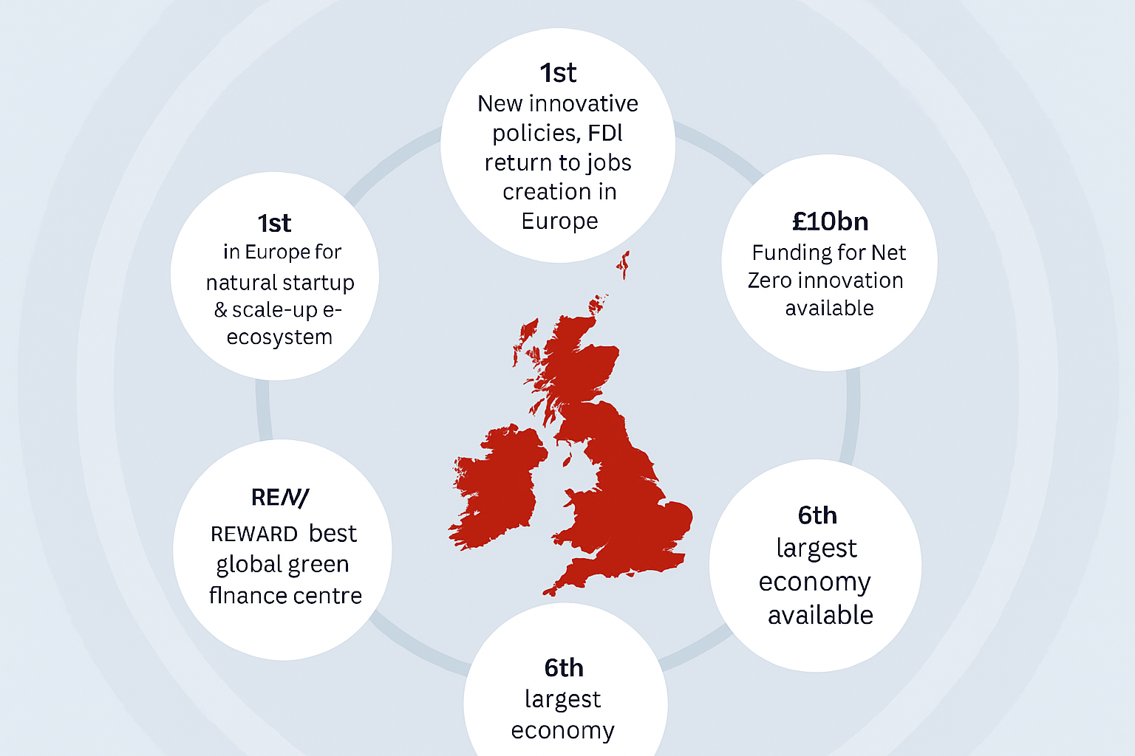
Figure 2 - Overview of the United Kingdom highlighting Birmingham’s leadership in AI-driven carbon reduction initiatives

2.2 Challenges in Evaluating Carbon Reduction Initiatives
Several studies highlight persistent challenges in assessing the effectiveness of city-level decarbonisation strategies [6], [7]. One frequently reported issue is the reliance on periodic reporting. These reports offer only a snapshot in time and are often outdated by the time they are reviewed, making it difficult to determine whether policies are delivering sustained impact [4], [6].
Another major challenge is data fragmentation. Information on transport, energy consumption, air quality, industrial emissions and social behaviour is typically stored across separate systems managed by different departments. This siloed approach makes it difficult to build a consistent, integrated picture of cause and effect [6], [7].
Attribution is also problematic. It can be difficult to determine whether changes in emissions are genuinely the result of a specific policy, or whether they stem from external factors such as economic shifts, seasonal weather patterns or fluctuations in fuel prices. Traditional methods often struggle to isolate these influences, which can lead to misleading conclusions [6].
Finally, most existing evaluation frameworks are retrospective rather than predictive. They describe what has already happened but rarely explore what might happen under alternative scenarios [4], [15]. This limits strategic planning, as decision-makers lack tools to test “what if” scenarios before committing resources. These limitations underscore the need for more adaptive, forward-looking approaches.
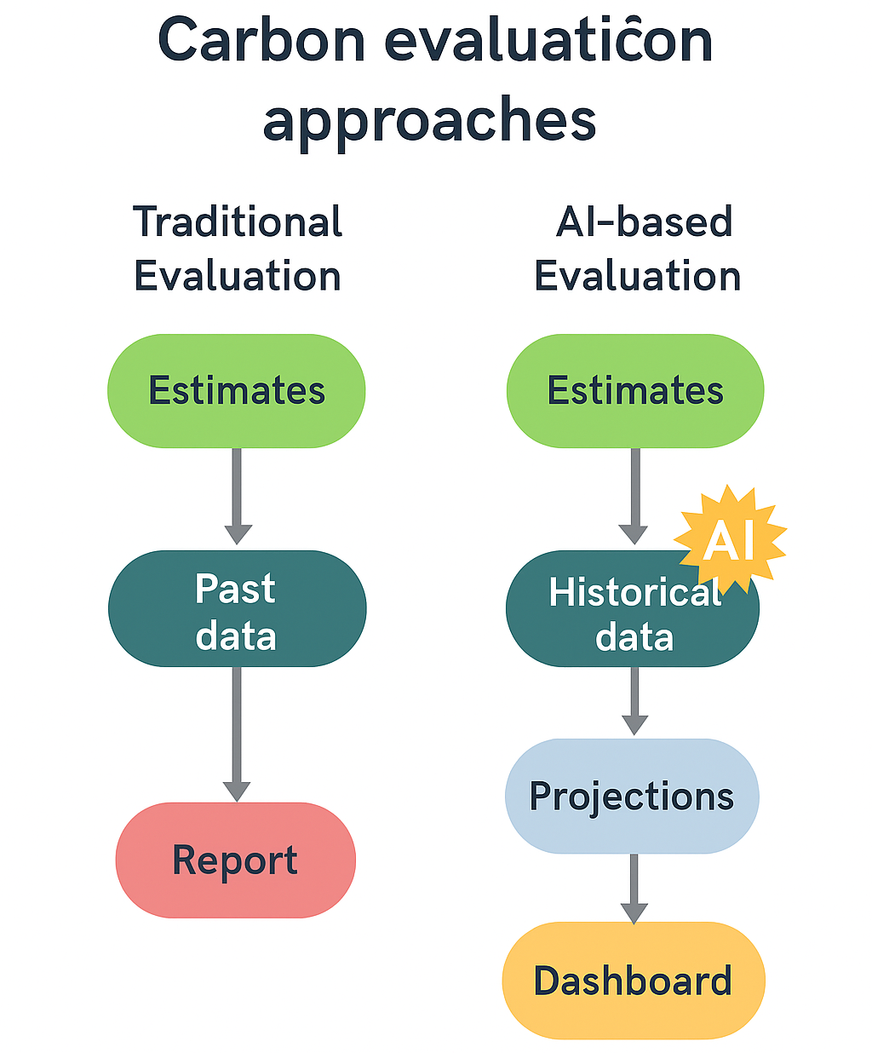
Figure 3 - Visual comparison of traditional and AI-based approaches to evaluating carbon reduction initiatives.

2.3 Artificial Intelligence in Environmental Sustainability
Artificial Intelligence (AI) and machine learning are increasingly being applied to environmental sustainability challenges, particularly where complex systems with many interacting variables need to be modelled [4], [16]. Techniques such as Random Forest, Gradient Boosting, XGBoost and Neural Networks have been used to forecast energy demand, predict local air quality and model how emissions respond to behavioural and economic drivers [11], [16], [17].
Evidence suggests that these machine learning models often outperform traditional regression-based approaches, especially in contexts where relationships between variables are non-linear and time-dependent [16], [17]. However, many AI models assume access to large, high-quality and consistent datasets [16]. This assumption does not always hold at the city level. Local authorities frequently face gaps in data coverage, inconsistent reporting practices and resource constraints in data management [7], [18].
While AI has demonstrated technical value in national and regional studies, its application within local public-sector decision-making is still emerging [4], [18]. There is a clear opportunity to adapt AI methods to work under the messy, fragmented data conditions typically found in cities like Birmingham.
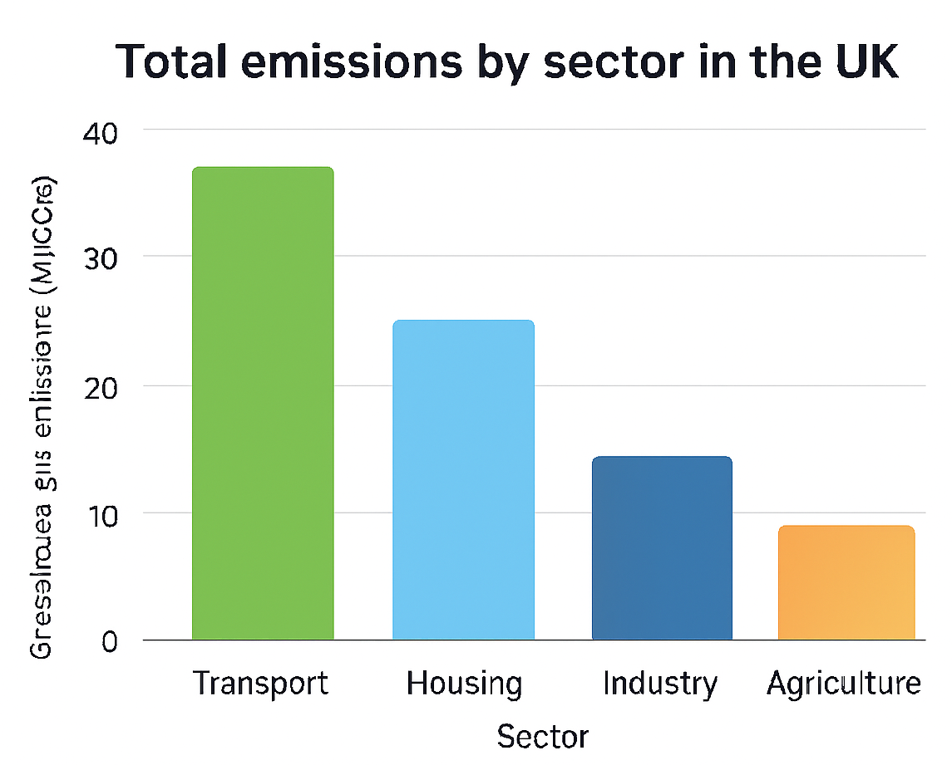
Figure 4 - Forecasted emissions under baseline, moderate, and AI-optimised policy scenarios
The AI-optimised scenario projects a steeper decline in emissions by focusing on high-impact interventions.

2.4 Integrating AI into Urban Emission Evaluation Frameworks
Recent studies have begun to integrate transport, energy and behavioural data into unified AI-driven frameworks that estimate the impact of different sustainability policies [19], [20]. These models can generate rapid assessments of likely outcomes under alternative choices, enabling policymakers to compare scenarios before implementation. This shifts evaluation from a passive reporting exercise to an active planning tool.
One key advantage of these approaches is the creation of continuous feedback loops between data collection, model analysis and policy adjustment. Rather than waiting for annual reports, decision-makers can access updated predictions and respond more quickly if a policy is underperforming [19], [20]. For a city like Birmingham, which must balance economic growth, transport needs and environmental targets, this kind of adaptive management is especially valuable. It supports not only environmental objectives but also political accountability, as decisions can be justified using transparent, data-backed evidence.

2.5 Theoretical and Technical Frameworks
This research is grounded in Design Science Research (DSR), a methodology focused on creating practical artefacts to solve real-world problems [21]. DSR follows an iterative cycle: identifying a problem, designing an artefact, testing it, and refining it based on evaluation. In this study, the artefact is an AI-based evaluation framework. DSR is particularly appropriate here, as the goal is not only to analyse Birmingham’s current position but also to design a tool that supports better decision-making over time [21], [22].
Technically, the framework will incorporate machine learning models such as Random Forest, Gradient Boosting Machines, XGBoost and Artificial Neural Networks [4], [16], [22]. Random Forest is useful for identifying which factors most influence emissions, as it can estimate feature importance in a transparent way. Gradient Boosting and XGBoost are well suited for forecasting, as they iteratively improve accuracy by learning from previous model errors. Neural Networks are ideal for capturing complex temporal patterns in energy use, transport behaviour and weather conditions, which are often difficult to model using linear techniques [16], [22].
Scenario analysis will be used to explore the consequences of different policy decisions. For example, the framework will simulate how emissions might change if Birmingham expands its Clean Air Zone, increases investment in home energy retrofits or accelerates public transport electrification [19], [20]. Sensitivity analysis will then test how stable these predictions are when assumptions such as population growth or energy demand are varied.

2.6 Literature Summary
The literature highlights three core issues. First, traditional approaches to evaluating local carbon reduction policies are fragmented, retrospective and slow to update [4], [6], [7]. Second, AI and machine learning have shown strong potential in emission forecasting and policy evaluation, particularly in complex and fast-changing environments [4], [16], [17]. Third, there remains a gap in applying these techniques directly within local authority decision-making, where data may be incomplete, inconsistent or politically sensitive [18], [20].
This project aims to address these challenges by developing an AI-based evaluation framework tailored to Birmingham’s carbon reduction strategy. The goal is to demonstrate not only that AI can generate more accurate and timely insights, but also that it can do so in a way that is transparent, ethically governed and accessible to non-technical decision-makers [21], [22], [23].

3. Research Design and Methodology

3.1 Research Design
This study adopts a Design Science Research (DSR) approach [21], [22], which is widely used in computing and information systems to develop and refine practical solutions to complex, real-world problems. In this case, the solution being developed is an AI-based decision-support framework.
The research will follow four iterative stages. The first stage, problem identification, involves analysing the limitations of current evaluation methods and establishing the need for a predictive, data-driven alternative. The second stage, design and development, focuses on building machine learning models capable of integrating data from multiple domains, including energy consumption, transport behaviour, weather and industrial activity. The third stage, testing and validation, will assess the predictive performance and robustness of these models using standard accuracy metrics such as Mean Absolute Error (MAE) and Root Mean Square Error (RMSE). The final stage, evaluation and reflection, will compare AI-generated insights with traditional evaluation results and assess their suitability for supporting policy decisions in practice [21], [22].
This structured approach ensures the research remains both academically rigorous and practically useful. It also allows for continuous refinement, meaning the AI system can be updated and re-evaluated as new data becomes available or as Birmingham introduces further sustainability policies.

3.2 Research Methods and Materials
This study will adopt a mixed-methods strategy, combining quantitative machine learning analysis with qualitative interpretation of policy context.
The quantitative component will focus on training predictive models to identify relationships between policy actions and changes in emissions. Models such as Random Forest regression, Artificial Neural Networks and Gradient Boosting will be used due to their effectiveness in modelling non-linear patterns and variable interactions [4], [16], [22]. Random Forest is particularly useful for identifying which policy levers such as transport restrictions or home retrofit schemes are most strongly associated with emission changes. Neural Networks are well suited to capturing temporal patterns in emissions and weather data, while Gradient Boosting methods can iteratively refine predictions by learning from previous model errors.
The qualitative component will involve reviewing Birmingham City Council policy documents, regional sustainability strategies and national guidance to interpret the AI outputs in context [2], [3], [8]. This is essential, as even highly accurate predictions must be relevant to political, social and economic constraints. Subject to ethical approval and access, informal consultations or interviews with local environmental officers and transport planners may be conducted to explore barriers to implementation and assess the realism of proposed interventions. If access is not granted, this stage will rely solely on document analysis.
Scenario analysis will be used to simulate the impact of alternative interventions. For example, different configurations of Birmingham’s Clean Air Zone, varying levels of investment in renewable energy infrastructure or different timelines for electrifying public transport can be tested to explore how emissions might evolve under each scenario [19], [20]. Sensitivity analysis will then assess the stability of these findings under different assumptions, such as changes in energy demand, fuel prices or population growth [26], [27].
Data will be sourced from multiple domains to ensure coverage and reliability. Energy consumption data including electricity and gas usage will be drawn from official energy statistics [1], [10]. Transport data, including traffic flow, public transport usage and emissions, will be obtained from the Department for Transport and Birmingham City Council [2]. Industrial emissions will be sourced from regulatory monitoring, while air quality and climate data will come from the Met Office and UK air-quality monitoring reports [2], [30]. The Birmingham Net Zero Action Plan, Clean Air Zone reports and related sustainability documentation will be used to map specific interventions to time periods [2], [3]. All data will be cleaned to remove errors and handle missing values. Any personal or sensitive information will be anonymised and stored securely in accordance with data protection standards.
Python will be the primary development environment, using libraries such as scikit-learn, TensorFlow and XGBoost. Tableau or Power BI will be used to create visual dashboards for non-technical stakeholders, and GitHub will support version control and model tracking. To manage large datasets and reduce training time, GPU-supported hardware will be used where available [22].
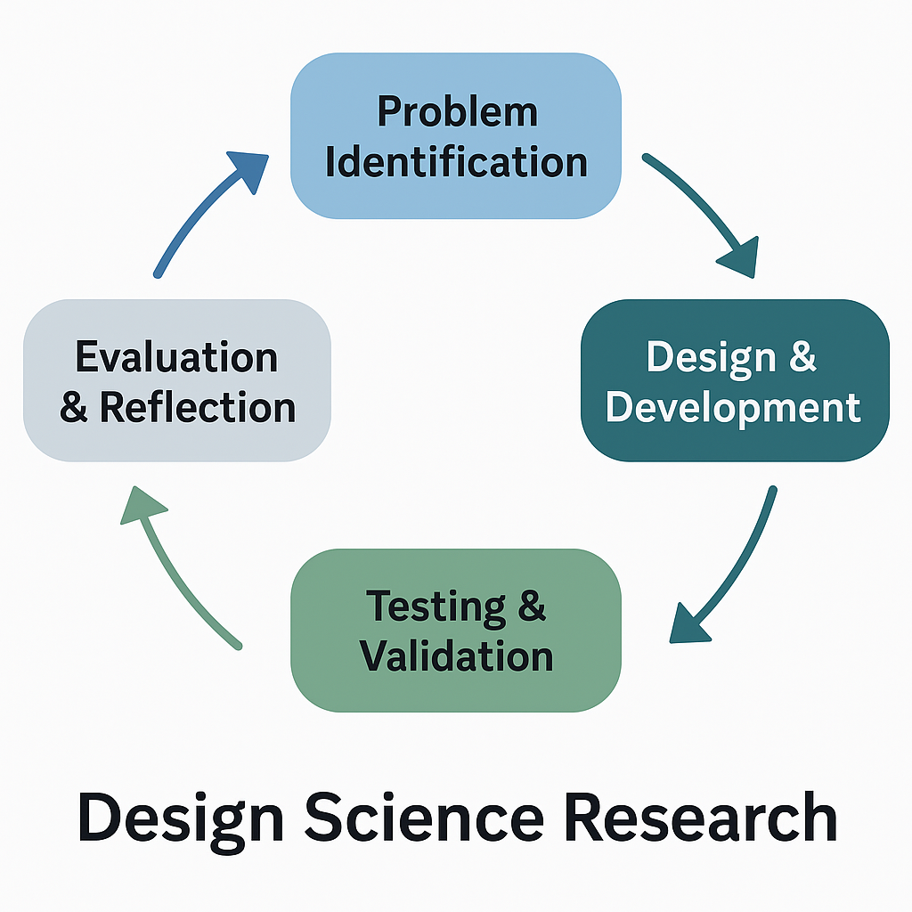
Figure 5 - Design Science Research process applied in this study

3.3 Data Analysis and Evaluation
Once the datasets have been cleaned and integrated, they will be analysed using a combination of statistical and machine learning techniques. The aim is to ensure the results are accurate, transparent and relevant to policymakers.
Model accuracy will be assessed using standard metrics. MAE and RMSE will measure how close the predictions are to observed emission values, while R² will indicate how much of the variation in emissions is explained by the model inputs. High R² values would suggest the model is capturing meaningful relationships between policy interventions and outcomes.
Feature importance analysis will identify which factors have the greatest influence on emissions. For example, this may reveal whether stricter transport policies or home energy retrofits are more strongly associated with measurable reductions in carbon output [29]. Scenario modelling will then be used to compare the potential effects of different future strategies. As shown in Figure 4, baseline, moderate and AI-optimised scenarios may diverge over time, with targeted interventions producing more favourable emission trajectories.
Sensitivity testing will assess the robustness of the model by running it under altered assumptions such as changes in economic activity, weather conditions or energy pricing and observing how stable the projections remain [26], [27]. This is important because local policy decisions are often influenced by external shocks that cannot be controlled directly.
The evaluation process will combine these quantitative metrics with interpretive analysis. AI-generated insights will be compared with findings from traditional evaluation methods, which typically rely on annual carbon reports and descriptive policy summaries. This comparison will help determine whether AI provides clearer and more actionable information, or whether conventional methods still hold value in certain contexts. The final stage will involve developing visual dashboards to present key findings in an accessible format. These dashboards are designed to support decision-makers who may not have technical expertise but are responsible for designing, approving or funding climate actions [19], [20].

3.4 Ethical Considerations
Ethical integrity is central to this research. All work will comply with the University of Wales Trinity Saint David’s Research Ethics Policy and Procedures Handbook and relevant data protection regulations [24]. Any personal or sensitive data such as location-linked transport records will be anonymised before analysis and stored securely with restricted access.
The study also acknowledges the broader ethical implications of using AI in public policy. Machine learning models can replicate patterns and biases present in their training data, which may lead to unfair or misleading recommendations if not properly addressed. To mitigate this risk, the framework will include fairness and bias checks, and all modelling assumptions will be documented. Transparency will be prioritised: all modelling decisions, including variable selection and prediction methods, will be recorded and explained in plain language to ensure accountability and public trust [23].
It is important to emphasise that the AI system is intended to support not replace human decision-making. The goal is to provide evidence that helps policymakers act more effectively and responsively, not to automate governance or remove political judgement.
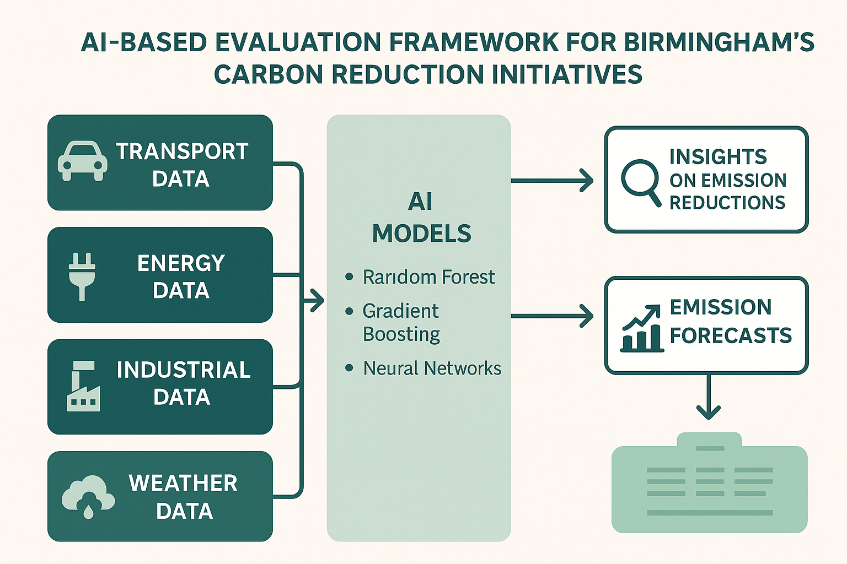
Figure 6 - AI-based framework illustrating the data flow, analytical models and decision-support process

4. Expected Outcomes

4.1 Anticipated Results
The AI-based framework is expected to generate timelier, detailed and policy-relevant insights than traditional assessment methods. The machine learning models should be able to identify which interventions such as building retrofit schemes, public transport improvements or restrictions on high-emission vehicles are most strongly associated with reductions in measured emissions [16], [19]. These models are also anticipated to demonstrate strong predictive performance, with low error scores and high explanatory power, indicating that meaningful patterns are being captured in the available data.
The framework is likely to reveal how different interventions interact. For example, it may show that investment in public transport is most effective when paired with targeted household energy efficiency measures, rather than pursued in isolation. Figure 7 illustrates how different policy combinations could produce varying emissions pathways over time, and how coordinated strategies may align more closely with Birmingham’s 2030 net zero target [2].
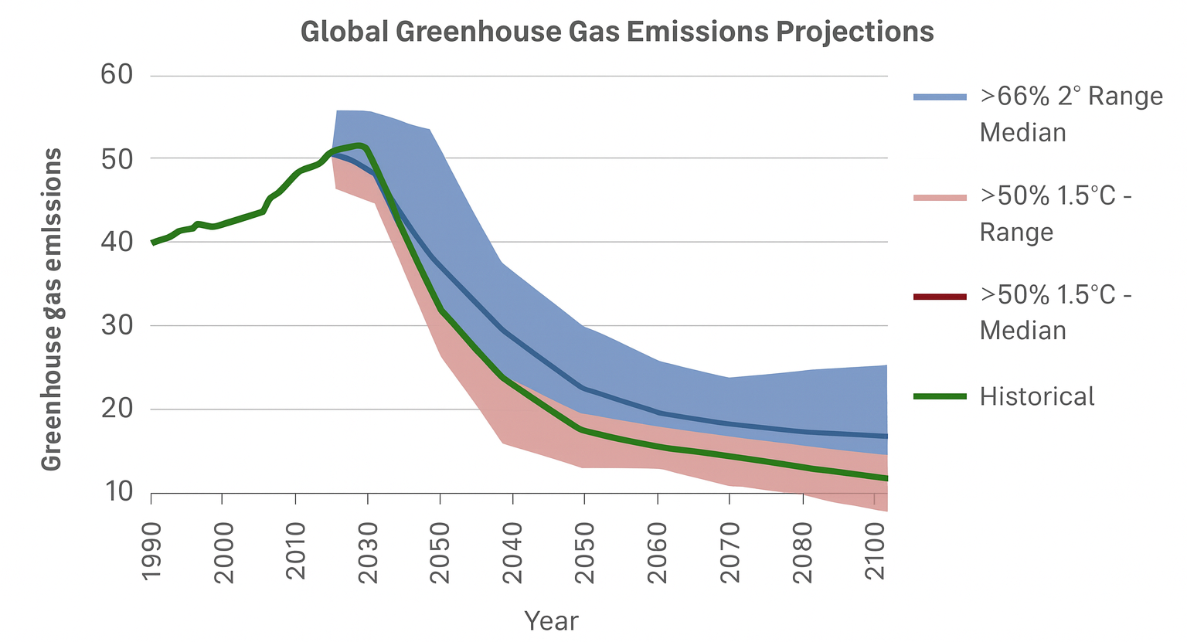
Figure 7 - Projected emissions pathways aligned with Birmingham’s net zero targets.
Results will be presented through visual dashboards designed for policymakers. These dashboards will allow users to explore trends, compare interventions and view projections without needing to understand the underlying machine learning code [19], [20], [32]. This enhances accessibility and supports practical use in planning.

4.2 Implications
The implications of this research span academic, practical and societal domains. Academically, the study contributes to environmental informatics by demonstrating how AI can be embedded within a Design Science Research process to create an operational decision-support artefact for sustainability planning [21], [22], [31].
Practically, the framework offers a structured method for Birmingham City Council and other local authorities to prioritise actions, allocate resources and justify decisions to stakeholders using evidence rather than assumption [2], [8], [19].
At a societal level, the research supports interventions that not only reduce emissions but also improve local air quality and public health. These outcomes align with the United Nations Sustainable Development Goals, particularly those focused on sustainable cities and climate action [9], [33].

4.3 Limitations
This study acknowledges several limitations. First, data quality and availability may be uneven. Some datasets, particularly those relating to industrial emissions at local resolution may contain gaps or inconsistent reporting intervals. In such cases, cautious interpolation or imputation will be applied, with all processing documented to avoid overstating confidence.
Second, machine learning models learn from historical patterns. Sudden policy shifts, disruptive technologies or behavioural changes may reduce predictive accuracy if the new conditions differ significantly from the training data.
Third, the framework is developed specifically for Birmingham. While the approach is designed to be adaptable, applying it to other cities may require adjustments to reflect differences in data structures, governance responsibilities and infrastructure [18], [20], [28].
Despite these limitations, the research is expected to provide a strong foundation for future AI-driven policy evaluation at the local authority level, both within the UK and internationally.

5. Timeline
The project will run from September 2025 to May 2026. The initial phase in September will focus on finalising the proposal, completing the literature review and securing access to relevant datasets. October will be dedicated to data collection, cleaning and preparation, alongside submission of the ethics application.
In November, initial AI models will be selected, designed and tested in preliminary form, and the overall research design will be refined. December and January will focus on building and training the main machine learning models, running baseline forecasts and initiating scenario simulations.
February will be used for feature importance analysis, sensitivity testing and model validation. March will centre on interpreting results, drafting findings and linking outcomes to Birmingham’s policy environment. April and May will be reserved for final analysis, dashboard development, report writing and revisions ahead of submission.
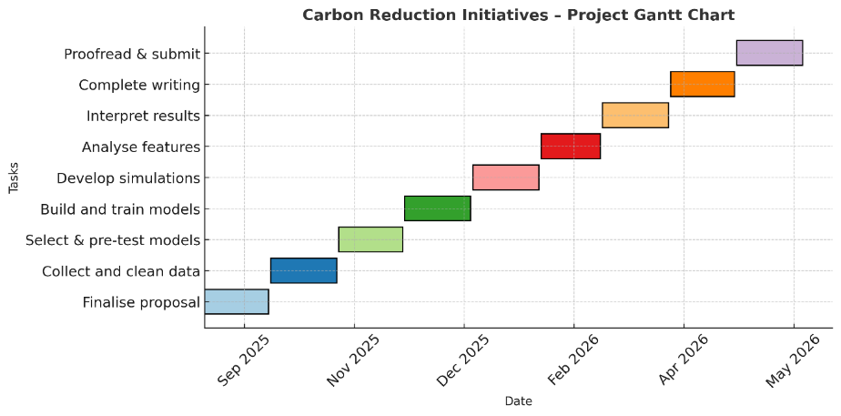
Figure 8 - Gantt chart of project
Project Gantt chart, showing major tasks from September 2025 to May 2026, including literature review, data acquisition, model development, evaluation and final write-up.

Conclusion
This proposal outlines a plan to evaluate Birmingham’s carbon reduction initiatives using Artificial Intelligence. The motivation stems from the growing need for timely, data-driven and forward-looking tools to support local climate action. Traditional approaches are reliant on static, fragmented and retrospective reporting are increasingly unsuitable for cities working towards ambitious targets like Birmingham’s 2030 net zero goal [2], [4].
The proposed framework will integrate transport, energy, industrial, air quality and policy data, and apply machine learning techniques to identify which interventions deliver the most meaningful reductions in emissions. By incorporating scenario analysis and sensitivity testing, the framework is designed not only to assess past performance but also to forecast future outcomes under alternative policy choices [16], [19], [20].
Grounded in Design Science Research, the project aims to produce a practical artefact: a transparent, auditable decision-support system that enhances evidence-based policymaking [21], [22]. Crucially, the AI system is intended to support not replace professional judgement. It will provide clearer evidence, faster feedback and transparent reasoning that can be communicated to the public, stakeholders and funding bodies [23], [31], [32].
If successful, the framework could be adapted for use in other UK cities, promoting a more consistent and evidence-based approach to local climate governance [8], [9], [33]. Ultimately, this project seeks not only to evaluate Birmingham’s current progress, but also to design, test and justify an AI-driven framework that can guide future climate decision-making at city scale [2], [34].

References
[1] Department for Energy Security and Net Zero, Net Zero Strategy: Build Back Greener (Updated 2022), London: HM Government, 2022. [Online]. Available: https://www.gov.uk
[2] Birmingham City Council, Birmingham Net Zero Action Plan, Birmingham: BCC, 2023. [Online]. Available: https://www.birmingham.gov.uk
[3] Climate Change Committee, Progress in Reducing Emissions: 2024 Report to Parliament, London: CCC, 2024.
[4] Saida M. Ibraimova, Ilham M. Saipidinov, Natalia M. Serbulova, Olga A. Glushko, and Svetlana B. Makeeva, “CLIMATE-RESPONSIBLE MANAGEMENT INFORMATION SYSTEMS TO RAISE PRODUCT QUALITY IN SUPPORT OF DECARBONISATION IN THE AI ECONOMY,” Proceedings on engineering sciences (Online), vol. 7, no. 1, pp. 129–136, 2025, doi: 10.24874/PES07.01A.004.
[5] P. Gudde, J. Oakes, P. Cochrane, N. Caldwell, and N. Bury, “The role of UK local government in delivering on net zero carbon commitments: You’ve declared a Climate Emergency, so what’s the plan?,” Energy policy, vol. 154, Art. no. 112245, 2021, doi: 10.1016/j.enpol.2021.112245.
[6] R. Willis, D. Robinson and P. Jones, “Evaluating city-level climate policies: Methods and challenges,” Urban Climate, vol. 42, p. 101055, 2022, doi: 10.1016/j.uclim.2022.101055.
[7] B. Wang, Q. Xing, and Y. Tian, “Quantitative research on the text of the dual carbon policy system—A three-dimensional analysis framework,” Energy & environment (Essex, England), 2025, doi: 10.1177/0958305X251343063.
[8] Local Government Association, Climate Action: The Critical Role of Councils in Delivering Net Zero, London: LGA, 2024.
[9] J. Hall et al., “Regional impact assessment of air quality improvement: The air quality lifecourse assessment tool (AQ-LAT) for the West Midlands combined authority (WMCA) area,” Environmental pollution (1987), vol. 356, Art. no. 123871, 2024, doi: 10.1016/j.envpol.2024.123871.
[10] L. Lian, X. Ma, Y. Wang, and Q. Dong, “Optimizing China’s carbon quota allocation for peak emissions: A novel AMLC framework tailored to regional dynamics,” PloS one, vol. 20, no. 4, p. e0321644, 2025, doi: 10.1371/journal.pone.0321644.
[11] P. Long, H. Chhit, and E. Toch, “A Study on Factors Influencing and Machine Learning Models for Renewable Energy Consumption Forecasting,” IOP conference series. Earth and environmental science, vol. 1511, no. 1, p. 12016, 2025, doi: 10.1088/1755-1315/1511/1/012016.
[12] A. Begum, S. Rahman and L. Chen, “A machine-learning approach to carbon-emissions prediction of the top emitters by 2030,” Scientific Reports, vol. 15, no. 11234, 2025, doi: 10.1038/s41598-025-11234-z.
[13] S. Chen and X. Guo, “AI-based integration of transport and energy data for emission forecasting,” Journal of Cleaner Production, vol. 435, p. 140958, 2024, doi: 10.1016/j.jclepro.2024.140958.
[14] Q. R. Wang, “Towards zero-emission urban mobility: Leveraging AI and LCA for targeted interventions,” Building Simulation, vol. 17, pp. 1653–1657, 2025, doi: 10.1007/s12273-025-1079-3.
[15] H. Wang, C. Wen, L. Duan, X. Li, D. Liu, and W. Guo, “Sustainable energy transition in cities: A deep statistical prediction model for renewable energy sources management for low-carbon urban development,” Sustainable cities and society, vol. 107, Art. no. 105434, 2024, doi: 10.1016/j.scs.2024.105434.
[16] A. Oke, C. Dore and P. Brimblecombe, “Artificial intelligence and urban air-quality monitoring,” Environmental Pollution, vol. 315, p. 120395, 2023, doi: 10.1016/j.envpol.2022.120395.
[17] “2023 Systems and Information Engineering Design Symposium (SIEDS) : 27-28 April 2023 Charlottesville, Virginia, USA,” Piscataway, New Jersey: IEEE, 2023. doi: 10.1109/SIEDS58326.2023.
[18] F. Zare, A. J. Jakeman, S. Elsawah, and J. H. A. Guillaume, “Bridging practice and science in socio-environmental systems research and modelling: A design science approach,” Ecological modelling, vol. 492, Art. no. 110719, 2024, doi: 10.1016/j.ecolmodel.2024.110719.
[19] J. Brown and E. Lane, “Predictive analytics for policy performance assessment,” Sustainable Cities and Society, vol. 110, p. 104628, 2025, doi: 10.1016/j.scs.2025.104628.
[20] L. Lu, S. Qureshi, Q. Li, F. Chen, and L. Shu, “Monitoring and projecting sustainable transitions in urban land use using remote sensing and scenario-based modelling in a coastal megacity,” Ocean & coastal management, vol. 224, Art. no. 106201, 2022, doi: 10.1016/j.ocecoaman.2022.106201.
[21] Energy Systems Catapult, Data and Digitalisation in Local Net Zero, London: ESC, 2024.
[22] S. Usman, R. Mehmood, I. Katib, and A. Albeshri, “Data Locality in High Performance Computing, Big Data, and Converged Systems: An Analysis of the Cutting Edge and a Future System Architecture,” Electronics (Basel), vol. 12, no. 1, p. 53, 2023, doi: 10.3390/electronics12010053.
[23] P. Paraman and S. Anamalah, “Ethical artificial intelligence framework for a good AI society: principles, opportunities and perils,” AI & society, vol. 38, no. 2, pp. 595–611, 2023, doi: 10.1007/s00146-022-01458-3.
[24] “University of Wales Trinity Saint David,” The Architects’ Journal, pp. 96–96, 2023.
[25] United Nations, Sustainable Development Goals Report 2024, New York: UN Publications, 2024.
[26] I. Mutambik, “IoT-Enabled Adaptive Traffic Management: A Multiagent Framework for Urban Mobility Optimisation,” Sensors (Basel, Switzerland), vol. 25, no. 13, p. 4126, 2025, doi: 10.3390/s25134126.
[27] C. Green and J. Patel, “AI and urban data fusion for real-time emission assessment,” Energy Informatics, vol. 7, no. 4, p. 98, 2024, doi: 10.1186/s42162-024-00217-x.
[28] M. Veličković, Đ. Stojanović, V. Ilin, and D. Mirčetić, “A Combined Multi-Criteria Decision-Making and Social Cost–Benefit Analysis Approach for Evaluating Sustainable City Logistics Initiatives,” Sustainability, vol. 17, no. 3, p. 884, 2025, doi: 10.3390/su17030884.
[29] S. Algburi et al., “The role of artificial intelligence in accelerating renewable energy adoption for global energy transformation,” Unconventional Resources, vol. 8, Art. no. 100229, 2025, doi: 10.1016/j.uncres.2025.100229.
[30] Department for Environment, Food and Rural Affairs, UK Air Quality Annual Report 2024, London: DEFRA, 2024.
[31] J. Ge et al., “Data-driven CFRP machining performance prediction and optimization: Advances, challenges and future prospects,” Thin-walled structures, vol. 216, Art. no. 113721, 2025, doi: 10.1016/j.tws.2025.113721.
[32] M. Nguyen, J. Thomas and C. Wright, “Assessing carbon-policy effectiveness through data integration,” Energy Reports, vol. 11, pp. 3312–3320, 2024, doi: 10.1016/j.egyr.2024.06.003.
[33] A. Sharma and N. Taylor, “Machine learning for environmental policy evaluation: A UK case study,” Sustainable Cities and Society, vol. 111, p. 104776, 2025, doi: 10.1016/j.scs.2025.104776.
[34] G. Kirdar and G. Cagdas, “Digital Participatory Model as Part of a Data-Driven Decision Support System for Urban Vibrancy,” Urban planning, vol. 9, no. 1, p. 1, 2024, doi: 10.17645/up.7165.

