
Applied Leadership and Management in the Workplace
Module Assignment Submission
Student Name: | Ceri Wiggins
Student Number: | 2006978
Module No: | BMSK5011
Module Title: | Developing Workplace Critical Thinking

Statement of Confirmation of Authenticity
By the act of making this submission, the student declares that this is the work of the student named above. The work has not, in whole or in part, been knowingly presented elsewhere for assessment, or where an assessment has been built on a previous assessment, this has been identified. Where materials have been used from other sources it has been properly acknowledged. If this statement is untrue, the student acknowledges that an assessment offence has been committed.
Attention is drawn to the plagiarism and unfair practice policies of UWTSD.

Contents
Introduction 2
Critical Thinking 2
Definition of Critical Thinking 2
Why do we need Critical Thinking? 3
Socratic Questions 4
Systems Thinking 4
Pearson Red Model 5
Values 5
Definition of Values 5
Where do they develop? 6
Benefits of Values 7
Attitudes 7
Definition of Attitudes 7
Where do attitudes develop? 7
Beliefs 8
Definition of Beliefs 8
Where do beliefs come from? 8
Behaviours 8
What Links Values, Attitudes, and Beliefs 9
My Values, Attitudes, Beliefs, and Behaviours. 9
Self-Assessment 9
My Values 10
Critical Analysis of Values Surveys 11
Self-assessment of my Values 12
How I got my Values, Attitudes, Beliefs, and behaviours 12
Management Styles and Theories 13
Leadership Styles 13
Four schools of Management Theories 14
Critical Assessment of Management Theories 16
How different workplaces affect Values attitudes behaviours and beliefs. 17
Impact of behaviour in the workplace based on management style. 18
Conclusion 19
References 20
Appendix 23
Appendix A Values surveys 23
Appendix B Job descriptions 30

Introduction

This essay looks at the effects of values, attitudes, beliefs and behaviours of the modern world and the management style used in their workplace. The use of critical analysis to identify their workplace behaviours and relevant school of management theories to substantive this.
The author is a civil servant who has been working in a new role as a work coach within the Department for Work and Pensions for just over a year.
Employed by DWP for over 7 years and has a variety of roles including telephonist for a benefit enquiry line, front-of-house support and checking benefit claims for accuracy, mentoring new staff and volunteering to be on the site people groups to help with engagement. She has sought to develop herself by joining the Southwest Wales development group, where she was part of a team who helped implement changes to the scheme for future participants.
She is a tenant member on the operations board for the executive management team of her local housing association.

Critical Thinking

Definition of Critical Thinking

‘Critical thinking is the development and use of information beyond memory and repetition’. Morgan, P. (2017). P.69 and defined as “the process of analysing information in order to make a logical decision about the extent to which you believe something to be true or false” by Oxford’s learning dictionaries webpage.
Critical thinking is a process that follows a path to take on information and process it, understanding the key points assumptions, arguments and the evidence presented, then justifying your argument, and conclusions to critical thinking.
Being able to critically think is the ability to analyse a piece of information or situation to problem solve or make a decision, and according to the UWTSD Carer centre website, “Open-mindedness, research skill and a creative mindset are all key aspects of critical thinking” it also helps one deliver work to a high standard and helps build ones work reputation as employers see it as value to the business, growth, and innovation.
In the Delphi Report, critical thinking was “defined as a purposeful, self- regulatory judgment which results in interpretation, analysis, evaluation, and inference, as well as an explanation of the evidential, conceptual, methodological, criteriological, or contextual considerations upon which that judgment is based”. Haber, Jonathan. Critical Thinking, MIT Press, 2020. ProQuest Ebook Central,
It is important to understand the content of a text and how the topic matter is developed, looking at who wrote it, why they wrote it, and if they have any confirmation biases towards the subject matter. We must also consider whether are they asking for our sympathy with the idea, statement, or notion. Is the point argued or contrasted and does achieve what it sets out to do?

Why do we need Critical Thinking?

We critically think to analyse information correctly and sort conflicting information not letting our thoughts, emotions, and judgements get in the way, to problem solve and make good judgements and decisions and build new ideas by linking opposing concepts and undertake deductive reasoning to link causes and effects.

Socratic Questions

Dating back to when Socrates was teaching Plato, critical thinking is a technique based on 6 different types of questioning which led the student to an idea. The questions used are, probing underlying concepts, probing assumptions, probing evidence, Probe implications, and consequences, questioning underlying position, and questions about the questions such as what, why when questions encouraging one to look at the subject matter further.

Systems Thinking

Systems thinking is also a diagnostic tool, a sensitivity to the circular nature of the world we live in. It allows us to ask better questions before jumping to conclusions and often involves moving from observing events or data to identifying patterns of behaviour over time, to surfacing the underlying structures that drive those events and patterns, Senge et al. (1994) suggested, for organisations to be a learning organisation and, it must practice five rules or disciplines.” “Systems thinking means viewing the whole context of the organisation; how pieces interact with each other and the environment” Senge et al. (1994)
The diagram shows a systems thinking flow chart where each of the factors is interdependent and shows if there is high staff turnover this affects recruitment which affects costs or training and the morale of staff, if we were to address the staff turnover then this could result in better staff morale, less need for recruitment and training and therefor reduce costs. We could look at increasing costs so investment could be made in recruiting the right staff so morale increases, there will always be the need for training but these costs would be reduced
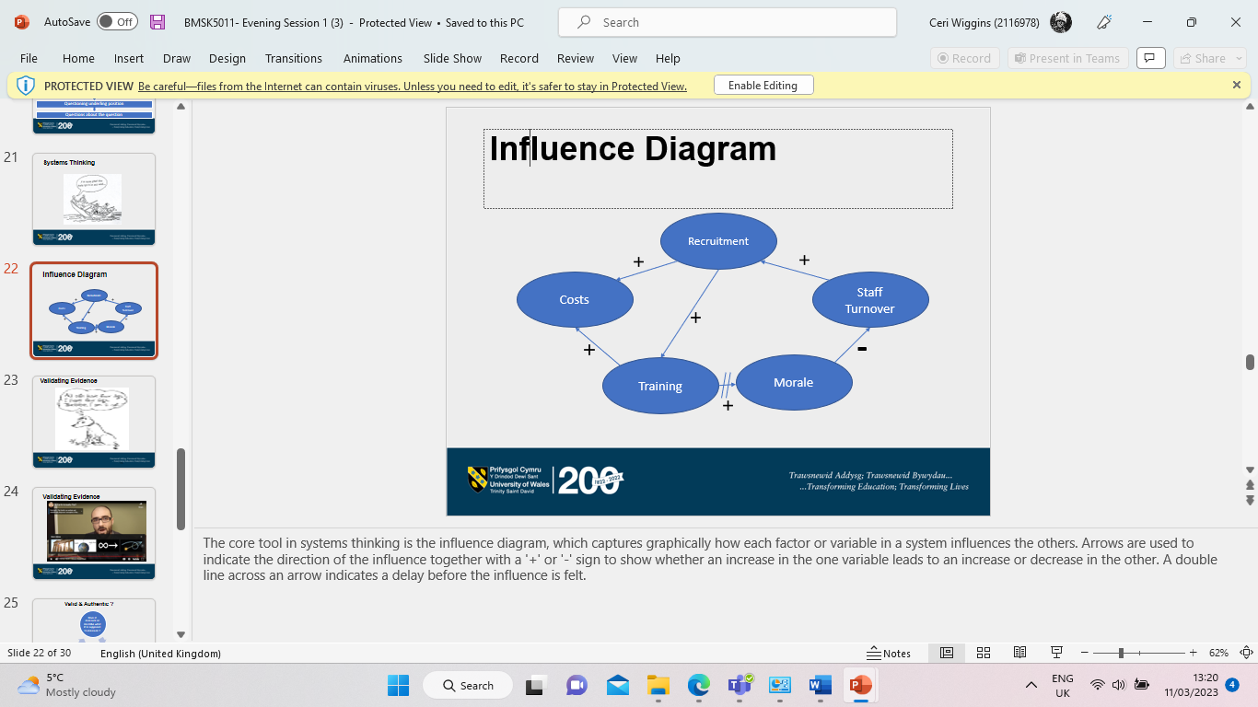

Pearson Red Model

The Pearson red model comprises of three areas, assumptions, evaluating arguments and drawing conclusions. Recognizing assumptions is “the ability to separate fact from opinion” http://www.thinkwatson.com/think-red/red-critical-thinking-model, and being able to question to reveal the gaps in information or logic whilst seeing the information through the eyes of other people.
Evaluating arguments – analysing the information objectively, questioning the supporting evidence, and understanding how emotion can influence a situation. Barriers could include emotions getting in the way or confirmation bias. “Being able to remain objective and sort through the validity of different positions helps draw more accurate conclusions” http://www.thinkwatson.com/think-red/red-critical-thinking-model
Drawing conclusions shows the ability to take all the information together and arrive at a logical conclusion that follows from the available evidence, they use good judgement to arrive at a quality judgement and could change their position if evidence directs them to do so.

Values

Definition of Values

A value is a measure of the worth or importance a person attaches to something, our values are often reflected in the way we live our lives e.g. I value freedom of speech, or I value my family. (Anderson +De Silvia 2009)
According to indeed a recruitment website that provides advice, “Values are the basic, most fundamental beliefs a person can have. They help to determine what a person prioritizes, who they want to be, how they live their lives, and how they interact with their community”. https://www.indeed.com/career-advice/interviewing/importance-of-values.

Where do they develop?

We gain our values from the ages of 0-7 from our parents, between the ages of 7-14 from our Heroes or Celebrities, from 14-21 Peers, and from 21-35 from business values i.e., the workplace. We can obtain our values from family, religion, cultures, the workplace, social influences/peers, and significant life/historical events. Values can be split into 3 groups. The foundation values are the basic values of our lives, Focus Values, are the value priorities in our lives that form attitudes to relationships and Future values which represent what is important to us in the future.
Values can change depending on what is important to us at the time and
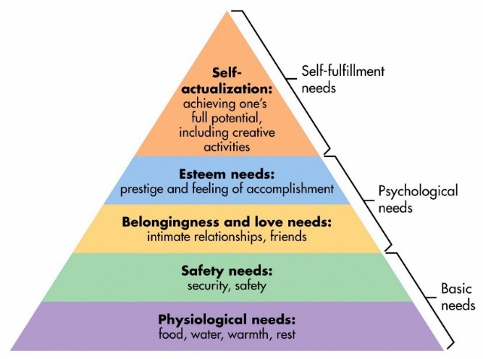Maslow’s Hierarchy of needs triangle 1943
“Maslow’s (1943) original triangle of needs initially stated that individuals must satisfy lower-level deficit needs before progressing to meet higher-level growth needs.
Basic needs such as food water, warmth, rest, security, and safety, by belonging, having relationships, friends, and a feeling of accomplishment would meet psychological needs, therefore most values would tend to start here before we get to the self-fulfilment stage, he later went on to add more levels into his theory.

Benefits of Values

The benefits of values help us understand why we believe what we do and if we want to change it, we sometimes will have shared values i.e. a married couple will have values on which their relationship is based, Values can motivate us to go after something we want such as promotion, or another goal, and if we know our values it can make us more tolerant to others as it will allow us to understand why someone is acting in a particular way. Values can give our lives meaningful significance.

Attitudes

Definition of Attitudes

“An attitude is the way a person expresses or applies their beliefs and values and is expressed through words and behaviour” Anderson & DeSilva 2012.

Where do attitudes develop?

Attitudes develop from our values and beliefs and are adopted by individuals and groups towards others, their surroundings, and society. “Attitudes are shaped, formed and developed by every influence, activity, and institutions that people come across in their lives” The disciplines of organisational behaviour. (Pettinger, 2010)
Attitudes are formed within the family, friends, occupations, societies, companies, and organisations that business is conducted with and knowledge of a person such as the King, Queen or prime minister but with no direct contact or experience with them.
Organisations can shape staff attitudes from the minute they make an application and continues right through the recruitment and selection process and how appointments are made. The induction process, initial attitudes of colleagues including management, and their styles including the culture of the workplace will also show the organisation attitude along with co-workers and you will be able to see their prevailing work ethic.

Beliefs

Definition of Beliefs

Beliefs are things that we hold to be true and underpin our values as per Anderson & DeSilva 2009 “A belief is an internal feeling that something is true, even though that belief maybe unproven or irrational”.

Where do beliefs come from?
A belief comes from different sources, including personal experience, culture, education, religion, faith, and mentors, and is adopted as part of their belief system.

Behaviours

Behaviour is the way you act. and the way we present ourselves to the world. During the day we see a wide range of behaviours from appearance (Clothing, hygiene) and body language that can provide you with insights that connect back to what someone was taught (their beliefs) as a child.

What Links Values, Attitudes, and Beliefs
Once a person accepts a belief as a truth, they will be willing to defend it and can form part of their belief system. Values, attitudes, and beliefs are all intertwined, and develop from family, work, and surroundings and all are part of our behaviours.
From the diagram below you can see how beliefs, values, and attitudes and linked and how beliefs affect values and beliefs and values both affect behaviours.
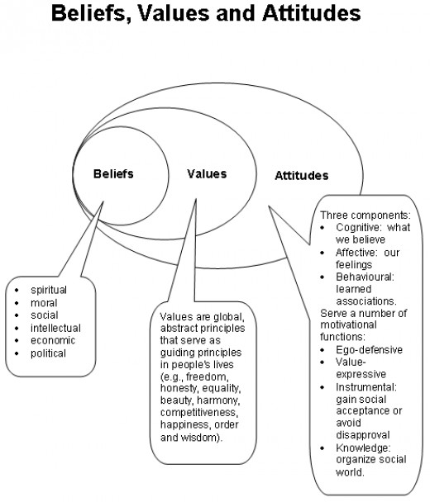

My Values, Attitudes, Beliefs, and Behaviours.

Self-Assessment

I completed two different values and surveys to see if I could identify what values were, and the surveys were the Rokeach Value survey, which has been used since 1968 to study instrumental and terminal values of individuals. The another is a Values Assessment survey, by the Skills Scan, (see appendix A for my results).

My Values

Looking at the Rokeach Vale survey my top five instrumental values were
- Loving,
- Responsible
- Polite
- Loyal
- Honest
My top 5 terminal values were.
- Health
- Family Security
- A comfortable life
- Mature love
- Pleasure
“The key difference between terminal and instrumental values is that terminal values are the highest values in a person’s value system, whereas instrumental values are the ones that are often used”. (Sethmini, 2021)
The Skills Values assessment exercise showed me that my top five activity-based values are: -
- Leadership
- Contributing
- Help others.
- New ideas/Learning
- Creativity
From analysing my values, they fall into a Mental/ Analytical/creative – an artistic theme, in which my definition is being able to have an input with new ideas that benefit the organisations I work for and colleagues and service users.
Secondly, humanitarian communication is a social theme that I have described as going above and beyond for a customer, a once-and-done approach to benefit the service users.
And lastly, Leadership/Management communication is an enterprising theme that I have defined as being able to progress by passing 1st year of education or gaining a promotion.

My top five work-life and environment values were.
- Teamwork- where I define as working as collaborating with others to meet an end goal and have personal experience with this when chasing a missing payment for a vulnerable customer via different departments.
- Recognition- Noticing my achievements and celebrating them- being selected for the people group by colleagues to present them in our cluster.
- A balanced lifestyle to me is having the flexibility to work from home, finish early, and be able to juggle the demands of work, family, and university commitments.
- A sense of community is the feeling of being part of something, helping each other- being part of a team, and getting along.
- Friendships- person/s with whom you develop a bond and help when needed.

Critical Analysis of Values Surveys and Self-assessment of my Values

The Values Assessment Exercise, (Devin Ryder, 2015) is split into 3 sections and you must complete step 1 then go on to list your top 6/8 values for each section and then give your definition of the value you have chosen, this made you think about the value and then give your own experience of the value/definition. This may have some unconscious bias to the definition as it is your thoughts and feelings but compared with the Rokeach Value Survey, which was developed by psychologist Milton Rokeach.
This consists of two sets of values; one set is called terminal values the other instrumental values there are 18 individual value items in each section and which is the basis for the association of fundamental values with beliefs and attitudes. You order these values between 1 and 18, this is a straightforward questionnaire but some of the terminal values such as salvation, world peace, and national security are all values that I would want but would necessarily have the means or know-how to help achieve this, so even though they are important to myself other values that are more attainable to myself would be higher up the list.

How I got my Values, Attitudes, Beliefs, and behaviours

I have gained my values, attitudes, beliefs, and behaviours from various sources over the years. My culture including my parents, grandparents, and the rest of my family such as aunts and uncles have helped install my first values and beliefs, then through my education via teaching staff, mentors such as sports club coaches, and my current and previous employers would shape them to what they are today my beliefs and values and attitude. As a result, my behaviours reflect what my values are and that I try to go above and beyond to help someone, I’ll chase and fight for something if I believe there is an injustice to a person and work hard to try and develop myself. And that health and family and friends are my 2 terminal values.

As we can see from the chart, beliefs, values, and attitudes shape our behaviours.
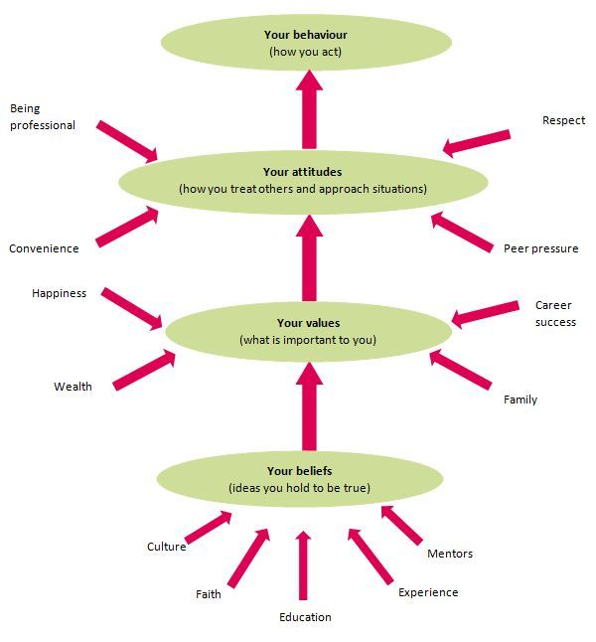

Management Styles and Theories

Leadership Styles

According to (MOISE, 2014) There are thought to be nine different styles of management some of these are: -
Autocratic – where managers have power over the team and team members have little opportunity to make suggestions.
Bureaucratic leaders work rigorously to rule and ensure staff works hard too, they work in involving safety-critical tasks,
Democratic or a participant leader will usually involve employees in the decision-making process but will have the last word,
A Laissez-Faire style leader will allow people to work on their own with a Leave it be attitude as team members as usually experienced, and self-motivated.
People-oriented will focus on developing individuals within a team, good teamwork and collaboration.
Servant Leadership is a leader who facilities his team whilst leading from behind.
Focussing on only getting the job done, with repetitive tasks and within a deadline would describe an oriented leader.
Transactional leaders focus on tasks but make sure that they reward/penalise their team members for completion/non-completion of tasks.
A transformational leadership style will adapt to their surroundings and work well for most business types and be flexible.

Four schools of Management Theories

The Scientific school can be described as time observations that led to the systematic training of workers with the workload evenly shared between them and not allowing them to use discretion in their tasks. With managers performing the science and instructions and the workers performing the labour, each group doing “the work for which it was best suited”. The concept of breaking the tasks down into subtasks was his biggest legacy but gained some criticism as his theories tended to dehumanize the workers-Frederick W Taylor 1911
Frank and Lillian Gilbreth developed a spirit of cooperation between workers and management to ensure that work is carried out by devised procedures, dividing work between workers and management into almost equal shares, with each group taking over the work for which it is best fitted

Elton Mayo and McGregor’s focused on human behaviour and Mayo’s studies looked at the impact of social factors and productivity. Mayo conducted the Hawthorn studies which saw increased productivity/human beings’ workers weren’t reacting to the surroundings only to the interest that was being taken in them – changing the environment doesn’t change the environment – watching someone does!
McGregor’s X and Y theory is that X type of managers will be driven by money or monetary concerns, will avoid work, lacks ambition and dislike responsibility, are indifferent to the organisational needs and can lack creativity and resist change. X-style managers are usually dominant in the way they manage.
Whilst Y managers are driven, actively seek work, show ambition, and seek responsibility, they are committed to the organisational objectives and welcome change and are also creative Y managers are mostly easier to get along with.
Both are good managers at the appropriate time and can sometimes need to be a mixture of both to be able to do their roles, with Mary p. Follet describing management as the “art of getting things done through the efforts of other people”. (Follett & Graham, 2003)
The Classical school focuses on a social system with cultural relationships, individuals working together in groups have their values which have a bearing on the contribution that they make towards the goals of the organisation, Max Webber’s style focuses on a bureaucratic style of management whilst Henri Fayol’s administrative.
The modern school of management thought highlights “there, are no single managerial
strategies that work for all the people at all times”. (Bennett, 1925)

Critical Assessment of Management Theories

Employers with low engagement have higher turnover rates, and issues with low morale and unhappy employees. By investing in the satisfaction of its employees, a business can increase engagement and motivation, which ultimately impacts productivity. Although the Herzberg theory can help you create greater job satisfaction in the workplace, it does have some limitations. It's subject to bias, since employees may focus on aspects of their jobs they like when the work environment is satisfying, and external factors can have a greater influence when challenges arise. Employees may uniquely perceive the workplace application of the theory may be most effective on an individual level. When employees are more satisfied with their job content and job environment. When job satisfaction is high, employees are more willing to do more for less and indulge in discretionary job activities, which are not rewarded.
On the other hand, the Herzberg Theory can also be a disadvantage, less-educated employees do not have the need for achievement and self-actualisation. Basic hygiene needs are all it takes to satisfy them.
If managers do not identify these types of employees, Instead of being motivated and having a sense of achievement, these employees would only be overwhelmed, and might also be dissatisfied, even though their basic needs have been fulfilled.
Based on Herzberg’s hygiene factor – money is also motivation for a lot of employees, it motivates them to work harder to gain recognition and in turn, leads to higher salaries
The X and Y management Most managers will likely use a mixture of Theory X and Theory Y, and naturally, favour one over the other.
Although both styles of management can motivate people, the success of each will largely depend on your team and choosing the correct method for the individual, as if you did not, it would likely have a demotivating effect and could damage your relationship.
Circumstances can also affect your management style and people are unlikely to find reward or fulfilment in their work. Theory Y tends to be favoured by organizations that have a flatter structure, and where people at the lower levels are involved in decision-making and have some responsibility.
Theory X being restrictive, could cause people to become demotivated and non-cooperative if your approach is too strict.
A Theory Y approach that gives people too much freedom, may allow them to stray from their key objectives or lose focus, less motivated individuals could advantage of this more relaxed working environment by evading their work. If there are no line managers present some staff members will take longer for breaks, which affects productivity and claimants can be waiting to be seen.

How different workplaces affect Values attitudes behaviours and beliefs.

The Gov.uk website shows the civil service values are, ‘integrity’ is putting the obligations of public service above your interests, ‘honesty’ is being truthful and open, ‘objectivity’ is basing your advice and decisions on rigorous analysis of the evidence and ‘impartiality’ is acting solely according to the merits of the case and serving equally well governments of different political persuasions” The civil service code. gov.uk
As a civil servant, you are in a position of trust and as per their value integrity this affects your behaviour inside and outside of the workplace, you cannot for example critique or support a particular political party and should be seen acting with integrity so any behaviour outside the workplace could be construed as bringing the organisation into disrepute. This could mean that you may change the way you act, for example, I have limited what I post on social media and limited who can see my posts so the general public cannot see only close family and friends.

Part of Asda’s values is “We get on with things, we make them happen” (eArcu) may mean that individuals give more of themselves to make this happen and the behaviours change they may come into work earlier or stay later or do things that are outside of the job description or do more than what is contractual. Working at Asda changed my views as a mother of young children I couldn’t increase my hours and felt they did not support me and felt though I was not kept on as I wasn’t as flexible as they would have liked, whereas when the need arose within DWP and I asked to reduce my working hours they accommodated me and continue to do so. This meant that I did not feel loyal to Asda and immediately started looking for other employment, on the other hand, I have continued to work for DWP due to the better working hours and benefits of the role.

Impact of behaviour in the workplace based on management style.

My role within DWP involves coaching the unemployed into work, engaging with internal and external departments, identifying vulnerabilities, and putting in suitable and appropriate measures to assist claimants, diary management and a combination of digital, telephone and face-to-face contacts daily. Giving feedback, positive and negative and helping claimants achieve their job aspirations. See appendix B.
There are several different management styles evident in my current role one being Herzberg’s motivation and hygiene theory as the hygiene factors were pay, working conditions, relationships, policies, benefits, and status of being associated with being a civil servant and that these are mostly up to level and the motivation factors of recognition, achievement, nature of the work and responsibility. “Herzberg assumed a correlation between satisfaction and productivity. But the research conducted by Herzberg stressed upon satisfaction and ignored productivity”. Herzberg’s Two-Factor Theory of Motivation (managementstudyguide.com). Impact of the Hygiene factors when staff are unhappy with pay and other factors they make their thoughts known and strike, productivity is reduced, and when the motivation factors are low as staff do not feel valued and affects working conditions. Theory Y believes that the employees are very responsible, and they are ambitious. This style of management gives a feeling of trust and recognizes the expertise of the staff member, resulting in positivity and more work. (Gurbuz et al. 2014)

A Laissez-Faire style of leadership comes to mind as the leader will come directly to speak to us if an issue arises, allows staff to develop by sharing additional responsibilities so they have new skill sets, also get involved themselves in raising issues, well-being activities and are committed to the DWP values.

As a temporary checkout operator for the Christmas period, I had to complete a personality questionnaire, then a work trial, and a role-playing situation selling a product and a final offer of employment. My main role was serving customers within a supermarket, scanning food and other items, and handling cash and card payments, I was trained with legislation involved in serving alcohol and other age-restricted products. The leaders were autocratic in their style and showed their power over the team, being told when to take breaks, move off till and allocating shift patterns, I found being employed there being a number and when you couldn’t work additional hours or change a shift due to childcare it placed you at a disadvantage, there was also a high turnover of staff and the recruitment process for a casual role rather lengthy and time-consuming.

Conclusion

The benefits of the X and Y management style are that with the Y management, I was free to work independently and not micro-managed but when needed my manager would come and give me constructive advice on how to do my role, and I could go and ask for help from her whenever the need arose, I felt respected as an employee and that their values that I was capable of doing my role however due to the hygiene factors slipping such as the pay, working conditions and policies this has meant motivation has decreased within the team and several members of staff have had sideways promotions so for better working conditions - working from home and smaller caseloads. This doesn’t reflect well on my values as I believe that we all are in the same pay grade and should be treated equally and fairly, so have joined the office’s people group to help argue for the same conditions for our roles. In the X style, I felt demotivated and merely just a number.

References

1). Anderson, M. and De Silva, S., (2009). Beliefs, Values and Attitudes. Cumbria: Me and US Ltd
2). Bennett, H. E. (1925). School efficiency; A Manual of Modern School Management. Ginn and Co.
3). The Civil Service Code. GOV.UK. (n.d.). Retrieved March 14, 2023, from https://www.gov.uk/government/publications/civil-service-code/the-civil-service-code
4). Devin Ryder, S. C. for C. D. (2015, August 29). Engaging assessments for career development. Skillscan. Retrieved March 16, 2023, from https://www.skillscan.com/
5). eArcu. (n.d.). There's so much more to Asda than you might imagine. and whatever role you're in at Asda, there are some universally good reasons to be part of our team: ASDA Careers. Retrieved March 14, 2023, from https://www.asda.jobs/about
6). Follett, M. P., & Graham, P. (2003). Mary Parker Follett--prophet of management: A celebration of writings from the 1920s. Beard Books.
7). Gurbuz, S Shin, F and Koksal, O 2014 Revisiting of Theory X and YA multilevel analysis of the effects of leaders’ managerial assumptions on followers’ attitudes. Management Decision 188-1906
8). Global leader in assessments: Pearson Talentlens. Global Leader In Assessments | Pearson TalentLens. (n.d.). Retrieved March 9, 2023, from http://www.thinkwatson.com/think-red/red-critical-thinking-model
9). Haber, Jonathan. Critical Thinking, MIT Press, 2020. ProQuest Ebook Central, http://ebookcentral.proquest.com/lib/trinity/detail.action?docID=6142274 Created from trinity on 2023-03-07 14:50:31.
10). Herzberg’s two-factor theory of motivation. Herzbergs Two-Factor Theory of Motivation. (n.d.). Retrieved March 18, 2023, from https://www.managementstudyguide.com/herzbergs-theory-motivation.htm
11). https://www.indeed.com/career-advice/interviewing/importance-of-values. (n.d.). Retrieved March 10, 2023, from https://ebookcentral.proquest.com/auth/lib/fjpw/login.action
12). Maslow, A. H. (1943). A theory of human motivation. Psychological Review, 50 (4), 370-96.
13). MOISE, C. (2014). Importance of beliefs, attitudes and values in the frame of human resource motivation. Annals of "Spiru Haret". Economic Series, 14(2), 17. https://doi.org/10.26458/1422
14). Morgan, P. (2017). The business student’s guide to study and employability. London, UK; Sage Publications Ltd.
15). Oxford Learner's dictionaries: Find definitions, translations, and grammar explanations at Oxford
16). Learner's dictionaries. Oxford Learner's Dictionaries | Find definitions, translations, and grammar explanations at Oxford Learner's Dictionaries. (n.d.). Retrieved March 9, 2023, from https://www.oxfordlearnersdictionaries.com/
17). Pettinger, R. (2010). Organizational behaviour: Performance management in practice. Routledge.
18). Senge, R, Kleiner, A., Roberts. C, Ross, R. and Smith, J. (1994), The Fifth Discipline Fieldbook, Nicholas Brealey, London.
19). Sethmini. (2021, September 6). What is the difference between terminal and instrumental values. Compare the Difference Between Similar Terms. Retrieved March 15, 2023, from https://www.differencebetween.com/what-is-the-difference-between-terminal-and-instrumental-values/
20). UWTSD, W. D. T.-. (n.d.). Student Careers Service. Careers Service | University of Wales Trinity Saint David. Retrieved March 9, 2023, from https://www.uwtsd.ac.uk/careers/ https://www.uwtsd.ac.uk/alumni/careers accessed 09/03/2023

Appendix

Appendix A Values surveys
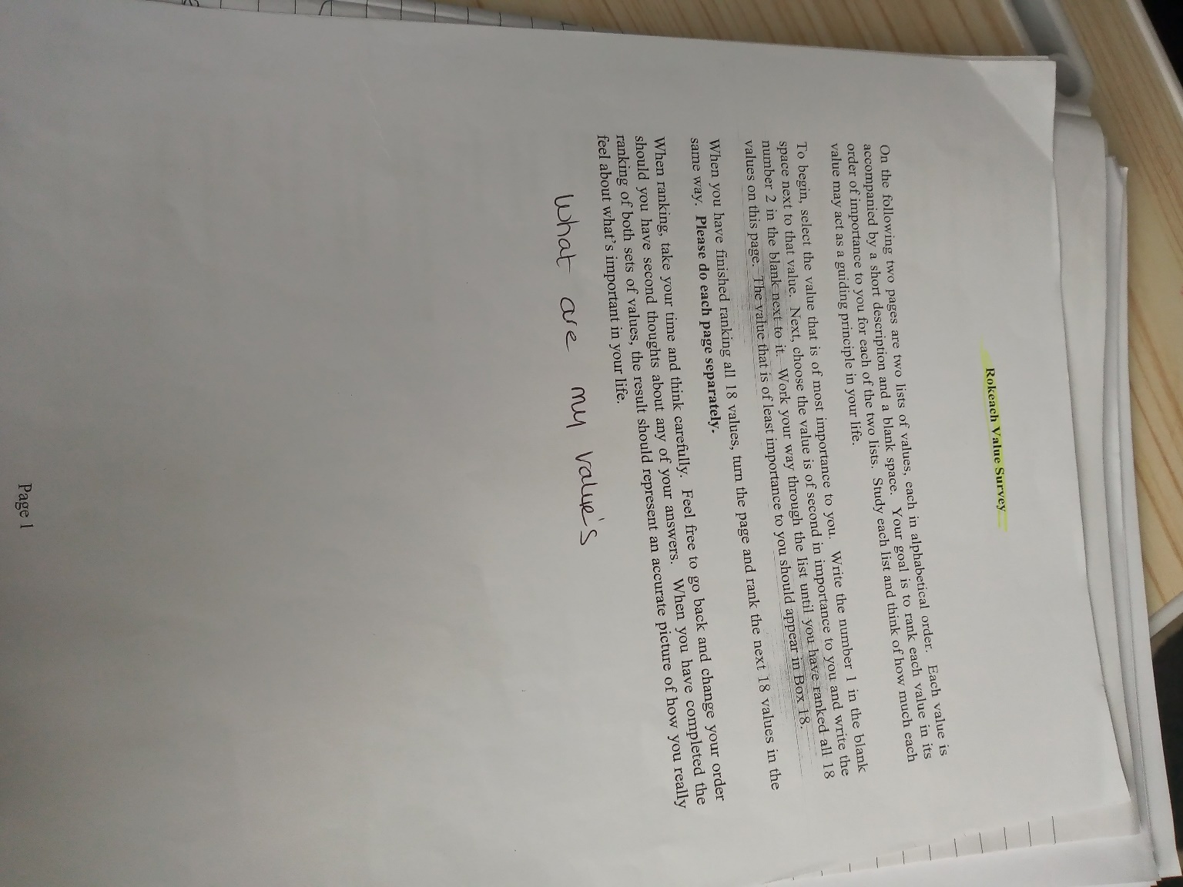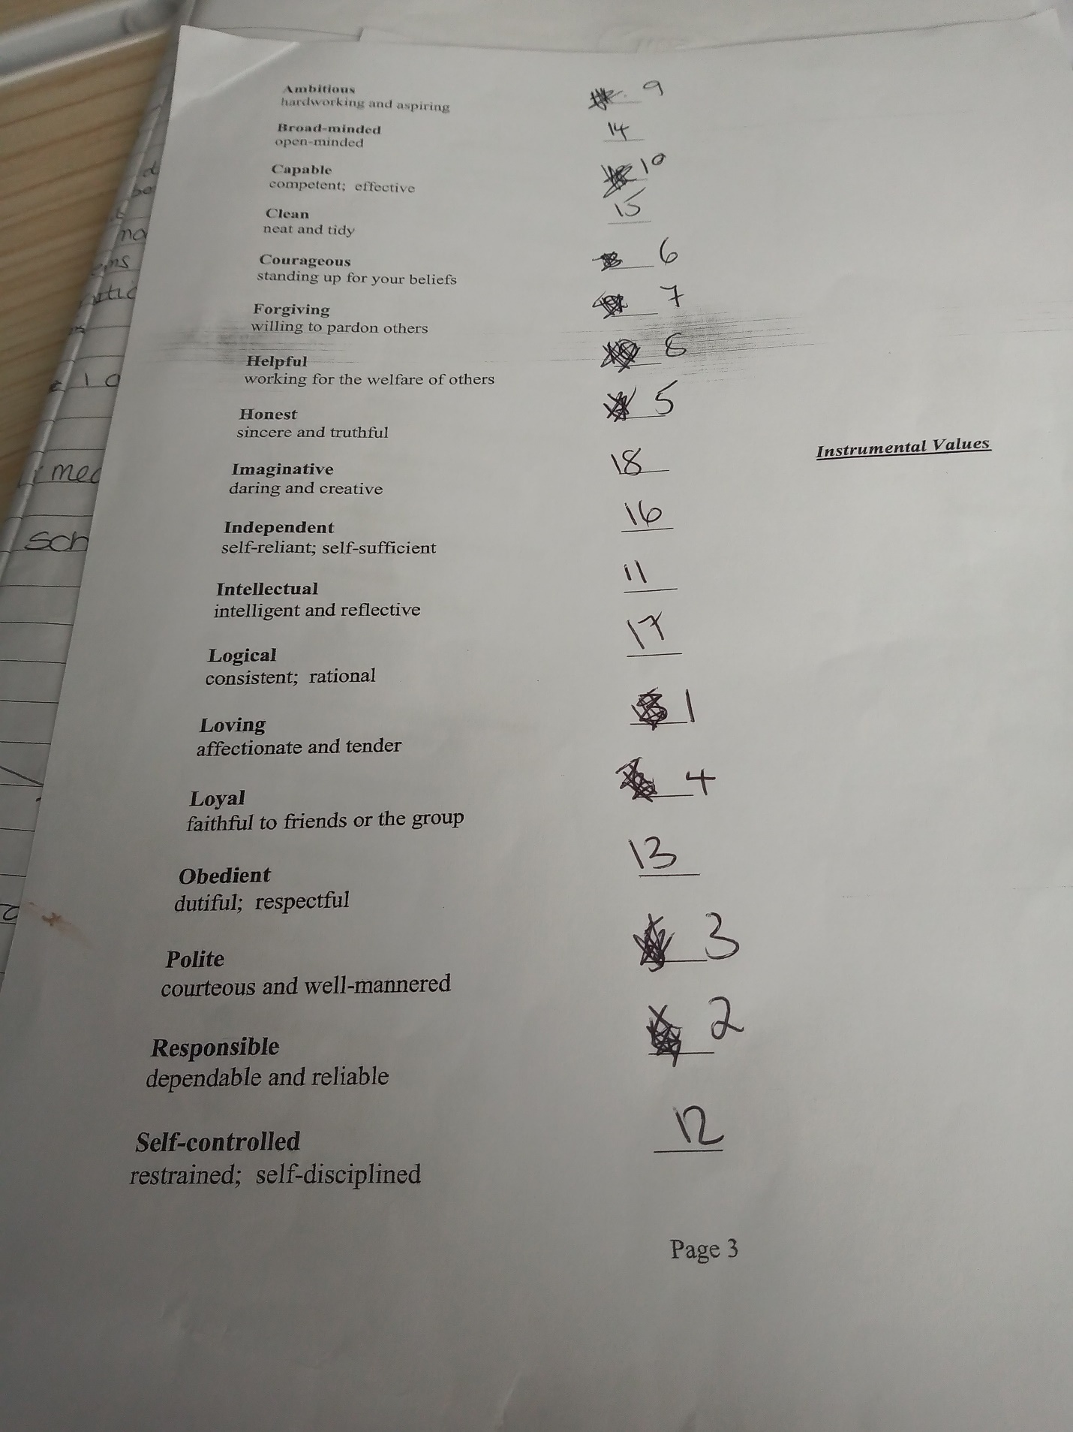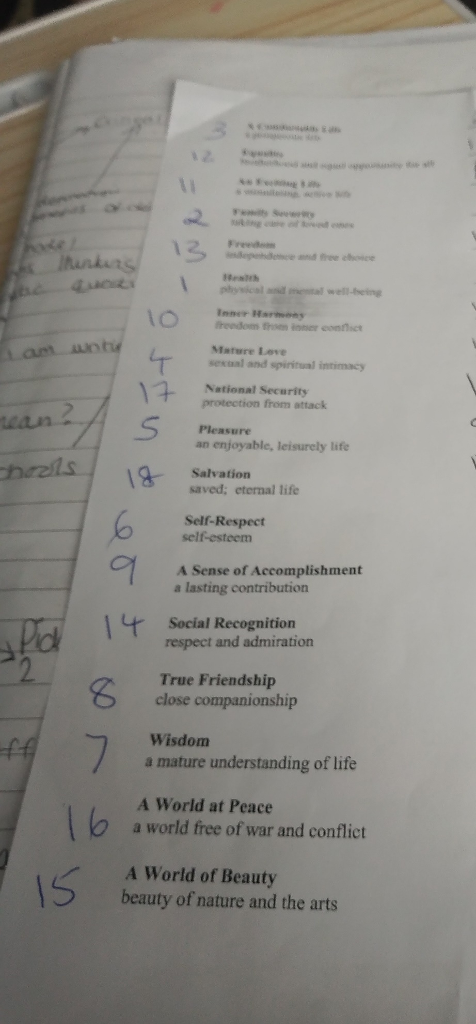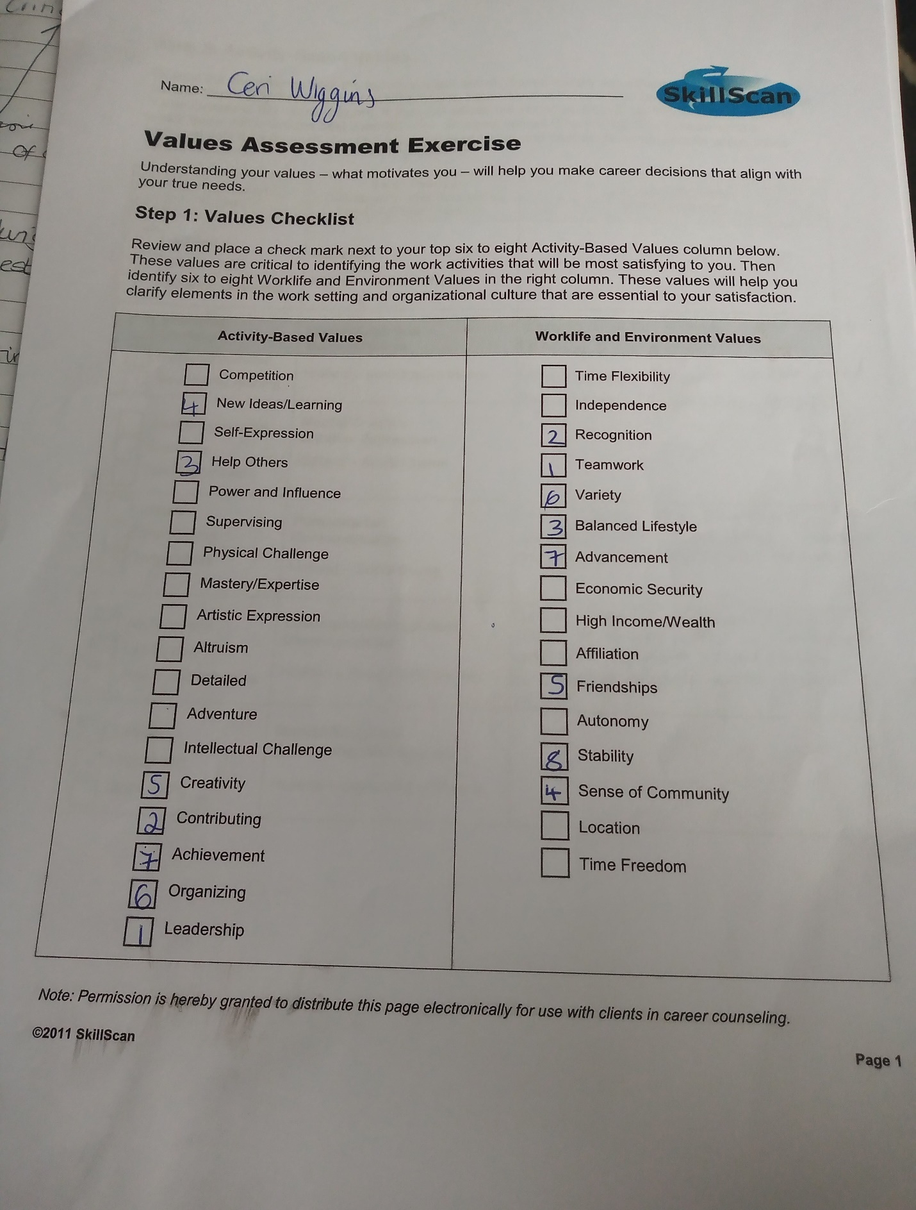
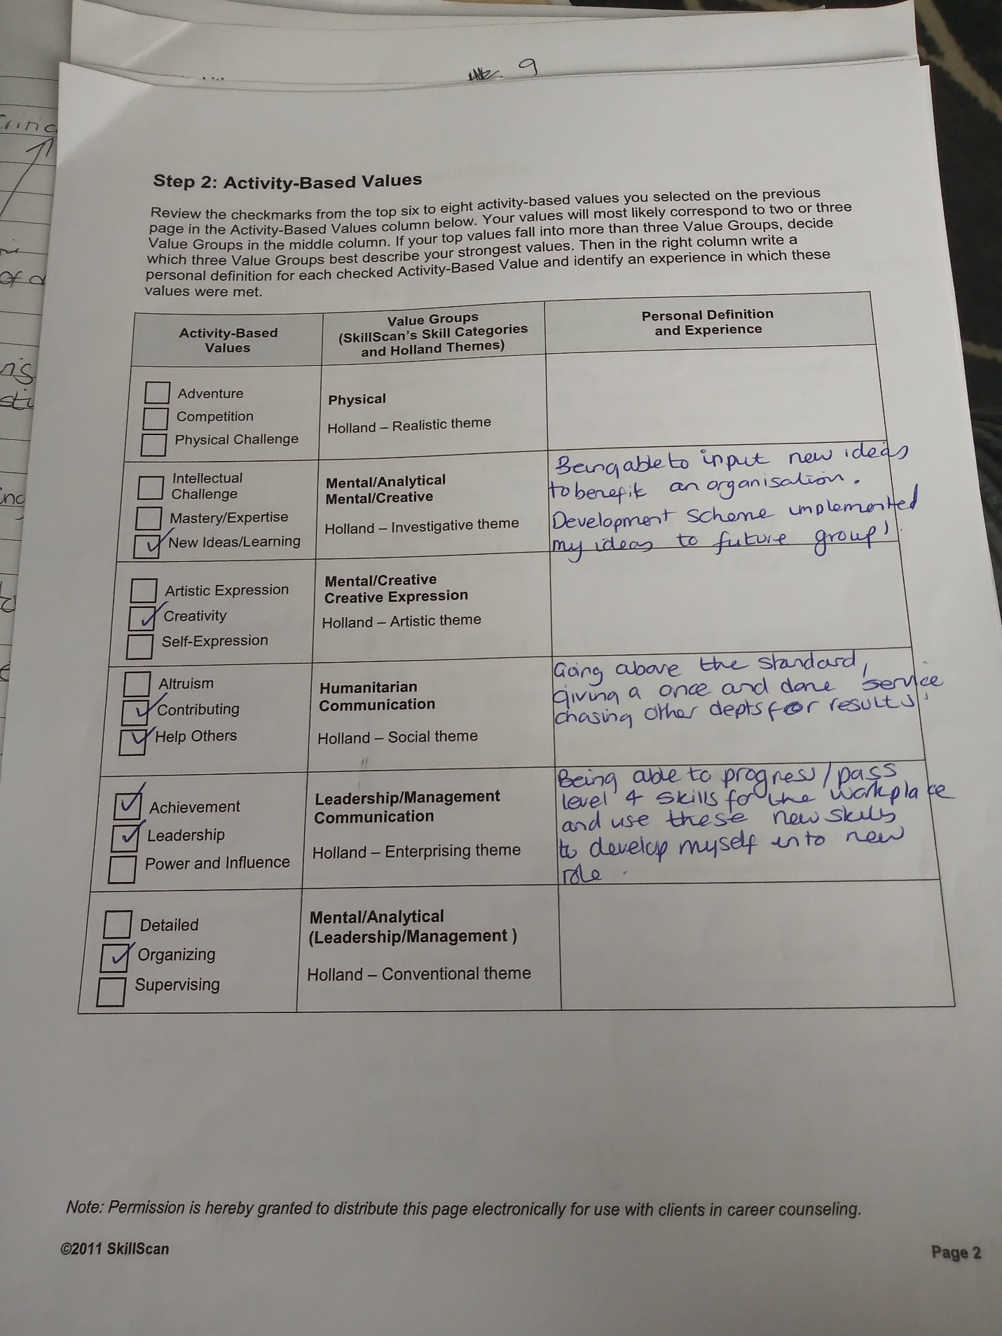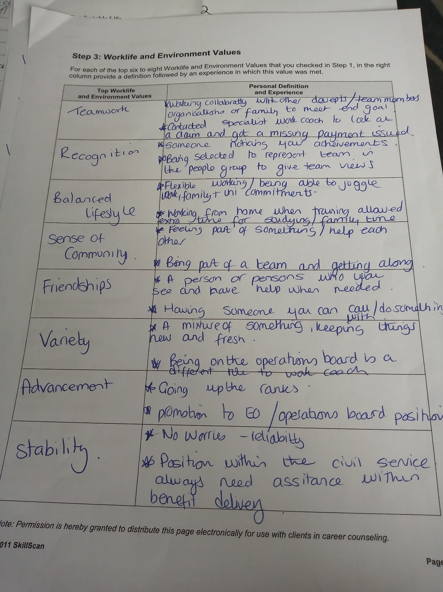

Appendix B Job descriptions

Work Coach Job description.
The Work Coach role is wide-ranging and diverse. You will be working with customers, employers and colleagues through a combination of digital, telephone and face to face contacts on a daily basis. Some of the main activities are set out below: • Providing support to Universal Credit, Jobseekers Allowance, Employment and Support Allowance & Income Support customers.
• Offering quality advice to customers about job search actions, supporting them to job search effectively in a largely digital world.
• Building positive relationships with customers that encourages, motivates and builds trust.
• Developing an in-depth knowledge of local employment opportunities, recognising the roles that our Partners and Employers have in helping our customers secure employment.
• Making timely decisions, based on customer needs, and referring them to appropriate help and support. Responsibilities To be successful you will need to demonstrate effective communication skills across a wide range of diverse customers, along with the ability to understand complex information and give explanations to the customer. You must be able to navigate a range of computer systems to action tasks as well as coach others to use digital work searching. You’ll also be required to handle telephony queries and have the ability to manage difficult situations.
Asda Team Member
Are you looking for a flexible role in a fast-paced environment? Do you love working as part of a team to deliver outstanding service to customers?
What's in it for you?
Alongside a competitive salary, we offer a great range of other benefits too. You'll receive a discount card for yourself and a second card for your nominated user, giving you 10% off your shopping and you'll also receive a company pension. On the ‘Our Asda' benefits site, you will have access to a wide range of discounts across various activities and services, anything from airport parking to theme parks and pet insurance to car tyres – whatever you're into there's something to suit everyone!
About the Role
Our stores operate 24 hours per day, 7 days per week, with that brings a wide variety of shift patterns – if you're looking for flexible working to fit around your lifestyle, then look no further! We'll work with you on your shifts, but weekend working is a requirement of the role and we may need to be flexible with your work pattern.
There's a role for everyone in retail - from serving our customers, perfecting pizzas, unpacking deliveries or filling shelves. Wherever you are, we put our customers first with excellent service, welcoming stores and ‘extra special' products – we work as a team to maximise sales and deliver a great shopping experience.
We'll help you to become a star colleague from learning about food safety to making sure our customers are served with a smile. If you're looking for flexible working or a chance to develop in retail, this could be the role for you!
About You
You'll be naturally friendly and want to get stuck in, working with your team to deliver great results. You'll have an enthusiastic approach to learning new skills across different departments. You care about giving customers a great shopping experience, helping them find what they need and having a chat along the way.

