
Project
Student: Yehor Kulikov
Student id: 2417098
LCLM5003
Project management
Lecturer: Xavier Matieni

April 2026

Table of contents
Part A - Poster 3
Part B – Reflection on the Presentation Using Gibbs’ Reflective Cycle 4
1.Description 4
2.Feelings 4
3.Evaluation 4
4.Analysis 4
5.Conclusion 5
6.Action Plan 5
Part C – Project Management Plan 6
1. Introduction 6
2. Project Description 6
3. Scope 7
3.1 In Scope 7
3.2 Out of Scope 8
3.3 Deliverables 8
3.4 Success Criteria 8
4. Work Breakdown Structure 9
4.1. Project Initiation 9
4.2. Project Planning 9
4.3. Procurement and Mobilisation 9
4.4. Reconstruction Works 9
4.5. Monitoring and Control 9
4.6. Project Closure 10
5. Quad Chart 10
5.1 Objectives 10
5.2 Stakeholders / Customers 10
5.3 Deliverables / Critical Success Factors 10
5.4 Measures of Success 11
6. Gantt Chart 11
6.1 Indicative Timeline 11
6.2 Key Milestones 12
7. Stakeholders’ Involvement 12
7.1 Key Stakeholders 12
7.2 Power–Interest Analysis 12
7.3 RACI Matrix 12
8. Allocation of Resources 13
8.1 Human Resources 13
8.2 Physical Resources 13
8.3 Financial Resources 14
8.4 Time Resources 14
8.5 Project Triangle 14
9. Risk Analysis 14
9.1 Risk Assessment Table 14
9.2 Discussion 15
10. Conclusion 15
11. References 16

Part A - Poster
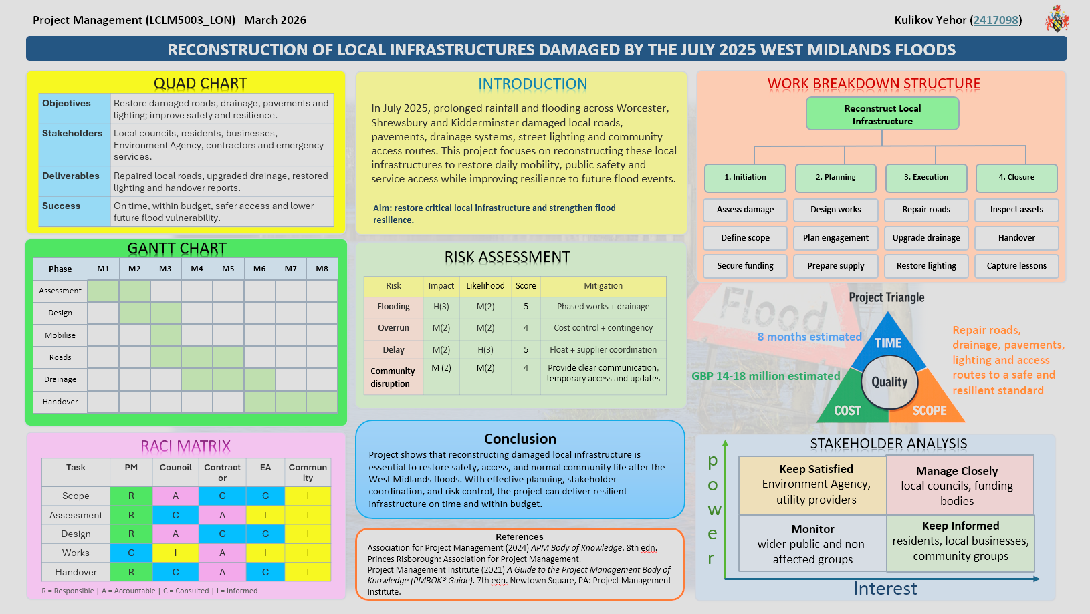

Part B – Reflection on the Presentation Using Gibbs’ Reflective Cycle

1.Description
For this assessment, I presented my poster to my tutor and peers. The poster included the main parts of my proposal, such as the aim, stakeholder analysis, Gantt chart, quad chart, project triangle, work breakdown structure, and risk assessment. While creating it, I spent a lot of time on both the content and the design. I wanted it to look professional, clear, and easy to read, so I focused carefully on layout, spacing, colours, and structure.
Before the presentation, I sent my poster to the lecturer for checking. He told me that it was missing a conclusion and references. I corrected these points quickly before presenting. On the day of the presentation, I was late, which made me feel rushed and stressed before I started speaking.

2.Feelings
Before the presentation, I felt very nervous. Being late made this worse because I did not have enough time to calm down. At the same time, I felt that I had done strong work. I knew I had put a lot of effort into the poster, and I believed that the design was one of its strongest features. This gave me some confidence, but I still felt anxious.
During the presentation, I felt tense and under pressure. I tried to stay focused and explain my work clearly, but I know my nervousness affected my confidence. After the presentation, I felt relieved that it was over, but also slightly disappointed because I did not think my delivery showed the full quality of the work.

3.Evaluation
One positive aspect was the quality of the poster itself. I believe it looked organised, readable, and professional. I also think that responding quickly to the lecturer’s feedback improved the poster before the presentation. Another positive point was that I knew my content well because I had worked hard on it.
However, there were also weaknesses. The main issue was my nervousness, which was increased by being late. In addition, during the class presentation I received feedback that my quad chart was formatted slightly incorrectly. This showed me that although my poster was strong overall, I still needed to check some technical details more carefully.

4.Analysis
This experience showed me that a good presentation depends on both strong preparation and confident delivery. One of my strengths is visual presentation, because I spent a lot of time making sure the poster was clear and easy to read. I also learned that feedback is very useful, because it helped me improve the poster before presenting.
At the same time, I realised that stress and poor timing can affect confidence. Even when the work itself is strong, nervousness can reduce the quality of presentation delivery.

5.Conclusion
Overall, this presentation helped me recognise that my strengths are effort, design, and willingness to improve after feedback. However, I also need to improve my confidence and pay more attention to technical accuracy.

6.Action Plan
In future presentations, I will arrive earlier, so I feel calmer and more prepared. I will also practise my speaking more and check all poster elements carefully, especially visual tools such as the quad chart.

Part C – Project Management Plan
Project Management Plan for the Reconstruction of Damaged Local Infrastructure in the West Midlands Following the July 2025 Floods

1. Introduction
In July 2025, severe flooding caused major damage to local infrastructure in Worcester, Shrewsbury, and Kidderminster. Following prolonged rainfall and the breaching of the River Severn, local roads, pavements, drainage systems, street lighting, and access routes were damaged or made unusable. This created serious disruption for residents, businesses, emergency services, and local authorities.
Local infrastructure is essential to daily community life because it supports safe movement, access to services, local business activity, and emergency response. When such infrastructure fails, the effects are immediate and widespread. For this reason, the selected project is the reconstruction of damaged local infrastructure in the affected West Midlands towns. The project aims not only to repair damaged assets, but also to improve resilience so that rebuilt infrastructure is better able to cope with future flooding events (APM, 2025; PMI, 2021).
A structured project management approach is appropriate in this context because it helps define objectives, control scope, allocate resources, manage stakeholders, and reduce delivery risk (Burke, 2013; Kerzner, 2022). It also supports accountability, which is especially important in publicly funded recovery work (Turner, 2016). This report therefore presents the project description, scope, work breakdown structure, quad chart, Gantt chart, stakeholder involvement, resource allocation, risk analysis, conclusion, and references.
The overall purpose of the project is to restore essential local infrastructure, improve community safety and access, and support recovery in the affected areas.

2. Project Description
The proposed project focuses on the reconstruction of local infrastructure damaged by the floods in Worcester, Shrewsbury, and Kidderminster. The project covers local public assets that are essential for everyday movement, access, and service delivery. These include local roads, pavements, drainage channels, culverts, street lighting, public walkways, and local access routes connecting residential and commercial areas.
The need for the project is significant for several reasons. First, damaged infrastructure creates direct safety risks. Broken pavements, unstable road surfaces, failed drainage systems, and damaged lighting increase the likelihood of accidents and restrict safe mobility. Second, damage to local access routes affects residents’ ability to reach healthcare, schools, workplaces, and public services. Third, the disruption also affects businesses, particularly smaller local firms that depend on functioning streets and service access. Finally, if damaged assets are rebuilt without resilience improvements, similar losses may occur again in future extreme weather events (Winch, 2014; Kerzner, 2022).
For that reason, the project will combine restoration and resilience improvement. Restoration involves repairing and rebuilding damaged public infrastructure so that communities can return to normal functioning. Resilience improvement involves using better drainage, stronger materials, improved design standards, and more effective inspection and maintenance planning to reduce future vulnerability (PMI, 2021; Winch, 2014).
The main aim of the project is:
To reconstruct damaged local infrastructure in the West Midlands in order to restore public safety, improve community access, support local recovery, and increase resilience to future flooding.
The project objectives are:
- To identify and prioritise damaged local infrastructure assets.
- To reconstruct essential roads, pavements, drainage systems, lighting, and access routes.
- To restore safe local movement for residents, services, and businesses.
- To reduce future flood vulnerability through resilient reconstruction measures.
- To complete the project within agreed time, cost, and quality constraints.
These objectives are important because clear project objectives help align stakeholder expectations with practical delivery constraints such as time, cost, and quality (Maylor, 2010; Kerzner, 2022).

3. Scope
Clear scope definition is necessary because flood recovery projects can easily expand beyond their original purpose. Without a defined scope, the project could face cost increases, delay, duplication of work, and disagreement among stakeholders. Scope management is therefore a core factor in project success (PMI, 2021; Burke, 2013).

3.1 In Scope
The following activities are included:
- Inspection and assessment of damaged local infrastructure.
- Prioritisation of assets according to safety, access, and service impact.
- Debris removal and site clearance where needed.
- Reconstruction and repair of local roads, pavements, drainage systems, street lighting, and local access routes.
- Temporary traffic and pedestrian diversion measures.
- Safety inspections, environmental controls, and quality checks.
- Stakeholder communication and public information updates.
- Final inspection, handover, and close-out reporting.

3.2 Out of Scope
The following are excluded:
- Reconstruction of private homes or private business premises.
- Major highway or trunk road reconstruction.
- Large-scale flood defence or river engineering works.
- Compensation, insurance, or personal claims management.
- Full restoration of utility networks except where directly necessary for project completion.

3.3 Deliverables
The key deliverables are:
- Repaired and reopened local roads and pedestrian routes.
- Restored drainage and water runoff systems.
- Repaired street lighting and local public access infrastructure.
- Documentation including inspections, progress reports, and final handover records.

3.4 Success Criteria
The project will be considered successful if:
- Priority infrastructure assets are restored and reopened on schedule.
- Costs remain within the approved budget.
- Rebuilt assets meet required safety and quality standards.
- Community access is restored.
- Resilience measures reduce vulnerability to similar flood damage in future.
A change control approach should be applied if additional requests arise, because uncontrolled scope changes often lead to cost and schedule problems (Lock, 2014; PMI, 2021).

4. Work Breakdown Structure
A Work Breakdown Structure (WBS) divides the project into manageable components and supports scheduling, responsibility assignment, and cost control (APM, 2025; Lock, 2014). It is particularly useful in infrastructure projects because it helps break complex activities into clearly defined work packages (Winch, 2014).

4.1. Project Initiation
- Confirm project need and objectives
- Identify affected towns and asset categories
- Conduct preliminary damage assessment
- Identify key stakeholders
- Prepare project charter and obtain approvals

4.2. Project Planning
- Detailed site surveys
- Infrastructure prioritisation matrix
- Engineering and design planning
- Procurement planning
- Budget planning and cost baseline
- Risk management plan
- Health, safety, and environmental planning
- Communication and stakeholder engagement plan
- Schedule development

4.3. Procurement and Mobilisation
- Prepare tender documentation
- Appoint contractors and suppliers
- Mobilise labour, equipment, and materials
- Establish temporary traffic and pedestrian controls

4.4. Reconstruction Works
- Clear debris and damaged materials
- Repair local roads
- Repair pavements and pedestrian access
- Restore drainage and culverts
- Reinstate street lighting
- Repair small access structures
- Install resilience improvements
- Undertake ongoing quality inspections

4.5. Monitoring and Control
- Monitor schedule performance
- Monitor cost performance
- Monitor quality and compliance
- Review risks and issues
- Manage stakeholder communications
- Approve corrective actions where required

4.6. Project Closure
- Final inspections
- Snagging and defect correction
- Handover to local authorities
- Final accounts and contract closure
- Lessons learned and final report
This WBS ensures that the project is organised logically and that each work package can be assigned, measured, and controlled effectively (Burke, 2013; Lock, 2014).

5. Quad Chart
A quad chart gives a concise summary of the project for decision-makers and stakeholders. This is useful because it presents objectives, stakeholders, deliverables, and success measures in a simple format that supports communication and oversight (Kerzner, 2022).

5.1 Objectives
- Restore damaged local public infrastructure.
- Improve safe access for residents and local services.
- Support community and economic recovery.
- Increase resilience against future flood damage.

5.2 Stakeholders / Customers
- Local councils
- Residents and community groups
- Local businesses
- Emergency services
- Contractors and suppliers
- Environment Agency
- Department for Transport and relevant public funders

5.3 Deliverables / Critical Success Factors
- Reconstructed local roads and pavements
- Restored drainage systems
- Reinstated lighting and access routes
- Safe and usable local infrastructure
- Timely completion with minimal disruption

5.4 Measures of Success
- Delivery within budget and timeframe
- Compliance with safety and engineering standards
- Reduction in access restrictions
- Positive stakeholder feedback
- Greater resilience of rebuilt assets

6. Gantt Chart
A Gantt chart supports scheduling by showing how activities are sequenced over time. It is useful because it helps project managers and stakeholders understand timing, dependencies, and milestones (Burke, 2013; Young, 2015). For this project, the expected duration is eight months
Indicative Timeline
Phase
M1
M2
M3
M4
M5
M6
M7
M8
Assessment
Design
Mobilise
Roads
Drainage
Handover

6.1 Indicative Timeline
- Month 1: Initiation, assessment, approvals
- Month 2: Detailed planning, design, procurement
- Month 3: Contractor appointment and mobilisation
- Months 3–6: Main reconstruction works
- Months 6–7: Inspections, testing, corrective works
- Month 8: Final handover and closure

6.2 Key Milestones
- Project approval confirmed
- Priority asset list completed
- Contractors appointed
- Reconstruction works started
- Priority local routes reopened
- Final handover completed
The logic of the schedule is important. Survey and prioritisation must happen before detailed reconstruction starts. Procurement must be complete before labour and materials are mobilised. Quality checks must be continuous, not left until the end. The schedule should also include small contingency allowances because weather, supply, and site conditions may create delays.

7. Stakeholders’ Involvement
Stakeholder involvement is central to successful delivery because this project affects local communities directly and relies on public-sector coordination.

7.1 Key Stakeholders
Local Councils – responsible for local coordination, approvals, communication, and long-term asset management.
Residents – directly affected by damaged infrastructure and reconstruction activity.
Local Businesses – require safe access and functioning local streets.
Emergency Services – depend on reliable local access.
Environment Agency – advises on drainage, flood risk, and environmental compliance.
Contractors and Engineers – responsible for technical design and delivery.
Funding Bodies / Government Departments – provide financial support and oversight.
Community Organisations – represent local concerns and vulnerable groups.

7.2 Power–Interest Analysis
- Manage Closely: local councils, funding bodies
- Keep Satisfied: Environment Agency, senior public authorities
- Keep Informed: residents, local businesses, emergency services
- Monitor: general public and non-direct stakeholders

7.3 RACI Matrix
This structure reduces confusion and clarifies decision authority, which is especially important in multi-stakeholder public projects (Morris, 2013; Turner, 2016).
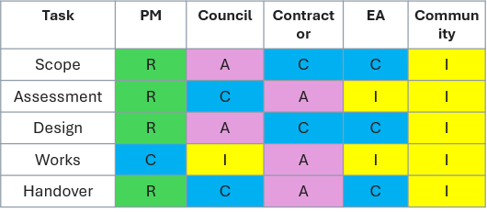

R = Responsible | A = Accountable | C = Consulted | I = Informed

8. Allocation of Resources

8.1 Human Resources
The project will require:
- Project manager
- Civil and drainage engineers
- Quantity surveyor
- Procurement officer
- Site supervisors
- Health and safety officer
- Environmental adviser
- Skilled contractors and labour
- Traffic and pedestrian management staff
- Communications/admin support

8.2 Physical Resources
Required physical resources include:
- Excavators and small plant
- Trucks and waste removal vehicles
- Asphalt, concrete, kerbs, paving materials
- Drainage pipes, channels, and culverts
- Lighting equipment and fixtures
- Barriers, signs, fencing, and PPE

8.3 Financial Resources
A provisional project budget of £12–15 million is proposed, depending on the final scale of prioritised works. This covers surveys, design, contractor mobilisation, labour, materials, temporary traffic measures, inspections, communication, and contingency.

8.4 Time Resources
Time is a critical resource because local infrastructure directly affects daily life. Delays prolong safety risks, service disruption, and inconvenience.

8.5 Project Triangle
The project triangle requires balance between:
- Time – rapid restoration is expected by communities and authorities.
- Cost – public funds must be controlled carefully.
- Scope – the project must stay focused on defined local infrastructure works.
Quality sits at the centre because the project cannot simply reopen damaged assets quickly; it must reopen them safely and to an acceptable standard. If the schedule is compressed too far, quality may suffer. If scope expands, budget and completion time may both increase. Therefore, trade-offs must be managed carefully throughout the project lifecycle (Maylor, 2010; Kerzner, 2022).
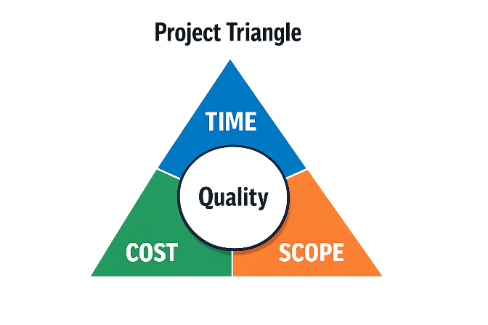
8 months estimated
GBP 14-18 million estimated
Repair roads, drainage, pavements, lighting and access routes to a safe and resilient standard

9. Risk Analysis
Risk management is especially important in flood recovery projects because site conditions, weather, public expectations, and funding pressures create uncertainty. Risk analysis helps identify threats, assess their significance, and plan mitigation before problems become critical (Hillson, 2017; PMI, 2021).

9.1 Risk Assessment Table

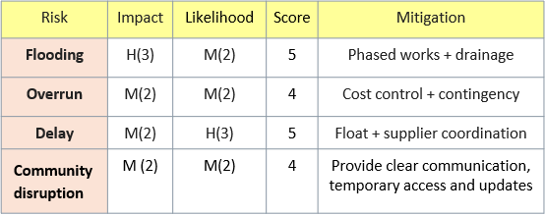

9.2 Discussion
The highest risks are further rainfall and hidden structural damage. Flood-damaged sites often contain weaknesses that are not obvious at first inspection. This can increase both cost and time. For that reason, surveys must be robust and contingency should be built into the budget and schedule.
Community dissatisfaction is also important. Even beneficial reconstruction work can create frustration through noise, closures, and temporary disruption. Communication is therefore a risk response as well as a stakeholder activity (APM, 2025; Turner, 2016).
A live risk register should be maintained throughout the project, reviewed regularly, and updated whenever circumstances change (Hillson, 2017; PMI, 2021).

10. Conclusion
The July 2025 floods caused severe damage to local infrastructure across parts of the West Midlands, disrupting safety, mobility, and community life. The reconstruction of damaged local infrastructure is therefore an appropriate and necessary recovery project.
This project management plan has applied structured project management tools to that challenge. It has defined the project scope, broken the work into manageable stages, summarised objectives through a quad chart, outlined delivery through a Gantt chart, identified stakeholder responsibilities, allocated resources, and assessed major risks.
The project’s success will depend on realistic planning, disciplined scope control, effective stakeholder communication, and strong quality assurance. Most importantly, the project should not only repair damaged assets but also improve their resilience. By doing so, it can support both immediate recovery and longer-term community resilience in Worcester, Shrewsbury, and Kidderminster (APM, 2025; Meredith, Mantel and Shafer, 2021).

11. References
Association for Project Management (APM) (2025) APM Body of Knowledge. 8th edn. Princes Risborough: Association for Project Management.
Burke, R. (2013) Project Management: Planning and Control Techniques. 5th edn. Chichester: Wiley.
Hillson, D. (2017) The Risk Management Handbook: A Practical Guide to Managing the Multiple Dimensions of Risk. London: Kogan Page.
Kerzner, H. (2022) Project Management: A Systems Approach to Planning, Scheduling, and Controlling. 13th edn. Hoboken: Wiley.
Lock, D. (2014) Project Management. 10th edn. London: Routledge.
Maylor, H. (2010) Project Management. 4th edn. Harlow: Pearson.
Meredith, J.R., Mantel, S.J. and Shafer, S.M. (2021) Project Management: A Managerial Approach. 10th edn. Hoboken: Wiley.
Morris, P.W.G. (2013) Reconstructing Project Management. Chichester: Wiley-Blackwell.
Project Management Institute (PMI) (2021) A Guide to the Project Management Body of Knowledge (PMBOK® Guide). 7th edn. Newtown Square, PA: Project Management Institute.
Turner, J.R. (2016) Gower Handbook of Project Management. 5th edn. London: Routledge.
Winch, G.M. (2014) Managing Construction Projects. 2nd edn. Chichester: Wiley Blackwell.
Young, T.L. (2015) Successful Project Management. 6th edn. London: Kogan Page.

