ASSESSMENT 1 – ORGANISATIONAL STRUCTURE & CULTURE IN AIRLINE INDUSTRY

Student: Laura-Andreea Doru (2125338)
Lecturer: Dr. Hoang Nguyen
Executive summary
This report is based on British Airways and sheds light on its organisational culture and structure. It has evaluated the reliability or dependence of organisational performance on organisational structure and culture. It provides an in-depth analysis of the organisational culture and structure of British Airways. Moreover, it highlights leadership and managers' contribution to maintaining a balanced organisational culture as well as structure. It also finds out several behavioural approaches that influence individual behaviour in workplace.
Table of Contents
Introduction 3
Dependence of organisational performance on appropriate culture and structure to accomplish organisational goals in context with British Airways 3
Variables that determine effective management and leadership 5
Influencing factors on individual behaviours at workplace in context with British Airways 6
Conclusion 8
References 9

Introduction
Organisational structure is an essential factor for success, profit and expansion of a business. Similarly, organisational culture is very important as employees "performance, productivity and engagement with organisation" depend on it. Organisational culture and structure are interconnected with each other and take active participation to achieve goals as well as objectives of an organisation. Toxic work culture and structure can negatively impact the growth of an organisation. This report is going to shed light on the relationship between "structure, culture, people and organisational performance" of British Airways. Moreover, it will explain the variables that determine effective management and leadership in British Airways. This report aims to gain in-depth knowledge and understanding of the behavioural approach of management along with the interconnectedness of structure, culture as well as success of organisational performance.

Dependence of organisational performance on appropriate culture and structure to accomplish organisational goals in context with British Airways
British Airways (BA) is the flag carrier of UK and has been providing customers with an excellent flying experience for more than 100 years. As per the views of Weedmark (2019), airline business is unique as well as challenging because it emphasises “speed, safety, and exceptional customer experience” while maintaining reasonable cost of tickets. Effective organisational structure and culture can positively contribute to the success of BA.
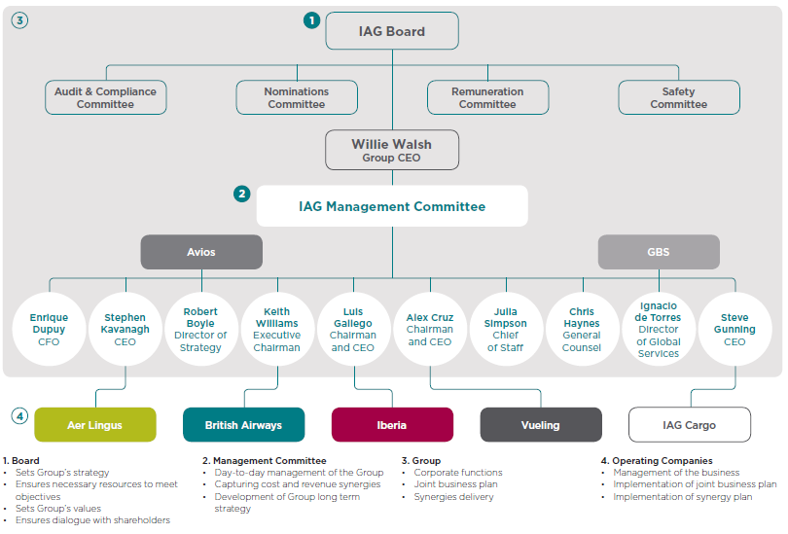
Figure 1: Organisational Structure of British Airways
(Source: Influenced by Moore, 2021)
BA changed its organisational structure in 2015 and currently it is governed by six leaders. As per the opinion of Moore (2021), BA has a "flat structure" that means it has less number management but has a vast span of control. “Commercial Director, Chief Information Officer, Director of Engineering, Director of Investments and Alliances, Director People and Organisational Effectiveness, and General Counsel” are leadership posts of BA. This organisational culture has few benefits and few disadvantages. Flat organisational culture helps in communication due to less number of managers (BBC, 2022). Moreover, it motivates employees and makes them responsible. Employee motivation increases productivity and helps to achieve the goal of the organisation efficiently. However, as argued by Meehan (2019), this type of organisational structure is an obstacle to "long-term" growth as management can reject new opportunities. Besides, it creates confusion among employees as they often do not understand "whom to report''.
Employees sometimes cannot understand their specific job roles due to the tendency of producing more generalists rather than specialists. In BA, employee motivation and quick decision making and effective communication are visible due to this work culture. It is important in the airline industry to be more motivated towards jobs and solve customer problems quickly, which is accelerated in "flat organisational structure".
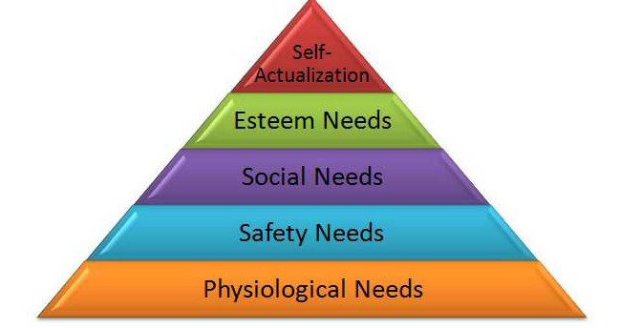
Figure 2: Aspects of Organisational Culture in British Airways
(Source: Influenced by Tiemeyer, 2021)
BA provides an excellent organisational culture that enables employees to be “creative, responsible, honest and respectful”. In the airline industry, respect is very important for employees as they have to handle numerous passengers every day. BA fosters diversity in their employees because they serve numerous passengers with different “cultures, backgrounds and nationality” (BRITISH AIRWAYS, 2018). It helps employees to become accustomed to people with different cultural backgrounds and can get help from an employee with the same cultural background.
Effective workplace culture enhances the customer service of this organisation and increases customer loyalty. Moreover, their work culture “embraces the best of Britain” and encourages people to be true to themselves. It serves British values and strengths such as “knowhow, creativity, energy, diversity and open-mindedness and a sense of respect, responsibility, fair play”. Besides, they encourage a work culture, in which employees are proactive that means they know “when to take responsibility”. BA achieved the “Best Airline Staff in Europe at the Skytrax 2019 World Airline Awards” because of consistent excellent service (BRITISH AIRWAYS, 2018). Furthermore, cabin crew get praised by customers for their friendly behaviour and effort to serve people. In the airline industry, competition is very high and a positive workplace culture provides competitive advantages to BA and increases its profitability. Employee motivation is high due to its “flat organisational structure” and their workplace culture also contribute effectively to boost their motivation. This organisation boasts about their employees and clearly states that BA employees are proud to work with this organisation.
BA provides more than a competitive salary as they provide an attractive reward that includes “alluring pension, discounted shoppings and travel benefits”. Their “earn, save and live” policies offer numerous alluring offers that make employees satisfied to work with this organisation. Their satisfaction increases productivity and motivates them to increase productivity. BA also looks after the environment and nurtures employees, who pledged to remove a quarter of a billion items of single-use plastics from flights by the end of 2020 (BRITISH AIRWAYS, 2018). They also look after the well-being of their employees. All of these indicate a positive environment to work with and foster positive attitude among employees. Thus, their work culture and organisational structure is ultimately good for encouraging those qualities that are required in the airline industry.

Variables that determine effective management and leadership
BA follows an autocratic leadership style and it was the main reason behind conflict among cabin crew. As per the views of Taylor et al. (2022), in 2009 there was a terrible conflict between cabin crew and organisation that led to loss of 150 million revenues. It was a reason for poor autocratic leadership of this organisation. However, there are few advantages of autocratic leadership. It helps to make decisions quickly, foster communication and provide sound command to reach organisational goals. However, it sometimes can lower productivity and make employees feel less empowered within an organisation. Sean Doyle is the Chief Executive Officer (CEO) of BA and he is appointed in October, 2020 (BRITISH AIRWAYS, 2021). He is known to be an autocratic leader and a soft speaker at the very same time. This organisation requires it to empower its employees to make decisions. However, no conflicts in this organisation have been witnessed under his leadership so he can eliminate the scars of poor leadership in the past. It indicates that this leadership is positively affecting the workplace structure and culture of BA.

Influencing factors on individual behaviours at workplace in context with British Airways
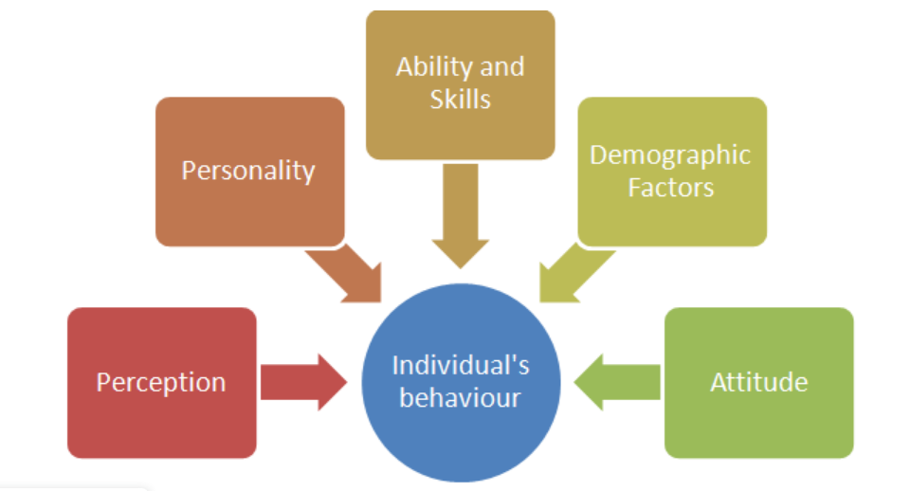
Figure 3: Aspects of Individual Behaviour
(Source: Influenced by Rawlings et al. 2019)
There are several factors that affect individual people’s behaviour at the workplace. In terms of BA, it is extremely important that each employee is patient and polite while attending to customers. Customer satisfaction depends on employee behaviour and a satisfied customer can become a loyal passenger in the airline industry. As per the views of Rawlings et al. (2019), factors such as “perception, personality, ability, skills, morale, values, demographic factor and attitude” influence or stimulate individual behaviour at the workplace. Moreover, organisational factors also contribute to individual behaviour at the workplace and these are “leadership, structure, culture, job responsibility and work environment”. BA recruits employees based on their intellectual abilities and groom them after identifying potential among a candidate.
Values of organisation and their mission are one of the most important factors that influence behaviour of individual people at workplace. The mission of BA is to "ensure customer satisfaction, boost flyers confidence in air, provide security to them, providing best customer service and becoming the number one leading airline organisation” (BRITISH AIRWAYS, 2022). Thus, employees have to follow this mission and work accordingly to achieve the goal of BA. Demography contributes to individual behaviour and BA recruits candidates from diverse demographics. As mentioned by Yadav and Lenka (2020), employees from diverse cultures and ethnicities eliminate talent gaps, bring new ideas and provide different perspectives. Thus, productivity improves and passengers from diverse demographics get to solve their problems efficiently.
Employees are required to have few in-born skills to serve passengers efficiently and it also stimulates individual behaviour at workplace. British airways recruit employees that have emotional resilience, make decisions quickly and can communicate efficiently (BRITISH AIRWAYS, 2022). It indicates that individual employees' behaviour is according to the mission of BA as emotional resilience shapes the personality and attitude of employees. As opined by Scott, (2020), emotional resilience improves "emotional awareness, perseverance and increased sense of humour". Emotional awareness helps to provide empathy to people and perseverance promotes "never giving up attitude". Hence, it can be said that employees of BA behave manner fully to serve passengers and face any kind of obstacle tactfully to resolve problems. Moreover, quick decision-making skill is essential for cabin crews. It is possible that any unexpected situation can happen and that requires effective decisions to solve problems quickly. Employees are the face of this organisation and the reputation of an organisation predominantly depends on their behaviours. For instance, a female passenger suddenly faces labour pain or has a cardiac attack in air. At that time an effective quick decision can save the lives of people as well as enhance the reputation of an organisation.
Organisational culture, leadership and structure are also contributing factors in individual people's behaviour in workplace. BA has a structure that contains fee managers. It makes them independent while making any decision and promotes effective communication between managers. Due to fewer managers, they can discuss a certain problem without being confused. Furthermore, BA provides numerous employee benefits and helps them to balance the family life of employees too. As per the views of Hamilton (2022), BA looks after employees mental health and recruits neurodivergent people in workplace. It indicates that people who love differences, curiosity, engagement and an ally. Ally refers to people that speak up while seeing that any passenger is treated unfairly.
Looking after individual employees' mental health is a very good step that positively impacts individual behaviours at workplace. Besides, BA provides alluring cruise deals and takes passengers on high-quality cruises to keep them cheerful. It increases employee satisfaction and their satisfaction makes them engage with the organisation even more. A motivated employee always maintains behaviour that fulfils the mission and vision of an organisation. All of these indicate that the employees of BA are well behaved and have ability to solve problems quickly, provide empathy to customers and attend to them in time of requirement. "Flat organisational structure", enables them to take decisions and responsibility, which increases productivity even more. BA wants to make passengers secure and provide security guidelines for safer journeys. Employees are trained according to the company's requirements and shape their personality to fulfil the goals of this organisation. Hence, it can be said that positive individual behaviour depends on those factors that are well-established in the personality of employees and that is the reason that customers are satisfied with BA. However, they lose £3.5 billion in 2020 due to Covid-19 but it is increasing in the post-pandemic situation due to high customer loyalty (STATISTA, 2022). It indicates that employees' behaviour serves the purpose of this organisation and makes customers satisfied, increasing reputation as well as profitability.

Conclusion
This report is based on British Airways and emphasises on organisation structure as well culture. It has been found that organisational performance is dependent on culture and structure. These factors contribute to individual behaviour in workplace. It has been witnessed that BA has a "flat organisational structure". It helps employees to be more responsible and make decisions independently. In the airline industry, quick decision-making is essential and effective decisions increase the reputation of an organisation. It has been found that BA recruits people who have good communication skills, analytic skills and emotional resilience. These personality traits improve individual behaviour.
Moreover, this research has found that BA provides numerous benefits to employees that make them satisfied and contribute to a positive work culture. BA has a salary policy that helps them to “earn, save and live”. Besides they get several benefits for families. All of these work cultures indicate towards satisfied employees who are motivated to work according to the organisation's mission. It has also been observed that BA looks after employee’s mental health and promotes a safe workplace. It indicates an ethical workplace culture and makes employees happy. It can be concluded that BA maintains a positive organisational structure and culture that fulfil its vision, mission as well as the purpose.

References
BBC, (2022) Organisational structures. Available at: https://www.bbc.co.uk/bitesize/guides/zb2vvk7/revision/2 [Accessed on 22nd August, 2022]
BRITISH AIRWAYS (2018) Rewards and Benefits. Available at: https://careers.ba.com/working-with-us#:~:text=You'll%20feel%20at%20home,a%20certain%20state%20of%20mind [Accessed on 22nd August, 2022]
BRITISH AIRWAYS (2022) British Airways Cabin Crew Requirements. Available at: https://www.cabincrewwings.com/blog/airlines/british-airways-cabin-crew-requirements/ [Accessed on: 22nd August, 2022]
BRITISH AIRWAYS, (2018) Working with us. Available at: https://careers.ba.com/working-with-us#:~:text=You'll%20feel%20at%20home,a%20certain%20state%20of%20mind. [Accessed on 22nd August, 2022]
BRITISH AIRWAYS, (2020) SEAN DOYLE, BRITISH AIRWAYS’ CHAIRMAN AND CEO. Available at: https://mediacentre.britishairways.com/factsheets/details/86/Management-Team-23/214?category=1&pgck=L2ZhY3RzaGVldHM- [Accessed on 22nd August, 2022]
BRITISH AIRWAYS, (2022) British Airways mission and vision statement analysis. Available at: https://mission-statement.com/british-airways/ [Accessed on: 22nd August, 2022]
Hamilton, J., (2022) See your career take off with a great role at British Airways. Available at: https://www.thesun.co.uk/money/18203436/british-airways-jobs-career-employment/ [Accessed on: 22nd August, 2022]
Meehan, L, C., (2019) Flat Vs. Hierarchical Organizational Structure. Available at: https://smallbusiness.chron.com/flat-vs-hierarchical-organizational-structure-724.html [Accessed on 22nd August, 2022]
Moore, S. and Taylor, P., (2021). Class reimagined? Intersectionality and industrial action–The British Airways dispute of 2009–2011. Sociology, 55(3), pp.582-599.
Rawlings, G.H., Williams, R.K., Clarke, D.J., English, C., Fitzsimons, C., Holloway, I., Lawton, R., Mead, G., Patel, A. and Forster, A., (2019). Exploring adults’ experiences of sedentary behaviour and participation in non-workplace interventions designed to reduce sedentary behaviour: a thematic synthesis of qualitative studies. BMC Public Health, 19(1), pp.1-16.
Scott, E., (2020) Why Emotional Resilience Is a Trait You Can Develop. Available at: https://www.verywellmind.com/emotional-resilience-is-a-trait-you-can-develop-3145235 [Accessed on: 22nd August, 2022]
STATISTA, (2022) Annual net profit of British Airways plc from 2011 to 2020. Available at: https://www.statista.com/statistics/1007530/net-profit-british-airways-plc/#:~:text=In%20the%20period%20of%20consideration,almost%203.5%20billion%20British%20pounds. [Accessed on: 22nd August, 2022]
Tiemeyer, P., (2021). Phil Taylor and Sian Moore, Cabin Crew Conflict: The British Airways Dispute 2009–11 (London: Pluto Press 2019). Labour: Journal of Canadian Labour Studies/Le Travail: revue d’Études Ouvrières Canadiennes, 87, pp.208-210.
Tyler, P., Moore, S., (2022) Cabin Crew Conflict: The British Airways Dispute 2009-11. Available at: https://www.scribd.com/book/413968003/Cabin-Crew-Conflict-The-British-Airways-Dispute-2009-11 [Accessed on 22nd August, 2022]
Weedmark, D., (2019) Airline Organization Structure. Available at: https://bizfluent.com/about-7219171-airline-organization-structure.html [Accessed on 22nd August, 2022]
Yadav, S. and Lenka, U., (2020). Workforce diversity: from a literature review to future research agenda. Journal of Indian Business Research, 12(4), pp.577-603.

