Case Study Report
Understanding Type 2 Diabetes: Blood Glucose Regulation, Cell Metabolism, Monitoring and Lifestyle Management in Primary Care

Module: Introduction to Physiology

Module Code: BMHP5023

Lecturer: Gillian Weaver

Student Name: Shamaila Kashan

Student Number: 2509254

1. Introduction
Diabetes mellitus is a chronic metabolic disease characterized by an elevated blood glucose level due to an inadequate production or action of insulin in the body. Type 2 diabetes (T2D) is the diabetes that is most commonly treated in general practice, and is associated with both insulin resistance in target tissues and a gradual loss of insulin-producing cells in the pancreas, which results in a deficiency of insulin. (Młynarska et al., 2025). With the continued hyperglycaemia, over time, it leads to kidney disease, retinopathy, neuropathy, and cardiovascular disease.
The problem is so large, patient education is important. As of 2021 there were just over half a billion adults living with diabetes, over 10.5% of the world's adult population, and this figure is expected to increase by 46% by 2045 (Sun et al., 2022). Prevalence was greater in urban versus rural settings (12.1% versus 8.3%) and in high income versus low-income countries (Sun et al., 2022) implying that in addition to biological factors, environment, and lifestyle influence risk.
Risk factors are a combination of the genetic predisposition and environmental exposures including obesity, which is very associated with T2D (Młynarska et al., 2025). Physical activity is a modifiable contributor as regular physical activity has been shown to have a beneficial effect on glycaemic management (Kanaley et al., 2022). Tobacco use is also associated with diabetes risk and support in quitting tobacco use is an integral component of diabetes care (Bajaj et al., 2025; Sung et al., 2024). Social determinants of health, which affect a person's ability to follow advice, are also emphasized by the ADA/EASD consensus.
This document has been written from a practice nurse's point of view for patients with T2D, and outlines how blood glucose is controlled, how the body turns glucose and oxygen into energy, why it is important to have data to help them manage their diabetes safely and what lifestyle changes have been proven to help.

2. How the Body Maintains Safe Blood Glucose Levels
The blood glucose is maintained within a narrow range so that the tissues, especially the brain have a continuous source of fuel without the damaging effects of prolonged excess. The control centre is a gland called the pancreas, which is located behind the stomach. Clusters of endocrine cells known as the islets of Langerhans can be found scattered throughout it, within which β-cells produce insulin and α-cells produce glucagon; complementary partners (Grubelnik et al., 2025). They both circulate in the blood to their primary organs of attack. In the body, the liver is the main source and store of glucose (as glycogen), the largest tissue to accept glucose, and the main site of storage of excess energy (adipose (fat) tissue) (Rodgers, 2022). Insulin attaches to receptors on the outside surface of the cell in muscle and fat, stimulating the production of more glucose transporters in the cell membrane, allowing glucose to enter the cell.
The absorption of glucose from the intestine leads to an increase in blood glucose levels, which triggers the release of insulin by the β-cells, via the process of glucose metabolism: the ATP produced is able to modulate ATP-sensitive potassium channels and calcium signalling leading to insulin release (Grubelnik et al., 2025). Insulin facilitates glucose to be taken up from the bloodstream by glucose-consuming tissues (like skeletal muscle and adipose tissue) and prevents glucose from being released from the liver, bringing blood glucose back towards normal.
Blood glucose decreases in-between meals or during exercise. Glucagon has a primarily hepatic action on the liver to mobilise glucose and restore supply, and in normal nutritional and metabolic conditions, the two hormones act in balance to maintain normal glucose levels under different nutritional and metabolic conditions (Rodgers, 2022). This negative feedback is summarised in figure 1. Opposing hormones is proven, but even for well-known physiology, ongoing research refines the process of mobilisation of glucose from the liver by glucagon.
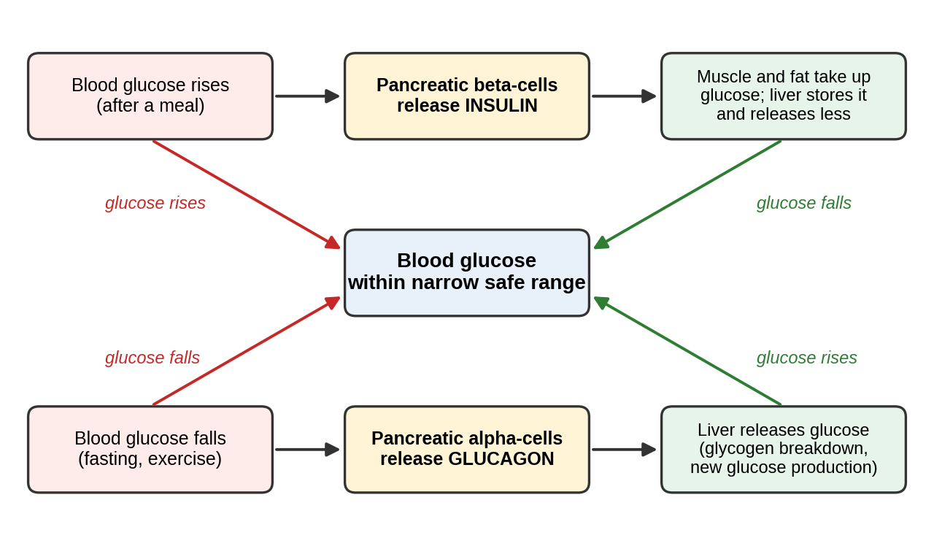
.
This loop breaks down in case of T2D. Insulin resistance refers to a decreased likelihood of muscle, fat and liver tissue responding to the same amount of insulin, and also to the inability of the β-cells to maintain their function when they are required to work hard for a long period of time, which is thought to involve mitochondrial dysfunction and oxidative stress (Młynarska et al., 2025). This leaves glucose in the blood, and cells have a relatively low concentration of usable fuel. Therefore, the aim of treatment is to make insulin more sensitive (as a result of weight loss and activity) and to reduce hyperglycaemia. A high reading does not indicate failure, but rather that the system is still strained.

3. Cell Metabolism: Converting Glucose and Oxygen into Energy
Glucose can only be utilized once it has been transformed into adenosine triphosphate (ATP) which is the usable form of energy for cells. Cellular respiration is a process that takes place in stages. In glycolysis, which occurs in the cytoplasm, one glucose molecule with six carbon is converted to two molecules of the three-carbon compound, pyruvate; two reduced electron carriers are generated in the process, and a small net gain of ATP. During glycolysis, one molecule of glucose (6-carbon) is converted to two molecules of the three-carbon compound, pyruvate, in the cytoplasm; two reduced electron carriers are produced in the process, and a small net gain of ATP.
In the presence of oxygen, the oxidised pyruvate produces acetyl-CoA that enters the mitochondria and is oxidized with the release of CO₂, electrons are absorbed by the carriers NADH and FADH₂ (Panov et al., 2026). These electrons pass along complexes I to IV of the electron transport chain in the inner mitochondrial membrane. The electron flow from complexes I, III and IV pumps’ protons across the membrane and at complex IV the electrons flow into oxygen, which is reduced to water, and the proton gradient energises ATP synthase (complex V) to make ATP, known as oxidative phosphorylation. Overall, glucose and oxygen are converted into carbon dioxide, water and ATP. Most of the energy released from glucose then requires oxygen and carbon dioxide is transported away in the blood and breathed out.
There are two points that need to be closely examined. First, Panov et al. (2026) note that the classical view is too simplistic: In the whole body, glycolysis and mitochondrial oxidation are interdependent, lactate is the typical product of glycolysis, and fatty-acid oxidation also provides fuel. The key message for patients remains the same, as glucose oxidation is closely linked with oxygen consumption, but cells are using mixed fuels. Second, metabolism is further related to glucose regulation: the ability to produce ATP by both glycolysis and mitochondrial oxidative phosphorylation is essential for the control of insulin secretion in β-cells (Grubelnik et al., 2025), while there is a link between mitochondrial dysfunction and oxidative stress with β-cell failure in T2D (Młynarska et al., 2025). Glucose-intake to cells is then reduced due to impaired insulin action and may result in cells being deprived of energy when the blood is high in glucose.

4. Recording and Tracking Blood Glucose in Type 2 Diabetes
One reading only takes a snapshot of a variable system. Acting over time provides a pattern of glucose and meal, activity, illness and medications so the patient and clinician can decide if the care plan is working. Routine data are also used at higher levels – for example, individual results to inform treatment decisions; practice data to identify patients who are not on target; and population data, such as that gathered by Sun et al. (2022) from 219 data sources, to drive prevalence and health expenditure estimates (which were 966 billion US dollars in 2021), informing service planning.
NICE suggests aiming to achieve and maintain an individual HbA1c target in adults with T2D, along with frequent (every 3–6 months, until stable and then every 6 months) monitoring, and encouraging people to reach and maintain the target if this does not lead to adverse outcomes such as hypoglycaemia or impact quality of life (Periodontitis-Diabetes Hub, 2025). Patients should therefore be aware that they should not be targeted for monitoring all the time and that HbA1c should be used in conjunction with other markers as it may be unreliable if red-cell turnover or haemoglobin type is abnormal. The main methods are compared in Table 1.
Table 1: Methods of recording glucose in adults with type 2 diabetes
Method | What it shows | Use in T2D | Key limitation
HbA1c blood test | The blood glucose average is the calculation of glucose levels from the past 3 to 6 months. | Every 3-6 months until stable than 6 monthly (Periodontitis-Diabetes Hub, 2025) | Unreliable if red-cell turnover is abnormal or haemoglobin type is abnormal
Capillary self-monitoring | Glucose at one instant | Not a routine measure, only used in specific cases, e.g., anyone at risk of developing hypoglycaemia, or in pregnancy. | A snapshot; needs to be documented in order to see patterns
Continuous glucose monitoring (CGM) | Continuous glucose trend data from a CG sensor | For those taking insulin, some expanded options in 2022: NICE for those not taking insulin, there was a new trial of short-term use in non-insulin T2D (Lau et al., 2024). | Access and cost, long-term benefit uncertain in NIDDM

by telemonitoring for 6 weeks lowered HbA1c by 0.69 percentage points at 12 weeks in a randomised trial of 105 adults with non-insulin-treated T2D and HbA1c > 7.0% relative to enhanced usual care, which lowered HbA1c by 0.33 percentage points; this was an adjusted difference of 0.65 (95% CI 0.17 to 1.12) at 12 weeks (Lau et al., 2024). The data gained from both groups are helpful, along with the interpretation and education that takes place during the educator visit. The trial was small, open label, single centre and short, and is not therefore able to show long-term benefit; and NICE's monitoring recommendations are selective.
There are also expenses associated with monitoring. The targets should be adjusted on an individual basis as tight targets can raise the risk of hypoglycaemia, especially in older or frailer adults. Good practice therefore emphasizes person-cantered, collaborative data review and not judgement of behaviour (Bajaj et al., 2025).

5. Evidence-Based Lifestyle Recommendations
Lifestyle modification is a first-line treatment intervention, and NOT an additional service. The emphasis at present is on weight management, physical activity, sleep, education, nutrition support and quitting smoking and vaping (Davies et al., 2022).
Weight and diet. There is the greatest evidence that changing the course of T2D with weight management. The American Diabetes Association (ADA) recommends a personalised approach of targeting at least 5–7% weight loss in individuals with overweight and obesity and referral to individualised medical nutrition therapy (MDNT) by a dietitian (registered) (Bajaj et al., 2025). An intensive strategy, a total diet replacement (825–853 kcal per day for 12–20 weeks) combined with drug withdrawal and a stepped food reintroduction and maintenance support (SUP) was tested in adult patients (20–65 years) who had T2D for less than 6 years, a BMI over 27 and not taking insulin in primary care in the UK in the Direct trial. At 2 years, mean weight loss was 7.6 kg and 36% were in remission; a 5-year extension revealed that 13% of those with data were in remission at 5 years, and 26% of those in remission at 2 years remained in remission at 5 years, with the intervention group having fewer serious events requiring hospitalisation (Lean et al., 2024). These results are subject to critical reading. Not everyone would benefit from these programmes, and such schemes should be clinically supervised since there is no universal remission and it is hard to maintain in an obesogenic environment with sharp reductions in energy intake, which would require different medication.
Physical activity. In adults with T2D, aerobic training has demonstrated significant improvement in glycaemic control, with an 0.5–0.7% reduction in HbA1C; and aerobic and resistance training could have even greater improvements compared to either form of exercise alone (Kanaley et al., 2022). There is agreement that reducing sedentary time is important and that HIET can yield greater benefits, but at a higher risk of developing musculoskeletal injury (Kanaley et al., 2022). Patients should progress slowly and select activities in which he or she is interested. Insulin users and people using medicines which could lead to hypoglycaemia should discuss with their nurse how often they need to check their blood glucose levels around exercise as NICE states hypoglycaemia is a reason for self-monitoring (Periodontitis-Diabetes Hub, 2025). Sleep and social factors are also included in the ADA/EASD consensus, and the advice should be based on each individual's ability to achieve (Davies et al., 2022).
Smoking. Healthy-living recommendations include quitting smoking and listed by the ADA Professional Practice Committee for Diabetes (2026) as an essential. One of the patient's concerns is weight gain following his/her quit. Sung et al. (2024) observed in a cohort of 386,558 adults without diabetes at baseline that the risk of developing diabetes in the next 12 years was temporarily elevated shortly after quitting smoking, perhaps due to a drop in weight, but former smokers exhibited no significant difference in risk compared with never-smokers (hazard ratio 1.04). This indicates that patients should not be discouraged if they gain weight when quitting, and they should implement a weight and activity support programme along with quitting. A study with a Korean population and without people with already diagnosed diabetes should be interpreted with caution.

6. Conclusion
Safe blood glucose requires a negative feedback mechanism which maintains glucose within a narrow range through insulin/glucagon action, and cellular metabolism turns glucose and oxygen into ATP. In T2D, the function of this system is impaired due to insulin resistance and β-cell dysfunction, resulting in an increase in glucose and inefficient use of the glucose by the cells. HbA1c and purposeful self-monitoring of glucose can be used to assess progress and interpret data in collaboration with individuals and their clinicians, with targets individualized. Evidence for weight management, physical activity and smoking cessation is strong and qualified – weight management, benefits do exist, but rely on support, sustainability and individual situation; PA benefits do exist but rely on support and sustainability; smoking cessation benefits do exist, but rely on support and sustainability. Therefore, the role of the practice nurse is to help the patient best by detailing the underlying physiology and establishing realistic goals and by creating a shared care plan, based on recorded data.

7. Reference List
Bajaj, M. et al. (2025) '5. Facilitating positive health behaviors and well-being to improve health outcomes: Standards of Care in Diabetes—2026,' Diabetes Care, 49(Supplement_1), pp. S89–S131. https://doi.org/10.2337/dc26-s005.
Davies, M.J. et al. (2022) 'Management of Hyperglycemia in Type 2 Diabetes, 2022. A consensus report by the American Diabetes Association (ADA) and the European Association for the Study of Diabetes (EASD),' Diabetes Care, 45(11), pp. 2753–2786. https://doi.org/10.2337/dci22-0034.
Grubelnik, V., Zmazek, J. and Marhl, M. (2025) 'The synergistic impact of glycolysis, mitochondrial OxPhOs, and PEP cycling on ATP production in beta cells,' International Journal of Molecular Sciences, 26(4), p. 1454. https://doi.org/10.3390/ijms26041454.
Kanaley, J.A. et al. (2022) 'Exercise/Physical Activity in Individuals with Type 2 Diabetes: A Consensus Statement from the American College of Sports Medicine,' Medicine & Science in Sports & Exercise, 54(2), pp. 353–368. https://doi.org/10.1249/mss.0000000000002800.
Lau, D. et al. (2024) 'The effectiveness of continuous glucose monitoring with remote telemonitoring-enabled virtual educator visits in adults with non-insulin dependent type 2 diabetes: A randomized trial,' Diabetes Research and Clinical Practice, 217, p. 111899. https://doi.org/10.1016/j.diabres.2024.111899.
Lean, M.E. et al. (2024) '5-year follow-up of the randomised Diabetes Remission Clinical Trial (DiRECT) of continued support for weight loss maintenance in the UK: an extension study,' The Lancet Diabetes & Endocrinology, 12(4), pp. 233–246. https://doi.org/10.1016/s2213-8587(23)00385-6.
Młynarska, E. et al. (2025) 'Type 2 diabetes mellitus: new pathogenetic mechanisms, treatment and the most important complications,' International Journal of Molecular Sciences, 26(3), p. 1094. https://doi.org/10.3390/ijms26031094.
Panov, A. et al. (2026) 'Rethinking human energy metabolism,' Current Issues in Molecular Biology, 48(2), p. 159. https://doi.org/10.3390/cimb48020159.
Periodontitis-Diabetes Hub (2025) NICE Guideline: Type 2 Diabetes in Adults - Management - The Periodontitis & Diabetes Hub. https://www.periodiabetes.org/guidance/nice-guideline-type-2-diabetes-in-adults-management/.
Rodgers, R.L. (2022) 'Glucagon, cyclic AMP, and hepatic glucose mobilization: A half‐century of uncertainty,' Physiological Reports, 10(9), p. e15263. https://doi.org/10.14814/phy2.15263.
Sun, H. et al. (2021) 'IDF Diabetes Atlas: Global, regional and country-level diabetes prevalence estimates for 2021 and projections for 2045,' Diabetes Research and Clinical Practice, 183, p. 109119. https://doi.org/10.1016/j.diabres.2021.109119.
Sung, D.-E. et al. (2024) 'Longitudinal analysis of Diabetes mellitus risk: Smoking status and smoking cessation,' Journal of Clinical Medicine, 13(13), p. 3927. https://doi.org/10.3390/jcm13133927.

