
Applied Leadership and Management in the Workplace
Module Assignment Submission
Student Name: | Carly Williams
Student Number: | 2319218
Module No: | BMSK4013
Module Title: | Management communication

Statement of Confirmation of Authenticity
By the act of making this submission, the student declares that this is the work of the student named above. The work has not, in whole or in part, been knowingly presented elsewhere for assessment, or where assessment has been built on a previous assessment, this has been identified. Where materials have been used from other sources it has been properly acknowledged. If this statement is untrue, the student acknowledges that an assessment offence has been committed.
Attention is drawn to the plagiarism and unfair practice policies of both the University and of ILM.
Introduction
Communication is essential in everyday life. It is our way of accessing and conveying information and expressing our needs and wants. It is how we explain our thoughts and emotions and interpret those of others, make choices, express feelings, and build relationships. It forms the basis of how we interact socially with others.
“Communication is the act of transferring the use of symbols, influenced, guided, and understood in the context of relationships” according to Duck, S & McMahan, D.T, (2015), p.5
Every communication involves (at least) one sender, a message, and a recipient. Communication is more complex than most people think. It can involve various forms of information (from written text to diagrams) as well as multiple people with different communication styles.
In this assignment I will look at 4 communication models, and the communication cycle, and compare them and reflect how they all work in my workplace. I will look at the importance of the tone language and formality when communicating and relate it to my place of work I will look at a range of ways we communicate verbally and written. I will look at motivation and factors that affect motivation in the workplace. I will look at workplace conflict. And I will produce a personal development plan (PDP) after making a questionnaire to get feedback on my communication.

Communication models and cycles
Communication models are theories and visual representations that outline how the communication process works. They aim to answer the question: Who says what to whom with what effect? By analysing this, communication theorists develop models that map out the clearest way to communicate.
These models are divided into three categories:
Linear models: One-way communication methods
Interactive models: Two-way communication methods.
Transactional models: Two-way conversations wherein the message becomes more complex as the event (discussion) progresses.

Communication Cycle

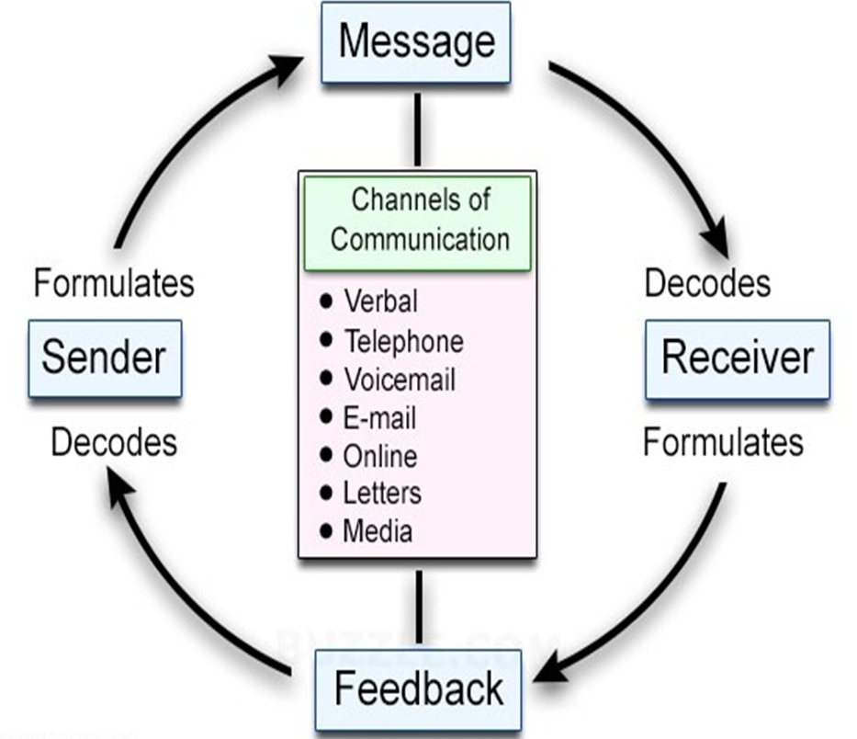

Shannon Weaver Communication Model (1948)

The Shannon–Weaver model of communication is a theory that was created by warren weaver and Claude Shannon in 1948. It was one of the first models of communication and has been known as the "mother of all models." It embodies the concepts of information source, message, transmitter, signal, channel, noise, receiver, information destination, probability of error, coding, decoding, information rate, channel capacity, etc. The model was designed as a linear model originally, but Norbert Weiner added some feedback to the model turning it from linear to cyclical.

A phone call is one way of describing the model. The caller is the sender, and the phone acts as the encoder, transforming the message into a format that can be transmitted over wires. Since the wires transfer data packets into the recipient's phone, which serves as a decoder, they serve as the channel. When the phone malfunctions, noise may be heard as the information travels through the wires. The recipient is the one on the other end who decodes the message and can provide the caller with feedback.

Many advantages come with the Shannon-Weaver model. It starts by taking into consideration factors that obstruct clear communication. making it possible to locate and fix problems with communication, such as noise which can disrupt communication. To help the recipient understand it better, the model also divides the communication process into manageable chunks. As it turns communication into a two-way process, it also applies in practically every kind of communication. It concludes by assessing communication as a measurable process. There are several criticisms despite its advantages. It is less effective for mass and group communication, but it is more effective for face-to-face communication. Another complaint is that during communication, the sender takes an active part, while the recipient stays passive. The communication process Loose's strengths because of this. A person who watches television, for instance, is passive because they are not receiving any input. Feedback is seen as less important in comparison to the main information provided by the sender. The model considers communication to be measurable. Since human communications are not mathematical in nature, critics contend that this makes it misleading
One of the most popular models of communication in the modern world, the Shannon-Weaver model, was one of the first to address the influence of “noise” in communication, which can disrupt a message.
The model, like many linear communication methods, looks at five key parts within an instance of communication: the sender, encoder, channel, decoder, and receiver. This model highlights the importance of encoding a message by turning it into written words, voice, video, or visuals. It also emphasizes the importance of a recipient being able to make sense of the message through decoding.
Shannon and Weaver suggest that common issues, such as noise or static on a radio broadcast, misspellings in an email, and other problems, can significantly influence the quality of communication. A newer version of the Shannon-Weaver model adds “feedback” as the sixth component of the framework, which makes the model more collaborative rather than simply linear

Berlo Communication (1960)

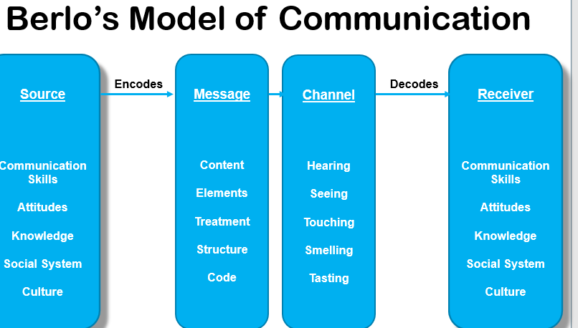

David Berlo was an American communications theorist who is known for developing the SMCR model of communication in 1960. Berlo’s model breaks communication down into four steps, with core components included in each of them: source, message, channel and receiver.
Watching the news on television is a perfect example of Berlo's S-M-C-R Model of communication. In this case, the news presenter is the source of the news, and they convey the message to the audience. The news is the message, the television is the channel, and the audience are the receivers of the message.
An advantage of Berlo's model is that it is straightforward in comparison to other modern communication models. The model also aligns the medium of the message and the receiver. There are more disadvantages to the Berlo model, it is a linear model of communication and there is a lack of feedback. There is no room for noise in Berlo's model. A mutual understanding is necessary for communication to be successful between the sender and the recipient. So both sender and recipient should be able to speak the same language and have the same level of knowledge between them. However, that rarely happens in everyday life. The main drawback of the model is that it omits the usage of sixth sense as a channel of communication, which is an asset to human beings (thinking, understanding, analyzing etc.)

Schramm Communication Model (1954)
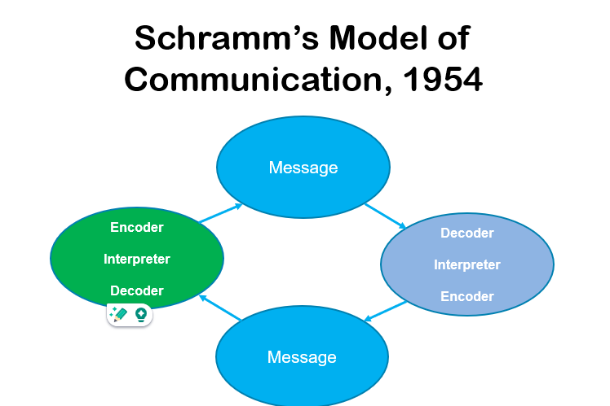

The model was first published in 1954 by Wilbur Schramm. His model is based on 3 basic components; a source, a destination, and a message. reflects a more humanistic and interpersonal approach to communication. It focuses on the interaction between individuals and the social context in which communication occurs.
Schramm's model is a circular model of communication where everyone involved in an interaction is treated equally. The sender and receiver in this model are the same they are two parts of a valuable conversation. An example of schramm’s model is a group of students working together to achieve a better understanding of a topic.
Explains how feedback can function: The cyclical feedback model provided by this model is a good fit. Some models consider communication to be a one-way street and do not take dialogue or feedback into account. With this model, the speaker can receive feedback on their use of language, humor, word choice, etc. in order for them to attempt speaking more and more coherently as the cycle goes on.
Understands that communication is complex: This model illustrates how humans can occasionally mishear and misinterpret information by taking into account encoding, decoding, and interpretation
Views us as active communicators: In contrast to other models, which regard information recipients as passive recipients, this one demonstrates how we actively interpret the information we are given.
Fails to acknowledge that communication can be imbalanced: In various situations, one individual may have the authority to speak while others are left to decipher the message. This creates a disparity in communication compared to Schramm's model, rendering it ineffective in scenarios where power dynamics are at play. Overall, this model lacks an understanding of how power influences communication. Not effective for mass communication This is another instance of unequal communication

The importance of formality in the workplace
Formality in the workplace promotes respect for coworkers, suppliers, and customers as well as a serious approach to job performance. In the end, this dedication to professionalism raises everyone's and the organization's levels of credibility.
The importants of language in the workplace
Teams with strong technical English skills can communicate requirements more clearly, negotiate the complexities of technical documentation with more skill, and reduce the possibility of misunderstandings

The importance of structure in the workplace
Planned message organization and preparation to guarantee efficacy and clarity is known as structured communication. Because it reduces ambiguity, increases transparency, and fosters understanding among team members, it is crucial for leaders. Leaders that are able to communicate expectations, ideas, and facts in an understandable and actionable manner are those who practice effective organized communication.

The importance of content and modes of communication The reason the content makes sense is because it sets the scene for the discussion. Readers need to be informed about the topics being discussed, the people involved, and the significance or relevance of the conversations in order to comprehend them. It can help readers grasp what was written by acting as an introduction or a conclusion. To make things easier to understand, content connects the .s between concepts and brings everything together (Lacinai, 2023)
Both spoken and non-spoken forms are possible. Building strong interpersonal relationships can be facilitated by effective communication, which makes it crucial. Excellent communication can foster a more therapeutic environment in healthcare settings, which can enhance patient outcomes and goal attainment.
The importance of tone in the workplace
Tone of voice plays a crucial role in effective communication. It allows us to express emotions, convey meaning, establish rapport, and influence other people's perceptions. By having a positive and effective tone when speaking, we can improve our communication skills and build stronger connections
The importance of different modes of communication.
If you don't adapt your communication style to the audience, it may cause misunderstandings, offense, and confusion. Therefore, it's critical that company owners take the time to thoroughly evaluate which communication channel and style are appropriate for each given circumstance

Range of communication in the workplace

Written | Usage in my workplace | Advantages  (in my workplace) | Disadvantages  (in my workplace)
Email | yes | Great at keeping track of conversation made | Can take a while for a reply if someone isn't online looking at their emails
Communication cook | yes | Great for important notes needed for the team to see | People not reading it and missing important appointments and information
Visitor book | yes | Great to keep track of contractors etc from outside services when they have been and carried out work. | Not everyone remembers to sign people in
Text message | yes | Quick response  Effective way to communicate if someone does not answer a phone call at first | Some people do not like to be bothered on their days off.
Social media | yes | Sharing photos via a social media group with other services all over the country | Some people do not like to use social media
Holiday request book | yes | Great for requesting days off for the upcoming months | Manager does not always know who the first person is to request a day off. As its not looked at every day
WhatsApp group | yes | Great to communicate with the team with photos, updates and any info, reminders, and social side of it too team bonding. | Not everyone wants to take part in WhatsApp group and doesn't like to be bothered on their days off.
Handover book | yes | Great for vital information after your shift has finished for the next person on shift. | Not everyone reads it

Verbal | Usage in my workplace | Advantages  (in my workplace) | Disadvantages  (in my workplace)
Hand over face to face | yes | Giving all important info and a breakdown of how the shift has been and the ladies we support | People are sometimes late for work meaning staff are late leaving their shift as staff need to give a thorough handover.
meetings in person with team | yes | Sorting out any concerns or problems and working as a team to find solutions | Not everyone attends if they have a day off.
Meetings 1-1 management in person | yes | Fantastic way to catch up and have a chat about any concerns | I work night shifts so face to face meetings don't always work well.
Management appraisal meeting | yes | Great to catch up and find out how your team think of how you work | Management cancel meetings a lot with the cross over of me only doing night shifts.
Teams call online | yes | Effective was to communicate seeing the team and being able to talk if we can't all make a meeting in person | Not many show up.  Cross over with night staff needing to sleep when teams' calls are arranged.
Over the phone | yes | Quick to get hold of people | There is no information recorded of the conversation like you would with an email so might forget what was said on the call.
Training courses | yes | Keeping up to date with relevant and important training. | Travelling to Cardiff for most training courses
Management 1-1 meeting on teams | yes | Being able to do it over teams is easier than in person more convenient | Cross over with nightshifts.

Recommendations to improve communication in my workplace
Management having regular 1 to 1s with your staff members making sure they are scheduled in, and the date is not changed all the time. Offering constructive feedback for improvement and acting on the feedback, Being mindful of different strengths and weaknesses
Planning weekly meetings to keep staff more engaged and working as a team, feeling valued for their input and opinions. Following up meetings with notes to keep track.
Recognising great work making staff feel more appreciated, taking time to listen to what others have to say, being mindful of your communication, always explaining the why. Sharing important news and updates

Motivation
Motivation is the word used to explain why someone acts in a certain way. Human behaviour is motivated by this. What starts, directs, and sustains goal-oriented behaviour is called motivation.
The two main types of motivation are frequently described as being either extrinsic or intrinsic.
Extrinsic motivation motivated by outside forces like incentives or penalties. depends on rewards like cash or recognition. could decrease if external incentives are eliminated. May encourage more rapid outcomes, but it can occasionally erode profound involvement. may result in erratic behaviors that alter in response to different rewards
Intrinsic motivation is internal motivation that comes from within and is "naturally" fulfilling to the individual. not motivated by outside benefits. driven by one's own "internal" motivations or the pleasure of carrying out a task; like doing a complicated crossword puzzle purely for the gratification of solving a problem. frequently more resilient and persistent since it is self-sustaining. can stimulate greater engagement and effort, which can result in better performance and creativity. leads to actions that, because they are consistent with one's values and interests, are frequently consistent over time (cherry,2023)

Motivational theories
Maslow’s Hierarchy of Needs (1943)

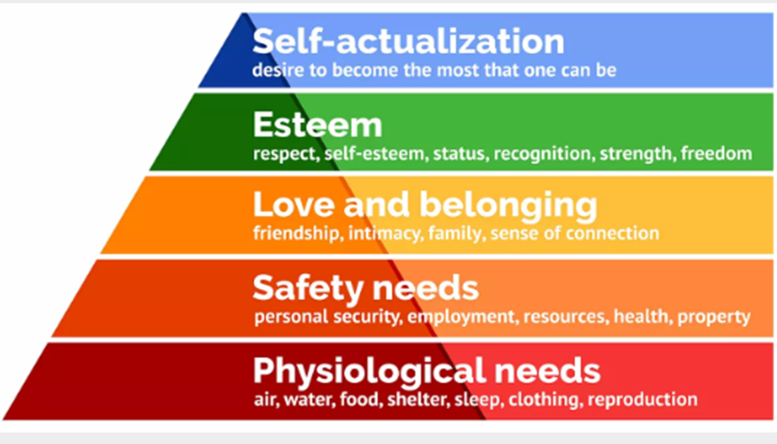

Maslow's hierarchy of needs is a psychological theory of motivation that consists of a five-tier model of human needs that is frequently represented as levels within a pyramid
The 5 levels are physiological, safety, love/belonging, esteem, and self-actualization
Prior to meeting more important needs, lower-level necessities like food, water, and safety must be satisfied
While it's thought that very few people ever achieve self-actualization, everyone can have moments of extreme experience. There is some flexibility in the levels' order. While some people can self-actualize in spite of poverty, others place more value on esteem than love. Our actions are typically driven by several needs at once. Applications include nursing, education, counseling, and workplace motivation
Advantages include a more individualized approach to employee motivation; managers are able to determine where staff members fit into the hierarchy; they have realized that employees are not solely driven by financial gain, and that what drives them today might not drive them tomorrow; this underscores the need of both monetary and non-monetary rewards; and they have improved working relationships within the workplace.
Disadvantages are quite different. Maslow's theory has exceptions: highly creative workers may not be interested in only financial reward. Match rewards to meet the needs of each individual worker. Underestimates staff desire to seek financial reward + upgrades in standard of living. Does every employee have the same set of needs + satisfied with job satisfaction, evidence also suggests you can more between needs and not complete one before the next need. (Jerd, 2023)

McCLelland Human Motivation Theory
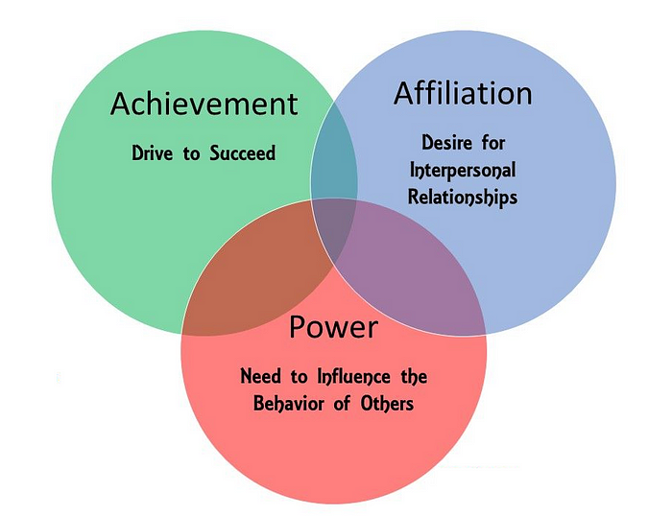

Mccleland's 3 needs theory (1987)
Key Points. According to McClelland's Human Motivation Theory, each individual is primarily driven by one of three basic motivational needs: a need for power, affiliation, or achievement. These motivations are not innate; rather, we acquire them via our upbringing and experiences in life. Regardless of gender, culture, or age. Need of power- Like to control others and be in charge. Need for achievement- Like to solve problems and achieve goals. Need for affiliation- Don't like to stand out or take risk.
Value relationships above anything else
Advantages of using this tool include its specificity in identifying key motivational drivers and its ability to be applied in targeted interventions for leadership development and team composition. It also has predictive capabilities, forecasting individual behaviors in different environments. For example, individuals with a high need for achievement may thrive in roles requiring innovation and personal initiative. Additionally, understanding an individual's dominant needs can allow managers to customize their approach, leading to better team dynamics and improved cultural adaptability on a global scale.
Limitations and drawbacks include: Measurement Challenges: Determining a person's dominant needs frequently necessitates the use of intricate and subjective techniques. Motivation Oversimplification: Limits motivation to three primary needs; Cultural Bias: Remains primarily centered around Western industrialized environments. Even though it recognizes the importance of culture, it might not adequately convey the driving forces that are important in non-Western cultures. Static Model: After they are developed, "needs" are seen as essentially static. ignores how a person's motivations change over the course of their life and at different stages.

McGregor X – Y Theory (1957)
Divides management attitudes and assumptions about worker motivation into two categories:
- Theory X Generally seen as Negative
- Theory Y Generally seen as Positive
It is a theory about managers' assumptions about their employees and how they manage (motivate) them.
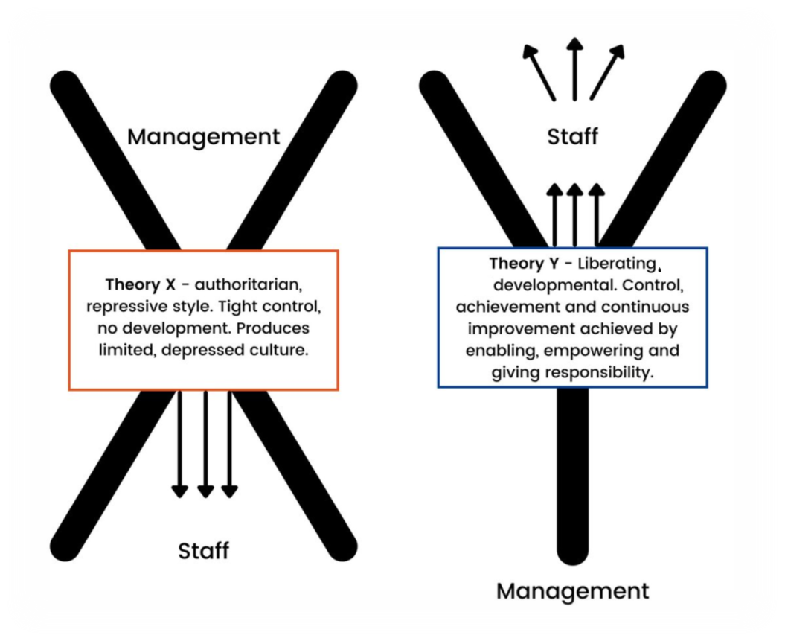
Theory X is seen as negativities based on the assumptions that employees do not really want to work, lack ambition, only work for the money, and need constant supervision.
Theory Y which is seen as positive is based on the assumptions that employees want to work, want to take responsibility, and do not need much supervision.
X Managers believe that workers are lazy and avoid taking on responsibility; they detest work and will avoid it at all costs. Are uninterested in the objectives of the organization; require direction; have little ambition; prioritize security; are resistant to change; and, as a result, are managed (motivated) by: Authority and supervision (more likely to have negative effects on workers who aspire to succeed).
Y Managers believe that workers do not innately detest their jobs. will apply self-control and self-direction to the work they dedicate themselves to. Are devoted to pursuing the organization's objectives. Take ownership of their actions rather than just accepting them. Possess an inventive mind and the capacity for problem-solving; driven by things like accomplishment, admiration, personal development, and contentment in one's work. Therefore, to manage (motivate): Provide opportunities and acknowledgement (more likely to produce positive results with motivated staff members).
Benefits. Encourages Self-Reflection in Management: This encourages managers to consider their own methods, which may result in more efficient management catered to the requirements of their team. Improves Knowledge of Motivational Dynamics: Assists managers in comprehending the variety of motivational techniques available. Promotes a participative management approach that can increase employee motivation to support adaptive leadership. Application Flexibility: Provides managers with the ability to apply either Theory X or Theory Y concepts based on circumstances. This allows for dynamic management styles that can adjust to changing organizational objectives and employee needs

Limitations and drawbacks. Oversimplification: Binary (2) classifications may not fully capture the "nuance" of motivation and behaviour in humans. Not just X and Y, but a variety of factors also affect behaviour. Possibility of Stereotyping: Managers who classify staff members as either X or Y may unintentionally "pigeonhole" them into these categories and handle them accordingly. Cultural bias is a theory that derives from presumptions derived from industrialized Western viewpoints. may differ dramatically depending on the cultural context, as managerial styles and motivations can change. Problems with adaptability: It might not consider how a person's motivation changes over time. Workers may display inclinations toward Theory X in some circumstances and Theory Y in others. Managerial Misinterpretation: For instance, a manager who supports Theory Y may grant a team that needs more direction and guidance too much autonomy, which can result in inefficiencies and a lack of focus.

Motivation affects in the workplace
Recognition and Appreciation: Feeling valued for your contributions is a powerful motivator for many employees. When your efforts are acknowledged and appreciated, you are more likely to feel motivated to continue performing well.
Opportunities for Growth and Development: Employees are often motivated by the chance to learn new skills, take on new responsibilities, and advance in their careers. Providing opportunities for professional development and growth can keep employees engaged and motivated.
Clear Goals and Expectations: When employees understand what is expected of them and have clear goals to work towards, they are more likely to feel motivated to perform well. Clear communication about goals and expectations helps employees stay focused and motivated.
Autonomy and Empowerment: Giving employees a sense of autonomy and control over their work can be highly motivating. When employees have the freedom to make decisions and take ownership of their work, they are more likely to feel motivated and engaged.
Positive Work Environment: A positive work environment, characterized by trust, respect, and support, can significantly impact employee motivation. When employees feel comfortable and supported at work, they are more likely to feel motivated to do their best.
Fairness and Equity: Employees are motivated when they perceive that they are being treated fairly and equitably. Fair compensation, opportunities for advancement based on merit, and fair treatment by managers and colleagues all contribute to a sense of motivation.
Meaningful Work: Employees are often motivated when they feel that their work is meaningful and makes a positive impact. When employees can see the purpose and significance of their work, they are more likely to feel motivated to put in their best effort.
Work-Life Balance: Striking a healthy balance between work and personal life is important for employee motivation. When employees feel that they have time to pursue their personal interests and spend time with loved ones, they are more likely to feel motivated and satisfied in their jobs.

Conflict in the workplace
Conflict in the workplace is a common occurrence that can arise due to various factors such as differences in personalities, communication styles, goals, values, and work methods among employees. Here are some common types of conflicts in the workplace:
Interpersonal Conflict: This occurs when individuals have differences in personalities, communication styles, or values, leading to tension and disagreement.
Task Conflict: Differences in opinions or approaches to work tasks or projects can lead to task conflict. This type of conflict often arises when team members have different ideas about how to achieve a common goal.
Role Conflict: Role conflict happens when there are discrepancies or misunderstandings regarding job responsibilities and duties within a team or organization.
Resource Conflict: Competition for resources such as budget, time, equipment, or personnel can lead to conflicts among team members or departments.
Conflict of Interest: Conflicts may arise when individuals or groups have competing interests or goals that are not aligned with the overall objectives of the organization.
Managing conflict in the workplace requires effective communication, active listening, empathy, and conflict resolution skills. Encouraging open dialogue, promoting a culture of respect and collaboration, and providing conflict resolution training can help address and mitigate conflicts before they escalate. Additionally, having clear policies and procedures in place for addressing conflicts and seeking mediation when necessary can also contribute to a healthier work environment.

Personal communication
In assessing my communication, I produced a questionnaire for myself to fill out to see how I communicate (Appendix A) I scored as being Passive: which suggests a tendency to avoid confrontation and suppress personal needs, along with strengths in listening and accommodating others.
I produced and sent out a questionnaire (Appendix B) To family friends and colleages to give me some feedback on my communication and then produced a personal development plan (PDP) (Appendix A:) to improve my communication skills
References
Covey, S. R. (2013). The 7 habits of highly effective people : powerful lessons in personal change. Simon & Schuster.
Duck, S., & McMahan, D. T. (2015). Communication in everyday life: The basic course edition with public speaking. Sage.
Morgan, P. (2017) The Business Student’s Guide To Study And Employability. London: Sage Publications Ltd.

Appendices
Appendix A: Questionnaire

Communication Styles Questionnaire: Key Areas and Strengths
Instructions: For each statement, please indicate how much you agree or disagree by using the following scale:
- Strongly Disagree
- Disagree
- Neutral
- Agree
- Strongly Agree
Statements:
Assertive Communication:
I feel comfortable expressing my opinions and feelings to others.
I can say "no" to requests without feeling guilty.
I try to find solutions that satisfy both my needs and the needs of others.
I maintain eye contact during conversations.
I speak clearly and directly without being rude or condescending.
Key Areas and Strengths in Assertive Communication:
I handle criticism well and use it as an opportunity for growth.
I express my needs and desires openly and honestly.
I negotiate and compromise effectively in conflicts.
I give and receive feedback constructively.
I show empathy and respect towards others' opinions.
Passive Communication:
I often avoid expressing my true feelings and opinions.
I find it difficult to say "no" to others.
I usually let others make decisions for me.
I tend to avoid conflict at all costs.
I often feel like others take advantage of me.
Key Areas and Strengths in Passive Communication:
I am a good listener and often understand others' perspectives well.
I tend to be accommodating and cooperative in group settings.
I am sensitive to others' feelings and avoid hurting them.
I adapt easily to others' needs and preferences.
I am often seen as easy-going and non-confrontational.
Aggressive Communication:
I tend to raise my voice to get my point across.
I often interrupt others while they are speaking.
I use sarcasm or put-downs when I’m frustrated.
I believe that being right is more important than maintaining relationships.
I frequently blame others for problems.
Key Areas and Strengths in Aggressive Communication:
I am confident in expressing my opinions and desires.
I can take charge in difficult situations.
I am decisive and assertive in decision-making.
I protect my interests strongly and stand up for myself.
I can motivate others to take action.
Passive-Aggressive Communication:
I express my anger indirectly (e.g., through sarcasm or silence).
I often agree to do things I don’t want to do and then complain about it later.
I use subtle behaviors to show my displeasure (e.g., procrastination, ignoring).
I sometimes give the silent treatment when I’m upset.
I feel resentful when others don’t notice my needs without me having to express them.
Key Areas and Strengths in Passive-Aggressive Communication:
I can identify underlying issues even if they are not openly discussed.
I am skilled at reading between the lines in conversations.
I often use humor or sarcasm to diffuse tension.
I am able to recognize and address indirect forms of communication.
I tend to be resourceful in managing conflicts indirectly.
Scoring:
- To identify predominant communication styles, tally the scores for each category (Assertive, Passive, Aggressive, Passive-Aggressive) and their corresponding key areas and strengths.
- Each style and its strengths have ten statements; thus, the total score for each style ranges from 10 to 50.
- Higher scores in a category indicate a stronger tendency and greater strengths in that communication style.

Interpretation of Results:
- Assertive: A high score indicates comfort with direct and respectful expression of thoughts and feelings, and strong skills in handling feedback and conflict resolution.
- Passive: A high score suggests a tendency to avoid confrontation and suppress personal needs, along with strengths in listening and accommodating others.
- Aggressive: A high score reflects a confrontational approach, often at the expense of others' feelings, but with strong confidence and decisiveness.
- Passive-Aggressive: A high score denotes indirect expression of hostility and discomfort with direct communication, with skills in reading between the lines and using humour to manage tension.

Apendix B- Communication Effectiveness Questionnaire
Instructions: For each statement, please indicate how much you agree or disagree by using the following scale:
- 1: Strongly Disagree
- 2: Disagree
- 3: Neutral
- 4: Agree
- 5: Strongly Agree
Statements:
Tone:
  - I consistently use a respectful and appropriate tone when communicating with others. (1 2 3 4 5)
  - I am mindful of my tone to ensure it matches the context of the conversation. (1 2 3 4 5)
  - My tone remains calm and composed even in stressful situations. (1 2 3 4 5)
Clarity:
  - I express my thoughts and ideas clearly and concisely. (1 2 3 4 5)
  - I avoid using jargon or overly complex language when it’s not necessary. (1 2 3 4 5)
  - I make sure my messages are easy to understand for my audience. (1 2 3 4 5)
Use of Language:
  - I use language that is appropriate for the audience I am communicating with. (1 2 3 4 5)
  - I ensure that my language is inclusive and non-discriminatory. (1 2 3 4 5)
  - I use a positive and constructive language, even when giving feedback. (1 2 3 4 5)
Appropriateness:
  - I tailor my communication style to fit the situation and the people involved. (1 2 3 4 5)
  - I am aware of cultural differences and adjust my communication accordingly. (1 2 3 4 5)
  - I consider the timing and setting when delivering important messages. (1 2 3 4 5)
Comments:
What aspects of your communication do you believe are your strongest?
Which areas of your communication would you like to improve?
How do you ensure your communication is effective in different contexts (e.g., personal vs. professional)?
Scoring:
- Each statement is rated from 1 to 5.
- Total scores range from 10 to 50, with higher scores indicating more effective communication skills.
Interpretation of Results:
- High Scores (41-50): Excellent communication skills, with strengths in tone, clarity, use of language, and appropriateness.
- Moderate Scores (31-40): Good communication skills, but there may be some areas for improvement.
- Low Scores (10-30): Communication skills may need significant improvement in several areas.

Appendix C: PDP
Area to improve | Goal | Action to improve | Support to achieve goal | When will it be reviewed
Active listening | Pay Attention: Focus fully on the speaker without distractions | Show Understanding: Nod, smile, and use verbal acknowledgments like "I see" or "Interesting." | Ted talks  Linked- in learning | 3 months
Clarity and Conciseness | Be Clear: Use simple and straightforward language. | Be Concise: Get to the point without unnecessary details. | Ted talks  Linked- in learning | 3 months
Nonverbal Communication | Body Language  Eye Contact  Facial Expressions | Maintain open and positive body language. Avoid crossing arms or looking away.  Maintain appropriate eye contact to show engagement.  Ensure your expressions match your words to convey sincerity. | Ted talks  Linked- in learning | 3 months
Feedback | Give Constructive Feedback and receive feedback | Be specific, focus on behaviors, and suggest improvements.  Be open to feedback and use it for personal growth. | Ted talks  Linked- in learning  books | 3 months
Confidence and Assertiveness | Be Confident and be assertive | Speak with a clear and firm voice. Express my thoughts and needs respectfully without being aggressive. | Ted talks  Linked- in learning  books | 3 months
Digital Communication | Email Etiquette  Social Media  Video Calls | Use proper grammar, a clear subject line, and be concise.  Be mindful of tone and context when communicating online.  Ensure good audio, maintain eye contact through the camera, and avoid multitasking. | Ted talks  Linked- in learning  books | 3 months

