By: Kate Rose

Fibre Stall for health promotion

A.I. declaration
I acknowledge the use of ChatGPT (https://chatgpt.com/) on 23 April 2026 to write my notes into submission format using the prompt(s):
- Please check the following text for readability, grammar and syntax.
- Please rephrase the following paragraph
I confirm that I have not presented any AI generated text as my own work. I confirm I have copies of my drafts, notes, and other resources I used before, and after the use of AI tools which I may be asked to provide in evidence.

The health promotion stall focused on dietary fibre, addressing the fact that according to the National Diet and Nutritional report done by the UK Government 2019 – 2023, “for children aged 11 to 18 years and for adults, 96% did not meet the fibre recommendation,” typically consuming only about two-thirds of the required amount.
“Fibre is the blanket term given to the non-digestible, mainly carbohydrate material found in plants, which our digestive enzymes can’t break down, so it passes through our digestive system relatively unchanged.”
Meeting your daily fibre requirement is essential for more than just a healthy bowel function. It can ‘lower risk of heart disease, stroke and diabetes, strengthen immune defences, support digestive efficiency, and manage blood sugar levels,’ as well as aid in weight management and obesity.

Primary aims for the day were to engage with the public to provide clear, informative guidance on what fibre is, its health benefits, and daily intake recommendations. Specific high-fibre foods were also highlighted to help individuals reach their nutritional goals. To make the session interactive, visitors were tested on their knowledge of hydration and digestive health using visual urine and stool charts, and overall, encouraged individuals to up their fibre consumption.
To support this message and achieve our objective, posters and leaflets covering the importance of fibre, portion control, and practical dietary changes that could be made were used to help inform the public.
Additionally, six plastic food models were featured with their fibre content per 100g labeled underneath, and participants were challenged to identify the most high-fibre-dense options. To conclude the experience, visitors completed a brief questionnaire to track their learning progress before receiving a complimentary "freebie" or their choice for their participation.

This project was executed rather efficiently with the planning phase proceeding smoothly. Several meetings were held outside of scheduled lecture times dedicated to coordinating all of the event preparations, and designing and building the stalls’ posterboard. Key responsibilities were divided among the team members, like the creation of leaflets and questionnaires, sourcing of which plastic food models were to be used and their researched fiber content, and compiling general information for the day of the event (e.g. what key information should be explained to the public). Additionally, presentation slides were distributed equally among the group (a slide per person).
The event itself had a slow start, but by the end of it, the team had established a productive routine. Each member contributed by encouraging engagement, explaining our materials, presenting information to our audience, or distributing leaflets. While rigid roles weren’t assigned to team members for the live event- allowing everyone to assist with any task- the collaboration worked well for those involved. However, I can see how a larger-scale health promotion project might require more structured organization.

Unfortunately, not everyone participated. One individual failing to contribute to the preparation or show up day of. Luckily, our group was large enough -with six active members – that we were able to handle the workload effectively despite the missing member. We functioned efficiently as a team, without conflict. Everyone's friendly attitude, both towards each other and the attendees, helped in attracting people to our stall.

In terms of improvements, space in the quad could have been managed more effectively. At times, when only one or two visitors were engaging with us, the rest of the team felt awkward and underutilized, all of us standing and watching the interaction between our presenting group member and their audience. Our group also tended to obstruct the walkway; in retrospect, pushing the stall closer to the wall would have created a better flow for both the team and those just passing by. Another improvement that could have made would have been in regard to the freebies; while the water bottles were popular and had involvement with our presentation, it would have been fun to offer a can of beans as a freebie, as it had been encouraged to participants to eat more beans in their diet as a high-fibre food.

This promotion event stall audited the event using a questionnaire. 47 responses were gathered from participants with the average response age being 18-24, the majority being in their second year at UWTSD university. The questionnaire contained the following questions “how much fibre is recommended daily?”, and “what foods are high in fibre?” (see appendix for data).
These two questions demonstrate that while the majority of participants learned something from our stall, their understanding was not perfect. This supports my theory that the stall's effectiveness was limited. It highlights the challenge of engagement; even if people appear to be listening, making eye contact and nodding along, they may not actually be taking in and absorbing the information. For instance, the simple question of daily fiber requirements was answered incorrectly by 6 out of the 47 people that took the questionnaire.

The Health Belief Model (Becker, 1974) is a foundational psychological framework used to explain and predict health-related behaviors. It suggests that individuals are most likely to adopt positive behavior changes when they perceive themselves as susceptible to a serious health problem and believe that the benefits of taking action outweigh any associated barriers, such as cost, effort, or pain. According to this model, health decisions are driven by six core beliefs: vulnerability, seriousness, perceived benefits, obstacles, internal or external triggers (cues to action), and self-efficacy. By balancing these factors, this long-standing model provides a comprehensive understanding of why people choose to adopt certain health behaviors, and remains a cornerstone of behavior research since its development by the U.S. Public Health Service in the1950s.

Many people may not prioritize fiber because the immediate effects of a low-fiber diet, such as bowel irregularities like constipation, are often dismissed as minor. “If you don’t think you’re at risk and don’t think the disease is serious, you’re unlikely to act no matter what else happens.” Furthermore, the long-term benefits for heart health, gut health, and cholesterol management are not something people can “feel” within themselves, making them go unnoticed and seen as future concerns rather than present priorities. While obesity is a visible concern, many do not yet recognize fiber's role, not understanding how great of an impact fibre can actually have in weight management. Under the Theory of Reasoned Action (Ajzen & Fishbein, 1980), people are influenced by those around them whom they value and admire. Unfortunately, fiber is not a currently "trending" topic among influencers or celebrities; and combined with Social Cognitive Theory (Bandura, 1986), which posits that people learn through their environment, it is clear that fiber lacks the necessary social momentum to trigger widespread behavioral shifts.
However, this does not mean our promotion stall was without value. In our current time, fiber is a critical health issue that requires a "kickstart" through repetition and ongoing conversation. Mentioning it once to 47 people may not spark an immediate change, but we fulfilled our role by informing them and providing the tools-such as leaflets-to encourage further self-education.
It is also worth noting that some participants were already well-informed, correctly answering posed questions left and right, leaving little room for us to actively "teach" them. Ultimately, while it is difficult to gauge the stalls exact impact, the hope is that it sparked curiosity in some, prompting them to take control of their long-term health in their own time.

Overall, I thoroughly enjoyed this experience. As it was my first time participating in an event like this, I found it incredibly exciting. I gained valuable insight into setting up a promotion stall and learned the essential components required to host a successful health promotion event.
The experience significantly improved my interpersonal skills, particularly in engaging with strangers about sensitive topics. I realize that many people are hesitant to discuss their health or dietary habits due to embarrassment or fear of judgment so I know developing the ability to navigate these conversations with empathy is a skill crucial for my future career in dietetics.
This opportunity was also a great addition to my resume. It allowed me to practice public speaking, information sharing, and networking. I also learned the importance of teamwork and effective task delegation for the efficiency is completing our stall. Furthermore, the event encouraged me to research fiber in-depth, providing me with knowledge about its numerous health benefits that I might not have discovered otherwise.
While it was challenging to engage people during their busy coffee breaks between classes and feeling like a nuisance, overcoming these obstacles was a rewarding part of the process. Overall, it was a productive and formative experience.

References:

Science Insights. (2026). What Is the Health Belief Model and How Does It Work? [online] Available at: https://scienceinsights.org/what-is-the-health-belief-model-and-how-does-it-work/.

Conner, M. and Norman, P. (2019). Health Belief Model - An overview. [online] Sciencedirect.com. Available at: https://www.sciencedirect.com/topics/medicine-and-dentistry/health-belief-model.

Tilt, L. (2026). How to hit your 30g fibre target, according to a dietitian. [online] BBC Food. Available at: https://www.bbc.co.uk/food/articles/cvgk7pxzdm7o.
‌
British Dietetic Association (2021). Fibre. [online] British Dietetic Association. Available at: https://www.bda.uk.com/resource/fibre.html.
‌
NHS (2022). How to get more fibre into your diet. [online] NHS. Available at: https://www.nhs.uk/live-well/eat-well/digestive-health/how-to-get-more-fibre-into-your-diet/.
‌
Office (2025). National Diet and Nutrition Survey 2019 to 2023: report. [online] GOV.UK. Available at: https://www.gov.uk/government/statistics/national-diet-and-nutrition-survey-2019-to-2023/national-diet-and-nutrition-survey-2019-to-2023-report.
‌

Appendix:

The following is a rough script of what was said to participants:
- Hello! Do you have five minutes to discuss the topic of fibre?
- Can you tell me anything about fibre or its benefits?
(So, fibre can prevent colon and bowel cancer, it lowers cholesterol, improves heart health, weight management, it keeps you full longer. It can help with constipation and keeping your bowel movements regular and can even help with depression)
- If you had to guess, how many grams of fibre do you need daily?
(You need 30g daily. 97% of the UK is not meeting this requirement and typically only gets around 20g)
- However, when you increase your fibre intake you also need to be increasing your water intake as well, this is because fibre acts as a sponge in your gut and draws in water. If you don’t increase your water intake, you can become dehydrated and it can make you constipated.
- Do you know how to tell how hydrated you are from the color of your urine/ which color is healthiest? [shows them the urine chart]
(Number 2 on the urine chart is healthy, you want it to be a straw color but it shouldn’t be clear or you’re too hydrated)
- And what about your poo? [show them the stool chart] Which number is healthy?
(Between a number 3 and 4 is considered to be healthy)
- Finally, we have some foods here; [show them the plastic food] can you tell me which food you think has the highest fibre content per 100g?
(The beans have the highest fibre per 100g, with around 10g. The peanuts are also quite high. Things like legumes, lentils, beans, nuts, and seeds are all great sources of fibre. Fun fact; dark chocolate has a higher fibre content then any of the displayed foods with around 11g)
- Can you tell me one change you could make in your diet to increase your fibre intake?
(Yes, so changing your white bread to wholemeal, eating beans on toast, or apples with peanut butter are great ways to increase your daily fibre intake)
- Would you be able to fill out a quick questionnaire to test what you’ve learned from our stall? [show them the QR code]
- Thank you so much, for your time feel free to take any of the freebies we have,
[offer the leaflets] and take these to learn more.

Survey Data

Meeting Minutes (at 1pm on Thursdays)

1st meeting
We allocated a slide each for the presentation, and which person does which slide topic. We brainstormed ideas. We allocated roles as to who is responsible for each component.
Leaflet (Lottie)
QR code and questionnaires (Amelie)
Banner for board (Lindsey)
We came to the decision that we will be using boxes and tins to display high fibre foods and have participants order them with highest to lowest in fibre

2nd meeting
We put together the poster for our board. We clarified roles and any questions regarding the presentation and resources needed for the event day.

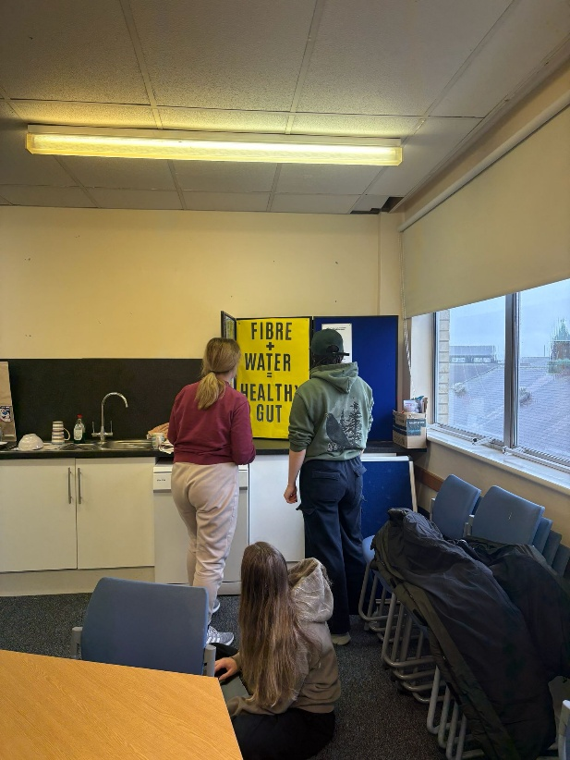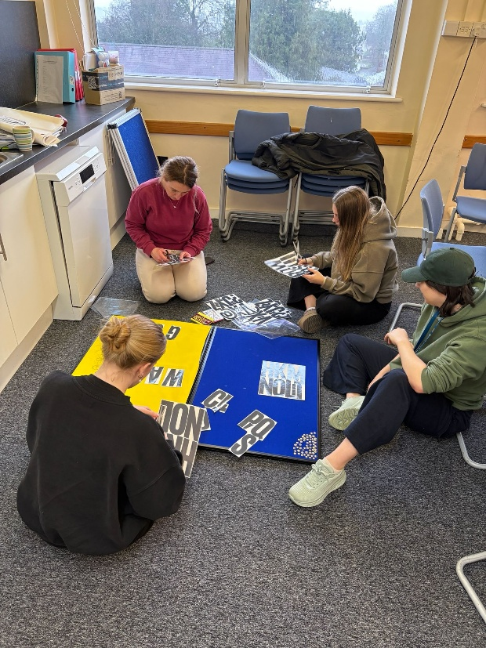

3rd meeting (day before event)
Finished final details for our board. Gathered together all leaflets and freebies. Labeled the bottom of our fake foods with their individual fibre content

Resources used
- 3 separate leaflets regarding fibre and how to increase your daily intake
- Poster with our stall title
- Informative posters on our board including urine and stool charts
- QR code and physical copies of our questionnaires
- A box of pens to fill out physical questionnaires if needed
- Freebies; water bottles, pens, highlighters, notepads, tote bags, and sun glasses
- An arrangement of fake plastic food; corn, apple, peas, green beans, wholemeal bread, peanuts and beans


