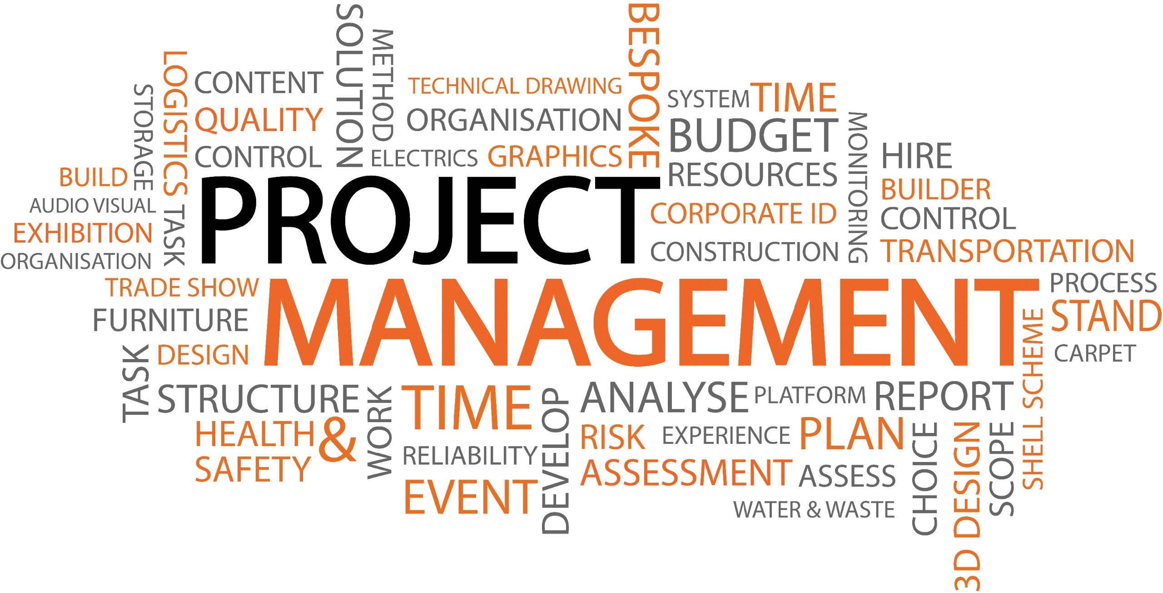  Project management report | Title: Project Management for Sustainability  Assignment Name: Project Management Report  Student Name: Daniel Ramsey  Course Name and Number: Project Management for Sustainability BMSP5008  Lecturer: Glen Behenna  Date: 22nd March 2019

Contents
Executive Summary 2
Introduction 4
Definition of Project Management 4
The Importance of Project Management 5
Project Management Methodologies 6
Comparison 13
Role of a Project Manager 13
Key Elements of Project Management 14
Lifecycle of a Project 14
Part 2 15
Project Management Plan 15
Stakeholder Analysis 18
Conclusion 19
References 21

Executive Summary
This report encompasses the effectiveness and requirements of project management and its principles. Contained within is the exploration of Agile, Waterfall and Prince2 methodology, each of which are utilized for their different strengths and ease of use. Furthermore, the prerequisites for a comprehensive project management plan is discussed, focusing on its key phases and the internal or external factors that determine a projects success or failure.

Introduction
This report was commissioned by Daniel Ramsey of University of Wales, Trinity St David’s and is to be authored by Daniel Ramsey and will consist of two parts:
Part 1 - To ascertain and analyse the varying concepts and methodologies of project management, comparing, evaluating and discussing the different theories relating to project management and its models, whilst performing a critical assessment on its tools, features and the key aspects that has bearing on the success or failure of any project undertaken.
Part 2 – To formulate and plan the implementation of a step by step project management plan, taking into consideration the management of appropriate stakeholders and elements of risk and how they are appropriately managed. This section will provide a deep insight into the meticulous planning process undertaken by the project manager, stakeholders and their counterparts to take a project from an idea to an end product.

Definition of Project Management
“Project management is the application of processes, methods, knowledge, skills and experience to achieve the project objectives” (The Chartered Body for the Project Profession , 2019).
“Project management is a method of organizing all activities related to a project and its parts” (Techopedia, 2019).
Projects have been conducted for years, with great landmarks such as The Great Wall of China and the Pyramids being testament to such facts, with the methods used in creation in that period attributed more to art than science (Frame, 2002). With that being said, developments in technology and education has enabled the evolution of project management, with projects undertaken now favouring the more scientific, systematic approach. However, there are varying degrees of views and misconceptions of the real definition (Kerzner, 2013), with the success of the project in question defined not only by the project manager himself, but by the team responsible for the deliverance (Roberts, 2011).
“Project management is the shared set of values, principles, processes and techniques – the governance – which is used by the project’s management team (not just the project manager) to deliver a successful project” (Roberts, 2011).

The Importance of Project Management
There are several determining factors to ensure a project is completed successfully. Unity of the team, a vision for success, budget and scope are just a few prerequisites for such tasks (DPM, 2019). Project management not only delivers the end product, it is also concerns itself with:
- Defining a plan and organising chaos – As projects are generally chaotic, project management is designed as a calming influence. One whose path is clearly mapped out to ensure the project goal is met.
- Establishing a schedule and plan – The key to any successful project is a clear schedule or timeline of events. This ensures delays are unlikely, whilst minimising the cost spend.
- Enforcing and encouraging teamwork – Project management encourages collaboration between different departments and areas of the business. Idea sharing and different perspectives could provide inspiration to steer the project in an alternative, more improved direction.
- Maximising resources – Resources, as a whole can be financially draining. The project management discipline ensures areas such as risk management and project tracking are
- Managing Integration – Project management identifies and manages the need to integrate various processes involved with any project. The integration of systems, organisations and business processes gives the project value which is often a key defining factor.
- Controlling cost – Project management strategies ensure the risk of a budget over run is greatly reduced.
- Managing change – A projects specification can change on a daily or weekly basis. Project management is intended to alleviate and manage complex tasks which come be perceived to be daunting.
- Managing Quality – Project management ensures production of the product or task is completed to a high standard with high regard to excellent quality.
- Retaining and using Knowledge – Project management encapsulates knowledge on all fronts. Knowledge, regarded as a weighty asset to any business, can quickly fade if not properly managed.
- Learning from failure – It is often the case that projects fail. Project management documents these failures, affording future ventures the cost saving benefits of (2020, 2019).

Project Management Methodologies
The methodologies developed in project management are the various disciplines designed in dictating, handling or steering your team and project outcome. Whilst conducting research, it has been discovered no methodology is superior to the next. Some methodologies are designed for speed, whilst others for their comprehensiveness features (Finance Online, 2019). For the purpose of this report, three project management methodologies will be explored in further detail. As stated previously, no two methodologies are alike. For the purpose of this report, only three methodologies will be explored in further detail. They are as follows:
Waterfall Methodology – this methodology of project management is characterised as being sequential and linear in its processes. Completed in phases, the continuation of the next phase is not possibly until the previous phase has ceased, and each completed phase is terminal. The allowance to revisit and amend a previous phase is not permitted. If mistakes are made, to rectify would mean a complete overhaul and beginning from phase one (Lucidchart Content Team, 2017).
Often referred to as the traditional methodology of software development, its origins coincide with the development of the software industry itself, and at the time of creation in the 1950’s, this methodology was as innovative as the software itself, and similarities were drawn to the manufacturing process, where employee numbers were high, documentation stern, and the process chronological (Sergeev, 2019). Versions of this concept differs from company to company, but at inception, generally speaking, the methodology consisted of these high level phases:
- Specification of Consumer Requirements.
- Concept, Design, and Planning.
- Creation of a Physical product (Construction, Coding, etc).
- Integration into Current Systems.
- Validation (Testing, Debugging, etc).
- Product Installation.
- Ongoing Maintenance (Finance Online, 2019)
The waterfall model, rigid and meticulous in its methods, has several advantages and disadvantages.
Advantages:
- This model is simplistic in form with ease of use and understanding.
- The waterfall model is easy to manage, with each phase having a review process and specialized deliverables.
- Each phase is processed and completed before the next phase begins.
- The project is clearly defined, enabling all phases to be easily and well understood.
Disadvantages:
- Each stage must be meticulously thought out as it is very difficult to make changes. The rectifying of any mistake would mean the project has to return to concept stage.
- No working model or software is produced until the latter stages of the project lifecycle.
- The risks involved are high, inflicting a vast amount of uncertainty.
- Complex and object-oriented projects are not suited to this model.
- Lengthy and ongoing projects are more suited to a different model (tryQA, 2019)
Waterfall Methodology Diagram
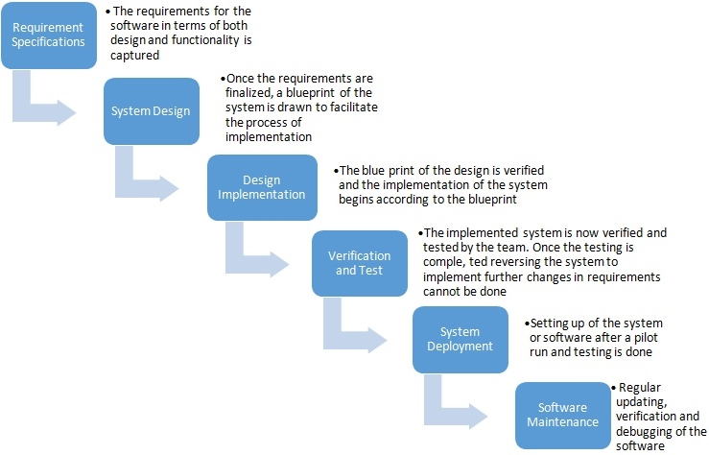
Source: What Should We Know About Project Management?

Prince2 Methodology – The standard project management methodology used by the government, and widely used and practiced internationally as well as the UK. Prince2 is a process based logic, utilized for its effectiveness with the project undertaken (Prince2.com, 2019). With its adaptability capabilities, Prince2 aides in selecting the key individuals needed on board each specific project. With its unique, easy to follow set of processes, Prince2, illustrates at each stage what information needs to be gathered (Adler, 2019). Moreover, not only is Prnice2 a flexible and scalable method, its capabilities are suitable to any project. One whose method is clearly defined and allows for:
- The business to change and manage any aspect including investment and return on investment.
- All parties involved to be active in the decision making, from developmental phase, to testing and to final product showcase. This ensures the project meets environmental, functional, service and management obligations of its operators.
- The development resources are more efficiently controlled (Bentley, 2002)
As stated earlier, Prince2 is the methodology most frequently used, however, advantages and disadvantages are still ever present.
Advantages:
- The Prince2 methodology is very predictable. Each project is broken down into stages and is closely monitored from implementation stage with a step by step method being used as a process. The documents are regularly revised which decreases the projects chances of failing.
- The project continuously utilises best practice which ensures the product delivered is of the highest quality and accurate to what was agreed at time of project commencement.
- This methodology is highly standardised, ensuring all documentation and all individuals involved obey a common project management language guaranteeing misdirection and miscommunication are extinguished.
- As the Prince2 method is highly standardised, time and cost are saved on the training of new employees that are familiar with the concept. All risks are identified at project initiation and any mistakes made can be easily rectified, thus saving time (Niekerk, 2016).
Disadvantages:
- Documentation and planning focused, extra time is required to comprehensively plan a project.
- This method offers little in the way of guidance in managing how judgements are to be made and problems are resolved when they arise. If problems are not resolved in an efficient manner, several consequences could occur, leading to more risk being developed in the project (Pawar & Mahajan, 2017)

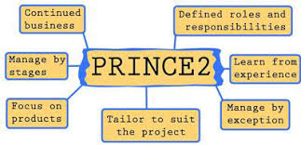
Source: International Journal of Advanced Research in Computer Science
Agile Methodology – Is said to centre around four focal points:
- Product development being impacted on by the rapid changes in opportunities created, commonly referred to as the agile revolution.
- The drive of having principles and values.
- The principles being amplified by those specific practices.
- The ethos to help not only project teams, but entire organisations (Highsmith, 2009)
Unlike Waterfall and Prince2 methodology, to implement Agile project management into a business strategy requires intense planning and analysis (Cobb, 2011). Cobb (2011) also state, to fully understand Agile methodologies, not only do they have to be perceived from a broader business strategy sense, but also a project and development prospective
must also be realised. To accomplish said fetes, individuals must forego and overcome three misconceptions allied with Agile, such as:
- The agile methodology is one of simplicity. Its main use consisting of just writing code with no discipline, planning or documentation.
- The only way to achieve Agile status is to implement alterior Agile methodologies such as Scrum.
- That the Agile methodology is situated at the far end of the spectrum, with no clear plan or direction, unlike the Waterfall methodology which prides itself on having plan driven, clearly defined goals.
Based around the spiral model, represented by iterations or amendments from company feedback, the Agile model requires intense relations amongst its individual users and developers. Heavily determining the project outcome or end result, its main disadvantage centres around an overall objective not being created upon project initiation (Shelly & Rosenblatt, 2009).
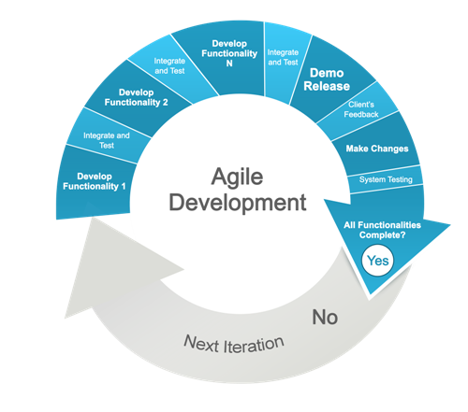

Comparison
A comparison of the various project management methodologies are contained in appendix 1.

Role of a Project Manager
The role of a project manager differs to that of a general manager. The individuals involved in the project could have no sense of loyalty to the team, therefore may become un co-operative. They could also view the project manager and his vision as nonsensical, disrespecting his authority in the process, therefore undermining the decisions being made (Lewis, 2004). In contrast to the last statement made, research has shown that the project managers main role is the initiation, development, design, execution, monitoring, controlling and the closure of projects (Haughey, 2019).
The role of a project manager requires many different skill sets. Their role incorporates many different activities when approaching a project, such as the ability to effectively scope and plan a project (Stratton, 2014). The process involves sequencing and planning of activities, the sourcing and planning of resources and the scheduling of development. Time is of the essence in any project, therefore, a competent project manager must be able to effectively estimate the time a project will take, whilst being mindful of the cost implications (Kleim, 2007). Budget development is also a major factor. A project managers role as principal financier can greatly influence the degree of success or failure of a project, as is his or her role in documenting, progress and monitoring reports and managing risks (Roberts, 2011). A project managers role is perhaps the most important role on any project (Wills, 2010). They bear the responsibility of a project’s failure or success, and as discussed earlier, being undermined or disrespected could create extra pressure.

Key Elements of Project Management
Although unique in their own right, projects are typically characterised with some or all basic fundamentals. Usually, projects consist of between three and twenty five members, with each member capable of working on multiple projects. The resources between projects are occasionally shared, and although team members have some degree of responsibility, frequent or any changes in the project’s priorities are issued and sanctioned by management. The key goal of any project is to enhance a business or enterprises’ holdings, however, there is limited impact on said business or enterprise in the event of project failure (Haugan, 2010).
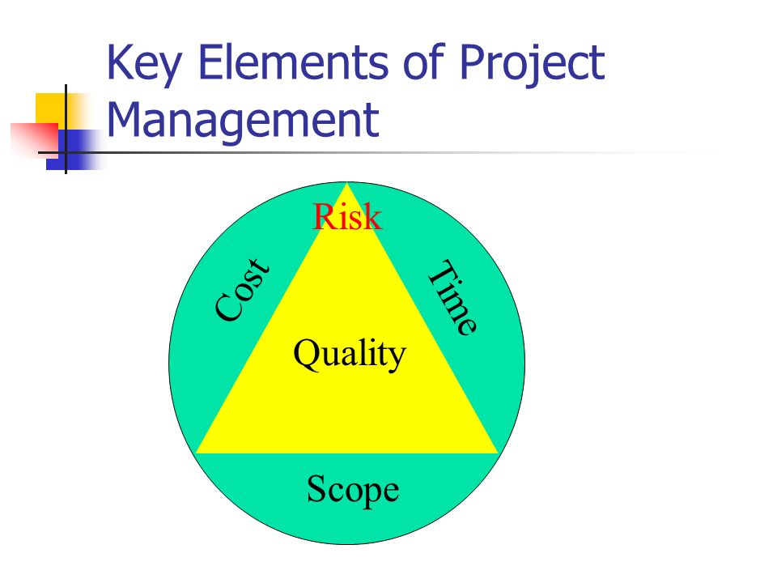

Lifecycle of a Project
The project lifestyle model is a representation of a projects’ and its management process as it develops over time, usually sequential in its stages or phases. Although each project differs, the general consensus is, each lifecycle phase being carried out in the sequence of:
- The project is initiated, building on from the concept that was formed.
- A detailed plan is produced.
- The work is executed, utilizing a team of highly skilled and trained workforce, led by the project manager.
- Once completed, final checks are made before the project is handed over (Cicmil, Cooke-Davies, Crawford, & Richardson, 2017).
The documentation of the lifecycle process is of great importance. This enables each party concerned with the project to effectively understand, plan and execute each task with great precision. The capturing of the documentation also allows for each phase of the project to be continually improved. Enabling future projects to benefit in the way of learning from past mistakes made .Overall, for complete success, specific roles of the project must be assigned to the correct individual, one whose skills are best suited to that phase (Archibald, Di Fillippo, & Di Fillippo, 2012).
Although a generalised system is in place, it is also key that any project, before inception, performs due diligence in the shape of a PESTEL and SWOT analysis. According to Symonds (2011), it is “not only a method used for controlling areas of planning and risk, but it is also used to highlight areas of the project that could be maximised to the benefit of the whole project or individual areas where some competitive advantage may be gained” (Symonds, 2011)

Part 2

Project Management Plan

Following initial meeting, the project manager’s task is to then condense all the information given into an informative, concise document that is well organized, known as a project plan. Known by various names such as, a “co-ordination procedure”, or “project plan”, contained are the key phases, parameters requirements and standards of the project, or in project management terms, the “Why”, “Who”, “What”, “Where”, “When”, and “How” (Lester, 2007). Generally speaking, for a project plan to be a success, each phase is carefully recorded:

Phase One: Process of Initiation- A project assessment is performed. The level of scope is defined, stakeholders analysed (will be discussed in further detail further on in this report), risk assessment undertaken, and any limitations of the project are assessed. These are all condensed into a “Project Initiation Document” (PID) (Pennartz, 2014), and provided phase one standards are met, a project charter is produced, and upon approval, phase two can begin. Phase one is usually concluded with the production of a Gannt chart. This allows for an easier overview of the project timeline. Below is an example of a simple Gannt chart used in project management.
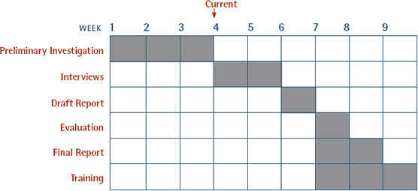
Source: Glenn Behenna UWT
Phase Two: The Process of Planning – Following the establishment of the project deliverables, the creation of the breakdown in structure of work can commence. A budget will then be allocated to the project, ensuring each item is carefully planned for, minimizing cost output for the company or business for whom the project is destined. Phase two of the project is now fully underway, and to finalize, several plans will be developed, such as:
- Human resource plan
- Communications plan
- Procurement plan
- Management of quality plan
- Management change plan
- Management of risk plan.
Thereafter, the master project plan is presented, a kick off meeting is conducted and phase three can begin.
Phase Three: The Process of Execution – This phase usually consists of the overseeing of the project. The project resources are obtained and properly managed, direction of the execution of the project is supervised and the original project management plan commences with the desired quality, allowing for any changes to be approved and implemented, whilst following and managing the impact of risk.
Phase Four: The Controlling and Monitoring Process – It is at this stage that the projects performance is closely measured. Changes that have or need to be made are implemented, ensuring the final project to be delivered is of the highest quality. Although regular updates are relayed to the project creator, as the project is nearing the lifecycle end, status is communicated on a more regular basis.
Phase Five: Project Closure – the project is finally completed. All documentation and transferring of deliverables ensues, along with the obtaining of the legal and executive cessation. Providing the project is a success, final reports are distributed and where necessary, the lessons learnt are systemised and documents archived. Finally, the projects performance is measured and the project signed off (Zaval & Wagner, 2011).

Stakeholder Analysis
“Stakeholders are individuals and organisations that are actively involved in the project, or whose interests may be affected as a result of project execution or project completion” (Projectmanagement .com, 2018). However, although a stakeholder is seen as an outside influence, the concept that the organisation itself should be considered as a primary stake holder has been explored. They are seen as “the focal group”. One whose needs and interests should be carefully managed, and one whose roles should be fulfilled (Friedman & Miles, 2006). Moreover, the majority of projects could have a various different interest groups or stakeholder, and, more often than not, each group’s ideas or interests could be conflicting (APM, 2019). To combat such conflicts, effective stakeholder management is required.
Both the management and engagement are viewed as arguably the most important determining factors to the successful delivery of a project (APM, 2019). According to APM (2019), to effectively manage stakeholders, ten key principles are required:
- The communication and sharing of information is paramount. Information should be gathered on all stakeholder involved to ensure the project delivered meets all requirements and satisfaction
- It is important to consult with all stakeholders early and often
- The acceptance that not all stakeholders will behave humanely and rationally. All personal feelings should be cast aside and a deeper analysis of the cause and root of the stakeholders problem should be explored
- Invest on careful planning before approaching stakeholders
- Develop a relationship with your stakeholders. This in turn will build trust, increasing confidence in the projects ability and minimizing ambiguity
- Anticipate all risks and hazards.
- Stakeholders should be treated as a potential risk and opportunity
- The ability to compromise is key
- Each individual’s perception of success differs. To able a successful project delivery, the context of success must be examined to cater for all needs.
As discussed previously, the ability to communicate effectively is key. Not only should each member of the project relay concerns in a professional manner, clarity should also be provided on stakeholder roles, and responsibility should be accepted by all parties.

Conclusion
This report examined the fundamentals of project management, its methodologies and the basic creation of a project management plan. Whilst each methodology serves it principal purpose for different projects, the general consensus is one of project management, if executed correctly, generally follows the same path and principles. An in depth analysis was performed on three main methodologies, Agile, Prince2 and Waterfall, investigating the ease of use, and their relevance to present day practices, concluding the Prince2 methodology to be the most suitable to any project as it’s the methodology more widely used. Furthermore, this report has realised the importance of stakeholders and their input to any project. Exploring the key principles that bond the project and stakeholder interests, and with the notion that stakeholders should be regarded risk, however, if properly managed, could be key to a projects success. This poses the question. Moving forward, will stakeholders eventually assume control on future projects undertaken?

References
2020. (2019). 10 Reasons why Project Management matters. Retrieved from 2020: https://2020projectmanagement.com/index.cfm?topNav=resources&subNav=general-interest-and-miscellaneous&subsubNav=10-reasons-why-project-management-matters
Adler, K. (2019). IMPLEMENTING PRINCE2 PROJECT MANAGEMENT METHODOLOGY. Retrieved from Project Smart: https://www.projectsmart.co.uk/implementing-prince2-project-management-methodology.php
APM. (2019). 10 key principles of stakeholder engagement. Retrieved from The Chartered Body For The Project Profession: https://www.apm.org.uk/resources/find-a-resource/stakeholder-engagement/key-principles/
APM. (2019). Stakeholder management. Retrieved from The Chartered Body For The Project Profession: https://www.apm.org.uk/body-of-knowledge/delivery/integrative-management/stakeholder-management/
Archibald, R., Di Fillippo, I., & Di Fillippo, D. (2012). The Six-Phase Comprehensive Project Life Cycle Model Including the Project Incubation/Feasibility Phase. PM World Journal, 1(v), 5. Retrieved from https://pmworldlibrary.net/wp-content/uploads/2013/08/PMWJ5-Dec2012-ARCHIBALD-DI-FILIPPO-Featured-Paper.pdf
Bentley, C. (2002). PRINCE2: A Practical Handbook (Illustrated ed.). Routledge. Retrieved from https://books.google.co.uk/books?id=qzsYAlN98A0C&dq=prince2+project+management+methodology&source=gbs_navlinks_s
Cicmil, S., Cooke-Davies, T., Crawford, L., & Richardson, K. (2017). Exploring the Complexity of Projects: Implications of Complexity Theory for Project Management Practice. Project Management Institute. Retrieved from https://books.google.co.uk/books?id=6cO4DgAAQBAJ&dq=the+golden+triangle+of+project+management&source=gbs_navlinks_s
Cobb, C. G. (2011). Making Sense of Agile Project Management: Balancing Control and Agility (illustrated ed.). John Wiley & Sons. Retrieved from https://books.google.co.uk/books?id=NtixCAsSvT0C&dq=agile+project+management&source=gbs_navlinks_s
DPM. (2019). Why Is Project Management Important? Retrieved from DPM: https://thedigitalprojectmanager.com/why-is-project-management-important/
Finance Online. (2019). List of Project Management Methodologies: Comparison & Examples. Retrieved from Finance Online Review for Business: https://financesonline.com/list-of-project-management-methodologies-comparison-examples/
Frame, J. D. (2002). The New Project Management. dawsonera. Retrieved from https://www-dawsonera-com.ezproxy.uwtsd.ac.uk/readonline/9780787963040
Friedman, A., & Miles, S. (2006). Stakeholders: Theory and Practice. OUP Oxford. Retrieved from https://books.google.co.uk/books?id=ITD8VWJGOYYC&dq=stakeholder+analysis+definition&source=gbs_navlinks_s
Haugan, G. (2010). Project Management Fundamentals: Key Concepts and Methodology. Berrett-Koehler Publishers. Retrieved from https://books.google.co.uk/books?id=4hhFDwAAQBAJ&dq=key+aspects+of+project+management&source=gbs_navlinks_s
Haughey, D. (2019). The Role Of The Project Manager. Retrieved from Project Smart: https://www.projectsmart.co.uk/the-role-of-the-project-manager.php
Highsmith, J. R. (2009). Recommendations: (2 ed.). Pearson Education. Retrieved from https://books.google.co.uk/books?id=VuFpkztwPaUC&dq=agile+project+management&source=gbs_navlinks_s
Kerzner, H. (2013). Project Management: A Systems Approach to Planning, Scheduling, and Controlling. John Wiley & Sons. Retrieved from https://books.google.co.uk/books?id=QgQQC5qRtzgC&dq=project+management+definitions&source=gbs_navlinks_s
Kleim, R. (2007). Effective Communications for Project Management. CRC Press. Retrieved from https://books.google.co.uk/books?id=kO76QxH1tAIC&dq=effective+role+of+a+project+manager&source=gbs_navlinks_s
Lester, A. (2007). Project Management, Planning and Control: Managing Engineering, Construction and Manufacturing Projects to PMI, APM and BSI Standards (illustrated ed.). Butterworth-Heinemann. Retrieved from https://books.google.co.uk/books?id=eLEIEPepXoMC&dq=pmi+what+is+a+project+management+plan&source=gbs_navlinks_s
Lewis, J. P. (2004). Team-Based Project Management. Beard Books. Retrieved from https://books.google.co.uk/books?id=9R0tUAuNLB8C&dq=role+of+a+project+manager&source=gbs_navlinks_s
Lucidchart Content Team. (2017). What the Waterfall Project Management Methodology Can (and Can’t) Do for You. Retrieved from Lucidchart: https://www.lucidchart.com/blog/waterfall-project-management-methodology
Niekerk, J. v. (2016). THE ADVANTAGES OF THE PRINCE2 METHODOLOGY. Retrieved from ITonlinelearning: https://www.itonlinelearning.com/blog/the-advantages-of-the-prince2-methodology/
Pawar, R. P., & Mahajan, K. N. (2017). Benefits and Issues in Managing Project by PRINCE2. International Journal of Advanced Research in, 7(3), 190-195. Retrieved from http://ijarcsse.com/Before_August_2017/docs/papers/Volume_7/3_March2017/V7I3-0134.pdf
Pennartz, R. (2014). PRINCE2 ® The Project Initiation Documentation (PID): Guidelines for writing the Project Initiation Documentation according to PRINCE2®. Rik Pennartz. Retrieved from https://books.google.co.uk/books?id=H2uMAwAAQBAJ&dq=pid+project+management&source=gbs_navlinks_s
Prince2.com. (2019). PRINCE2 Methodology. Retrieved from Prince2.com: https://www.prince2.com/uk/prince2-methodology
Projectmanagement .com. (2018). What is Stakeholder Analysis? Retrieved from PM.com: https://project-management.com/what-is-stakeholder-analysis/
Roberts, P. (2011). Effective Project Management: Identify and Manage Risks Plan and Budget Keep Projects Under Control. Kogan Page Publishers. Retrieved from https://books.google.co.uk/books?id=7BDCtEj5syoC&dq=why+is+project+management+important&source=gbs_navlinks_s
Sergeev, A. (2019). What Is Waterfall Methodology? Retrieved from HYGGER: https://hygger.io/blog/what-is-waterfall-methodology/
Shelly, G., & Rosenblatt, H. (2009). Systems Analysis and Design (8 ed.). Cengage Learning. Retrieved from https://books.google.co.uk/books?id=xZVJKFtYrlsC&dq=agile+methodology+advantages&source=gbs_navlinks_s
Stratton, M. (2014). The Effective Project Manager. (A. J. Carolyn Daughters, Ed.) eBookIt.com. Retrieved from https://books.google.co.uk/books?id=mAxEBQAAQBAJ&dq=effective+role+of+a+project+manager&source=gbs_navlinks_s
Symonds, M. (2011). SWOT ANALYSIS IN PROJECT MANAGEMENT. Retrieved from https://www.projectsmart.co.uk/swot-analysis-in-project-management.php
Techopedia. (2019). Techopedia. Retrieved from Project Management: https://www.techopedia.com/definition/13838/project-management
The Chartered Body for the Project Profession . (2019). What is project management? Retrieved from APM: https://www.apm.org.uk/resources/what-is-project-management/
tryQA. (2019). What is Waterfall Model. Retrieved from tryQA: http://tryqa.com/what-is-waterfall-model-advantages-disadvantages-and-when-to-use-it/
Wills, K. (2010). Essential Project Management Skills (illustrated ed.). CRC Press. Retrieved from https://books.google.co.uk/books?id=VLh40K3nqMgC&dq=importance+of+the+project+manager&source=gbs_navlinks_s
Zaval, L., & Wagner, T. (2011). Project Manager Street Smarts: A Real World Guide to PMP Skills (2, illustrated ed.). ohn Wiley & Sons. Retrieved from https://books.google.co.uk/books?id=PHEJw4dXFjsC&dq=pmi+what+is+a+project+management+plan&source=gbs_navlinks_s

Appendix 1


