

Student Name:CORINA COSMA
Student ID:2114145

Table of Contents
Introduction 3
The key business and corporate strategies of GSK 4
Focus on Pharmaceuticals 4
Driving Growth Through Innovation 4
The resources and capabilities of GSK 5
Resources’ alignment 5
Capabilities’ alignment 5
The success of GSK in implementing business and corporate strategies 6
Focus on Pharmaceuticals 6
Driving Growth Through Innovation 6
Competitive Advantage 7
GSK is more competitive with sustainability and the environment 7
Current Initiatives 7
Competitive Advantage Potential 7
Limitations of the Current Approach 8
Moving Forward 8
Available choices for GSK’s strategic direction 8
Conclusion 9
References 11
Appendix 12

Introduction
GlaxoSmithKline is one of the most popular companies and market leaders in the global pharmaceutical and vaccine industry. This company provides several types of products and services to cure several types of diseases of people across the globe (Garçon, Chomez, and Van Mechelen, 2023). This report has examined this company's key business and corporate strategies, resource alignment, implementation successes, and approaches to sustainability. Today's business landscape is changed with intense levels of competition. To hold its market-leading position, this company needs to focus more on ensuring better innovations. This report examines the strategies that could help GSK be on top in future also. It also assesses the current strategies of this company and their alignment with organizational aspects.
Porter’s generic competitive strategy is a framework that is useful for planning the strategic direction of the business that assists in gaining an advantage in the marketplace over the competitors.

The key business and corporate strategies of GSK
Glaxo Smith Kline has a two-sided strategic approach. One is to focus on the pharmaceutical sector, and another is to drive growth through innovation. These key strategies and the frameworks explaining the rationale can include several types of methods, concepts, and sub-strategies.

Focus on Pharmaceuticals
As a company in the pharmaceutical industry, GSK divested its consumer healthcare business in 2022. Besides this company has also emphasised its vaccine and specialty medicine portfolios recently. As the company has started prioritising, it resulted in increasing their research and development expenditure. The R&D expenditure of GSK reached £5.3 billion in 2021. It was a more than seven 5% increase from the previous year (Evangelista, 2022). The core reason behind increasing the investment in R&D is the prioritisation of innovation. GSK knows that innovation is one of the most crucial elements and strengths of a business which can put it in front of the competition in any industry. This is why this company is constantly focusing more on strengthening its R&D activities to fight strongly against all the competitors in the market. The R&D department of this company has also shown its expertise in meeting the demands of people from around the globe (Shang, 2021). GSK was one of the successful companies to innovate the vaccine for COVID-19. That year, this company was heavily praised by the people, organisations, groups, and companies worldwide. However, this company has also shown its expertise in innovating more effective vaccines for severe diseases.

Driving Growth Through Innovation
GSK has a strategy named “Ahead Together”. According to this strategy, GSK prioritises innovation to prevent and treat diseases early. GSK always wants to establish the notion that prevention of any disease is very easy in the early stage. It keeps becoming more and more complex as soon as it evolves. This is why another aspect of this company’s R&D activities is to innovate products or services that can help prevent diseases in the early stages (Nisen, and Rockhold, 2022). It also aims at improving health outcomes and reducing healthcare system burden. Lots of people all over the globe face difficulties and complexities in getting rid of diseases only because of not curing them in the early stages. GSK is heavily committed to this approach, for which it has ensured a significant investment in the R&D department.

The resources and capabilities of GSK
Glaxo Smith Kline has a strong set of resources and capabilities that are properly aligned with its current business and corporate strategies. R&D expertise and infrastructure, strong brand reputation, global manufacturing footprint, commercialization capabilities, innovation, focus or some core resources and capabilities of this company.

Resources’ alignment
As mentioned earlier, GlaxoSmithKline invests heavily in its research and development activities. This company is increasing its number of investments in this department. This increment of investment in R&D is quite crucial for developing innovative vaccines and speciality medicines. Innovation of these vaccines and medicines is the core strategy of this company to grab the market. This is why it's its R&D and infrastructure are properly aligned with its strategic focus (Evangelista, 2022). On the other hand, this company also has a global manufacturing footprint as shown in the SWOT analysis in Figure 1. This robust global manufacturing network with a presence in more than 70 countries, is quite significant for this company to efficiently produce and distribute their products to a worldwide market. Finally, GSK also has a strong brand reputation. It is a well-established brand in the pharmaceutical industry globally. Besides, this company is recognised for its research and development capabilities (Brown, 2023). This brand image of this company posters trust with patients, investors, and healthcare providers. This company can use this trust and relationship to be more connected to them which will ultimately help this company thrive more in its industry.

Capabilities’ alignment
Apart from these resources, GSK also has some significant capabilities which put this company forward in the competition in the pharmaceutical industry. This company focuses primarily on innovation, possesses a global reach and has commercialization capabilities. GSK always ensures maximum utilisation of its R&D expertise to drive innovation and develop new drugs and vaccines. These drugs and vaccines are mostly suitable for patients across the globe. This is a significant capability of this component that directly supports its strategy of focusing on speciality medicines and vaccines (Kulp, et. al., 2023). On the other hand, this company also has established a robust manufacturing infrastructure. It allows the company to capitalise on their global presence. This key capability is a major factor behind the success of the international pharmaceutical market. It also aligns with this company's strategy to reach patients worldwide with its products and services. Finally, the commercialization capabilities of this company are also quite crucial. This company has been successful in bringing new drugs and vaccines to market for a long time. It demonstrates its commercialization capability, which is essential for translating its efforts into revenue. It also fosters the achievement of this company’s growth objectives.

The success of GSK in implementing business and corporate strategie
The Ansoff Matrix was originally developed by H.Igor Ansoff in 1957 and it offers a simple and effective way of weighing the options and the risks involved when taking new strategic decision .
GSK's effort to implement its business and corporate strategies has provided mixed results, including both success and failure. Besides, there are also some major challenges to be faced by this company to be more successful in future.

Focus on Pharmaceuticals
GSK has been focusing on the pharmaceutical industry since the beginning of its formation. In this regard, this company has been successful in this industry to achieve its objective. GSK’s divestiture of Haleon allowed this company to dedicate resources solely to the pharmaceutical centre. It also offered this company a higher growth potential (Shang, 2021). There are some more factors to be taken into consideration for this company regarding this issue. The long-term impact on shareholder value from the spin-off is yet to be seen. It needs to be properly assessed and suitable actions are to be taken accordingly to survive strongly in the market in future too.

Driving Growth Through Innovation
A major driving factor behind the success of GSK is its continuous focus on innovation. This company has a strong R&D pipeline that has yielded new drugs and vaccines. For example, Shingrix for Shingles Prevention is a prime example of the success produced by the R&D department of GSK. This company has an aim to achieve over 5% growth in sales, and over 10% in adjusted operating profit each year (Danese, 2023). Their R&D department and relevant activities can be highly helpful for this company to fuel this growth. However, there are some challenges to be faced too. In one aspect, bringing innovative products and services to the market consistently is quite essential for achieving sustainability. However, some flagship drugs are approaching patent expiring. These require continuous improvement to ensure success in maintaining market share.

Competitive Advantage
GSK has a high growth rating for its focus on speciality medicines. Besides, it also ensures a less commoditised market segment compared to generic drugs. In addition, the global reach of this company also provides a competitive edge in accessing new markets. However, there are also competitions and several challenges to be faced (Rockhold, Metz, and Traber, 2022). The established players in the market are throwing huge competition. Besides, innovative biotech companies are also in a fierce mood. This is why this company now needs to maintain its strong R&D pipeline. Besides, it also has to successfully commercialise new products, which is quite crucial for differentiation and long-term competitive advantage.

GSK is more competitive with sustainability and the environment
The global pharmaceutical industry is heavily competitive nowadays, as shown in Figure 2. In this context, GlaxoSmithKline has taken several steps towards incorporating sustainability into its business practices. However, there is still room for a more strategic approach to use it for a competitive edge.

Current Initiatives
GSK currently has some ambitious goals for reducing carbon emissions, water usage and waste generation. These initiatives from this company are aimed at minimising their environmental footprint. On the other hand, this company is also focusing on the use of renewable energy. It is committed to using 100% renewable electricity for imported and generated sources by 2030 which will contribute significantly to reducing its carbon footprint (Nisen, and Rockhold, 2022). Finally, this company has also acknowledged the significance of responsible sourcing practices in its operations.

Competitive Advantage Potential
The brand image and reputation of GSK can be called as its core strengths to grab the attention of the consumers. They are highly environmentally conscious nowadays, and this company needs to have a stronger focus on sustainability. It could enhance GSK's brand image and attract environmentally responsible investors and talents (Hughes, et. al, 2023). In addition, GSK also has a reputation for being a cost-saving company. Performing sustainable practices like reducing wastage and using renewable energy can help this company minimise its cost to the maximum extent. Finally, there are still innovation opportunities that can be used by the R&D department of this company. It can drive innovation in areas like developing eco-friendly packaging or optimising production processes to minimise environmental impact.

Limitations of the Current Approach
Limited integration is a major limitation of the current approach. This company needs a more strategic approach to integrate sustainability throughout its whole value chain. There is also a lack of transparency in the activities of GSK (Gnanakumaran, and Babu, 2023). This company could benefit from increased transparency regarding its sustainable practices. It needs to highlight specific achievements and future goals to be more successful.

Moving Forward
GSK needs to focus on ensuring sustainable product development from now on. This company can also establish partnerships with other companies and NGOs on sustainability initiatives (Kumar, and Kumar, 2021). Finally, this company also needs to develop a clear connection strategy to effectively communicate its sustainable goals and achievements to all the stakeholders.

Available choices for GSK’s strategic direction
GSK needs to select specific strategic choices to ensure future success. There are some potential directions for this company. Besides, sustainability will also play a crucial role in shaping the success of GSK.
Maintaining A robust R&D pipeline will remain crucial for any company, including GSK. The RN department of this opening can explore several areas like personalised medicine, digital health technologies and gene therapy. It can lead towards groundbreaking, innovative products and solidify the position of GSK's leader in innovation in the promise tickle industry (Brown, 2023). In addition, its expansion into emerging markets will also remain important in future. There are high-growth emerging markets like China, India, Vietnam, and Bangladesh that offer significant opportunities. This company can tailor products and pricing strategies to these markets. That will fuel its revenue growth.
In the future race to hold the top position in the pharmaceutical industry, sustainability will play a major role in providing a competitive advantage to any company, including GSK. This company needs to focus on products with lower environmental footprints. It can focus on using biodegradable materials or medications with reduced energy consumption during production (Yeates, 2022). It will help this company attract environmentally conscious consumers. Besides, this company also needs to implement circular economy principles like product life cycle management and resource recovery. It will help this company optimise resource use and reduce costs and waste. Finally, transparency is also quite crucial. GSK should try to ensure increased transparency in sourcing practises and suppliers’ sustainability efforts that can build trust with environmentally conscious investors, consumers, and talents.
The most significant recommendation to GSK will be to develop a Sustainability roadmap. Creating a clear road map for integrating sustainability throughout its value chain will be very beneficial for GSK in the long run. Besides, GSK can also invest in sustainable technologies along with investing more in R&D activities (Kulp, et. al., 2023). Sustainability-driven innovations will be the key players in the future where most people and businesses will prefer environmentally conscious companies. GSK needs to consider these facts and continue serving people across the globe with more effective products and services. These activities will also help this company enhance its brand image, ensure regulatory compliance, and save costs to the maximum extent possible. However, GSK should be conscious about ensuring the accurate implementation of all the planning and strategies to be successful in achieving its objectives.

Conclusion
GSK has been focusing on pharmaceuticals and innovation for a long time. This focus of GSK on these particular fields has yielded mixed results with both benefits and challenges. The R&D investments and its strong global presence are the core strengths of this company that position it well. However, there are challenges in maximising shareholder value and maintaining a competitive edge for a long time. This component needs to have a more strategic and integrated approach to sustainability. It will help this company create significant opportunities and leverage its resources. This company also needs to focus on sustainable product development, transparent communications and partnerships which will help GSK enhance its brand image and reach a larger consumer base worldwide.

References
Brown, W.M., 2023. Cilomilast GlaxoSmithKline. Curr Opin Investig Drugs, 6(5), pp.545-58.
Danese, P., 2023, January. Beyond vendor-managed inventory: the GlaxoSmithKline case. In Supply Chain Forum: An International Journal (Vol. 5, No. 2, pp. 32-40). Taylor & Francis.
Evangelista, S., 2022. Talnetant GlaxoSmithKline. Current opinion in investigational drugs (London, England: 2000), 6(7), pp.717-721.
Garçon, N., Chomez, P. and Van Mechelen, M., 2023. GlaxoSmithKline Adjuvant Systems in vaccines: concepts, achievements and perspectives. Expert review of vaccines, 6(5), pp.723-739.
Gnanakumaran, G. and Babu, K.S., 2023. Technology evaluation: mepolizumab, GlaxoSmithKline. Current Opinion in Molecular Therapeutics, 5(3), pp.321-325.
Hughes, S., Wells, K., McSorley, P. and Freeman, A., 2023. Preparing individual patient data from clinical trials for sharing: the GlaxoSmithKline approach. Pharmaceutical Statistics, 13(3), pp.179-183.
Kulp, S.L., Randall, T., Brandyberry, G. and Potts, K., 2023. Using organizational control mechanisms to enhance procurement efficiency: how GlaxoSmithKline improved the effectiveness of e-procurement. Interfaces, 36(3), pp.209-219.
Kumar, B.R. and Kumar, B.R., 2021. GlaxoSmithKline merger. Wealth Creation in the World’s Largest Mergers and Acquisitions: Integrated Case Studies, pp.137-145.
Nisen, P. and Rockhold, F., 2022. Access to patient-level data from GlaxoSmithKline clinical trials. New England Journal of Medicine, 369(5), pp.475-478.
Rockhold, F., Metz, A. and Traber, P., 2022. Response from GlaxoSmithKline. The British Journal of Psychiatry, 180(6), pp.548-548.
Shang, J., Tadikamalla, P.R., Kirsch, L.J. and Brown, L., 2021. A decision support system for managing inventory at GlaxoSmithKline. Decision Support Systems, 46(1), pp.1-13.
Yeates, C., 2022. Sitamaquine (GlaxoSmithKline/Walter Reed Army Institute). Current opinion in investigational drugs, 3(10), pp.1446-1452.

Appendix
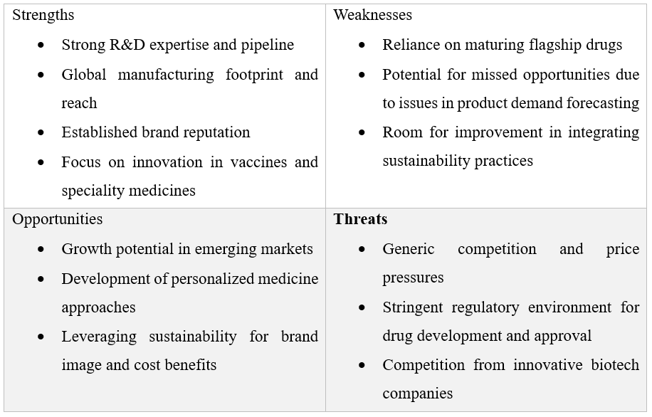
Figure 1: SWOT Analysis of GSK (Self-made)
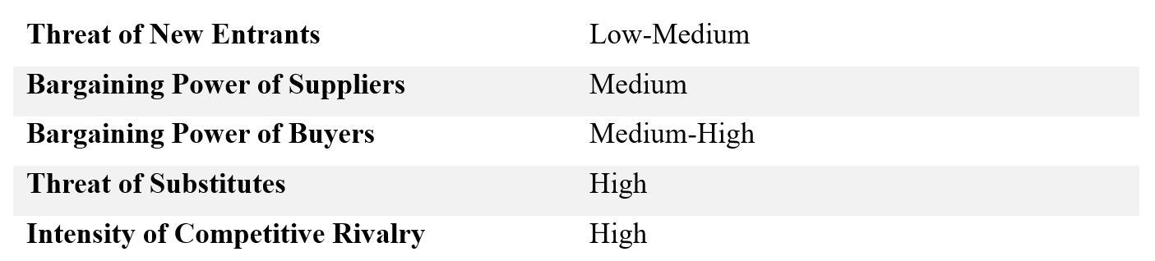
Figure 2: Porter's Five Forces analysis for the pharmaceutical industry (Self-made)

