Name: Eduardo Polanco Adoka
ID: 2132108
Programme: BA International Hotel Management
Module: Financial Management for the Hotel Industry
Lecturer: Chris Wilkin
Assignment Title: Business Report - Comparison of Two Hospitality Organisations
Table of Contents
Introduction 3
1. Total Revenue 3
2. Market Position 6
3. Growth Potential 7
4. Financial Commitment to CSR (Corporate Social Responsibility) 9
Recommendations 9
Conclusion 11
Reference List 12
Appendix 1 - Income statement of Shangri-la 15
Appendix 2 - Income statement of Premier Inn 17

Introduction
Management accounting is useful for individuals in ensuring that the responsibilities of the individuals are carried out that are relative to controlling, decision-making and motivation (Seal, 2019). Financial accounting is mainly concerned regarding the provision of all the information to the parties (Drury, 2021). Financial management within the hotel industry includes conducting an analysis of the trends observed in the financial trends of organisations. The report aims to cover a comparison between Premier Inn and Shangri-la hotels including their overall performance. The objectives are to cover the sources of revenue, the trends associated with it, their share in the market and the customer demographics. The next section aims to highlight the growth potential of the organisations including their expansion strategies. Lastly, both the company’s commitment towards CSR practices is also to be highlighted.

1. Total Revenue
Sources of revenue
There are numerous sources of revenue for Shangri-la hotels. Some of the sources of revenue for the firm while operating in both the UK and in the global firm are Hotels and Resorts. The hotels and resorts of Shangri-la hotels have been successful in the generation of revenue from its events and meetings and any other services. The restaurants and services which also include their bar services are important in the generation of revenue from the sales of food and beverage. Some other services from which revenue is being generated for the company are the wellness centers, managed clubs and experiences of family members (Shangrila, 2025). In comparison, deriving from the latest occupancy data, it was estimated that Premier Inn’s expenditure of the customer was done on the food and drink services. Some other sources from which revenue was generated are the spendings on the purposes of entertainment, local shopping and travels that was responsible for generating around £1.6 billion on a yearly basis (Whitebread, 2023).
Revenue and cost trends
Revenue
From the annual report, Shangri-la earned a total revenue of $1,033.4 million (£820.00 million) which slowly rose to $1,241.0 million (£984.72 million) in the year 2021 (Shangrila, 2021). The revenues kept rising considerably since it further increased to $1,462.1 million (£1,160.17 million) and reached a peak value of $2,141.8 million (£1,699.50 million) in 2023 (Shangrila, 2023). From the views of Tranter et al. (2024), the rise in revenue of an organisation is strongly dependent on several aspects such as capacity, supply and demand.
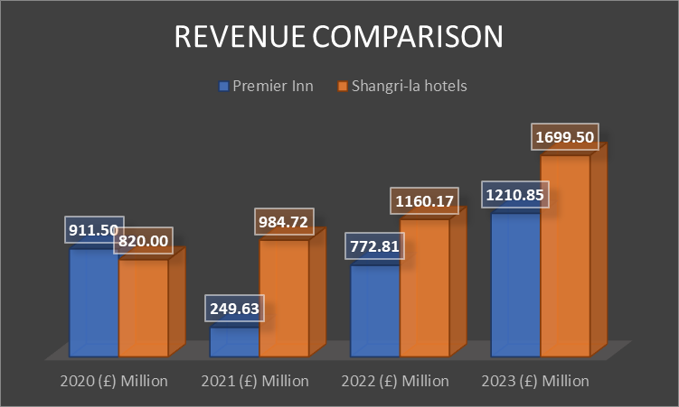
Figure 1: Revenue Comparison
(Source: Created by the learner)
In comparison, the revenue of Premier Inn was retrieved at £911,501 thousand in 2020 and the data fell drastically to £249,627 thousand in the following year, that is 2021 (Gov, 2025). After the fall, the values started increasing again in the year 2022 reaching £772,806 thousand and further escalating to £1,210,845 thousand (Gov, 2025). This concludes that the revenue trend of premier inn showcased two scenarios, one is downward during the pandemic and post pandemic it rose upwards.
Cost
The operating cost’s data of Shangri-la hotels was at $499.9 million (£396.67 million) in 2020 and decreased slightly to $451.9 million (£358.58 million) in 2021 (Shangrila, 2021). This further escalated to $527.1 million (£418.25 million) and $650.4 million (£516.09 million) in 2022 and 2023 respectively (Shagrila, 2023). As opined by Ogbonnaya et al. (2022) argued that when an organisation is experiencing rising costs, it faces pressure on increasing prices, decreased investment in the overall initiatives of growth and cost-cutting requirements.
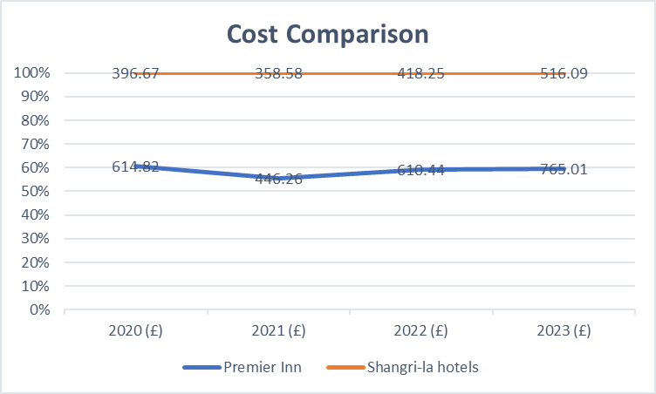
Figure 2: Cost Comparison
(Source: Created by the learner)
In comparison, the operating costs of Premier Inn slowed down to £446,261 thousand in 2021 after being at £614,822 thousand in the previous year (Gov, 2025). This further kept rising to £610,442 thousand and £765,005 thousand in 2021 and 2022 respectively (Gov, 2025). The trends were similar in the costs where both the organisations had an upward and downward trend in its overall expenses.
Factors driving revenue growth or decline
Some of the key factors that were the contributors of the growth in revenue of Shangri-la hotels was reputation of the brand, its strategic location and efficiency in its management during the pandemic. In the onset of the pandemic, Shangri-la was responsible for the implementation of measures relatable to cost-cutting and laid emphasis on retaining staff. This was helpful for the organisation for making a quick rebound after the restrictions on travelling were lifted. The brand reputation of Shangri-la includes being the developer, owner and having a mindset of continuing its operations by offering insights into the market intelligence (Shangrila, 2025). On the other hand, the pandemic resulted in travel restrictions on Premier Inn which also resulted in the costs for the organisation including the labour costs rising considerably. However, the increment in direct bookings also resulted in the upward movement of the company’s earnings and expanding into Germany.

2. Market Position
Market share
Being one of the biggest hoteliers in the UK, the share in the UK market of premier inn consists of 12% share within the entire market (Whitebread, 2023). Along with that, around 853 hotels of Premier Inn were in the UK and in Ireland as of 2023/24 and since 2012/13, there has been continuous growth in the number of hotels within the UK market (Statista, 2024). In comparison, Shangri-la hotels are not much popular in the UK market due to its lack of recognition in the organisation. However, the organisation has opened up close to 100 hotels in a total of 76 destinations (Shangrila, 2024). This indicates that in the global market, Shangri-la has a higher competitive advantage compared to Premier Inn.
Customer demographics
The guests that premier inn targets are travellers associated with business, leisure travellers and families. Based on this theory, Premier Inn mainly aims for psychographic and demographic segmentation for the individuals belonging to the middle-aged category and price conscious customers who cannot afford expensive hotels. On the other hand, Shangri-la focuses on the individuals that belong to the high-income group, business tourists and travellers seeking for luxury services. Shangri-la follows a culture of thoughtful service by being engaged and interacting with the customers to ensure that they have a sense of belonging in the organisation (Shangrila, 2025).
Brand perception
The bowman’s strategy clock is a model that helps businesses in having an understanding of the ways through which competition might occur in the marketplace. The brand perception relative to Shangri-la’s services includes having a delightful culinary experience along with valuable cultural services. The brand strongly aims in enabling the guests in helping them to be committed to the anticipation of their needs in order to deliver unforgettable experiences (Shangrila, 2025). Relating to Bowman's strategy clock, Shangri la hotels strongly aim in high value and high price where an organisation charges a premium price for its services to have the highest level of premium service that defines its quality. In contrast, the brand awareness of Premier Inn has been noted to be 91% being the highest in the UK (Statista, 2024). Having a multi-channel approach within the operations helped the entity to focus on a proper audience of the firm by having visibility of numerous consumer touchpoints. Relating to Bowman's strategy clock, the organisation is able to position themselves at a strategy that not only offers lower prices to customers but also maintains a competitive position of themselves.
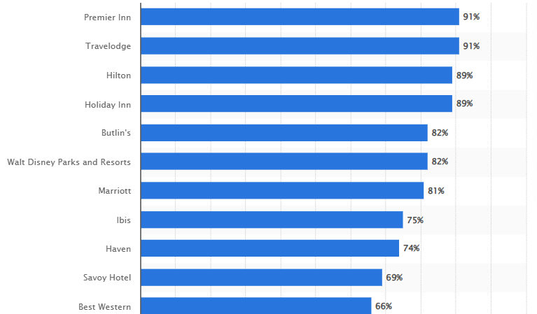
Figure 7: Leading hotels having the highest brand awareness in the UK
(Source: Statista, 2024)

3. Growth Potential
Expansion strategies
Globalisation has been on the rise compared to internal and external knowledge and experience along with demand being high (Walker, 2017). Shangri-la hotels follow an aggressive strategy for expanding its purposes that includes both building new hotels and renovation of existing ones. The growth strategies of Shangri-la hotels mainly comprise differentiation, localisation, international expansion and training. The company provides Asian-style hospitality by being a distinctive model. Also, training is provided for the employees for making sure that consistency is maintained within the service delivery model. Since 1971, the company has been responsible in pioneering all the landmark projects by being able to work closely with the partners in frontier destinations (Shangrila, 2025). In comparison, Premier Inn is being strictly followed based on the ownership of the property which has allowed the organisation to grow significantly faster than its competitors (Whitebread, 2025). Also, the organisation strongly aims to expand its presence in the UK by converting some of its hotels into the mini-hotels of the company. The organisation is also willing to increase its inventory on all of its platforms one of which is Trivago. These are the services that include cancelled rates and increasing rooms.
Market opportunities
The market opportunities can be related to the concepts of demand and supply where a significant variation in demand is observed during peak seasons where hotels usually charge higher prices. The demand for Shangri-la hotels has been increasing considerably due to the rebound of the tourism industry along with the creation of stronger demand for the services of luxury hospitality. Also expanding in newer markets have helped the company to increase its supply strategy by expansion into emerging markets, enhancement of the services of digital marketing and improvement in targeting the right audience. The total rooms and development pipeline for Premier Inn has a current portfolio of more than 82,700 rooms along with adding nearly 2000 more rooms in 2023 and having a total number of rooms of 125,000 (Whitebread, 2023).
Potential barriers to growth
Premier Inn might face challenges of rising overall labour costs and higher competitive levels. Rising rates of interest might create limitations on the opportunities of new hotel development followed by rising competition levels. Increasing labour costs might result in the organisation trying to cut down costs and trim staff. In contrast, Shangri-la can face expansion in higher wage economies like Europe and North America. As per the opinion of Christiaensen et al. (2021), the potential barriers that organisations might face while expanding into higher wage economies are the higher cost of labour, non-availability of skilled labour, stricter regulations in labour and having potential for higher costs of operations. The adaptation of different cultures in different countries can not only be challenging but might also require carefully adapting to the local traditions and customs.

4. Financial Commitment to CSR (Corporate Social Responsibility)
The corporate social responsibility of Shangri-La Hotels continues in operating in an economically and environmentally viable manner along with creating balance on the needs for the stakeholders. For instance, in Paris, Shangri-la has decided to use recycled bottles as a part of their procedure for slowing down global warming along with the integration of sustainable measures in the operations (Shangrila, 2025). Also, the company is able to raise awareness for sustainable food sourcing that provides support to the local suppliers for helping them to cater to shorter delivery routes. In comparison, charity fundraising is undertaken by Premier Inn that is responsible for providing adequate support regarding the Great Ormond Street Hospital Children's Charity (GOSH Charity). As an ongoing procedure of its renewed property, the company made its commitment in raising around £20 million for the “Build it. Beat It” fundraising procedure (Premierinn, 2023). The company is strongly committed in the minimisation of the activities within the environment through the prevention of pollution and promotion of environmental practice (Whitebread, 2021).

Recommendations
- Diversification of revenue: Some of the key strategies that can be adopted by Shangri-la regarding the diversification of revenue includes diversifying its services. It includes focusing more on high quality restaurants with diverse menus along with spaces for events. Furthermore, in the UK market, Shangri-la needs to emphasise more on wellness and services for spa along with retail and merchandise.
- Opportunities for growth: Premier Inn needs to focus more on expanding into different countries apart from the UK and Germany. A franchise model can be adopted by granting licences to the local retailers in allowing them to operate a hotel under the name of the brand.

Conclusion
From the assignment, it is observed that Shangri-La is in a slightly better position in terms of its finances compared to Premier Inn due to its higher brand image and recognition in international markets. However, both the organisations have faced challenges of rising operational costs during the pandemic. The Bowman strategy clock indicates that Shangri-la follows on premium pricing by prioritising quality for the premium customers. On the other hand, premier inn focuses on cost-effective services for its customers. Both the organisations are strongly prioritised in maintaining the health and wellbeing of the guests, employees and the environment.

Reference List
Christiaensen, L., Rutledge, Z. and Taylor, J.E. (2021) ‘The future of work in agri-food.’ Food Policy, 99, p.101963.
Drury, C. (2021) Management and Cost Accounting. 11th Edition. London, Prentice Hall.
Gov (2025) PREMIER INN HOTELS LIMITED [Online] Available at: <https://find-and-update.company-information.service.gov.uk/company/05137608/filing-history> [Accessed on 20 February 2025]
Ogbonnaya, C., Dhir, A., Maxwell-Cole, A. and Gorny, T. (2022) ‘Cost-cutting actions, employment relations and workplace grievances: Lessons from the 2008 financial crisis.’ Journal of Business Research, 152, pp.265-275.
Premierinn (2023) How we’re supporting Build it. Beat it – Great Ormond Street Hospital Children’s Charity’s new fundraising campaign [Online] Available at: <https://www.premierinn.com/gb/en/news/2023/build-it-beat-it.html> [Accessed on 20 February 2025]
Seal, W. (2019) Management Accounting, London. 6th Edition. McGraw Hill.
Shangrila (2021) Annual Report 2021 [Online] Available at: <https://sitecore-cd.shangri-la.com/-/media/Project/Shangri-La-Group/Investor/Files/Public-Disclosures/Latest-Top-Publications/2021_Annual-Report_E.pdf> [Accessed on 20 February 2025]
Shangrila (2023) Annual Report 2023 [Online] Available at: <https://sitecore-cd.shangri-la.com/-/media/Project/Shangri-La-Group/Investor/Files/Public-Disclosures/Latest-Top-Publications/2023_Annual_Report_E.pdf> [Accessed on 20 February 2025]
Shangrila (2024) Join Shangri-La Circle today [Online] Available at: <https://www.shangri-la.com/> [Accessed on 17 February 2025]
Shangrila (2025) Corporate Social Responsibility [Online] Available at: <https://www.shangri-la.com/paris/shangrila/about/corporate-social-responsibility/> [Accessed on 20 February 2025]
Shangrila (2025) Culture of Thoughtful Service [Online] Available at: <https://www.shangri-la.com/group/our-story/people-and-culture> [Accessed on 17 February 2025]
Shangrila (2025) For the latest updates and information about Shangri-La Asia Limited [Online] Available at: <https://www.shangri-la.com/group/investors/> [Accessed on 20 February 2025]
Shangrila (2025) Hotels and Resorts [Online] Available at: <https://www.shangri-la.com/group/our-businesses/hotels-and-resorts> [Accessed on 20 February 2025]
Shangrila (2025) Owner, Developer, Operator Mindset [Online] Available at: <https://www.shangri-la.com/group/our-businesses/hotels-and-resorts#:~:text=Whether%20it%20is%20through%20its,and%20delivering%20memorable%20experiences%20with> [Accessed on 17 February 2025]
Shangrila (2025) Wellness [Online] Available at: <https://www.shangri-la.com/group/our-businesses/wellness> [Accessed on 20 February 2025]
Statista (2024) Number of Premier Inn (Whitbread) hotels in the United Kingdom and Ireland from 2012/13 to 2023/24 [Online] Available at: <https://www.statista.com/statistics/739855/whitbread-premier-inn-hotels/> [Accessed on 17 February 2025]
Tranter, K. Stuart-Hill,T. and Parker, J. (2014) Introduction to Revenue Management for the Hospitality Industry. London, Pearson.
Walker, J. (2017) Introduction to Hospitality. 7th Edition. Harlow, Pearson.
Whitebread (2021) Premier Inn Environmental Policy Statement [Online] Available at: <https://cdn.whitbread.co.uk/media/2021/02/03141905/Premier-Inn-Environmental-Policy-Statement.pdf> [Accessed on 20 February 2025]
Whitebread (2023) The Economic Impact of Premier Inn Hotels [Online] Available at: <https://cdn.whitbread.co.uk/media/2023/08/The-Economic-Impact-of-Premier-Inn-hotels_2022-study_final.pdf> [Accessed on 17 February 2025]
Whitebread (2025) Our business model and strategy [Online] Available at: <https://www.whitbread.co.uk/about-us/our-business-model/> [Accessed on 17 February 2025]
Appendices

Appendix 1 - Income statement of Shangri-la
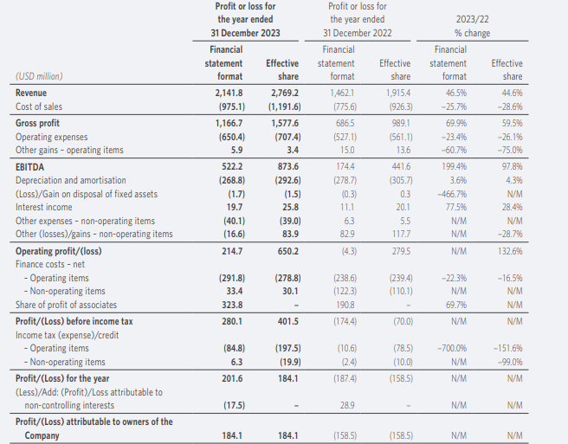
Figure 3: Income statement of Shangri-la hotels in 2022 and 2023
(Source: Shangrila, 2023)
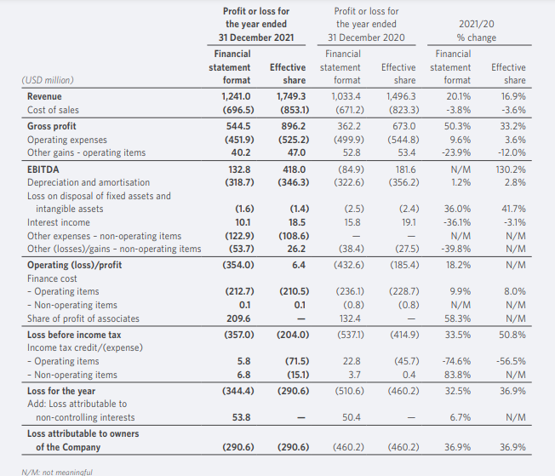
Figure 4: Income Statement of Shangri-la hotels in 2020 and 2021
(Source: Shangrila, 2021)

Appendix 2 - Income statement of Premier Inn
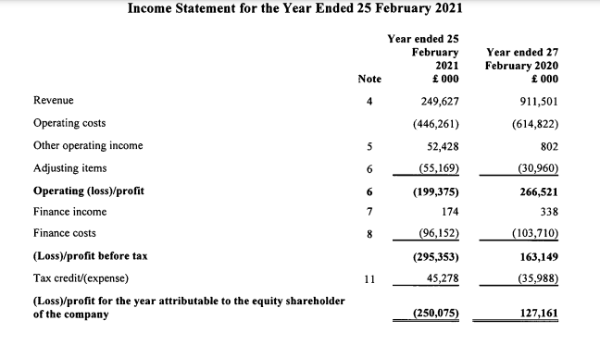
Figure 5: Income statement of Premier Inn in the year 2020 and 2021
(Source: Gov, 2025)
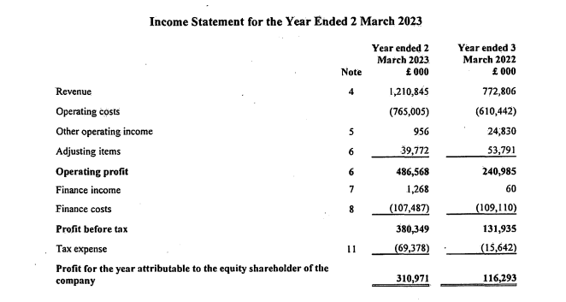
Figure 6: Income statement of Premier Inn from 2022 and 2023
(Source: Gov, 2025)

