Information Engineering Level 4
Steven Moon (1904741)

Table of Contents
- Database Design Page 3
- Table Creation Page 4
  - SQL Creation Page 4
  - GUI Creation Page 4
- Data Entry Page 5
  - SQL Data Entry Page 5
  - Datasheet View Entry Page 5
  - Access Form Page 5
- User Guidance Page 6
  - Main Menu Page 6
  - Enter Additional Stock Page 7
  - Replenish Stock Page 7
  - Order from Stock Page 8
  - Create New Customer Page 8
  - Order From Supplier Page 9
- Reporting Page 9

1.0 Database Design
The below database image shows the table designs with the relationships present between each. These primary/foreign key relationships allow for data integrity to be maintained and also allows us to keep reference data in a single location to limit storage requirements.
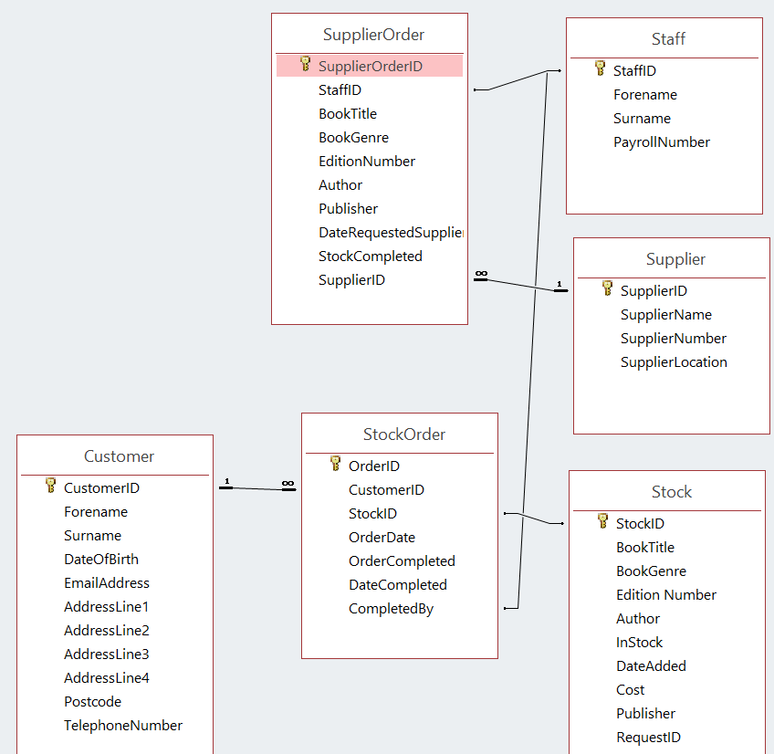

2.0 Table Creation
There are a few different options when creating tables within an access database, below shows the most used methods used within the creation of the bookshop database.
2.1 SQL Creation
The first method for table creation in access would be to use a SQL create command which will allow each column to be given a set data type and field length. This method is useful as the script can be used over multiple databases and software platform without major changes to the design being required.
This example show the SQL script used to create the customer table.
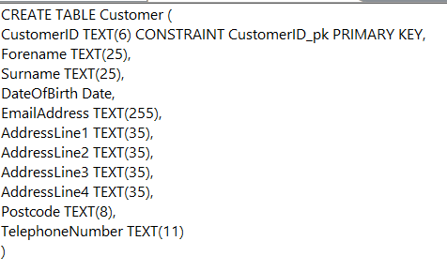
2.2 GUI Table Creation
The other method to table creation is the inbuilt GUI which allows for easy creation without the need to know SQL scripting language. The down side to this method is that this is very specific to an access database and cannot be easily implemented into other database structures.
The below example is the Stock table
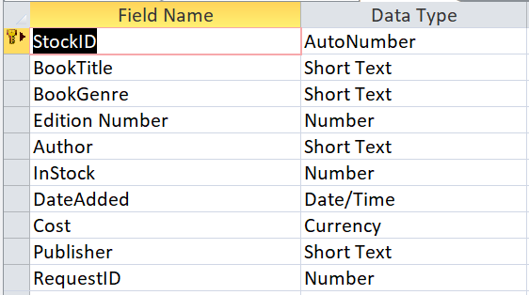

3.0 Data Entry
There are multiple ways for users to enter information into the various tables of the database. In the database for the bookstore there have been 3 different data inputs demonstrated as outlined below:
3.1 SQL Data Entry
Using a SQL query it is possible to enter data into the various tables, this method however can be quite time consuming and is not intuitive for most users so will not be used by staff who are employed by the bookstore.
The below is an example of entering a row of information into the “Customer” table
3.2 Datasheet View Entry
The second method of entering data into an access database is via the datasheet view which provides an interface more users will familiar with as it looks similar to excel. Below is an example of the datasheet view of the “Stock” table.
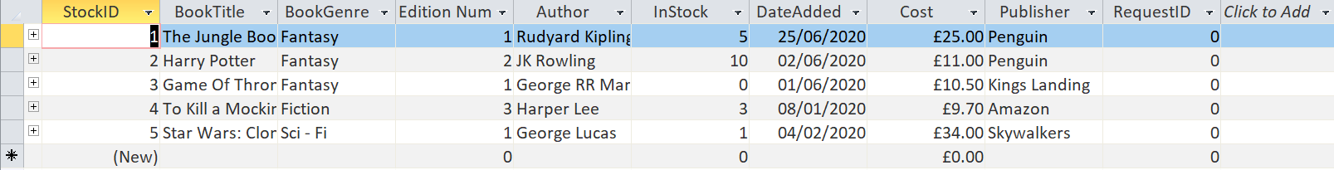
3.3 Access Form
The final way to enter data into the bookstore database is via the use of an access form. These allow the administrator to only allow certain fields to be populated, this is useful if there are some fields being populated from other tables the user does not need/have access to. The below is of the form staff will use to input additional stock into the book store
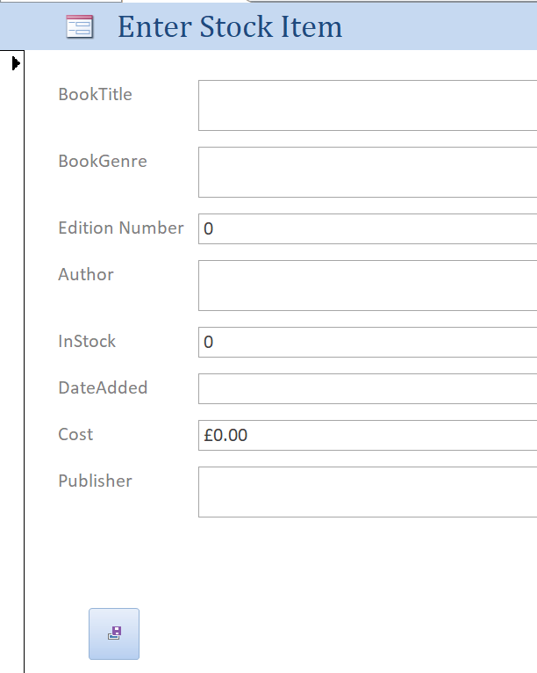
4.0 User Guidance
Below is guidance on how the staff would interact with the database and includes information on reporting from the data that is within the database.
4.1 Main Menu
When opening the database the main navigation menu is automatically opened to allow the user to navigate quickly to the required function and also to view the current orders that are not yet fulfilled.
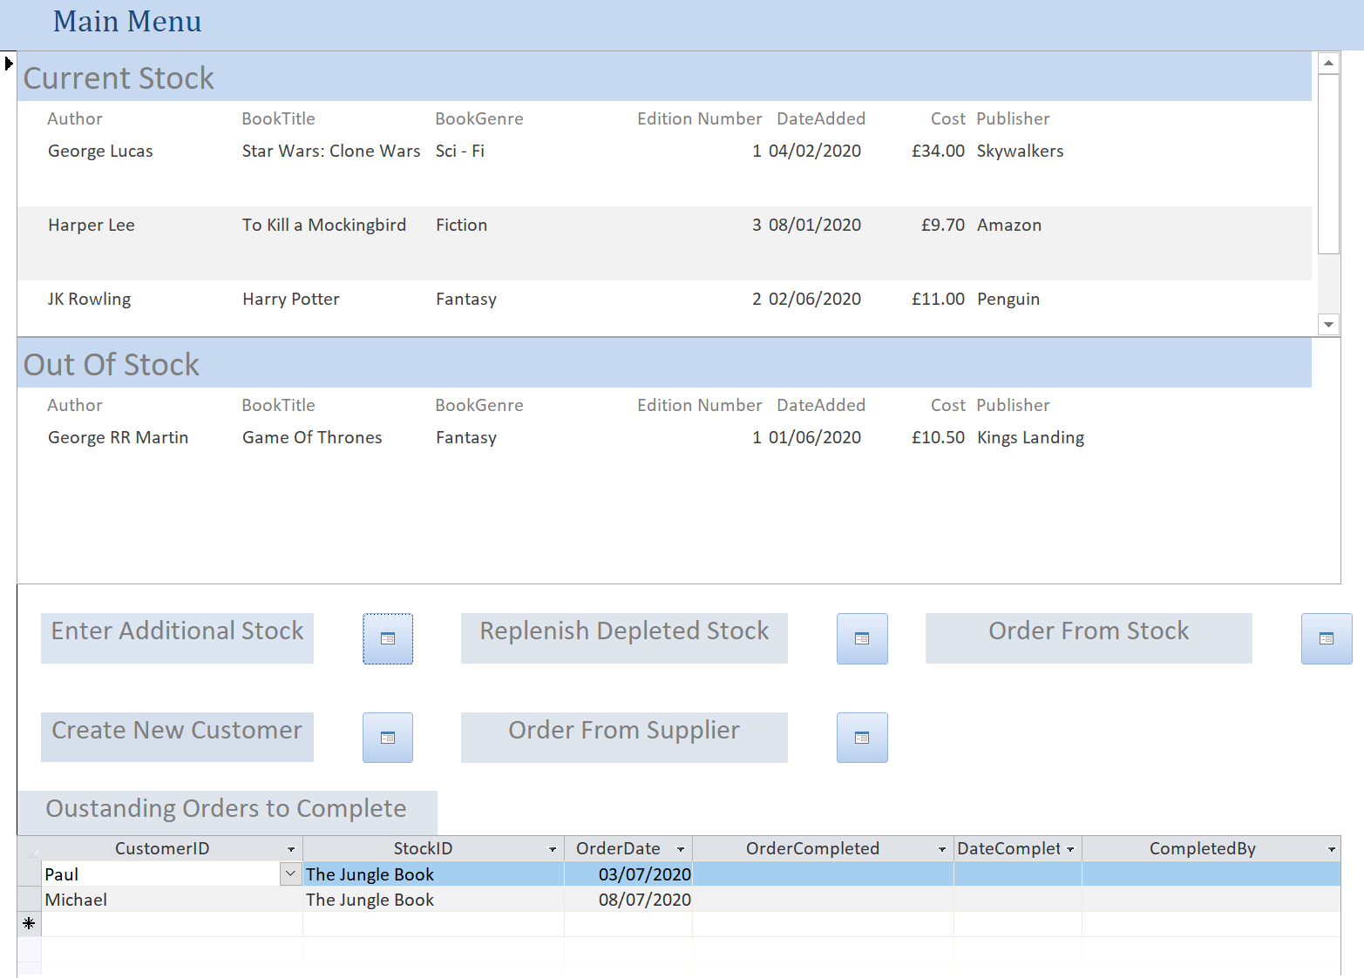
The various links present on the main menu take the user to an embedded access form to allow for various actions to be undertaken.

4.2 Enter Additional Stock
This function takes the user to a form that allows additional different stock to be added to the database in which orders can then be placed. Data entered into this form will then appear in the “Current Stock” report which is viewable at the top of the form.
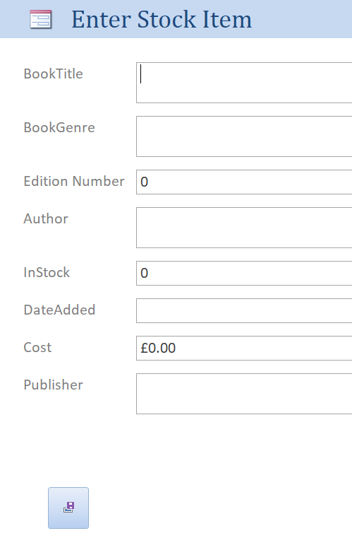
4.3 Replenish Stock
This form will allow users to add additional copies of books that have previously been stocked by the book store. This form will only allow for books that have been stocked before to be replenished, if the store has never stocked this book then the “Enter Additional Stock” form should be used. Once completed the book will move from the “Out of Stock” to the “Current Stock” tables within the main menu.
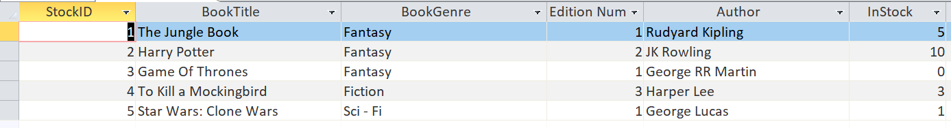

4.4 Order From Stock
The “Order From Stock” form will allow the staff to place on order on behalf of the customer from those the store has presently available. This form will only allow the staff to place order from those books that are present in the “Current Stock” area of the main menu. If the book is not in stock then an order needs to be placed with supplier using the “Order from Supplier” form. Those order that have yet to be completed are shown in the “Outstanding Orders to Complete” report at the bottom of the main menu where staff are able to confirm when orders have been sent. NOTE: Customer first needs to exist within the database, new customers can be created using the “Create New Customer” form.
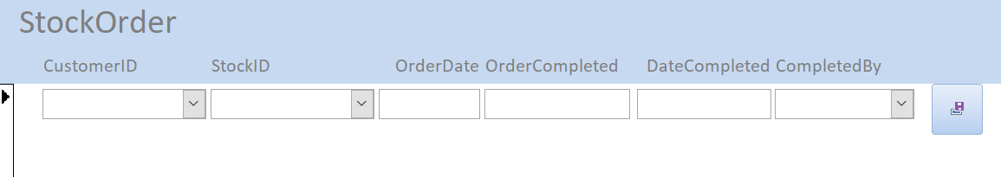
4.5 Create New Customer
This form allows staff to enter in the details of a new customer to the store, this captures various demographic information which will allow staff to complete the order for the customer efficiently and has the capability of reporting customer locations to see where books are popular.
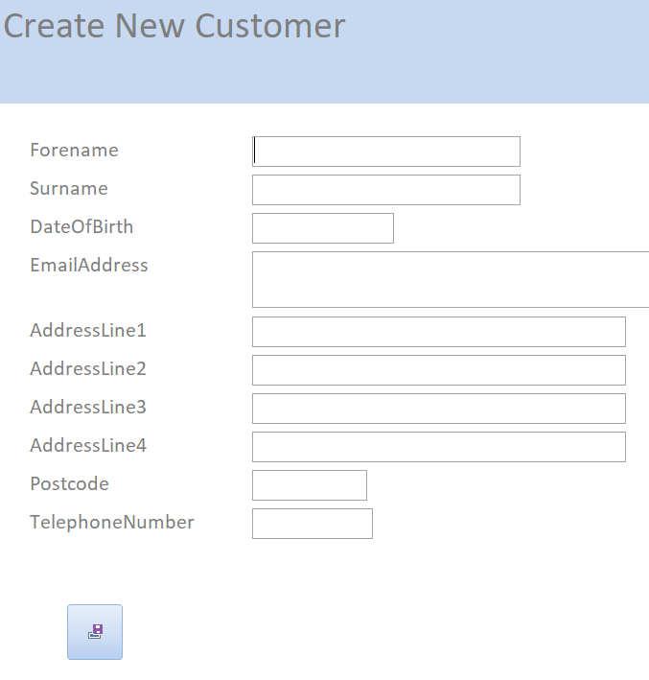
4.6 Order From Supplier
This form will staff to order books from the various suppliers either based on customer requests or from knowledge of what they expect will be popular or that collectors will be interested in. Once the book store receives the books then then “Enter Additional Stock” form should be used for customer to then order from.
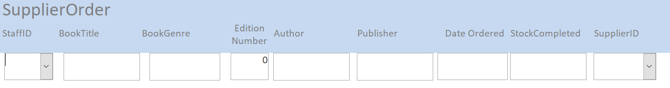
5.0 Reporting
The main reporting requirement for the bookstore was for the team to be able to produce a quarterly newsletter which shows new and interesting stock to the various customers. To allow for this functionality the database contains a report called “RecentlyAddedAndFirstEdition” which will display all the books that are currently in stock that have either been added in the last 3 months (since the last newsletter) or that are a first edition which have been designated as being ‘interesting’ stock.
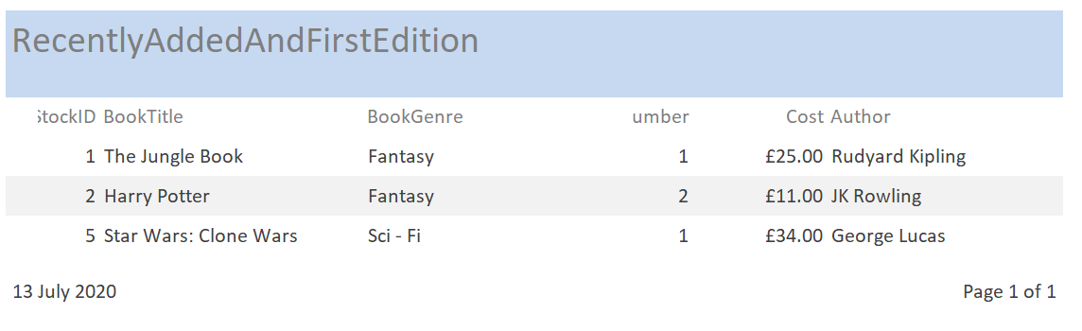
This report is generated by the use of a SQL query which could be edited in future if the newsletter becomes more frequent or the team re-define what stock is going to be considered as interesting stock.


