Assignment 1
SOFTWARE SOLUTION FOR BUSINESS

Module Name: Learning in the Digital Era
Module Code: ACCA 4025

Student Name: Alexandre Jesus Da Hora
Student ID: 2514099
Group: 1

Lecturer’s Name: Dr. Fadah Ahmed

UNIVERSITY OF WALES TRINITY SAINT DAVID
LONDON CAMPUS
Alexandre Jesus

Table of Contents
Introduction 1
Task 1. e-Commerce Website builders or software solutions 1
1.1 WooCommerce 1
1.2 Wix 1
Task 2. Mind-map of contemporary software applications 1
a. Mind mapping and explain the benefits of using mind mapping in business operations 1
b. Create a mind map of contemporary software applications 1
Task 3. Office Applications 1
a. Four office software solutions for business operations 1
MS Word 1
MS PowerPoint 1
MS Excel 1
MS Access 2
b. Practical demonstration of Two Office Features 2
Mail Merge 2
If Statement 2
Task 4. Communication and Collaboration applications 2
a. One contemporary Communication and one Online Collaboration applications/tools 2
MS Outlook 2
MS Teams 2
b. One feature of a freely available Communication (1) and one feature of a Collaboration (1) application 2
MS Outlook 2
Ms Teams 2
Conclusion 2
References 3

Introduction

Software Solution Definition
Historical Background
Types of

The current digitally enabled ecosystem has made software solutions imperative tools in companies across various sizes. The solutions simplify business procedures, increase productivity levels, facilitate collaboration, and foster data-informed decision-making. Today’s companies use various software applications to handle day-to-day business functions, increase customer satisfaction levels, and gain a competitive advantage in the market.

Starting from cloud storage solutions that enable teams to safely store and share data, software assists in improving the efficiency of business processes. Productivity software like editors, spreadsheets, and project managers help companies organize and prioritize their workload. Online shopping solutions and designing applications further help companies create successful online platforms. At the same time, analytics software assists in providing companies with valuable data necessary for effective strategic planning and optimization. All of this indicates that software has become essential in business nowadays.

Overall, software solutions enable companies to carry out business functions in more effective and efficient manners.
With the constantly changing advancements in technology, implementing the proper combination of software applications has become an essential determinant in ensuring successful outcomes over time.

Task 1. e-Commerce Website builders or software solutions

WooCommerce

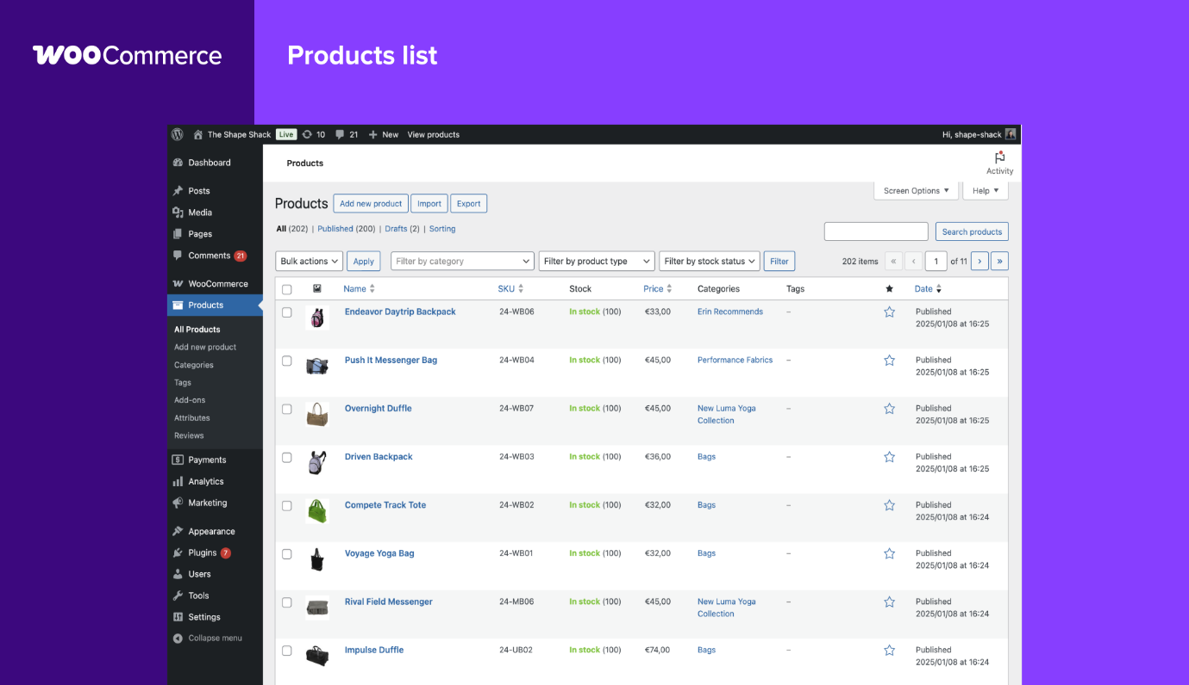
Fig:01

WooCommerce – Contemporary E-Commerce Website Builder / Software Solution
WooCommerce is an open-source e-commerce plugin designed for WordPress, the world’s most widely used content management system. It allows users to turn a standard WordPress website into a fully functional online store. Because it is flexible, customizable, and scalable, WooCommerce has become one of the most popular e-commerce solutions globally.
Key Features
- Open-source and free: The base WooCommerce plugin is free to install. Users only pay for hosting, optional extensions, or premium themes.
- Full customization: Because WooCommerce is open-source, developers and users can modify almost every part of the store—from layout design to backend operations.
- Product management: Supports unlimited products, product variations (size, colour, style), digital products, and subscriptions.
- Wide range of extensions: Thousands of plugins add functionality such as payments, shipping, marketing, analytics, and inventory enhancement.
- Payment gateway options: Integrates with PayPal, Stripe, Apple Pay, credit cards, bank transfers, and many region-specific payment solutions.
- SEO-friendly: Built on WordPress, WooCommerce benefits from strong SEO capabilities, making it easier for businesses to improve their search visibility.
- Control over hosting: Users can choose their own hosting provider, offering greater performance control than fully hosted solutions.
Advantages
- Highly flexible and customizable compared to hosted platforms like Shopify or Wix.
- Cost-effective for small businesses—especially if they already use WordPress.
- Large global community offering tutorials, themes, and support.
- Ideal for content-rich websites that combine blogging, marketing, and online selling.
Limitations
- Requires more technical knowledge, especially for installation, hosting setup, and maintenance.
- Performance depends on hosting quality—poor hosting can slow down the store.
- Additional features (e.g., advanced shipping, subscriptions) may require paid extensions.
- Users are responsible for updates, security, and backups.
Best For
WooCommerce is particularly suitable for:
- Businesses already using WordPress.
- Users who want full customisation and control.
- Medium to large online shops that need flexible configurations.
- Sellers who want to combine content (blogs, articles, media) with e-commerce

1.2 Wix
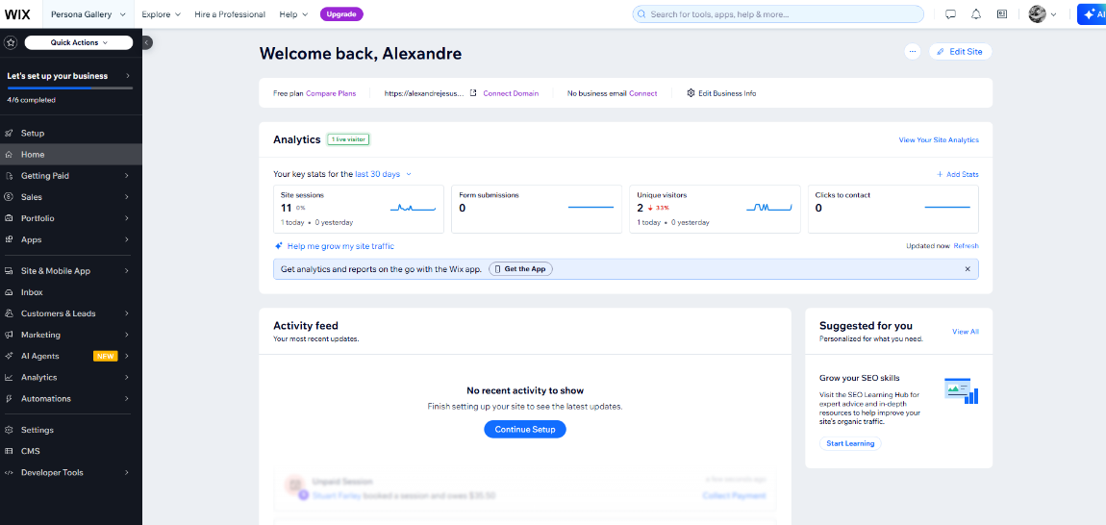
Fig Link :02

Wix – Contemporary E-Commerce Website Builder
Wix is a popular cloud-based website builder that allows individuals and businesses to create professional websites and online stores using an intuitive drag-and-drop interface. It is widely used because it requires no coding skills and provides an all-in-one environment for designing, hosting, and managing a full e-commerce site.
Key Features
- Drag-and-drop editor: Users can design their store visually by placing elements (images, buttons, galleries) directly on the page, making it accessible for beginners.
- E-commerce toolkit: Wix’s eCommerce platform supports product listings, inventory management, shipping options, tax settings, shopping cart, and secure checkout.
- Built-in payment solutions: It supports major payment gateways like PayPal, Stripe, credit/debit cards, and Wix Payments.
- Templates: Over 500 professionally designed templates, including many specifically for online stores.
- Marketing & SEO tools: Wix provides integrated email marketing, social media advertising, discount coupons, abandoned-cart recovery, and SEO tools to improve store visibility.
- All-in-one hosting: Since Wix is a fully hosted solution, users do not need to manage servers, updates, or security — everything is handled by the platform.
- App Market: Thousands of add-ons for extra functionality (e.g., bookings, reviews, chatbots, automation).
Advantages
- Very easy to use — ideal for beginners with no technical experience.
- All features included in one platform: hosting, design tools, e-commerce functions.
- Attractive templates and strong design flexibility.
- Suitable for small to medium-sized online shops.
Limitations
- Less scalable compared to advanced platforms like Shopify or WooCommerce.
- Switching templates often requires redesigning the website from scratch.
- Some advanced features require higher tier paid plans or paid apps.
- Limited backend customization because Wix is a closed, hosted system.
Best For
Wix is ideal for:
- Small businesses, creators, freelancers, and new entrepreneurs.
- Users who prioritize attractive design and ease of use over deep technical customization.
- Those wanting an affordable and simple way to launch an online store quickly.

Task 2. Mind-map of contemporary software applications.

Mind mapping and explain the benefits of using mind mapping in business operations.
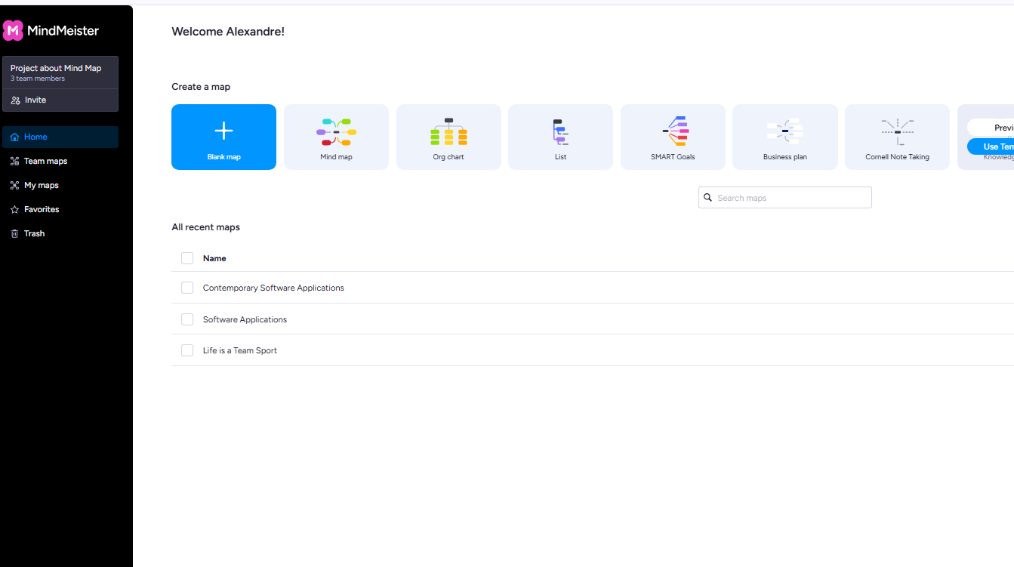
Fig LInk:03
Mind Mapping and Its Benefits in Business Operations

Mind mapping is a visual thinking tool that helps organize information, ideas, and concepts around a central theme. Tony Buzan developed and popularized this method, allowing individuals and teams to structure their thoughts in a way that reflects how the brain naturally processes and connects information. A typical mind map starts with a central idea in the middle of a page, with branches extending outwards. Each branch represents a key subtopic or category, while smaller sub-branches show more detailed points. This non-linear approach makes mind mapping flexible, intuitive, and effective for exploring, analysing, and presenting complex information.

In business operations, mind mapping has become increasingly valuable due to the growing need to manage information efficiently, support team collaboration, and encourage innovation. One major benefit of mind mapping is that it boosts creativity and brainstorming. During planning or development sessions, teams can use mind maps to generate ideas freely, without the limitations of traditional note-taking. The branching structure allows ideas to be added naturally, encouraging diverse thinking. This openness often leads to more original and innovative solutions, making mind mapping particularly useful for marketing, product development, and strategic planning.

Another important advantage of mind mapping is better organization and planning. Businesses often manage complex projects with many tasks, departments, and timelines. Mind maps simplify this complexity by breaking large projects into smaller, manageable parts. For instance, a project manager can create branches for tasks, resources, deadlines, risks, and responsibilities. This visual overview makes it easier to grasp the entire project briefly, reducing confusion and ensuring that key details are not overlooked. Consequently, mind mapping supports clear planning, improved workflow design, and more effective project execution.

Mind mapping also plays a significant role in decision-making. Business decisions often involve many factors, such as costs, risks, opportunities, and alternatives. Mind maps allow decision-makers to gather all relevant information on one page, making it easier to analyse relationships between different elements. By visually mapping out scenarios, teams can identify connections, compare options, and evaluate consequences more effectively. This leads to more informed and strategic decisions.

Communication and collaboration within organizations are strengthened by mind mapping as well. Because mind maps present information visually, they are easy for team members to understand, regardless of their background or role. During meetings or workshops, teams can build a mind map together, ensuring that everyone contributes and is on the same page. This shared visual reference reduces misunderstandings, increases engagement, and supports clearer communication across departments.

Moreover, mind mapping boosts productivity by helping individuals and teams stay organized. Employees can use mind maps to structure daily tasks, plan workloads, and prioritize responsibilities. The clarity provided by a mind map reduces time spent searching through lengthy documents, allowing better focus on key objectives. This leads to quicker problem-solving and improved time management.
Finally, mind mapping supports training and knowledge management within businesses. Mind maps can summarize training materials, outline procedures, or store organizational knowledge in a format that is easy to understand and remember. This is especially helpful for onboarding inexperienced staff and ensuring a consistent understanding across teams.
In conclusion, mind mapping is a powerful tool that offers many benefits to business operations. Its ability to support creativity, organization, decision-making, communication, productivity, and knowledge sharing makes it an essential technique for modern business environments.

Create a mind map of contemporary software applications.

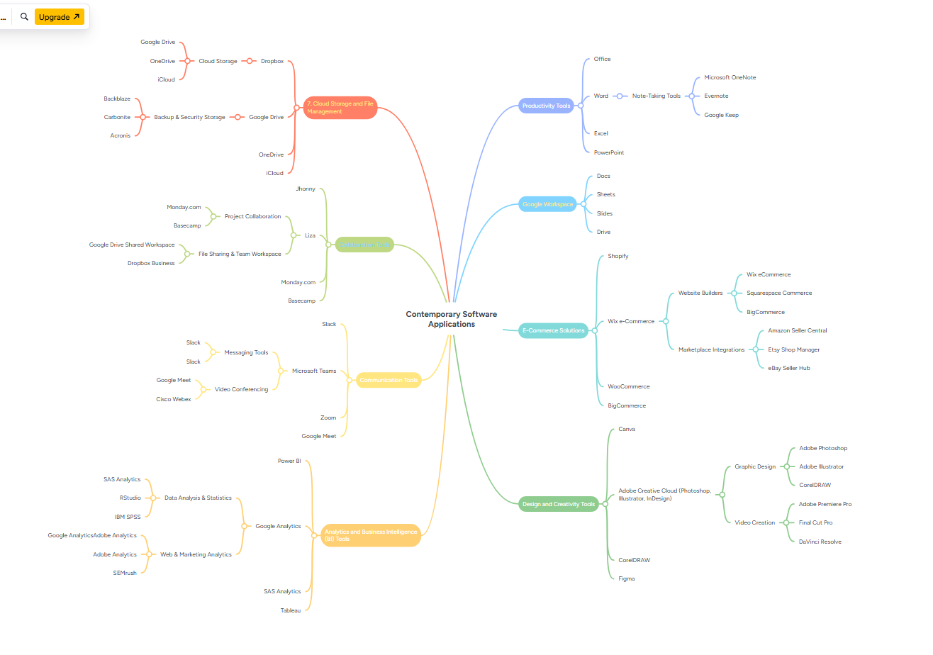
Fig Link:04

The image is a mind map titled Contemporary Software Applications. It visually organizes modern software tools into major categories, showing how each set of applications relates to a broader purpose. Here’s a clear explanation of the links between the branches:

1. Cloud Storage and File Management
Includes services like:
- Google Drive, OneDrive, iCloud → General cloud storage
- Back blaze, Carbonite, Acronis → Backup & security‐focused storage
- Dropbox Business, Google Shared Workspace → File sharing & team workspaces
Link:
All these tools handle storing, securing, and sharing digital files, supporting both individuals and teams.

2. Collaboration Tools
Includes:
- Monday.com, Basecamp → Project management
- Google Drive Shared Workspace, Dropbox Business → Shared working environments
- Zoom, Teams, Google Meet (overlaps with communication)
Link:
These tools focus on teamwork, project coordination, task tracking, and shared content creation.

3. Communication Tools
Includes:
- Slack → Messaging and team chats
- Microsoft Teams, Zoom, Google Meet, Cisco Webex → Video conferencing
Link:
These applications enable real-time communication—text, audio, or video—to support remote or distributed teams.

4. Productivity Tools
Includes:
- Microsoft Office (Word, Excel, PowerPoint)
- Note-taking apps like OneNote, Evernote, Google Keep
- Google Workspace tools (Docs, Sheets, Slides, Drive)
Link:
All are designed to enhance individual and team productivity by enabling document creation, data handling, note-taking, and organizing work.

5. E-Commerce Solutions
Includes:
- Shopify, WooCommerce, BigCommerce → Full e-commerce platforms
- Wix eCommerce, Squarespace Commerce → Website builders with online store features
- Amazon Seller Central, Etsy Shop Manager, eBay Seller Hub → Marketplace integrations
Link:
These tools are connected by their role in enabling online selling—either through independent websites or major online marketplaces.

6. Design and Creativity Tools
Includes:
- Graphic design: Adobe Photoshop, Illustrator, CorelDRAW
- Video creation: Adobe Premiere Pro, Final Cut Pro, DaVinci Resolve
- UI/UX & digital design: Figma, Canva
Link:
These applications support creative work, including graphics, branding, videos, and interface design.

7. Analytics & Business Intelligence
Includes:
- SAS, RStudio → Statistical analysis
- Google Analytics, Adobe Analytics, SEO brush → Web & marketing analytics
- Power BI, Tableau → Business intelligence dashboards
Link:
These tools help organizations make decisions using data analysis, insights, and reporting.

How They All Connect
All categories branch from the center: Contemporary Software Applications.
The overarching link between them is that these are the core digital tools used in modern workplaces. Each category supports a specific business function:
- Communication + Collaboration + Cloud Storage → Work together efficiently
- Productivity + Google Workspace → Create documents and manage information
- E-commerce + Design Tools → Build and market online businesses
- Analytics Tools → Measure success and guide decisions
Together, they form a complete ecosystem that supports digital work, creativity, online business, data analysis, and team collaboration.

Task 3. Office Applications

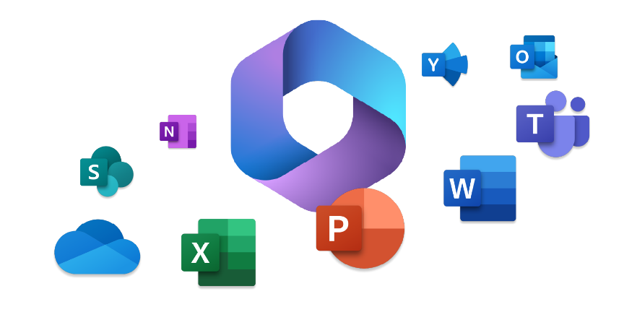
Fig:05

Four office software solutions for business operations

MS Word

1. Microsoft Word
Microsoft Word is one of the most widely used word-processing applications in business, education, and personal computing. Developed by Microsoft as part of the Microsoft Office suite, it provides a comprehensive set of tools for creating, editing, formatting, and sharing documents. Its user-friendly interface and powerful features make it an essential application for producing professional written content such as reports, letters, proposals, memos, essays, and business documents.
One of the key strengths of Microsoft Word is its rich formatting capabilities. Users can customize fonts, styles, margins, spacing, and page layouts to create well-structured and visually appealing documents.
Word also includes templates for resumes, business letters, brochures, and other common document types, enabling users to save time and maintain a consistent professional look.
Features such as spell check, grammar check, and the built-in editor help improve the quality and accuracy of writing, making Word particularly valuable for producing error-free and polished content.
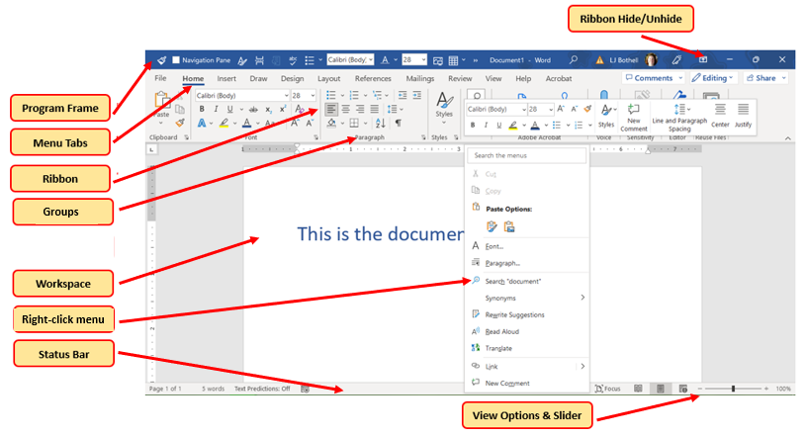
Fig:06
Major Features
- Word processing for creating documents, reports, letters, and proposals
- Templates for invoices, CVs, business letters, and forms
- Spell check, grammar check, and formatting tools
- Collaboration features (comments, track changes, real-time editing)
- Integration with cloud services like OneDrive
Benefits
- Easy to use for general writing tasks
- Professional formatting options for business documents
- Enhances collaboration among team members
- Widely compatible with other software and devices
- Suitable for producing high-quality, print-ready materials
Limitations
- Not ideal for handling large datasets
- Limited graphic design capabilities compared to dedicated design tools
- Complex formatting can become difficult for beginners

MS PowerPoint

1.Microsoft PowerPoint
Microsoft PowerPoint is a popular presentation software created by Microsoft, part of the Microsoft Office suite. It allows users to make engaging and professional slide-based presentations for work meetings, school lectures, training sessions, marketing pitches, and conferences. PowerPoint is well-known for its user-friendly interface and a wide range of features that cater to both simple and complex presentations.

One of the key strengths of Microsoft PowerPoint is its use of slides as a visual communication tool. Each slide can include a mix of text, images, charts, tables, audio, and video, helping presenters share information clearly and effectively. PowerPoint provides various templates, themes, and design elements that allow users to create consistent and attractive presentations without needing advanced design skills. Features like animations, transitions, and SmartArt graphics help users boost the visual appeal and flow of their presentations.
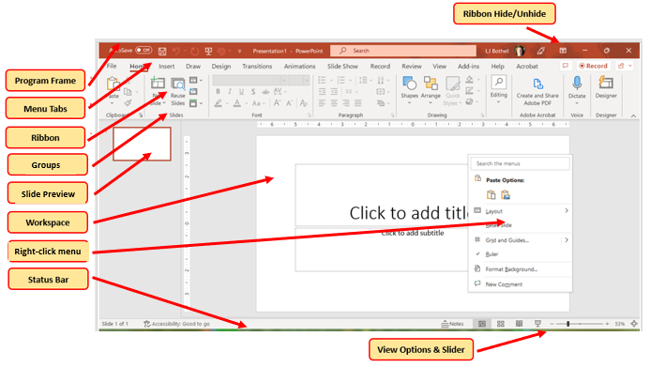
Fig:07
Major Features
- Slide-based presentation creation
- Built-in themes, templates, and design tools
- Animation and transition effects
- Ability to embed images, videos, charts, and audio
- Presenter view, rehearsal timer, and slideshow tools
Benefits
- Excellent for business presentations, training, and meetings
- Visually appealing and easy to customize
- Supports multimedia integration for impactful communication
- Allows collaboration and cloud-based access
- Professional templates save time when preparing presentations
Limitations
- Overuse of animations can reduce professionalism
- Not designed for complex data analysis
- Presentations may become text-heavy if not designed effectively

MS Excel

Microsoft Excel
Microsoft Excel is a powerful spreadsheet application developed by Microsoft and widely used in business, education, finance, data analysis, and everyday administrative tasks. As part of the Microsoft Office suite, Excel enables users to organize, calculate, analyze, and visualize data efficiently. Its grid-based structure of rows and columns makes it ideal for handling numerical information, performing calculations, and creating structured datasets.
One of Excel’s greatest strengths is its extensive range of formulas and functions. Users can perform simple arithmetic operations as well as complex calculations using functions such as SUM, AVERAGE, IF, VLOOKUP, and COUNTIF. This allows businesses to automate financial calculations, budget planning, forecasting, and performance tracking. Excel’s ability to create charts and graphs—such as bar charts, line graphs, and pie charts—helps users present data visually, making trends and patterns easier to understand.
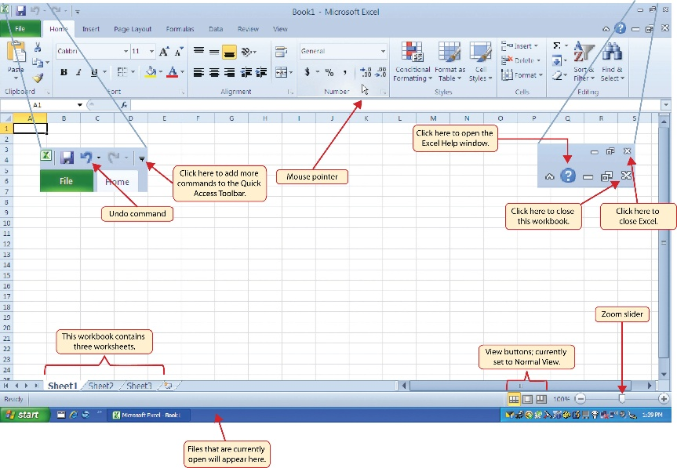
Fig:08
Major Features
- Spreadsheet-based data organization and analysis
- Functions and formulas for calculations (e.g., SUM, IF, VLOOKUP)
- Data visualization tools (charts, graphs, pivot tables)
- Sorting, filtering, and data validation
- Macros and automation features

Benefits
- Highly powerful for data management, financial planning, and forecasting
- Widely used for budgeting, accounting, and inventory tracking
- Pivot tables allow fast summarization of large datasets
- Improves decision-making with clear data insights
- Can automate repetitive tasks using macros
Limitations
- Steep learning curve for advanced functions
- Errors in formulas can affect decision-making
- Large spreadsheets may become slow or difficult to manage

MS Access

1.Microsoft Access
Microsoft Access is a database management system (DBMS) developed by Microsoft and included in the Microsoft Office suite. It is designed to help users store, organize, manage, and analyze large amounts of structured information. Unlike Excel, which uses spreadsheets, Access uses relational databases made up of tables, queries, forms, and reports, making it more suitable for complex data relationships and long-term data management.
One of the core strengths of Microsoft Access is its ability to create relational databases. This allows users to link different tables through common fields, reducing duplication and improving data accuracy. For example, a business can link customer information, product inventory, and sales orders in a single system. Access also provides powerful query tools that allow users to search, filter, and extract specific information efficiently. The Query Design feature and SQL view offer flexibility for both beginners and advanced users.
Access includes user-friendly forms that improve data entry by providing an interactive interface, reducing errors and allowing staff to input information without navigating raw tables.
The report feature allows users to create professional, printable summaries of data such as invoices, sales reports, employee records, or stock lists

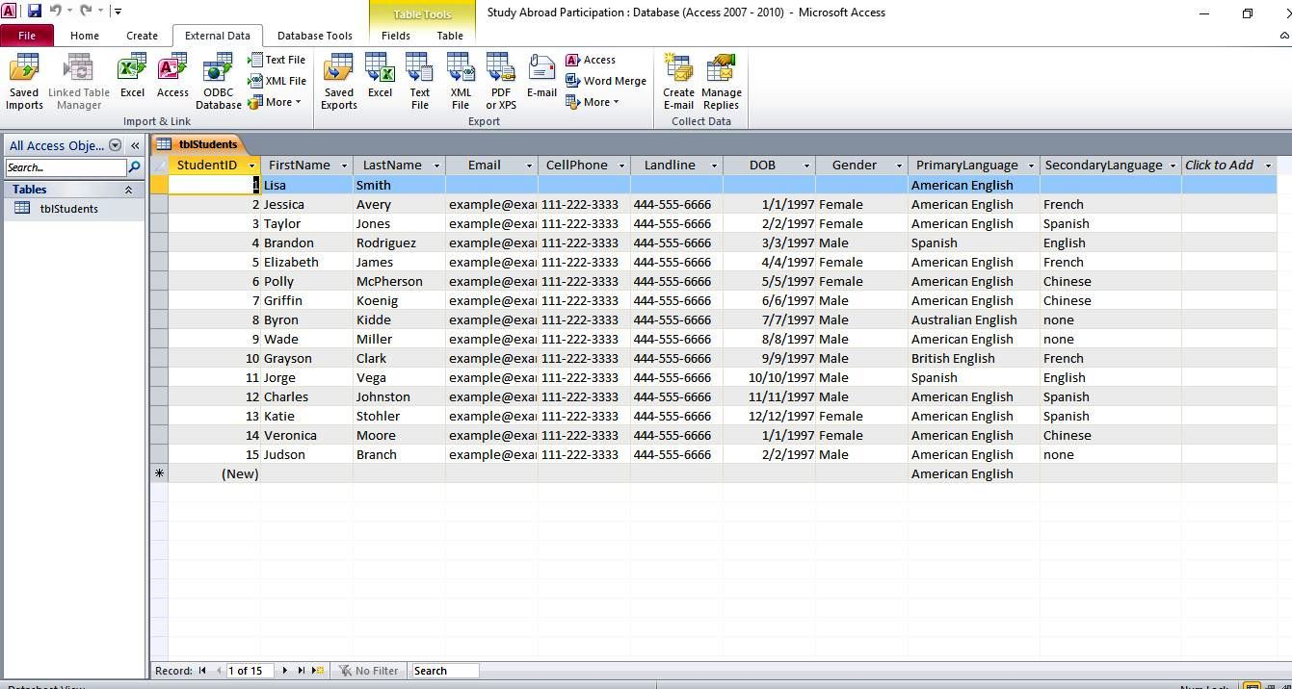
Fig:09
Major Features
- Database creation and management
- Tables, queries, forms, and reports for structured data handling
- Relational database capabilities
- Integration with Excel and SQL
- Useful for small to medium-sized business databases
Benefits
- Efficient for storing and managing large volumes of structured data
- Customizable forms and reports for business operations
- Ideal for customer records, inventory systems, and data tracking
- Less complex and more cost-effective than full SQL systems
- Allows quick creation of database-driven applications
Limitations
- Not suitable for very large enterprise databases
- Requires some technical knowledge to design databases
- Limited compatibility with non-Microsoft platforms
- Can become unstable if the file size grows too large

Practical demonstration of Two Office Features

Mail Merge
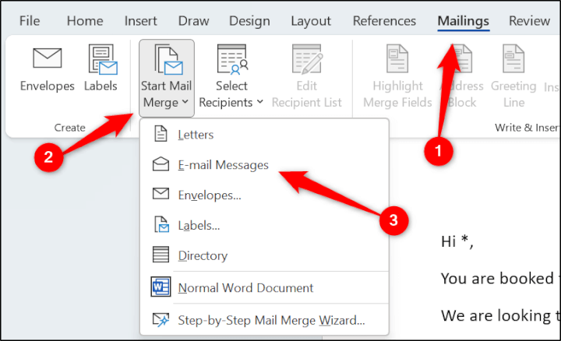
Fig:10

If Statement
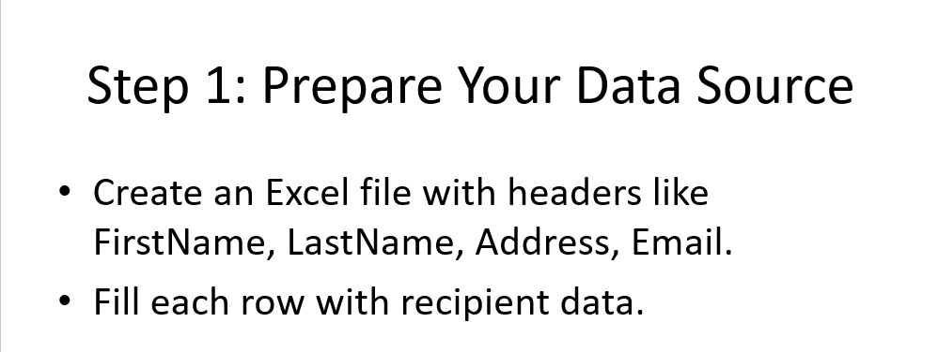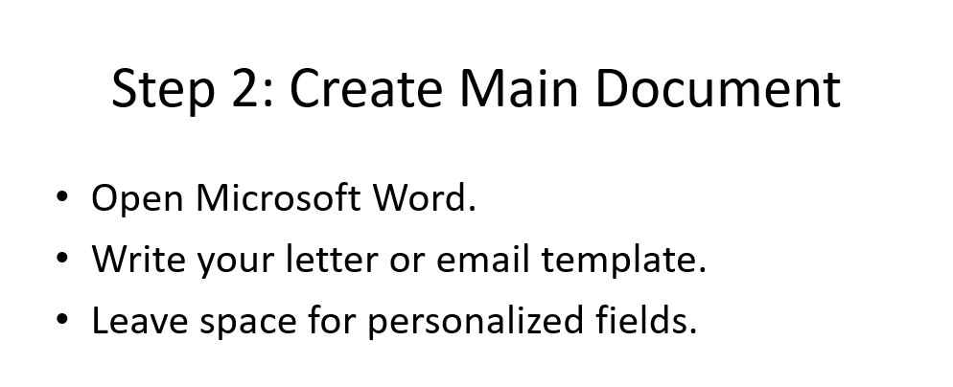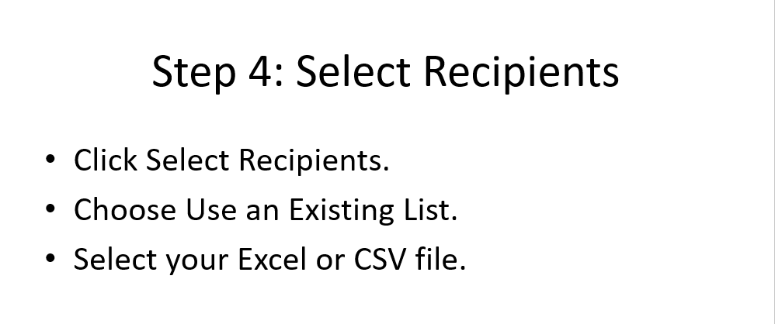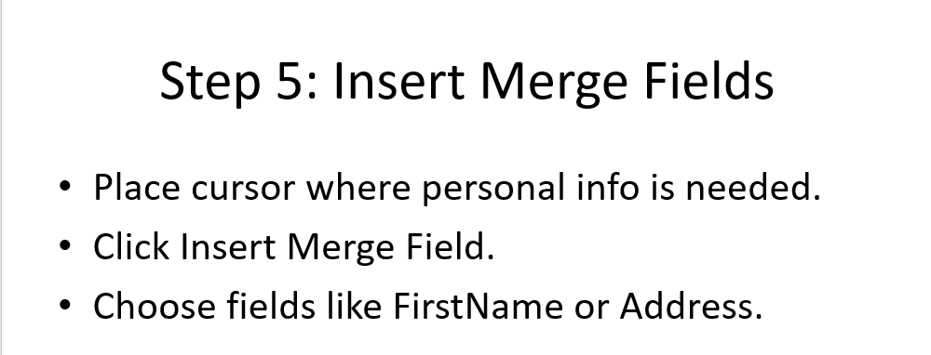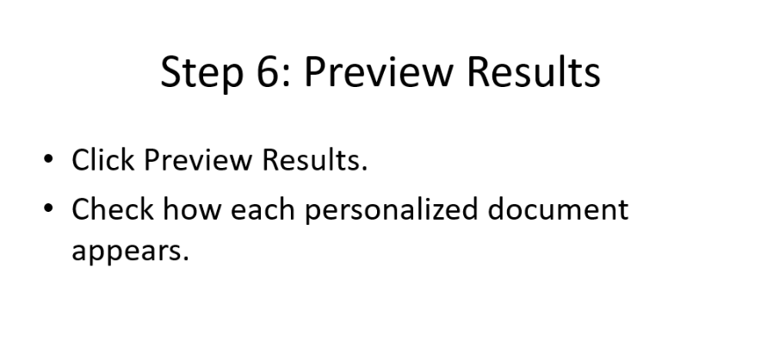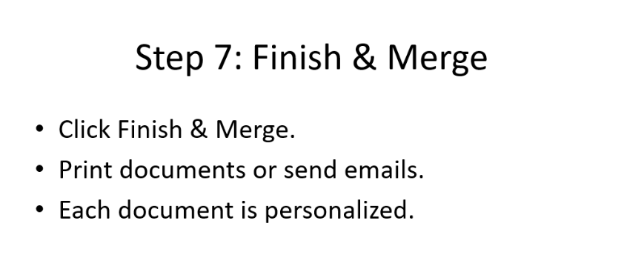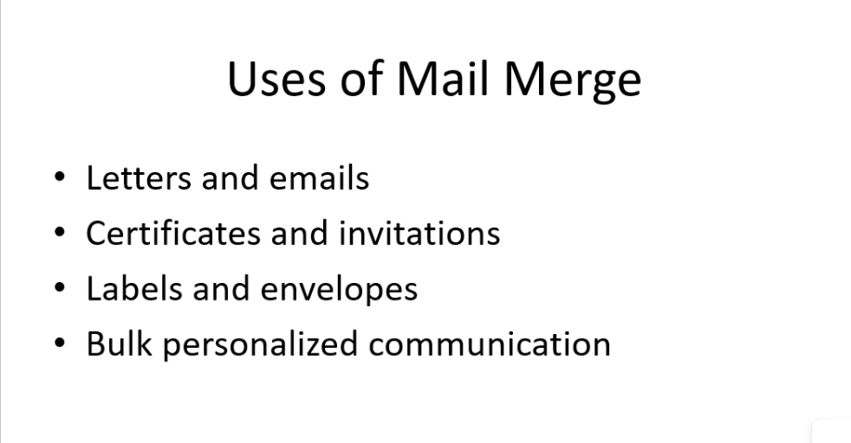

Task 4. Communication and Collaboration applications

One contemporary Communication and one Online Collaboration applications/tools

MS Outlook
1. SharePoint: The Centralized Content and Knowledge Hub 🏗️
SharePoint's core function is to provide a secure, scalable, and organized environment for document management and organizational knowledge sharing.² It is the definitive Online Collaboration Tool for structured data.³
Feature | Description | Collaboration Impact
Document Management | Provides version control, security permissions, metadata tagging, and robust indexing for files (documents, images, videos). | Teams manage the official, final versions of all documents (policies, contracts, templates), ensuring all team members are working from the single source of truth and preventing version control chaos.
Team Sites and Intranets | Creates structured websites for departments, projects, or the entire organization to publish news, resources, forms, and announcements. | Acts as the organizational knowledge base and operational manual. It is crucial for onboarding new team members and ensuring consistent access to standard operating procedures (SOPs) and company information.
Workflows and Forms | Allows the creation of automated processes for document review, approval, and data collection using embedded forms. | Supports structured, official collaboration by automating routine bureaucratic processes (e.g., expense reports, vacation requests), minimizing reliance on manual email chains for approvals.
Integration with Microsoft 365 | Seamlessly integrates with all Microsoft apps (especially Teams), acting as the underlying storage layer for collaborative files. | Ensures files shared and co-authored in Teams are securely stored and managed with SharePoint's enterprise-level governance.

2. Microsoft Outlook: The Formal Connector and Scheduler 📧
Outlook's primary role in collaboration is to facilitate official, asynchronous communication and to coordinate the schedules necessary for synchronous teamwork.
Feature | Description | Collaboration Impact
Formal Communication (Email) | Provides a professional, recorded audit trail of formal decisions, signoffs, and critical communications with external parties or senior management. | Establishes the necessary accountability and governance framework, ensuring decisions made are formally logged, which is often required before proceeding with project work managed in SharePoint.
Calendar and Scheduling | Allows users to view colleague availability, schedule meetings (virtual and physical), and coordinate project milestones. | This is the essential logistical mechanism for collaboration, ensuring team members and necessary resources (like meeting rooms) can be aligned to work together at the same time.
Sharing SharePoint Links | Instead of attaching large files, users email links directly to documents stored in SharePoint. | Promotes best practice content management. It drives users to the single official copy of a file in SharePoint, reducing storage duplication and ensuring document integrity.
Conclusion
When viewed together, SharePoint and Outlook provide a comprehensive system for organized work:⁴
- SharePoint manages what the team works on (content, documents, data).⁵
- Outlook manages who needs to know, when they need to know it, and when they need to meet to execute the work.
They ensure that while communication is organized, the foundational knowledge and official company resources are securely governed and centrally available.

MS Teams
Contemporary Online Collaboration Tool: Microsoft Teams and SharePoint 🏗️
Microsoft Teams, built upon the foundation of SharePoint Online, represents a modern, centralized digital workspace that transcends basic communication. While it includes robust chat and video conferencing capabilities, its primary function is to serve as a comprehensive Online Collaboration Platform, focusing intensely on team organization, content co-creation, and unified workflow management.
In the current professional landscape, where remote and hybrid work models are prevalent, Teams and SharePoint provide the critical infrastructure necessary to replicate and enhance the functionality of a physical office.
The Power of Integration and Co-Creation
The core value of Teams as a collaboration tool lies in its seamless integration of different services, with SharePoint serving as the foundational file storage and content management system for every Team channel.
Feature | Description | Collaboration Impact
Integrated File Sharing (via SharePoint) | Every Team channel is automatically linked to a dedicated SharePoint site. This storage ensures that documents, files, and resources are maintained in a structured hierarchy with robust security and version control. | This functionality is crucial for direct co-authoring. Multiple team members can simultaneously edit documents (Word, Excel, PowerPoint) in real-time. This eliminates the confusion and errors associated with emailing document attachments and managing numerous versions, ensuring the team always works from a single source of truth.
Tabs and Applications | The interface allows channels to be customized with "Tabs" that embed specific applications (e.g., Planner for task management, OneNote for shared notes, Power BI for data visualization, or even third-party apps). | This feature is vital for centralized workflow management. Instead of switching between multiple platforms, all necessary project-related tasks, planning tools, and reference materials are accessible within the same Team interface, reducing context-switching and improving project visibility.
Persistent Conversations | Unlike fleeting emails, discussions are maintained within channels and can be linked directly to specific files, tasks, or meeting notes, ensuring full historical context. | Supports structured project management. New members can quickly get up to speed by reviewing past decisions and discussions. This persistent thread of communication facilitates informed decision-making and ensures accountability throughout the project lifecycle.
Team-Based Meetings | Scheduled video conferences include features like shared screens, real-time whiteboarding, and automatic transcription. Critically, the meeting recording and chat history are automatically saved and linked directly to the Team channel. | These meetings support coordinated action and knowledge retention. Decisions made and actions assigned during the meeting are immediately documented and stored where the team works, effectively closing the loop between discussion and execution.
Conclusion
Microsoft Teams, supported by SharePoint, has successfully positioned itself as the central nervous system of modern organizational collaboration. Its ability to unify communication, content, applications, and workflow management into a single, navigable platform enables globally distributed teams to co-create, manage projects, and achieve business objectives with speed and efficiency that traditional communication methods cannot match. It shifts the work environment from a decentralized system of individual tools to a unified digital workspace built on collective effort. These categories show how communication tools focus on exchanging words, while collaboration tools focus on co-creating work.

One feature of a freely available Communication (1) and one feature of a Collaboration (1) application

MS Outlook
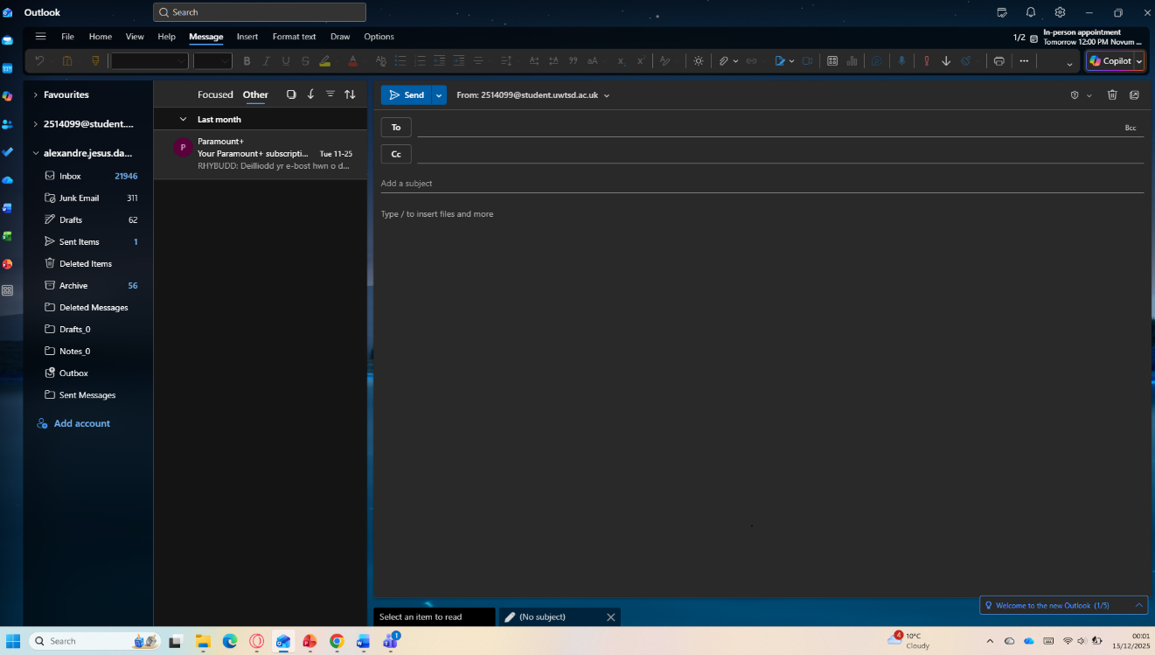

One Feature of a Communication Application
Application: Microsoft Outlook (freely available with basic email services)
Feature: Email Communication
Outlook allows users to send and receive emails instantly, enabling effective one-to-one or group communication with attachments, formatting tools, and message tracking.

Ms Teams
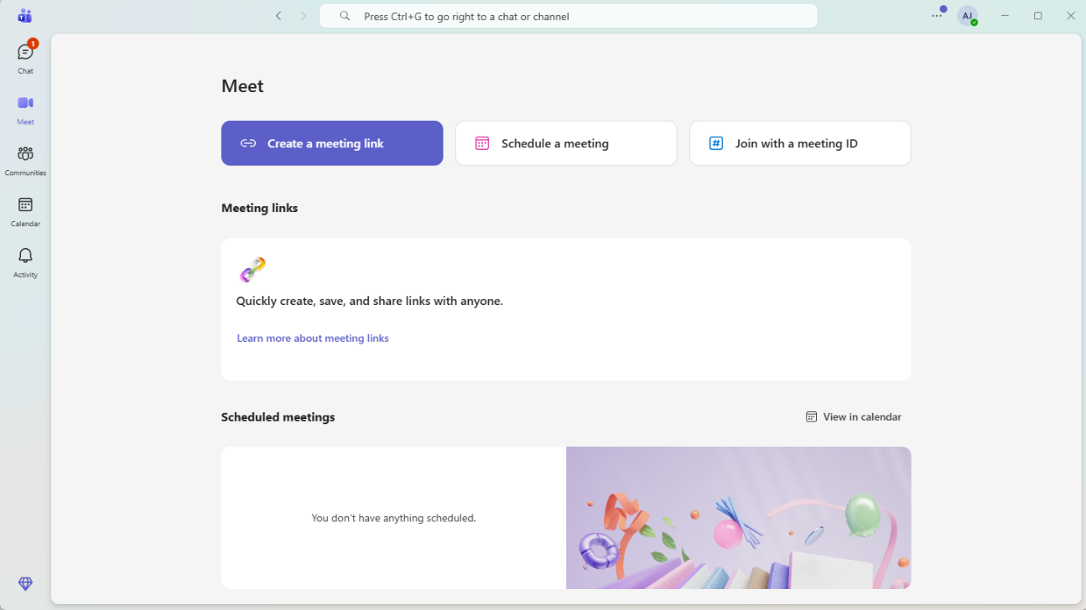

One Feature of a Communication Application
Application: Microsoft Teams
Feature: Instant Messaging (Chat)
Microsoft Teams allows users to communicate in real time through instant messaging. This feature supports one-to-one and group chats, enables the sharing of files, links, emojis, and images, and helps teams collaborate and communicate quickly and efficiently without the need for emails.

Conclusion
In conclusion, communication applications such as Microsoft Outlook and Microsoft Teams play a vital role in modern digital learning and workplaces. Features such as email communication and instant messaging enhance real-time interaction, improve collaboration, and support effective information sharing. These tools help users stay connected, work efficiently, and adapt to the demands of learning and working in the digital era [1].

References
[1] Microsoft, "Microsoft Teams Overview," Microsoft Learn, 2023. [Online]. Available: https://learn.microsoft.com. [Accessed: 14-Dec-2025].
[1] Microsoft, “Outlook – Email and Calendar,” Microsoft Support. [Online]. Available: https://support.microsoft.com. Accessed: 2025.

[2] Microsoft, “SharePoint – Collaboration and Content Management,” Microsoft Learn. [Online]. Available: https://learn.microsoft.com. Accessed: 2025.

[3] Microsoft, “Microsoft Teams – Collaboration Platform,” Microsoft Learn. [Online]. Available: https://learn.microsoft.com. Accessed: 2025.

