Leading and Implementing Workplace Change

Student – Rume Meah
Student ID -
BMSW6103
Lecturer – Nauman Ali

Table of Contents

Abstract……………………………………………………………………………………….4

Introduction…………………………………………………………………………………...4

Section 1: Situation Analysis…………………………………………………...5

Business Canvas…………………………………………………………………………...6

Time Management………………………………………………………………………….7

Gram Bangla Strategy……………………………………………………….…………….9

Process mapping – Supply chain management……………………………………..…10

SWOT Analysis…………………………………………………………………………….11

VRIO Analysis ………………………………………………………………………..……12

PESTLE………………………………………………………………………………….…13

5 Porters Analysis……………………………………………………………….……….. 16

Section 2: Stakeholders & Change……………………………………………17

Internal and External Stakeholders……………………………………………….……..18

PI Matrix…………………………………………………………………………………….19

Stakeholders Vested Interest………………………………………………………….…20

Strategical Change………………………………………………………………………..21

Strategical change in cliental……………………………………………………….……21

Section 3 Change Management………………………………………………22

Change Curve Model………………………………………………….…………………23

Cotters 8 stage – Implementing change in customer purchase………….………… 24

Table of Contents

Section 4: Change management & organisation………………………………31

Circular Organizational Structure………………………………………………..…………. 31

Organizational Culture………………………………………………………….….…………32

Supplier Organizational Culture…………………………………………………..…………35

Organizational Cube…………………………………………………………..…….………..37

Data Management…………………………………………………………………………….38

Communications Management………………………………………………….….……….39

Competition Data…………………………………………………………….……….……….40

Customer Data……………………………………………………….…………….….………41

Analysis of Organisational culture and learning………………….………………………..42
.
Current position – McKinsey 7s…………………………………….……………………….43

Implementing Change Roadmap……………………………………….…………………..46

Section 5: Reflection………………………………………………….……………………48

Bibliography………………………………………………………………..………………49

Appendix………………………………………………………………….…….……………. 51

Abstract
Post Covid, businesses need to innovate IT strategies to stay in business. It has been identified that Asian Supply Chain management do not use IT to its best advantage, primarily due to primary stakeholder’s lack of IT skills and knowledge, making this industry stagnant. Onus is placed on “real time” factor, stakeholders’ preference is to is keep within their business need, survival is key, limiting innovation. Research implies “if it’s not broken, don’t try and fix it”, stakeholders do not feel the “need” to innovate. Until this attitude changes in a broader aspect by larger influential companies, IT innovation will be slow. Gram Bangla business strategies can only be realigned in its business scope. This paper investigates current strategy and how they can better manage their resources, through strategic theories, stakeholder management and time data analysis.

Introduction
The Covid 19 pandemic has dramatically changed the way organizations conduct their businesses. A full configuration of business strategies and plans are required to meet the current changed global environment, as previous strategies and plans have lost their validity. Traditional face to face work is now conducted through technological resources. Therefore, it is important that businesses now utilise their technological infrastructure, to full capacity to gain maximum productivity.

Gram Bangla is a private owned ‘wholesale fruit and Vegetable’ Limited company who commenced Business in October 2018; their customer segment is Business to Business. Gram Bangla has 2 permanent employees, with 1 Company Van (LWB Mercedes Sprinter). Usage of additional subcontracted Drivers is on a ‘as and when’ basis. Day to day business is conducted from a rental warehouse (appendix 1) based in central Birmingham. Gram Bangla has over an annual turnover of over £200,000, however profit varies, due to the seasonal nature of Fruit and Vegetable., which have a limited shelf life and are highly perishable. Effective time management is ‘essential’ to the success of the business.

This portfolio will highlight Gram Bangla Wholesale current position post covid. To ascertain the current position of Gram Bangla, an External and Internal SWOT and PESTEL analysis will be conducted to see what is being done and identify potential areas of improvement. The Business Model Canvas element will breakdown all the components required to focus on Gram Bangla’s business strategy. As Stakeholders have an impact on the decision-making process, PI matrix will establish how important they are through individual scores. The data collated will be used to develop a change management plan, this will impact the changes required in both structure and culture of the organisation. The final evaluation will help direct Gram Bangla into advancing into the technological arena and improve their business.

At present Gram Bangla’s digital presence is very basic, communication is via emails, and use of phone and WhatsApp social app – this is the main correspondent for liaising with Customers and overseas Suppliers, as they are all registered with this application at present. Evaluating IT presence and how to best to improve this will be analysed.

Section 1: Situation analysis

Organisation’s current position
Gram Bangla primarily operates in Central Birmingham’s locality, this is due to having 1 employee, the reach is limited. Gram Bangla’s productivity is to efficiently use time management to utilise the customers within the geographical area to their best advantage through providing the best quality Fruit and Vegetable within a timescale. They use historical customer data, to plan and execute sales logistically, delivery route is planned systematically each working day. Gram Bangla uses the Kanban Lean workflow management method, incorporating the “just in time” system. To satisfy customers, the right produce at the correct time, in the required quality, must be provide by managing the flow of produce and information to satisfy the customer (Burganova et al, 2021, pp.553-560.) Internal logistics (Appendix 1) work well in proportion to the size of the company.

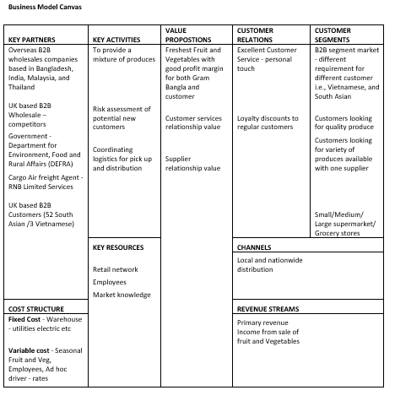

Time management
Gram Bangla’s produce arrives from Bangladesh, India, Thailand, and Malaysia via airplane freight. Suppliers produces are packed dependent fruits/ vegetables longevity, they use EPS polystyrene or cardboard boxes, both recyclables i.e., Mangos are pre-packaged in cardboard boxes, Durian are pre-packaged in polystyrene. Retailers discard packaging through recycling companies every week.

Gram Bangla’s Strategy to acquire customers and adapt to customer demands
Gram Bangla identifies the greatest density of Asian Fruit and Vegetable shops in the immediate geographical area (fig 1), here they identify the areas in which there are locations adapts their strategies to each customer (fig 2), they structure their business around the size of each customer business, their demands and how best to accommodate them. By using this tactic, they have managed to accumulate a customer data base of 151, over a period of 2 years. Of the 151, Gram Bangla have acquired customer loyalty base of 20-30. In the last 3 month period Gram Bangla have ventured in to supplying to the Vietnamese market and have acquired 3 loyal customers.

Fig 1 Geographical Reach (Source - Google Maps, 2022)
Gram Bangla Strategy
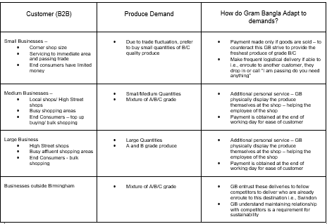

Fig 2

How Gram Bangla Adapt to customer demands
Gram Bangla adapts their strategies to each customer (fig 2), they structure their sales tactic around the size of each customer business and demands and how best to accommodate them. By using this tactic, they have managed to accumulate a customer data base of 55, over a period of 2 years. Of the 55, Gram Bangla have acquired customer loyalty base of 10. Recently they have branched out to Vietnamese customers already acquiring 3 loyal customers.

Process mapping – Supply chain management
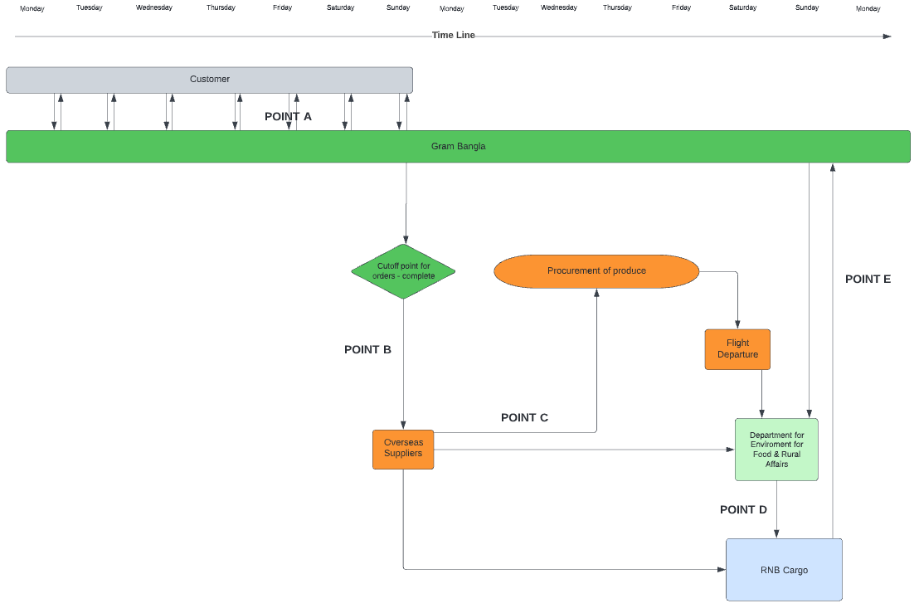 SWOT ANALYSIS 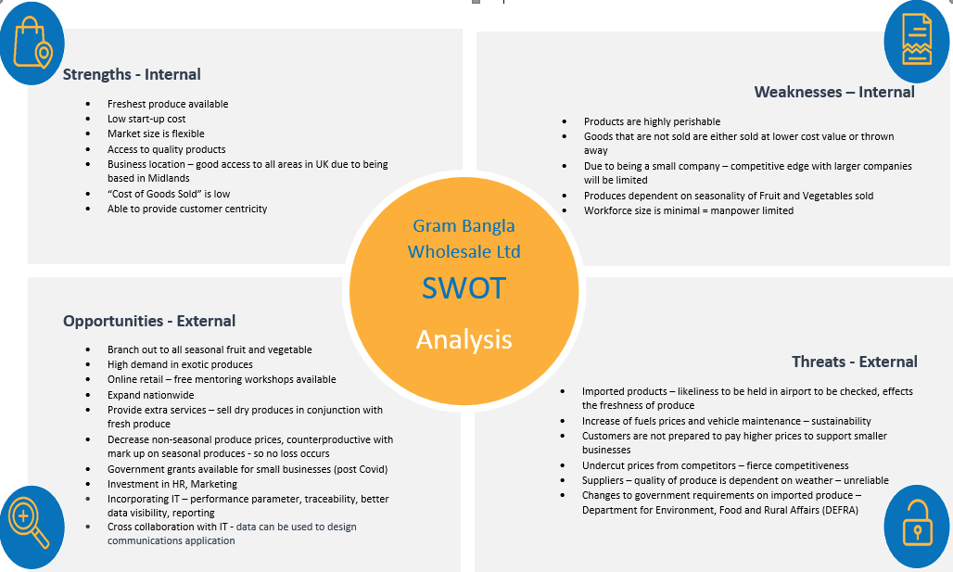
IT communications in GB Supply chain management

Point A – WHATSAPP/ PHONE - Order UPDATED each day

Point B
WHATSAPP Order sent o supplier manager

Point C
EMAIL - Shipment details to DEFRA and RNB Cargo

Point D
EMAIL - Cargo checked and released to RNB Cargo

Point E
WHATSAPP - Release reference sent to GB to pick up from airport
VRIO
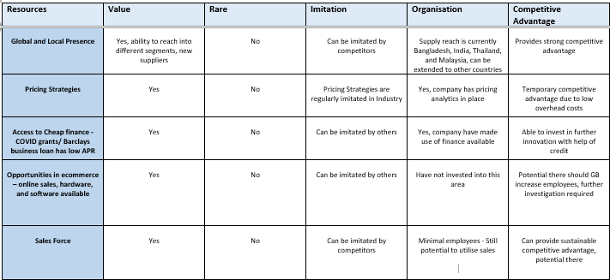

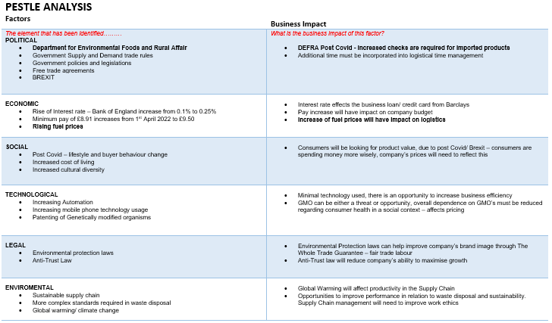

Gram Bangla’s focus is on time management and distribution within costs. Post Covid, various factors have arisen that can adversely affect Gram Bangla’s supply chain management either directly or indirectly if not managed efficiently.

Primary Factors –
Direct
Importers are required to provide pre-notification material, at least 4 hours before the cargo lands, for air roll-on-roll-off freight (DEFRA, 2021). During the changeover period, flow of data was disrupted as suppliers overlooked additional documents, this delays the time of release, negatively affecting the lead time from inbound to outbound flow to end users, decreasing the quality of produce. However, this can be overcome by stringent feedback from supply chain stakeholders, this will target ensure well-orchestrated schedules from order to delivery, and reduce any lack of clarity in responsibilities, particularly where there are shared workflows (Wyman, O, 2018, p22).

The rise of fuel prices directly affects the logistical element of Gram Bangla, to be cost effective, logistics must be strategically planned in coloration to customer demand, geographical and time required to deliver. Systematic backhauling is a method that is currently used to reduce mileage, as some customers require distribution twice a day to replenish stock.

Indirect
Post Covid Department for Environment Food and Rural Affairs have introduced increased Phytosanitary checks for certain imported products, however in 2021 the government failed to implement controls and checks on EU goods imports which meant they were given preferential treat to that of non-EU, with the additional checks and non-compliance of EU imports provided EU an edge in competition. (House of Lords, 2021, p42).

Secondary factors –
Direct
Covid has increased Global shipping costs, impacting the supply chain management, Shipping firms anticipated during the Covid pandemic, a dip in demand and created a mothball situation, however demand remained high and since increase, resulting in backlogs. Due to this, costs in shipping have increased dramatically, in September 2022 a large container was four times higher than in September 2021 (Institute of Government, 2022). However, shipping costs make up a small portion of the supply chain management and increments of costs will have minimal impact generally on a firm.
Indirect
The end consumers are factors within the supply change; however, Gram Bangla is not able to influence the buying trends that are currently established, they are only able to provide what the demands are of the end consumers.

Nominal Factors
Due to the size of Gram Bangla, Environmental Protection Laws and Legal issues arising will not affect the running of the business. According to the Qualitative Research Report, SME’s & Competition Law (p17, 2015), commissioned by the “Competition and Markets Authority” excluded very small businesses from their research, due to the size, small businesses that are only 1 to few employees are predominantly focused on survival than to worry about competition law.

5 PORTERS
Threat of New Entrants | Medium | Even though market is easy to enter on paper, without contacts it is hard to purchase produce – suppliers require a recommendation, for a new entrant to be considered. New businesses starting out, are ex-employees who have acquired skills and contacts whilst being an employee. Once established, failure is primarily due to not being able to commit to quality and orders.  Competitors are all using basic technology for communication – telephone, Facebook, messenger, WhatsApp, emails. IT is not utilized in the maximum capacity even though resources are there, this is due to the following factors –  - Limited knowledge and Skills in IT
Bargaining power of Suppliers | Medium | There is some movement between the high and low end of cost price.
Bargaining power of Buyers | High | Wholesalers offering similar Asian produces/ price. Wholesales catering large supermarkets i.e., Asda, Tesco’s etc Asian produce.
Threat of Substitutes | Medium | Pre-packaged Asian frozen/fresh, fruit/ vegetables provided by larger retailers – Ada, Tesco’s.  Highly perishable goods, limited manoeuvre in selling price due to produce being from developing countries where agricultural economic can fluctuate due to i.e., floods, weather, covid, government policies etc.
Intensity of Rivalry | High | By using similar suppliers, selling similar quality produce equates to intense rivalry between competitors.

Overall due to the size of Gram Bangla, they can concentrate their resources in the immediate vicinity of Birmingham. Lower overheads and minimal employees are positive in staying in competition. They can supply and satisfy customers using resources within their capabilities. Stakeholders of the Supply Chain Management do not realise the full potential of IT in supply chain management as present system is working fine, organisations prefer to use resources elsewhere rather than IT. However, for sustainability of the Gram Bangla they must strategize their current business management to maintain position for competitive advantage.

Gram Bangla current use of Information Technology
IT use in Gram Bangla is limited, they use telephone, social app - WhatsApp, and email communication to operate their Supply chain management system. The process of Supply Chain Management from Orders taken (Monday to Sunday) to eventual distribution takes 2 weeks, this is a continuous process 7 days a week.

The fruit and Vegetable Industry has a ‘real time’ factor due to the shelf life of the perishable produces. Orders are taken verbally or over the phone through the week, order cut off point every Sunday, order is then placed with the Supplier manager via WhatsApp. This is then procured over 5 days, both Gram Bangla and suppliers still update order throughout this time via telephone for any last-minute changes.
Section 2: Stakeholders & Change

Stakeholders are very significant in any change required in an organisation, they can influence and be influenced by the actions of the organisation. All stakeholders have low/ high vested interest, recognition of stakeholders is determined by the part they play in an organisation as they provide information that help in organisational, system design, gathering relevant data to implement change (Qureshi et al, 2017. p113). It is important that all stakeholders are included when creating a change management.

In 2004 Tesco’s opened establishments in China, they conducted 6 years research to gain insight into the taste and preferences of the Chinese consumers, their key stakeholder (Kris, 2020). After 9 years of being in business in 2013, Tesco’s formally closed because they did not meet the demands that Chinese consumers required.

Assumption can be made that how can a large organisation such as Tesco’s fail, who have access to funding, able to recruit R and D specialists., have all the resources and tools to be able to manage change. Tesco’s provided own branded food products, and food that did not suit the consumers tastes, placing limitations on what was offered. Consumer’s preference was to shop frequently and buy small qualities., in shops that offered product sampling/ tasting (culture). Tesco’s did not sell products tailored to the local consumers, here Tesco’s failed to grasp the characteristics of their main stakeholder, the Chinese consumers. By not understanding their stakeholder they failed to be productive in their management change process (Woohyoung et al, 2020).

Internal and External Stakeholders
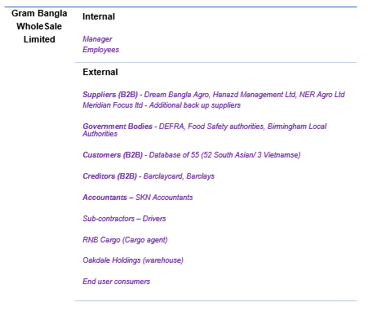

Gram Bangla’s need for change

Covid Impact
Covid has presented an environment where nothing stays the same, dependency has changed, consumers way of purchasing food has changed, the move to online grocery shopping has been significant and is here to stay. A potential long-term trend may emerge from the pandemic; however, this may only arise, dependent on customer satisfaction (Richards, Rikard, 2020). At present it is not productive to the Gram Bangla to sell online, end consumers are still physically buying good through retailers, further analysis is required if Gram Bangla decide to implement this.

At present the employees work very hard to keep up with competitors, utilising time to the best advantage is crucial. Gram Bangla have a set routine for their day to day activities, product deliveries are counted and loaded into van, route is planned logically taking into account traffic etc. Payment is not taken at time of delivery but at the day end.

PI Matrix
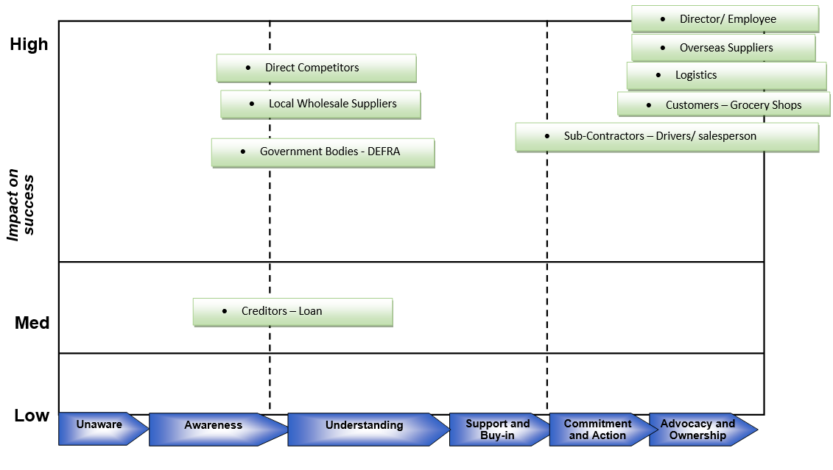
Stakeholders – Vested Interest
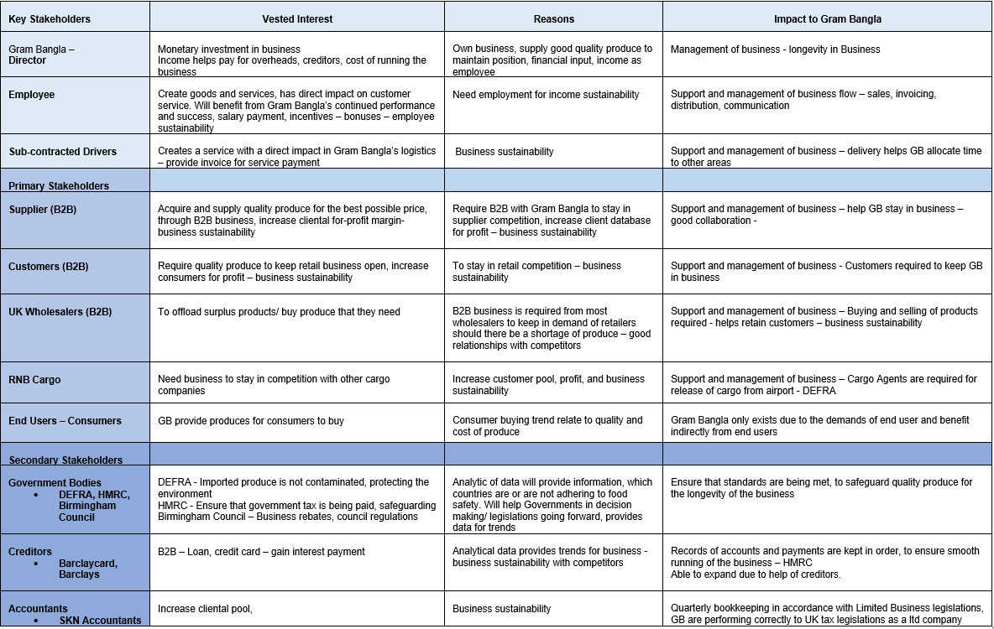

Strategical Change
Competition in the local area is very fierce, Gram Bangla have managed this well because they are a small company and overheads are minimal. However due to this, employees must work twice as hard to maintain a place in the market. This can lead to employee exhaustion and possible loss of employees.

Incorporation of IT into the SCM can alleviate pressure from Gram Bangla. SCM linkage through Information Technology, means to plan and execute an integrated business process and operations. Companies are focusing on Information Technology to attain significant and competitive advantage by configuring and managing the supply chain process and operations. (Lee & Kwon, 2007, p445)

Strategic change in cliental
Gram Bangla have recently acquired business in the Chinese community, primarily selling Durian. To break into this sector, Gram Bangla required someone credible to recommend them to through word of mouth. The obstacles that they encountered was predominantly the cultural element, getting the foot through the door with little or no information about the Chinese business ethics and culture was difficult. The Chinese community business ethics is “here’s what I will be willing to pay, if it suits you, we can do business”, bartering was non-existent, whereas in Indian (Indian) cliental price was managed through bartering. on time delivery was predominant, in maintaining a good relationship enabling trust between businesses. In return, payment was made promptly after receipt of goods. The working relationship improved as Gram Bangla provided both good quality and prompt delivery, once established, here Gram Bangla experienced a very good line of due to clear and concise communication, this was down to understanding the client’s cultural business ethics.

Section 3: Change management

The world is changing every day, through climate change, societal change, everything evolves and does not stay the same. The same is said for the workplace environment, when businesses fail to keep up with these constantly moving targets, they become stale and ultimately will fail. Covid 19 has impacted society, to stay in competition, technology has been used in more innovative ways i.e., cloud is used to easily access data in any given place, helped with working from home. When change is required, the main obstacles faced are the employees, not everyone will accept it. However, this can be overcome with clear and concise communicative definition of the change management process and what benefits will come with it.

Change management is a 3-phrase process that helps businesses manage change. The goal of change is to enhance organisational internal/ external performance ability, through proactive/ reactive actions. Lewin’s generic 3 step model helps with identifying and managing the factors to resistance change and how to sustain it once it has been implemented (Karnouskos, 2015). This process implements strategies and interventions in a systematic and structed way. However, it has been argued that this process predominantly emphasises on small scale, incremental change and is not appropriate to situations that require rapid and transformational changes (By, 2005).

Change Curve Model
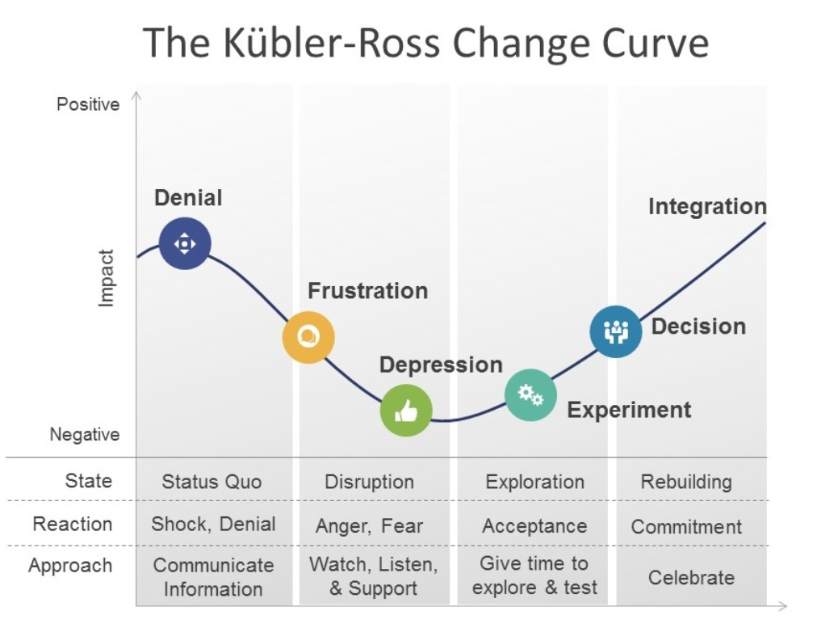

Fig 3 The Kubler-Ross Change Curve, Source – Saboe, D, 2018

There are many modes of reactions towards change in business. The change curve model (fig 3) provides insights into people react to change/ disruption to the norm. Gram Bangla’s integration of an IT purchase order form into the supply chain management is a simple, small-scale implementation, so Lewin’s 3 step model is most advantageous to implement.

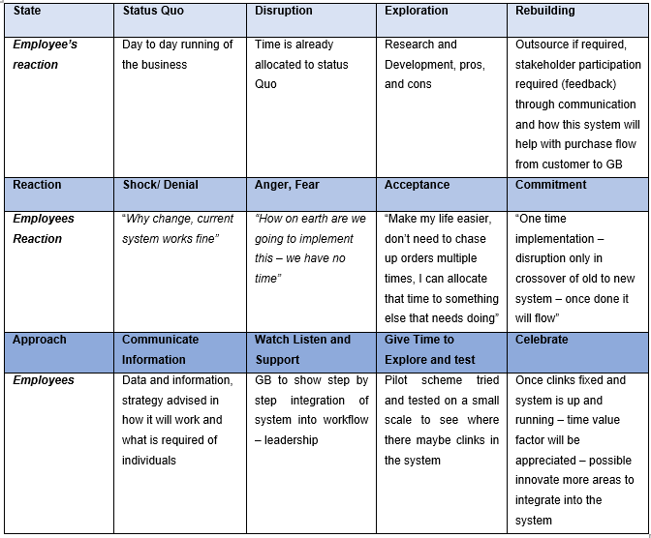
Stakeholders have their own organisation structure and is reflected in the style of communications provided (supplier – Appendix 2),

Cotters 8 stage – Implementing change in customer purchase

- Create a sense of Urgency
Covid 19 has provided a sense of urgency that nothing stays the same. IT implementation in business is increasing due to the change of the working environment. Gram Bangla is a small business and to compete with larger competitors they need create a business advantage. Best practice for time management can be created through streamlining the business process. It is estimated that in a 10 hour working day Gram Bangla are on the phone with customers for an average of 2 hours (fig 4), this time can be better allocated to logistics. Problems arising from regular communications care misinterpreted orders, change of order - customers may feel the need to change orders when they feel like, due to the openness of conversations i.e., Customers have provided order with Gram Bangla, but meanwhile competitors have dropped in and supplied produce, in turn customers ring back to change order. This can become very erratic and disrupt the purchase order system. Providing a structure for orders at the end of the day, will minimise duplicate information/ orders.

Fig 4

- Form a powerful coalition
Gram Bangla requires employees to understand why the change is required. Employee knowledge and understanding of the current system make them key in influencing decision making in any change. Gram Bangla’s vision to streamline business strategies to company advantage will have a ripple effect to the supply chain management stakeholders. Each stakeholders have their own experiences, knowledge and skills that can help further Gram Bangla’s advantage, strategic collaboration is key.

By streamlining orders, employees decrease the need to deal with unhappy customers, which will positively affect the motivation of employees.

- Create a vision for change
Once a coalition is formed, providing a vision is important. For business growth they require utilisation of employees implicit and knowledge in sales and marketing. They adapt selling tactics (mannerisms) to each individual customer persona, and businesses as they cater to small, medium, and large stores. Growth of customers will provide incentives to recruit employees.

Digitalising the customer purchase order will a steady flow of data. Figure 5 provides the flow of purchase chain development; this system provides how set variables flow, once IT change has been implemented in the purchase order system. This system will help decease unhappy customers.

This change is required for business advantage, as time management is key, employees is minimal, competition is high. Employees are known to work hard but they need to see the progress and that their hard work is amounting to a goal – sustainability of the business.

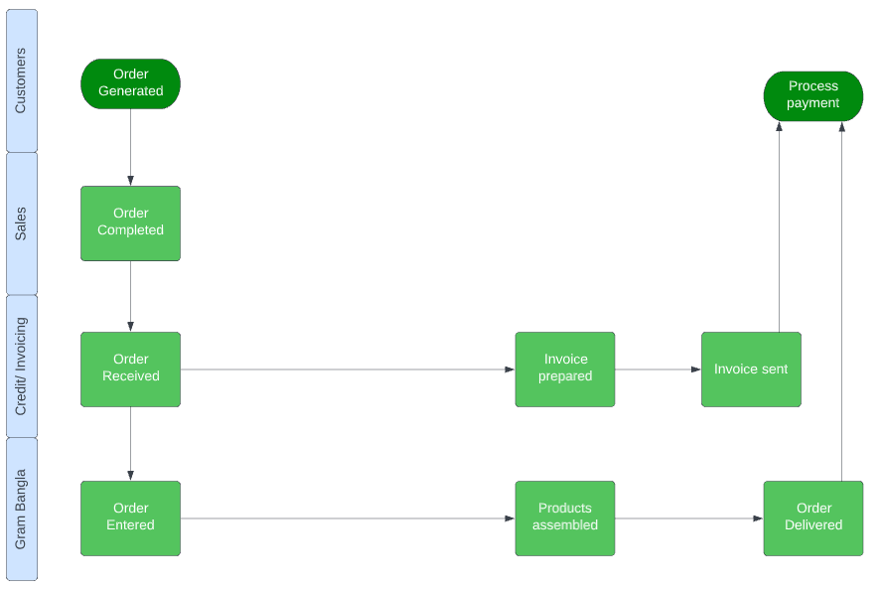
Fig 5 Flow of Purchase order after IT implementation

- Communicate the vision
Gram Bangla requires employees to buy into their vision of streamlining business systems(fig 6). According to Molin and Age (2017), social processes are an important element in successful streamline implementation. Streamlined time management (fig 7) will provide less interruptions enabled through transparent communications. Face to face dialogue is the most effective way of communicating a vision, it promotes understanding and shared meaning. This personalises the meaning to the employee (Jensen et al. 2018 p352). High stakeholder engagement from the start is a factor in achieving business outcomes, this minimises resistance (Anderson and Anderson, 2010, p23).

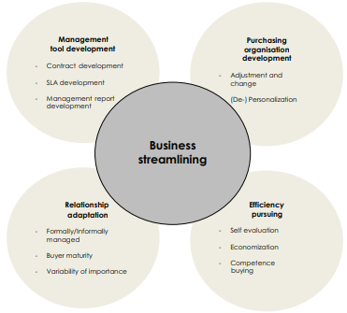

Fig 6 Source: Molin & Age, 2017

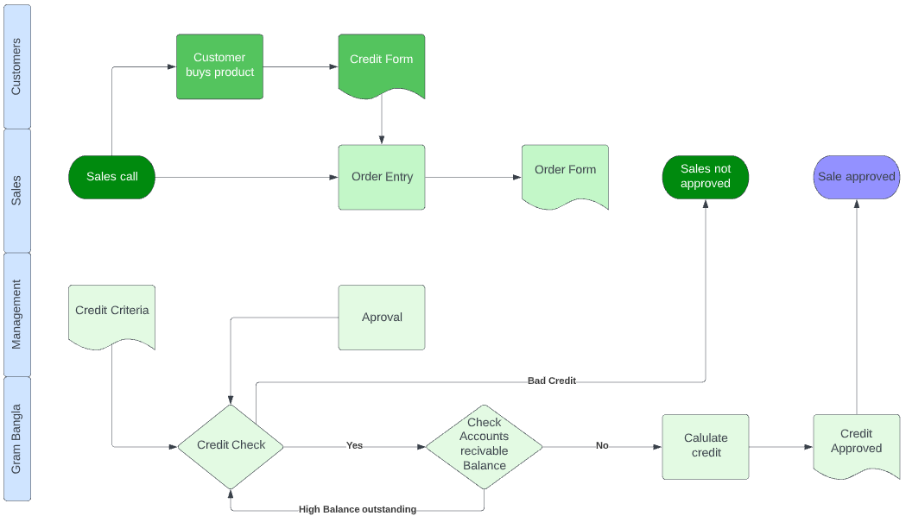
Fig 7 Business System flow in IT implementation of customer purchase order
- Remove Obstacles
Given the size of Gram Bangla, trust is implicit to the running of the business. Not all decisions need to be authorised by the Director. Employees are each given individual tasks, the daily repetitiveness of these actions builds knowledge and skills. It encourages employees to make on the spot decision making without notifying the director.

Managing effective lead time in supply chain management is an obstacle as it must go through many channels. Human error is a natural element, misinformation and forgetfulness has been known to interrupt time management. This can be managed through on screen (phone, Computer) “pop up’s” reminders through software such as *calendar. For a more integrated system, Gram Bangla and suppliers can invest into a Supply Chain Management software (real time analytical system) which integrate supplier, customers, so that the right produce is distributed at the right qualities at the appropriate time. However, this can best be utilised when the company expands.

- Create Short term wins
Digitalisation of the customer purchase form has proved to a marginal win. A simple customer order form was designed though Microsoft forms. It was sent to (Appendix 3) 5 Customers, 3 replied (fig 8). This a short-term win as feedback was good. Customers acknowledged the system and were prepared to use it. However, this is advantageous to Gram Bangla’s loyal customers who buy more produce than the smaller customers.

Implemented using Gram Bangla’s current resources i.e., laptop, Microsoft software. Simple purchase form was constructed to see how well the flow of data was. between Gram Bangla and 5 customers. 3 customers provided feedback, it was simple and easy to use. This is the best option for a simple addition and will work well at present. However, should Gram Bangla want to incorporate this into a larger scale IT development system, the integration capabilities are limited.

Fig 8 Integrate IT purchase system into the supply chain management – Pilot Scheme
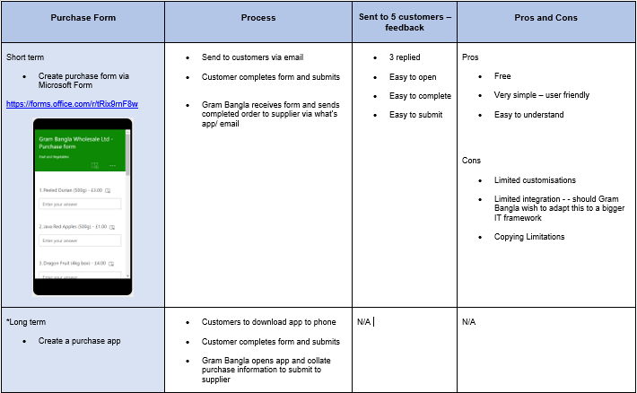

- Build on the change
Cliental change to Vietnamese has opened a new market, in comparison to the Indian, Bangladeshi, and Pakistani customers. Vietnamese are easier to deal with, already Gram Bangla have acquired 3 loyal customers, and they are building on the relationship through providing good quality produce. Obtaining payments from Indian, Bangladeshi, and Pakistani customers was a long process, as payment was only given after the produce had been sold, the cultural norm of these customers is “payment will be made after the produce has been sold”, if not sold then customers expect to pay low. In some instances, payment was never made creating a loss for the business. However, Vietnamese customers pay promptly when products are purchased, should produce not sell, feedback is provided, Gram Bangla are happy to exchange produce and renegotiate price, both individuals have mutual understanding of what is required from them to promote loyalty from one another.

Once the simple purchase customer form is integrated into the system, The next step would be to creating a purchase app (fig *Long term), this can be outsourced to companies/ individual to set up through websites such as “Fiverr Business”, this is a website dedicated to technological services, where individuals and companies can develop an app within your budget and requirements. This is the best option long term, as you can dictate whether you require further IT integration and adapt with Suppliers, this would require collaboration with stakeholders.

- Anchor the change to corporate culture
To be able to provide to Vietnamese customers, Gram Bangla have not needed to change suppliers. They have developed new cliental through the resources that they currently use. This change has been beneficial as customers buy the produce “Durian” which is a luxury item, highly sought after and demand is steadily rising. Sustaining and expanding customer pool is very profitable as it has a healthy profit margin. Gram Bangla can concentrate in building a new cliental base and recruit new employees to manage old customers. This will be beneficial as it prepares Gram Bangla to expand without losing customers.

Feedback from the simple customer purchase order has been positive. Gram Bangla must apply this to their loyal customers first, to see how well it can adjust. Once this done, increments of additional customers should take place, slow transition will provide less disruptions.

Section 4: Change management & organisation

Circular Organizational Structure
Gram Bangla have implemented a circular organisational structure due to the size of the company, this is a democratic management practice, which enables employees to provide their input in finance, sales, services, and marketing before the director makes a decision. It helps both employee and manager to work together to achieve company goals and provides efficient and clear information exchange. This works best to empower employees though additional responsibilities and relives the burden of daily business operations for the manager and even though he has full control of all aspects in the running of the business it allows employees to make micro approvals in decision making, creating a self-sustaining working environment. Should Gram Bangla increase the size of employees, this structure enables employees to cross collaborate from their individual functional level to help each department.

However, when the company expands on a larger scale, it will become more aligned to a matrix structure, a circular structure by itself will provide dual communication and lead to communication gaps, in additional it will slow down decision making and implementation process and will affect the business negatively, so a change in structure will be required (Hamidizadeh, Asli, 2019, p411).

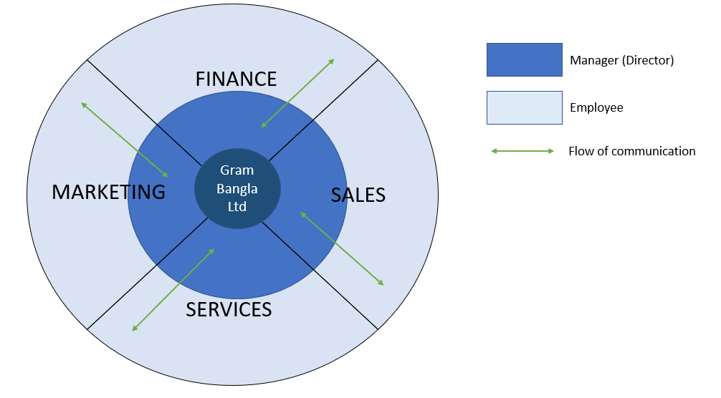

Circular Organisational Structure

Organisational Culture
Organisational Culture derives from the environment that the business is conducted. Gram Bangla organisational culture incorporates their mission, Vision and values (fig 9 in addition to this, it includes the beliefs and values of the Asian community. They understand that reputation is utmost in creating greater customer relationships.

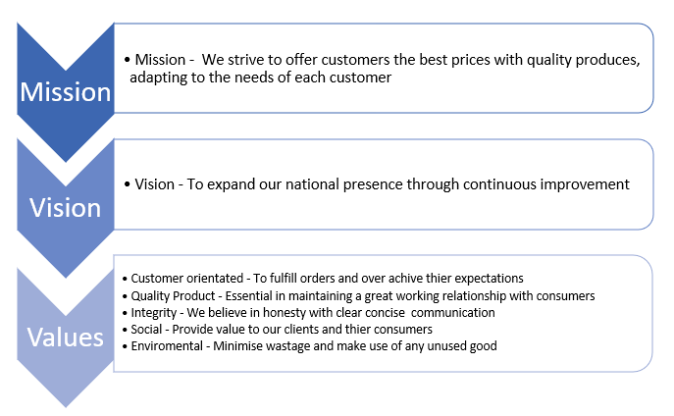
Fig 9

Who and how do Gram Bangla Service to?

Customer (B2B)
These are people from 1st generation minorities (Pakistani’s/ Bangladeshi/ Indians). People from these minorities come from rural areas with low education and occupational position, are likely to into manual labour, progression into professional managerial roles have declined over the decades. 1st and 2nd generations faced greater disadvantages during recession in gaining employment. However, in the last 50 years, some minorities, Indians, and Chinese are doing better than their white ethnic counterparts (Commission on Race and Ethnic Disparities, 2021).

Fruit and Vegetables are highly perishable and have a limited shelf life. To obtain the best profit margin a quick turnaround method must be adopted. Gram Bangla do not have the luxury of “take it or leave it approach”, time management is a major factor for long term sustainability.

Employees have basic selling skills but have developed additional skills through trial and error, for example when providing a discount, employees have noted that to keep the loyalty of customer they need to provide discounted produce, this requires employee to figure out the optimal price that they can sell without a heavy loss, say at a marginal cost, here customer response is foremost considered and then the analytical process comes after. When produces are not sold, Gram Bangla uses the opaque selling method, this is primarily selling various produces together, in which the customer may think they are getting a great deal but not really. Gram Bangla have adopted “risk pooling management”, this a method which deals with volatile and unpredictable customer demand, which has been proven to work well in supply chain management (Sasanuma et al, 2022. P2)

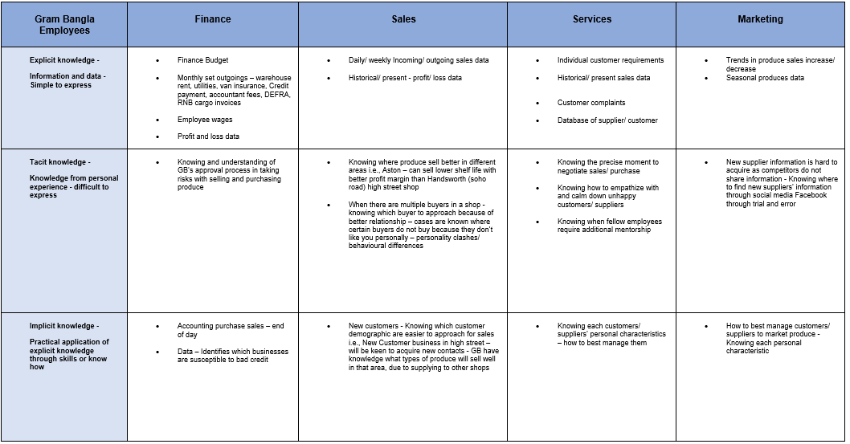
Fig 10

To be able to deliver customers with the best prices and quality produces they adapt their services to each customer (fig 10), this also includes managing good relationships with competitors.

Supplier Organisational Culture
Gram Bangla’s suppliers’ growth development is directly linked to each country’s environmental climate, which depicts culture. Figure 11 show comparisons in country growth, Malaysia, Thailand, India and lastly Bangladesh has been identified as a poor performer.

Suppler sustainability incorporates environmental variants (fig 11) to consider through each stage of the supply chain these factors are not within our control, however Supplier sustainability in the market is affected by economic factors each country faces, (fig 11,12, 13) is indicative of which suppliers put in the most effort in the supply chain management system for quality assurance. These factors directly impact their own style of business management which has a ripple effect into the supply chain management. “One shoe does not fit all”, Gram Bangla understands that all customers and Suppliers (B2B) have different requirements to consider.

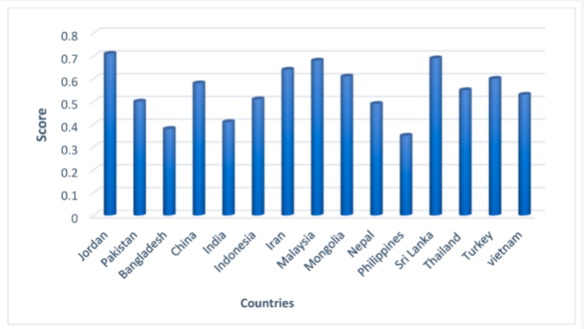

Fig 11 MDPI, Environmental index. Source: authors’ calculations.

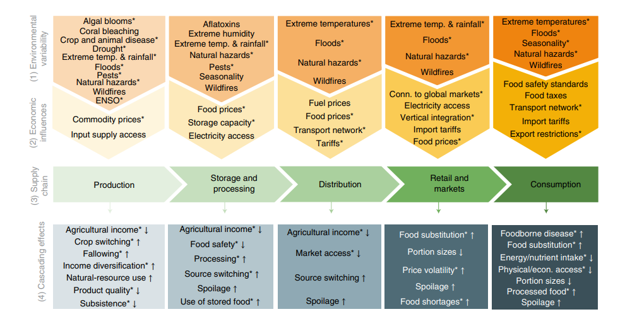
Fig 12

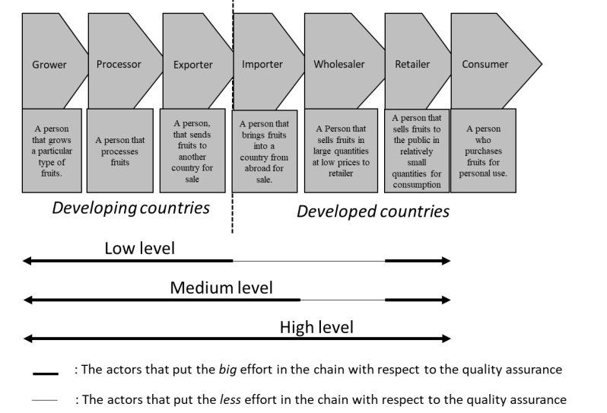
Fig 13 Degree of Collaboration complexity of the chain

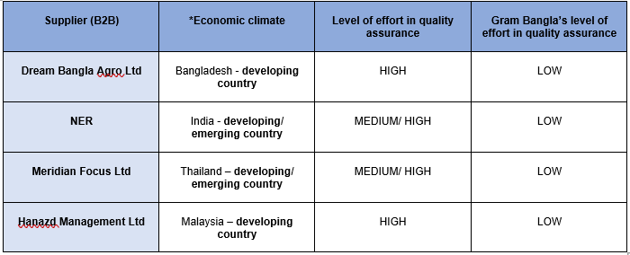
Fig 13

Organisational cube
Data flow and Communications Analysis
Even with regular communication there are disruptions in the supply chain management. It is compulsory to include hardcopy Phytosanitary documents with the cargo itself, DEFRA and RNB cargo require soft copies to be (emailed) submitted for checking. GB are not required to be emailed these documents as they will have acquired the hardcopy with the cargo. Out of the 4 suppliers only 1, NER (India) have streamlined the process by providing one clear invoice via email to GB, and supporting documents are emailed directly to RNB Cargo/ Defra, minimising duplication of documents.

Time management is affected by duplicated documents, product misinformation/ mismanagement, leading to stakeholder dissatisfaction. The problems noted, primarily arises from human error, Gram Bangla can only rectify their own mistakes and can provide feedback to stakeholders, to better align the process.

To counteract this Gram Bangla can incorporate a technology-based purchasing app, streamlining the flow of data where duplication through written/verbal is minimalised, providing less area for mistakes.

Data Management
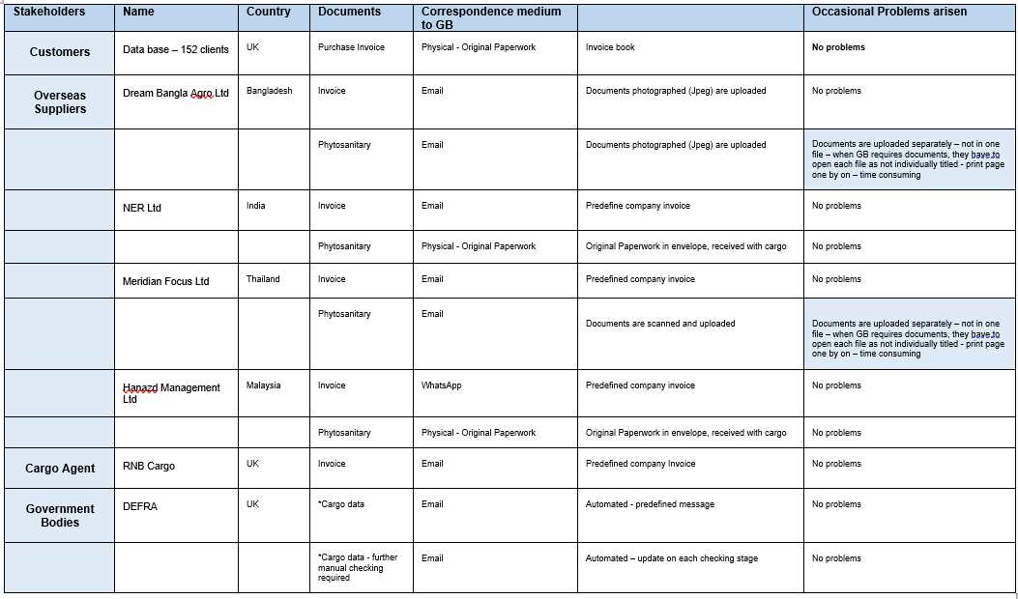
Communications management
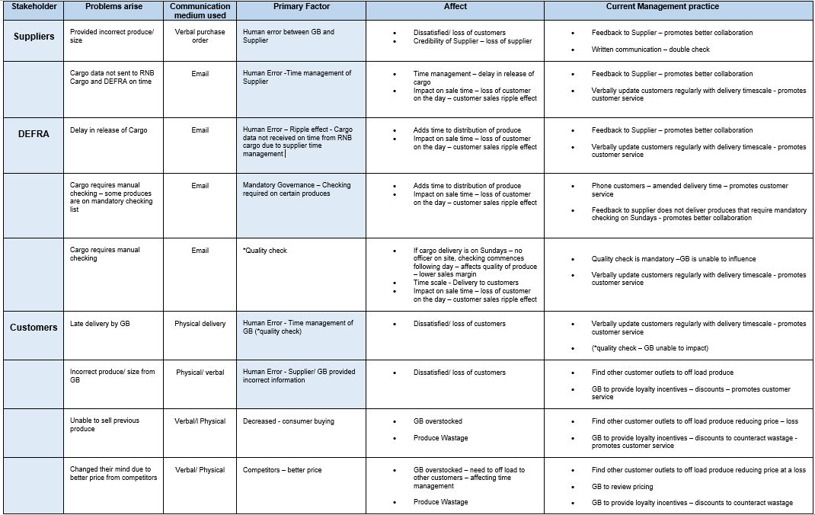

Competition Data
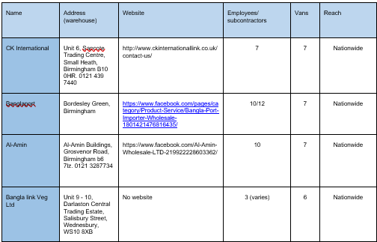

Gram Bangla direct competitors are 4 large companies based in Birmingham. Being an ex-employee of these companies, the director has acquired inside knowledge of the running of these businesses by observing their business systems, selling tactics, employee and managerial relationships dynamics, some employees do not possess the required skills of selling, many internal conflicts arose from individual personality. IT use is basic, websites are very basic, they are not updated and are really shown as a presence in the industry.

Gram Bangla is a threat to these companies, they are aware of the directors’ skills and competencies, as these companies still trying to recruit him back into their business by offering higher wages and incentives for their business advantage.

Relationships with competitors are a requirement, due to needing additional produce because of demand shortage or offloading surplus produce. Gram Bangla is advantageous in being a smaller company as there is less conflicts than of a larger company.

Customer Data
Gram Bangla has a customer pool of 55, 10 are loyal customers.

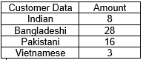
Analysis of Organisational culture and learning
As it stands, Gram Bangla’s organisation structure does have elements of an organisational learning culture, employees have input into the decision making and what works best is adapted. Feedback from customers and Suppliers is acted upon.

Venturing into a new cliental base “Vietnamese”, Gram Bangla has learnt not to focus on one demographic cliental. This has provided insight that Gram Bangla is able to satisfy new clients by diversifying their cliental base. Vietnamese clients are clear in what quality/ quantity produce required and require prompt delivery. In 2 months, since they have started to expand, they have acquired 3 loyal Vietnamese clients and in the process of negotiating with a large Vietnamese supermarket based in Birmingham City Centre. However, if they do not increase employees then it would mean they will need to decrease their Asian cliental.

Technological advancement will be hard to implement into supply chain management, as customers and suppliers are still rigid and use the old systems of telephone, email, and social app WhatsApp consistently. This is primarily due to the lack of understanding and skills that IT has to offer. The realisation that IT can help the system has not been fully investigated or applied. Due to this lack of connectivity in the supply chain, retailers and suppliers are only just starting to understand the value of such open and transparent collaboration, its likely it will take a few years before technology realises its full potential (Wyman, O., 2018, p45).

Current position - McKinsey 7’s
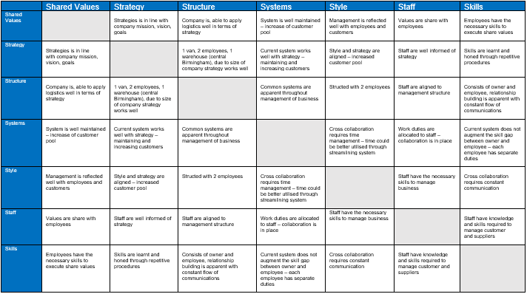
Further analysis
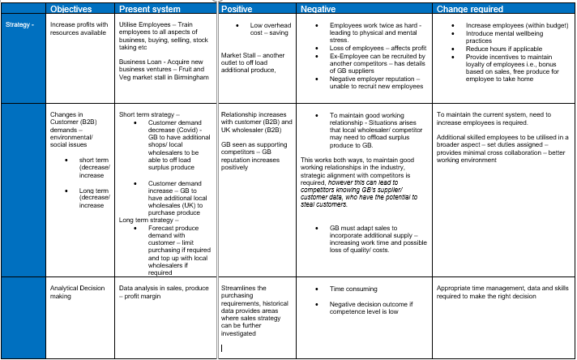
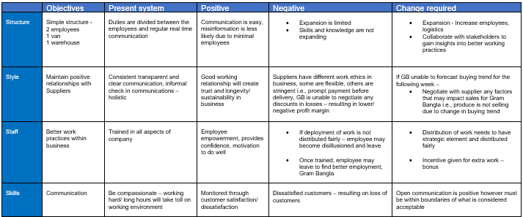
Implementing Change Roadmap – created using project management (Tello)
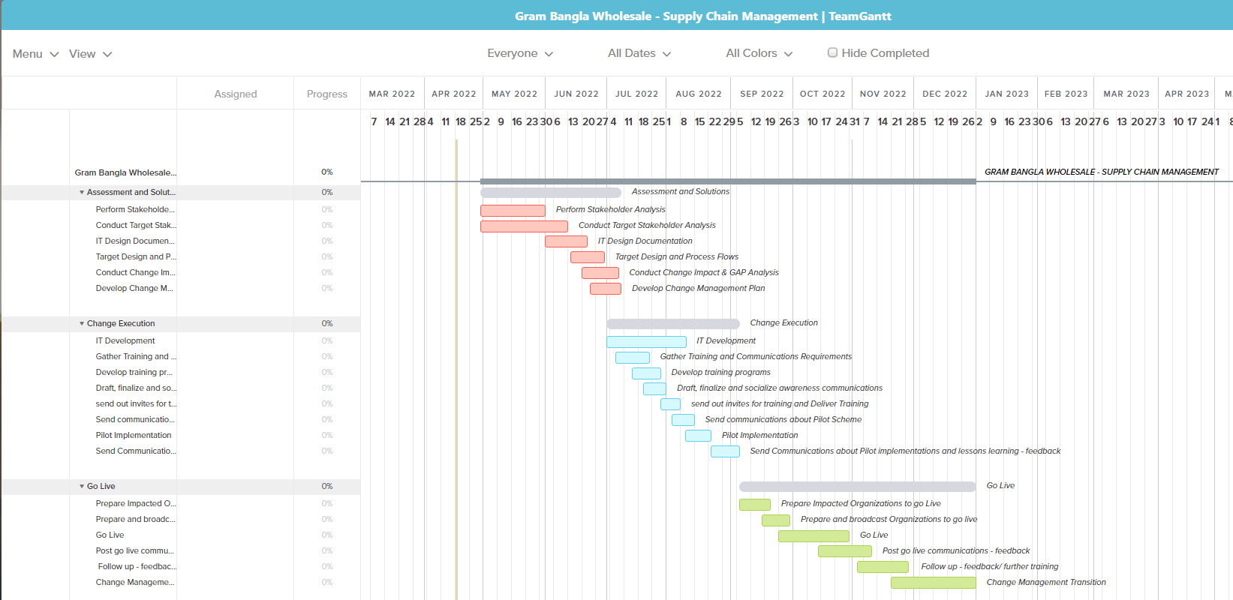

Section 5: Reflection

There are various factors, that impact business change. In the UK, Asian fruit and vegetables wholesale companies are mostly owned by of 1st generation – people who have immigrated to the UK in the 1960’s – 1970’s, the 2nd generation do not have desire to want to stay in the than stay in the family business. Due to minimal pay, recruitment is based on unskilled workers, those immigrating to the UK. The impact of culture and its non-movement has hindered change in this industry.
There are many obstacles in digitalising the supply Chain Management system. Minimal IT skills and knowledge have greatly impacted IT change and is stagnated due to the fact the system that are currently used are basic, and stakeholders appear not to have the need or desire to change.

Organisational prospective
Due to Gram Bangla size, they have limitations in influencing the whole supply change management procedure, however they can streamline their own strategy to their best advantage. Implementing IT in the customer purchasing system is adaptable and will lead to better time management. This is a onetime change and does not require external stakeholder set up, inherently it is a simple process, purchases forms are to be completed and sent back However it does require the support of stakeholders to be successful. Setting up meetings, collaboration is required to show how this will benefit stakeholders.

Gram Bangla needs to recruit skilled employees; minimal employees will lead to employee exhaustion, decreased motivation, and loss of employees. If someone falls ill the responsibility will be left to 1 individual to manage the business this is not sustainable.

To tackle suppliers providing duplicate information/ misinformation can be managed by placing information flow protocols in receiving and delivering through IT set ups - reminders or step by step guidance in written form – feedback from Gram Bangla.

Consultant overview
Based on present business practice/ structure, Gram Bangla must increase employees for business sustainability. At present business practice is manageable, not practical in terms of minimal employees. Recruiting 2 further employees and purchasing a further van will improve geographical customer reach. Employee recruited in either “Allrounder” skilled employee (full UK driving licence) OR if not – unskilled who will require a hands-on training program, which will be a better working practice in this business. Once recruited, realign work tasks, sale, marketing etc. to optimise resources.

Incremental IT progression required to provide Gram Bangla competitive advantage. Simple customer purchase order integration into a wider network. To enable this process, a pilot scheme needs to be implemented, incorporating all the stakeholders in the purchase chain, this can be done by management collaboration. To create a further implementation of the next stage of supplier integration, Gram Bangla can create an online project planning management software i.e., “Teamwork.com” including stakeholders to provide feedback and continue to innovate and adapt new strategies to streamline communications better. Real time information and data will create a more robust system for sustainability.

Bibliography

Anderson, D., Anderson, L.A., 2010. Beyond change management: how to achieve breakthrough results through conscious change leadership. Available at: https://www-vlebooks-com.ezproxy.uwtsd.ac.uk/Product/Index/11540?page=0 (Accessed: 19 April 2022)

Burganova, N., Grznar, P., Gregor, M. and Mozol, Š., 2021. Optimalisation of Internal Logistics Transport Time Through Warehouse Management: Case Study. Transportation Research Procedia, 55, pp.553-560.

By, R., 2005. Organisational change management: A critical review. Journal of change management, 5(4), pp.369-380. Available at: https://www.researchgate.net/publication/233604011_Organizational_Change_Management_A_Critical_Review (Accessed: 17 April 2022)

Department for Environment Food and Rural Affairs, 2021. Plant Health & HMI Imports/ HMI Exports – user guide to pre-notification on PEACH. Available at: https://planthealthportal.defra.gov.uk/eu-exit-guidance/imports/peach-user-guide/ (Accessed: 4 April 2022)

Commission on Race and Ethnic Disparities, 2021. The social mobility of ethnic minorities in Britain in the last 50 years (1972-2019). By professor Yaojun Li. Available at: https://www.gov.uk/government/publications/the-report-of-the-commission-on-race-and-ethnic-disparities-supporting-research/the-social-mobility-of-ethnic-minorities-in-britain-in-the-last-50-years-1972-2019-by-professor-yaojun-li (Accessed: 12 April 2022)

Competition Laws and Cartel, (2015) Small businesses’ understanding of competition law. Available at: https://www.gov.uk/government/publications/small-businesses-understanding-of-competition-law (Accessed: 4 April 2022)

Google Maps, 2022. Geographical Reach, 2km. [Google maps online]. Available at: https://www.google.co.uk/maps/@52.4912385,-1.9003065,12.3z. (Accessed: 15 April 2022)

House Of Lords, 2021. European Affairs Committee, One Year On – Trade in goods between Great Britain and European Union. Available at: https://committees.parliament.uk/publications/8266/documents/84391/default/. (Accessed: 4 April 2022)

Institute For Government, 2022. What is Causing Supply Chain Problems? Available at: https://www.instituteforgovernment.org.uk/publication/supply-chains/causes. (Accessed: 31 March 2022)

Jensen, U.T., Moynihan, D.P. and Salomonsen, H.H., 2018. Communicating the vision: How face‐to‐face dialogue facilitates transformational leadership. Public Administration Review, 78(3), pp.350-361.

Karnouskos, S, 2015. Linnaeous University Sweden, Effective Change Management in Modern Enterprises. Available at: https://www.diva-portal.org/smash/get/diva2:903428/FULLTEXT01.pdf (Accessed: 17 April 2022)

Kris, BV, 2020. Theories of Management. Why Tesco’s failed in the United States and China? Available at: https://theoriesofmanagement.com/why-tesco-failed-in-the-united-states-and-china/. (Accessed: 15 April 2022)

Lee, C.W., Kwon, I.W.G. and Severance, D., 2007. Relationship between supply chain performance and degree of linkage among supplier, internal integration, and customer. Supply chain management: an international journal.

Molin, J. and Åge, L.-J. 2017. ‘Business streamlining – an integrated model of service sourcing’, Journal of business & industrial marketing, 32(2), pp. 194–205. doi:10.1108/JBIM-01-2015-0011.

Reza Hamidizadeh, M. and Asl, S.S., 2019. ANALYSIS OF ORGANIZATIONS WITH A CIRCULAR STRUCTURE (DEMOCRATIC HIERARCHY). ITJEMAST 10 (3) 2019, p.411.

Qureshi, H.M., Malik, R.H. and Qureshi, W., 2017. Role of stakeholders in requirement change management. International Journal of Computer Science and Information Security, 15(2), p.113.

Richards, T., Rikard, B., 2020. National Library of Medicine, COVID-19 impact on fruit and vegetable markets. Available at: https://www.ncbi.nlm.nih.gov/pmc/articles/PMC7264629/ (Accessed: 15 April 2022)

Sasanuma, K., Hibiki, A. and Sexton, T., 2022. Operations Research Perspectives, An opaque selling scheme to reduce shortage and wastage in perishable inventory systems, p.2. Available at: https://reader.elsevier.com/reader/sd/pii/S2214716021000336?token=5DDC6E424B89E0E8EC7E835D4A11E19AD06266A35453914C3CF4FD74BDE5C16289E5C3B7A896286DCDC5B24A74C91FF0&originRegion=eu-west-1&originCreation=20220412074503. (Accessed: 12 April 2022)

Saboe, D, 2018. The Kubler-Ross Change Curve. Available at: https://masteringbusinessanalysis.com/mba154-change-leadership/kubler-ross-change-curve/ (Accessed: 17 April 2022)

Wyman, O., 2018. Disruption in fruit and vegetable distribution. Fruit Logistica Trend Report. P22 & 45. Available at: https://www.oliverwyman.com/content/dam/oliver-wyman/v2-de/publications/2018/Feb/Fruit_Logistica_Trend_Report_2018.pdf (Accessed: 13 March 2022)

Woohyoung, K., Kim, H. and Hwang, J., 2020. MDPI, Transnational Corporation’s Failure in China: Focus on Tesco’s. Available at: https://www.mdpi.com/2071-1050/12/17/7170. (Accessed: 15 April 2022)
Appendix
Appendix 1
Mercedes Sprinter Van long wheel

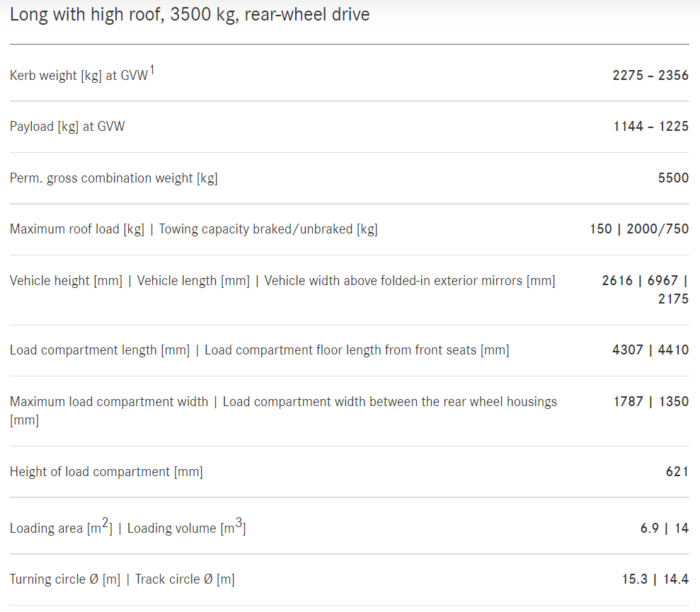
Warehouse

Appendix 2
Meridian Focus - Thailand
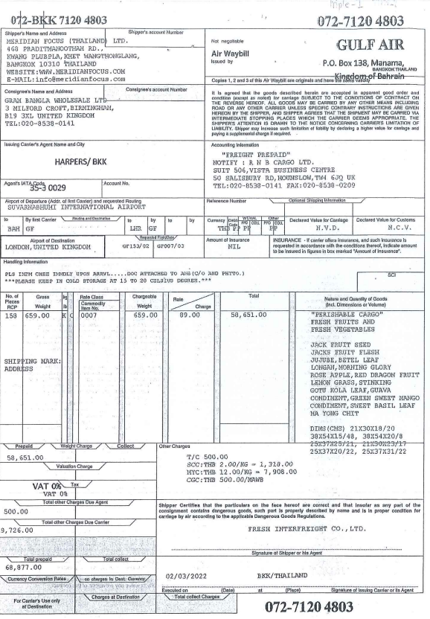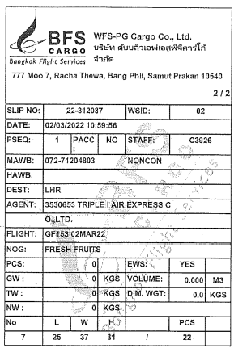
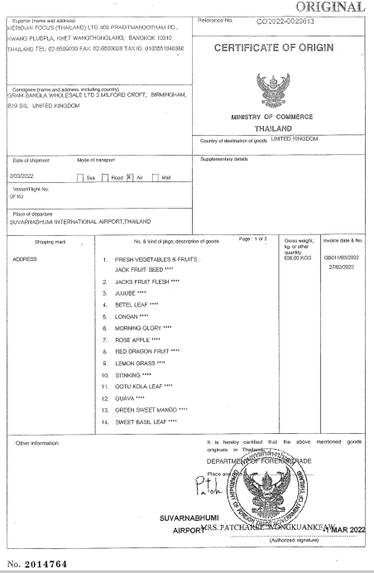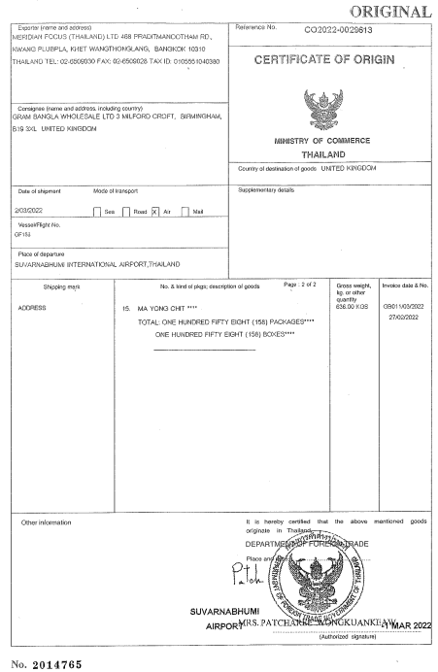
Appendix (cont)
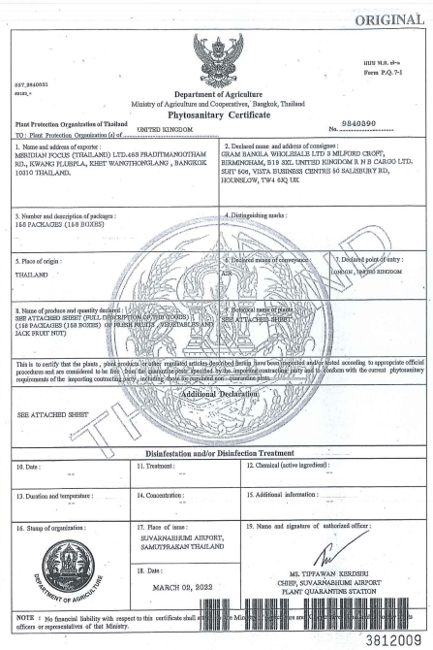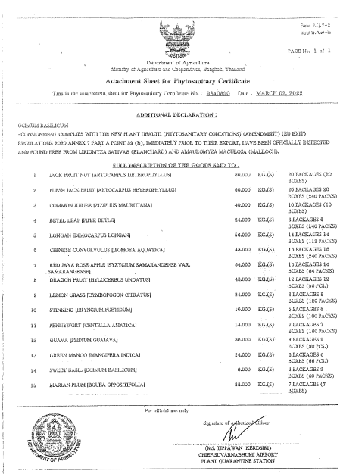
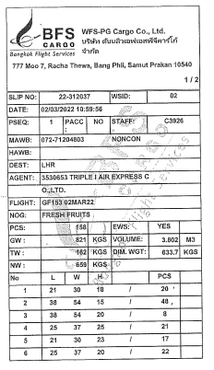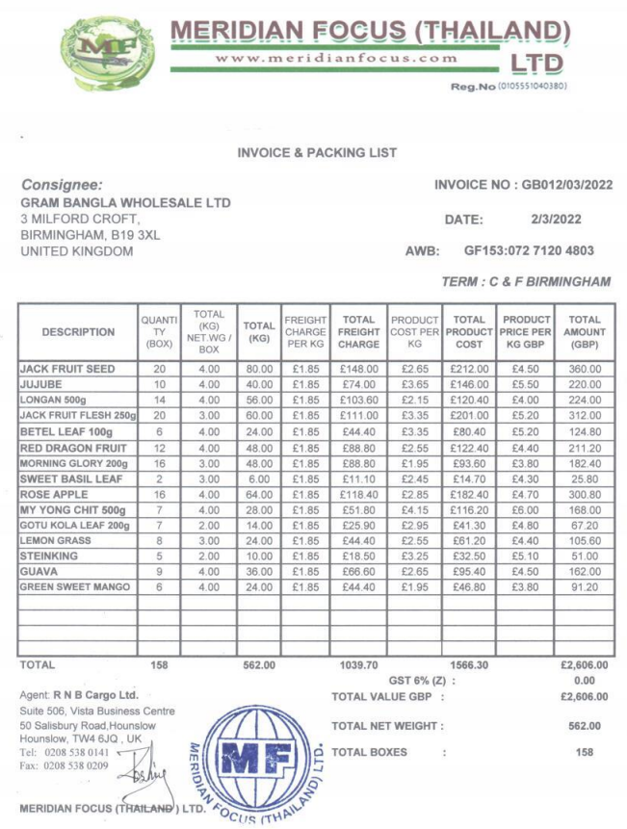

India
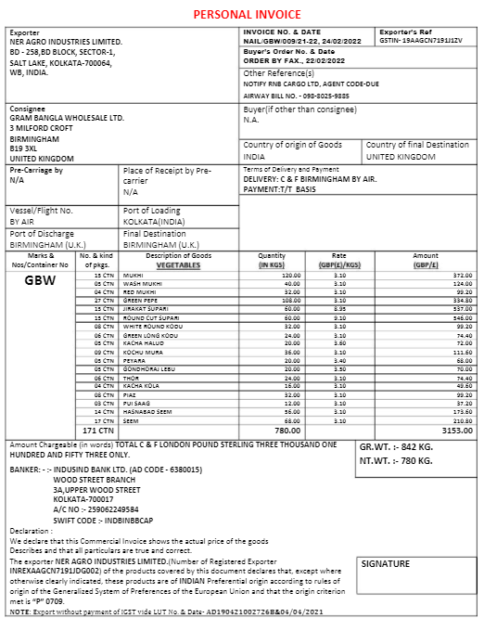

Bangladesh
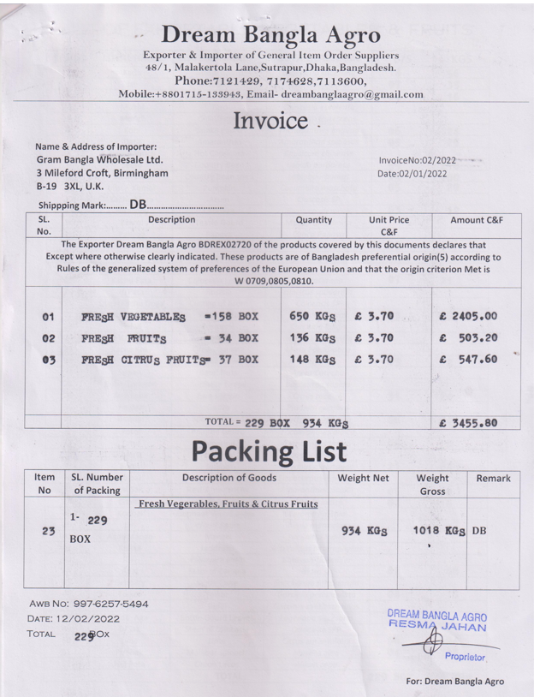
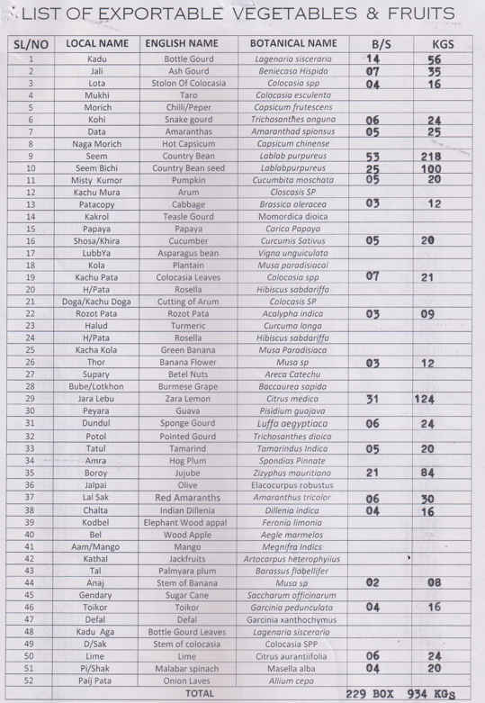

Appendix (continued)
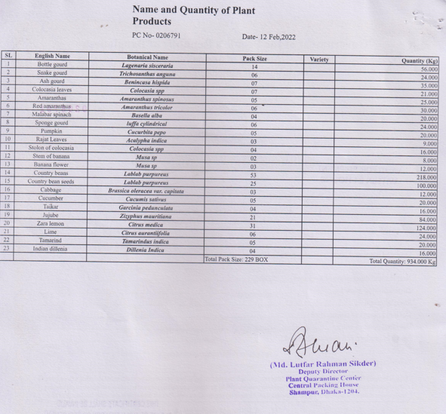

Malaysia

Appendix 3


