- Task 2: Object Analysis (1,500 words)
  - Critically analyse ONE artefact or inscription of your choice and discuss why you consider it to be a key source for understanding religious change in a province during the Principate.
    - Nota Bene: your object is meant to be an artefact or inscription, like the Pillar of the Boatmen from Lutetia/Paris that we discussed in Week 4. These objects provide an insight into a local community, while most of our literary sources only provide an external view, e.g. written by member of the Roman elite, like Tacitus or Pliny.

Object analysis of: Curse Tablets in Bath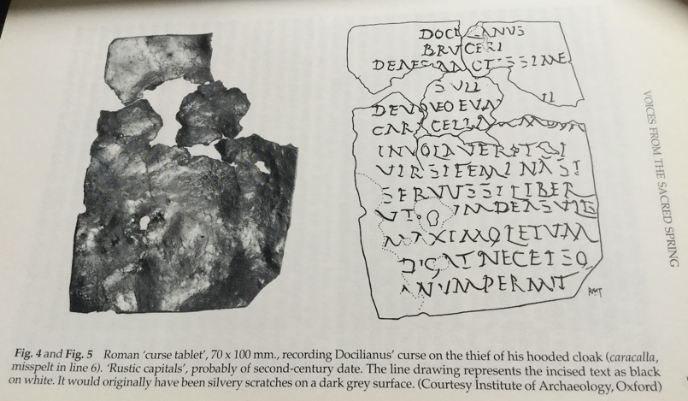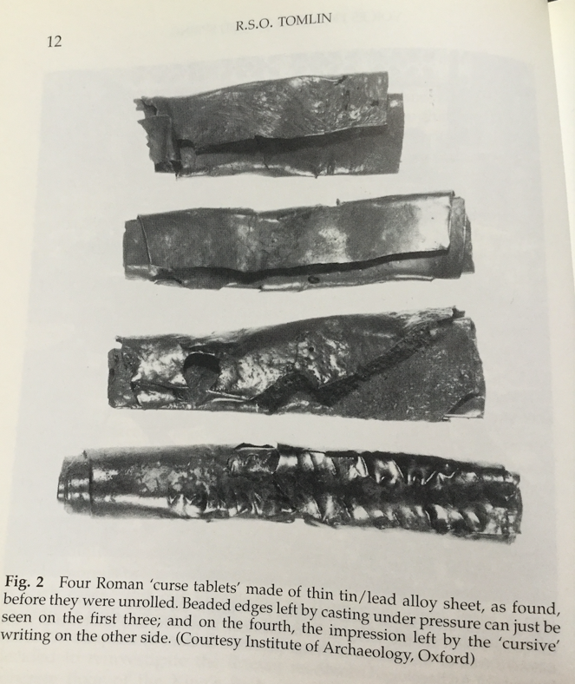
The use of curse tablets or defixiones as they were known in Latin, represented a practice common throughout the Greco-Roman world. These curses, normally inscribed upon small, thin lead sheets, were both easy to write upon as well as cheap to produce. The use of curse tablets originated in the classical Greek context were later adopted by the Romans who spread the practice across the Roman Empire. Curse tablets have been found across the Roman world, from sites in Spain, Britain, Israel, Germany and Rome. The number and continued use of curse tablets demonstrates their popular use up until the 7th century A.D when they disappear from the archaeological record. One of the largest collections of Roman curse tablets were found at the site of Bath in the UK, at which 130 were recovered. These curse tablets have, so far, only been found in Roman sites surrounding the Severn estuary, and thus represent a localized form of a greater Roman religious/magical practice. At Bath the tablets were found within the sacred spring that “lay directly between the temple and the baths.” Despite the great quantity of tablets found, little is known of their authors and their way of life. However, they give a window into a practice largely disparaged by classical authors who labelled such practice as “superstitio.”
Roger Tomlin describes the practical use of curse tablets as follows,
They are not anonymous spells consigning enemies to demons and the Underworld,
but messages written to respectable gods, asking (but not compelling) their intervention; the petitioner says that he (or she) has been maltreated, and seeks divine redress. The gods are treated like superior Roman officials…”
These tablets are written in a quasi-legal form and are “[…]in a sense a prayer for justice addressed to a deity whose task is to punish the offender and to restore his property to the petitioner.” While the petitions and goals made by the inscribers of the tablets vary, they all in some sense, “express a formalized wish to bring other persons or animals under the client’s power.” There are wide range of curses found that include but are not limited to:

“death, illness (fever, consumption, blindness, dumbness, lameness, broken limbs), loss of memory, various forms of mental suffering, sleeplessness, involuntary celibacy, loss of family and house, public humiliation, defeat in war and athletic competition, failure in business, conviction on public courts, denial of an afterlife, and general lack of success. In racing spells, horses are to fall down, break their limbs and rear up at the start. In the relatively few cases of tablets directed against inanimate targets, public baths are to be restrained and hindered, and the gates of Rome are to be stuck.”

Of the tablets that survived, most are normally inscribed on thin lead sheets however, the consistency of the lead in the tablets make-up varies as does their style of deposition. Some tablets were pre-written by specialists, while others were written by the individual enacting the curse. Many are rolled, some have nails going through them, some contain images and others utilize voces mysticae “words not immediately recognizable as Greek, Hebrew, or any other language in common use at the time” How literally these curses were to be taken, their effectiveness and reasons for their continued popular practice is a matter of conjecture, but Gager and Tomlin state that:

“the practice of inscribing them for two centuries… implies that they did work. Or rather that they were believed to work… we need not assume that they worked in the same way that the participants themselves believed […] the process ‘removed intolerable tensions’ […] ‘to inscribe a curse tablet and throw it into the sacred pool relieved the injured party’s feelings; something at least had been done.”

The tablets found at Bath represent one of the largest collections of curse tablets found, numbering around 130. Guy de la Bedoyere is very critical of the Bath tablets, stating that while they are “often described as the most potent and vivid record of how the Romano-British used a cult centre, in some senses they are but in others they are almost useless.” His reasoning is that we do not know who the individuals inscribing each tablet were, who was using the cult centre and when each tablet was being deposited. If there was any form of religious shrine at Bath prior to Roman use no evidence remains. However, the deity Sulis, associated with Minerva and inscribed in many of the tablets is clearly a local one. From coins deposited at the site we can roughly estimate that the site was in use from between the mid-first century A.D. until the end of the fourth century A.D. Overall the use of the site, the method of deposition via water and the inscriptions on tablets found show a striking similarity to other curse tablet depositions found across the Roman Empire.
As stated earlier, the lack of dating found for curse tablets makes it very hard to assign a relative time period to such finds. However, Gager has noted several general changes to the inscriptions found in curse tablets over the course of the Roman period. Firstly, Late Roman curse tablets (fourth to fifth century A.D.) display a greater amount of voces mysticae, mystical language, in some cases up to eighty or even ninety percent. This is heavily contrasted with early tablets which have maybe a line or two in such language. Secondly the names of deities found on curse tablets become “notably longer, more complex, and aggressively international in later examples.” A third difference in curse tablets is the drawing of human, animal figures as well as “astrological charaktêres, become omnipresent.” Fourthly, there is an increase in the use of Egyptian elements, showing a “fusion of Greek, Egyptian and other cultures typical of Egypt from the first century C.E. onwards.” Lastly, Gager describes that names ending in -êl and -ôth are “built off of Jewish and Hebrew models” and thus indicate a later Roman date. However, it must also be stated that these examples are drawn from tablets found across the Roman Empire and may not specifically apply to the curse tablets found in Bath.
Perhaps the greatest information to be gleaned from the Bath curse tablets is their use in the study of language. The curse tablets are a prime example of the everyday domestic use of Latin by the people of Britain. These are not official dedications used on monuments but rather personal use of the Latin language. While we cannot fully assign a tablet to a social stratum of society we can see from their use that it was not just Roman officials who understood written Latin. Of the 130 tablets found at Bath 112-130 bear no legible text. According to Douglas:
“this leaves us with a corpus of 59 texts which bear a certain number of words, ranging from the almost complete […] to those bearing only one word. With the exception of Tab. Sul. 95-96, each tablet has a different author, or at least a different scribe. Their authors vary from the well-practiced […] to the practically illiterate […], although the majority appears to have been written personally.”
Adams states that most of the tablets are so badly spelt that it is “difficult to distinguish phonetically significant misspellings from plain slips.” However, the errors present are those which are common throughout the empire and cannot be assigned to any specific socio-economic group. In terms of Welsh loan words, several names appear upon the tablets. Douglas suggests that “there is strong evidence that [ae] and [e] became closer, and that the word final -ae was weakened and often lost entirely” and that u and o merged “to a significant extent.” However, Douglas refuses to assign a date to these changes and states that these trends are in line with the Western Empire generally, stating that “Britain, and Bath in particular, was not linguistically isolated, but, presumably through regular contact with the European mainland, underwent broadly similar changes in language.”
In conclusion, the curse tablets from Bath represent one of the largest collections of curse tablets found to date, depicting a form of popular religious practice used across the Roman Empire, throughout the period. The practice of written curses on lead tablets, dedicated to various deities petitioning for justice, usually for materials lost in hopes of compensation was a common practice used by many. While general changes in tablet structure, such as the increase in Egyptian influences and the increase in voces mysticae, mystical language, indicate a general trend of change, the point to be emphasized is the continuation and similarity of such curse tablet from before the Roman Period until the 7th century A.D. In terms of the Bath tablets, much work has been done to understand the vulgar Latin used by ordinary people to understand basic literacy and spelling. This work done by scholars such as Pearce (2004), Adams (1992), Douglas (2015), Mullen (2013) and others analyze the texts for Welsh loan words, changes in vulgar grammar, as well as trying to differentiate spelling errors from general trends in written Latin. These leaden curse tablets give a fascinating insight into the common religious beliefs and practices of the people who inhabited Britain and beyond during the Roman Period. They also give insight into the literacy of the people who lived around the Severn estuary or who came to visit Bath during the Roman Period.

Bibliography

Adams, J.N. (1992) British Latin: The Text, Interpretation and Language of the Bath Curse Tablets, Britannia, Vol. 23, pp. 1-26.

Beard, Mary, North, John, and Price, Simon. (1998) Religions of Rome Volume I: A History, Cambridge University Press.

Beard, Mary, North, John, and Price, Simon. (1998) Religions of Rome Volume II: A sourcebook, Cambridge University Press.

Burrell, Barbara. (1998) Curse Tablets from Caesarea, Near Eastern Archaeology, Vol. 61, No. 2 p. 128.

Davenport, Peter, Poole, Cynthia, and Jordan, David. (2007) Archaeology in Bath: Excavations at the New Royal Baths (the Spa) and Bellott’s Hospital 1998-1999. Oxford Archaeology.

Dietrich, B. C. (1993) Review: Curse Tablets and Binding Spells from the Ancient World by John G. Gager. The Classical Review, New Series, Vol. 43. No. 2. P. 313-314.

de la Bédoyère, G. (2007) Gods with Thunderbolts: Religion in Roman Britain. Tempus Publishing Ltd.

de la Bédoyère, G. (2006) Roman Britain, A New History. London: Thames & Hudson Ltd.

Douglas, Sam. (2015) Evidence for the Spoken Language in Roman Britain: A Study of the Curse Tablets from the Sulis Minerva Sanctuary in Bath. The Student Researcher, Vol 3. No. 2. p. 71-78.

Gager, John G. (1999) Curse Tablets and Binding Spells from the Ancient World, Oxford University Press.

Mullen, Alex. (2013) New thoughts on British Latin: A Curse Tablet from Red Hill, Ratcliffe-on-soar (Nottinghamshire), Zeitschrift für Papyrologie und Epigraphik, Bd. 187, p. 266-272.

Pearce, John. (2004) Archaeology, writing tablets and literacy in Roman Britian. Gallia, Vol. 61. P. 43-51.

Tomlin, Roger. (2005) Cursing a Thief in Iberia and Britian, Chapter 7 of Magical Practice in the Latin West: Papers from the International Conference held at the University of Zaragoza, Religions in the Greco-Roman World, Vol. 168. Brill. p. 245-275.

Tomlin, Roger. (1992) Bath History: Volume IV. Millstream Books.

Tomin, Roger. (1988) Chapter 4 of The Temple of Sulis Minerva at Bath: Volume 2 the finds from the Sacred Spring. Oxford Committee for Archaeology.

Turner, Eric G. (1963) A Curse Tablet from Nottinghamshire, The Journal of Roman Studies, Vol. 53. p. 122-124.

Woodward, Ann. (1992) English Heritage: Shrines and Sacrifice, B.T. Batsford Ltd/English Heritage London.

Veale, Sarah. Defixiones and the Temple Locus: The Power of Place in the Curse Tablets at Mainz, Magic, Ritual and Witchcraft, University of Pennsylvania Press. (2017) p. 279-313.

Tomlin (1992) p. 12 & 17.
Tomlin (1998) p. 81.
Tomlin (2005). p. 245.
Dietrich (1993). P. 314.
Burrell (1998).
Veale (2017).
Beard, North & Price (1998). Vol II. p.266.
Dietrich (1993) p. 314
Adams (1992)
Tomlin (1988) p. 59.
De le Bédoyere (2007) p.79.
Beard, North & Price (1998). Vol I. p.225.
Tomlin (2005) p. 246.
Tomlin (1988) p. 70.
Turner (1963) p. 122.
Gager (1999) p. 21.
Gager (1999) p. 21-22.
Gager (1999) p. 20.
Gager (1999) p. 9 & 18.
Gager (1999) p. 23.
Woodward (1992) p. 71.
De la Bédoyere (2007) p. 79.
De la Bédoyere (2007) p. 79.
De la Bédoyere (2007) p. 70.
Davenport, Poole & Jordan (2007) p.25.
De la Bédoyere (2006) p. 222.
Tomlin, (2005) p. 247.
Gager, (1999) p. 6.
Gager, (1999) p. 6.
Gager, (1999) p. 6.
Gager, (1999) p. 6.
Adams (1992) states, “Britain is now the main source of new Latin.” p. 1.
Pearce (2004) p. 44.
Douglas (2015) p. 72.
Douglas (2015) p. 72.
Adams (1992) p. 24.
Douglas (2015) p. 76.
Douglas (2015), p. 76.

