

Student name: Marianna Florea
Student ID: 2244840
Module name: Empowering the Older Person
Module code: BMHP6027
Lecturer’s name: Dr Laila Surani

I confirm that I have not used any AI tools in the research and creation of this assignment. I confirm that I have not presented any AI-generated materials as my work. I confirm I have copies of my drafts, notes, and other resources I used, which I may be asked to provide as evidence.

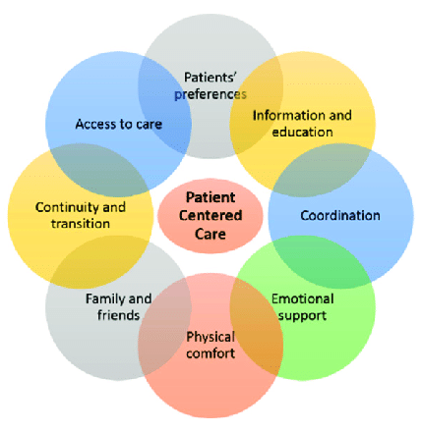 |  | 2. Care, Empowerment, and Support Needs  Maintaining independence and choice supports the well-being of older adults. A holistic approach addressing physical, psychological, social, and empowerment needs enhances participation and satisfaction (Parra-Rizo and Sanchís-Soler, 2021).  - Physical Needs: Access to mobility aids and physiotherapy (Torres de Araújo et al., 2022).  - Psychological Needs: Counselling and social activities promoting dignity (Lataster et al., 2022).  - Social Needs: Community centres and volunteering opportunities (Czaja, Moxley, and Rogers, 2021).  - Empowerment Needs: Shared decision-making and personalised care plans (Tsubouchi et al., 2021). |  | 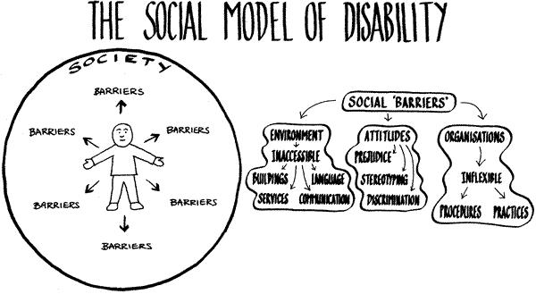
- Introduction |  |  |  | 4. Challenges Encountered by Older Adults in Maintaining Independence
Older adults, typically defined as individuals aged 65 and above, often experience changes in their physical, social, and emotional health that influence overall well-being (Sappington et al., 2025).  - Empowerment within health and social care provides older adults with choice, control, and participation in decision-making processes, supporting autonomy and confidence (Raemdonck et al., 2022).  - By 2030, older adults are expected to represent 23% of the UK population, highlighting the growing importance of inclusive, person-centred approaches to promote independence and quality of life (Ageing Better, 2025). |  |  |  | Older adults face multiple challenges that can hinder their ability to maintain independence and quality of life.  - Economic barriers, with nearly 1 in 5 elderly living in poverty, limit access to services and supports (Joseph Rowntree Foundation, 2024).  - Chronic health conditions affect daily living for older adults (CDC, 2024).  - Social isolation impacts nearly one million elderly in the UK, increasing risks of depression and cognitive decline (Age UK, 2023).  - Ageism reduces elderly involvement, confidence and perceived value in decision-making processes (von Humboldt et al., 2024).  5. Recommendations for improvement of services  - Emphasise Person-Centred Care to support individualised, empowering approaches (Nilsen et al., 2022).  - Integrate assistive technologies and improve digital literacy to promote self-sufficiency and independence (Van Leeuwen et al., 2023).  - Provide training and support for care staff on person-centred and culturally competent care practices (Bennett et al., 2022).  - Promote community-based programs to reduce social isolation and encourage meaningful engagement among older adults (Jiménez et al., 2021).  - Enhance collaboration between health, social care, and the community of care and support networks (Santa et al., 2025).  6. Conclusion  - Older adults require care, empowerment, and support to improve their quality of life.  - A person-centred approach focuses on autonomy, dignity, and meaningful involvement (Ekman 2022).  - Financial, health, and social barriers must be addressed to maintain independence.  - Effective empowerment depends on supportive policies, improved practices, and better funding (Laetitia and Amolo, 2025)

3.Effectiveness and Benefits of Approaches and Interventions
Various policies and theoretical frameworks guide effective interventions for promoting the independence and well-being of older adults in the UK.
- The Care Act 2014 promotes individual well-being, empowers service users, and integrates health and social care services to ensure person-centred support (Damant et al., 2025).

- The Health and Social Care Act 2001 improved care coordination, expanded patients’ choice, introduced Care Trusts, strengthened quality regulation, and person-centred services (Tynkkynen 2023).

- Person-Centred Care Theory and Maslow`s Hierarchy of Needs (1943) emphasise individualised, holistic care that meets personal values and basic needs, enhancing older people`s wellbeing, satisfaction, and independence (Yang et al., 2023).

References
Age UK (2023). Loneliness research and impact. Age UK. Available at: https://www.ageuk.org.uk/our-impact/policy-research/loneliness-research-and-resources/. (Accessed: 20 October 2025).
Ageing Better (2025) Our ageing population: The State of Ageing 2023-24 (no date) Centre for Ageing Better. Available at: https://ageing-better.org.uk/our-ageing-population-state-ageing-2023-4 (Accessed: 16 October 2025).
Bennett, P. et al. (2022) ‘Effectiveness of an aged simulation training suit to support development of compassion and person‐centred care in the aged‐care workforce’, Australasian journal on ageing, 41(2), pp. 314–324. Available at: https://doi.org/10.1111/ajag.13057
CDC (2024). About chronic diseases. Centers for Disease Control and Prevention. Available at: https://www.cdc.gov/chronic-disease/about/index.html (Accessed: 20 October 2025).
Czaja, S.J., Moxley, J.H. and Rogers, W.A. (2021) `Social Support, Isolation, Loneliness, and Health Among Older Adults in the PRISM Randomized Controlled Trial’, Frontiers in Psychology, 12, p. 728658. Available at: https://doi.org/10.3389/fpsyg.2021.728658
Damant, J., Hamashima, Y., Toma, M., Smith, N., Taylor, J., Caprioli, T., Jasim, S., Prato, L., Mcleod, H., Giebel, C. and Peters, M., (2025). Investigating Person‐Centred Care Planning in Care Homes Across England: An Exploratory Study of Practices and Contextual Factors. Journal of Advanced Nursing. (7 April) https://doi.org/10.1111/jan.16965
Ekman, I. (2022) ‘Practising the ethics of person‐centred care balancing ethical conviction and moral obligations’, Nursing philosophy, 23(3), pp. e12382-n/a. Available at: https://doi.org/10.1111/nup.12382
GR Berntsen, M Chetty, L Ako-Egbe, S Yaron, P Phan, C Curran, I Castro, C Canfield, P Lachman (2022) White Paper Person-centred care systems: From theory to practice. ISQua. Available at: https://isqua.org/media/attachments/2022/10/03/person-centred-care-systems_-from-theory-to-practice.pdf (Accessed: 17 October 2025).
Jiménez, F.N. et al. (2021) ‘A Technology Training Program to Alleviate Social Isolation and Loneliness Among Homebound Older Adults: A Community Case Study’, Frontiers in Public Health, 9, p. 750609. Available at: https://doi.org/10.3389/fpubh.2021.750609
Joseph Rowntree Foundation (2024). UK Poverty 2024: the Essential Guide to Understanding Poverty in the UK | Joseph Rowntree Foundation. www.jrf.org.uk. Available at: https://www.jrf.org.uk/uk-poverty-2024-the-essential-guide-to-understanding-poverty-in-the-uk. (Accessed: 19 October 2025).
Laetitia, B.I. and Amolo, A.E.J. (2025) ‘Stakeholder Empowerment Strategies and Community Development Project Performance’, International Journal of Finance & Banking Studies, 14(1), pp. 157–165. Available at: https://doi.org/10.20525/ijfbs.v14i1.4000.

Lataster, J. et al. (2022) ‘Basic Psychological Need Satisfaction and Well-Being Across Age: A Cross-Sectional General Population Study among 1709 Dutch Speaking Adults’, Journal of Happiness Studies, 23(5), pp. 2259–2290. Available at: https://doi.org/10.1007/s10902-021-00482-2
Nilsen, E.R. et al. (2022) ‘What matters to older adults? Exploring person‐centred care during and after transitions between hospital and home’, Journal of Clinical Nursing, 31(5–6), pp. 569–581. Available at: https://doi.org/10.1111/jocn.15914.
Parra-Rizo, M.A. and Sanchís-Soler, G. (2021) ‘Physical Activity and the Improvement of Autonomy, Functional Ability, Subjective Health, and Social Relationships in Women over the Age of 60’, International Journal of Environmental Research and Public Health, 18(13), p. 6926. Available at: https://doi.org/10.3390/ijerph18136926.
Raemdonck, E. et al. (2022) ‘Giving voice to informal caregivers of community‐dwelling older adults: A systematic review of empowerment interventions’, Health & social care in the community, 30(6), pp. e3354–e3368. Available at: https://doi.org/10.1111/hsc.13928
Santa, K. et al. (2025) ‘Collaborative networks in community-based health and social care services: insights from Blackpool and the Fylde Coast (United Kingdom)’, Health research policy and systems, 23(1). Available at: https://doi.org/10.1186/s12961-025-01303-1
Sappington, E. et al. (2025) ‘Patient-Centred Care in Healthcare Services: Feedback from Older Adults Engaging in Primary Care–Based Behavioural Health Programs’, The journal of behavioural health services & research [Preprint]. Available at: https://doi.org/10.1007/s11414-025-09971-1
Torres de Araújo, J.R. et al. (2022) ‘Mobility Limitation in Older Adults Residing in Nursing Homes in Brazil Associated With Advanced Age and Poor Nutritional Status: An Observational Study’, Journal of geriatric physical therapy (2001), 45(3), pp. E137–E144. Available at: https://doi.org/10.1519/JPT.0000000000000301
Tsubouchi, Y. et al. (2021) ‘A conceptual analysis of older adults’ empowerment in contemporary Japanese culture’, BMC Geriatrics, 21(1). Available at: https://doi.org/10.1186/s12877-021-02631-x
Tynkkynen, L. (2023) ‘What a journey! – A short history of the Finnish health care and social service reform and administrative integration of health care and social services’, European Journal of Public Health, 33(Supplement_2). Available at: https://doi.org/10.1093/eurpub/ckad160.125.
Van Leeuwen, C., Jacobs, A. and Mariën, I., (2023). `Catching the digital train on time: Older adults, continuity, and digital inclusion`. Social Inclusion, 11(3), pp.239-250.
von Humboldt, S. et al. (2024) ‘Older adults, perceived ageism, civic participation and mental health: a qualitative study’, Aging & mental health, 28(11), pp. 1489–1501. Available at: https://doi.org/10.1080/13607863.2024.2348611
Yang, Y. et al. (2023) ‘The unmet needs of patients in the early rehabilitation stage after lung cancer surgery: a qualitative study based on Maslow’s hierarchy of needs theory’, Supportive care in cancer, 31(12). Available at: https://doi.org/10.1007/s00520-023-08129-z

