
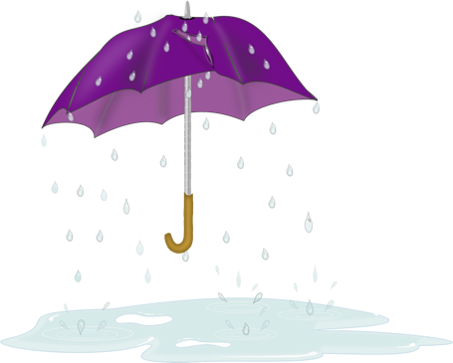

This Photo by Unknown Author is licensed under CC BY-SA

Cymylog
Heulog
Bwrw glaw

Sut
Mae’r
Tywydd
Heddiw?
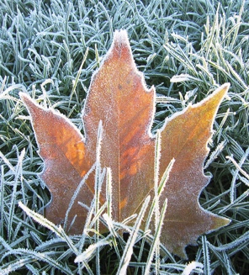
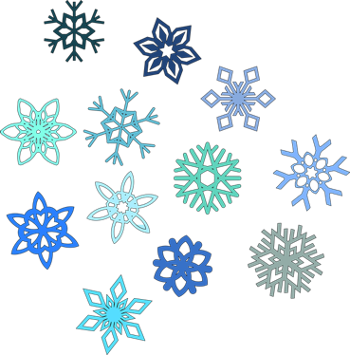
This Photo by Unknown Author is licensed under CC BY-SA
This Photo by Unknown Author is licensed under CC BY-SA


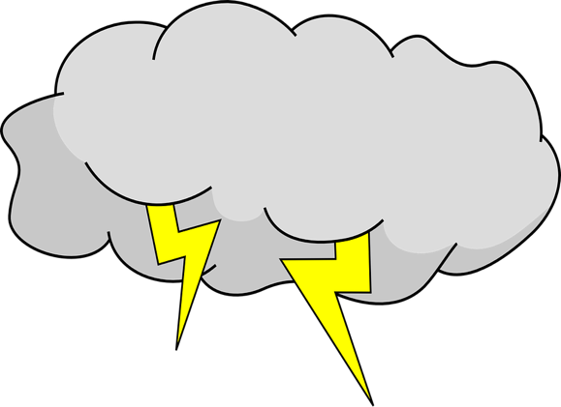
rhewi
This Photo by Unknown Author is licensed under CC BY
Heulog a cymylog
Stormus
Bwrw eira

