

Assessment- 1 Understanding of Cloud Computing Perceptions for UWTSD staffs
ACCA5025_BIRM
University of Wales Trinity Saint David, Birmingham
Student Name: Cristian-Constantin Paraschiv
Student ID: 2026077
Contents
Introduction 3
Concept of Cloud computing 3
Background of Cloud Computing 3
Characteristics of cloud computing 4
Computing on demand and the providing of services by the user themselves 4
Resource pooling 4
Ability to scale, as well as quick flexibility 4
Utilization-based pricing or PPU 4
Services of Cloud Computing 4
IaaS, PaaS, and SaaS with respect to UWTSD requirements 4
Infrastructure as a Service (IaaS) 4
Platform as a Service (PaaS) 5
Software as a Service (SaaS) 6
Cloud Computing Models 6
Public Cloud Model 7
Private Cloud Model 7
Hybrid Cloud Model 8
Cloud security and mitigation of security issues 9
Breach of Data 9
Misconfigurations 9
Threats from Within 9
Malware 10
Best Practices for Cloud Security Mitigation of Security Issues 10
Virtualization Concept and Hypervisor I & II 10
An Overview of Virtualization 10
Hypervisor-Based Concepts 10
Type-1 hypervisor 10
Type-2 hypervisor 11
Modern cloud services 11
Containers, Dockers & Kubernetes 11
Conclusion 12
References 13

Assessment- 1 Understanding of Cloud
Computing Perceptions for UWTSD staffs

Introduction
By making them available on demand, the cloud may be used to store massive quantities of a variety of data and applications. The Cloud Computing Architecture, on the other hand, may be seen as the easy access to robust components, hosts, memory, and enterprise software provided by datacentres without requiring one to incorporate sizable inputs to its own structure, application, and components [1]. The whole study has provided readers a proper understanding of cloud computing by evaluating its background, outlining its attributes, the solutions it provides, and discussing its security concerns (threats and vulnerabilities) and best - practice for mitigating them, as well as its delivery models and a closer examination of the ideas of virtual machines and hypervisors. The study will address how The University of Wales Trinity Saint David (UWTSD) could profit from the simplified advantages that cloud computing services offer as a result.

Concept of Cloud computing
Concerning cloud computing, it's all about the services, not the actual goods. The technology allows for the distribution of digital resources on demand, giving people and organisations the freedom to get rid of or decrease the use of old data applications and infrastructure. Users only need to pay for the amount of hardware and software they actually use when they use pay-as-you-go cloud services. Cloud computing allows businesses to become nimbler, save costs, innovate more quickly, and alter their company goals and objectives with the use of advanced analytics tools [1], [2], [4], [5].

Background of Cloud Computing
The emergence of data centers in the 1950s marked the beginning of a gradual progression. The concept of "cloud computing," which is more of an abstract term, emerged during the time in which mainframe computers prevalent utilized to access programmes and data that resided on the localised foundation of clients. In the 1960s, the first information technology services introduced concurrently with a rising demand for personal computers that made use of distributed computing resources. Towards the latter half of the 1990s, amid the dot-com boom, businesses began adopting dynamic client/server designs, and service providers began offering virtual private networks.
In the 2000s, even before companies required its powers to deliver sophisticated solutions for virtual servers through cloud - hosted settings, this was the impetus for the beginning of the trend of outsourcing the administration of IT infrastructure.
The distribution strategies for community cloud, including infrastructure as a service (IaaS), platform as a service (PaaS), and software as a service became an integral part of cloud computing in 2010. (SaaS). Multiple users are now able to collaborate on the same project at the same time thanks to a service that is available today called cloud collaboration. Cloud collaboration is a hybrid collection of corporate software and virtualized social interaction tools [1], [2], [4], [5].

Characteristics of cloud computing

Computing on demand and the providing of services by the user themselves
When using cloud computing, developers don't have to wait for fresh systems to be sent to a consumer data facility; instead, they could choose the support and technologies they require, generally via the self-service portal of a cloud provider, and immediately build the server they require. Cloud computing provides this benefit. Users still have the ability to design, test, and deploy applications in any manner they see appropriate so long as they stay within the parameters of the regulations that the administrator establishes. The administrator will need to establish policies that restrict what IT and development teams may run [1], [2], [4], [5].

Resource pooling
Multi-tenant architectures are used by public cloud service providers to facilitate the simultaneous usage of a greater number of customers. The workloads of the users are separated from the underlying hardware and software, which are responsible for serving several users on identical venue. Cloud service suppliers are depending more on specialised technology and abstraction strata to boost customers' access to resources, as well as their own level of security [1], [2], [4], [5].

Ability to scale, as well as quick flexibility
Pooling resources allows cloud providers and consumers to scale their operations more easily since computation, additional or upgraded space, connectivity, and other resources deleted depending on need. This will assist the university's IT staff in optimising the workloads that are hosted in the cloud and avoiding bottlenecks caused by end users. Users may take use of automation technologies offered by cloud service providers to manage dynamic scaling on their behalf. Clouds can grow either vertically or horizontally [1], [2], [4], [5].

Utilization-based pricing or PPU
This feature of cloud computing causes the university's IT spending to shift from capital expenditures to operational expenditures. This is that cloud vendors give each charging, whereby that you will only have to the cost of the operations that you use rather than for the comprehensive service offering. Due to the anticipated fluid nature of their resource requirements, the IT staff at the institution need to exercise consideration. Virtual machines (VMs) should be of the appropriate size, switched off when they are not being used, or scaled down as the circumstances need.

Services of Cloud Computing

IaaS, PaaS, and SaaS with respect to UWTSD requirements

Infrastructure as a Service (IaaS)
IaaS, or infrastructure as a service, is a type of cloud computing in which virtualized infrastructure is supplied to and maintained for the institution by its external cloud providers. IaaS gives businesses the ability to outsource their storage, server space, and data centre space, as well as their cloud networking components, which are all connected through the internet. This provides businesses with functionality that is comparable to that of on-premises infrastructure, which results in significant cost savings. These Infrastructure as a Service (IaaS) offerings include automated and policy-driven activities such as website hosting, backup and recovery, monitoring, clustering, and internal networking. The construction of the servers and storage facilities, as well as the networking firewalls and other security measures, is within the purview of the service provider [1], [2], [4], [5].
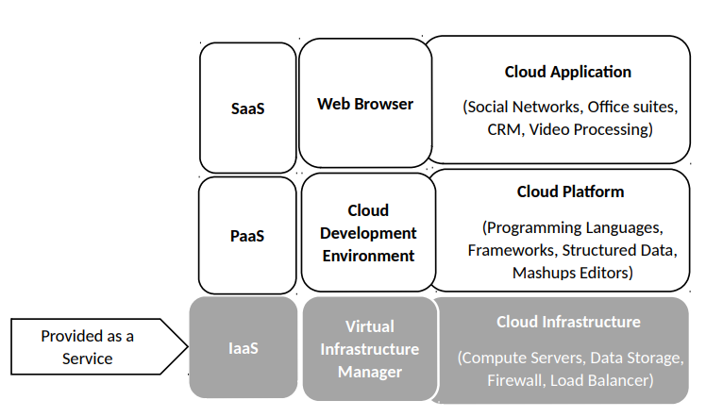

Platform as a Service (PaaS)
IaaS serves as a foundation for PaaS. As part of PaaS, cloud service providers provide the software and hardware infrastructure components needed for application development and testing, including middleware and operating systems. Data sets, development tools, and business analytics apps may all be installed and hosted using PaaS without having to worry about developing and maintaining an infrastructure [1], [2], [4], [5].
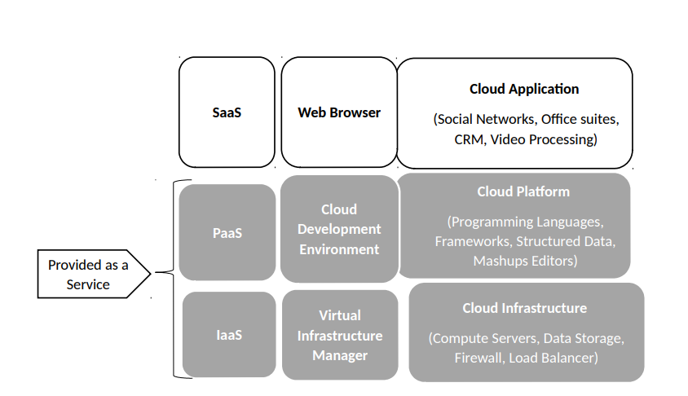

Software as a Service (SaaS)
Because it combines IaaS and PaaS, SaaS is a one-of-a-kind model. SaaS is a subscription-based cloud computing paradigm in which users pay only for the services they utilise. SaaS enables internet-based access to software programmes such as email [1], [2], [4], [5].
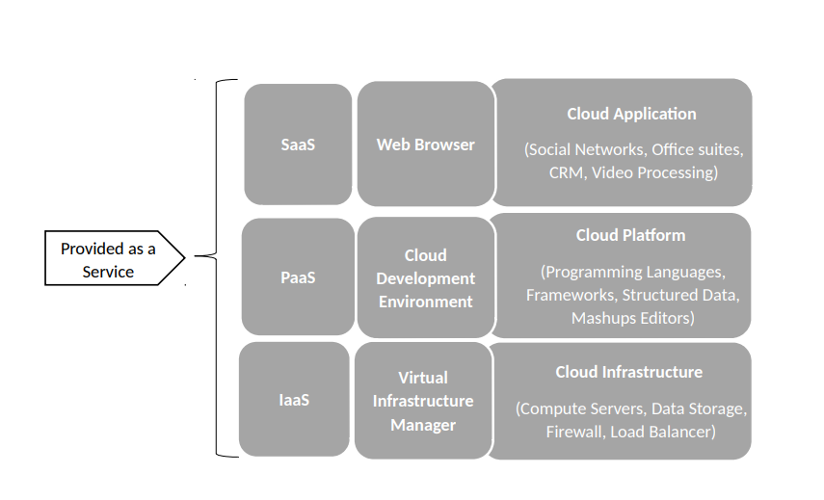

Cloud Computing Models

Public Cloud Model
It's the most cost-effective choice for consumers, has fewer configuration options and is priced according to consumption capacity in the paradigm of the public cloud where the service provider pays for all bandwidth and infrastructure costs. Public cloud, despite its dependability, reduced costs, minimal maintenance, and on-demand scalability, is not advised for institutions with sensitive data and tight security rules, even though it has these advantages [1], [2], [4], [5].
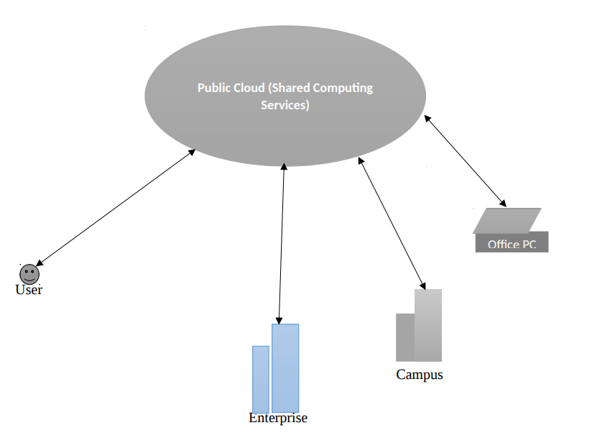

Private Cloud Model
With the private cloud, you have greater control over customizability, scalability, and flexibility, as well as improved asset and company security. Either in-house or outsourced, a private cloud infrastructure is available. In contrast to the public cloud, the private cloud possesses the ability to control the physical and logical architecture over a private network for such operator exclusively. Large and medium-sized financial institutions, as well as government bodies, endorse this strategy [1], [2], [4], [5].
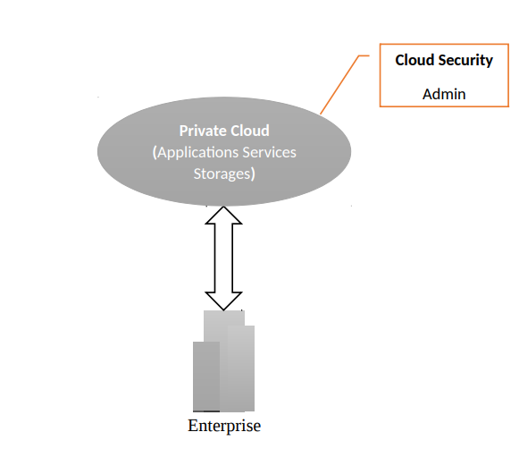

Hybrid Cloud Model
To put it another way: Hybrid clouds are the mix of private and public cloud services. This allows enterprises and institutions to have more control over their vital processes and assets, allowing for more flexibility. Organizations and institutions may use a single interface to manage their private and public clouds and tailor their workloads to the capabilities of each environment. When it comes to operating high-volume apps like email, the institution can use the public cloud, but when it comes to more private assets like financial records and the need for data recovery and periodic maintenance, the university can use the public cloud instead [1], [2], [4], [5].
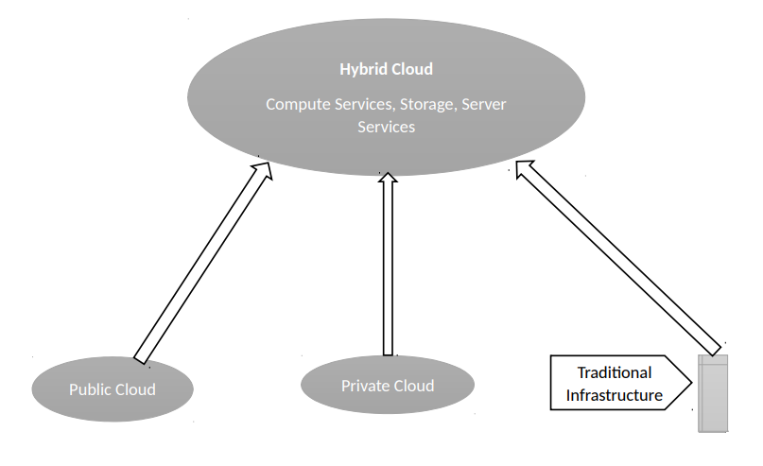

Cloud security and mitigation of security issues

As with any large-scale deployment method, cloud computing gives the user smooth advantages, but it also poses some unexpected obstacles. Security and risk mitigation are the users' responsibility, not the systems, networks, or apps themselves, in the cloud. To put it another way, cloud infrastructure providers offer for a great level of control when it comes to setting up and configuring the environment in which the service is running, as well as protecting and monitoring that environment.
The foregoing are some possible risks that come with the aid of cloud computing those designers have had some ideas at our arsenal too though. on how to mitigate such dangers best:

Breach of Data
Theft or loss of data may occur because of a data breach, compromising the security, accessibility, and integrity of sensitive information. Inadequate identity and credential management, simple registration systems, phishing and pretexting, and insecure APIs are all factors that contribute to cloud data breaches.

Misconfigurations
Human mistake, allowing excessive user rights, permitting excessive sharing settings, and deactivating conventional security safeguards are all examples of misconfiguration risk problems.

Threats from Within
An unhappy employee may be motivated to retaliate, or an admin may have made a mistake. Insider threats might be purposeful or unintentional. Users are not the lone insider, unless is individual. Additionally possible for contractors, availability of information by affiliates, manufacturers in an unauthorised manner, disclose the data, or enable it to be stolen. The absence of insight into user and administrator activity and application use across their cloud storage systems might result in such dangers. Insight dangers include privileged account misuse, compromised VPNs and gateways, or linked users, privileged accounts, and service accounts that may be accessed by unauthorised individuals.

Malware
By tricking the user into opening an email attachment or social media link that contains malicious code, the attacker may download malware built to avoid detection and meant to spy on, steal data from, or otherwise undermine the security of cloud service apps.

Best Practices for Cloud Security Mitigation of Security Issues
The research proposes the subsequent actions for the UWTSD to keep their cloud secure both especially near such connections and facilities: Establishing functional default setups and conducting regular arrangement audits to look for any deviation from the benchmark are all a must, as is permission is being removed from resources whenever there are adjustments made within the university both growing effective enterprise-wide cloud use permission regulations. Their systems must be monitored for suspicious activity, such as an increase in failed access attempts, so that they can detect any suspicious patterns in the use of important or crucial information. They must also simply discover all the data, using information finding and categorization technologies. their sensitive and critical data, knowing who their system users, contractors, and partners are and tracking their activities [1], [2], [4], [5].

Virtualization Concept and Hypervisor I & II

An Overview of Virtualization
Many logical devices (computers) may share the same physical hardware via the use of virtualization (VMs). When people talk about virtualization, they usually mean the well-known and well-developed technology of server virtualization. This divides up the server's resources, such as its processors and memory, into several instances, each of which is isolated from the others. It is possible to separate distinct abstractions, such as desktop virtualization, network virtualization, operating system virtualization, or server virtualization, by using an abstraction layer that shares the same processing, storage, and network resources as the other abstractions [3].

Hypervisor-Based Concepts
When numerous operating systems are placed on the same physical infrastructure, they seem to be utilising their own physical resources, but are sharing the same hardware resources and appear to be running independently. Type-1 and Type-2 Hypervisors are the two main varieties [3].

Type-1 hypervisor
In comparison to the type-2 hypervisor, the type-1 hypervisor offers better performance and isolation because it runs directly on the hardware. However, because the host OS is absent and the hypervisor is self-contained, it is more difficult to deploy because compatibility testing between the hardware and hypervisor is required. VMWare and Microsoft Hyper-V type-1 hypervisor samples [3].

Type-2 hypervisor
It is easier and faster to install type-2 hypervisors since they operate on top of a host OS and share resources with the guest OS. For example, Oracle VirtualBox and VMWare Workstation do not have to be tested against hardware, which reduces costs and deployment effort [3].

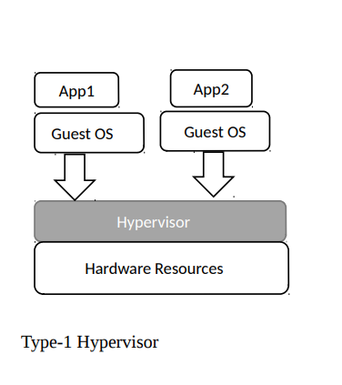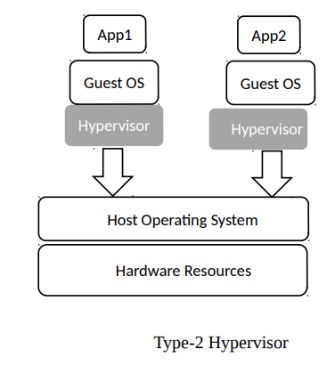

Modern cloud services

Containers, Dockers & Kubernetes
Kubernetes and Dockers both run Linux apps. Containers bundle software. Containers' behaviour is predictable and unchangeable. Containers travel easily across environments and machines [6]. Containers store dependencies, programmes, and libraries. A container is an OS-less virtual machine. Time-saving containers.
Dockers deliver software. Dockers operate, produce, and ship software. Dockers simplifies programme creation, deployment, and operation. Dockers work like virtual machines, except instead of producing an entire system image, they merely require the missing bits. This increases programme speed and size. Because Docker is open source, anybody may contribute and change it. Docker is an admin-and-developer DevOps toolset. Dockers reduce developers' worries about several platforms. It offers developers hundreds of Docker-optimized applications [9], [10]. Docker's adaptability and small footprint minimise system count.
Complex applications for several platforms need specific technology. Kubernetes containers applications [7]. Kubernetes manages container clusters open source. Kubernetes deploys, scales, and manages containerized apps. Kubernetes is versatile and fault-tolerant, allowing application components to restart across systems. Kubernetes is a framework that lets clients choose application frameworks, monitoring and logging systems, languages, and other tools [7]. Kubernetes is written in Go and available on GitHub. Google launched Kubernetes in 2014 to manage containers on their servers and infrastructures [8]. The tool is popular in the Open-Source community, with contributions from RedHat, Google, and other organisations. Kubernetes' organisational unit is Pods [11]. A pod is a group of containers regulated by the same hardware/virtual computer, a node.
Kubernetes and Dockers use Linux containers. Linux containers isolate apps from the host. Developers may bundle software in containers. Developers may bundle programmes with libraries and dependencies [11]. Containers let developers easily move code across environments. They just utilise the system's parts, unlike virtual machines. Virtual computers don't require a native host and have a protective layer. Open-source Kubernetes, Dockers, and Containers [9], [10]. A huge community helps the platform expand and serve clients.
The Docker project is Containers' biggest advantage since it enables developers to utilise a command line tool that has enhanced their contact with systems [12]. Microservice architecture simplifies applications using containers.

Conclusion
A new age in information and communication technology has begun with the advent of cloud computing, which introduces a paradigm shift that has the potential to fundamentally alter how computing is now carried out. The transition from on-premises computing to cloud computing will proceed gradually as users get more familiar with the technology. If you have a creative concept for an internet service, you don't have to spend a lot of money creating your software and hardware infrastructure, but you may instead concentrate on providing the best service possible. When a company's user base expands and the service provider can multiplex over a wide range of customers, economies of scale become more important to cloud providers. Cloud computing has several disadvantages in addition to its numerous benefits. Data protection, personal space, and dependability concerns, stability in availability of services, integration problems caused by non-standard software and applications that are specific to various providers, problems with preparation and development, as well as high data transmission ends up costing are just a few of the obstacles that cloud computing gifts. After a comprehensive and extensive examination of relevant literature, this research discusses intelligent, efficient, and effective strategies to tackle cloud computing issues. Even though cloud computing is a relatively new technology, it still has a long way to go before it reaches its full potential, thanks to continued research and development.

References

[1] Wang, L., Von Laszewski, G., Younge, A., He, X., Kunze, M., Tao, J. and Fu, C., (2010). Cloud computing: a perspective study. New generation computing, 28(2), pp.137-146.
[2] Subashini, S. and Kavitha, V., (2011). A survey on security issues in service delivery models of cloud computing. Journal of network and computer applications, 34(1), pp.1-11.
[3] Khan, A., Zugenmaier, A., Jurca, D. and Kellerer, W., (2012). Network virtualization: a hypervisor for the Internet?. IEEE Communications Magazine, 50(1), pp.136-143.
[4] Carlin, S. and Curran, K., (2012). Cloud computing technologies. International Journal of Cloud Computing and Services Science, 1(2), p.59.
[5] Ma, S., (2012). A review on cloud computing development. Journal of Networks, 7(2), pp.305.
[6] Computer Weekly. (2019). What are containers and microservices?. Retrieved 14 October 2019, from https://www.computerweekly.com/feature/What-are-containers-and-microservices
[7] CTL. (2019). An Intro to Google's Kubernetes and How to Use It - CenturyLink Cloud Developer Center. Retrieved 14 October 2019, from https://www.ctl.io/developers/blog/post/what-is-kubernetes-and-how-to-use-it/
[8] Develop Intelligence. (2019). What does Kubernetes actually do and why use it? | DevelopIntelligence Blog. Retrieved 14 October 2019, from http://www.developintelligence.com/blog/2017/02/kubernetes-actually-use/
[9] Docker. (2019). What is a Container? | Docker. Retrieved 14 October 2019, from https://www.docker.com/resources/what-container
[10] Docker. (2019). Why Docker? | Docker. Retrieved 14 October 2019, from https://www.docker.com/why-docker
[11] Kubernets.io. (2019). What is Kubernetes. Retrieved 14 October 2019, from https://kubernetes.io/docs/concepts/overview/what-is-kubernetes/ OpenSource. (2019). What are Linux containers?. Retrieved 14 October 2019, from https://opensource.com/resources/what-are-linux-containers
[12] Rubens, P. (2019). What are containers and why do you need them?. Retrieved 14 October 2019, from https://www.cio.com/article/2924995/what-are-containers-and-why-do-you-needthem.html

