Critically evaluate and explain the role and activities of the marketing department within your own organisation or an organisation you are familiar with: Spire Healthcare Group plc

Florence Kashora

Student number: 1705533

Module: Marketing Management SBMA7102D Part A

Date of Submission: 04/08/2018

Word count: 2774

The Spire Healthcare Group plc is a private healthcare organisation in the United Kingdom. Based on revenues, it is the largest provider of healthcare services, second only to the National Health Service (NHS) (Spire Healthcare Group plc, 2018). It offers similar services to the NHS from its 39 hospitals, 11 clinics and Specialist Cancer Care Centre across England, Wales and Scotland. Its selling point is that patients can be beat the waiting times of the NHS. However, this comes at a cost, which the patient is responsible for paying directly or through their insurance. The NHS at times employs the services of the private healthcare sector; for instance, to try to reduce its own waiting times for certain surgical procedures.

Role of the department in the organisational structure
The organisation claims to want to integrate its “sales and marketing functions to leverage scale and best practice” (Spire Healthcare Group plc, 2017). There is a central commercial team who spearhead the marketing function. However, it is not clear whether the different hospitals or regions have their own local marketing departments which work together with, or report to, this central commercial team. The organisation has also contracted external organisations to be involved in their marketing initiatives. This includes creation of its website and consumer segmentation (The Drum, 2017; Spire Healthcare Group plc, 2018). Overall, the organisation seems to have an “Elastic” marketing department structure. This is because the marketing function seems to be generic but flexible, and changes as the organisation’s product offerings change (Modern Marketing Partners, 2018). Instead, I believe the company should be aiming for a more “Inbound” structure which provides tailored advertising, especially because of how healthcare is such as personal service. However, such targeting, and use of data analytics may not be allowed due to the vulnerability of patients. Furthermore, the data used may only be superficial as there are limitations on the use of patient’s medical notes (General Medical Council, 2017).
On observation, there also seems to be disjointed advertising within the organisation, especially on the social media sites where a combination of marketing inputs from several hospitals are put together (#spirehealthcare, 2018), or where some hospitals have more developed marketing media compared to others (Spire Leicester Hospital, 2018). This is in sharp contrast to the website which integrates all of the organisation’s services in one place. In fact, Spire Healthcare Group plc has recently employed an external agency to integrate all of its marketing activities including across the different hospitals (OLIVER, 2018). This should include integration of their digital marketing media. Additionally, the marketing department should work to integrate the software vendors it employs to deal with customer data and marketing programs (Whitler, 2016). This could ultimately lead to a more seamless and targeted customer brand experience. Whitler also stresses the importance of leadership. The Chief Marketing Officer (CMO) may also need to lead the trend and update their digital media skills, as well as keeping on top of new developments.
Marc de Swaan Arons et al (2014) also encourage the marketing department to align its activities with the organisation’s strategy, as well as involving the rest of the organisation in its marketing functions, to increase marketing success. Although Marc de Swaan Arons et al emphasise the importance of an integrated marketing department with a common focus, they also discuss how the department should still be flexible agile enough to achieve fast turnaround of new marketing campaigns. Such agility can be facilitated by the Orchestrator Model which allows marketing departments to create task forces that each focus on one aspect of a marketing campaign.

Key target markets
Currently, the organisation seems to be focusing on the local market in order to increase the private patient base (Spire Healthcare Group plc, 2017). They also describe wanting to target the “right people” and using local demographics to win more clients (Spire Healthcare Group plc). This includes paying attention to trends in the NHS system. However, there is no further detail regarding who the organisation is specifically targeting. This may be a reflection of the heavy regulation in healthcare.

Hanlon (2018) discusses the Segmentation, Targeting and Positioning (STP) model. The organisation discusses how they do this by profiling each client based on their personal information (Spire Healthcare Group PLC, 2018). Many organisations can now do this using data analytics, which now has faster and more accurate algorithms (Gurbuxani, 2013) . This is followed by tailored marketing which includes targeted ads via social media sites such as Facebook™. However, the extent to which the organisation can follow the STP model may be limited by restrictions on advertising in healthcare. For instance, Hanlon describes certain categories into which patients can be segmented. This may work if the organisation advertises sports injuries on a sports’ channel. However, other ways of categorising consumers such as ethnicity may be deemed discriminatory. Additionally, psychographics may be too intrusive or manipulative. The same restrictions may also apply to data analytics. For instance, the organisation may benefit from using data analytics to build customer loyalty and aid marketing operations (Columbus, 2016). However, there may be restrictions on the depth of data analytics to ensure that there are no breaches on patient’s confidentiality.

The organisation has also analysed its sales and identified areas with high growth (Spire Healthcare Group plc, 2017). Such analyses can also be performed in the context of the Boston Consulting Group’s growth-share matrix (Kotler and Armstrong, 2017, pp. 67-70). However, categorisation may be made difficult and less reliable as sales are affected by other factors such as trends in the NHS system, and these can change unpredictably. For instance, there may be less sales from orthopaedic operations in the private sector if the NHS develops better ways to meet its waiting time targets. Kotler and Armstrong also argue how these matrices can be costly, time-consuming and complex.

On the other hand, I would argue that the organisation should focus more on customer loyalty and retention instead of targeted marketing which is restricted by advertising regulators. For instance, Banali Malhotra, Head of Marketing at RAKBANK, advises placing a high importance on customer service, performing a needs analysis of different customer segments and producing benefits that reflect this, as well as ensuring “unmatched value” for customers and that products are of the same quality as originally advertised (RAKBANK, 2011). In the course discussion, Taylor (2018), also discusses the replacement of healthcare secretaries with patient pathway coordinators as a way of improving customer relationships. Additionally, Bruycker (2016) argues that we should move away from traditional marketing campaigns and let the quality of the product be the actual marketing. This requires spending more money on product development than loud marketing campaigns. This is in contrast to marketing activities such as creating a position statement to attract the consumer and manipulate their view of the brand (Bueno and Jeffrey, 2017). Overall, I believe that these techniques increase customer loyalty and may even attract new customers.

Selection of appropriate media channels

Spire Healthcare Group plc’s marketing tools include digital marketing (Spire Healthcare Group plc, 2017). This seems to be the most visible marketing method the organisation is using. However, it is not clear whether, as discussed by Kotler and Armstrong (2018), digital marketing is the primary marketing approach or supplementary. In this case, Spire Healthcare Group plc is using digital media such as social media as a supplementary tool in their marketing toolbox. This includes social medial tools such as Twitter™, Facebook™, Instagram™ and YouTube™. This allows the organisation to reach a range of consumers across the world with access to digital devices. As illustrated by Eval (2013), the social media presence acts as an external trigger or “hook” to draw the consumers in. This is enhanced by posting patient’s stories of successful treatment, images of celebrities and even engaging consumers with a competition (#spirehealthcare, 2018). Benefits of social media include the lower cost and faster turnover of marketing campaigns compared to other media such as print or television (Kotler and Armstrong, 2018). Social media also allows immediate and timely engagement with the consumers. For instance, the advertisement can link in with real-time events such as the advert for children’s services during sports day week (Spirelondoneast, 2018) (see Appendix A).

However, there are several challenges encountered when using social media as a marketing tool. There is heavy regulation from several organisations, including the General Medical Council (GMC, 2018) and the Advertising Standards Agency (ASA, 2018), especially because of the vulnerability of patients and the greater consequences due to patients’ health being at stake. Consumers are also in control and have a strong social media voice (Ohanian, 2009). Therefore, there is a risk that engagement with marketing campaigns may be negative and content criticised if the it is deemed offensive or not well thought-out. An example is the Gap advert which was deemed offensive and detrimental to race relations (BBC trending, 2016).

Additionally, some evidence shows that consumers may not engage with social media despite investment in large marketing budgets (Ritson, 2015). However, there are examples of organisations which have had great engagement of consumers with their social media campaigns, leading to increased sales. As argued by Nthere (2018) in the course discussion, this includes Starbucks. On the other hand, there may be fake engagement, and the organisation may have to deal with fake consumer feedback (Hertz, 2013) and fake followers. If left for others such as the mass media to discover, this could lead to disastrous consequences for the organisation’s reputation and sales. Therefore, the organisation needs to ensure a risk assessment has been done and that safeguards are in place to prevent this from happening. Overall, the marketing team has to work hard to maintain a balance by working together with the regulatory agencies and being sensitive to consumers, as well as being creative in their approaches for engaging real consumers.

Cooperate social responsibility (CSR) initiatives may also help to increase media opportunities, which could attract consumers and increase sales (EuropeanCEO, 2015). An example is a team from one of the hospitals raising money for a charity (Spiremanchester, 2018); see Appendix B. This is one way in which the organisation involves its employees in marketing its message via social media. As discussed by the EuropeanCEO, CSR can also help to engage and retain employees, as well as increasing their productivity. However, CSR may not apply to healthcare services advertising in the same way as other industries such as household goods. This is especially because the healthcare industry already has to follow higher standards anyway due to the particular vulnerability of patients. Therefore, the organisation should be aiming to maintain, instead of developing, a reputation for being responsible.

Other digital tools which Spire Healthcare Group plc used include a website which requires the consumer to actively access it (see Appendix C). The website provides information on the services provided, contact details and testimonials. The website’s creators emphasise how they wanted to create a website which would engage and retain consumers (The Drum, 2017). However, the organisation is not able to take advantage of tools that increase consumer engagement within the website. These include a forum or allowing personalised subpages (Kotler and Armstrong, 2018). Ultimately this could lead to lack of consumer engagement with the website.

The organisation also uses direct marketing methods such as email marketing (Spire Healthcare Group plc, 2018). Kotler and Armstrong (2018) describe how this can be personalised and reach a large number of consumers. However, marketing emails can become spam and may be viewed as a nuisance by consumers. The organisation does not seem to make much use mobile marketing, viral marketing, or blogs. For instance, with viral marketing the marketing team can easily lose control of the original message they intended to deliver (Ohanian, 2009). Mobile marketing may be viewed as too intrusive and may be deemed as targeting vulnerable people who may not have otherwise accessed private healthcare. This is important as healthcare services marketing is under heavy regulations.
Other marketing methods used by Spire Healthcare Group plc include; print media such as brochures and banners; video adverts. The organisation does not seem to make much use of display and search-related ads on the internet. For instance, if one types in “private healthcare UK” into Google™, BUPA™ shows high up, whereas Spire Healthcare Group plc does not show up. This is something which the marketing team should look into and employ internal or external digital marketing experts to correct. Telephone marketing is also something that the organisation do not seem to use (Spire Healthcare Group plc, 2018); this may again be due to the heavy advertising regulations the organisation is under.

Measuring success
The organisation describes certain measures of success, or goals, which it aims to achieve with its marketing activities. For instance, Spire Healthcare Group plc (2017) also aims to carry out local marketing and digital marketing to increase its private patient base. Additionally, the marketing department helps consultant doctors with individual marketing packages to help increase their business (Spire TW Hospital, 2018) (see appendix D). The organisation also used the website to attract new clients, and soon after the launch was starting to see an increase in its website visitors and new enquiries for services (The Drum, 2017). Other markers of campaign effectiveness that the organisation uses are the increase in the number of its younger patients. Overall, the organisation has increased investment in its marketing function to increase growth in its self-paying patient base (Spire Healthcare Group plc). However, investment in marketing, and start-up ventures, has led to a reduction in profits for the last financial year. Therefore, it is currently too early to determine whether the organisation will profit from its marketing activities. Additionally, it may be difficult for the organisation to show a direct link between these activities and the profits they make. For instance, in the course discussion, Davies (2018a) argues that it is difficult to prove a direct link between social media presence and profits.

The organisation also gains business from referrals from the NHS (Spire Healthcare Group plc., 2017). For instance, if a patient does not receive a certain operation within the recommended timeframe in the NHS. This form of Business-to-Business marketing is discussed by Fran Brosnan in an interview by Dobbie (2010) who encourages activities such as the building of relationships and targeted marketing to increase sales. However, there are restrictions in how external businesses can interact with gatekeepers in the NHS such as the General Practioners (GP) (General Medical Council, 2013). The relationship should not cause the doctors’ practice to veer outside the NHS guidelines.

Additionally, the organisation should be looking to measure their success against that of their competitors, and aiming to surpass them. In the course discussions, I argue for Urbany (2011)’s assertation that in order to beat the competition, marketing departments need to focus on the value which matters to customers but which is different to competitors (Kashora, 2018b). For instance, looking at shoe retailers, Clarks™ is known for the authentic leather and durability of its shoes, instead of cheaper shoes sold by ShoeZone™. In the same light, Spire Healthcare Group plc should make more explicit its reduced waiting times as this seems to be the biggest value it offers, compared to the NHS (see Appendix E). Hooley et al (2017, pp. 5- 6) also discuss how consumers have more power because they have access to more information and more choice. This is reflected in how consumers may choose the private sector over the public sector and Spire Healthcare Group plc which should maximise this. However, in the same course discussion, Davies (2018b) also discusses how companies should actively seek the feedback of consumers regarding what they value about the company, as well as the main competitor. This may shed more light on other aspects the consumers value, and may challenge currently held assumptions

In conclusion, I believe that the key to Spire Healthcare Group plc’s success will be integrating their marketing activities across its different hospitals and services, and creating a responsive and agile department. This should also include integration of its digital advertising. The marketing team will also need to work to adhere to heavy advertising regulations as well as being sensitive to consumers. Additionally, instead of targeted marketing activities which may be restricted in the healthcare industry, I believe that increasing customer loyalty and offering a quality service are some of the less overt marketing techniques which the organisation should take advantage of. Finally, it is not yet clear whether the organisation will benefit from its recent marketing activities and the measurement of this success may require new tools to be developed.
References

#spirehealthcare. 2018. Instagram [ONLINE]. Available at: https://www.instagram.com/explore/tags/spirehealthcare/?hl=en [Accessed: 22 July 2018].

Advertising Standards Agency. 2018. Health and Beauty. [ONLINE]. Available at: https://www.asa.org.uk/topic_category/health_and_beauty.html [Accessed: 22 July 2018].

BBC Trending. 2016. Is this Gap advert racist?. Available at: https://www.bbc.co.uk/news/blogs-trending-35968787 [Accessed: 3 July 2018].

Bruycker, J. 2016. The Future Of Branding Is Debranding. Fast Company. [ONLINE]. https://www.fastcompany.com/3060658/the-future-of-branding-is-debranding [Accessed: 3 August 2018].

Bueno, B.J. and Scott Jeffrey, S. 2017. How to Create Strong Brand Positioning in Your Market. The Cult Branding Company. [ONLINE]. http://cultbranding.com/ceo/create-strong-brand-positioning-strategy/ [Accessed: 3 August 2018].

Columbus, L. 2016. Ten Ways Big Data Is Revolutionizing Marketing And Sales. Forbes. [ONLINE]. Available at: https://www.forbes.com/sites/louiscolumbus/2016/05/09/ten-ways-big-data-is-revolutionizing-marketing-and-sales/#7c0be2bb21cf [Accessed: 03 August 2018].

Davies, C. 2018a. Step 6.1: Why social media is over-rated (Mark Ritson "The brand doctor"). Online discussion forums, Marketing Management (SBMA7102D). University of Wales Trinity Saint David.

Davies, C. 2018b. Step 7.1 Competitive strategy in 3 minutes (Prof. Joe Urbany, Notre Dame University). Online discussion forums, Marketing Management (SBMA7102D). University of Wales Trinity Saint David.

Dobbie, P. 2010. B2B vs B2C Marketing. What's the Difference? Moneywatch. [ONLINE]. Available at: https://www.cbsnews.com/news/b2b-vs-b2c-marketing-whats-the-difference-btalk/ [Accessed: 03 August 2018].

EuropeanCEO. 2015. Corporate social responsibility: the ultimate marketing tool. Available at: https://www.europeanceo.com/business-and-management/corporate-social-responsibility-the-ultimate-marketing-tool/ [Accessed: 3 July 2018].

Eyal, N. 2013. Hooked Model [ONLINE]. Available at: https://www.slideshare.net/nireyal/hooked-model [Accessed: 3 July 2018].

General Medical Council. 2013. Financial and commercial arrangements and conflicts of interest. [ONLINE]. Available at: https://www.gmc-uk.org/-/media/documents/financial-and-commercial-arrangements-and-conflicts-of-interest_pdf-58833167.pdf [Accessed: 03 August 2018].

General Medical Council. 2017. Confidentiality: good practice in handling patient information. [ONLINE]. Available at: https://www.gmc-uk.org/-/media/documents/confidentiality-good-practice-in-handling-patient-information---english-0417_pdf-70080105.pdf [Accessed: 03 August 2018].

General Medical Council. 2018. Domain 4: Maintaining trust. [ONLINE]. Available at: https://www.gmc-uk.org/ethical-guidance/ethical-guidance-for-doctors/good-medical-practice/domain-4---maintaining-trust [Accessed: 22 July 2018].

General Medical Council. 2017. Confidentiality: good practice in handling patient information. [ONLINE]. Available at: https://www.gmc-uk.org/-/media/documents/confidentiality-good-practice-in-handling-patient-information---english-0417_pdf-70080105.pdf [Accessed: 03 August 2018].

Hanlon, A. 2018. The Segmentation, Targeting and Positioning model. Available at: https://www.smartinsights.com/digital-marketing-strategy/customer-segmentation-targeting/segmentation-targeting-and-positioning/ [Accessed: 3 August 2018].

Hertz, N. 2013. Eyes Wide Open: Author Noreena Hertz Talks to Marketing Smarts About Consumer Behaviour [Podcast]. Available at: http://www.marketingprofs.com/podcasts/2013/11708/consumer-behavior-noreena-hertz-marketing-smarts [Accessed: 3 July 2018].

Hooley, G., Nicolaud, B., Piercy, N. and Rudd, J. 2017. Marketing Strategy and Competitive Positioning, 6th Ed. Harlow, Pearson.

Kashora, F. 2018a. Step 2.2 Marketing present (meet Mr. Splashy Pants). Online discussion forums, Marketing Management (SBMA7102D). University of Wales Trinity Saint David.

Kashora, F. 2018b. Step 7.1 Competitive strategy in 3 minutes (Prof. Joe Urbany, Notre Dame University). Online discussion forums, Marketing Management (SBMA7102D). University of Wales Trinity Saint David.

Kotler, P. and Armstrong, G. 2018. Principles of Marketing, 17th edition, Hoboken: Pearson Higher Education.

Marc de Swaan Arons, M., van den Driest, F. and Weed, K. The Ultimate Marketing Machine. 2014. Harvard Business Review [ONLINE]. Available at: https://hbr.org/2014/07/the-ultimate-marketing-machine [Accessed: 03 August 2018].

Modern Marketing Partners. 2018. 7 types of marketing organization structures. [ONLINE]. Available at: https://www.modernmarketingpartners.com/7-types-of-marketing-organization-structures/ [Accessed: 28 July 2018].

Nthere , J. 2018. Step 6.1: Why social media is over-rated (Mark Ritson "The brand doctor"). Online discussion forums, Marketing Management (SBMA7102D). University of Wales Trinity Saint David.

Ohanian, A. 2009. Alexis Ohanian: How to make a splash in social media. [online video]. Available from: https://www.youtube.com/watch?v=tPgQsv2KPwc [Accessed: 3 July 2018].

OLIVER. 2018. OLIVER appointed as lead design agency for Spire Healthcare. [ONLINE]. Available at: https://marcommnews.com/oliver-appointed-as-lead-design-agency-for-spire-healthcare/ [Accessed: 23 July 2018].

RAKBANK. 2011. RAKBANK Case Study: Relationship Marketing. Available at: https://www.youtube.com/watch?v=Rzora4B-DyY&feature=youtu.be [Accessed: 3 August 2018].

Ritson, M. 2015. 2015 Media Forum: Mark Ritson. Available at: https://www.youtube.com/watch?v=kxYGrSO5jjM [Accessed: 3 July 2018].

Spirelondoneast. 2018. National school sports week. [ONLINE]. Available at: https://www.instagram.com/p/BkcLjYMAxjY/?hl=en&tagged=spirehealthcare [Accessed: 22 July 2018].

Spiremanchester. 2018. No title. [ONLINE]. Available at: https://www.instagram.com/p/Bhdr-gOj-RM/?hl=en&tagged=spirehealthcare [Accessed: 22 July 2018].

Spire Healthcare Group plc. 2017. Spire Healthcare Annual Report 2017 Strategic Report. Available from: https://investors.spirehealthcare.com/media/1241/spire_ar17_p255_strategic_report.pdf [Accessed: 16 July 2018].

Spire Healthcare Group plc. 2018. Experts in private healthcare. Available from: https://investors.spirehealthcare.com/about/ [Accessed: 15 July 2018].

Spire Leicester Hospital. 2018. Facebook page. Available from: https://www.facebook.com/SpireLeicester/ [Accessed: 15 July 2018].

Spire Parkway Hospital. 2018. Worried about your health. [Advert]. https://directory247.co.uk/business/spire-parkway-hospital/ [Accessed: 3 August 2018].

Spire TW Hospital. 2018. Richard Benson [ONLINE]. Available at: https://pbs.twimg.com/media/DhlpEqxXcAMyNUZ.jpg [Accessed: 22 July 2018].

Taylor, J. 2018. Step 5.3 Relationship marketing (Oxford University RakBank case study - UAE). Online discussion forums, Marketing Management (SBMA7102D). University of Wales Trinity Saint David.

The Drum. 2017. The digital coming of age for private healthcare with Spire Healthcare [ONLINE]. Available at: https://www.thedrum.com/profile/project/263226/digital-coming-age-private-healthcare-with-spire-healthcare [Accessed: 22 July 2018].

Urbany, J. 2011. Competitive Strategy in 3 Minutes. Available at: https://www.youtube.com/watch?v=bl5cyZlay4k [Accessed: 3 August 2018].

Whitler, K. 2016. 5 Tech Challenges Marketers Face In 2017. Available at: https://www.forbes.com/sites/kimberlywhitler/2016/11/13/5-tech-challenges-marketers-face-in-2017/#1ceef7103577 [Accessed: 4 July 2018].

Appendix A: Aligning marketing with occurrence of special events

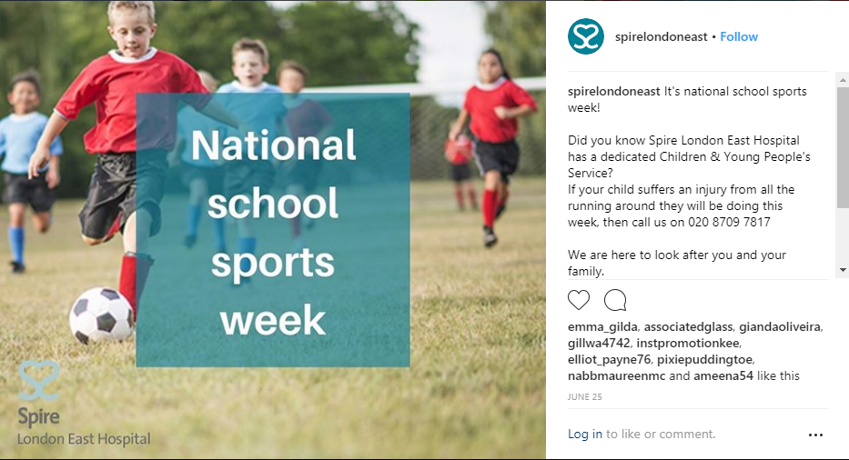

Appendix B: Example showing corporate social responsibility


Appendix C: Main Website
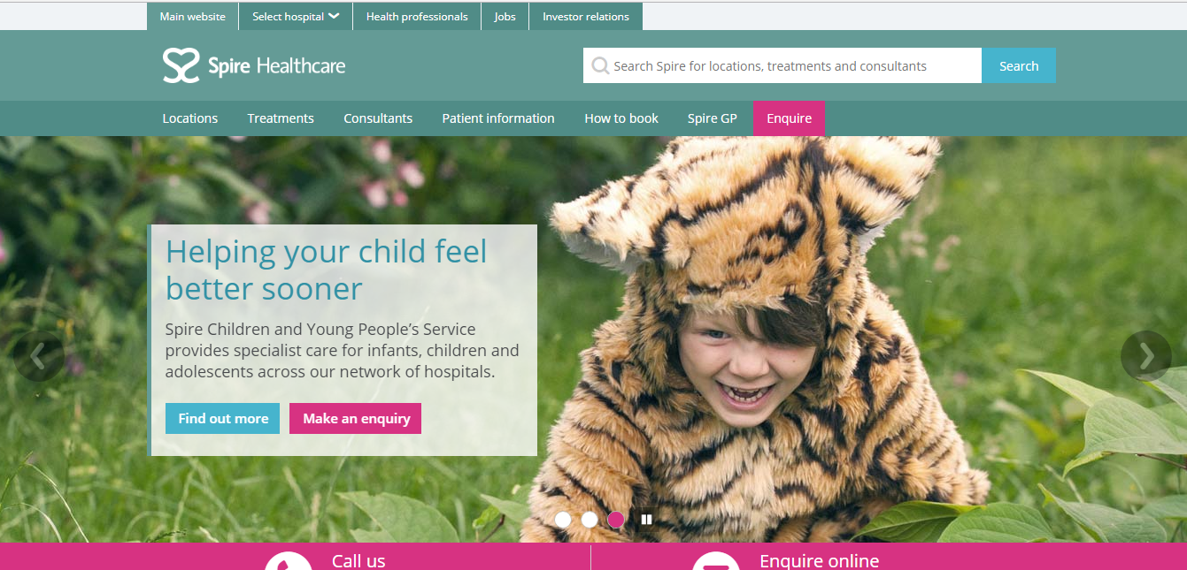

Appendix D: Marketing for individual consultants

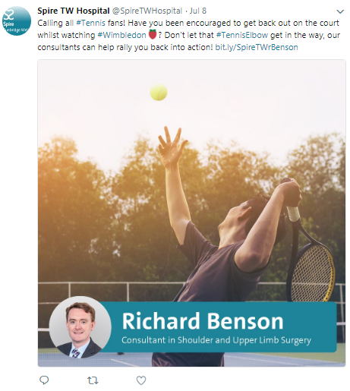

Appendix E: Advertising the reduced waiting times


